Vancouver Housing Market Analysis

Sanghoon Lee

3/29/2020

# Introduction

We study price trends in Vancouver housing market.

# Data

We use BC Assessment housing transaction data. The data is available for January 2000 to August 8 2018. We have 867,216 observations.

# Analysis

The following graph shows how average transaction price has changed over time.

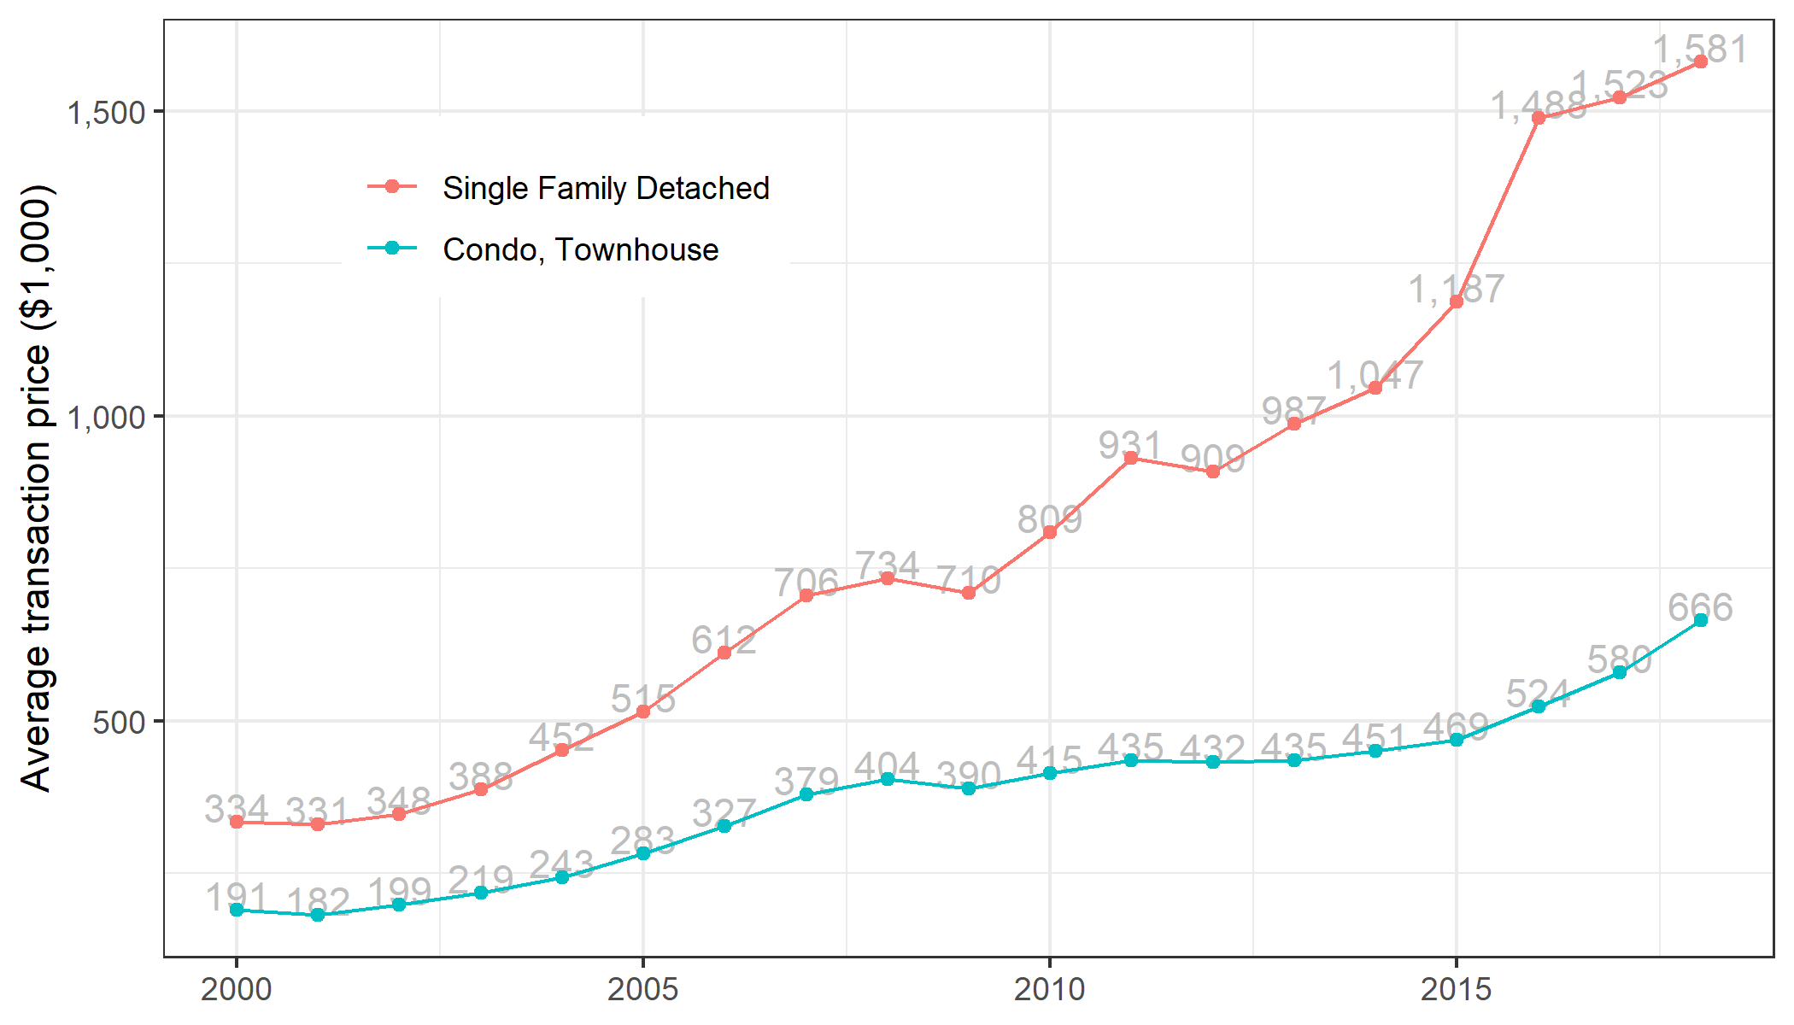

The graph shows that average price has increased about 450 % for Single Family houses and 350 % for condos and townhouses.