

Carbon Reduction Plan
Supplier name: ………COMPREHENSIVE CARE LTD.
Publication date: ………12/09/2024..............

Commitment to achieving Net Zero

[COMPREHENSIVE CARE LTD] is committed to achieving Net Zero emissions by 2050.

Baseline Emissions Footprint
Baseline emissions are a record of the greenhouse gases that have been produced in the past and were produced prior to the introduction of any strategies to reduce emissions. Baseline emissions are the reference point against which emissions reduction can be measured.
Baseline Year: 2016
Additional Details relating to the Baseline Emissions calculations.
Our baseline year is 2016, during which our total emissions were 805.36 tCO₂e, comprising Scope 1: 47.67 tCO₂e, Scope 2: 79.00 tCO₂e, and Scope 3: 678.69 tCO₂e (including Waste: 0.10 tCO₂e, Business Travel: 282.67 tCO₂e, and Employee Commuting: 395.92 tCO₂e). At that time, Scope 3 reporting was limited to these categories in line with available data. Future reporting will expand to include additional Scope 3 sources as our data collection systems mature. This baseline serves as our reference point for tracking progress toward our commitment to achieving Net Zero emissions by 2050.

Baseline year emissions:
EMISSIONS | TOTAL (tCO₂e)
Scope 1 | 147.67
Scope 2 | 279.00
Scope 3 (Included Sources) | 3678.69
Total Emissions | 805.36

Current Emissions Reporting
Reporting Year: 2024
EMISSIONS | TOTAL (tCO₂e)
Scope 1 | 23.07
Scope 2 | 46.26
Scope 3 (Included Sources) | 325.90
Total Emissions | 395.23

Emissions reduction targets

We are fully committed to achieving Net Zero greenhouse gas emissions by 2050 in line with UK Government targets. To support this long-term goal, we have set the following interim reduction targets:

By 2030: Reduce total Scope 1 and Scope 2 emissions by 40% from our 2016 baseline through energy efficiency improvements, transition to low-carbon transport, and adoption of renewable energy sources.

By 2035: Reduce combined Scope 1, 2, and measurable Scope 3 emissions by 55%, supported by sustainable procurement, digital transformation, and waste reduction measures.

By 2040: Achieve a 75% total reduction across all measurable scopes through continued investment in low-emission technologies and partnership with supply chain stakeholders.

By 2050: Achieve Net Zero emissions across our full organisational footprint.

Our progress will be reviewed annually, with emission data verified and published as part of our ongoing Carbon Reduction Plan updates.

In order to continue our progress to achieving Net Zero, we have adopted the following carbon reduction targets.

We project that carbon emissions will decrease over the next five years to 320 tCO₂e by 2030. This is a reduction of 40%

Progress against these targets can be seen in the graph below:

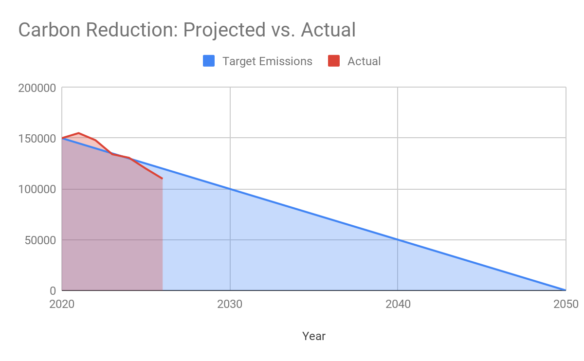

Carbon Reduction Projects

Completed Carbon Reduction Initiatives
The following environmental management measures and projects have been completed or implemented since the 2016 baseline. The carbon emission reduction achieved by these schemes equate to 395.23 tCO₂e, a 49.07%ge reduction against the 2016 baseline and the measures will be in effect when performing the contract
We have undertaken several initiatives to reduce our organisational carbon footprint and improve environmental performance across our operations:
- Energy Efficiency and Lighting Improvements
We replaced all traditional lighting in our office and operational areas with LED systems and PIR motion sensors, resulting in a measurable reduction in energy consumption and maintenance costs.
- Digital Transformation and Paperless Operations
The introduction of digital care management tools (CarePlanner and Office 365) has significantly reduced paper use, printing, and document transport. Staff training and communication now take place primarily through secure digital platforms, reducing travel-related emissions.
- Fleet and Travel Policy Changes
We adopted a Green Travel Policy, encouraging car sharing, use of public transport, and virtual meetings wherever possible. Our aim is to transition to electric or hybrid vehicles for community visits as leases are renewed.
- Waste Management Improvements
We implemented stricter waste segregation and recycling procedures, reducing landfill contributions and promoting sustainable disposal methods for office and care-related waste.
- Environmental Governance and Certification
Our management team has initiated alignment with ISO 14001 Environmental Management System standards, ensuring structured monitoring and continuous improvement. We are also exploring registration with the Science Based Targets initiative (SBTi) to formalise future carbon reduction commitments.
Future carbon reduction initiatives
We are committed to building on our progress and will continue to implement additional measures to further reduce our carbon footprint:
- Transition to an Electric Fleet
We plan to gradually replace our petrol and diesel vehicles with fully electric or hybrid alternatives, supported by the installation of on-site EV charging points.
- Renewable Energy Procurement
We intend to switch to 100% renewable electricity supply for all offices and facilities, partnering with accredited low-carbon energy providers.
- Enhanced Staff Training and Engagement
We will launch an environmental awareness and sustainability training programme for all employees to promote energy conservation, waste reduction, and sustainable working practices.
- Sustainable Procurement and Supply Chain
We aim to work with low-carbon suppliers and include sustainability criteria in our procurement processes to reduce indirect (Scope 3) emissions.
- Carbon Offset and Biodiversity Projects
We are exploring opportunities to invest in verified carbon offset schemes and local tree-planting or community green initiatives to help balance unavoidable emissions.
- Environmental Management Certification
We plan to achieve ISO 14001 certification by 2027 to formalise our commitment to continuous environmental improvement and compliance.

Declaration and Sign Off

This Carbon Reduction Plan has been completed in accordance with PPN 006 and associated guidance and reporting standard for Carbon Reduction Plans.
Emissions have been reported and recorded in accordance with the published reporting standard for Carbon Reduction Plans and the GHG Reporting Protocol corporate standard and uses the appropriate Government emission conversion factors for greenhouse gas company reporting.
Scope 1 and Scope 2 emissions have been reported in accordance with SECR requirements, and the required subset of Scope 3 emissions have been reported in accordance with the published reporting standard for Carbon Reduction Plans and the Corporate Value Chain (Scope 3) Standard.
This Carbon Reduction Plan has been reviewed and signed off by the board of directors (or equivalent management body).

Signed on behalf of the Supplier:
………………………………….
Date: ……12/09/2024………………….……….

https://ghgprotocol.org/corporate-standard
https://www.gov.uk/government/collections/government-conversion-factors-for-company-reporting
https://ghgprotocol.org/standards/scope-3-standard

