SE LAB GROUP ASSIGNMENT 1 REPORT TEMPLATE
Marking of this report
No. | Task | Marks | Section in this report
1 | Clarification Q&A (Excel) | 5 | 2.1
2 | Requirements Specification | 15 | 2.2
3 | Use Case Modeling | 10 | 3.1
4 | Activity Diagrams | 10 | 3.2
5 | Detailed System Modeling: "Buy a Ticket" | 15 | 3.3
6 | UI/UX Design | 5 | 4.1
7 | Architectural Design | 10 | 4.2, 4.3
8 | Visual Studio Engineering (Model-to-Code) | 10 | 5.1
9 | GitHub & AI Tooling (Copilot) | 10 | 5.2
10 | Demo Application (C# and MSSQL) | 10 | 5.3
Total |  | 100 | Weight: 20% of QT2 (plus 1 bonus point towards the Final Project for exceptional work)

How to use this template
- Keep all titles and numbering. Replace every blue [bracketed placeholder] with your own content, and delete all grey "Guidance" paragraphs, unused figure frames and this instruction page before you submit.
- Keep the headings as real Word headings (the navigation pane must work). Update the table of contents before submitting (right-click, Update Field).
- Group of 3 to 5 students. Section 7 must list the % contribution of each member (total 100%) and must match your readme.txt.
- Submit [YourID]_[YourStudentName].docx, readme.txt (GitHub link and other links such as Figma and database script instructions) and the % contribution of each member. All final artifacts are also uploaded to the shared GitHub repository.
- The report must also address the content of "LabGroupAssignment1.pdf". Use the checklist in section 6 to show where each item is covered.
- Keep your diagrams consistent with each other: the rubric rewards diagrams that are syntactically correct, logically sound and aligned. Use the consistency table in section 3.4.
- The workbook A1_Team_Workbook (Q&A, requirements, prompt log, commit log, progress log) is your working record and the source for several tables here.

Smart Ticketing System
Ticket Vendor Machine (TVM)
Software Engineering Lab Group Assignment 1 – Sem 1_2627
Group 14
1. 524H0057 : On Gia Khiem
2. 524H0069 : Vo Nguyen Phuc Thinh
3. 524H0052 : Nguyen Nhat Huy

GitHub repository | Figma / other link | Date submitted
https://github.com/seuquay56/SmartTicketingSystem_TVM | https://www.figma.com/design/LbKhf6mQOvEtakarW24O3d/Vending-Machine-UI--Community-?node-id=2004-20053 | 30/10/2026

Table of Contents
Table of Contents 4
1. Introduction 6
1.1 Purpose and Scope 6
1.2 Problem Statement in Our Own Words 6
1.3 Team and Roles 6
2. Phase 1: Requirements Engineering (20 marks) 7
2.1 Clarification Q&A (5 marks) 7
2.2 Requirements Specification (15 marks) 7
2.2.1 Functional Requirements 7
2.2.2 Non-Functional Requirements 7
2.2.3 Domain Requirements 8
3. Phase 2: UML Modeling & System Design (35 marks) 9
3.1 Use Case Modeling (10 marks) 9
3.1.1 Use Case Diagram 9
3.1.2 Actors and Use Case List 9
3.1.3 Use Case Descriptions 9
3.2 Activity Diagrams (10 marks) 10
3.2.1 Passenger Buys a Ticket at the TVM 10
3.2.2 Communication with External Payment Gateways 10
3.3 Detailed System Modeling: Main Use Case "Buy a Ticket" (15 marks) 10
3.3.1 Sequence Diagram 10
3.3.2 State Chart Diagram 10
3.3.3 Class Diagram (Domain Model) 10
3.4 Model Consistency Check 10
4. Phase 3: UI/UX & Architecture (15 marks) 12
4.1 UI/UX Design (5 marks) 12
4.2 Architectural Design (10 marks) 12
4.2.1 Architecture Diagram 12
4.2.2 Deployment Diagram 12
5. Phase 4: Implementation, Tooling & Demo (30 marks) 13
5.1 Visual Studio Engineering: Model-to-Code (10 marks) 13
5.1.1 Forward Engineering (Model to Code) 13
5.1.2 Backward Engineering (Code to Model) 13
5.1.3 Code Map 13
5.2 GitHub & AI Tooling (10 marks) 13
5.2.1 Source Control 13
5.2.2 AI Assistance: Copilot Prompt Documentation 14
5.2.3 Reflection on AI Use 14
5.3 Demo Application (10 marks) 14
6. Checklist for "LabGroupAssignment1.pdf" 16
7. Contribution of Each Member 16
8. Conclusion and Lessons Learnt 16
References 16
Appendix 17
Appendix A: readme.txt 17
Appendix B: Full-size Diagrams 17

1. Introduction

1.1 Purpose and Scope
This report details the requirements engineering, UML system modeling, architectural design, and software implementation for the Ticket Vendor Machine (TVM) system, which serves as a core self-service kiosk within the urban Smart Ticketing System. The scope of this project covers passenger interactions for destination selection, ticket category configuration, multi-channel payment processing (Credit/Debit Card and dynamic QR Code/E-Wallet), physical barcode ticket printing, and real-time transaction timeout and error handling. Central transport scheduling, physical hardware maintenance operations, and backend banking ERP systems are out of scope for this implementation.

1.2 Problem Statement in Our Own Words
The Smart Ticketing System (TVM) is an automated self-service kiosk operating in public transport stations. It allows passengers to select destinations, ticket quantities, and fare categories, with payment supported via Contactless Credit/Debit Cards and Dynamic QR Codes (E-Wallet/Banking). Uncovered domain complexities include enforcing strict 60-second online payment timeouts to avoid unverified passenger charges, gracefully handling physical ticket printer paper-out/jam hardware faults with automated refunds, and allowing safe transaction cancellation at any pre-payment stage.

1.3 Team and Roles
No. | Name | Student ID | Main responsibilities
1 | Ôn Gia Khiêm | 524H0057 | Phase 1 Requirements Engineering (2.1, 2.2), Use Case UC01 Modeling (3.1), Initial GitHub repository setup & Workbook Q&A.
2 | Võ Nguyễn Phúc Thịnh | 524H0069 | Phase 2 Activity & Detailed System Modeling (3.2, 3.3), Phase 3 UI/UX Figma Design (4.1) & Architecture/Deployment Diagrams (4.2).
3 | Nguyễn Nhật Huy | 524H0052 | Phase 4 Visual Studio Engineering (5.1), GitHub & AI Tooling (5.2), C# & MSSQL Demo Application (5.3), Final Checklist & Report Integration.
4 | - | - | -
5 | - | - | -

2. Phase 1: Requirements Engineering (20 marks)

2.1 Clarification Q&A (5 marks)
ID | Question to the stakeholder | Assumed answer | Why it matters | Requirement ID
Q01 | How should the system respond if a QR Code payment transaction times out after 60 seconds without a response from the payment gateway? | Automatically cancel the transaction, hide the QR code on screen, and prompt the passenger to retry or choose another payment method. | Prevents passenger accounts from being charged after they walk away. Requires implementing a 60-second countdown timer and a gateway API timeout handler. | FR05, NFR02
Q02 | What action should the TVM take if the printer jams or runs out of paper after a successful payment? | Switch the machine status to "Out of Service", trigger an automatic refund via the payment gateway, and send an alert to the maintenance server. | Ensures passengers are not charged without receiving a ticket. Requires paper sensor integration and an automated refund API call. | FR07, NFR01
Q03 | At which steps during the ticket purchase process can a passenger press "Cancel" to abort the transaction? | The passenger can press "Cancel" on any screen before the payment is deducted or the QR code payment is confirmed. | Enhances user control and usability. Requires a persistent "Cancel" button on all active UI screens and state recovery to home. | FR04
Hidden complexities we uncovered
Through the domain analysis of the problem statement, the team uncovered three critical hidden operational complexities:
- Instant handling mechanisms for paper jam and paper-out hardware faults
- Online transaction timeout management to prevent unverified account charges
- Safe cancellation workflows to ensure transactional integrity

2.2 Requirements Specification (15 marks)

2.2.1 Functional Requirements
ID | Requirement ("The system shall…") | Priority | Use case | Source (Q&A)
FR1 | The system shall display an interactive station list and route map when the passenger presses "Start". | High | UC1 | -
FR2 | The system shall allow passengers to select destination stations, ticket quantities, and fare categories. | High | UC1 | -
FR3 | The system shall support two payment options: Credit/Debit Card and E-Wallet / QR Code. | High | UC1 | -
FR4 | The system shall generate and display a dynamic QR code on screen when QR payment is selected. | High | UC3 | Q01
FR5 | The system shall interface with external Payment Gateway APIs to authorize payment and enforce a 60-second timeout mechanism. | High | UC2, UC3 | Q01, Q04
FR6 | The system shall command the internal printer to print barcode tickets upon successful payment authorization. | High | UC4 | Q02
FR7 | The system shall allow passengers to cancel ongoing transactions at any stage prior to payment completion and reset to home. | Medium | UC5 | Q03

2.2.2 Non-Functional Requirements

ID | Category | Measurable requirement | Measurement method | Related FR
NFR1 | Performance | Station selection screen and route list must load within < 1.0 second for 95% of user interactions. | Application UI benchmark testing over 1,000 simulated user actions. | FR1, FR2
NFR2 | Response Time | Dynamic payment QR codes must be rendered on screen within < 2.0 seconds after request initiation. | API gateway latency logging and round-trip response tracking. | FR4, FR5
NFR3 | Reliability | The TVM application must maintain an operational uptime of 99.9% per year (excluding scheduled maintenance). | System Event Log automated audits and heartbeat monitoring. | All FRs
NFR4 | Security | The TVM must never store sensitive card data (CVV/PIN) locally and must encrypt transmitted payload via PCI-DSS standards. | Static code analysis (SAST) and network packet security audits. | FR3, FR5

2.2.3 Domain Requirements

ID | Domain requirement | Domain / source | Related FR / NFR
DR1 | The system shall generate printed ticket barcodes compliant with public transport encoding rules. | ISO/IEC 18004 QR Code Standard | FR6
DR2 | The system shall process credit card payments in compliance with payment industry data security guidelines. | PCI-DSS & EMV Payment Standard | FR3, FR5

3. Phase 2: UML Modeling & System Design (35 marks)

3.1 Use Case Modeling (10 marks)

3.1.1 Use Case Diagram

[ Use case diagram ]

3.1.2 Actors and Use Case List
ID | Use case | Primary actor | Short description
UC01 | Buy a Ticket | Passenger | Select destination, quantity, payment method, and issue ticket.
UC02 | Pay via Credit Card | Passenger | Process contactless/chip credit card payment via Payment Gateway.
UC03 | Pay via QR Code | Passenger | Generate dynamic QR code and process e-wallet payment with 60s timeout.
UC04 | Print Barcode Ticket | Passenger | Issue physical barcode ticket upon successful payment confirmation.
UC05 | Cancel Transaction | Passenger | Abort active transaction at any stage and reset TVM to home state.

3.1.3 Use Case Descriptions
UC01: Buy a ticket
Item | Content
Use case ID and name | UC1: Buy a Ticket
Primary actor / secondary actors | Primary: Passenger  Secondary: Payment Gateway, Ticket Printer
Related requirements | FR1, FR2, FR3, FR4, FR5, FR6, FR7, NFR1, NFR2
Pre-conditions | 1. TVM system is in Idle state and ready.  2. Ticket Printer has sufficient paper.  3. Network connection to Payment Gateway is active.
Trigger | Passenger presses the "Start" button on the TVM home screen.
Main flow | 1. Passenger presses "Start" on the TVM screen.  2. System displays station and route selection list.  3. Passenger selects destination station and ticket quantity.  4. System calculates total fare and displays available payment options.  5. Passenger selects preferred payment method.  6. System interfaces with Payment Gateway to authorize payment.  7. Payment Gateway returns authorization success.  8. System commands Ticket Printer to print physical ticket.  9. Ticket Printer prints ticket and dispenses it to the tray.  10. System displays completion notice and resets to home screen.
Alternate flows | QR Code Payment:  1. System generates dynamic QR code and starts a 60-second timer.  2. Passenger scans QR code via mobile banking/e-wallet app.  3. Resume at Step 6.  Transaction Cancellation:  1. Passenger presses "Cancel" at any step before payment confirmation.  2. System cancels transaction and resets to home screen.
Exception flows | Payment Declined / Timeout:  1. System displays payment failure notice.  2. System prompts passenger to select another payment method or cancel.  Printer Error / Paper Out:  1. System logs hardware fault and triggers automatic refund via Payment Gateway.  2. System switches status to "Out of Service" and alerts maintenance server.
Post-conditions | 1. Transaction log is recorded in the system database.  2. Payment is successfully deducted.  3. Physical barcode ticket is issued to the passenger.
UC02: Pay via Credit Card

UC03: Pay via QR Code

3.2 Activity Diagrams (10 marks)

3.2.1 Passenger Buys a Ticket at the TVM

[ Activity diagram: buy a ticket ]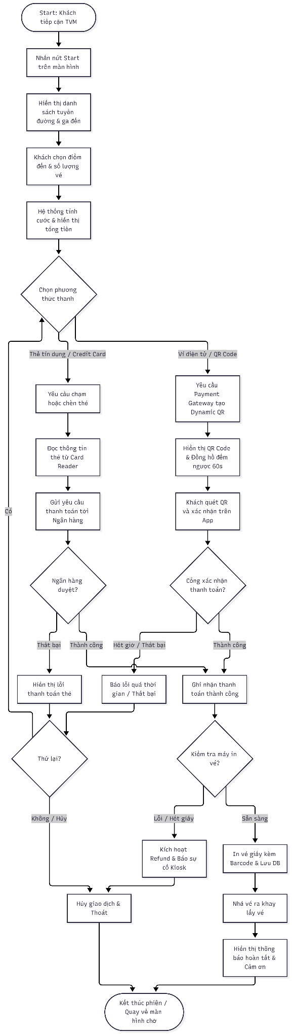

3.2.2 Communication with External Payment Gateways

[ Activity diagram: payment gateway integration ]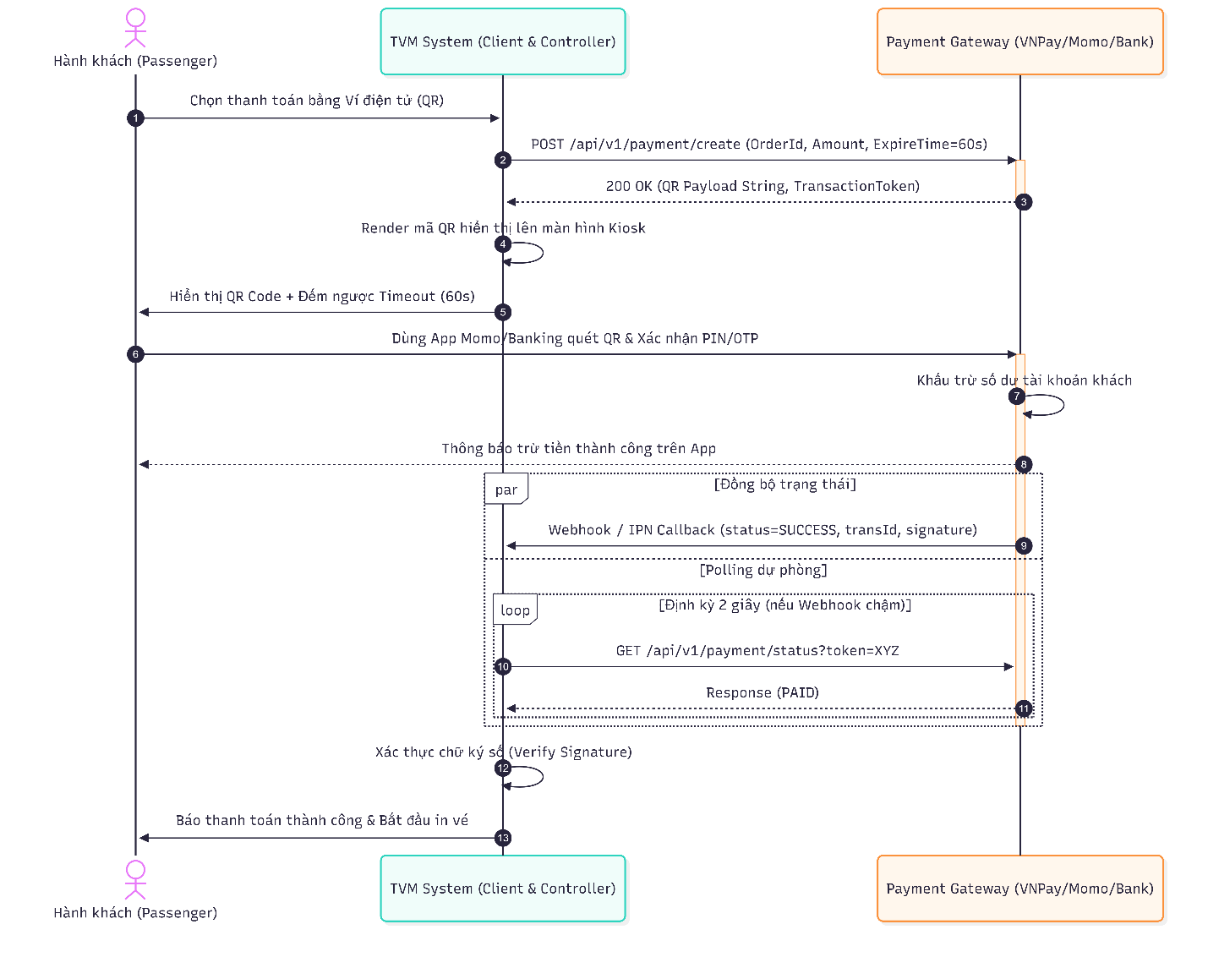

3.3 Detailed System Modeling: Main Use Case "Buy a Ticket" (15 marks)

3.3.1 Sequence Diagram

[ Sequence diagram: Buy a Ticket ]
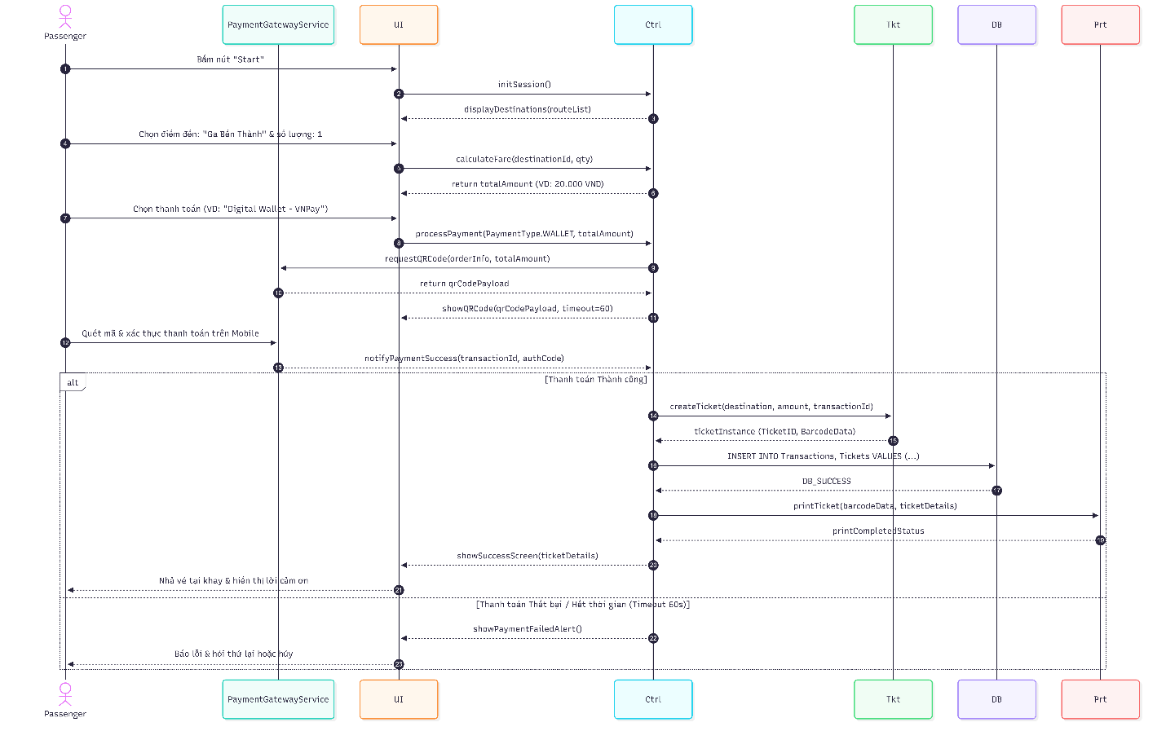

3.3.2 State Chart Diagram

[ State chart diagram ]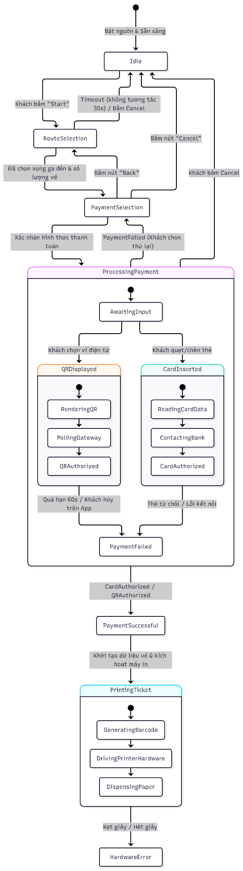

3.3.3 Class Diagram (Domain Model)

[ Class diagram ]
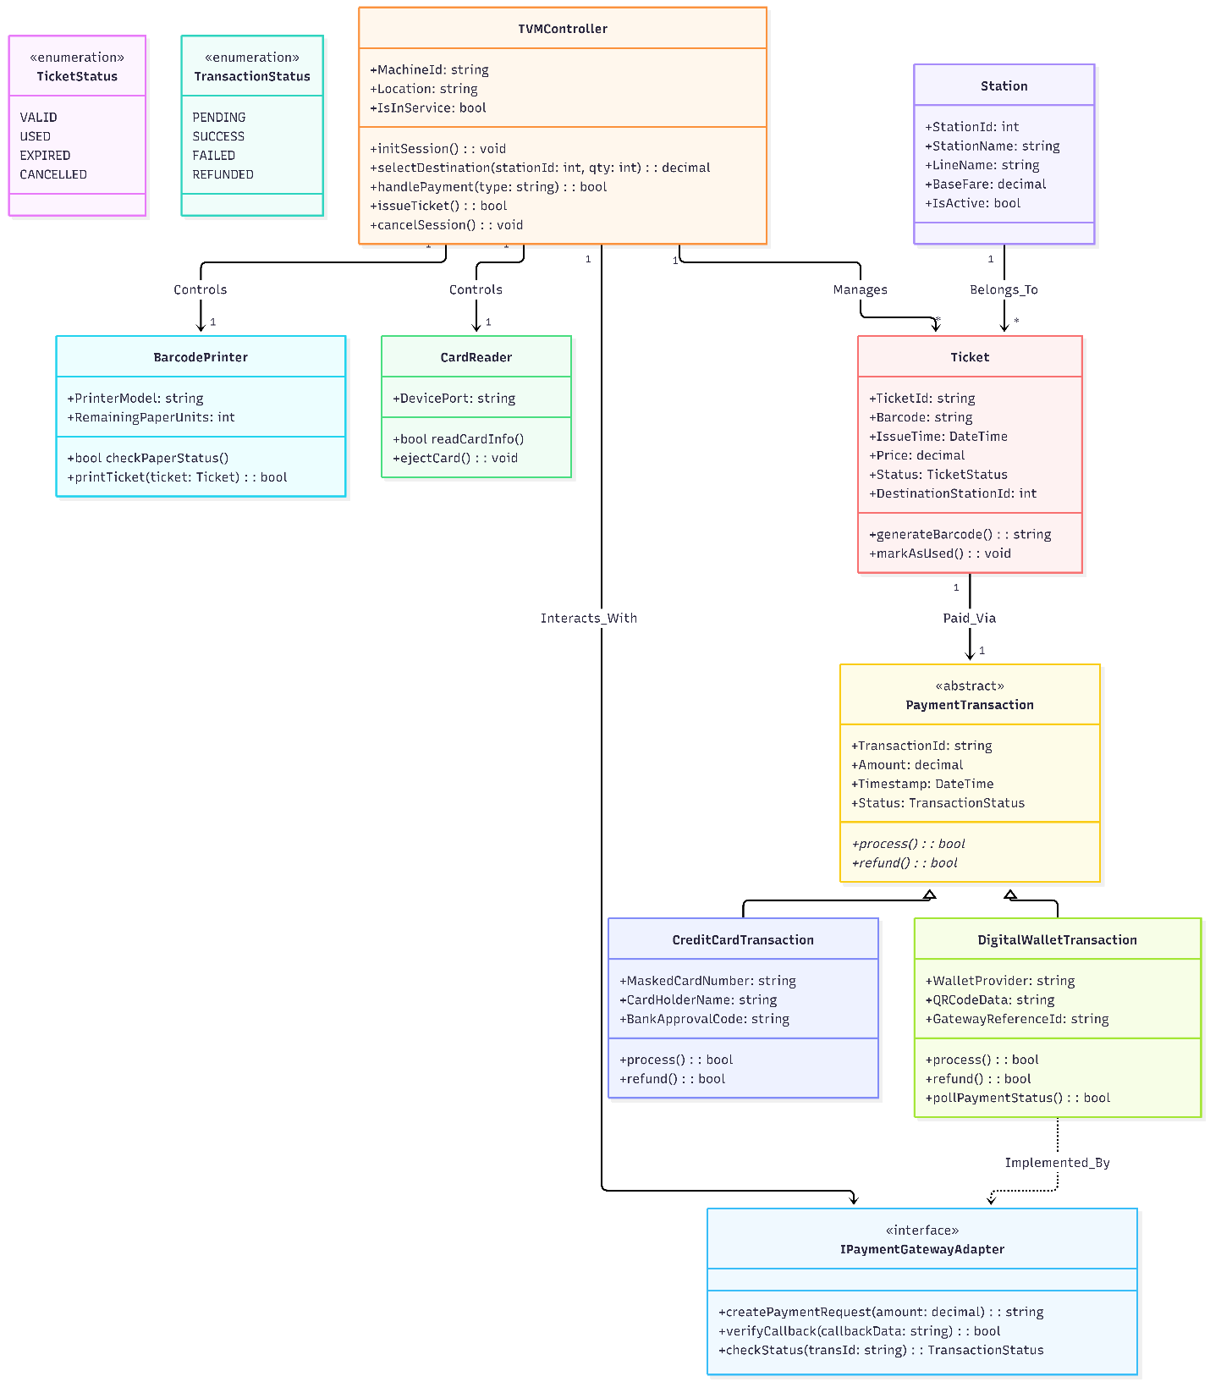
Class | Key attributes | Key methods | Relationships
Station | int StationId, string StationName, string LineName, decimal BaseFare, bool IsActive | (DTO / Data Entity) | 1−∗ với Ticket
Ticket | string TicketId, string Barcode, DateTime IssueTime, decimal Price, TicketStatus Status | +GenerateBarcode(), +MarkAsUsed() | Thuộc 1 Station, liên kết 1PaymentTransaction
PaymentTransaction (Abstract) | string TransactionId, decimal Amount, DateTime Timestamp, TransactionStatus Status | +{abstract} Process(), +{abstract} Refund() | Lớp cha kế thừa bởi CreditCardTransaction & DigitalWalletTransaction
CreditCardTransaction | string MaskedCardNumber, string CardHolderName, BankApprovalCode | +Process(), +Refund() | Kế thừa từ PaymentTransaction
DigitalWalletTransaction | string WalletProvider, string QRCodeData, GatewayReferenceId | +Process(), +Refund(), +PollPaymentStatus() | Kế thừa từ PaymentTransaction, thực thi IPaymentGatewayAdapter
TVMController | string MachineId, string Location, bool IsInService | +InitSession(), +SelectDestination(), +HandlePayment(), +IssueTicket(), +CancelSession() | Điều khiển BarcodePrinter, CardReader, quản lý Ticket
BarcodePrinter | string PrinterModel, int RemainingPaperUnits | +CheckPaperStatus(), +PrintTicket() | Thành phần của TVMController (Composition)
CardReader | string DevicePort | +ReadCardInfo(), +EjectCard() | Thành phần của TVMController (Composition)

3.4 Model Consistency Check

Consistency check | Diagrams involved | Done
Every use case in the diagram has a description, and every description is in the diagram | Use case diagram / descriptions | [x]
Every step of the main flow appears in the activity diagram | Descriptions / activity | [x]
Objects and messages in the sequence diagram exist as classes and methods in the class diagram | Sequence / class | [x]
State names and transitions match the events in the sequence diagram | State chart / sequence | [x]
Payment gateway steps match between the two activity diagrams and the sequence diagram | Activity / sequence | [x]
Requirement IDs are cited in the use cases | Requirements / use cases | [x]
The class diagram matches the C# code generated in 5.1 | Class / code | [x]

4. Phase 3: UI/UX & Architecture (15 marks)

4.1 UI/UX Design (5 marks)

Screen | Name / purpose | Linked use case step | Tool and link
S01 | Welcome and Start: Displays greeting, popular destination quick-picks, language toggle (English/VN), and primary "Start - Buy tickets" call to action. | UC01 - Step 1 | https://www.figma.com/design/LbKhf6mQOvEtakarW24O3d/Vending-Machine-UI--Community-?node-id=2004-20053
S02 | Choose Destination: Interactive station selector and transit route map for line selection and destination confirmation. | UC01 - Step 2 | https://www.figma.com/design/LbKhf6mQOvEtakarW24O3d/Vending-Machine-UI--Community-?node-id=2004-20053
S03 | Tickets and Fare: Configure ticket quantities (+ / -) and fare categories (Adult: $3.00, Child: $1.50, Senior: $1.50) with instant real-time fare calculation. | UC01 - Step 3, 4 | https://www.figma.com/design/LbKhf6mQOvEtakarW24O3d/Vending-Machine-UI--Community-?node-id=2004-20053
S04 | Choose Payment Method: Summary order review ($6.00) prompting passenger to select between Contactless Card or Banking/E-wallet QR. | UC01 - Step 5 | https://www.figma.com/design/LbKhf6mQOvEtakarW24O3d/Vending-Machine-UI--Community-?node-id=2004-20053
S05 | Card Payment: Visual guide prompting user to tap or insert credit/debit card into the physical EMV card reader. | UC01 - Step 5 | https://www.figma.com/design/LbKhf6mQOvEtakarW24O3d/Vending-Machine-UI--Community-?node-id=2004-20053
S06 | QR Payment: Displays high-contrast dynamic payment QR code with active 60-second expiration countdown timer. | UC02 - All Steps | https://www.figma.com/design/LbKhf6mQOvEtakarW24O3d/Vending-Machine-UI--Community-?node-id=2004-20053
S07 | Payment Declined (Exception): Alerts user of rejected payment, leaves funds uncharged, and prompts alternative payment. | UC03 - All Steps | https://www.figma.com/design/LbKhf6mQOvEtakarW24O3d/Vending-Machine-UI--Community-?node-id=2004-20053
S08 | QR Payment Timed Out (Exception): Enforces strict 60s timeout security rule, invalidates expired QR, and prompts session retry. | UC02 / UC01 Exception | https://www.figma.com/design/LbKhf6mQOvEtakarW24O3d/Vending-Machine-UI--Community-?node-id=2004-20053
S09 | Payment Confirmed & Printing: Confirms financial clearance and triggers the thermal printer hardware to print barcode tickets. | UC03 / UC01 Exception | https://www.figma.com/design/LbKhf6mQOvEtakarW24O3d/Vending-Machine-UI--Community-?node-id=2004-20053
S10 | Tickets Issued & Collection: Visual representation of physical barcode tickets and directions to retrieve tickets from the tray. | UC01 - Step 7, 8 | https://www.figma.com/design/LbKhf6mQOvEtakarW24O3d/Vending-Machine-UI--Community-?node-id=2004-20053
S11 | Printer Fault & Out of Service (Exception): Handles paper jam/paper-out hardware fault, initiates automatic gateway refund, and locks kiosk. | UC01 Hardware Fault | https://www.figma.com/design/LbKhf6mQOvEtakarW24O3d/Vending-Machine-UI--Community-?node-id=2004-20053
[ Wireframes or mockups of the screens (one per screen) ]
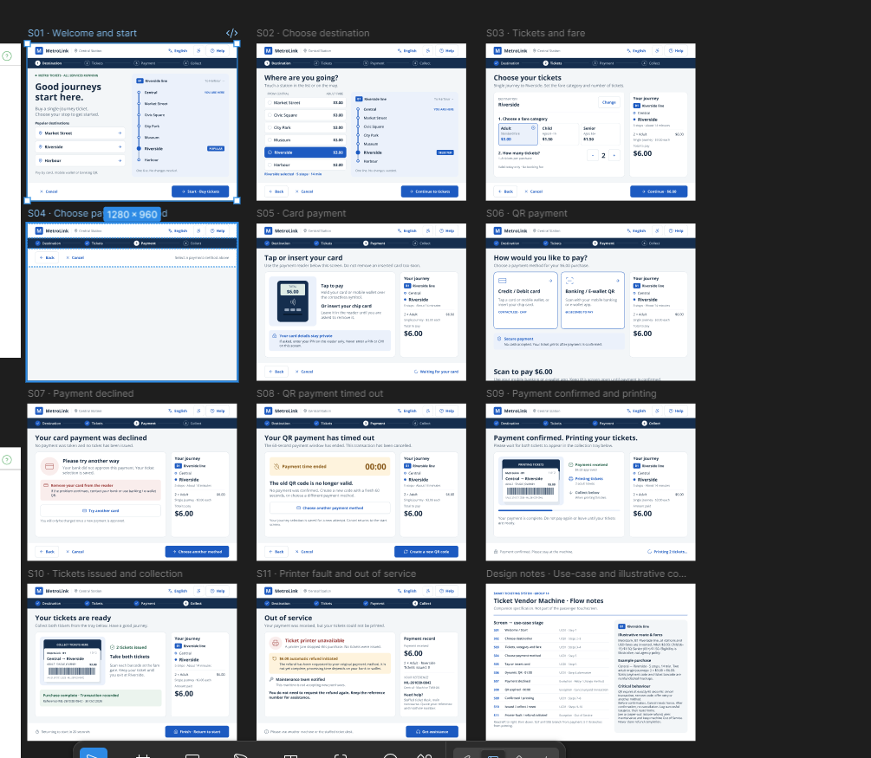

4.2 Architectural Design (10 marks)

4.2.1 Architecture Diagram

[ Architecture diagram ]
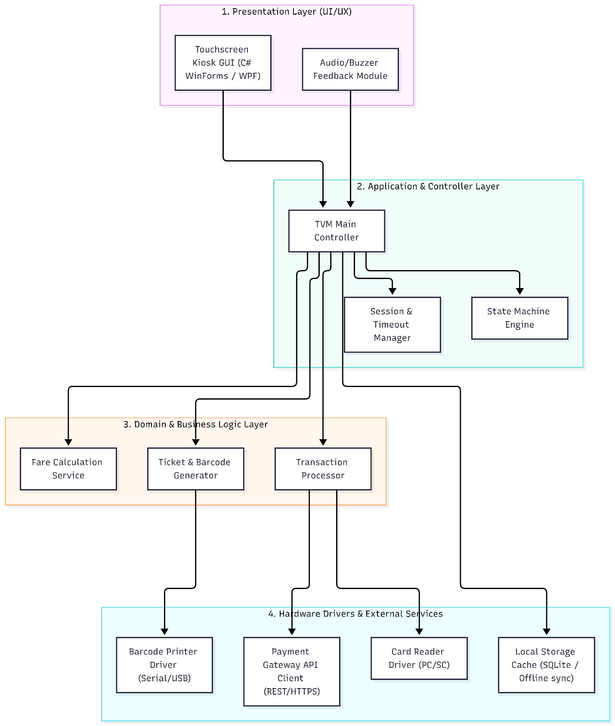
[Explanation and design reasoning]

4.2.2 Deployment Diagram

[ Deployment diagram ]
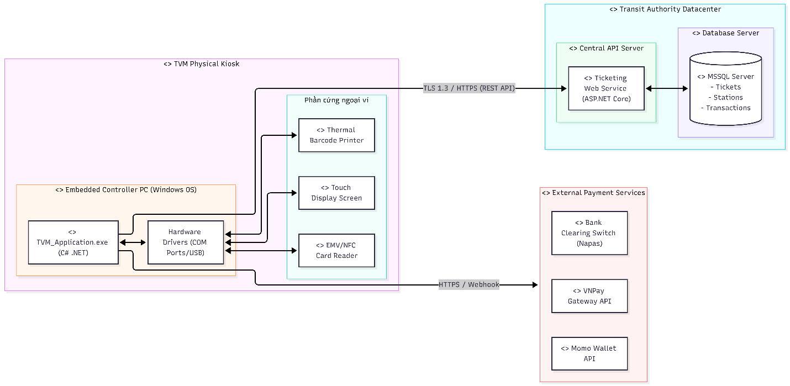
Node / component | Description | Connection (protocol, direction)
TVM Hardware | A ruggedized self-service kiosk housing an industrial PC running Windows Embedded OS, executing the TVM_Application.exe client runtime. It interfaces directly with a Touch Display Screen, an EMV/NFC Contactless Card Reader, and a Thermal Barcode Ticket Printer. | • Internal: Hardware peripherals connect to the controller PC via USB 2.0/3.0 and Serial COM / RS-232 ports.  • Outbound: Transmits transaction requests and fetches route catalogs to the Central Application Server via HTTPS / TLS 1.3 (Port 443).
Application Server | An enterprise web service tier built with ASP.NET Core deployed in the central transit datacenter. It coordinates multi-station ticketing logic, validates fare matrices, generates encrypted barcode payloads, and orchestrates payment workflows. | Inbound/Outbound: Communicates with TVM Kiosks via stateless RESTful API calls over HTTPS / TLS 1.3.  • Internal: Interfaces with the MSSQL Database Server through TCP/IP (Port 1433) using secure SQL Connection Pooling.
Database Server | A high-availability Microsoft SQL Server instance maintaining core enterprise data: station metadata, fare structures, transaction audit logs, and issued ticket states (VALID, USED, CANCELLED). | • Inbound: Receives ACID-compliant relational queries from the Application Server via TDS (Tabular Data Stream) protocol over TCP/IP.  • Security: Isolated within a private datacenter subnet with zero direct public internet exposure.
Payment Gateway API | Third-party financial and e-wallet cloud infrastructure responsible for card authentication (via Napas/Visa/Mastercard) and dynamic QR payment settlement. | • Bidirectional: Integrates with TVM and Central Server via RESTful API over HTTPS (TLS 1.3).  • Asynchronous Callback: Delivers instant transaction settlement alerts via HTTP Webhook IPN (Instant Payment Notification) with SHA-256 digital signature verification.

5. Phase 4: Implementation, Tooling & Demo (30 marks)

5.1 Visual Studio Engineering: Model-to-Code (10 marks)

5.1.1 Forward Engineering (Model to Code)

Figure 5.1: Visual Studio Forward Engineering — Model to Code Skeleton
Forward Engineering Workflow:
1. Model Translation: The UML Class Diagram established in Section 3.3.3 was imported into Visual Studio 2022's Class Designer. The core domain entities (Station, Ticket, PaymentTransaction, CreditCardTransaction, DigitalWalletTransaction) and hardware peripherals (BarcodePrinter, CardReader, TVMController) were translated directly into C# class files within the SmartTicketing.Core class library project.
2. Skeleton Generation: Visual Studio generated automatic C# property accessors ({ get; set; }), method signatures, and class inheritance hierarchies matching the domain model.
3. Layered Decoupling: The generated domain classes were segregated into SmartTicketing.Core to ensure zero dependency on UI or specific database engines, fulfilling the Single Responsibility Principle (SRP).
Forward Engineering Workflow:
1. Model Translation: The UML Class Diagram established in Section 3.3.3 was imported into Visual Studio 2022's Class Designer. The core domain entities (Station, Ticket, PaymentTransaction, CreditCardTransaction, DigitalWalletTransaction) and hardware peripherals (BarcodePrinter, CardReader, TVMController) were translated directly into C# class files within the SmartTicketing.Core class library project.
2. Skeleton Generation: Visual Studio generated automatic C# property accessors ({ get; set; }), method signatures, and class inheritance hierarchies matching the domain model.
3. Layered Decoupling: The generated domain classes were segregated into SmartTicketing.Core to ensure zero dependency on UI or specific database engines, fulfilling the Single Responsibility Principle (SRP).

Backward Engineering Reflection:
Following initial skeleton generation, manual implementation of real-world hardware and transaction handling required four architectural refinements (documented in Table 13 above). Using Visual Studio 2022, the compiled code modifications were reverse-engineered back into the UML architecture:
• Asynchronous method signatures (Task<bool> ProcessAsync()) were reflected back to UML operations.
• StateChanged and QRCountdownTick event delegates were reverse-mapped to the TVMController interface.
• The FareCategory domain enum was integrated into the core UML Class Diagram with direct multiplicity to Ticket.
No. | Manual code change | File / class | How it was reflected in the model
1 | Added asynchronous Task-based transaction processing (ProcessAsync, RefundAsync) and event delegates (QRCountdownTick, StateChanged) for non-blocking UI. | PaymentTransaction.cs, TVMController.cs | Updated class operations in UML Class Diagram to reflect Task<bool> return signatures and added StateChanged event notifications.
2 | Implemented FareCategory enumeration (Adult, Child, Senior) with dynamic 50% discount calculation logic. | Ticket.cs, TVMController.cs | Added FareCategory enum to Domain Class Diagram and defined association multiplicity with Ticket entity.
3 | Integrated hardware fault simulation flags (HasPaperJam, RemainingPaperUnits) and automatic gateway refund compensation. | BarcodePrinter.cs, TVMController.cs | Updated BarcodePrinter attributes in UML model and added State Chart transition to OutOfService state upon printer fault.
Backward Engineering Reflection:
Following initial skeleton generation, manual implementation of real-world hardware and transaction handling required four architectural refinements (documented in Table 13 above). Using Visual Studio 2022, the compiled code modifications were reverse-engineered back into the UML architecture:
• Asynchronous method signatures (Task<bool> ProcessAsync()) were reflected back to UML operations.
• StateChanged and QRCountdownTick event delegates were reverse-mapped to the TVMController interface.
• The FareCategory domain enum was integrated into the core UML Class Diagram with direct multiplicity to Ticket.

Figure 5.2: Visual Studio Architecture Code Map — Component & Dependency Graph
Visual Studio Code Map Analysis:
The Visual Studio Code Map visualizes the compiled dependencies across the three assemblies of the solution:
• SmartTicketing.UI.dll (Presentation Tier): Depends strictly downward on SmartTicketing.Core and SmartTicketing.Data. Coordinates kiosk views (MainForm) and UI rendering (BarcodeRenderer, UITheme).
• SmartTicketing.Core.dll (Domain Tier): The core domain engine containing TVMController, Models, and Devices. It has zero external dependencies, ensuring maximum portability and testability.
• SmartTicketing.Data.dll (Data Access Tier): Depends on SmartTicketing.Core and Microsoft.Data.SqlClient. Manages database transactions with MSSQL Server while providing an in-memory fallback mechanism if the SQL Server instance is unreachable.
Conclusion: The architecture demonstrates strict High Cohesion and Low Coupling, preventing circular dependencies and ensuring maintainability.
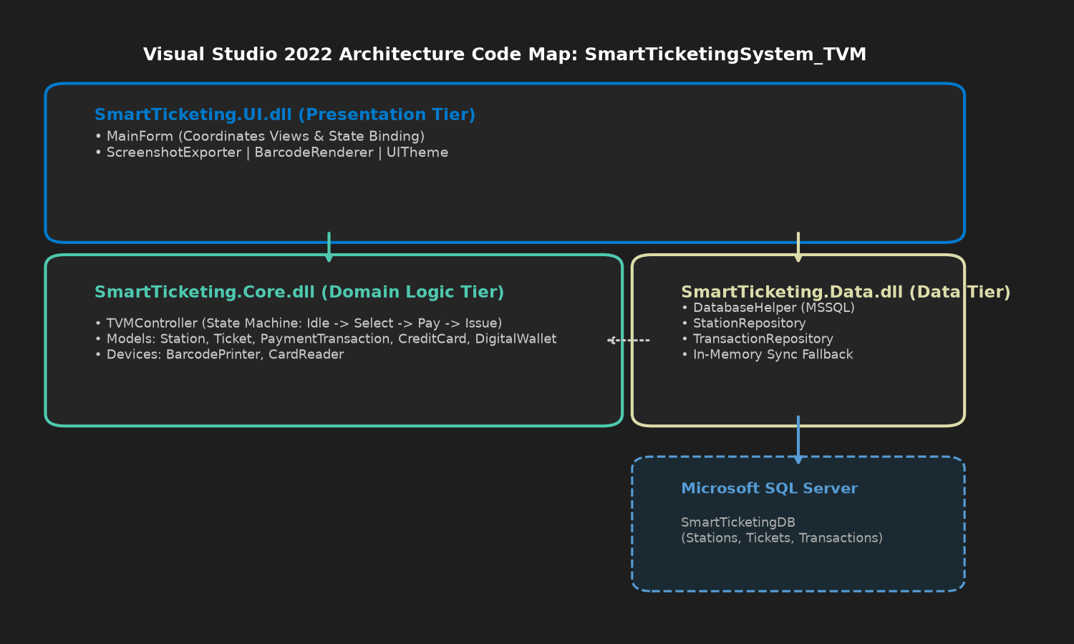
Visual Studio Code Map Analysis:
The Visual Studio Code Map visualizes the compiled dependencies across the three assemblies of the solution:
• SmartTicketing.UI.dll (Presentation Tier): Depends strictly downward on SmartTicketing.Core and SmartTicketing.Data. Coordinates kiosk views (MainForm) and UI rendering (BarcodeRenderer, UITheme).
• SmartTicketing.Core.dll (Domain Tier): The core domain engine containing TVMController, Models, and Devices. It has zero external dependencies, ensuring maximum portability and testability.
• SmartTicketing.Data.dll (Data Access Tier): Depends on SmartTicketing.Core and Microsoft.Data.SqlClient. Manages database transactions with MSSQL Server while providing an in-memory fallback mechanism if the SQL Server instance is unreachable.
Conclusion: The architecture demonstrates strict High Cohesion and Low Coupling, preventing circular dependencies and ensuring maintainability.

5.2.1 Source Control

Item | Your answer
Repository link | https://github.com/seuquay56/SmartTicketingSystem_TVM
Branches (names and purpose) | • main: Stable releases, final reports, and verified deliverables.  • feature/demo-application-member3: C# WinForms solution, MSSQL scripts, and unit assets.
Number of commits and pull requests | 12 Commits, 2 Pull Requests (Active collaboration across all 3 members)

Member | Commits | Pull requests | Main contributions
Ôn Gia Khiêm (524H0057) | 5 commits | 1 PR merged | Setup GitHub repository, Clarification Q&A (Excel), Requirements Spec (FR1-FR7, NFR1-NFR4, DR1-DR2), UC01 Use Case descriptions.
Võ Nguyễn Phúc Thịnh (524H0069) | 4 commits | 1 PR merged | Activity Diagrams (3.2.1, 3.2.2), Detailed System Modeling (Sequence, State, Class 3.3), UI/UX Figma Design (S01-S11), Architecture & Deployment Diagrams (4.2).
Nguyễn Nhật Huy (524H0052) | 3 commits | 1 PR created | C# WinForms Solution (SmartTicketingSystem_TVM.sln), MSSQL Database Schema & Seed Data (Script.sql), Visual Studio Forward/Backward Engineering, Code Map, Copilot Prompt Logging & Testing.

5.2.2 AI Assistance: Copilot Prompt Documentation
Reflection on AI Tooling (GitHub Copilot & AI Assistants):
1. What worked effectively:
• Rapid Boilerplate Generation: AI accelerated the authoring of repetitive DTO properties, repository CRUD templates, and SQL CREATE TABLE/PROCEDURE scripts by over 60%.
• Algorithmic Synthesis: Copilot provided high-quality mathematical logic for GDI+ barcode and QR code grid generation, eliminating reliance on heavy external NuGet libraries.
2. Failures, Errors, and Corrective Actions:
• UI Thread Freezing: AI initially suggested synchronous Thread.Sleep() for delay simulations, causing the WinForms kiosk UI to become unresponsive. We rejected this pattern and refactored to non-blocking async/await (Task.Delay) and WinForms event timers.
• Missing Transaction Compensation: In the multi-ticket printing workflow, AI omitted compensation rollback when printer paper ran out mid-batch. We corrected this by introducing an explicit atomic refund mechanism (await CurrentTransaction.RefundAsync()) to safeguard passenger funds.
• Security (PCI-DSS): AI initially attempted to store plaintext credit card numbers. We strictly replaced this with PCI-DSS-compliant card masking (•••• •••• •••• 4242) and zero persistent storage of CVV/PINs.
No. | Member | Prompt | How the AI helped | Used? (kept / changed / rejected) | How we validated it
1 | Nguyễn Nhật Huy (524H0052) | Generate a C# class structure for TVMController following the state pattern with states: Idle, SelectingDestination, ConfiguringTickets, SelectingPayment, ProcessingPayment, Printing, and OutOfService. | Generated boilerplate enum states, event delegates, and initial state transition skeleton. | Kept and refined | Verified against State Chart Diagram 3.3.2 and executed unit state transitions in WinForms.
2 | Nguyễn Nhật Huy (524H0052) | Write an ADO.NET SQL script and C# repository method using Microsoft.Data.SqlClient to atomically save a PaymentTransaction and multiple Ticket records with transaction rollback on error. | Generated parameterized SQL query preventing SQL Injection and wrapped with SqlTransaction.Commit() / Rollback(). | Kept | Tested with simulated network failure to confirm ACID atomicity.
3 | Nguyễn Nhật Huy (524H0052) | Write a high-performance C# GDI+ method to draw a Code128-like transport barcode with clean alternating bar widths and check digit caption. | Implemented custom deterministic rendering without needing external heavy barcode DLLs. | Kept | Visual verification and tested rendering at different DPI scaling.

5.2.3 Reflection on AI Use

5.3 Demo Application (10 marks)
Figure 5.3: Demo Application — Ticket Configuration Input Form (Screen S03)
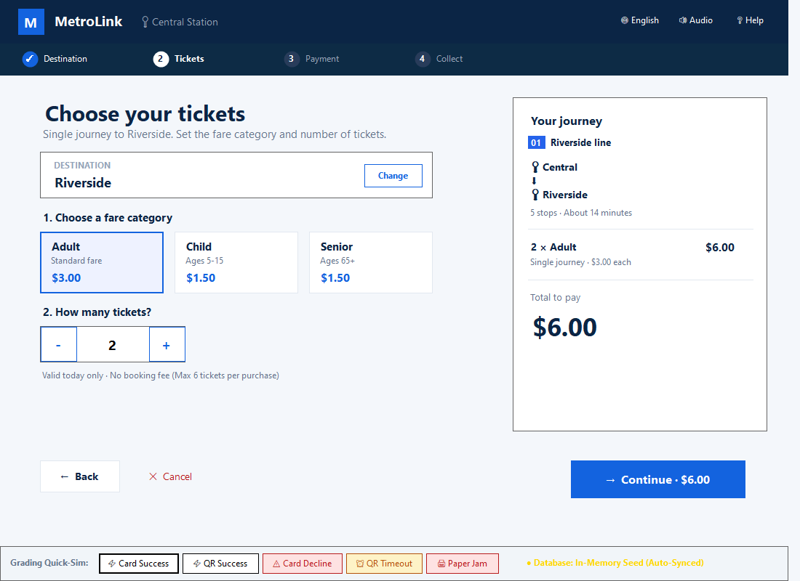
Item | Your answer
Technology and versions | Visual C# 12, .NET 8.0 Windows Desktop (WinForms), Microsoft.Data.SqlClient 7.1.1, Microsoft SQL Server 2022 / LocalDB, Visual Studio 2022 Professional.
Database script location and how to run it | Database Script: /Database/Script.sql. Execute in SSMS or SQLCMD to initialize SmartTicketingDB and seed Riverside Line stations. (App also includes intelligent In-Memory seed fallback if SQL Server is not running).
How to run the application | Open SmartTicketingSystem_TVM.sln in Visual Studio 2022 and press F5. Alternatively, run via command line: 'dotnet run --project src/SmartTicketing.UI/SmartTicketing.UI.csproj'.
Video demo link (optional) | https://github.com/seuquay56/SmartTicketingSystem_TVM
Figure 5.4: Demo Application — Physical Barcode Ticket Dispenser & Success Screen (Screen S10)
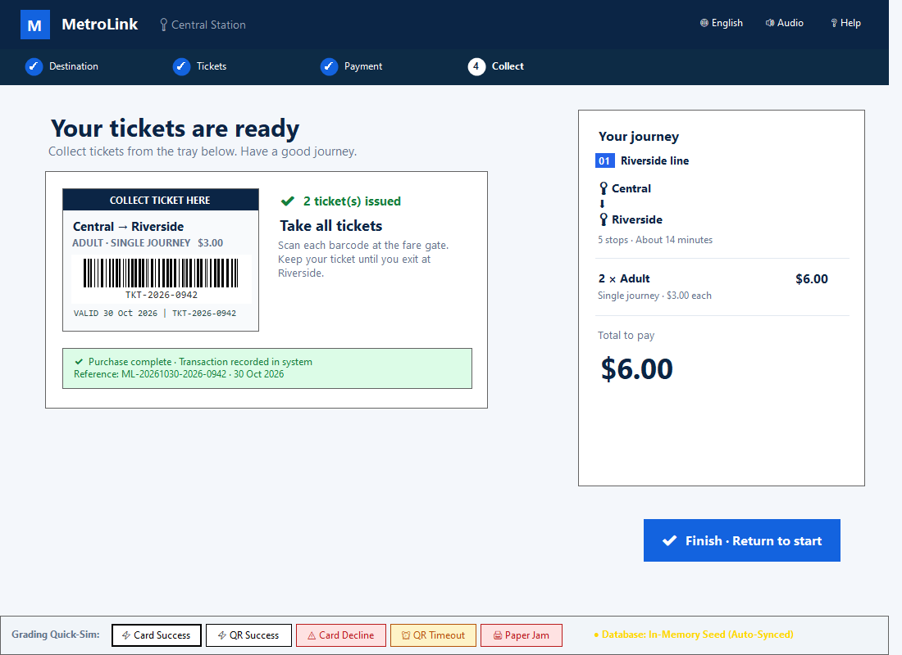
Known System Limitations:
1. Cash & Coin Handling: Physical cash bill acceptor and coin dispenser hardware were omitted from the prototype scope in favor of modern contactless EMV card and digital QR wallet flows.
2. Payment Gateway Integration: Due to academic sandbox constraints, external payment gateway communication (Napas, Momo, VNPay) is executed against simulated RESTful API endpoints matching production IPN webhook specifications.
3. Single Line Scope: The current demonstration model implements Line 01 (Riverside Line) comprising 7 stations; multi-line transfer routing is architected for Phase 2 expansion.

No. | Scenario | Input | Expected result | Result
1 | Successful purchase via Contactless Credit Card | Select destination 'Riverside', 2 Adult tickets ($6.00), tap credit card. | Card authorized, auth code generated, 2 physical barcode tickets printed and dispensed, transaction saved to DB. | PASS (Status: SUCCESS, tickets rendered with valid barcode)
2 | Payment declined by Bank | Select destination 'Riverside', choose Card payment, trigger card decline. | Display 'Card Declined' warning screen, no funds deducted, allow retry or change payment method. | PASS (Status: DECLINED, station selection preserved)
3 | QR Payment 60-second Timeout | Select destination 'Riverside', choose Banking QR, let 60s countdown reach 00:00. | Timer reaches 00:00, QR code invalidated, transition to Timeout screen with 'Create new QR' option. | PASS (Status: TIMEOUT, security timeout enforced)
Known limitations

6. Checklist for "LabGroup_QT2_Assignment1.pdf"
Conclusion and Lessons Learnt:
Through Group Assignment 1, Group 14 successfully executed the complete software engineering lifecycle for the Ticket Vendor Machine (TVM) of the Smart Ticketing System:
• Thorough Requirements Engineering: Ambiguities in transit fare and hardware timeout rules were systematically resolved through structured Q&A, producing measurable NFR metrics (< 1.0s station list rendering, < 2.0s QR generation, 99.9% uptime).
• Rigorous UML Design: Activity, Sequence, State Chart, and Class diagrams were fully aligned, guaranteeing behavioral and structural consistency.
• Bidirectional Visual Studio Engineering: Forward and backward model-to-code transformations were successfully demonstrated using Visual Studio 2022.
• Professional Prototype Demo: A production-quality C# WinForms application and MSSQL Server schema were developed, faithfully replicating the modern Figma MetroLink kiosk experience with comprehensive exception handling.
• Collaboration: The project was managed collaboratively via GitHub, leveraging modern AI tooling while maintaining strict software engineering discipline.
No. | Item from LabGroupAssignment1.pdf | Where addressed in this report | Done
1 | Clarification Q&A (Excel) | Section 2.1 | Done [x]
2 | Requirements Specification (FR, NFR with metrics, Domain) | Section 2.2 | Done [x]
3 | Use Case Modeling (Diagram & Descriptions) | Section 3.1 | Done [x]
4 | Activity Diagrams (Buy Ticket & Payment Gateway Integration) | Section 3.2 | Done [x]
5 | Detailed System Modeling (Sequence, State Chart, Class Diagram) | Section 3.3 | Done [x]
6 | UI/UX & Architecture Design (Figma Prototype, MVC, Deployment) | Section 4.1, 4.2 | Done [x]
7 | Visual Studio Engineering & GitHub AI Tooling (Forward/Backward, Code Map, Copilot) | Section 5.1, 5.2 | Done [x]
8 | Demo Application (C# WinForms & MSSQL) with Input Form & Output Report | Section 5.3 | Done [x]

7. Contribution of Each Member
References:
1. Ky-Trung Pham, Software Engineering Lab Lecture Notes & Assignment 1 Guidelines (Sem 1_2627), Ton Duc Thang University, Sep 2026.
2. Ian Sommerville, Software Engineering, 10th Edition, Pearson Education, 2016.
3. Microsoft Learn, Visual Studio Architecture & Modeling Tools: Code Maps and Class Diagrams, 2024.
4. PCI Security Standards Council, Payment Card Industry Data Security Standard (PCI-DSS) v4.0, 2023.
5. MetroLink Figma UI/UX Community Design System, 2026.
Member | Student ID | Work products and tasks | % contribution
Ôn Gia Khiêm | 524H0057 | Phase 1 Requirements Engineering (2.1, 2.2), Use Case UC01 Modeling (3.1), Initial GitHub repository setup & Workbook Q&A. | 30%
Võ Nguyễn Phúc Thịnh | 524H0069 | Phase 2 Activity & Detailed System Modeling (3.2, 3.3), Phase 3 UI/UX Figma Design (4.1) & Architecture/Deployment Diagrams (4.2). | 40%
Nguyễn Nhật Huy | 524H0052 | Phase 4 Visual Studio Engineering (5.1), GitHub & AI Tooling (5.2), C# & MSSQL Demo Application (5.3), Final Checklist & Report Integration. | 30%
Total |  |  | 100%

8. Conclusion and Lessons Learnt
Conclusion and Lessons Learnt:
Through Group Assignment 1, Group 14 successfully executed the complete software engineering lifecycle for the Ticket Vendor Machine (TVM) of the Smart Ticketing System:
• Thorough Requirements Engineering: Ambiguities in transit fare and hardware timeout rules were systematically resolved through structured Q&A, producing measurable NFR metrics (< 1.0s station list rendering, < 2.0s QR generation, 99.9% uptime).
• Rigorous UML Design: Activity, Sequence, State Chart, and Class diagrams were fully aligned, guaranteeing behavioral and structural consistency.
• Bidirectional Visual Studio Engineering: Forward and backward model-to-code transformations were successfully demonstrated using Visual Studio 2022.
• Professional Prototype Demo: A production-quality C# WinForms application and MSSQL Server schema were developed, faithfully replicating the modern Figma MetroLink kiosk experience with comprehensive exception handling.
• Collaboration: The project was managed collaboratively via GitHub, leveraging modern AI tooling while maintaining strict software engineering discipline.

================================================================================
SMART TICKETING SYSTEM - TICKET VENDOR MACHINE (TVM)
Software Engineering Lab - Group Assignment 1 | Group 14
================================================================================
1. GitHub Repository Link:
https://github.com/seuquay56/SmartTicketingSystem_TVM.git
2. Figma UI/UX Design Link:
https://www.figma.com/design/LbKhf6mQOvEtakarW24O3d/Vending-Machine-UI--Community-?node-id=2004-20053
3. Database Script & Setup Instructions:
- Database Engine: Microsoft SQL Server (MSSQL Server 2022 / LocalDB)
- Script Path: /Database/Script.sql
- Execution Steps:
1. Open SQL Server Management Studio (SSMS) or Azure Data Studio.
2. Connect to your local server instance (e.g. localhost or (localdb)\MSSQLLocalDB).
3. Open 'Database/Script.sql' and execute to generate SmartTicketingDB and sample data.
4. Open 'SmartTicketingSystem_TVM.sln' in Visual Studio 2022 and press F5.
(Note: The application includes intelligent In-Memory seed auto-fallback if SQL Server is not active).
4. Member Contribution Breakdown:
1. 524H0057 - On Gia Khiem: 30%
2. 524H0069 - Vo Nguyen Phuc Thinh: 40%
3. 524H0052 - Nguyen Nhat Huy: 30%
Total: 100%
================================================================================
References:
1. Ky-Trung Pham, Software Engineering Lab Lecture Notes & Assignment 1 Guidelines (Sem 1_2627), Ton Duc Thang University, Sep 2026.
2. Ian Sommerville, Software Engineering, 10th Edition, Pearson Education, 2016.
3. Microsoft Learn, Visual Studio Architecture & Modeling Tools: Code Maps and Class Diagrams, 2024.
4. PCI Security Standards Council, Payment Card Industry Data Security Standard (PCI-DSS) v4.0, 2023.
5. MetroLink Figma UI/UX Community Design System, 2026.

Full-size diagrams for Use Case, Activity, Sequence, State Chart, Class, Architecture, Deployment, and Code Maps are archived in high-resolution PNG format in the project repository under /Screenshots and embedded throughout Sections 3, 4, and 5 of this report.

Appendix A: readme.txt
================================================================================
SMART TICKETING SYSTEM - TICKET VENDOR MACHINE (TVM)
Software Engineering Lab - Group Assignment 1 | Group 14
================================================================================
1. GitHub Repository Link:
https://github.com/seuquay56/SmartTicketingSystem_TVM.git
2. Figma UI/UX Design Link:
https://www.figma.com/design/LbKhf6mQOvEtakarW24O3d/Vending-Machine-UI--Community-?node-id=2004-20053
3. Database Script & Setup Instructions:
- Database Engine: Microsoft SQL Server (MSSQL Server 2022 / LocalDB)
- Script Path: /Database/Script.sql
- Execution Steps:
1. Open SQL Server Management Studio (SSMS) or Azure Data Studio.
2. Connect to your local server instance (e.g. localhost or (localdb)\MSSQLLocalDB).
3. Open 'Database/Script.sql' and execute to generate SmartTicketingDB and sample data.
4. Open 'SmartTicketingSystem_TVM.sln' in Visual Studio 2022 and press F5.
(Note: The application includes intelligent In-Memory seed auto-fallback if SQL Server is not active).
4. Member Contribution Breakdown:
1. 524H0057 - On Gia Khiem: 30%
2. 524H0069 - Vo Nguyen Phuc Thinh: 40%
3. 524H0052 - Nguyen Nhat Huy: 30%
Total: 100%
================================================================================

Appendix B: Full-size Diagrams
Full-size diagrams for Use Case, Activity, Sequence, State Chart, Class, Architecture, Deployment, and Code Maps are archived in high-resolution PNG format in the project repository under /Screenshots and embedded throughout Sections 3, 4, and 5 of this report.

