Word2MediaWikiPlus demo document

About this software
Word2MediaWikiPlus is a set of Visual Basic macros that converts Microsoft Word document contents to MediaWiki markup.

Usage requires a running copy of Microsoft Word that supports Visual Basic macros (Word 2000 to 2003).

Information about this tool is here:

https://www.mediawiki.org/wiki/Extension:Word2MediaWikiPlus

The project site and download center is here:

http://sourceforge.net/projects/word2mediawikip

What we can do:

Text formatting

This is colored text.

This is bold, italic, underlined, strike through and combined.

If you set convertFontSize=true then you get

Text in big letters.
Text in small letters.

But we consider only smaller than normal and bigger than normal, not its actual size.
You may have noticed the indention, too.

The macro recognizes manual line breaks
and puts a <br> into it.

But it will not
recognize single line breaks, as the Wiki-style will make a blank line in between.

Empty spacings in the beginning will be deleted, as they mean manual indention, which in my opinion should not be used.

We can make footnotes, too (needs cite extension).

Tables

This is a complex table:
Heading | Heading | Heading | Heading
Text 1 | Text2 |  | Text4
Background colors | Background colors | Background colors
left | centered and colors  and some blank  lines | right | justified text is not supported by MediaWiki. I need to write a litte more in this cell so there is enough text to see the effects of justification
Merged cells  horizontally | Horizontally merged |  | Merging has limitations!
Merged cells  vertically 1 | Vertically merged | nested tables:  with text above and below | Merging has limitations!
  A | B
  merged and right
  C
Merged cells  vertically 2 | Vertically merged

Lists

We can make simple lists
- Item 1
- Item 2
- Item 3

We can make simple numbered lists
- List Item 1
- List Item 2
- List Item 3

Hyperlinks
Http-Links are easy to do: Link to MediaWiki Handbook.

Here is how to lin an mail address: mail me. If it does not work in your wiki, change you LocalSettings.php to accept mailto-references.

And a file reference, which will not work, unless you put it there
(c:\temp\Word2MediaWiki_Demo_and_Macro.doc). The file name must not contain spaces.

File inclusion
There a number of ways to include a file within the document, these two are supported (they will just make a wiki-link, so you need to convert the contents separatly and put in the new article page):
- As a reference:
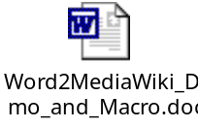
- As a file:
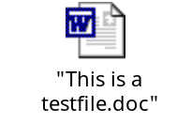

This of course can not be converted, so the macro just adds a link and the symbol as picture, which needs to be replaced later.

Pictures
This part of the macro will not work unless you (yes: you) customized it correctly!

The macro can convert pictures. It uses the MS Photo Editor. If you do not have it installed, you need to install it. You find it on your office CD. Run the installation routine an choose MS Photo Editor.

Included pictures are easy, but you need to customize the macro first.
- The picture will be extracted as png (Portable Networks Graphics).
- Optional: The pictures can be converted to png (use for screenshots), jpg (use for photos) or gif.
- Optional: if you can program, you may use your own converter, look in the code.
- Optional: The converted pictures can be automatically uploaded to your wiki.
- since both optional features use sendkeys, they might not work in your environment and must be customized

Example:
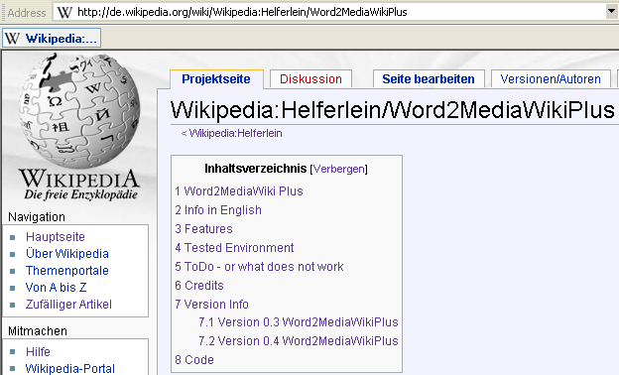

Sitting above the text:
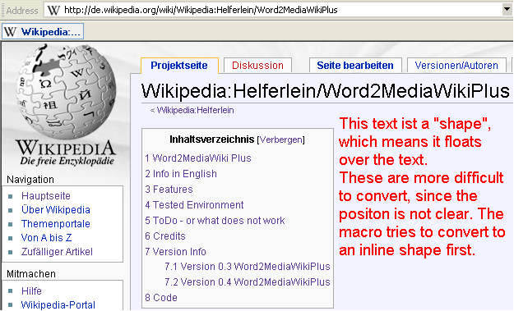

More text below.

To Do: What the macro can not convert:

Text formatting
Colored text like this text. I think there is no way in html either.

Text which is indented (do you say so, meaning eingerückt in german)
And continues like this.

This is how it would work

:Text which is indented (do you say so, meaning eingerückt in german)
And continues like this.

Different font types (names) are not converted.
Font spacing is not converted.

Tables
Table features:
What we can't do yet |  |  | text orientation  (turned sideways) | not full width of table and table position
exact width of cells
frame-styles

Pictures
Some pictures, e.g. powerpoint slides, can not be extracted.
If you use Word 2002 or above the results will be better.

Lists
We can make nested lists (Word 2000 is difficult here, too)
- List Item 1
  - Item 1
  - Item 2
  - Item 3
- List Item 2
- or like this
- fsfsf
- sfsd
- List Item 3

We can not do lists with blank lines, but we can do them by inserting the numbers "manually":

- Special list
- Second Item
With something to say.
Leave some blank.

- Continue the list here
- maybe put some items here
- and more
- End of list

This is the text of the footnote.

