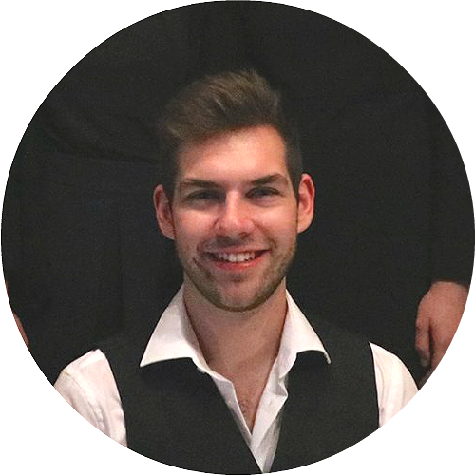
Sebastiaan.vanhoecke@hotmail.be
+32 476 079 332
sevaho.com
9200 Dendermonde, Belgium
Driving license: B
Sebastiaan Van Hoecke

Who am I

I have a realistic logical mind which can quickly adapt to change. I am a creative, curious, out-of-the-box thinking person, who is determined and eager to learn new things.

I have a genuine interest in Linux, networking, operating systems, web design & development , AI and security.

EDUCATION
At College of Ghent
2014-... Bachelor: Applied Informatics

At University of Ghent
2013-2014 Bachelor: Bioscience

At Heilige Maagd College Dendermonde
2007-2013 ASO: Modern Languages and Science

STUDENT JOBS
07-2016 Jobstudent Containerpark Wetteren
07-2015 Jobstudent Containerpark Wetteren
08-2014 Jobstudent Containerpark Dendermonde
08-2013 Jobstudent Containerpark Berlare
07-2012 Jobstudent Containerpark Wetteren
08-2011 Jobstudent Containerpark Dendermonde

SKILLS
Language | Speaking | Writing | Reading
Dutch | Native proficiency | Native proficiency | Native proficiency
English | Full professional proficiency | Full professional proficiency | Full professional proficiency
German | Elementary proficiency | Elementary proficiency | Elementary proficiency
French | Limited working proficiency | Limited working proficiency | Limited working proficiency

ICT-skills  - Linux, Linux security, Linux scripting  - Windows server, powershell  - BSD  - HTML, CSS, JS, PHP  - Python, Java, C, ASM, .NET, SQL  - CCNA, Docker, LXC, Vagrant  - Penetration testing  - Continuous integration, Orchestration  - Configuration management | Soft-skills  - Teamplayer  - Creative  - Curious  - Realistic  - Thinks out of the box

OTHER ACTIVITIES
I play competitive table tennis, Once in awhile I go out with a solid group of friends, I listen to electronic music or immortalized classics. To maintain a healthy mind in a healthy body I try to run three times a week.

In the field of ICT, I adore Linux, At home I have some servers where I try a lot of things on. I like to configure servers or disassemble computers, I’m also busy with web design, web development, pentesting, creating my own operating system. I'm also webmaster of my table tennis club ttcteneramonda (ttcteneramonda.be).

When not sitting behind a computer you may find me at conferences, I like to meet new people and talk about the new technologies.

