Machine Learning Operations (AIMLCZG523)
Assignment 1
CardioRisk
End-to-end MLOps for heart disease risk prediction
Data, experiment tracking, CI/CD, containerisation, Kubernetes deployment and monitoring
Student: Sevanth Gajula
BITS ID: 2025AE05634
Programme: M.Tech AI & ML (WILP), BITS Pilani
Repository: https://github.com/sevanth-gajula03/cardiorisk-mlops
Submitted: 20 October 2026

Contents
1. Introduction 3
1.1 Architecture overview 3
1.2 Setup and installation 3
2. Data acquisition and exploratory analysis 4
2.1 Acquisition 4
2.2 Cleaning 4
2.3 Key findings 5
3. Feature engineering and model development 6
3.1 Feature pipeline 6
3.2 Model selection and tuning 6
4. Experiment tracking with MLflow 7
5. Model packaging and reproducibility 8
6. CI/CD pipeline and automated testing 9
6.1 Tests 9
6.2 GitHub Actions workflow 9
7. Model serving and containerisation 10
8. Production deployment on Kubernetes 11
9. Monitoring and logging 12
10. Challenges and lessons learned 13
11. Conclusion and future work 14
Appendix A. Deliverables and access 14

1. Introduction
Heart disease is still the leading cause of death worldwide, and many of the warning signs - chest pain type, exercise ECG response, the number of blocked vessels - are captured in routine tests. The goal of this assignment was to build a classifier that estimates the risk of heart disease from those measurements, and, more importantly, to wrap it in the engineering practices that make a model trustworthy in production: reproducible data processing, tracked experiments, automated testing, a packaged model, a containerised API, a Kubernetes deployment and live monitoring.
I called the project CardioRisk. Everything described here runs from a clean checkout of the repository with one requirements.txt, and the same code path is exercised by the CI pipeline on every push.

1.1 Architecture overview
Figure 1 shows the whole system. Data is pulled from the UCI repository and validated, three model families are tuned and tracked in MLflow, and the winning pipeline is packaged into a Docker image tagged with the model version. GitHub Actions rebuilds and tests all of this on every push. The image is deployed to a Minikube cluster behind an nginx Ingress and a LoadBalancer service, and Prometheus and Grafana watch both the service and the model's behaviour.
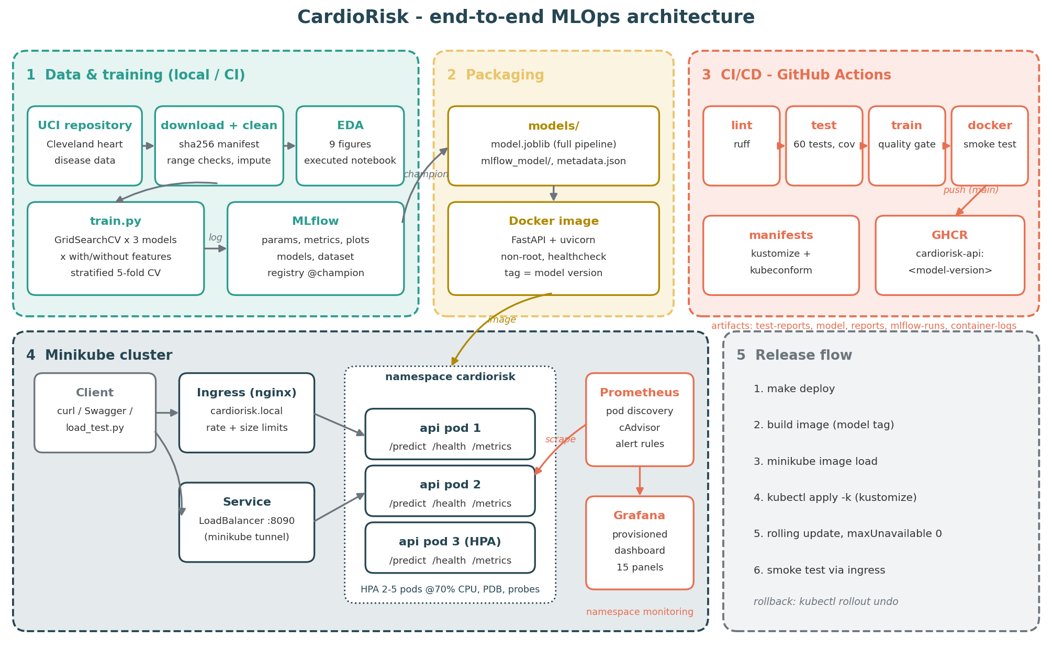
Figure 1: End-to-end architecture of the CardioRisk system

1.2 Setup and installation
The project targets Python 3.10+ (developed on 3.11). The full workflow is driven by a Makefile so each stage can also be run on its own:
git clone https://github.com/sevanth-gajula03/cardiorisk-mlops && cd cardiorisk-mlops
python -m venv .venv && source .venv/bin/activate
pip install -r requirements.txt # or: conda env create -f environment.yml
make all # download -> clean -> EDA figures -> train -> tests
make predict # score samples/patients.json with the packaged model
make docker-build docker-run smoke # container on :8080 + 6 end-to-end checks
make deploy monitoring # Minikube deployment + Prometheus/Grafana
Table 1: Technology stack
Area | Tools
Data & modelling | pandas, NumPy, scikit-learn 1.5, matplotlib / seaborn
Experiment tracking | MLflow 3.17 (SQLite backend, model registry)
Serving | FastAPI, Pydantic, uvicorn, prometheus-client
Testing & CI | pytest + coverage, ruff, GitHub Actions, kubeconform
Containers & deployment | Docker (Colima), Minikube, kustomize, nginx Ingress, HPA
Monitoring | Prometheus 3.5, Grafana 12.1, structured JSON logs

2. Data acquisition and exploratory analysis

2.1 Acquisition
heartrisk.data.download downloads the official UCI archive, extracts processed.cleveland.data (303 patients, 13 features plus the diagnosis) and falls back to the direct file link if the archive endpoint is unavailable. It writes a MANIFEST.json with the source URL, timestamp and SHA-256 checksum; the same checksum is stored in the model metadata, so every trained model can be traced back to the exact bytes it was trained on. Because my network re-signs HTTPS traffic, TLS is verified against the operating system's certificate store (via truststore) rather than Python's bundled CA list.

2.2 Cleaning
Table 2: Cleaning steps (logged to reports/data_quality.json)
Step | What I did | Effect on the data
Missing values | ? parsed as NaN; mode imputation for the coded columns | ca: 4 rows, thal: 2 rows filled
Duplicates | Exact duplicate rows dropped | None in the Cleveland file
Range checks | Values outside clinical limits in params.yaml treated as missing | No violations (kept as a guard for new data)
Target | Diagnosis 0-4 collapsed to 0 = no disease, 1 = disease | 164 vs 139 patients (54% / 46%)
Encoding | One-hot cp, restecg, slope, thal with readable names | heart_encoded.csv, 23 columns

I chose the mode rather than the median for the two incomplete columns because they are categorical codes: a median of thal values 3 and 7 would be 5, which is not a valid code. Scaling is deliberately not done at this stage; it lives inside the model pipeline so it is only ever fitted on training folds.

2.3 Key findings
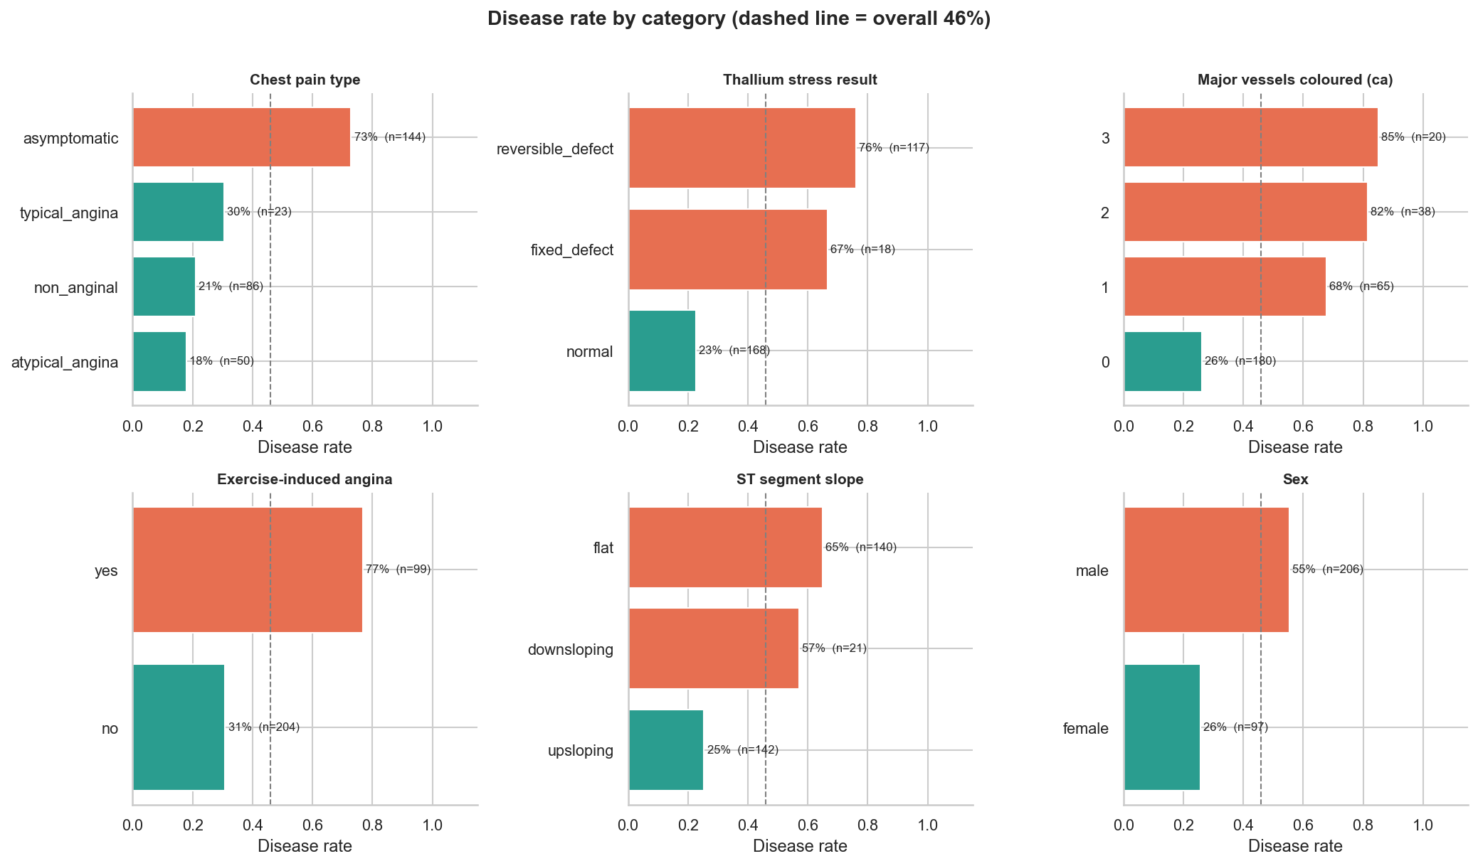
Figure 2: Disease rate per category with group sizes; the dashed line is the overall 46% rate
- The classes are reasonably balanced (54/46), so accuracy is meaningful, but I still report precision, recall and ROC-AUC and use stratified folds.
- The strongest signals are thal (reversible defect: 76% disease), ca (any coloured vessel: 68-85%), exercise-induced angina (77% vs 31%) and asymptomatic chest pain (73%) - counter-intuitive, but typical of this cohort where silent ischaemia was referred for testing.
- chol (r = 0.09) and fbs (r = 0.03) carry almost no linear signal; oldpeak is heavily right-skewed.
- Max heart rate falls with age for everyone, but patients with disease sit further below the 220 - age reference, and risk rises with age much faster for men (Figure 3).
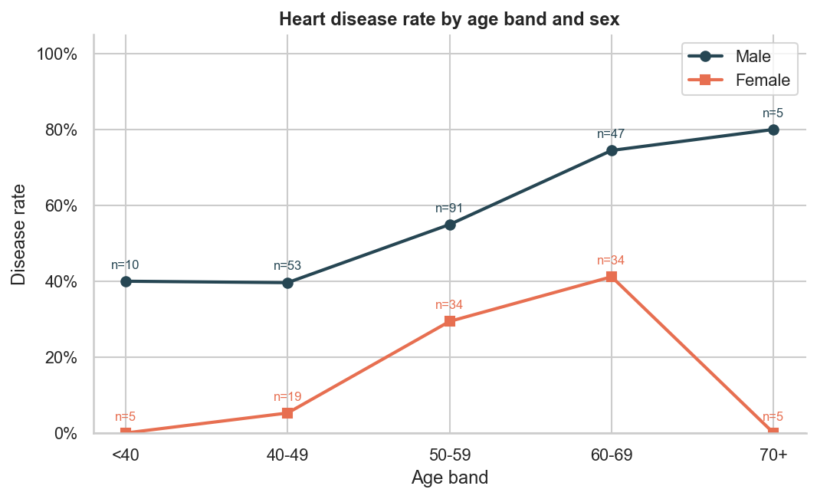
Figure 3: Disease rate by age band and sex - the motivation for an age x sex feature
These last two observations directly shaped the feature engineering in the next section. The executed notebook notebooks/01_eda.ipynb contains all nine EDA figures with commentary.

3. Feature engineering and model development

3.1 Feature pipeline
All preprocessing is one scikit-learn Pipeline (src/heartrisk/features.py), so the same object is used for training, batch scoring and the API, and nothing has to be re-implemented at serving time:
- ClinicalFeatures (custom transformer) adds hr_reserve = thalach / (220 - age) - achieved heart rate as a fraction of the age-predicted maximum - and age_x_male = age x sex.
- Median imputation and StandardScaler for continuous columns and the ordinal ca; a Yeo-Johnson power transform for the skewed oldpeak.
- Mode imputation and one-hot encoding (unknown categories ignored) for cp, restecg, slope, thal.

3.2 Model selection and tuning
I tuned three model families with GridSearchCV using stratified 5-fold cross-validation, ROC-AUC as the refit metric, and accuracy, precision, recall and F1 recorded alongside. As a personal experiment, every model was trained twice - with and without the engineered features - to measure whether they actually help. The data was split 80/20 (stratified, seed 42); tuning and model selection used only the training split, and the 20% hold-out was reported but never used to choose anything.
Table 3: Results of the tuning session (5-fold CV on 242 rows, test on 61 rows)
Run | Grid | CV ROC-AUC | Test ROC-AUC | Test recall | Train-CV gap
logreg-eng (champion) | 24 | 0.915 +/- 0.013 | 0.948 | 0.929 | 0.010
logreg-base | 24 | 0.908 +/- 0.014 | 0.953 | 0.929 | 0.025
rf-eng | 36 | 0.903 +/- 0.021 | 0.945 | 0.893 | 0.067
rf-base | 36 | 0.900 +/- 0.026 | 0.950 | 0.929 | 0.064
gbm-eng | 16 | 0.894 +/- 0.024 | 0.956 | 0.929 | 0.073
gbm-base | 16 | 0.883 +/- 0.028 | 0.960 | 0.929 | 0.078

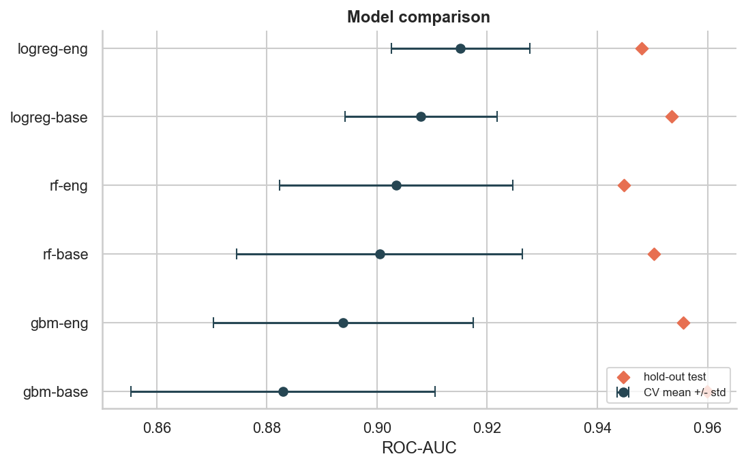
Figure 4: CV ROC-AUC (mean +/- std) against hold-out ROC-AUC for all six runs
Why logistic regression (C = 0.1, L2)? It has the highest and most stable cross-validated ROC-AUC, the smallest gap between training and validation scores (0.01 against roughly 0.07 for the tree ensembles, which overfit 303 rows noticeably), reasonably calibrated probabilities and readable coefficients - important for a clinical risk score. Gradient boosting looks best on the 61-row test set but worst in CV; with so few test rows that difference is within noise, so I trusted CV. The engineered features improved CV ROC-AUC for all three families (+0.007, +0.003 and +0.011).
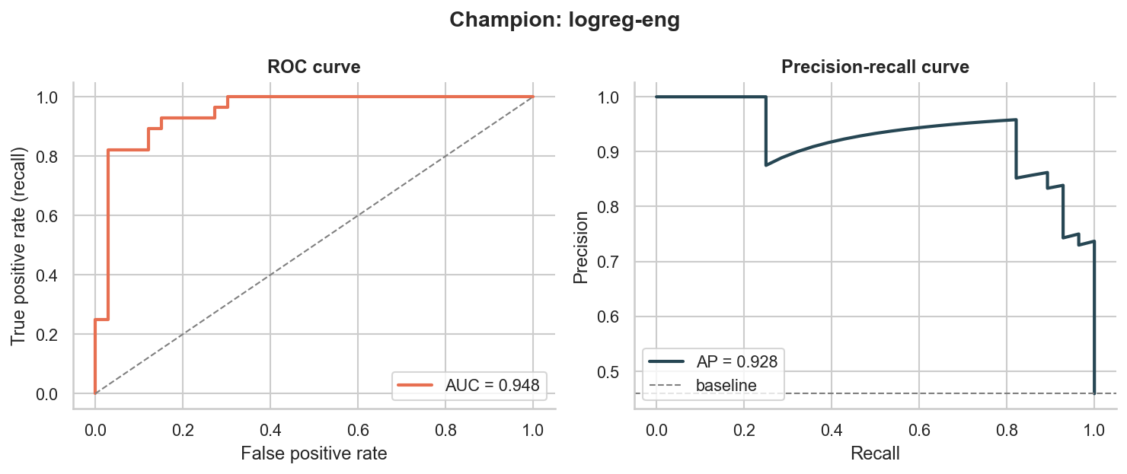
Figure 5: Champion ROC and precision-recall curves on the hold-out set
On the hold-out set the champion reaches accuracy 0.869, precision 0.813, recall 0.929 and ROC-AUC 0.948. For a screening tool, high recall (few missed patients) is the more important property. The chosen configuration is finally refitted on all 303 rows for the shipped model.

4. Experiment tracking with MLflow
Each run of python -m heartrisk.models.train creates one parent MLflow run (a training session) with a nested child run per model and feature set. The tracking store is a local SQLite database; setting MLFLOW_TRACKING_URI points the same code at a remote server.
Table 4: What is tracked for every run
What | Logged
Parameters | model type, feature set, best hyper-parameters, grid size, CV folds, seed, data SHA-256, train/test sizes
Metrics | CV mean and std for accuracy, precision, recall, F1, ROC-AUC; train ROC-AUC; overfit gap; all test metrics
Plots | confusion matrix, ROC + PR curves, calibration curve, feature importance (each run); comparison and ROC overlay (session)
Artifacts | cv_results.csv, feature_importance.csv, search_space.json, params.yaml, model comparison table
Dataset | heart_clean logged as the training input with its digest
Models | every tuned pipeline with signature and input example; champion registered as cardiorisk-classifier@champion

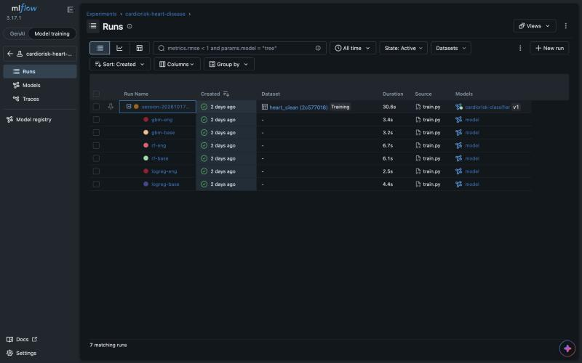
Figure 6: MLflow: a training session with its six nested runs and the registered model
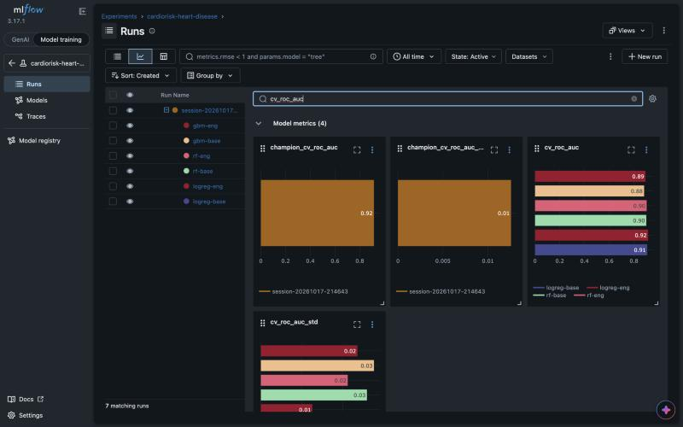
Figure 7: MLflow chart view comparing cv_roc_auc and its standard deviation across runs

5. Model packaging and reproducibility
The champion is written to models/ in two equivalent formats plus metadata:
- model.joblib - the complete pipeline (features, preprocessing and model), used by the API.
- mlflow_model/ - the same pipeline in MLflow format with MLmodel, conda.yaml, requirements.txt and an input example, loadable with mlflow.pyfunc.load_model.
- metadata.json - model version, hyper-parameters, metrics, feature list, decision threshold, training-data SHA-256 and the MLflow run IDs.
Reproducibility comes from: pinned versions in requirements.txt (with an environment.yml alternative and a slimmer requirements-serve.txt for the container), a single random seed and all paths and choices in config/params.yaml, a deterministic split, data checksums, and the preprocessing living inside the saved model. I verified this by rebuilding a fresh virtual environment from the requirements file and re-running the whole pipeline: it produced identical metrics.
MLflow 3 serialises scikit-learn models with skops and refuses unknown classes. Rather than hard-coding a list, the training script asks skops which types the pipeline contains (our own ClinicalFeatures, NumPy dtypes) and passes exactly those as trusted.

6. CI/CD pipeline and automated testing

6.1 Tests
There are 60 pytest tests (73% line coverage) across data cleaning (missing values, duplicates, range checks, encoding), the engineered features and preprocessing pipeline, model helpers and the inference wrapper, evaluation plots, the downloader (network mocked, including the fallback path) and the API (validation limits, batch limits, request IDs, metrics). Model tests use a small synthetic dataset so they need no download.

6.2 GitHub Actions workflow
.github/workflows/ci.yml runs on every push to main, on pull requests and on demand. Jobs depend on each other, so a failure stops everything after it.
Table 5: CI jobs
Job | Steps | Artifacts / output
Lint | ruff (pycodestyle, pyflakes, isort, bugbear, pyupgrade, simplify) with inline PR annotations | -
Validate manifests | kustomize render of the app and monitoring stacks, strict kubeconform validation | -
Unit tests | pytest with coverage | JUnit XML, coverage XML/HTML; coverage in job summary
Train and evaluate | download, clean, EDA, full tuning session with MLflow, model quality gate, sample predictions | model, reports, mlflow-runs; results table in summary
Container | build image with the model trained in this run, run it, smoke test; push to GHCR on main | container logs; image size in summary

The model quality gate (scripts/check_model_quality.py) is my addition: the run fails if a retrained champion drops below CV ROC-AUC 0.85, test ROC-AUC 0.85 or test recall 0.80, so a data or code change cannot silently ship a worse model. The first run on GitHub completed all five jobs in 6 min 38 s and pushed the image to ghcr.io/sevanth-gajula03/cardiorisk-api.
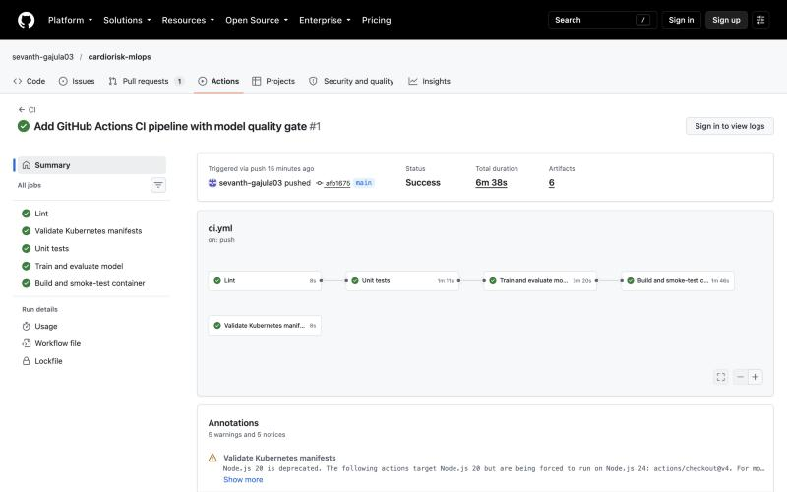
Figure 8: Successful pipeline run: lint, manifest validation, tests, training and container jobs
To prove the pipeline fails on errors, I opened a pull request that widens the low-risk band from 0.30 to 0.35 without updating the tests. The run stopped at the unit-test job with AssertionError: assert 'low' == 'moderate' in test_risk_band[0.3-moderate], and training and the container build were skipped (Figure 9).
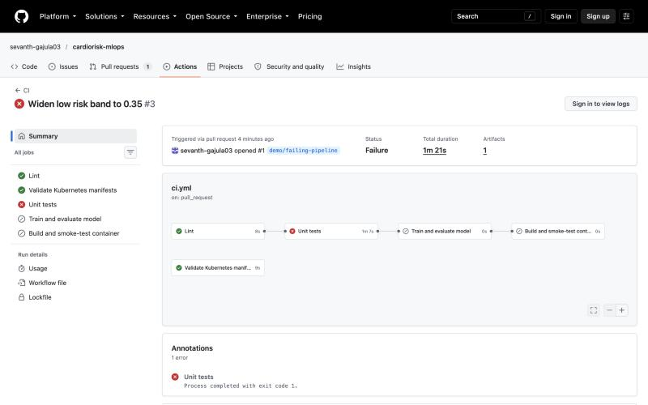
Figure 9: The same pipeline failing on a pull request with a broken test

7. Model serving and containerisation
The API (src/heartrisk/api) is built with FastAPI and exposes:
Table 6: API endpoints
Method | Path | Purpose
POST | /predict | score one patient; returns prediction, label, probability, confidence, risk band and top factors
POST | /predict/batch | score 1-100 patients in one call
GET | /health, /ready | liveness and readiness (503 until the model is loaded)
GET | /model/info | version, hyper-parameters and metrics of the loaded model
GET | /metrics | Prometheus metrics

Every input field has clinical limits and allowed codes (Pydantic), and unknown fields are rejected, so bad input returns a clear 422 instead of a silent wrong answer. Two personal touches: each response includes a risk band (low < 0.3 <= moderate < 0.6 <= high) and the three factors that pushed this patient's prediction most (coefficient x standardised value), and every response carries the model version and a request ID that also appears in the logs.
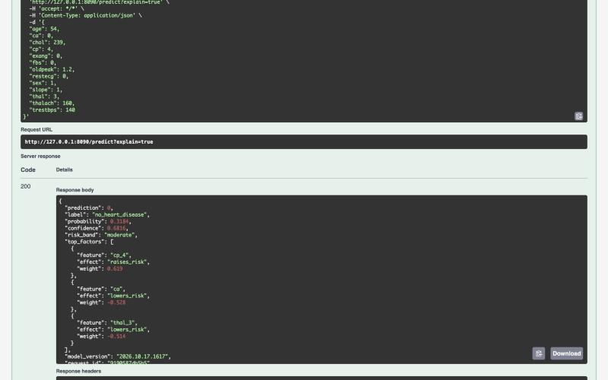
Figure 10: A live /predict call from Swagger UI against the Kubernetes deployment
The Dockerfile is a two-stage build: wheels are compiled in a builder stage and bind-mounted into the runtime stage so they never end up in an image layer. The runtime image runs as a non-root user (UID 10001), has a HEALTHCHECK on /health, and stores the model version and git SHA as labels. I run a single uvicorn worker per container because Prometheus counters are per-process; scaling is done with Kubernetes replicas instead. scripts/smoke_test.sh checks health, readiness, a known high-risk prediction, batch scoring, input validation and the metrics endpoint, and is used locally, in CI and after each deployment.

8. Production deployment on Kubernetes
The service runs on Minikube (Docker driver on Colima). Manifests live in k8s/base with a k8s/overlays/minikube kustomize overlay that pins the image tag to the model version.
Table 7: Kubernetes resources
Resource | Configuration
Deployment | 2 replicas; rolling update with maxUnavailable 0; startup, liveness (/health) and readiness (/ready) probes; CPU/memory requests and limits; non-root, read-only root filesystem, all capabilities dropped; Prometheus annotations
Service | type LoadBalancer on port 8090 (external IP from minikube tunnel)
Ingress | nginx, host cardiorisk.local, request size and rate limits
HPA / PDB | 2-5 pods at 70% CPU; at least one pod always available

make deploy builds the image tagged with the model version, loads it into Minikube, applies the manifests, records a change-cause, waits for the rollout and runs the smoke test through the Ingress. Retraining therefore always produces a new tag and a zero-downtime rolling update, and kubectl rollout undo returns to the previous model. During a load test the autoscaler scaled the deployment from two to three pods.
$ kubectl -n cardiorisk get deploy,svc,ingress,hpa
deployment.apps/cardiorisk-api 2/2 2 2
service/cardiorisk-api LoadBalancer 10.107.235.53 127.0.0.1 8090:30570/TCP
ingress.networking.k8s.io/cardiorisk-api nginx cardiorisk.local 192.168.49.2 80
horizontalpodautoscaler.autoscaling/cardiorisk-api cpu: 3%/70% 2 5 2

$ scripts/smoke_test.sh http://127.0.0.1:8090
[ok] GET /health [ok] GET /ready
[ok] high-risk patient predicted as disease
[ok] POST /predict/batch [ok] invalid input rejected [ok] metrics exposed
All 6 checks passed.
Access: minikube tunnel then http://127.0.0.1:8090/docs, or kubectl -n ingress-nginx port-forward svc/ingress-nginx-controller 8081:80 and requests with the Host: cardiorisk.local header.

9. Monitoring and logging
Every request produces one JSON log line with request ID, method, route, status, latency and client, and every prediction adds a line with label, probability, risk band and model version. The request ID is taken from the caller or the Ingress X-Request-ID header, so one ID can be followed from nginx to the pod log to the response. The API exposes request counts and latency histograms by route and status, in-flight requests, predictions by label and risk band, the predicted-probability distribution, model-only inference time and a model-info gauge. Unknown URLs share a single unmatched label so scanners cannot create unbounded metric series.
I wrote a small Prometheus and Grafana stack instead of installing a large chart. Prometheus discovers API pods through the Kubernetes API using their annotations and scrapes container CPU and memory from cAdvisor. Grafana is provisioned entirely from code: the data source, the dashboard provider and a 15-panel dashboard generated by scripts/build_dashboard.py.
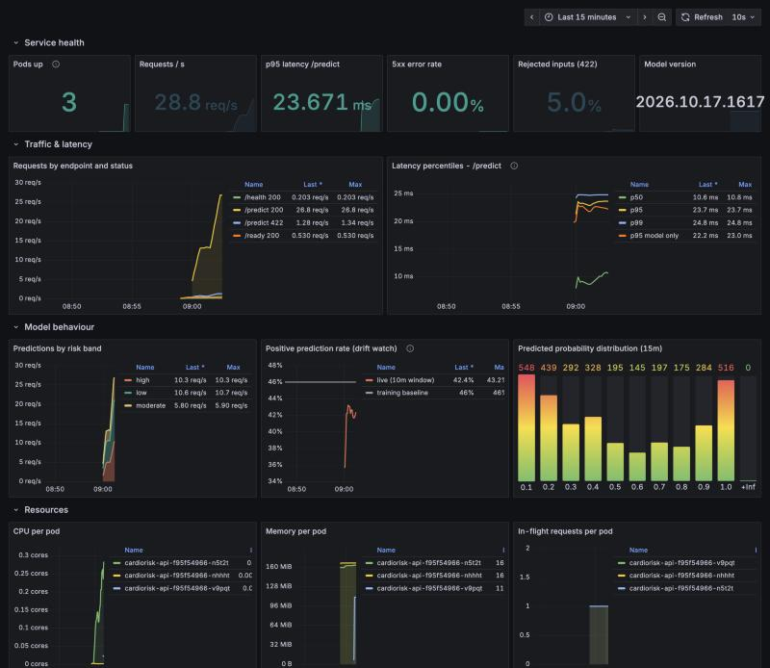
Figure 11: Grafana dashboard under load: service health, latency, model behaviour and resources
Alert rules cover the API being down, more than 2% server errors, p95 latency above 250 ms and more than 20% invalid requests. I also added a simple prediction-drift alert: the share of positive predictions over ten minutes is recorded as a series and compared with the 46% seen in training; leaving the 15-75% band raises an alert. Under load the live positive rate was about 43%, p95 latency about 24 ms and the server error rate 0%.

10. Challenges and lessons learned
- TLS-inspecting corporate proxy. Downloads, Minikube image pulls and Docker pulls failed with certificate errors. I used the OS trust store in Python, installed the company root and issuing CAs into Minikube (~/.minikube/certs, --embed-certs) and the Colima VM, and loaded images that still failed to pull with minikube image load.
- runAsNonRoot needs a numeric user. Pods were rejected until the image used a fixed UID (10001) that Kubernetes can verify.
- Per-process metrics. Two uvicorn workers made counters jump between scrapes; one worker per pod with Kubernetes replicas fixed it.
- Small data, noisy test set. With 61 test rows, test-set rankings flipped between runs; selecting on cross-validation and logging the train-CV gap gave a far more stable choice.
- Testing the pipeline itself. Running the CI steps from a fresh copy before pushing caught two regressions introduced by lint fixes before GitHub ever saw them.

11. Conclusion and future work
CardioRisk takes a small public dataset through a complete, automated MLOps lifecycle: a validated and checksummed dataset, documented EDA, tuned and tracked models, a packaged pipeline, a tested and containerised API, a Kubernetes deployment with autoscaling and zero-downtime updates, and monitoring of both the service and the model. Natural next steps are a remote MLflow server with artifact storage, promoting models through registry aliases from CI, data-drift checks on the input features (not just the predictions), probability calibration, and deploying the same manifests to a managed cluster with GitOps.

Appendix A. Deliverables and access
Table 8: Where each deliverable lives
Deliverable | Location
Code repository | https://github.com/sevanth-gajula03/cardiorisk-mlops
Dataset + download script | data/, src/heartrisk/data/download.py, data/raw/MANIFEST.json
EDA notebook / scripts | notebooks/01_eda.ipynb, src/heartrisk/eda/plots.py
Training / inference | src/heartrisk/models/train.py, src/heartrisk/models/predict.py
Tests | tests/ (60 tests)
CI workflow | .github/workflows/ci.yml
Dockerfile, requirements | Dockerfile, requirements.txt, requirements-serve.txt, environment.yml
Deployment manifests | k8s/base, k8s/overlays/minikube, k8s/monitoring
Screenshots | screenshots/
Container image | ghcr.io/sevanth-gajula03/cardiorisk-api

Local access: after make deploy, run minikube tunnel and open http://127.0.0.1:8090/docs; Grafana with make grafana (http://localhost:3000) and Prometheus with make prometheus (http://localhost:9090).

