**Nguyễn Trọng Châu**

**QA Test Engineer**

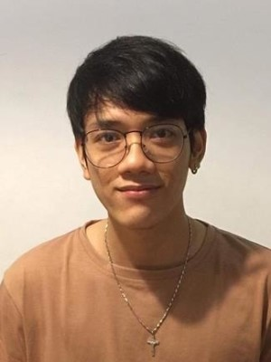

January 07, 1997

⬧

Male



0901116948



sevben2356@gmail.com

→

 HCM, Vietnam

|  |  |
| --- | --- |
| **OBJECTIVE**   * Stable work for a long time. * Seek opportunities for advancement at work. * Contribute to building a development company. | **EDUCATION**  **HongBang University** (October 2015 > May 2019)  **Major: Information Technology** GPA: 6.2 |
| **SKILLS**  HTML CSS  Responsive  Convert PSD to HTML  Javascript  ReactJs  Read English | **WORK EXPERIENCE**  **NAANSOLUTION** (Apr 2019 > Dec 2019)  **Intern**  - Company specializing in creating products on websites - Working in environment C#, model MVC. - Knowledge of HTML CSS SASS JS JQuery, Bootstrap,... - Convert PSD to HTML.  **CMC GLOBAL** (Dec 2019 > May 2020)  **Fresher Front-end**   - Back end + Knowledge of Java Spring Data JPA Framework, Hibernate, SQL and database, Java Core & OOP & RESTful API. - Front- end + Knowledge of Angular 8, Canvas HTML5, ReactJs,...  **AMPERE COMPUTING (Dec 2020 > Dec 2021)**  **QA Test Engineer** - Skill: Automation test, Performance test, Manual test, Report data, Debug issue,... - Knowledge of Tool: Jira, Postman, Git, ...  - Salary expected: 15.000.000 VND.  - Reason for leaving AMPERE COMPUTING: The environment is not suitable & I want to improve skills.  **ACTIVITIES PROJECT**  **LocPhucJewelry (04/2019 > 09/2019)**  Sell  - Design layout .  - Convert PSD to HTML.  - Create effects for pages by javascript and jquery.  **IDL Edu (10/2019 > 12/2019)**  Education  - Design layout .  - Convert PSD to HTML.  - Create effects for pages by javascript and jquery.  **Chart (12/2019 > 5/2020)**  Create products for the company  - Using HTML 5 and canvas.  - Create interactive transition between chart.  **AVL (12/2020 > 12/2021)**  - Create guidelines for test devices (Automation tool & Manual scripts for test performance). - Execute AVL Test (Approved Vendor List) devices on Window or Linux OS. |