Homework 1 – Analysis

Jianxiang Fan

(09/03/2015)

* Environment

CPU: Intel Xeon E312xx 2.4GHz x 4; Memory: 8GB; OS: Ubuntu 14.04.3 LTS Linux 3.19.0-27 x86_64

* The relation between K and Accuracy

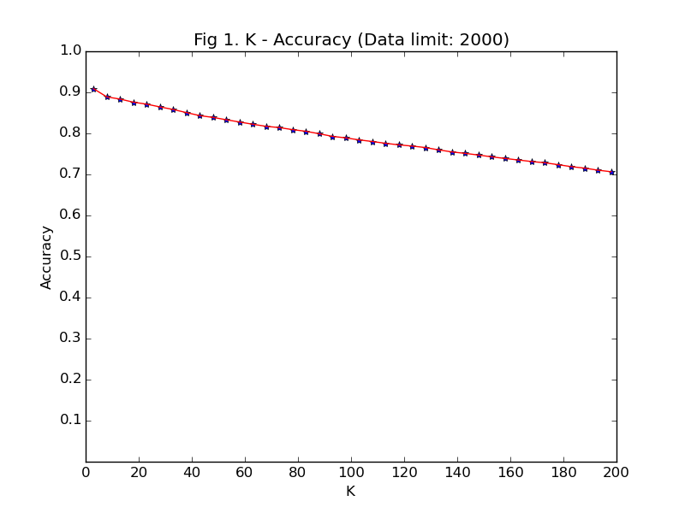 (Figure plotted by Python matplotlib)

* The relation between Size of Training Set and Accuracy

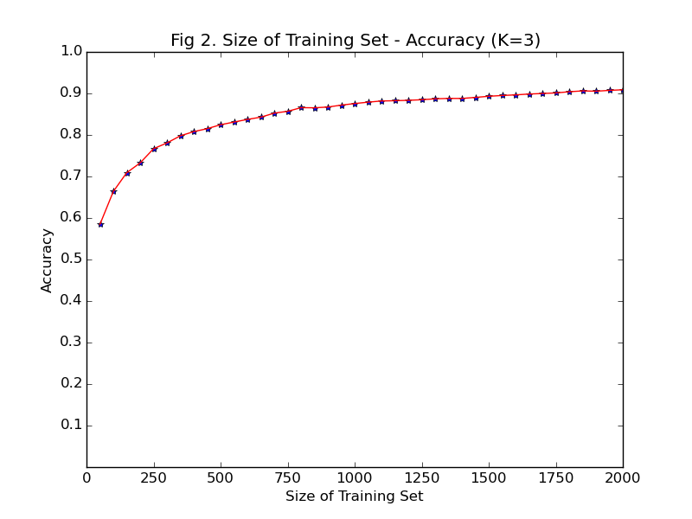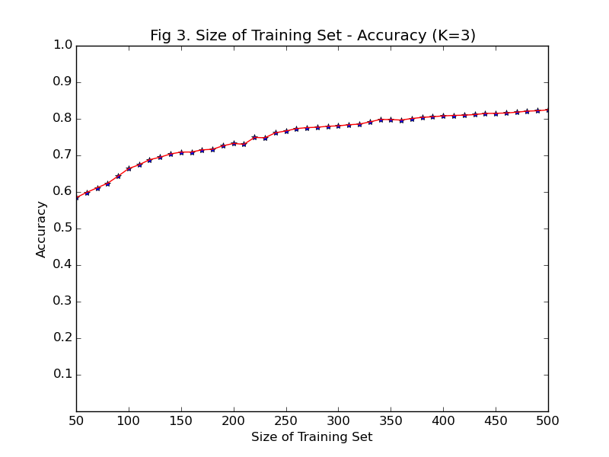

Fig3

* Easily confused numbers

Classifier trained by whole training set (k=3)

Test Results:

Accuracy: 0.972800

Confused over 10 times:

2=>7 (18) 4=>9 (19)

5=>3 (19) 5=>6 (15)

8=>3 (11) 8=>5 (16)

9=>4 (14)