**Analysis - HW4** Jianxiang Fan [jianxiang.fan@colorado.edu](mailto:jianxiang.fan@colorado.edu)

1. **Order of hypothesis classes in terms of complexity:**

Hyperplanes through the origin < arbitrary hyperplanes < axis-aligned rectangles

***Experimental result of Rademacher Complexity (20 random points in [-20, 20] x [-20, 20]):***

Axis-aligned rectangles: 0.573000 Hyperplanes (origin): 0.400500 Arbitrary hyperplanes: 0.528100

***VC-Dimension analysis:***

**(a) Hyperplanes through the origin: VC-Dim = 2.** Two points can be shattered (a). Three points: If we let the left and right ones be positive, and the middle one be negative, (b) no hypothesis can realize this labeling.

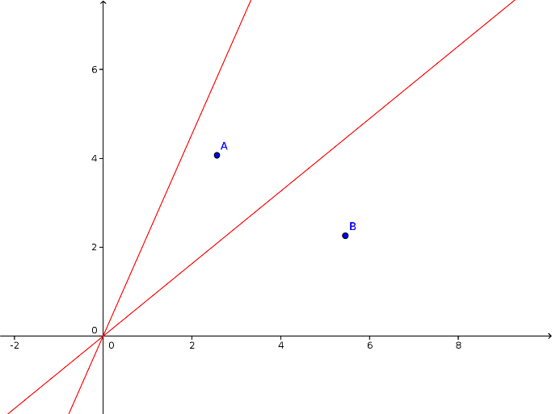 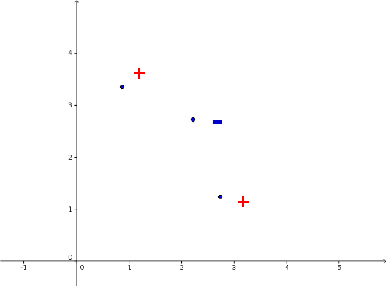

**b**

**a**

**(b)** **Arbitrary hyperplanes: VC-Dim = 3.** Three points can be shattered (c). Four points: (Case 1) The four points can make up a quadrangle (d): let one opposite pair be positive and another pair be negative, no hypothesis can realize this labeling. (Case 2) The four points can’t make up a quadrangle: Let the interior point be negative and the others be positive (e), no hypothesis can realize this labeling.

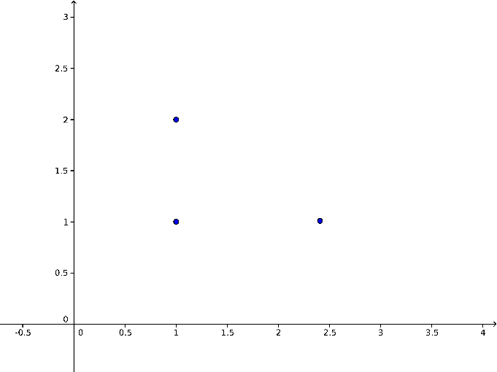 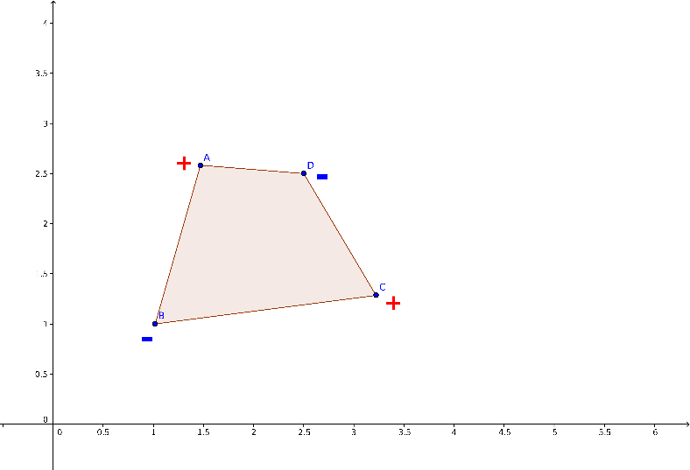 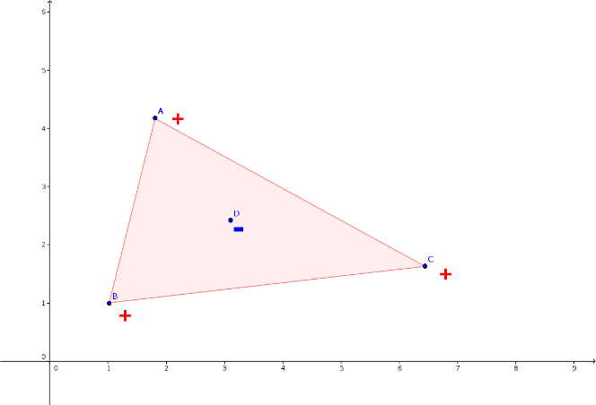

**e**

**d**

**c**

**Axis-aligned rectangles: VC-Dim = 4.** Four points can be shattered (f). Five points: If we construct the minimal axis-aligned rectangle containing these points, assign a negative label to this interior point and a positive label to each of the remaining four points (g), no hypothesis can realize this labeling..

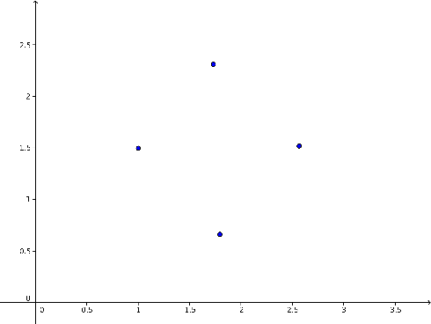 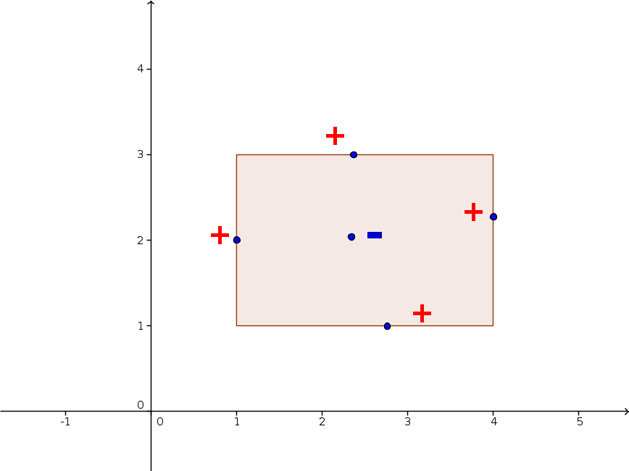

**f**

**g**

1. **Prove that your frequency correctly classifies any training set**

Frequency: $ω=π\left(1+\sum_{i=1}^{m}{\frac{1-y_{i}}{2}2^{x_{i}}}\right)$

For any $j \left(1≤j≤m\right)$

$$ω2^{-x_{j}}=π\left(2^{-x_{j}}+\sum_{i=1}^{m}{\frac{1-y_{i}}{2}2^{x_{i}-x_{j}}}\right)=π\left(2^{-x_{j}}+\frac{1-y_{j}}{2}+\sum_{i=1}^{x_{j}-1}{\frac{1-y_{i}}{2}2^{x_{i}-x_{j}}}\right)$$

$$ω2^{-x_{j}}≤π\left(2^{-x_{j}}+\frac{1-y_{j}}{2}+\sum_{i=1}^{x_{j}-1}{2^{x_{i}-x_{j}}}\right)=π\left(\frac{1-y_{j}}{2}+\sum_{i=1}^{x_{j}}{2^{-i}}\right)<π\left(\frac{1-y_{j}}{2}+1\right)$$

$$ω2^{-x_{j}}≥π\left(2^{-x_{j}}+\frac{1-y_{j}}{2}\right)>π\frac{1-y_{j}}{2}$$

If $y_{j}=1, 0<ω2^{-x_{j}}<π,$ then $\sin\left(ω2^{-x_{j}}\right)>0, h\left(x_{j}\right)=sign\left(\sin\left(ω2^{-x_{j}}\right)\right)=1$

If $y_{j}=-1, π<ω2^{-x_{j}}<2π,$ then $\sin\left(ω2^{-x_{j}}\right)<0, h\left(x_{j}\right)=sign\left(\sin\left(ω2^{-x_{j}}\right)\right)=-1$

1. **Classifying real numbers**

Choose four points x = 1, 2, 3, 4. They can't be shattered by this sine classifier.

Proof:

Suppose there is an $ω$ labeling these four points as +, -, -, -, thus:

$$\sin{ω}≥ 0, \sin{2ω}< 0, \sin{3ω}< 0, \sin{4ω}< 0$$

Since $\sin{4ω}=2\sin{2ω}\cos{2ω}=2\sin{2ω}\left(1-2\sin^{2}{ω}\right)<0$ and $\sin{2ω}< 0$,

we have $1-2\sin^{2}{ω}>0$, then $\sin^{2}{ω}<1/2$.

While $\sin{3ω}=3\sin{ω}-4\sin^{3}{ω}=\sin{ω}\left(3-4\sin^{2}{ω}\right)<0$ and $\sin{ω}≥ 0$,

we have $3-4\sin^{2}{ω}<0$, then $\sin^{2}{ω}>3/4$.

These two results lead to a contradiction, so this classifier can’t realize this labeling.

Although the sine classifier can’t shatter these four points, this conclusion is not related to its VC dimension. Actually the VC-dimension of the family of sine functions is infinite, as we can see in question 2.