Homework 2 Analysis – Jianxiang Fan

* **Learning Rate -** Smaller learning rate means slower to converge, while too large rate tends to skip around and miss the optimal point. In my model, 0.1 is a pretty fair learning rate.

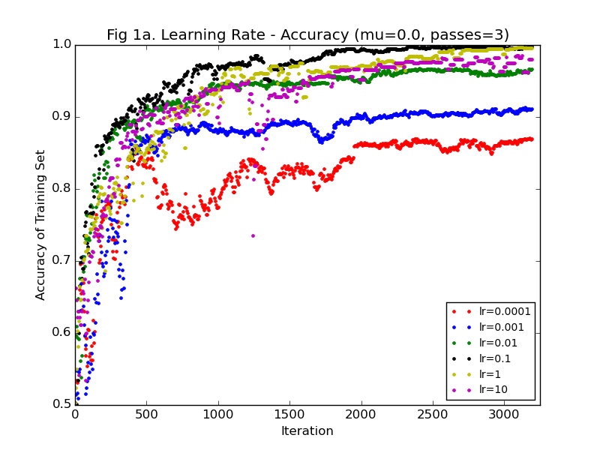 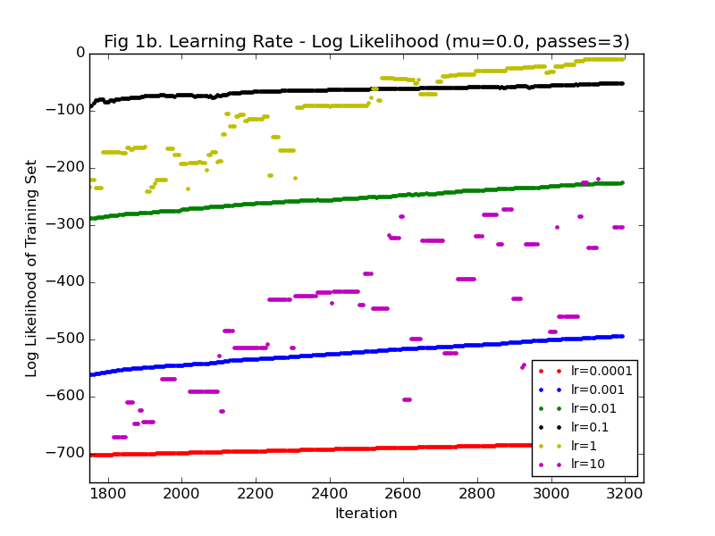

* **Passes –** The unregularized version usually needs 3 passes to get stable accuracy, while the regularized version needs more, 4 or 5 passes in avarage.

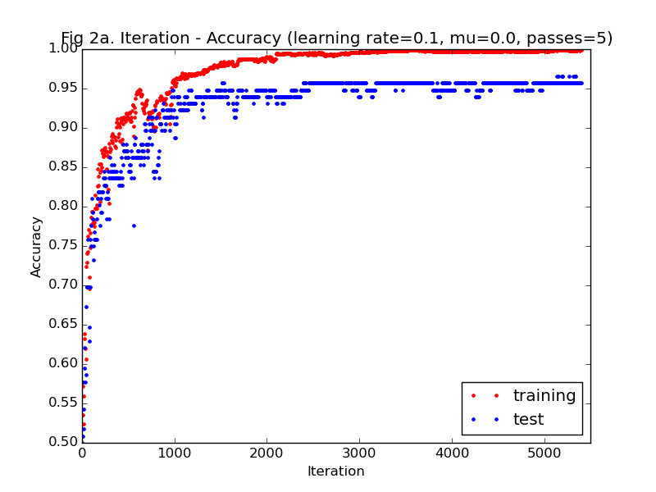 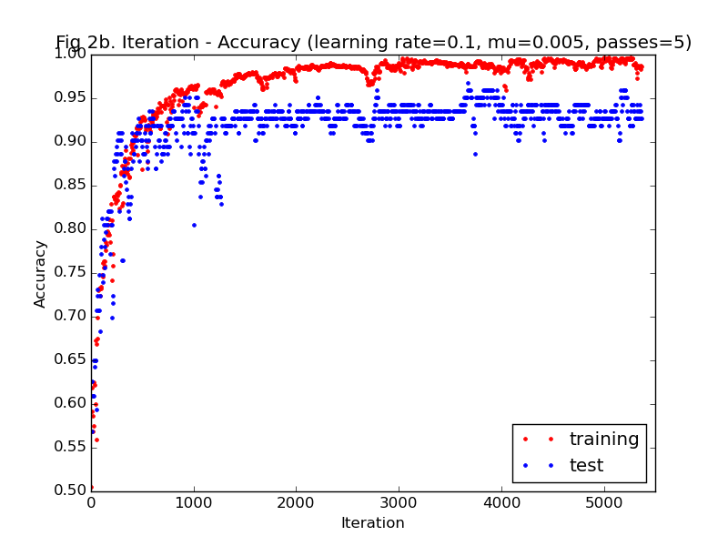

* **Best/Poorest Predictors –** Words with **largest positive** and **smallest negative** weights are the best predictors. And those words with **smallest absolute value (near 0)** weights are poorest predictors. Top 20 best and poorest:

**Best for baseball:** ['batting', 'happens', 'pitched', 'still', 'losing', 'steph', 'usa', 'stadium', 'dwarner', 'bob', 'rickert', 'pitcher', 'luriem', 'ball', 'run', 'anyone', 'hit', 'baseball', 'pitching', 'runs']

**Best for hockey**: ['hockey', 'playoffs', 'next', 'points', 'playoff', 'golchowy', 'ice', 'goal', 'traded', 'pick', 'goals', 'finals', 'round', 'beat', 'gld', 'contact', 'biggest', 'need', 'coverage', 'predictions']

**Poorest:** ['blasted', 'hooked', 'silence', 'intermissions', 'deceased', 'tone', 'rode', 'riel', 'hesitate', 'racist', 'vintage', 'everywhere', 'memoriam', 'wrestling', 'pitiful', 'broad', 'bloody', 'retiring', 'privately']

* **Schedule to update the learning rate –** Update function: **rate = initial_rate/(1+alpha*initial_rate*iteration).** It helps to improve the convergence. Left one **alpha=0 (without update)**, right one **alpha=0.01**

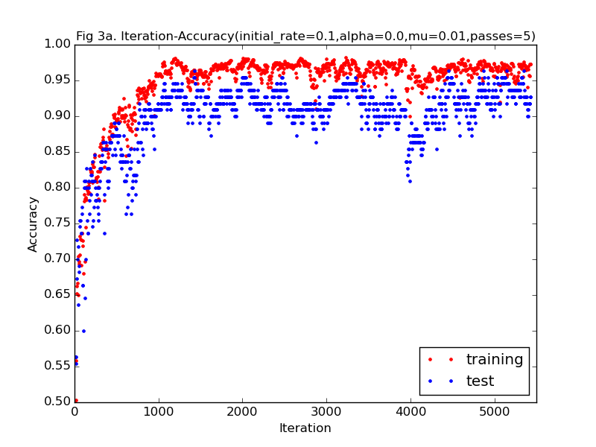 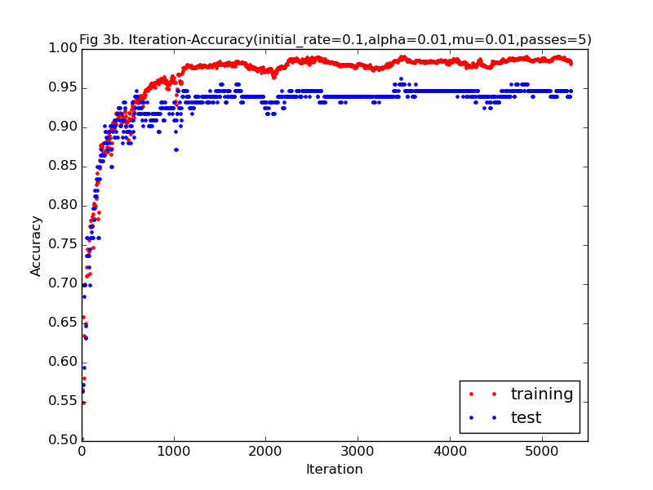

* **Use TF-IDF –** It makes training set more representative. Left one uses word frequency, right one uses tf-idf.

 