**Analysis - SVM**

Jianxiang Fan

jianxiang.fan@colorado.edu

* ***Use SVM (sklearn) to train a classifier to distinguish 3's from 8's***

Confusion Matrix and Accuracy on the test set:

Kernal=linear, Training limit=2000, c=1.0

3 8

------------------------------

3: 974 56

8: 56 953

Accuracy: 0.945071

Kernal=rbf, Training limit=2000, c=1.0

3 8

------------------------------

3: 995 35

8: 40 969

Accuracy: 0.963217

* ***Try at least 5 values of the regularization parameter C and at least 2 kernels.***

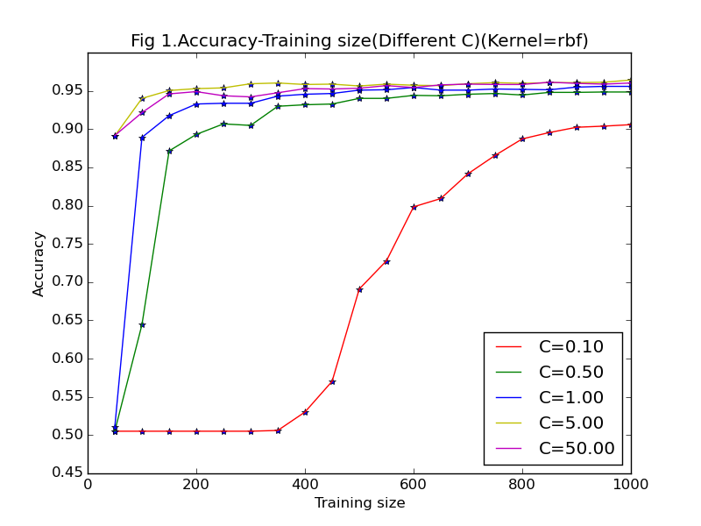 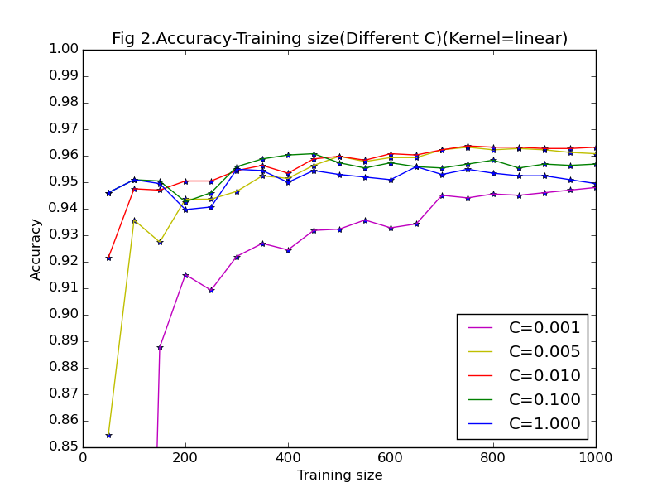

With both rbf and linear kernels, the classifiers using very small C don't perform well, which overfit the training set. Especially when the size of training set is small, the overfitting problem is worse, so we should choose larger regularization parameter C when using a small training set.

We may choose different best regularization parameter values according to different kernels. A fair choice with rbf kernel can be C=5.0. While using linear kernel, we may choose a smaller C, such as C=0.01.

* ***Support vectors with a linear kernel***

**Support vectors - label = 3, Training example indices:**

1,3,21,57,61,84,91,112,166,172,186,189,191,194,223,242,244,245,265,271,282,285,306,312,322,343,344,348,355,357,365,377,418,506,528,555,560,566,571,584,588,589,625,637,653,682,695,705,708,726,733,741,756,771,780,805,…

**Support vectors - label = 8, Training example indices:**

13,14,17,31,39,64,90,111,144,158,180,187,196,209,212,226,228,236,237,253,257,258,261,307,318,326,332,335,339,368,372,378,386,397,411,424,457,458,475,480,492,498,509,514,537,541,561,562,573,580,609,612,621,636,641,676,723,…