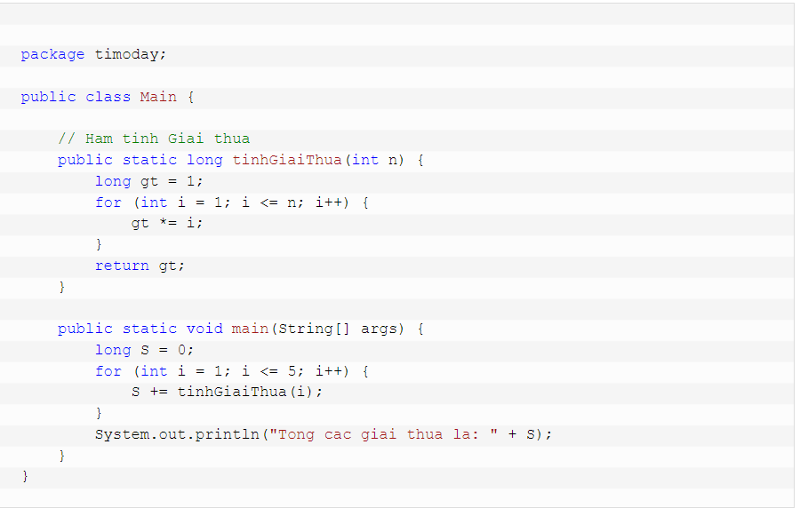

/**

* @(#)bt_demi.java

*

* bt_demi application

*

* @author

* @version 1.00 2022/5/16

*/

import java.util.Scanner;

public class bt_demi {

public static void main(String[] args) {

// TODO, add your application code

int a,b,c,n;

int []d = new int[100];

Scanner sc = new Scanner(System.in);

System.out.print("nhap a:");

a = sc.nextInt();

System.out.print("nhap b:");

b = sc.nextInt();

System.out.print("nhap c:");

c = sc.nextInt();

System.out.print("nhap n:");

n = sc.nextInt();

tinhab(a,b);

tinhtong(n);

tinhnhan(n);

ptbat2(a,b,c);

}

public static void tinhab(int a,int b){

int tong1 = 0;

tong1 = a+b;

System.out.print("tong a va b :"+tong1);

}

//tong s=1+2+3...n

public static void tinhtong(int n){

int tong = 0 ;

for(int i = 1 ; i <= n ; i++)

{

tong += i;

}

System.out.println("\nS to 1.."+n+": "+tong);

}//tinh p=1*2*3...n

public static void tinhnhan(int n){

int nhan = 1 ;

for(int i = 1 ; i <= n ; i++)

{

nhan *= i;

}

System.out.println("\np to 1.."+n+": "+nhan);

}

public static void ptbat2(float a, float b, float c)

{

// kiem tra vo nghiem , 1 nghiem

if(a==0){

if(b==0)

System.out.println("pt vo so nghiem");

else{

System.out.println("pt co 1 nghiem" + "x="+(-c/b));

}

return;

}

//

float delta = b*b - 4*a*c;

float x1;

float x2;

// tinh delta

if (delta > 0) {

x1 = (float) ((-b + Math.sqrt(delta)) / (2*a));

x2 = (float) ((-b - Math.sqrt(delta)) / (2*a));

System.out.println("pt co 2 nghiem: "

+ "x1 = " + x1 + " vÃ  x2 = " + x2);

} else if (delta == 0) {

x1 = (-b / (2 * a));

System.out.println("pt co nghiem kep: " + "x1 = x2 = " + x1);

}

else {

System.out.println("pt vo nghiem");

}

}

}

//tính giai thua

|  |
| --- |
| import java.util.Scanner; |
|  |  |
|  | public class App { |
|  | public static void main(String[] args) throws Exception { |
|  | int n; |
|  | Scanner ip = new Scanner(System.in); |
|  |  |
|  | System.out.print("Nhap N = "); |
|  | n = ip.nextInt(); |
|  | System.out.println("Giai thua cua " + n + " = " + tinhGiaiThua(n)); |
|  | } |
|  |  |
|  | public static double tinhGiaiThua(int n) { |
|  | double ketQua = 1; |
|  | if (n == 0 || n == 1) { |
|  | return ketQua; |
|  | } else { |
|  | for (int i = 2; i <= n; i++) { |
|  | ketQua *= i; |
|  | } |
|  |  |
|  | return ketQua; |
|  | } |
|  | } |
|  |  |
|  | public static double tinhGiaiThuaDeQuy(int n) { |
|  | if (n > 0) { |
|  | return n * tinhGiaiThuaDeQuy(n - 1); |
|  | }else { |
|  | return 1; |
|  | } |
|  | } |
|  | } |