Final report materials

Smart Event Management and Ticketing System

Use cases design problems and implementation evidence
25 October 2026
SEMS implements the complete free-ticket workflow from event publication and booking to individual ticket issuance, assigned-staff check-in, cancellation, in-app notifications and reporting. This material brings the use-case and design discussion up to the implementation recorded at release 565f08b and consolidates the supporting acceptance evidence.
The document follows the C1 to C10 structure of the 12 October consolidation. Earlier proposed ticketing, check-in and notification designs now have implemented counterparts. Paid checkout remains deferred. The evidence distinguishes implementation, deployment, business acceptance, coverage and capacity baselines.

Individual use case responsibility
Member | Primary use case | Section
Lu Junyi | UC04 Manage events | C4
Hu Jia | UC02 Login | C5
Chai Muyang | UC03 Manage users and roles | C6
Huang Haoyang | UC06 Book tickets | C7
Luo Runzhou | UC07 Check in ticket | C8

Each member has a primary use case and its associated design problem. Lu Junyi also covers UC05 Browse events, and Hu Jia covers UC01 Register. These labels identify report and presentation responsibility, following the previous allocation; they do not imply exclusive coding authorship.

Reading guide
C1 covers scope, C2 architecture and C3 data. C4 to C8 contain the individual use cases and design problems DP01 to DP05. C9 explains the analysis-to-design transition and implemented patterns. C10 records testing, capacity, DevSecOps and evidence references.

Evidence baseline
Release record: 565f08b, 21 October 2026. Business acceptance and backend coverage: 270c2b8, 20 October. Capacity measurements: 037720b, 21 October. Results retain their original environments and dates. References E1 to E12 identify repository evidence and reproducible implementation sources.

C1 Scope and evolution
The application supports organizers running limited-capacity events and attendees obtaining free admission tickets. Staff verify admission within an event-specific time window. Administrators manage roles and view system-wide reports, while event management remains owner-scoped. [E1, E2]
Use case | Actor | Delivered behaviour
UC01 Register | Visitor | Create an active account with ATTENDEE membership
UC02 Login | Registered user | Authenticate and obtain a time-limited JWT
UC03 Manage users and roles | Administrator | Search users and update supported roles with last-admin protection
UC04 Manage events | Organizer or admin | Create, edit, publish, cancel, copy and configure owned events
UC05 Browse events | Visitor or user | Search published events and inspect details
UC06 Book tickets | Attendee | Book free tickets, view individual tickets and cancel eligible orders
UC07 Check in ticket | Assigned staff | Validate admission, reject duplicates and retain audit records

Supporting workflows
Saved attendee details and pre-registration reduce repeated data entry. Pre-registration saves intent without reserving stock or placing an order. Staff assignments control access to individual events. In-app notifications cover relevant booking, event, staff and role changes, including opening reminders. Reports provide event and ticket-type summaries.

Changes since the October 12 material
Ticket issuance, check-in, notifications and reporting are implemented. Effective backend roles combine current database roles with JWT claims, so revocation applies on subsequent requests. Ticket State and booking-field Strategy are implemented patterns. Current notifications run synchronously in the business transaction rather than after commit.

Scope boundaries
Tickets remain free and confirmed bookings use paymentStatus NOT_REQUIRED. Paid checkout, refunds, seat maps, coupons, email/SMS delivery and self-service login email/password changes are outside the delivered scope. Pricing Strategy remains deferred. The original 1000-concurrency proposal is not fully demonstrated by the measured scenarios in C10.

C2 Overall system architecture
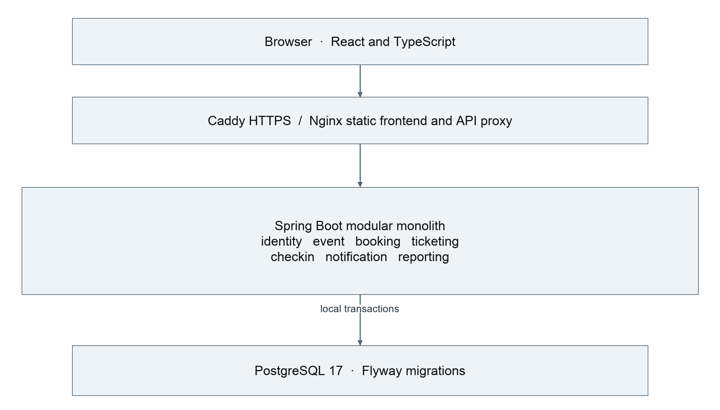
Figure C01 Current deployment layers and implemented business modules
A modular monolith keeps cross-module inventory and cancellation rules inside one PostgreSQL transaction. This reduces deployment and failure coordination overhead for the project scale. React provides the browser interface, Nginx serves frontend assets and proxies the API, and the shared Caddy proxy terminates HTTPS. [E3, E9]

Responsibilities and boundaries
Web endpoints validate transport data and authorization. Application services coordinate use cases, domain objects enforce business transitions and repositories persist state. Public services and synchronous application events provide the intended module contracts. CheckInController orchestrates JDBC access across tables, and ReportingService uses read-only SQL projections. These are explicit exceptions to full module isolation.

Design tradeoffs
An event row serializes inventory-affecting operations, which simplifies correctness across bookings, quota changes and cancellations but limits write concurrency for a popular event. A message broker or distributed transaction is unnecessary for the implemented workflow. External delivery would require a separate reliability design. A shared injected Clock makes time-dependent rules and tests deterministic.

C3 Data model and consistency contracts
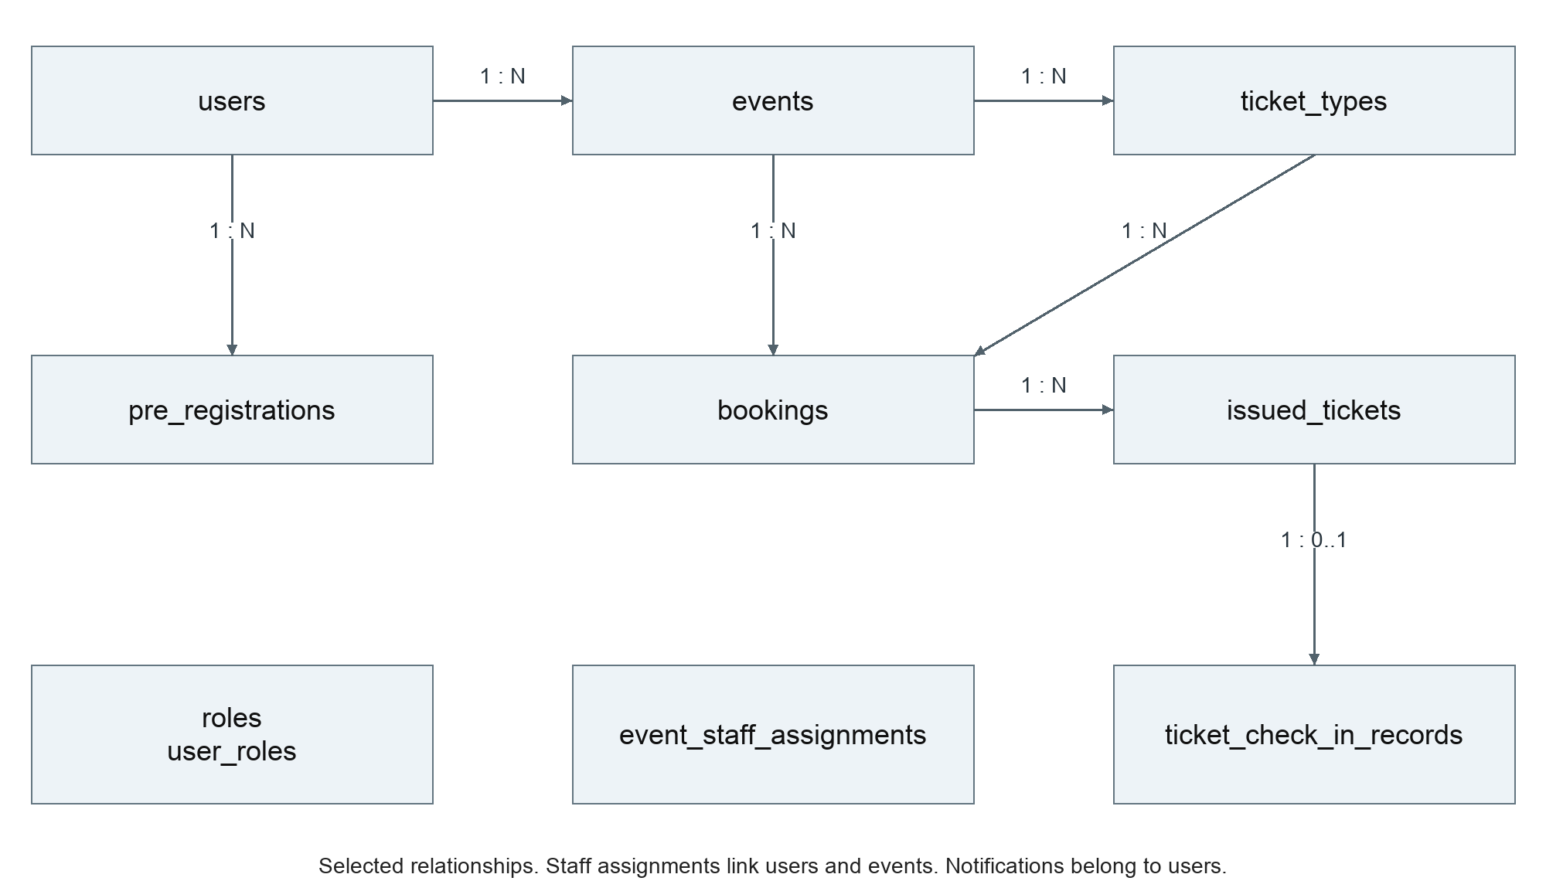
Figure C02 Core booking and admission relationships with selected supporting tables
Persistent model | Key rule
users, roles, user_roles | Account identity and many-to-many role membership
events, ticket_types | Owner and lifecycle checks; summed quotas fit event capacity
bookings, pre_registrations | Unique user/request key; one pre-registration per user/event
issued_tickets | One admission ticket per booked unit with unique issuance identity
event_staff_assignments | Staff authorization belongs to a specific user and event
ticket_check_in_records | At most one audit record per ticket; retained after cancellation
notifications | Recipient user FK; event/booking context IDs are not all FK relationships

The schema contains 11 application tables plus Flyway history and 14 migrations at the recorded baseline. Bookings retain offer and contact snapshots. Profile edits do not rewrite orders; currentEvent exposes the current arrangement separately. Copying an event creates a fresh draft without orders, sold inventory or attendance history. [E4]
Foreign keys also connect bookings to users and events, pre-registrations to users/events/ticket types and optionally bookings, staff assignments to users/events, and check-in records to tickets/events/bookings/operators. The database reference supplies the complete ERD and constraints. Times are stored as instants and displayed in Singapore time.

C4 Event management and browsing

UC04 Manage events by Lu Junyi
Actor and preconditions. ORGANIZER or ADMIN may manage an event only when it belongs to that account. The actor authenticates before creating a draft or opening a management view.
Main flow. Create a draft with valid details, capacity, registration window and booking requirements. Configure ticket types within the capacity limit. Publish with the current version and a valid future start. Participants can then discover the event and book within its registration window. The organizer can inspect orders, assign staff and view reports.
Alternative flows. Edit permitted fields using the current version. Booking requirements stay fixed after publication, and an already-open registration start cannot be moved. Ended published events cannot be reopened by changing dates. Copy creates a fresh draft, while cancellation updates associated bookings, tickets and notifications transactionally.
Failures and postconditions. Invalid input produces 400, missing authentication 401, wrong role 403 and non-owned or absent resources 404. Version/lifecycle conflicts produce 409. Failed writes leave no partial inventory or cancellation update. Cancelled events remain historical records and cannot be restored.

UC05 Browse and search events by Lu Junyi
Visitors and authenticated users browse published events, filter by title, location, Singapore dates and event phase, and inspect public details. Draft and cancelled events are excluded from public access. Empty and failed searches remain distinct UI states.

DP01 Lifecycle and concurrent changes
Problem. Stale edits can conflict with bookings or cancellations, and capacity changes can invalidate allocated quotas. UI checks alone cannot protect against competing requests.
Selected design. Event domain guards and optimistic version checks protect lifecycle rules and stale editing context. EventManagementService applies owner-scoped access and locking. Synchronous listeners coordinate related ticketing and booking rules within the originating transaction. These mechanisms address different risks and work together.
Alternative and tradeoff. Separate State classes for event lifecycle would add indirection to a small guarded lifecycle. The implementation keeps event guards while using State for individual ticket behaviour. Database locking favours correctness over parallel writes to one event.

Analysis and evidence
Boundary: organizer and public event pages/controllers. Control: EventManagementService and EventBrowseService. Entity: Event. Persistence: EventRepository. EventBrowseIntegrationTest, TicketTypeIntegrationTest and BookingIntegrationTest cover visibility, owner isolation, versions, quotas and cancellation. [E2, E3, E5]

C5 Registration and login

UC01 Register by Hu Jia
Actor. A visitor without the submitted account identity. The registration endpoint validates and normalizes the request, checks duplicates, hashes the password with BCrypt and creates an ACTIVE account with ATTENDEE membership. A safe UserView excludes the password hash. Registration does not complete login.
Invalid input returns 400 and duplicate identities return 409, including concurrent duplicates caught by database constraints. New registration and bootstrap passwords use 8 to 16 ASCII letters or digits. Existing passwords remain usable through the login flow. [E1, E2]

UC02 Login by Hu Jia
The user submits email and password. AuthController delegates to AuthService, which loads the account, verifies active status and the BCrypt password and calls TokenService. The response contains a signed JWT and UserView. Unknown identity, invalid credentials or an inactive account do not establish a session.
The configured JWT lifetime is one hour. Protected requests validate signature, issuer and time boundaries. Effective authorities are the intersection of token roles and current stored roles. Removing a role therefore affects subsequent requests; granting a new role requires login again. The frontend handles expiration and checks role changes on focus, periodically and after forbidden responses.

DP02 Testable authentication and token validity
Problem. Direct wall-clock reads, persistence access and password logic in a controller create coupling and make expiry tests unreliable.
Selected design. AuthService receives UserAccountRepository, PasswordEncoder and TokenService through constructor injection. TokenService uses JWT configuration, an encoder and an injected Clock. DTOs keep persistence fields out of responses. Current account/role lookup complements JWT verification.
Alternative and tradeoff. Stateless role claims alone avoid a database lookup but postpone revocation until token expiry. The chosen current-role lookup improves revocation behaviour at a per-request query cost. Dependency injection and repository abstractions improve testability but are not counted as additional GoF patterns.

Analysis to design and validation
Analysis responsibility | Implementation
Account input boundary | AuthPage, AuthContext and AuthController
Authentication control | AuthService and TokenService
Identity entity and storage | UserAccount and UserAccountRepository
Protected request authorization | JWT security configuration and current account lookup

AuthServiceTest and TokenServiceTest cover authentication logic and token time behaviour. AuthenticationFlowIntegrationTest verifies endpoint boundaries, role changes and safe responses. The recorded lookup optimization reduces selected fields without removing revocation checks. [E5, E11]

C6 User roles and resource authorization

UC03 Manage users and roles by Chai Muyang
Actor and trigger. An authenticated ADMIN opens user management, searches or pages through users and changes a target account’s roles.
Main flow. Validate a nonempty supported role set, load the target account, protect the last active administrator, apply the role change and persist it. A real change produces an in-app notification in the same transaction. Return an updated safe UserView. A no-op role update does not imply a new role-change event.
Alternative flows. Missing authentication produces 401, insufficient role 403 and missing target 404. Invalid role input is rejected. Concurrent attempts cannot remove the final active administrator. Notification failure rolls back the associated role update.

DP03 Roles and resource ownership
Problem. A role grants a type of permission but does not establish ownership of an event or assignment to its admission desk. Hidden frontend controls cannot secure direct API calls.
Operation | Required conditions
Role administration | Effective ADMIN role and valid supported role set
Event management and event orders | ORGANIZER or ADMIN plus ownership
Own bookings and tickets | ATTENDEE plus user-scoped resource access
Staff admission | STAFF plus assignment to the requested event
Reports | Owner-scoped organizer access or authorized global admin scope

Selected design. Backend method/endpoint authorization combines roles with owner-scoped or assignment-scoped data access. Identity comes from the authenticated principal rather than a client-submitted user ID. A serialized administrator guard protects the last active administrator. Stored role revocation takes effect on subsequent requests even for an unexpired token.
Alternative and tradeoff. A general authorization Strategy or Specification could model more delegated policies, but explicit guards and scoped queries are adequate for current rules. ADMIN does not bypass ownership when editing another organizer’s event. Role-change notifications are not a claim of a comprehensive immutable role audit log.

Analysis and evidence
Boundary: admin page and UserAdminController. Control: UserAdministrationService. Entity: UserAccount and roles. Persistence: UserAccountRepository. AuthenticationFlowIntegrationTest covers role change, concurrency and rollback. Event, booking and check-in integration tests cover resource boundaries. [E2, E5]

C7 Ticket booking and cancellation

UC06 Book tickets by Huang Haoyang
Actor and preconditions. An ATTENDEE selects a free ticket type, quantity from 1 to 10 and the requested attendee information for a published event within its registration window.
Main flow. Submit an Idempotency-Key. BookingService acquires a transaction-scoped user/key lock and looks for a prior booking. A new request locks the event, validates attendee information and reserves stock through TicketReservationService. It saves a CONFIRMED order with immutable snapshots and paymentStatus NOT_REQUIRED, links a matching pre-registration if present and publishes BookingConfirmed. Synchronous listeners issue individual tickets and write the notification. All effects commit together.
Replays and failures. An identical request returns the previous order without reserving inventory again. Reusing the key with different parameters produces 409. Replaying a cancelled order returns its cancelled result. Missing/invalid information, closed windows, paid tickets and insufficient inventory are rejected. Failure during issuance or notification rolls back the order and stock reservation.

Cancellation
Before the event starts, an attendee may cancel an owned eligible booking. A checked-in booking cannot be individually cancelled. BookingCancelled coordinates ticket invalidation and notification with inventory release. Repeated cancellation does not return stock twice. Event cancellation voids tickets, including previously checked-in tickets, while preserving admission history. [E6]

DP04 Inventory consistency and validation
Problem. Concurrent requests can oversell the final ticket, retries can create duplicate orders and inconsistent field validation can admit malformed data through a service call.
Selected design. A user/key advisory lock and database unique constraint establish request idempotency. The event row is the common serialization point for inventory-affecting operations. BookingInfoValidator uses field-validation strategies before reservation. Local transactions and synchronous events provide rollback across modules.
Alternative and tradeoff. Conditional inventory updates can reduce lock scope but require coordination with capacity changes and event cancellation. Event-level locking is easier to reason about but constrains a hot event. Pricing Strategy does not solve inventory races and remains deferred with payments.

Analysis and evidence
Boundary: booking page and BookingController. Control: BookingService. Entities: Event, TicketType, Booking and IssuedTicket. Supporting controls: BookingRequestLock, TicketReservationService and BookingInfoValidator. BookingIntegrationTest covers idempotency, last-ticket concurrency and rollback; validator/service tests cover non-HTTP malformed input without stock reservation. [E2, E5, E6]

C8 Staff check-in and audit

UC07 Check in ticket by Luo Runzhou
Actor and preconditions. An authenticated STAFF member must also have an assignment to the event. The ticket must belong to an eligible booking and event, be VALID and fall within the admission window.
Main flow. Scan the QR code or enter its ticket code. Resolve the ticket on the server and verify role, event assignment, event/booking eligibility and the time window. Within the transaction, coordinate access through the event lock, apply IssuedTicket.checkIn, persist CHECKED_IN and record the operator and check-in time. Return confirmation and current ticket information.
The admission window starts 15 minutes before the event and ends 15 minutes after its start, or at event end if earlier. The server’s injected clock determines eligibility. The camera UI decodes ticket content; the backend remains authoritative.
Alternative flows. Unknown, cancelled or already-used tickets cannot create another successful admission. An unassigned staff member cannot check in a ticket merely by possessing its code. Duplicate requests and competing check-in/cancellation operations must preserve one consistent outcome.

DP05 Duplicate admission and ticket eligibility
Problem. Multiple scans can race with one another or with cancellation. A boolean in a page or a client-side status check cannot prevent a second admission or protect audit history.
Selected design. IssuedTicket delegates behaviour to TicketState implementations for VALID, CHECKED_IN and VOID. Transactional coordination and database uniqueness support concurrency correctness, while the check-in record provides a durable audit. State handles lifecycle behaviour; authorization, assignment and time checks remain outside the State classes.
Alternative and tradeoff. A transition table or switch can be adequate for simple states. Separate state objects keep the behaviour of checkIn and voidTicket explicit and testable. CheckInController still includes JDBC orchestration, so a future application-service extraction would improve separation without changing admission policy.

Postconditions and evidence
At most one check-in audit exists per ticket. Event cancellation changes the ticket to VOID and preserves the record, so current valid attendance differs from historical admission count. Reports must use the intended definition. IssuedTicketTest verifies state behaviour; StaffCheckInIntegrationTest verifies HTTP authorization, time boundaries and audit; BookingIntegrationTest covers relevant concurrency and cancellation cases. Cloud acceptance records check-in and cancelled-event statistics. [E5, E6, E7]

C9 Analysis to design transition
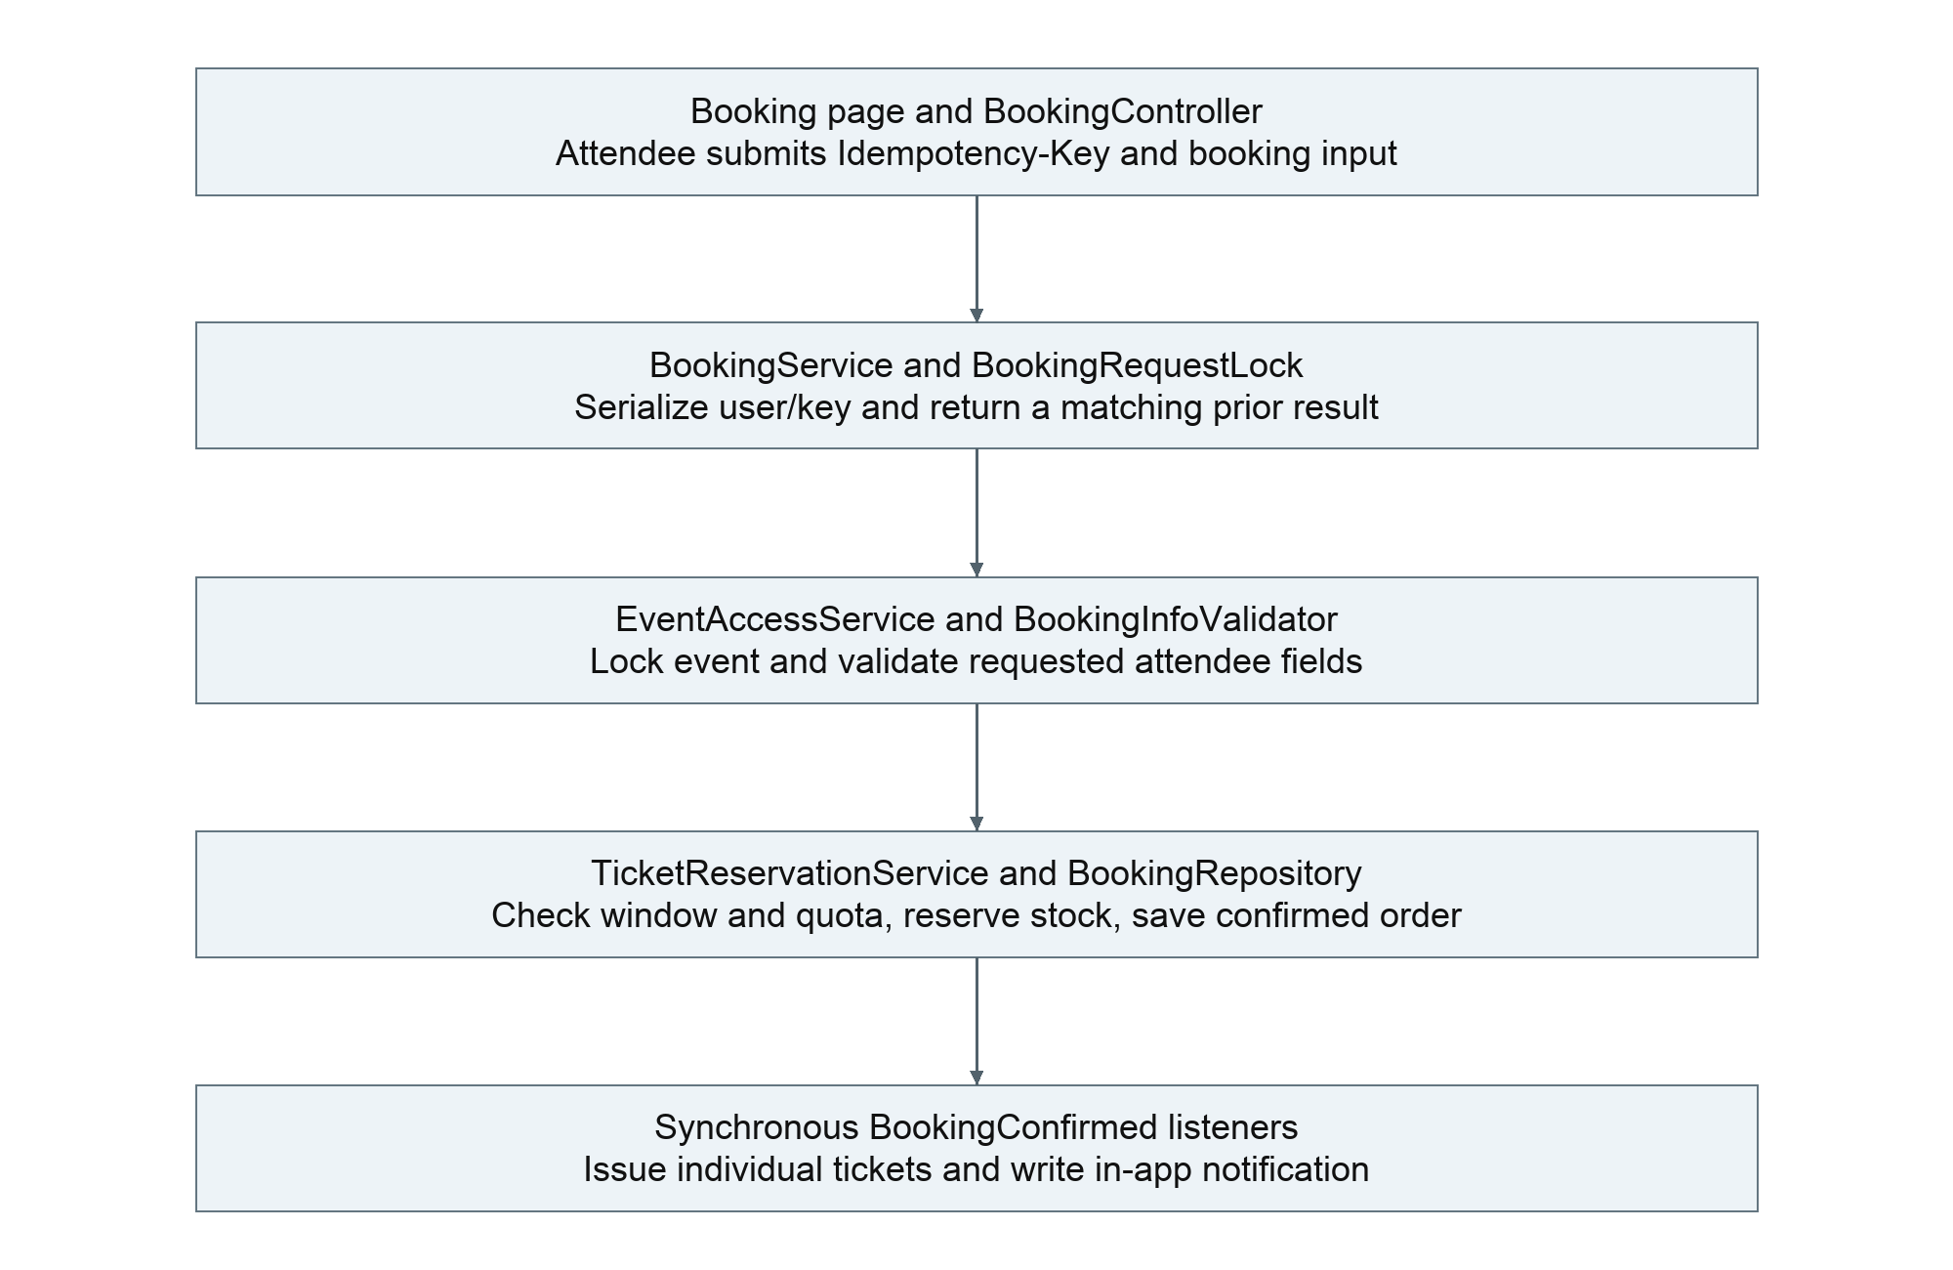
Figure C03 Booking collaboration from boundary input to transactional side effects
Analysis identifies a booking boundary, a reservation control and the event, ticket type, booking and ticket entities. Design distributes the control responsibility across BookingService, public event/ticket services, persistence locks and synchronous listeners. The source names below tie the model to implementation. [E2, E3, E5]
Requirement | Design realization
Retry without duplicate orders | BookingRequestLock plus user/request-key uniqueness
Do not oversell or book a cancelled event | Event lock, eligibility checks and TicketReservationService
Confirmation includes tickets and notification | BookingConfirmed listeners join the original transaction
Keep failed operations atomic | Transactional rollback, verified by listener-failure tests

The entire new-booking path runs in one transaction. A matching replay exits before reservation. The diagram shows responsibility flow rather than asynchronous message delivery; listeners do not require an execution-order dependency.

C9 Observer for booking side effects
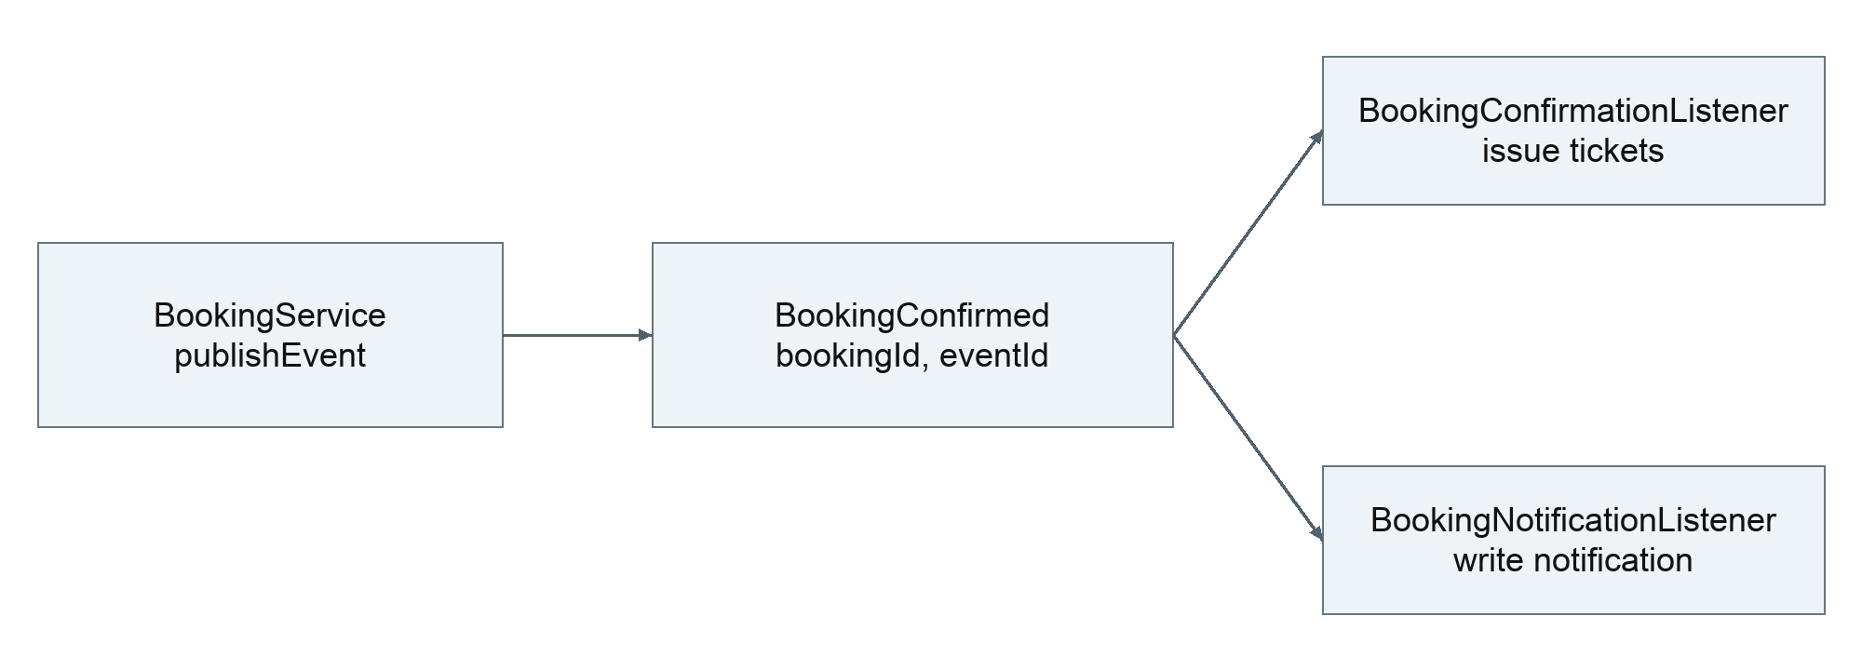
Figure C04 Publisher and observers for confirmed bookings

Design problem and chosen collaboration
Booking confirmation requires ticket issuance and an in-app notification. Calling both implementations directly from BookingService would couple order coordination to their internal responsibilities. The service publishes BookingConfirmed through ApplicationEventPublisher; BookingConfirmationListener creates tickets and BookingNotificationListener creates the notification. [E6, E12]
The collaboration applies Observer through Spring application events. Listeners run synchronously and require an existing transaction with Propagation.MANDATORY. A failure in either listener prevents the booking transaction from committing. Cancellation uses BookingCancelled with the corresponding ticket and notification listeners.

Alternative and consequences
Direct service calls would make the call chain more explicit and can be simpler for a single side effect. Events reduce direct coupling when multiple modules react, but make the execution path less visible and require transaction-aware tests. After-commit or asynchronous delivery would permit a confirmed order without completed side effects and needs a different recovery policy.
The current design provides local transactional consistency. It does not introduce a queue, durable external delivery or a distributed exactly-once guarantee. Idempotent request handling and database uniqueness protect duplicates; Observer alone does not.

Verification
BookingIntegrationTest exercises ticket or notification failure with whole-operation rollback, repeated requests and persisted ticket behaviour. The report should pair the collaboration with those failure cases, because successful UI confirmation alone does not establish atomicity.

C9 State for ticket lifecycle
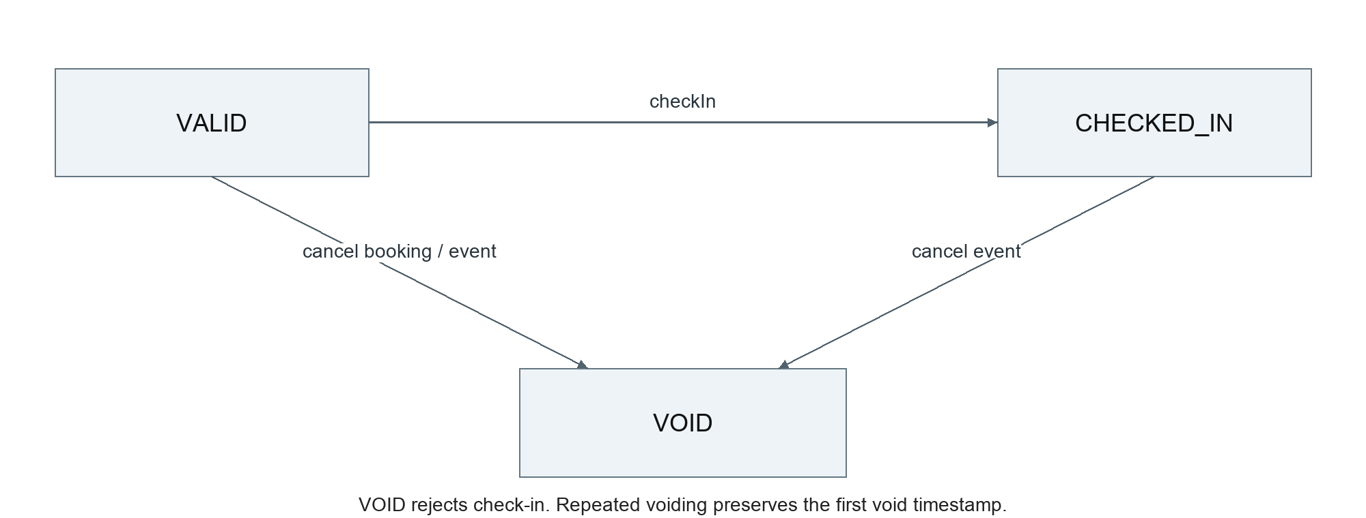
Figure C05 Implemented ticket transitions and cancellation outcomes

Context and state objects
IssuedTicket is the context. Its checkIn and voidTicket methods delegate to TicketState, implemented by ValidTicketState, CheckedInTicketState and VoidTicketState. TicketState.fromCode maps the persisted code to an object; transition behaviour belongs to the concrete state rather than that mapping switch. The objects are stateless and reusable. [E12]
Current state | Check in | Void
VALID | Transition to CHECKED_IN | Transition to VOID
CHECKED_IN | Reject duplicate admission | Transition to VOID for event cancellation
VOID | Reject admission | Remain VOID and retain initial void time

Design choice and limits
A single conditional implementation would use fewer classes, while separate State objects make differing behaviour explicit. Persistence still stores familiar status codes, so no schema migration is necessary for this design. The context owns ticket data and package-level mutation helpers.
State does not authorize staff, evaluate the admission window or acquire database locks. Those checks remain in orchestration. The booking cancellation flow rejects personal cancellation of a checked-in order before its invalidation can complete. Event cancellation intentionally permits CHECKED_IN to VOID while retaining audit history.

Verification
IssuedTicketTest covers the transition matrix and timestamp behaviour. Integration tests verify reloaded persisted tickets, duplicate check-in and cancellation interactions. This separates domain-state correctness from transaction and HTTP authorization correctness. [E5, E6]

C9 Strategy for booking information
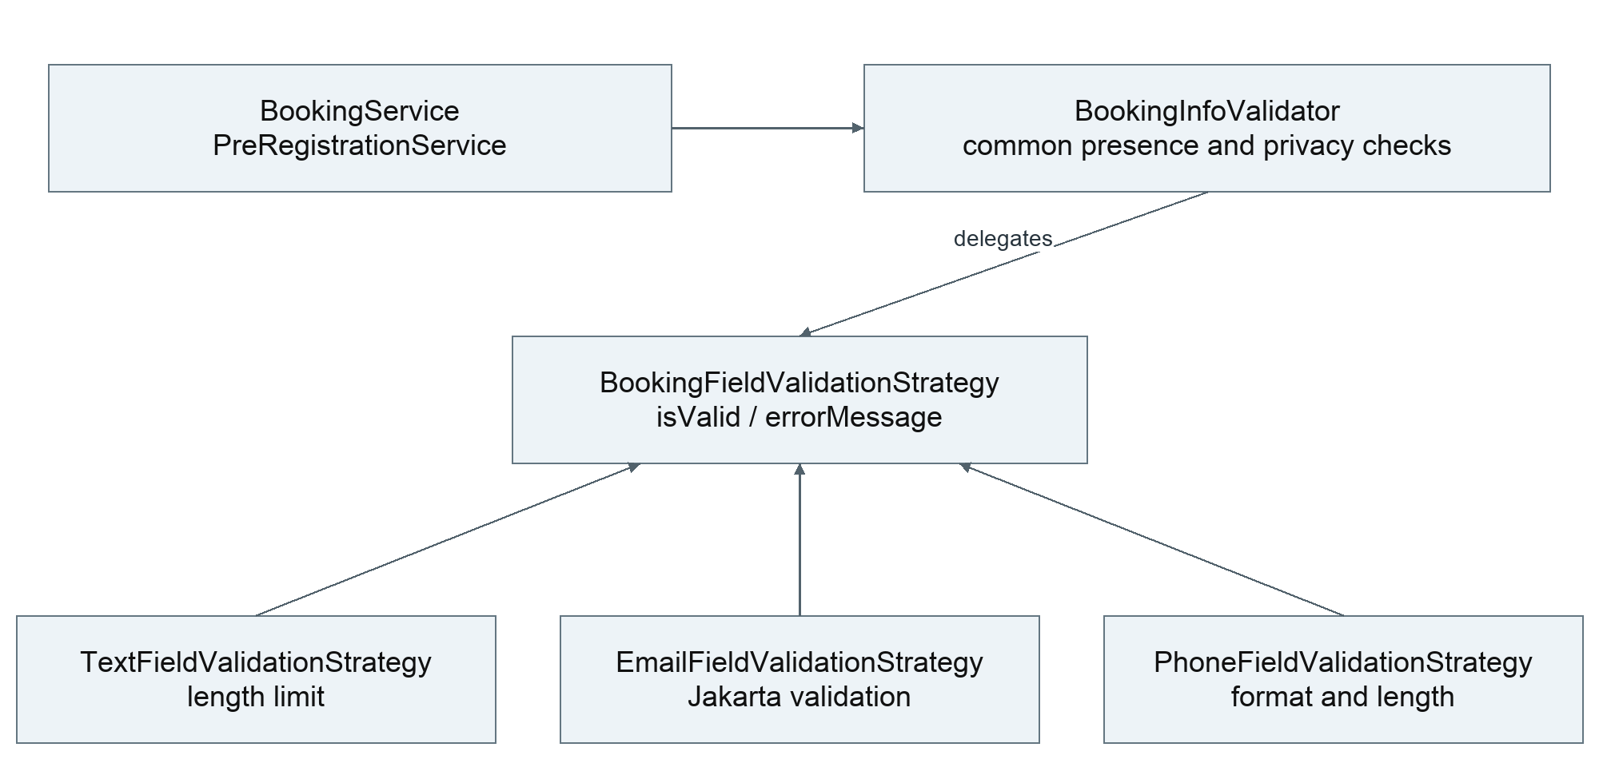
Figure C06 Shared validator context and interchangeable field algorithms

Design problem and selected strategy
Events can request names, email, phone, student ID, passport details and a custom answer. Booking and pre-registration must share these rules, including calls that bypass HTTP Bean Validation. BookingInfoValidator first checks required fields and rejects personal information the event did not request. It then delegates content checks to the field’s BookingFieldValidationStrategy. [E12]
Strategy | Validation responsibility
TextFieldValidationStrategy | Length limits: ordinary fields 100, custom answer 500
EmailFieldValidationStrategy | Reuse the email field’s Jakarta validation and length constraints
PhoneFieldValidationStrategy | Shared phone character rule and 5 to 30 character limit

A single validator with repeated branches is a simpler alternative for a few fixed fields. Strategy isolates the varying algorithms while the context keeps shared presence/privacy policy. DTO validation remains for compatible HTTP errors. Format checks do not prove a real identity or reachable phone number.

Verification and distinction from State
BookingInfoValidatorTest tests algorithm boundaries. BookingServiceTest includes malformedEmailFromNonHttpCallerNeverReservesInventory, proving that service-level validation rejects bad data before reservation. A browser error alone may originate at DTO validation and does not prove Strategy execution.
Strategy selects an algorithm for a field; it does not change an object’s lifecycle. Ticket State controls behaviour as the ticket changes status. Pricing Strategy is still deferred with paid checkout and must not be claimed as implemented.

C10 Testing and acceptance evidence
Testing combines domain/unit tests, real PostgreSQL integration tests, frontend component and logic tests, deployed business acceptance and security checks. These layers provide different evidence and are not interchangeable. [E5, E7]
Check | Recorded result | Baseline or limit
Backend functional tests | 215 passed; 1 optional query comparison skipped | 216 total in release CI record
Frontend tests | 244 passed across 32 files | Component tests commonly mock APIs
Backend line / branch coverage | 94.58% / 81.68% | 270c2b8 historical coverage baseline
Frontend line / branch coverage | 92.75% / 83.47% | Recorded release log; original counters separately retained
Cloud business acceptance | Booking, issuance, check-in, cancellation and audit | 270c2b8; dated screenshots and API assertions
DAST | 0 high, 0 medium, 0 low; 4 informational | Unauthenticated passive public scan
Database restore | 12 tables including Flyway, 14 migrations | Isolated database with nonempty business data

Critical failure protection
Tests cover the last available ticket under contention, idempotent request replays and conflicting parameters, stock and side-effect rollback, staff assignment and owner isolation, duplicate admission, cancellation races and last-active-administrator protection. These behaviours demonstrate more than CRUD success.

Interpretation of coverage and acceptance
Backend line coverage is 1326/1402 and branch coverage is 428/524 at 270c2b8. Do not attach those counters to a later release as a new measurement. Frontend historical counters are 1332/1436 lines and 1722/2063 branches. There is no configured minimum percentage gate. Full browser E2E is not part of CI.
The restore checked schema, constraints and data in temporary databases, which were removed afterwards. Its approximately 2.34-second operation on a small backup is not a production RTO or proof of whole-host recovery. Phone scanning was confirmed by the maintainer, but device/browser details do not support a broad compatibility claim.

C10 Capacity results and limits
The 21 October cloud test used deployment 037720b on a shared 2 vCPU host with approximately 3832 MiB RAM. The 500 VU read/mixed stages met the recorded thresholds. At 1000 VU, only reads met all criteria. The pass condition included overall and per-endpoint p95 below three seconds and all state/content checks passing. [E8]
Scenario | Requests | p95 seconds | Hold | Outcome
Read 500 VU | 21,048 | 2.056 | 30 s | Pass
Mixed 500 VU | 23,092 | 1.923 | 30 s | Pass
Read 1000 VU | 95,360 | 2.938 | 180 s | Pass
Mixed 1000 VU | 83,164 | 3.509 | 180 s | Latency fail
Contention 1000 planned VU | 1,000 | 4.100 | One attempt each | Latency and connection fail

Workload and measurement
Read iterations request the event list, event detail, own profile and own orders, followed by one second of thinking time. Mixed traffic adds booking, ticket retrieval and cancellation every five iterations, distributed across ten events. Read/mixed p95 uses the hold phase; request counts include ramp-up and completion. Contention p95 uses its full stage.
Contention attempted one request per planned VU against 100 tickets. The sampled peak was 983 VU, with 100 successful bookings, 899 expected inventory-conflict responses and one refused TCP connection. The request received no HTTP response and was not retried. The connection failure’s root cause remains unconfirmed.

Correctness and resources
The database audit found occupied stock, confirmed quantity and valid tickets all equal to 100 for the hot event, with no duplicate ticket sequence and no overselling. No OOM, container restart or health-protection interruption was observed. All planned test phases executed, but final criteria did not all pass. The retained STOPPED result must not be misread as a successful complete suite.

Conclusion
VU means active virtual users with thinking time, not equivalent RPS or browser sessions. These short API tests do not establish maximum capacity or long-term stability. The team’s 500 VU acceptance target differs from the original 1000-concurrency proposal; that internal adjustment is not proof of lecturer approval. Stock correctness does not cancel a latency or reliability failure.

C10 DevSecOps and operational evidence

Source and artifact lifecycle
Pull requests run lint, backend unit/integration tests, frontend tests and build, static security checks, and image scanning/smoke tests. Main additionally publishes tested images and deploys pinned digests through the staging environment. The workflow backs up PostgreSQL, deploys, checks public HTTPS and runs DAST. Telegram reports outcomes but is not a quality gate. [E9]
Runtime images use the tested JAR and frontend dist rather than an unrelated rebuild. Scripts retain release-manifest validation and isolated registration/login smoke checks. New Flyway migrations evolve the database; applied migrations remain immutable and Hibernate validates schema.

Security evidence and bounded exceptions
Static checks include SAST, dependency and secret scanning. Runtime images also undergo scanning. The passive DAST result covers unauthenticated public surfaces only; it does not establish the security of every authenticated path. Two Spring MVC applicability exceptions expire on 17 November 2026 and do not mean the dependencies have been fixed. Their current scope excludes XSLT views and SSE view fragments. [E5, E10]

Technical findings
The original deployed request path exposed a proxy Host preservation issue. Later capacity work reduced authentication lookup fields and corrected Nginx upstream connection reuse and connection/file limits. Recorded proxy regression checks verified one upstream connection across 20 requests and a separate 1200-connection configuration scenario. These local checks explain a change; the cloud measurements in the preceding section establish the observed capacity outcome. [E5, E8, E11]

Recovery and evidence retention
Deployment creates a database backup, but automated rollback and full-host disaster recovery are not implemented. Isolated restore results provide evidence for database recovery only. Raw security/performance reports and video files remain in local ignored directories and require separate transfer if included as report attachments.
The system recording uses 565f08b material. The CI/CD recording explains identified historical success and failure runs rather than one uninterrupted deployment. Screenshots and test reports should retain their own dates and versions when reused in slides or the final report.

C10 Evidence index and report references
Repository paths below are relative to SWE5006-SEMS. Evidence labels used throughout the material identify the source of each implementation or measurement claim. The repository URL is https://github.com/seventh720/SWE5006-SEMS.

E1 Product scope and runtime rules
README.md and README.zh-CN.md

E2 API and authorization contracts
docs/sprint-3-api.zh-CN.md

E3 Architecture and boundary exceptions
docs/adr/0001-modular-monolith.md

E4 Schema, full ERD and migrations
docs/database/README.md; backend/src/main/resources/db/migration/

E5 Test counts, coverage and security limits
docs/testing.zh-CN.md

E6 Cancellation and notification consistency
docs/sprint-4-cancellation.zh-CN.md; docs/notification-integration.zh-CN.md

E7 Cloud workflow and database restore
docs/acceptance/sprint4-2026-10-20/README.md; cloud-api-results.json; restore-results.json

E8 Capacity and stock audit
docs/acceptance/capacity-2026-10-21/README.md; fixture-audit.json; outcome.json

E9 Deployment and pipeline implementation
docs/deployment.md; .github/workflows/; scripts/cd/

E10 DAST and scoped exceptions
docs/dast.zh-CN.md; scripts/security/trivyignore.yaml

E11 Authentication lookup validation
docs/acceptance/auth-lookup-2026-10-20/README.md

E12 Pattern implementations and tests
backend/src/main/java/com/team10/sems/ booking and ticketing modules; corresponding backend/src/test/java tests

Versioned CI records
Release 565f08b: Actions run 39566477705. Business and coverage baseline 270c2b8: run 39311200552. Capacity deployment 037720b: run 39475238673. Each run is available beneath the repository URL at /actions/runs/<run-id>.

Historical and course sources
Materials_for_Final_Report_Consolidated_20261012.docx supplies the earlier C1 to C10 use-case structure and ce5d860 checkpoint. The presentation guidelines and August–November 2026 briefing establish the course emphasis on analysis/design, patterns, quality attributes and DevSecOps. Historical Sprint stories and DoD remain traceability targets, not evidence of actual effort or completed retrospectives.

