Project Report for
Smart Event Management
and Ticketing System

Practice Module for Certificate in Designing Modern Software Systems

Group 10
Members:
Lu Junyi • Hu Jia • Chai Muyang
Huang Haoyang • Luo Runzhou
27 October 2026

CONTENTS
1. Introduction 5
1.1 Background 5
1.2 Business Needs 5
1.3 Stakeholders 5
1.4 Project Scope 6
1.4.1 Functionality in Scope 6
1.4.2 Functionality out of Scope 6
1.4.3 Quality Attributes 6
2. Project Conduct 7
2.1 Project Plan 7
2.1.1 Work Packages and Responsibilities 7
2.1.2 Design Problem Ownership 7
2.2 Project Status 8
2.2.1 Definition of Done 8
2.2.2 Sprint Retrospective and Next Steps 8
2.3 Project Metrics 9
2.3.1 Achieved Milestones 9
2.3.2 Actual Effort through Sprint 4 9
3. System Design 10
3.1 Software Architecture 10
3.1.1 Platform and Deployment 11
3.2 Transition from Analysis to Design 12
3.2.1 TS1 Boundary and control separation 13
3.2.2 TS2 Persistence and transaction boundaries 14
3.2.3 TS3 Effective authorization 15
3.2.4 TS4 Side effects as synchronous events 16
3.2.5 TS5 Variable behaviour behind interfaces 17
3.3 Use Case Model 18
3.3.1 Use Case Diagram 19
3.3.2 Use Case Description 1 20
3.3.3 Use Case Description 2 21
3.3.4 Use Case Description 3 22
3.3.5 Use Case Description 4 23
3.3.6 Use Case Description 5 24
3.3.7 Use Case Description 6 25
3.3.8 Use Case Description 7 26
3.4 Analysis & Design Models 27
3.4.1 Use Case 1 by Hu Jia 28
3.4.2 Use Case 2 by Hu Jia 32
3.4.3 Use Case 3 by Chai Muyang 36
3.4.4 Use Case 4 by Lu Junyi 40
3.4.5 Use Case 5 by Lu Junyi 52
3.4.6 Use Case 6 by Huang Haoyang 56
3.4.7 Use Case 7 by Luo Runzhou 65
3.5 Design Problems and Patterns 74
3.5.1 DP01 Event cancellation collaboration by Lu Junyi 75
3.5.2 DP02 Replaceable credential verification by Hu Jia 79
3.5.3 DP03 Role-change notification separation by Chai Muyang 83
3.5.4 DP04 Booking information validation by Huang Haoyang 87
3.5.5 DP05 Ticket lifecycle behaviour by Luo Runzhou 91
3.6 Database Schemas 95
3.6.1 Admission and Supporting Data 96
3.6.2 Constraints and Transaction Design 97
3.6.3 Complete Entity Relationship Diagram 98
4. DevSecOps and Development Lifecycle 99
4.1 Source Control Strategy 99
4.2 Continuous Integration 100
4.2.1 Test Strategy and Functional Results 101
4.2.2 Performance Evaluation 102
4.2.3 Security and Operational Verification 103
4.2.4 Verification Artifacts and Provenance 104
4.3 Continuous Delivery 105
4.3.1 Deployed Workflow Evidence 106
5. Individual Members Activity Contribution Summary 107
5.1 Lu Junyi 107
5.2 Hu Jia 107
5.3 Chai Muyang 107
5.4 Huang Haoyang 107
5.5 Luo Runzhou 107
5.6 Team Reflection and Conclusion 108
Appendix A Verification Artifacts 109
A.1 Lint and Automated Test Output 109
A.2 Static Security and Container Results 110
A.3 Saved DAST Results 111
A.4 Performance Results and Stock Audit 112

1. Introduction

1.1 Background
Smart Event Management and Ticketing System (SEMS) coordinates the lifecycle of a free-ticket event, from publication and reservation to controlled admission and cancellation. The business problem is maintaining a consistent account of availability, orders and attendance while several roles act on the same event.
We implemented a browser application with a Spring Boot backend and PostgreSQL. The delivered workflow includes individual ticket issuance, event-specific staff authorization, notifications and reporting. Business and capacity validation retain their recorded 20–21 October baselines. A fresh pull-request verification on 27 October supplies the lint, automated-test, coverage and static/container security artifacts in Section 4.2.4 and Appendix A.

1.2 Business Needs
Organizers need reliable capacity controls, clear publication rules and an accurate account of bookings. Attendees need a recoverable booking result when requests are retried, private access to their orders, and usable admission credentials. Staff need to reject duplicate or cancelled tickets without losing the admission audit. Administrators need safe role changes that preserve at least one active administrator.

1.3 Stakeholders
Table 1 distinguishes the responsibilities that determine access to events, orders and operational records.
Stakeholder | Need and responsibility
Visitor / attendee | Discover events, register, book and manage own tickets.
Organizer | Manage owned events, ticket quotas, assigned staff and reports.
Assigned staff | Verify and admit tickets only for assigned events.
Administrator | Manage accounts/roles and authorized global reporting.
Development and operations team | Maintain implementation, delivery pipeline, backups and evidence.
Table 1. Stakeholders and responsibilities

1.4 Project Scope
We cover the free-ticket event lifecycle; paid checkout and refunds are deferred. Our architecture and detailed designs describe the implemented system. Delivery progresses through identity, event publication, booking, admission and cancellation, then final consolidation. Sections 1.4.1–1.4.3 define the scope and quality requirements; Sections 2.1 and 3.3 detail the delivery plan and use cases.

1.4.1 Functionality in Scope
The implemented scope includes UC01 registration, UC02 login, UC03 user/role management, UC04 event management, UC05 public browsing, UC06 free-ticket booking and UC07 staff check-in. Supporting features include ticket-type configuration, saved booking profiles, private pre-registration, one ticket per admission, event copying, cancellation, in-app notifications and reporting.

1.4.2 Functionality out of Scope
Paid checkout, payment-gateway integration, refunds and pricing Strategy remain deferred. The current system does not implement email/SMS delivery, WebSocket push, a message broker, independent microservices, automatic rollback or full-host disaster recovery. Pre-registration saves private input and never reserves stock or automatically buys a ticket.

1.4.3 Quality Attributes
The quality requirements in Table 2 guide the consistency, authorization and acceptance checks used to evaluate the delivered scope.
Attribute | Acceptance objective and observed boundary
Consistency | No overselling, duplicate issuance or partial booking side effects. Event locks, uniqueness and rollback tests support this.
Authorization | Combine current roles with ownership or staff assignment. Reject cross-user and cross-event access.
Performance | Overall and endpoint p95 below 3 s with all checks passing. 500 VU read/mixed passed; 1000 VU mixed failed latency.
Maintainability | Business modules, public services, migration discipline and automated tests. Check-in/reporting retain documented JDBC exceptions.
Recoverability | Backup and isolated database restore verified. This does not establish a production RTO or complete host recovery.
Usability | Responsive browser workflows, explicit error states, repeatable booking and ticket-code entry/scanning.
Table 2. Quality requirements and validation boundaries
The original proposal targeted 1,000 concurrent users. We used 500 VU as an intermediate acceptance target and also measured 1,000 VU. The latter target was not fully met. Scripted virtual users include think time and are not equivalent to simultaneous browser sessions.

2. Project Conduct

2.1 Project Plan
We planned five sprints. Work is organized into vertical increments: identity and foundation, event publication, transactional booking, admission/cancellation integration, and final consolidation. The first four sprints account for 476 hours of our actual effort. Sprint 5 covers final report, presentation and release consolidation; no unrecorded Sprint 5 hours are added to that total.

2.1.1 Work Packages and Responsibilities
Work is divided by business responsibility, with a named member accountable for each package in Table 3. Integration and peer review span these packages.
Work package | Scope and accountable member
Foundation and architecture | Hu Jia: UC02 login, with UC01 registration and architectural explanation.
Events and project integration | Lu Junyi: UC04 event management, UC05 browsing, project conduct and demonstrations.
Authorization and testing | Chai Muyang: UC03 users/roles, test methods and verification of role boundaries.
Reservation consistency | Huang Haoyang: UC06 booking, analysis-to-design mapping and validation Strategy.
Admission and persistence | Luo Runzhou: UC07 check-in, ticket State and database relationships.
Table 3. Work packages and ownership

2.1.2 Design Problem Ownership
Each member also explains a design problem arising from their primary use case. Table 4 links these responsibilities to the implemented patterns; Section 3.5 evaluates the alternatives and resulting collaborations.
Member | Problem and implemented pattern
Lu Junyi | DP01 Event cancellation collaboration — Observer
Hu Jia | DP02 Replaceable credential verification — Strategy through PasswordEncoder
Chai Muyang | DP03 Role-change notification separation — Observer
Huang Haoyang | DP04 Booking information validation — Strategy
Luo Runzhou | DP05 Ticket lifecycle behaviour — State
Table 4. Design problem ownership

2.2 Project Status
The free-ticket lifecycle is delivered and supported by database-backed tests and recorded cloud acceptance. The status below separates working functionality from outstanding scope and engineering limitations.
Area | Status
Delivered | Registration/login, multi-role access, owned event management, browsing, idempotent free booking, individual tickets, assigned-staff admission, cancellation, in-app notifications and reporting.
Functional scope outstanding | Paid checkout and refunds remain deferred. No external notification channels are implemented.
Performance outstanding | 1000 VU mixed traffic exceeded the latency threshold. Contention preserved stock correctness but failed latency and had one connection refusal.
Architecture follow-up | Move check-in orchestration out of its controller and encapsulate cross-module JDBC queries. Reporting currently reads shared tables.
Operations follow-up | Two scoped dependency exceptions remain open; automatic rollback and full-host recovery are not implemented.
Table 5. Delivery status and outstanding issues

2.2.1 Definition of Done
A completed increment requires satisfied acceptance criteria, relevant unit/integration/frontend tests, peer review, CI artifacts and deployment or browser evidence. Migration changes must preserve existing data. The delivered workflows have test and acceptance evidence; outstanding scope and failed performance criteria remain explicit rather than being included in a blanket completion claim.

2.2.2 Sprint Retrospective and Next Steps
The retrospective identified two practical lessons. Authorization and lifecycle changes must be tested together: revoked staff access, duplicate admission and event cancellation affect the same ticket and audit guarantees. Passing at 500 VU also does not establish capacity at 1,000 VU.
For the next sprint, we will freeze optional scope earlier, reserve integration/deployment time and save browser acceptance evidence as tasks finish. The next review will check the integrated flow and its evidence. These actions keep final consolidation focused on cross-module behaviour and measured outcomes.

2.3 Project Metrics
We track project progress using completed delivery milestones and the effort recorded by each team member. The following sections link delivery checkpoints to their evidence and summarize the team-confirmed hours through Sprint 4.

2.3.1 Achieved Milestones
The milestones in Table 6 track delivery from the event workflow to cloud acceptance and capacity measurement.
Date in 2026 | Actual milestone | Evidence
24 September | Docker and browser acceptance of the event flow | Sprint 2 delivery record
6 October | Core free booking accepted and merged | PR #22; Sprint 3 acceptance
20 October | Cloud check-in, cancellation and reporting acceptance | 270c2b8
21 October | Capacity measurements and release checks | 037720b / 565f08b
Table 6. Achieved project milestones

2.3.2 Actual Effort through Sprint 4
Table 7 records the team-confirmed effort for Sprint 1–4. The total of 476 hours excludes unrecorded Sprint 5 consolidation work.
Member | S1 h | S2 h | S3 h | S4 h | Total h
Lu Junyi | 32.6 | 34 | 55 | 44 | 165.6
Hu Jia | 21.6 | 15 | 32 | 38 | 106.6
Chai Muyang | 17.6 | 15 | 22 | 27 | 81.6
Huang Haoyang | 11.6 | 14 | 5 | 24 | 54.6
Luo Runzhou | 10.6 | 16 | 8 | 33 | 67.6
Total | 94 | 94 | 122 | 166 | 476
Table 7. Actual effort by member and sprint
We confirmed the actual effort figures. Sprint totals are 94, 94, 122 and 166 hours. Individual totals sum to 476 hours. Effort is reported independently of commit counts and automated test counts.
The recorded release has 215 passing backend functional tests and 244 passing frontend tests. One optional backend query-comparison test is skipped. Cloud acceptance demonstrates the booking/admission/cancellation lifecycle, while performance tests expose the remaining 1,000-VU limitations. Historical coverage baselines are retained separately in Section 4.2.

3. System Design

3.1 Software Architecture
SEMS uses a modular monolith: one React client, one Spring Boot backend and one PostgreSQL database. A local transaction can therefore coordinate booking, inventory, ticket issuance and notification without a distributed transaction. This reduces deployment and recovery coordination for the project scope.
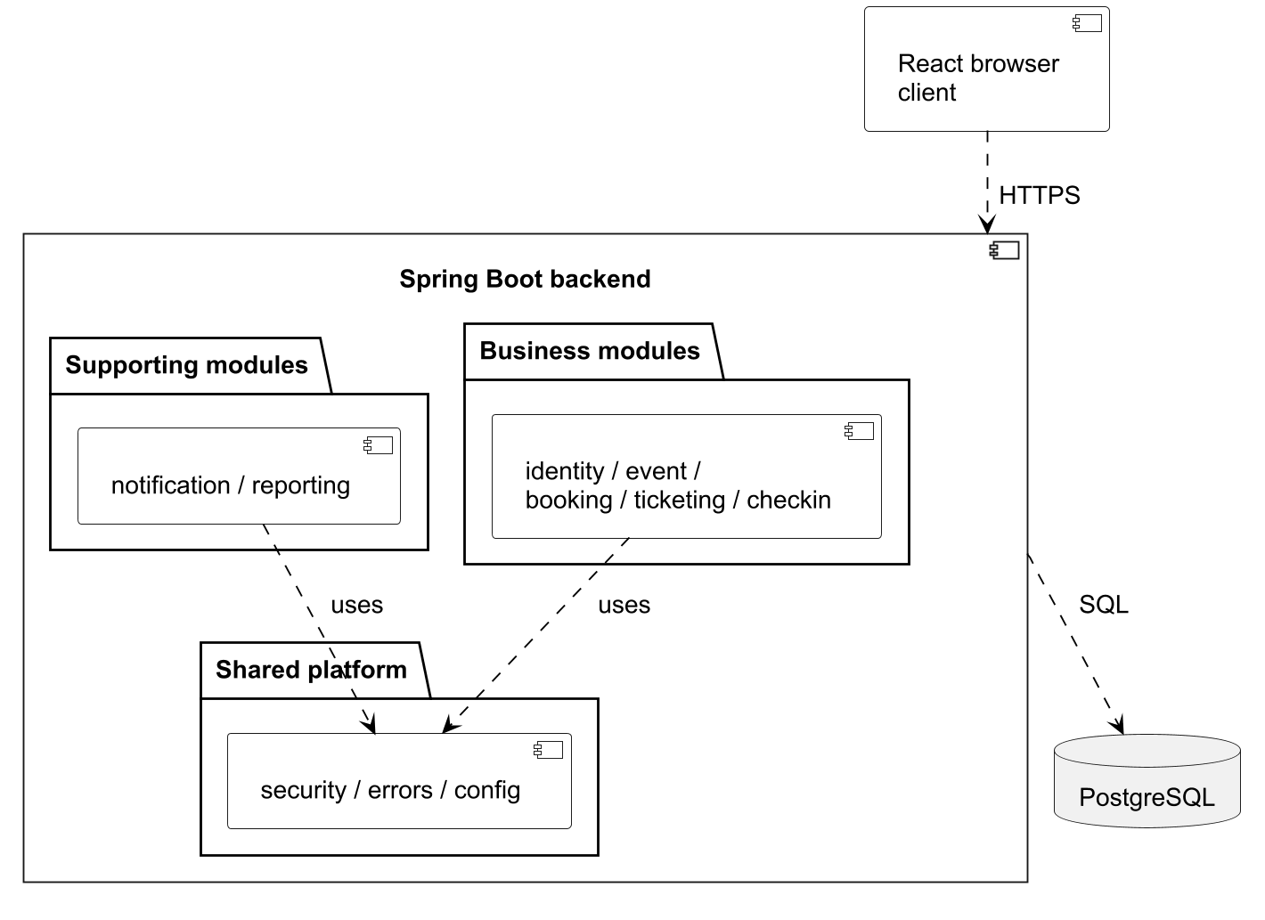
Figure 1. Logical component and package view. Business collaboration stays inside one backend.
Modules collaborate through public services and synchronous application events. Controllers adapt HTTP input, application services coordinate transactions, entities enforce domain rules and repositories persist data. The deployed checkin package is the implemented admission module; attendance remains a placeholder.
CheckInController performs cross-table JDBC checks and orchestration. ReportingService uses shared-table read projections with repeatable-read isolation. These are actual exceptions to the API/event-only boundary, so the diagram does not imply complete persistence isolation. Event-level locking also limits write concurrency for a popular event.

3.1.1 Platform and Deployment
The platform in Table 8 implements the client, application and persistence layers described above.
Layer | Implementation
Client | React 19, TypeScript and Vite; browser routing and API calls.
Server | Java 21, Spring Boot 3.5, Spring Security, JPA and JDBC.
Persistence | PostgreSQL 17, Flyway SQL migrations; Hibernate validates the schema.
Runtime | Docker images and Compose on the recorded cloud host; Nginx reverse proxy and public HTTPS.
Automation | GitHub Actions, Maven, Vitest, Testcontainers, security/image scans and deployment scripts.
Table 8. Implementation platform
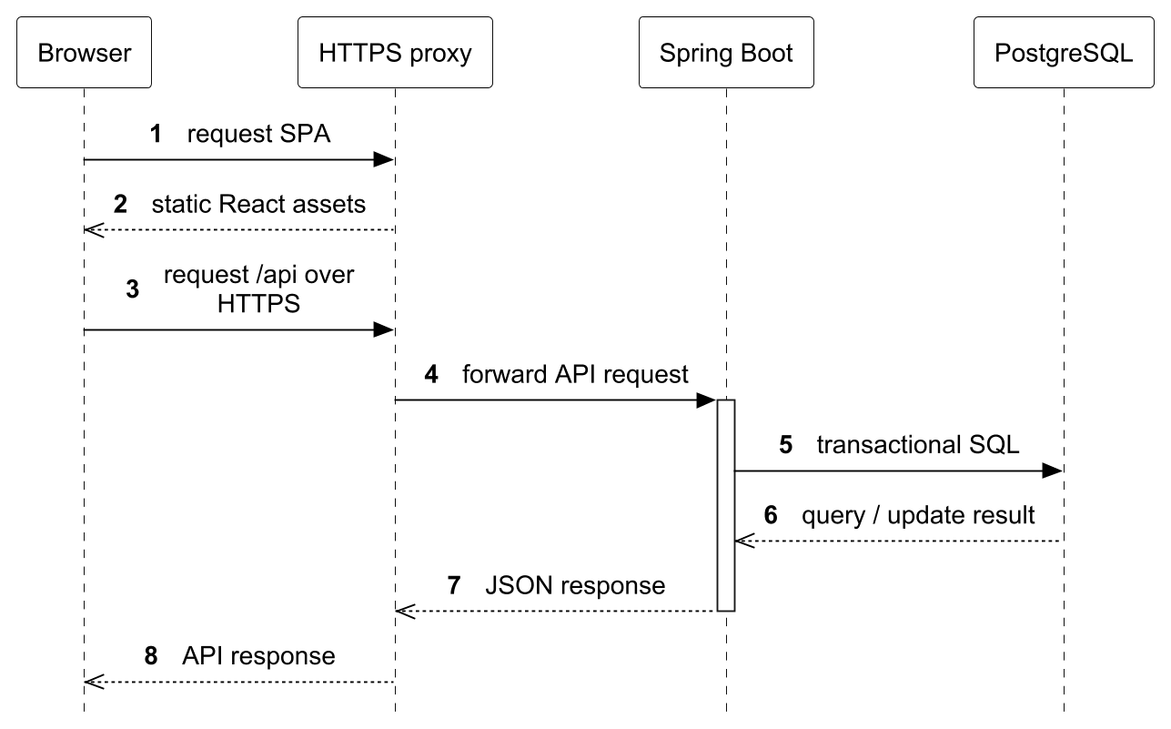
Figure 2. Deployment request path and server/database responsibility.
One cloud staging deployment is described in the workflow. Local development and ephemeral CI test databases are separate contexts, not additional promoted production environments. Release images are pinned by digest. Deploy verification checks health/public HTTPS and follows with passive DAST.

3.2 Transition from Analysis to Design
Table 9 lists the strategies used to transform boundary/control/entity analysis into implemented classes and interactions. Together they cover request handling, persistence, authorization, cross-module reactions and variable behaviour across the seven use cases. Sections 3.2.1–3.2.5 explain how each strategy changes the structure and execution of the analysis model.
Strategy | Analysis objects and affected use cases | Design change and purpose
TS1 Boundary and control separation | Boundaries, controls and entities in UC01–UC06; UC07 retains a combined boundary/control. | Map screens to React/HTTP boundaries, controls to services and entities to domain objects. Validate, invoke the service and return a DTO to separate transport concerns from business policy.
TS2 Persistence and transaction boundaries | Persistent entities and consistency rules in UC01, UC03, UC04, UC06 and UC07. | Add repositories, constraints and transaction boundaries. Apply a consistent lock order and commit related writes together; failures roll back to preserve business invariants.
TS3 Effective authorization | Actor identity, resource ownership and staff eligibility in protected UC03, UC04, UC06 and UC07 requests. | Add JWT/current-account checks, owner-scoped access and staff assignments. Check effective roles before resource policy so authorization reflects current privileges and ownership.
TS4 Side effects as synchronous events | Role notifications, event lifecycle and booking collaborations in UC03, UC04 and UC06. | Introduce event values, publishers and listeners. Execute mandatory reactions inside the originating transaction so listener failures roll back dependent writes.
TS5 Variable behaviour behind interfaces | Credential algorithms, booking-field validation and ticket states in UC01/UC02, UC06 and UC07. | Introduce PasswordEncoder, BookingFieldValidationStrategy and TicketState. Contexts delegate variable behaviour through interfaces, keeping shared policy and data in one place.
Table 9. Transition strategies and their application

3.2.1 TS1 Boundary and control separation

3.2.1.1 Analysis Objects and Scope
TS1 applies to boundary objects that collect or display information, controls that coordinate a use case, and entities that hold business state. UC01–UC06 separate HTTP boundaries from application services. UC05 provides the worked example: EventBrowser, BrowsingControl and Event express the analysis responsibilities in Figure 28. UC07 remains a documented exception because CheckInController currently combines boundary and transaction orchestration.

3.2.1.2 Static Structure and Rationale
Compare the analysis class diagram in Figure 28 with the design class diagram in Figure 30. The user-facing boundary is realized by React components and PublicEventController; BrowsingControl becomes EventBrowseService. EventRepository provides persistence access, and EventView is added as an output representation. Event remains the persistent entity: the DTO does not replace it. These dependencies keep HTTP parameter handling outside query policy and prevent the browser from depending on entity internals. The class diagram selects backend collaborators; the frontend boundary is described by the architecture.

3.2.1.3 Dynamic Behaviour and Rationale
Compare Figures 29 and 31. The analysis first finds published events, returns the result page and then handles the actor’s selected detail. Design refines this into validated controller/service queries, repository predicates restricted to PUBLISHED records, and mapping to EventView and public ticket views. Empty results and missing/unpublished detail are separate alternatives. The ticket request rechecks publication, because event state can change after selection. No browse interaction reserves stock; UC06 performs the authoritative reservation check.

3.2.1.4 Applying and Verifying the Strategy
For a new case, identify which input/output belongs to the boundary and which decision belongs to the control. Give the service a use-case operation, place persistence access behind its repository or public module API, and define an explicit response view. Draw the service call and each rejection/empty-result path before implementing the endpoint. EventBrowseServiceTest and EventBrowseIntegrationTest check the representative public-query boundaries.

3.2.2 TS2 Persistence and transaction boundaries

3.2.2.1 Analysis Objects and Scope
TS2 applies to entities whose invariants must survive persistence, retries or competing requests, and to the controls coordinating their changes. It affects UC01 account uniqueness, UC03 last-administrator protection, UC04 event lifecycle/capacity, UC06 reservations and UC07 admission. The booking example starts with ReservationControl and Booking/TicketType in Figure 32; one conceptual reservation must become one durable, consistent business outcome.

3.2.2.2 Static Structure and Rationale
Figures 32 and 36 refine ReservationControl and the booking entities into BookingService, BookingRequestLock, BookingRepository and persistent Booking, with PreRegistrationService and its repository handling private preferences. Database uniqueness on (user_id, request_key) complements request serialization. TicketReservationService supplies the public inventory API. A constraint alone cannot coordinate booking, stock, tickets and notifications, so related writes also need a transaction and shared event locking. The selected class diagram omits listener internals, which are expanded in Section 3.5.

3.2.2.3 Dynamic Behaviour and Rationale
Compare Figures 33 and 37. A booking request validates its key, acquires the user/key lock and searches for an earlier result. Matching input returns immediately; conflicting input is rejected. A new request locks the event, validates requested attendee information, then reserves eligible free stock through the ticket API. The service saves the confirmed booking, links any pre-registration and publishes synchronous confirmation effects. Mandatory side-effect failure rolls back related writes. Grouped persistence/API/listener lifelines expose the coordination without suggesting that those groups are implementation classes. Figures 34 and 38 separately model private pre-registration; Figures 35 and 39 pair personal cancellation.

3.2.2.4 Applying and Verifying the Strategy
First state the invariant and identify every writer, then choose one transaction owner and document its lock order. Creation uses request key then event; cancellation and check-in begin with the event lock and do not acquire a creation request-key lock. Add persistent uniqueness checks and draw replay, conflict and rollback alternatives. BookingIntegrationTest verifies concurrent stock requests, replay and rollback; analogous role/admission tests cover their own invariants.

3.2.3 TS3 Effective authorization

3.2.3.1 Analysis Objects and Scope
TS3 refines actor identity, permissions, ownership and event assignment from analysis preconditions into enforceable request decisions. It applies to protected operations in UC03, UC04, UC06 and UC07. Registration/login establish identity; public UC05 browsing remains available without authentication. In UC07, CheckInScreen and AdmissionControl require an eligible staff actor in Figures 40 and 42. The design must establish both an effective STAFF role and assignment to the requested event.

3.2.3.2 Static Structure and Rationale
Figures 40 and 43 show AdmissionControl realized inside CheckInController, with EventAccessService and JdbcTemplate supporting event and assignment checks. There is no separate CheckInService in this implementation. The additional security-entry dependencies appear in Figure 46: SecurityConfiguration configures JWT decoding and JwtAuthenticationConverter, which queries UserAccessService.activeRoles. Endpoint/service methods use @PreAuthorize, followed by resource-specific checks. These responsibilities separate token validity, current privileges and access to one object. ADMIN or STAFF membership does not itself prove ownership or event assignment.

3.2.3.3 Dynamic Behaviour and Rationale
Figure 47 supplies the shared security entry. The security layer validates the token, loads current active-account roles and intersects them with token roles. Method authorization checks the effective role before resource policy runs. Revocation therefore affects later requests, while a newly granted role requires a fresh token. UC07 then separates read-only verification in Figures 41 and 44 from admission in Figures 42 and 45. Both check current assignment/window under the event lock; only admission invokes ticket-state mutation and inserts a unique audit record. Guard failure stops later mutation.

3.2.3.4 Applying and Verifying the Strategy
For each protected operation, write the required role and the object-level predicate separately. Derive the actor ID from the authenticated principal, scope object queries to that actor/event, and place the guard before the first mutation. Include revoked roles, missing assignments, foreign owners and wrong-event IDs in the alternatives. AuthenticationFlowIntegrationTest exercises effective-role changes; StaffCheckInIntegrationTest checks resource eligibility and admission boundaries.

3.2.4 TS4 Side effects as synchronous events

3.2.4.1 Analysis Objects and Scope
TS4 applies when an analysis control produces a business fact that requires another module to react. Relevant cases include UC03 role-change notification, UC04 lifecycle/capacity validation and cancellation, and UC06 confirmation/cancellation. The analysis Account/Role collaboration in Figures 12 and 13 and event-cancellation flow in Figure 21 describe required outcomes without committing to a publisher/listener mechanism.

3.2.4.2 Static Structure and Rationale
Compare the UC03 analysis classes in Figure 12 with Figure 14, then use Figure 58 for the explicit event design. UserAdministrationService publishes the UserRolesChanged value through ApplicationEventPublisher; UserRolesChangedListener depends on NotificationDeliveryService. The event carries the operation identity and changed role information instead of exposing notification storage to identity policy. For cancellation, Figure 50 shows the selected booking/ticket collaboration; EventCancelled itself is described by the messages in Figure 51 and the source. These diagrams select dependencies rather than listing every event value. The publisher retains the business decision and listeners own the dependent reaction.

3.2.4.3 Dynamic Behaviour and Rationale
Compare the role-change analysis sequence in Figure 13 with Figures 15 and 59. The service locks assignments, protects the last active administrator and compares the old/new role sets. Only a real change publishes an event. Its listener runs synchronously and writes the private notification before the transaction commits. For event cancellation, Figures 21 and 51 show the refinement into EventCancelled, booking cancellation, BookingCancelled reactions and stock release. Mutating ticket/notification listeners require an existing transaction through MANDATORY propagation. Publication/capacity validation listeners are synchronous @EventListener methods; they participate in the publisher’s transaction without all declaring MANDATORY. A propagated failure prevents a partially committed outcome.

3.2.4.4 Applying and Verifying the Strategy
Identify which reactions are required for the business operation to succeed, define the event data, and keep those reactions in the same transaction. Draw the publication point, listener calls, commit and rollback alternative; do not label this implementation asynchronous or after-commit. Suppress no-op role events and retain operation/source identifiers used by notification uniqueness rules. Role-change tests and BookingIntegrationTest verify notifications and failed-listener rollback.

3.2.5 TS5 Variable behaviour behind interfaces

3.2.5.1 Analysis Objects and Scope
TS5 applies where a control delegates a varying algorithm or an entity changes behaviour with its lifecycle state. It covers password representation in UC01/UC02, attendee-field validation in UC06 and pre-registration, and ticket behaviour in UC07. Shared presence/privacy rules, transaction coordination and authorization remain the responsibility of their existing contexts rather than being moved into every strategy or state.

3.2.5.2 Static Structure and Rationale
The UC06 analysis control in Figure 32 becomes BookingService with BookingInfoValidator in Figure 36. Figure 62 then expands that validator into the BookingFieldValidationStrategy interface and text, email and phone implementations. The context retains event requirements and field selection while format algorithms are extracted behind the interface. Figures 54 and 66 show the other forms: AuthService depends on PasswordEncoder, and IssuedTicket delegates to TicketState with VALID, CHECKED_IN and VOID implementations. Strategy permits algorithm substitution; State makes an operation depend on the ticket’s current lifecycle. Both reduce duplicated decisions without relocating unrelated business policy.

3.2.5.3 Dynamic Behaviour and Rationale
In Figure 63, BookingService calls the validator before reservation. The context first checks all required and unsolicited fields, then dispatches each supplied value to its field strategy. An error stops inventory changes. This order prevents format checks from obscuring required/privacy rules and gives non-HTTP callers the same validation. Figure 55 shows login delegating password matching before token issuance; Figure 7 covers encoding during registration. Figure 67 shows IssuedTicket resolving the stored state and delegating checkIn; the same State interface also defines voidTicket. VALID may check in; CHECKED_IN and VOID reject duplicate admission. Event cancellation can void a checked-in ticket while its separate audit survives. Service authorization, time windows and locks are established before state behaviour runs.

3.2.5.4 Applying and Verifying the Strategy
Identify the changing decision, define the smallest interface used by the context, and retain shared preconditions in that context. Choose an algorithm strategy for interchangeable validation/encoding; choose State for lifecycle-dependent operations. Reuse the validator in booking and pre-registration, and test the complete ticket transition matrix. BookingInfoValidatorTest, the non-HTTP BookingServiceTest rejection case and IssuedTicketTest cover these boundaries; compatibility with stored password hashes remains a separate concern when changing encoders.

3.3 Use Case Model
Table 10 lists the use cases shown in Figure 3, including the deferred payment scope. Each implemented case has a named member responsible for its analysis and design. Sections 3.3.2–3.3.8 specify the normal and exceptional flows; Section 3.4 develops the corresponding models.
Use case | Primary actor | Goal and scope | Responsible member
UC01 Register | Visitor | Implemented: create an attendee account. | Hu Jia
UC02 Login | Registered user | Implemented: authenticate an active account. | Hu Jia
UC03 Manage Users and Roles | Administrator | Implemented: manage users and role assignments. | Chai Muyang
UC04 Manage Events | Organizer or administrator owning the event | Implemented: create, publish and cancel owned events. | Lu Junyi
UC05 Browse Events | Visitor or account holder | Implemented: find published events and view details. | Lu Junyi
UC06 Book Tickets | Attendee | Implemented: reserve free tickets and manage own bookings. | Huang Haoyang
UC07 Check In Ticket | Assigned staff | Implemented: validate and admit a ticket once. | Luo Runzhou
Paid checkout / refund | Attendee | Out of scope: paid checkout and refunds. | Not assigned
Table 10. Use case inventory, scope and ownership

3.3.1 Use Case Diagram
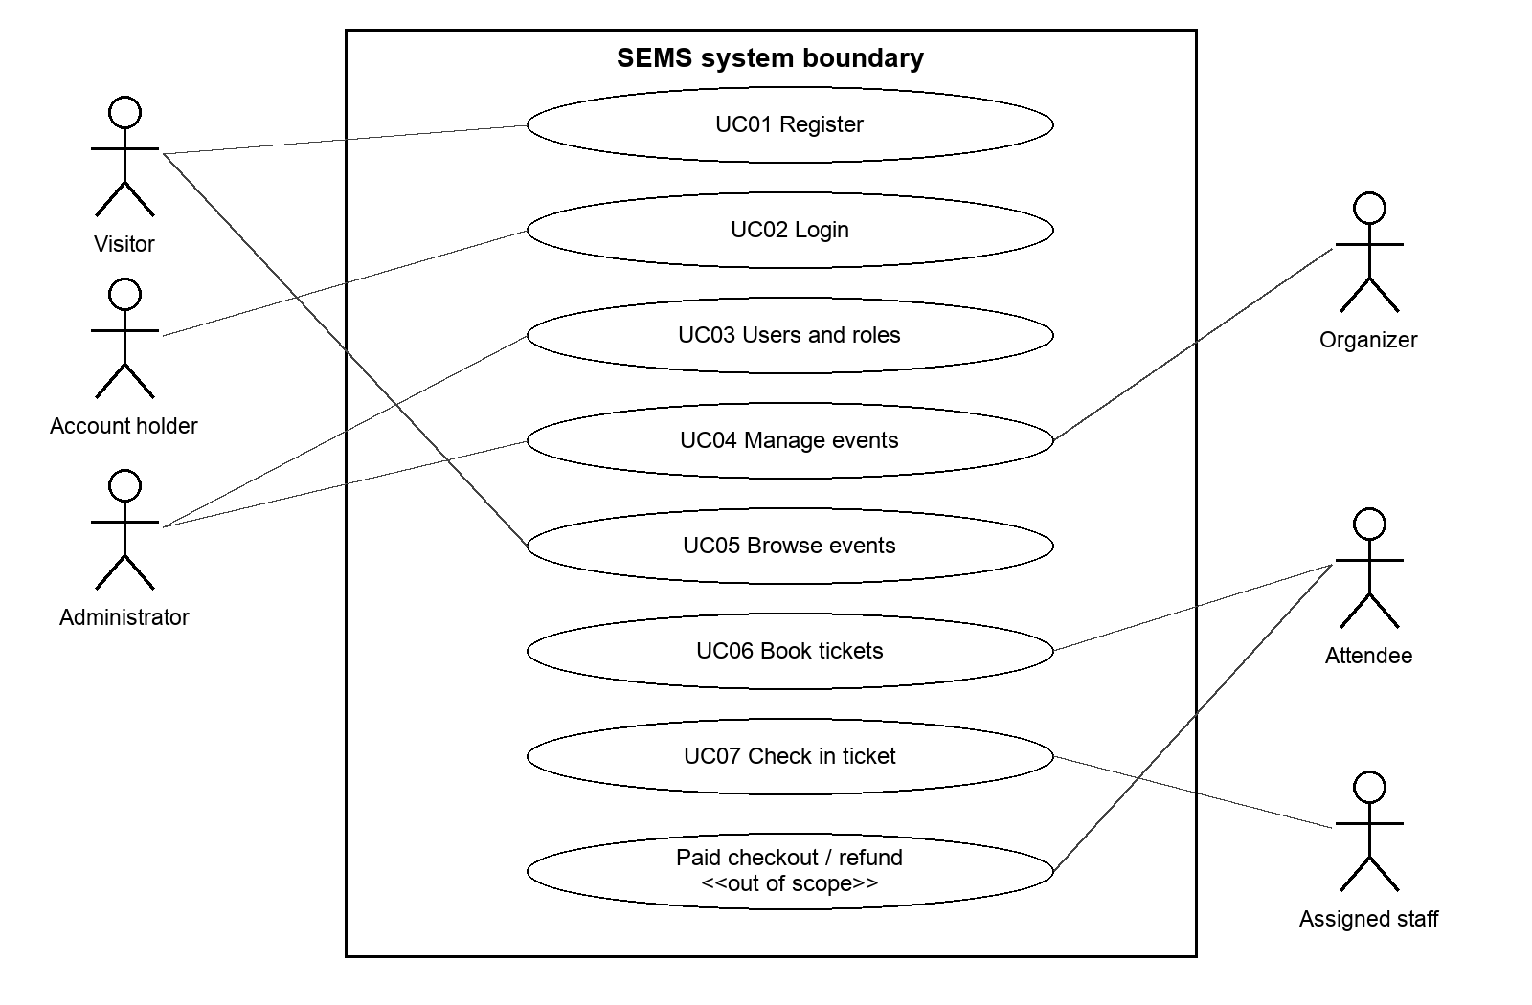
Figure 3. Use case overview, including deferred paid checkout/refund. Actor associations show participation, not role inheritance.
An account may hold several roles. ADMIN does not bypass the ownership rule for event management. Assigned staff require both the STAFF role and an event assignment. Paid checkout/refund appears for scope context but has no implemented payment flow. The following specifications cover the seven implemented use cases.

3.3.2 Use Case Description 1
Use case: UC01 Register
Actor: Visitor. Responsible member: Hu Jia.
Trigger: The visitor chooses Register.
Preconditions: The visitor is not signed in and can access the registration form.
Normal flow
1. The visitor opens registration; the system displays username, email and password fields.
2. The visitor enters these details and submits the form.
3. The system checks required values and format/length rules: username 3–50 English letters, digits, dots, underscores or hyphens; valid email up to 255 characters; and password 8–16 English letters or digits.
4. The system normalizes username/email to lowercase and checks that neither identifies an existing account.
5. The system creates one ACTIVE account with the ATTENDEE role, stores a protected password and confirms creation without returning the stored credential.
6. The browser invokes UC02 Login to establish the session after successful registration.
Alternative and exceptional flows
A1. Step 3: Missing or invalid values are reported; no account is created. The visitor corrects the form and resubmits at step 2.
A2. Step 4: A duplicate username/email is reported. The visitor changes the identifier and returns to step 2, or chooses Login for an existing account.
A3. Step 5: If a concurrent registration claims the identifier first, this attempt fails with the corresponding duplicate conflict; no second account is created. Recovery follows A2.
A4. Step 6: If the separate login fails, the created account remains. The visitor can retry UC02; registration is not rolled back.
Postconditions: Success leaves one ACTIVE ATTENDEE account. A rejected registration creates no account from that attempt. Session establishment is the separate outcome of UC02.

3.3.3 Use Case Description 2
Use case: UC02 Login
Actor: Registered user. Responsible member: Hu Jia.
Trigger: The user chooses Login, or UC01 invokes login after account creation.
Preconditions: The user can submit the login form. Account existence, status and credentials are checked during the flow.
Normal flow
1. The system displays email and password fields; the user enters the credentials and submits.
2. The system validates the input and finds the account using the normalized email address.
3. The system checks that the account is ACTIVE and that the supplied password matches its protected credential.
4. The system issues a time-limited access token containing the account identity and roles, and returns the public account view.
5. The browser stores the session and shows the signed-in workspace. Subsequent protected requests carry the token; the system checks its validity and the account’s current effective roles.
Alternative and exceptional flows
A1. Step 2: Missing or malformed input is reported. The user corrects it and resubmits at step 1; no token is issued.
A2. Steps 2–3: An unknown email, inactive account or incorrect password produces the same invalid-credentials response. The user may correct the credentials and retry; no token is issued.
A3. Step 5: An expired/invalid token or unavailable account fails authentication. The browser clears the invalid session and the user signs in again.
A4. Step 5: A revoked role no longer authorizes protected operations. Newly granted roles require a fresh login; the user cannot gain them merely by retaining an older token.
Postconditions: Successful login establishes a session with a token whose default lifetime is one hour. Failed login establishes no new session and changes no account or role data.

3.3.4 Use Case Description 3
Use case: UC03 Manage Users and Roles
Actor: Administrator. Responsible member: Chai Muyang.
Trigger: The administrator opens user management and chooses a target account.
Preconditions: The administrator is signed in with an effective ADMIN role. Authorization is checked again on each request.
Normal flow
1. The administrator searches by username/email or changes page; the system displays matching accounts and their current roles.
2. The administrator selects a target and a non-empty role set drawn from ATTENDEE, ORGANIZER, STAFF and ADMIN, then chooses Save roles.
3. The system finds the target and checks the proposed change against the current assignments. Concurrent changes must not remove the last ACTIVE administrator.
4. If the role set changes, the system replaces it and creates a private notification for the target containing the previous/new roles and a request to sign in again.
5. The system commits the role change and notification together, then returns the updated account for display.
Alternative and exceptional flows
A1. Steps 1–2: Missing/invalid authentication requires UC02. A caller without effective ADMIN is denied; no role data changes.
A2. Step 1: Invalid paging is rejected; the administrator corrects it. No matches returns an empty list and permits another search.
A3. Steps 2–3: An empty or unsupported role set is rejected for correction. A missing target is reported as not found; the administrator refreshes the list.
A4. Step 3: Removing the last ACTIVE administrator conflicts, including concurrent removals. The administrator first grants ADMIN to another active account, then retries.
A5. Step 4: An unchanged role set returns the current account without another change notification.
A6. Steps 4–5: A notification/write failure rolls back the change. The administrator reloads before retrying. Revoked permissions cease on later requests; newly granted permissions require UC02.
Postconditions: Success persists the requested valid roles and, for a change, its notification. Rejection/failure preserves the previous role set and at least one ACTIVE administrator.

3.3.5 Use Case Description 4
Use case: UC04 Manage Events
Actor: Organizer or administrator. Responsible member: Lu Junyi.
Trigger: The actor chooses Create event or selects an event in My events.
Preconditions: The actor is signed in with effective ORGANIZER or ADMIN. Existing-event actions also require ownership; ADMIN does not bypass it.
Normal flow
1. The actor requests a new event; the system displays its draft form.
2. The actor submits title, description, location, start/end times, positive capacity, registration times and required attendee fields. The system validates them and saves a DRAFT owned by the actor.
3. The actor configures at least one ticket type, including name, price, currency and quota. The system checks ticket rules and total quota against event capacity; a default free-admission type may use the full capacity.
4. The actor reviews the saved draft and confirms Publish with its current version.
5. The system checks ownership/version, DRAFT status, future start and registration deadline, and the presence of ticket types. It saves PUBLISHED and makes the event publicly browsable.
Alternative and exceptional flows
A1. Existing-event entry: The system lists only owned events. A missing/foreign event is not found; an unauthenticated or unauthorized actor is denied before mutation.
A2. Steps 2–3: Invalid details, an opening not before the deadline, a deadline after the start, or excessive ticket quotas are rejected. The actor corrects the input. Capacity cannot fall below allocated quotas.
A3. Steps 4–5: A stale version requires reload/review before retry. Failed publication checks leave the event DRAFT; the actor fixes dates or adds ticket types.
A4. Edit branch: The actor edits an owned event using its current version. The system validates/saves changes and notifies affected users of published-detail changes. Published attendee requirements and an already-open registration time are fixed. Ticket-type editing freezes after its first booking. After an event starts its schedule is fixed; ended/cancelled events cannot be edited.
A5. Cancel branch: The actor confirms cancellation with the current version. The system cancels the event and confirmed bookings, releases stock, voids tickets and creates notifications together. Failure rolls back. Repeated cancellation conflicts; cancelled events cannot be republished. Check-in history remains.
A6. Copy branch: The actor requests Copy. The system creates a separate owned DRAFT with copied details/ticket types, excluding orders/personal data. The actor reviews dates before step 4.
Postconditions: Success saves the requested draft, publication, edit, copy or cancellation consistently. A rejected operation leaves existing records unchanged; only PUBLISHED events appear publicly.

3.3.6 Use Case Description 5
Use case: UC05 Browse Events
Actor: Visitor or signed-in user. Responsible member: Lu Junyi.
Trigger: The actor opens public events or follows an event-detail link.
Preconditions: Public browsing is available without login. Event visibility is checked when each view is requested.
Normal flow
1. The system displays the public event list and available search controls.
2. The actor enters any title/location keywords, start-date range, time-status filter (all, upcoming, ongoing or ended), and page selection.
3. The system validates the query, searches only PUBLISHED events, orders results by start time/identifier, and returns the requested page with totals.
4. The actor selects a result; the system rechecks public visibility and displays title, description, location, schedule, registration times and requested attendee fields.
5. The system displays the event’s ticket types and current availability. The actor may proceed to UC06; this view does not reserve any places.
Alternative and exceptional flows
A1. Steps 2–3: Invalid paging, an unsupported status or a reversed date range is rejected. The actor corrects the query and returns to step 2.
A2. Step 3: No matches, including a page beyond available results, returns an empty page. The actor changes filters or selects another page.
A3. Steps 4–5: An unknown, DRAFT or CANCELLED event is not exposed as public detail/ticket data. The system reports it unavailable and the actor returns to the list.
A4. Step 5: A sold-out ticket type or registration that is not open can still be displayed. The actor may choose another event, or use the pre-registration branch of UC06 where offered. Availability can change after viewing; UC06 rechecks it before committing a booking.
Postconditions: The actor receives a read-only view of visible events and ticket options. No booking, ticket or inventory mutation occurs.

3.3.7 Use Case Description 6
Use case: UC06 Book Tickets
Actor: Attendee. Responsible member: Huang Haoyang.
Trigger: The attendee chooses Book or opens My bookings.
Preconditions: The attendee is signed in with ATTENDEE. Event eligibility is checked during booking.
Normal flow
1. The attendee selects a free ticket type and quantity (1–10); the system displays requested attendee fields.
2. The attendee submits those details for the selected event/ticket type. The browser attaches an idempotency key identifying this attempt.
3. The system checks this user/key for an existing booking result.
4. For a new request, the system checks publication, event/registration times, requested information, ticket/event membership and stock.
5. The system reserves stock, creates a CONFIRMED booking, issues one VALID ticket per place and creates a confirmation notification together.
6. The system returns the booking; the attendee views owned orders/ticket codes for UC07.
Alternative and exceptional flows
A1. Steps 1–2: Invalid ATTENDEE access is denied. Invalid quantity/key or missing, unrequested or malformed attendee fields are rejected for correction.
A2. Step 3: Matching user/key and parameters return the existing result without new stock allocation, tickets or notification. Different parameters conflict; the attendee reviews the prior attempt.
A3. Step 4: Missing/foreign ticket types, unpublished/started events, a closed/not-yet-open window, paid tickets or insufficient stock reject creation without stock changes. The attendee refreshes or chooses another option.
A4. Step 5: Booking, issuance or notification failure rolls back new writes and stock. After an uncertain response, retry unchanged parameters with the same key.
A5. Pre-registration branch: Before a scheduled opening, the system can validate/save the attendee’s private preference and details without reserving stock or issuing tickets. The attendee explicitly books at opening (steps 2–6); places are not guaranteed.
A6. Cancel branch: The attendee selects an owned booking and confirms cancellation. Before event start, with no checked-in tickets, the system cancels it, voids tickets, releases stock and creates a notification together. Missing/foreign bookings are not found; started/used bookings conflict. Failure rolls back; repeating cancellation returns the cancelled booking without releasing stock twice.
Postconditions: Success creates one booking with tickets, stock allocation and notification; rejection creates none. Cancellation retains history. Replay returns the existing outcome.

3.3.8 Use Case Description 7
Use case: UC07 Check In Ticket
Actor: Assigned staff member. Responsible member: Luo Runzhou.
Trigger: Staff opens the arrival workspace to verify an attendee’s ticket.
Preconditions: Staff is signed in with effective STAFF and has an event assignment. Each verification/admission rechecks access and the event’s current window.
Normal flow
1. The system lists assigned events; staff selects the event and scans a QR code or enters a ticket identifier.
2. Staff chooses Verify. The system checks assignment, PUBLISHED status and the admission window: from 15 minutes before the start, until 15 minutes after the start or the event end, whichever is earlier.
3. The system parses the code, finds the ticket for the selected event and displays its current status. Verification alone changes no ticket or attendance record.
4. For a VALID ticket, staff chooses Confirm check-in to admit the attendee.
5. The system rechecks access, window, ticket/event membership and an active booking against current data, then changes VALID to CHECKED_IN.
6. The system saves one check-in record containing ticket, booking, event, operator and time together with the status change, and displays success and the refreshed history.
Alternative and exceptional flows
A1. Steps 1–2 or 5: Invalid authentication requires UC02; missing effective STAFF or assignment denies access. Staff must obtain the appropriate role/assignment, then reload the workspace.
A2. Steps 2 or 5: An unpublished/cancelled event or a request outside the admission window is rejected. Staff selects an eligible event or waits until opening; no admission is recorded.
A3. Step 3: A missing/malformed code or ticket for another event is rejected. Staff corrects the code/event and verifies again. A found VOID or CHECKED_IN ticket may be displayed but cannot be admitted.
A4. Step 5: A cancelled booking, VOID ticket or duplicate/concurrent check-in is rejected. Staff refreshes the status; no second record is created. Changes after verification never authorize admission from a stale result.
A5. Steps 5–6: Admission and cancellation are serialized for the event. If cancellation wins, admission fails; if admission completes first, later event cancellation voids the ticket while retaining its check-in history. An audit-write failure rolls back the status change.
Postconditions: Success admits the ticket once with a matching audit record. Failed admission creates no new record or status change. Verification is read-only; later event cancellation retains historical operator/time evidence.

3.4 Analysis & Design Models
The seven named use cases below pair business analysis with implemented design. Each has one analysis class diagram and one design class diagram, plus matching sequence diagrams for every major flow listed in Table 11. The analysis identifies boundary, control and entity responsibilities; design introduces actual services, repositories, guards and transaction mechanisms from Section 3.2. Each member has at least one use case to their name.
Sequence diagrams use UML alt, opt, loop, break and ref fragments for alternatives, repetition, early rejection and referenced interactions. Synchronous calls use filled arrowheads; returns use dashed lines with open arrowheads. A colon identifies an anonymous instance, while a named group collects the stated collaborators rather than inventing an implementation class. Execution bars show selected coordinating operations. Class diagrams show selected attributes and operations; ellipses abbreviate parameter lists, and underlining marks static operations. Dependency arrows point to the supplier; dashed hollow triangles point from implementing classes to their interfaces. Shared framework and pattern details are expanded where cited.
Use case and member | Paired major flows and transition strategies
UC01 Register — Hu Jia | Registration. TS1, TS2, TS5.
UC02 Login — Hu Jia | Credential login; later authorization uses UC07’s shared entry. TS1, TS3, TS5.
UC03 Manage Users and Roles — Chai Muyang | Search/select users, then change roles, with no-op and rejection alternatives. TS1, TS2, TS3, TS4.
UC04 Manage Events — Lu Junyi | Create/configure draft; publish; edit; copy; cancel. TS1, TS2, TS3, TS4.
UC05 Browse Events — Lu Junyi | Search public list, select a result, then read current detail/ticket options. TS1.
UC06 Book Tickets — Huang Haoyang | Book/retry; private pre-registration; personal cancellation. TS1, TS2, TS3, TS4, TS5.
UC07 Check In Ticket — Luo Runzhou | Read-only verification; admission with fresh guards and audit. TS2, TS3, TS5; TS1 exception explained below.
Table 11. Major flows and applicable transition strategies by use case

3.4.1 Use Case 1 by Hu Jia
Use case: UC01 Register. The normal and relevant alternative flows are specified in Section 3.3.2.

3.4.1.1 Analysis Models
RegistrationForm receives the visitor’s details; RegistrationControl validates them and creates Account. Account carries identifiers, credentials, status and roles. The sequence distinguishes invalid input, a duplicate identity and successful creation. Establishing a signed-in session belongs to UC02, so registration and login remain separate interactions.
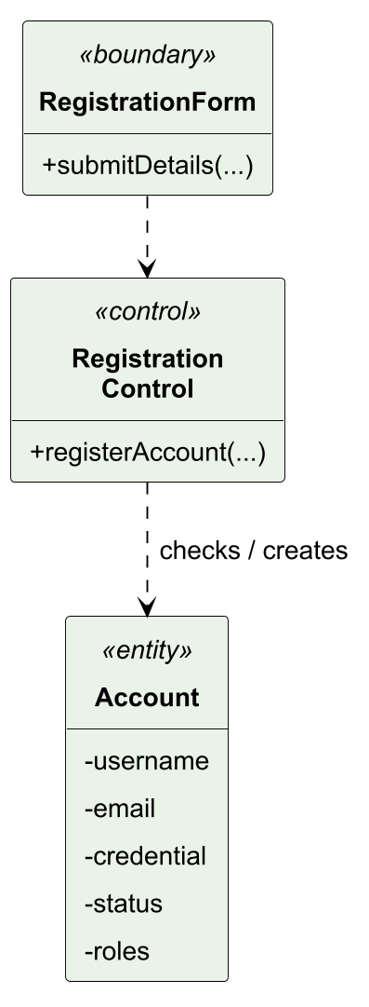
Figure 4. UC01 analysis class model.
Figure 5 traces registration from the visitor’s submission to account creation. Invalid details return field errors; an existing identifier returns a conflict. Only an available identity produces an active attendee account. The final reference to UC02 shows that establishing a session is a separate interaction.
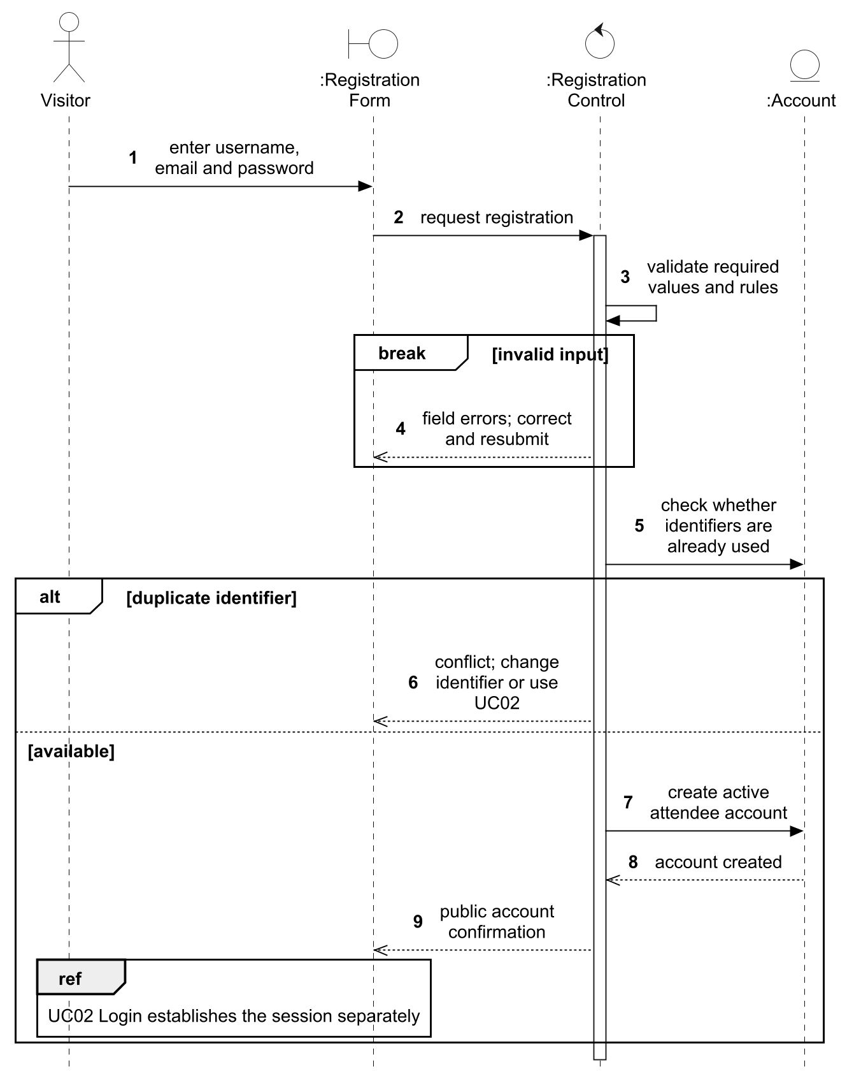
Figure 5. UC01 analysis sequence for registration.

3.4.1.2 Design Models
TS1 refines RegistrationForm into the browser form and AuthController, RegistrationControl into AuthService, and Account into UserAccount plus UserAccountRepository. This keeps HTTP validation separate from account rules and persistence. TS5 delegates password encoding to PasswordEncoder, allowing the credential algorithm to vary independently. Under TS2, identifier pre-checks improve feedback; a database unique constraint remains authoritative when registrations race. saveAndFlush exposes a known duplicate constraint inside the transaction. The later browser login uses UC02, so a login failure does not undo the created account.
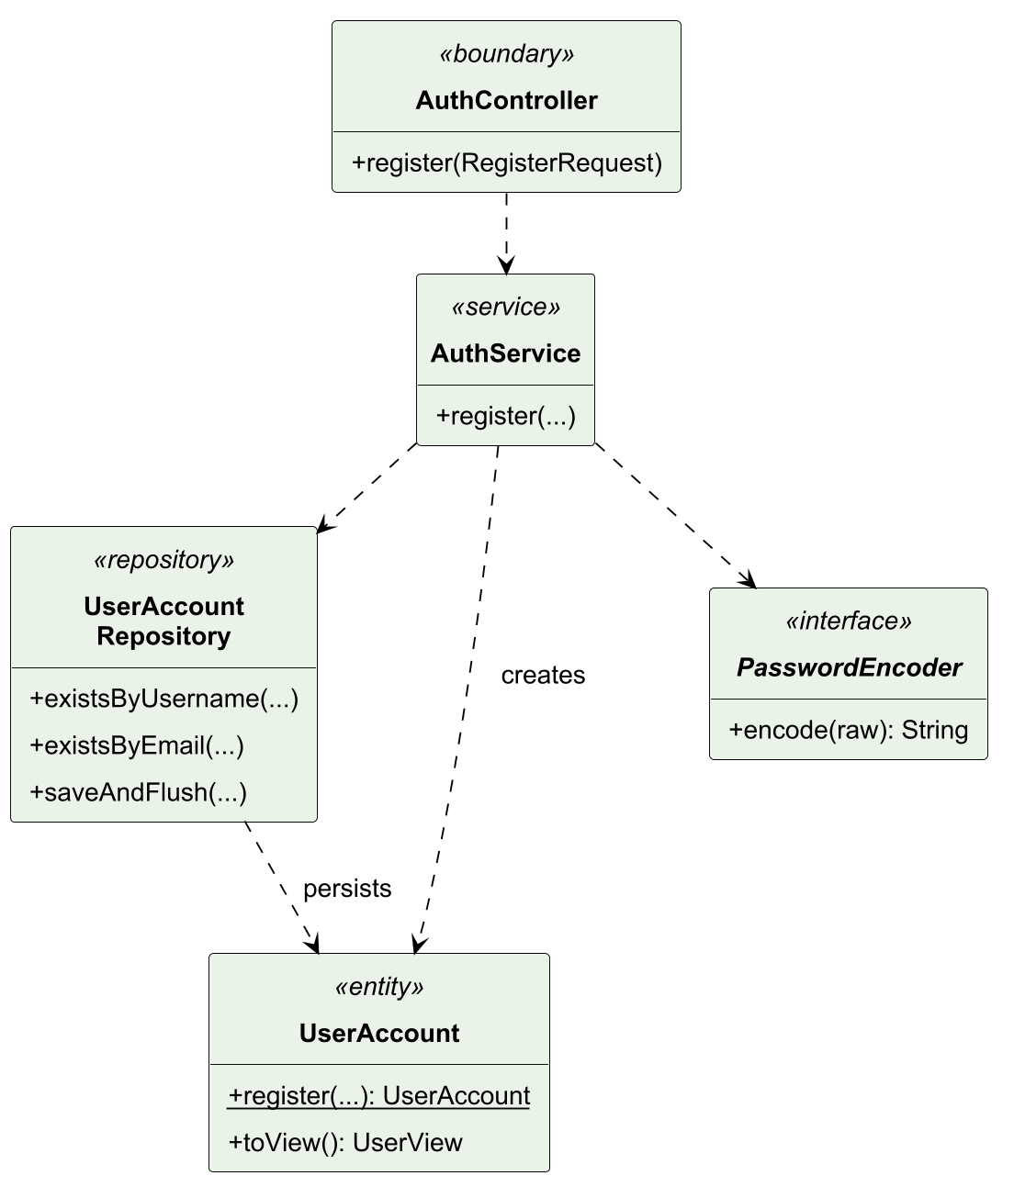
Figure 6. UC01 design class model.
In Figure 7, the duplicate pre-check is followed by a flush-time constraint branch to cover concurrent creation. Neither rejection path returns a successful account result; a committed registration hands off to UC02 separately.
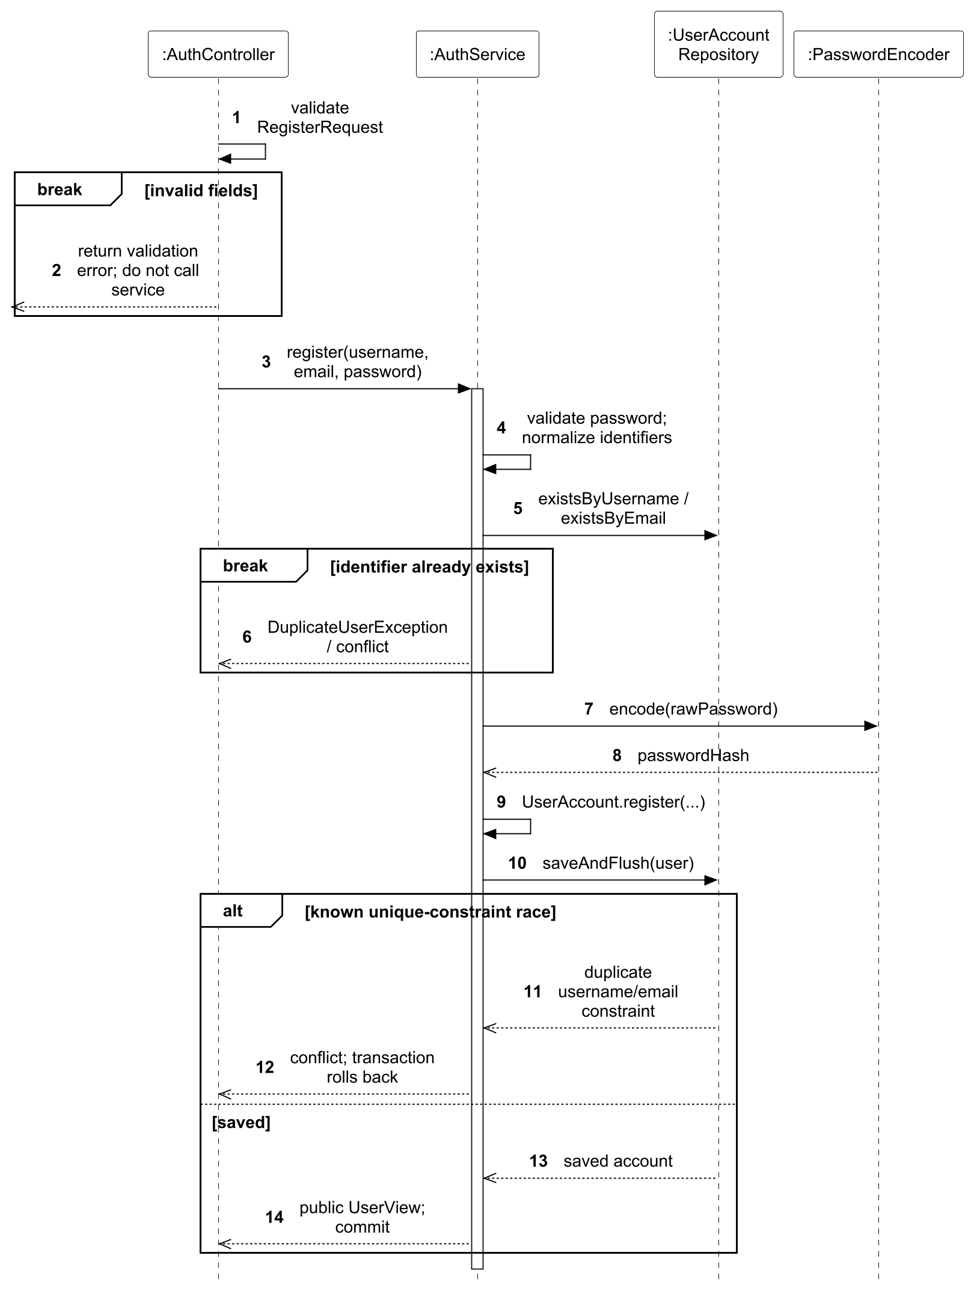
Figure 7. UC01 design sequence for registration.

3.4.2 Use Case 2 by Hu Jia
Use case: UC02 Login. The normal and relevant alternative flows are specified in Section 3.3.3.

3.4.2.1 Analysis Models
LoginForm passes credentials to AuthenticationControl, which checks Account and establishes the conceptual Session. Session describes identity, permissions and expiry without selecting a storage mechanism. The sequence rejects absent, inactive or mismatched accounts before returning a session; authentication does not itself grant access to every protected resource.
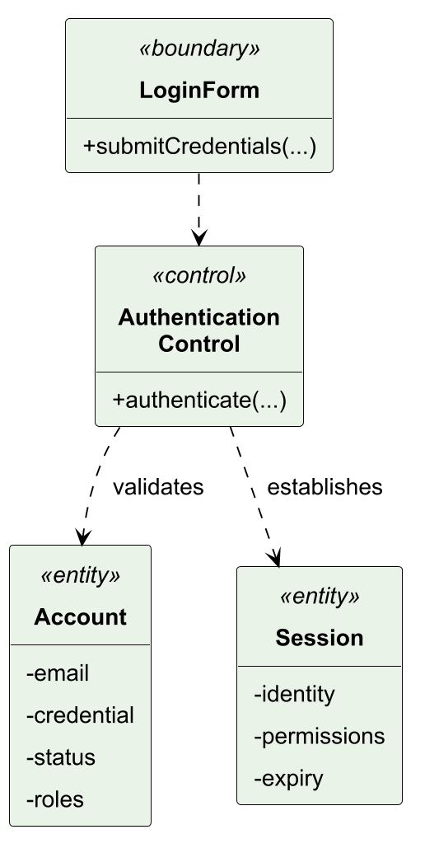
Figure 8. UC02 analysis class model.
Figure 9 follows the login request from LoginForm through AuthenticationControl to Account. A missing, inactive or mismatched account returns an error so the user can correct the credentials. Successful validation establishes the conceptual expiring session and returns the signed-in outcome to the boundary.
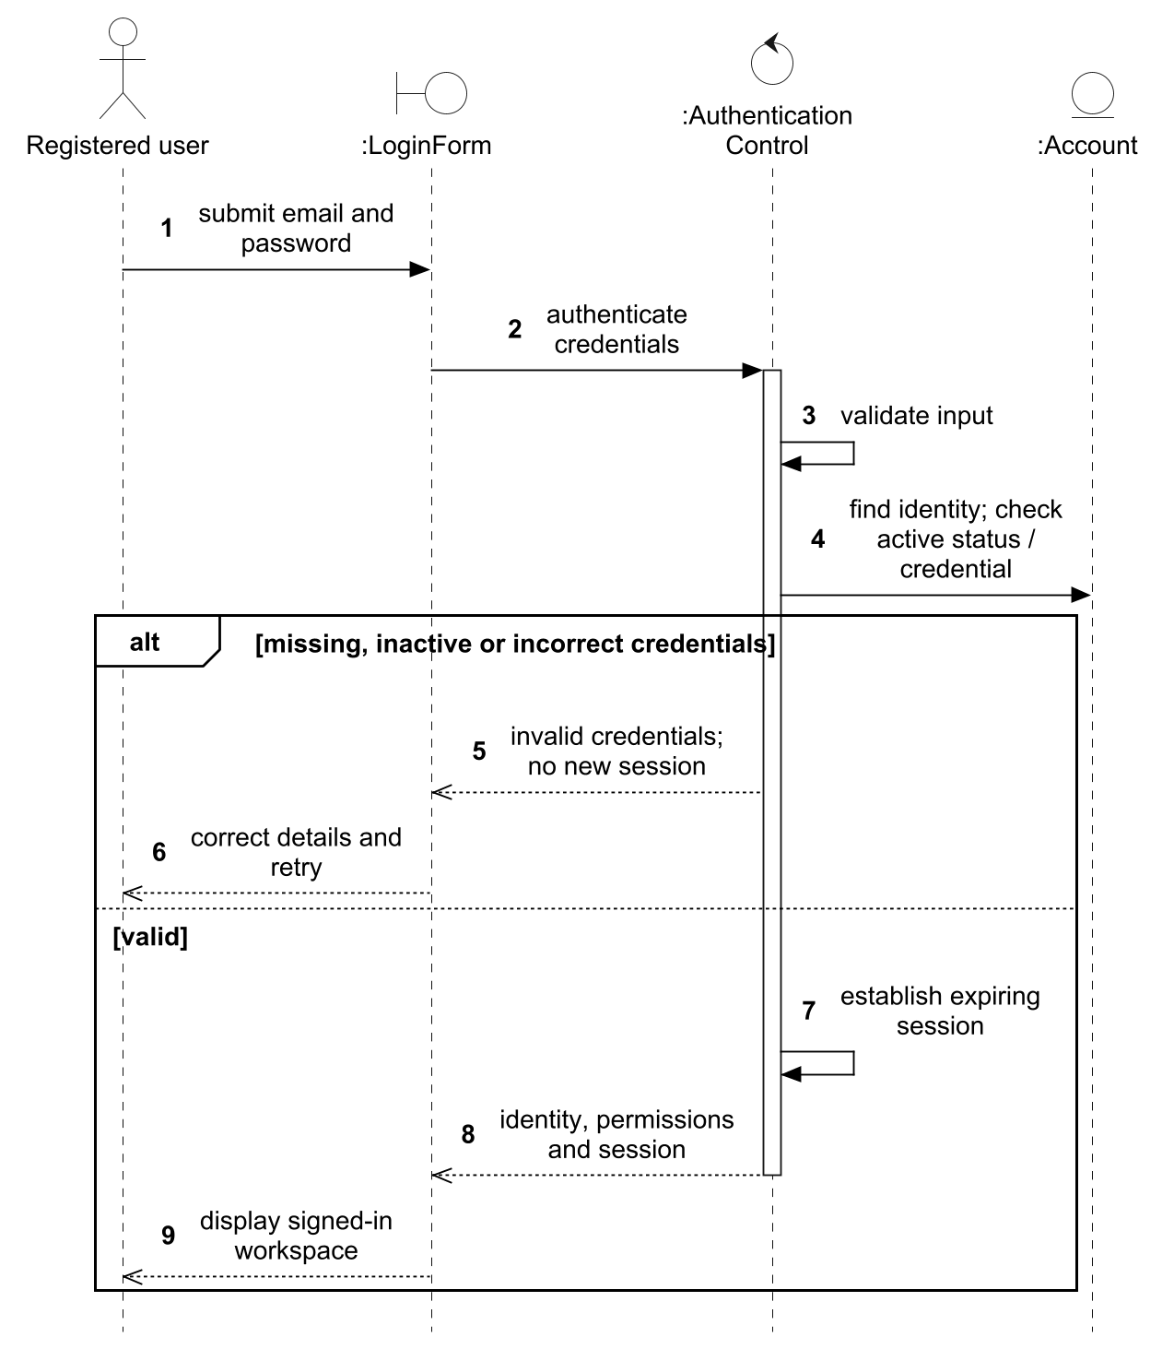
Figure 9. UC02 analysis sequence for login.

3.4.2.2 Design Models
TS1 maps LoginForm to the browser and AuthController, AuthenticationControl to AuthService, and Account to UserAccount/its repository. The conceptual Session becomes a JWT issued by TokenService and stored by the browser; it does not require a server-side Session entity or table. TS5 delegates matching to PasswordEncoder. Token issuance follows successful account and password checks to avoid creating a session on failure. TS3 applies on later requests through Figures 46 and 47: intersecting token roles with current active-account roles makes revocation effective, while newly granted privileges require a fresh login.
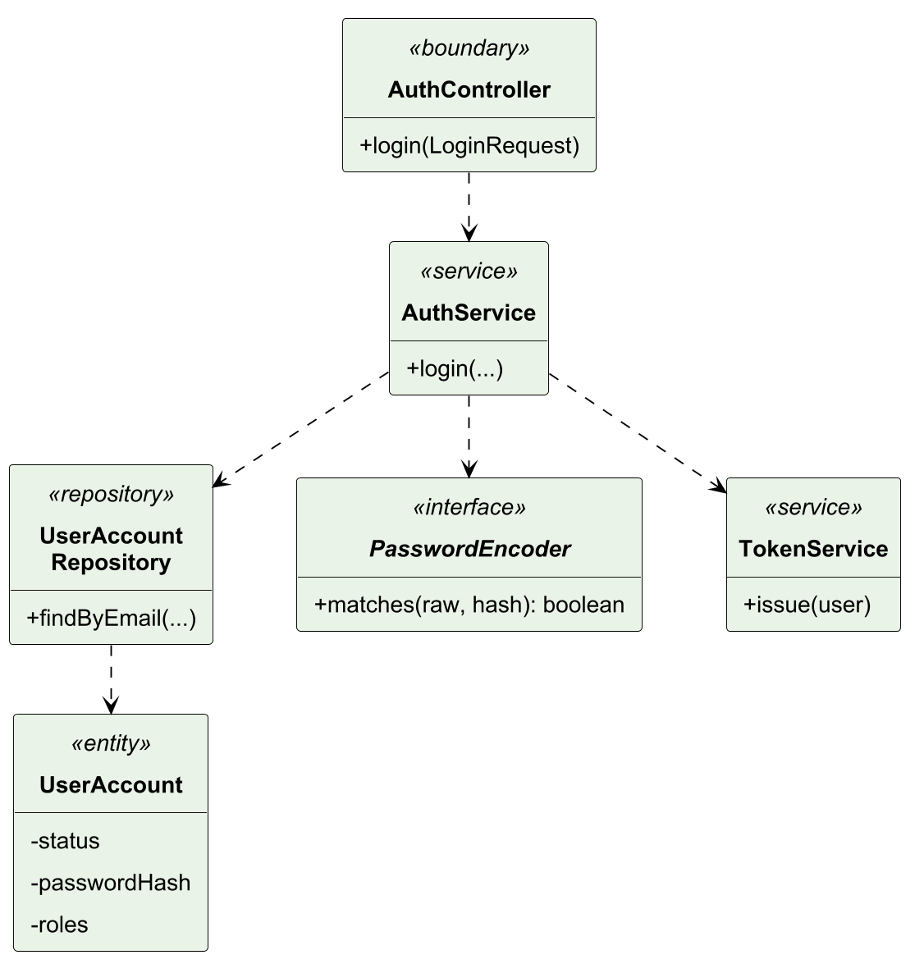
Figure 10. UC02 design class model.
In Figure 11, the design replaces conceptual credential checking with repository lookup, PasswordEncoder.matches and TokenService.issue. Every failure exits before issue; resource authorization is deferred to the shared protected-request entry.
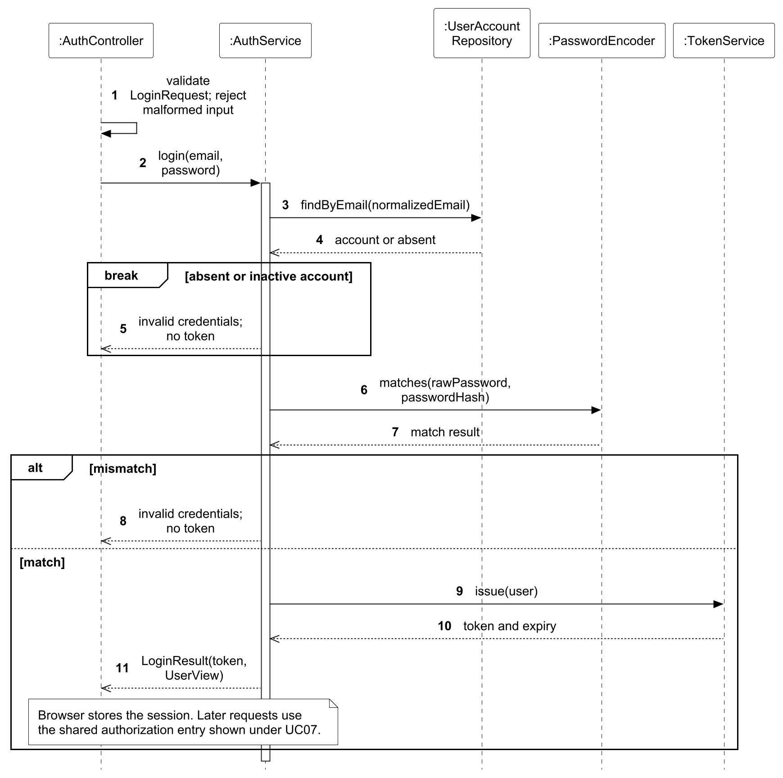
Figure 11. UC02 design sequence for login.

3.4.3 Use Case 3 by Chai Muyang
Use case: UC03 Manage Users and Roles. The normal and relevant alternative flows are specified in Section 3.3.4.

3.4.3.1 Analysis Models
UserAdministrationPage supports finding an Account and submitting its replacement Role set. RoleAdministrationControl protects the last active administrator and creates a private Notification only when roles change. Search and selection lead into the mutation in one major flow, with explicit rejection and unchanged-request alternatives.
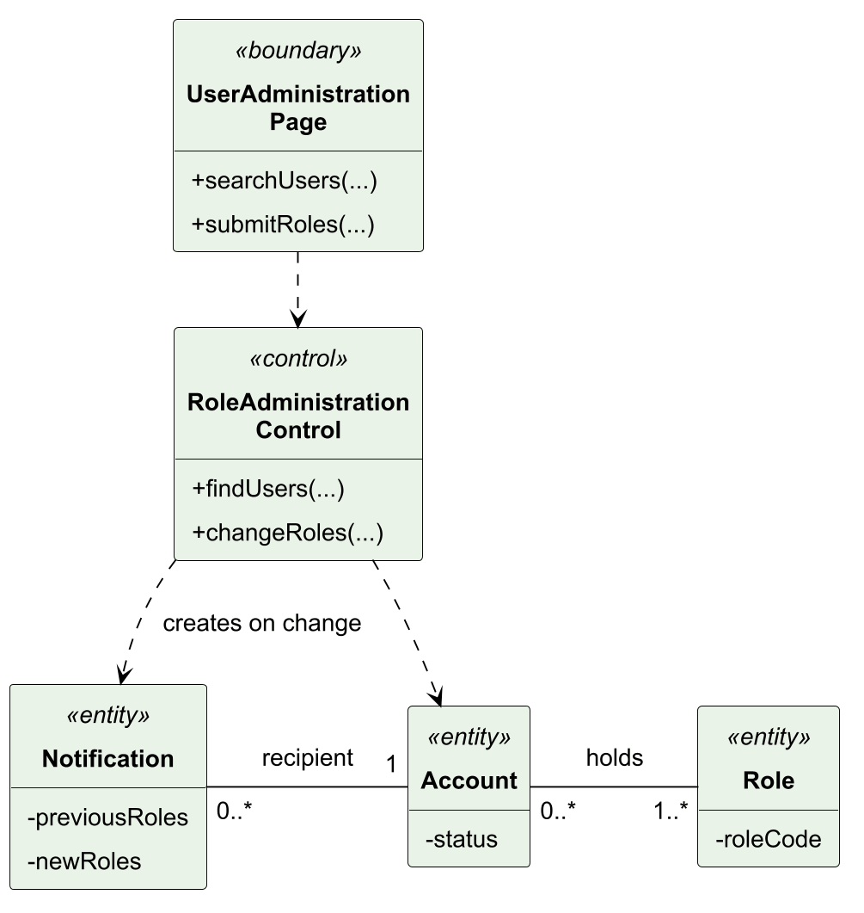
Figure 12. UC03 analysis class model.
Figure 13 connects searching for accounts and roles with the administrator’s selected role change. Invalid targets, invalid role sets and removal of the last active administrator are rejected. An unchanged request returns the existing account; an actual change updates roles and creates the private notification together.
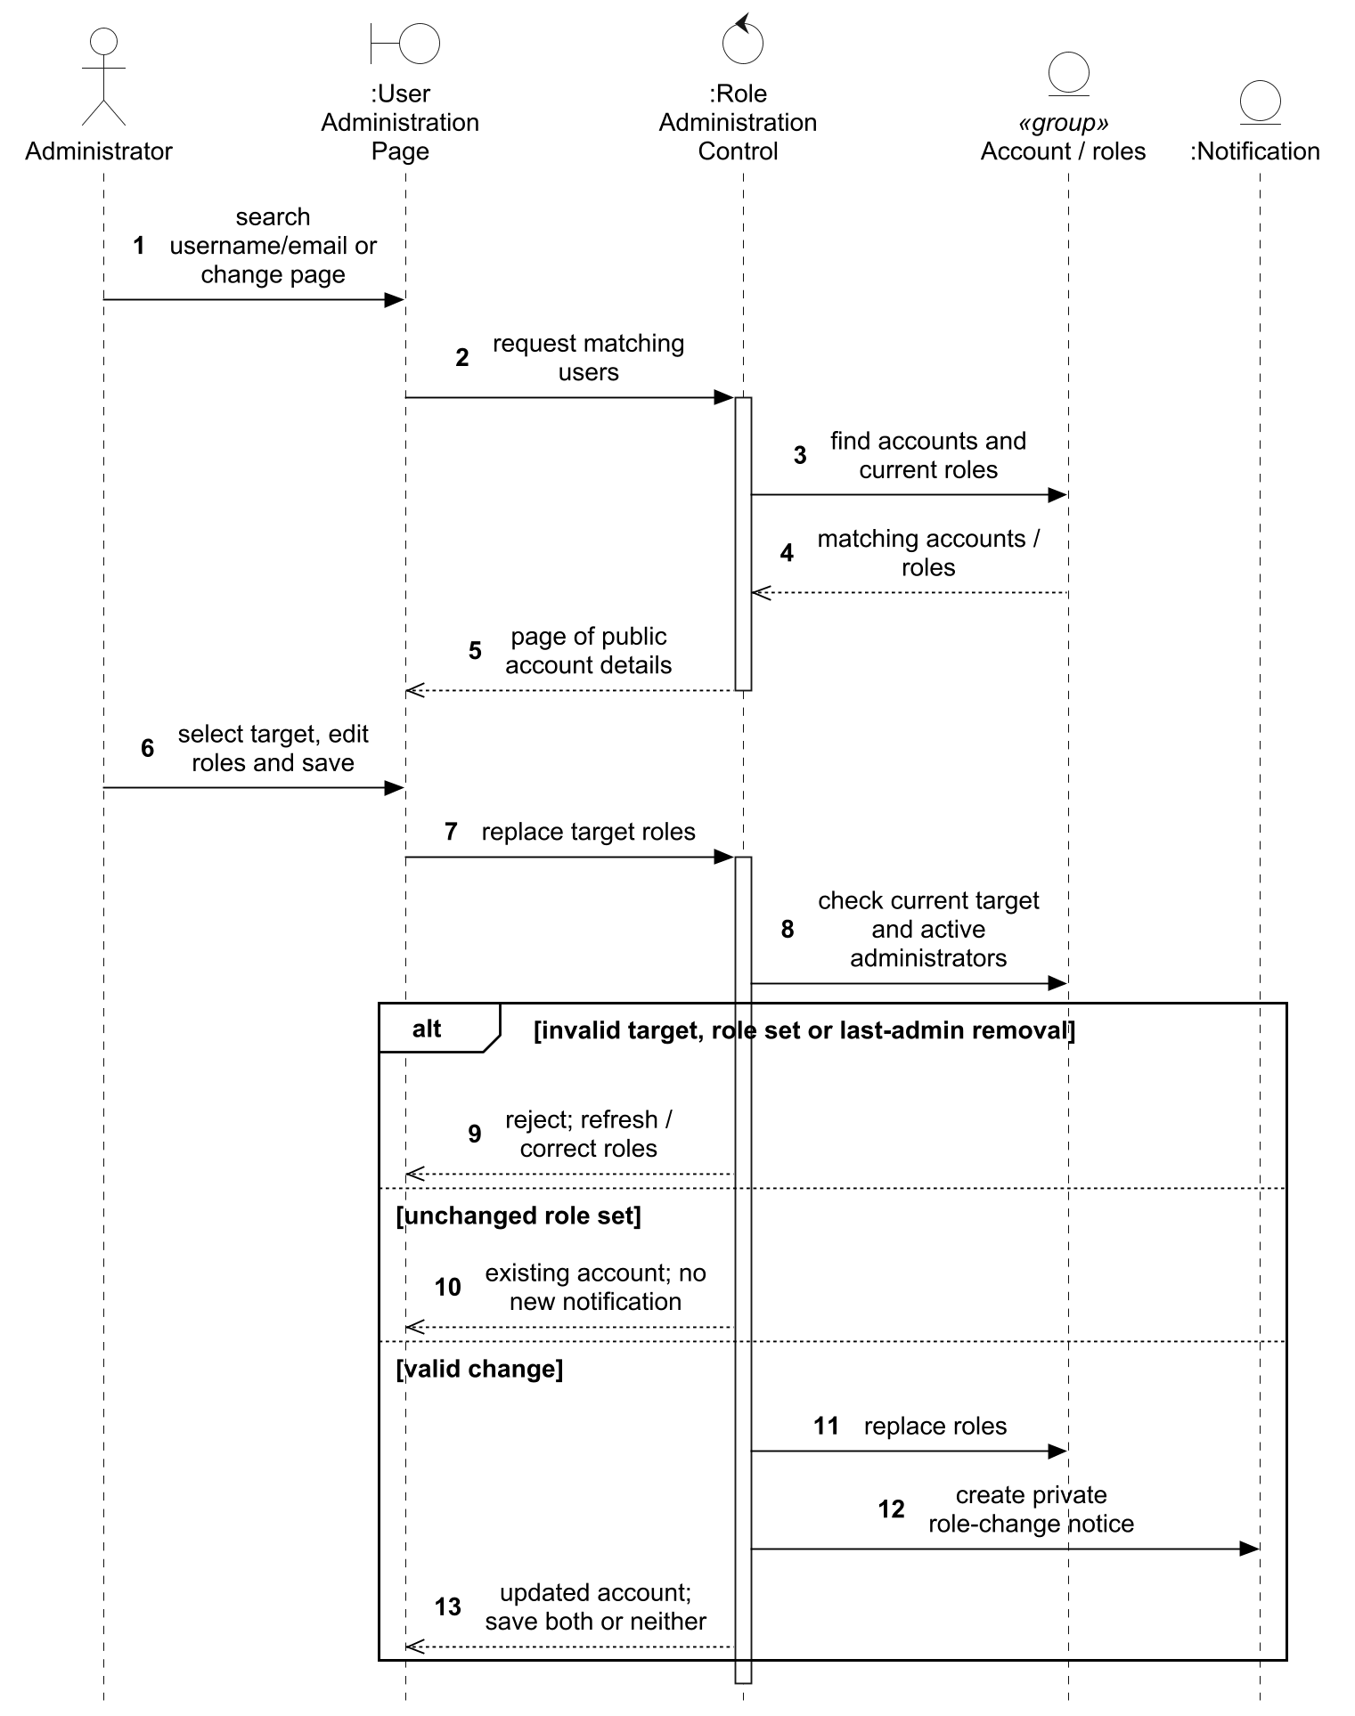
Figure 13. UC03 analysis sequence for finding users and changing roles.

3.4.3.2 Design Models
TS1 maps the boundary to UserAdminController and the control to UserAdministrationService with UserAccountRepository. Analysis Role becomes the role collection on UserAccount; Notification is realized through UserRolesChanged, UserRolesChangedListener and NotificationDeliveryService. TS3 checks effective ADMIN before dispatch. Under TS2, a shared role-assignment lock precedes the last-active-admin count, preventing two individually valid removals from jointly removing every administrator. TS4 emits an event only for a real change; its synchronous listener writes the private notice in the same transaction, so a listener failure rolls back both roles and notice.
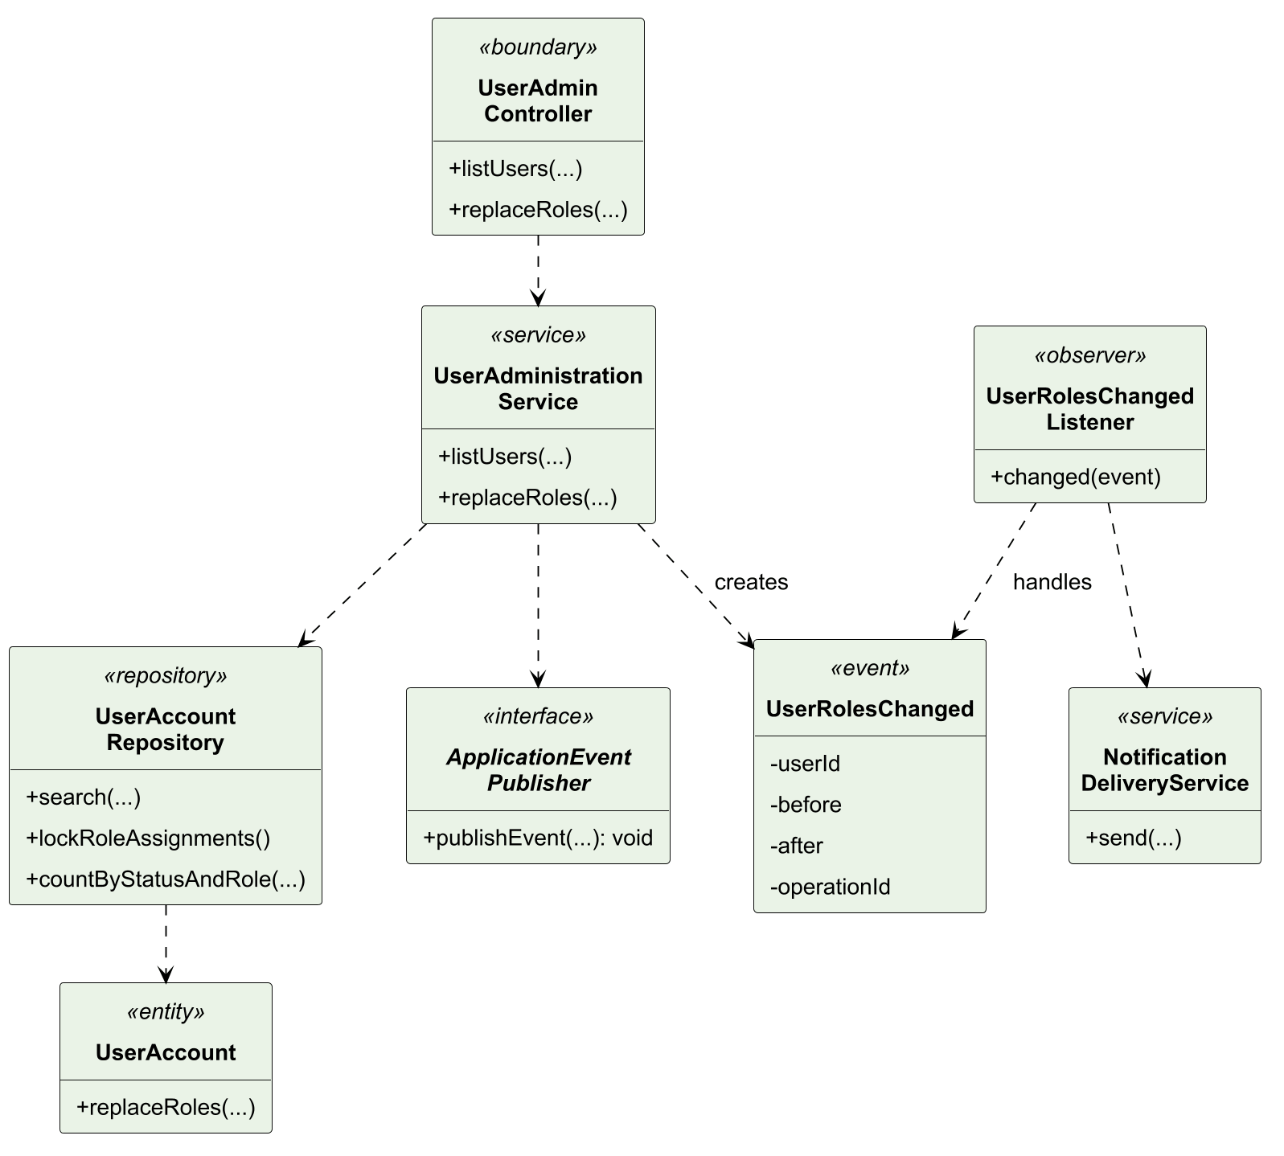
Figure 14. UC03 design class model.
In Figure 15, search returns public account views before a target is selected. During replacement, locking precedes the last-admin decision, and comparing before/after precedes publication; this preserves the administrator invariant and avoids duplicate notices on a no-op.
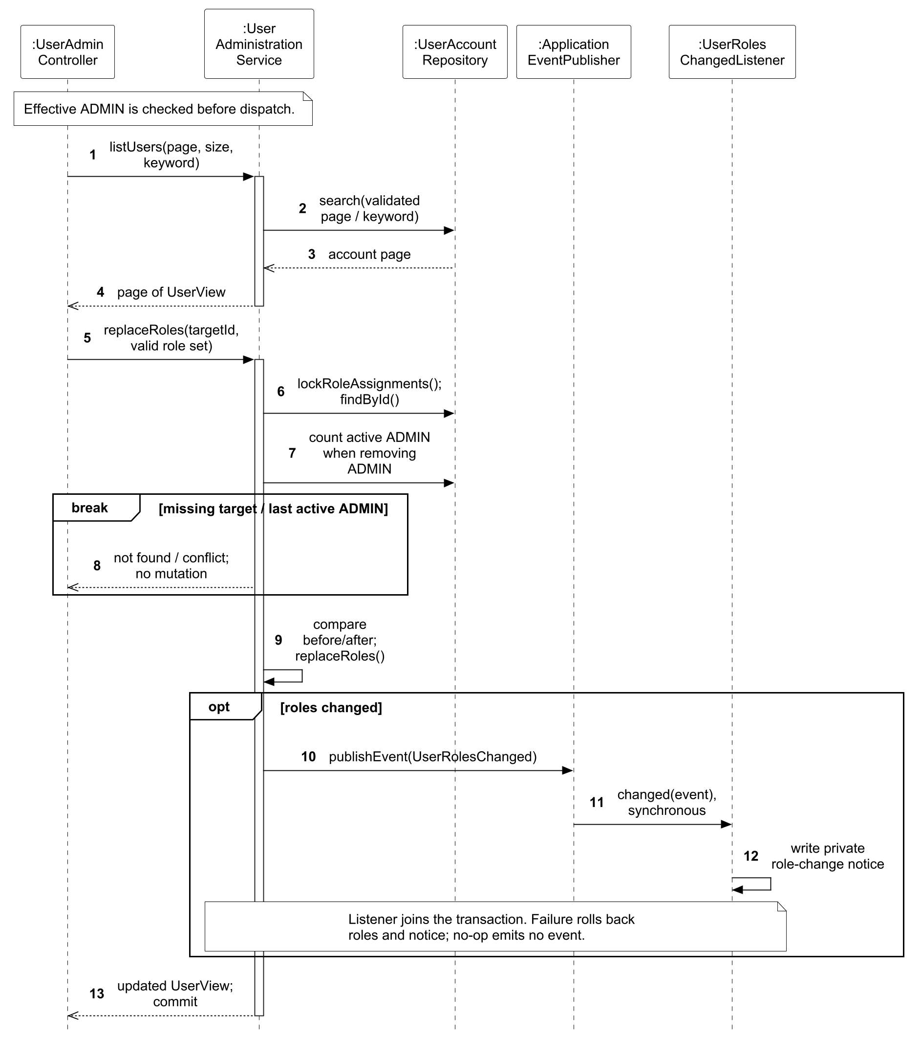
Figure 15. UC03 design sequence for finding users and changing roles.

3.4.4 Use Case 4 by Lu Junyi
Use case: UC04 Manage Events. The normal and relevant alternative flows are specified in Section 3.3.5.

3.4.4.1 Analysis Models
EventEditor delegates five lifecycle flows to EventManagementControl. Event owns its schedule, publication status, capacity and requested attendee information; TicketType defines the offered quota and price. Booking, AdmissionTicket and Notification expose the consequences of cancellation. The following analysis sequences separate draft/configuration, publication, editing, copying and cancellation, including their relevant rejection paths.
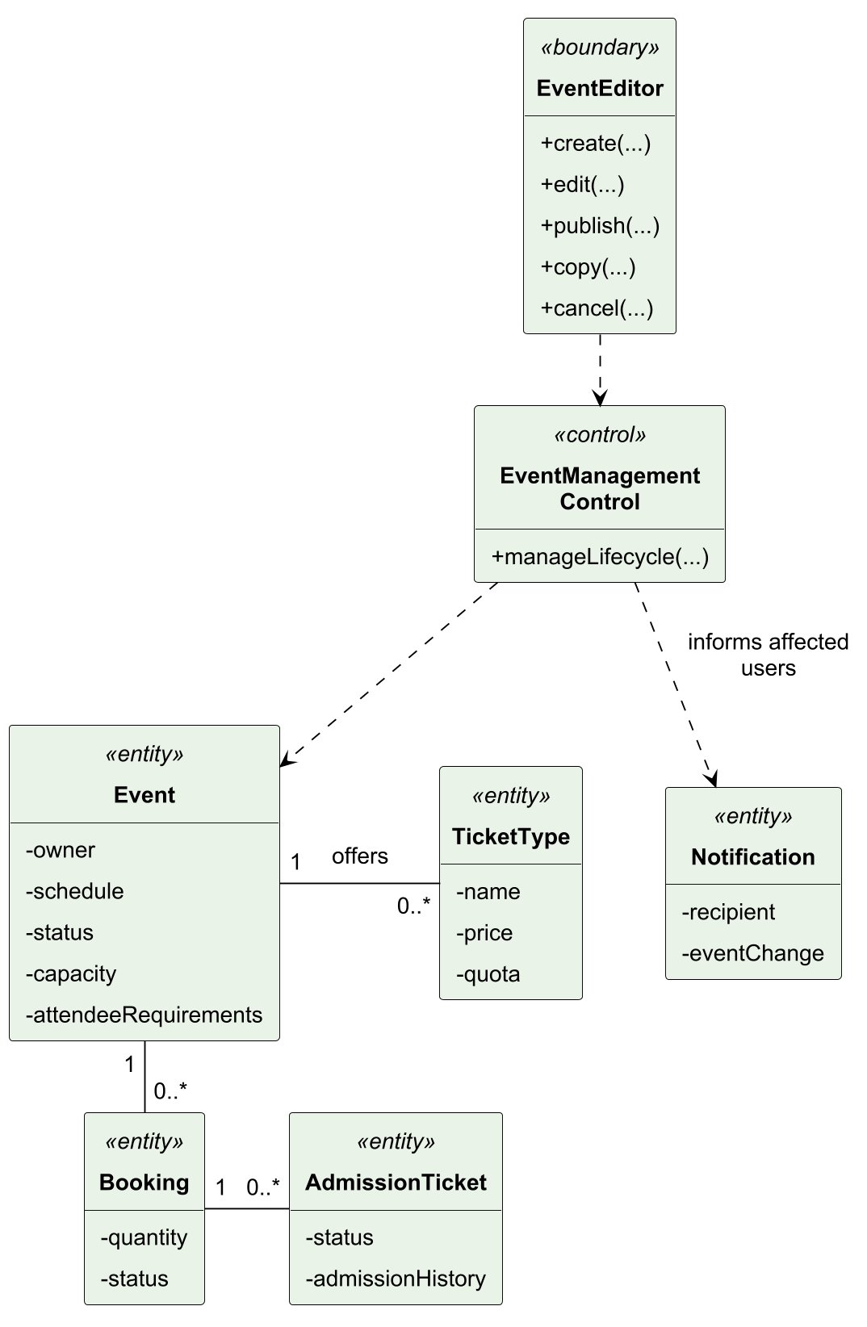
Figure 16. UC04 analysis class model.
Figure 17 follows creation of an owned draft and the subsequent configuration of its ticket types. Invalid event details return field errors before a draft is created. Ticket configuration checks ownership, editable state and total capacity; publication remains a separate decision after the draft has been configured.
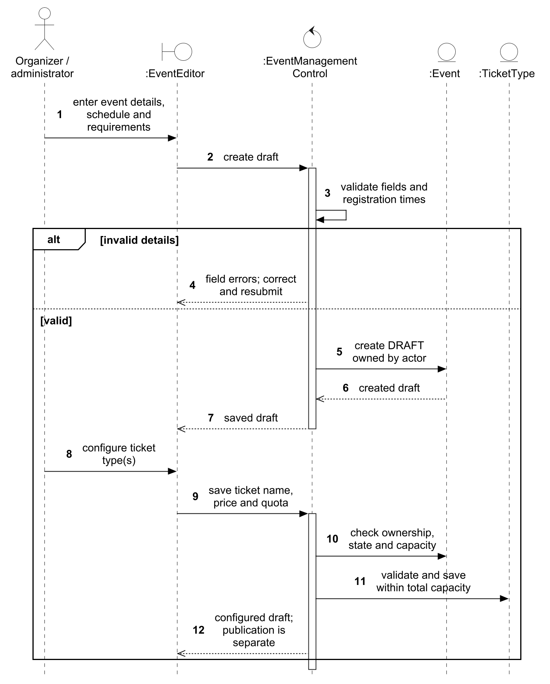
Figure 17. UC04 analysis sequence for creating and configuring a draft.
Figure 18 shows how publication depends on ownership, the current version, draft state, future timing and at least one ticket type. A failed check returns an error for correction or reload. Only an eligible draft changes to PUBLISHED and becomes publicly visible.
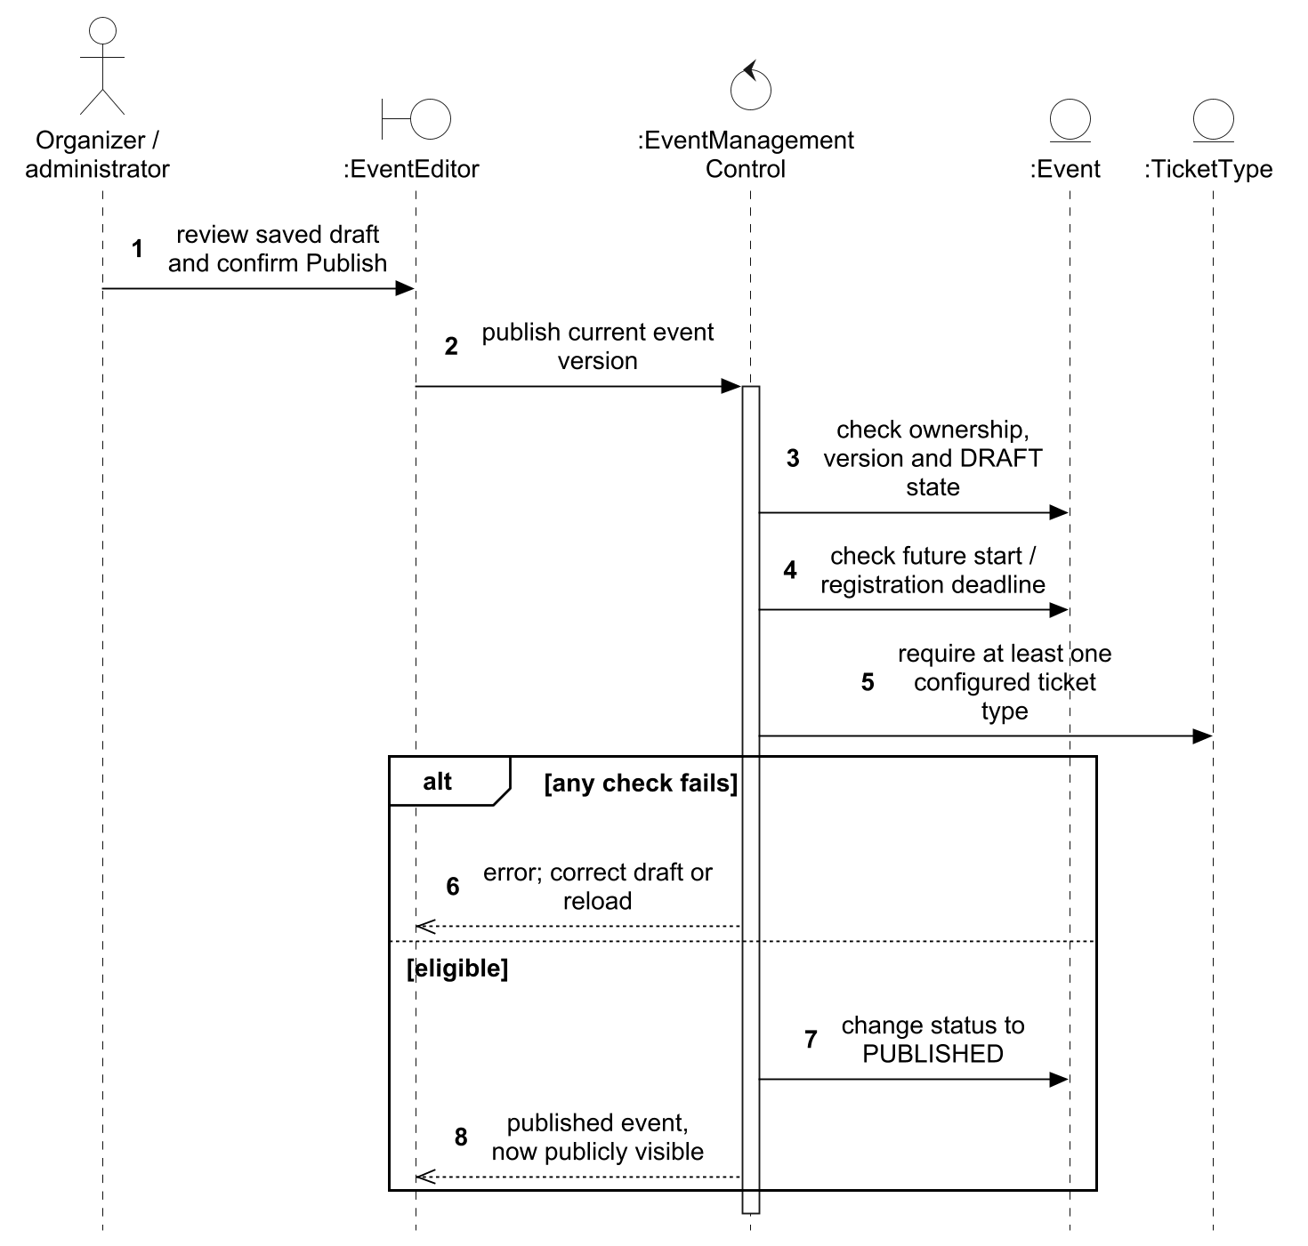
Figure 18. UC04 analysis sequence for publishing an event.
Figure 19 follows an organizer’s changes to the current event version. Invalid, stale or forbidden changes are rejected so the editor can correct or reload the event. Accepted changes update the details, and changes affecting users of a published event also create the relevant notifications.
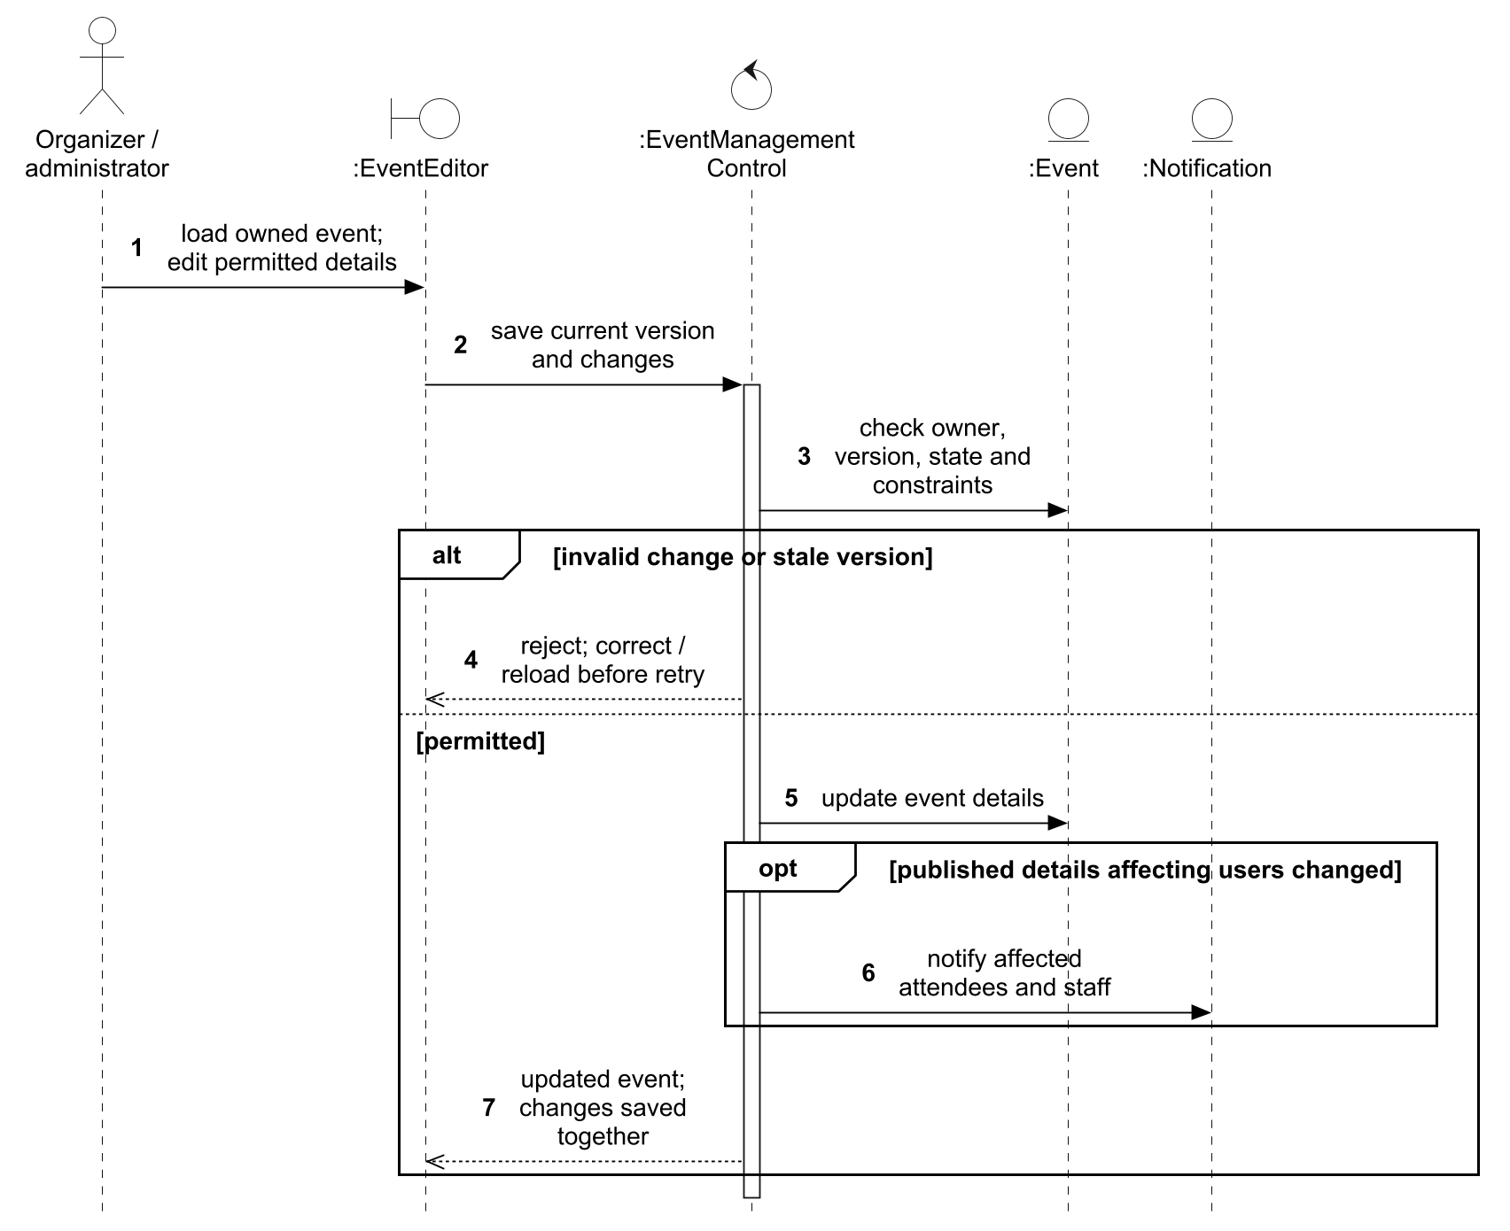
Figure 19. UC04 analysis sequence for editing an event.
Figure 20 shows the organizer selecting an owned source and creating a separate draft. A missing or foreign source returns not found. A successful copy recreates ticket definitions with fresh inventory, excludes bookings and personal data, and returns the new draft for review before publication.
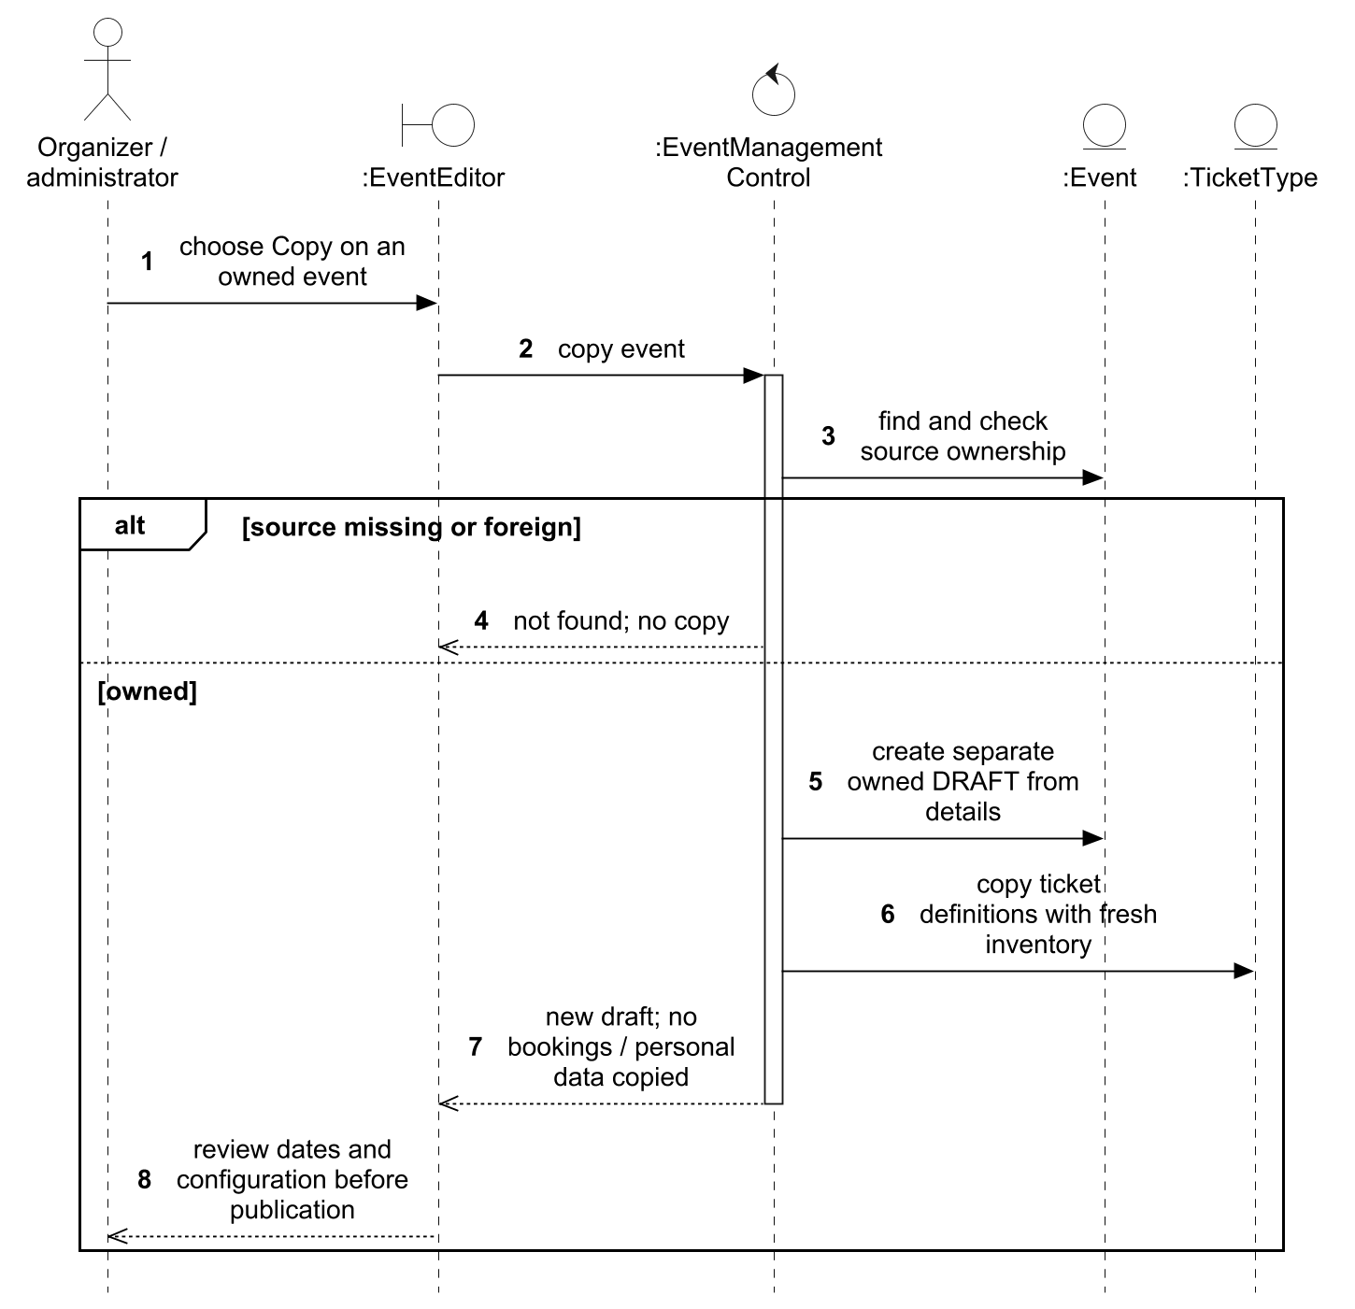
Figure 20. UC04 analysis sequence for copying an event.
Figure 21 follows cancellation from confirmation through its effects on the event, bookings and tickets. An invalid, stale or already-cancelled event is rejected. A permitted cancellation releases reserved places, voids tickets and notifies affected users while retaining historical admission records; the required changes are saved together.
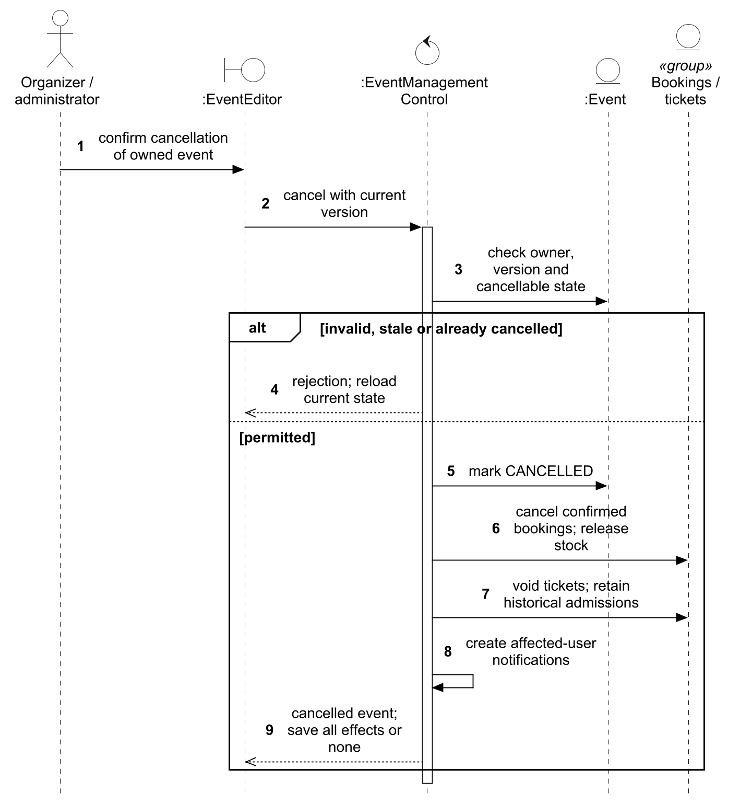
Figure 21. UC04 analysis sequence for cancelling an event.

3.4.4.2 Design Models
TS1 refines EventEditor into OrganizerEventController and OrganizerTicketTypeController. EventManagementControl splits into EventManagementService for lifecycle policy and TicketTypeManagementService for ticket configuration. Event and TicketType remain domain entities with separate repositories; the ticket service accesses the event through EventAccessService. The selected class view omits the ticket controller and secondary listeners, which appear in the flow sequences. TS3 requires effective ORGANIZER/ADMIN and ownership; ADMIN does not bypass ownership. TS2 adds locks, version checks and explicit transaction boundaries. TS4 delegates validation, copy, update and cancellation reactions to synchronous listeners; the per-flow notes explain why their commit boundaries differ. DP01 evaluates cancellation’s Observer design.
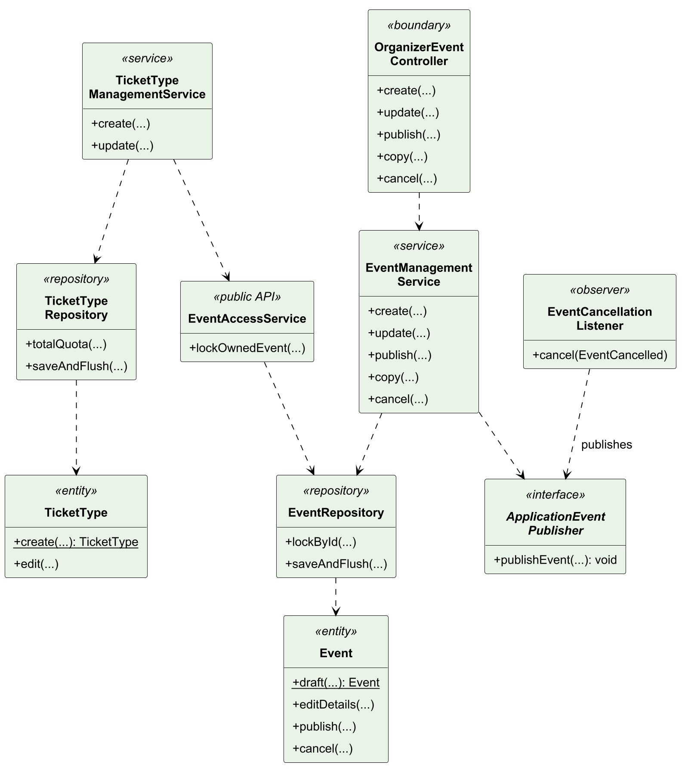
Figure 22. UC04 design class model.
In Figure 23, the Organizer controllers lifeline groups OrganizerEventController and OrganizerTicketTypeController. Draft creation commits before the separate ticket-configuration request; a rejected ticket configuration therefore preserves the draft for correction. Configuration checks the event and quotas before saving its own transaction.
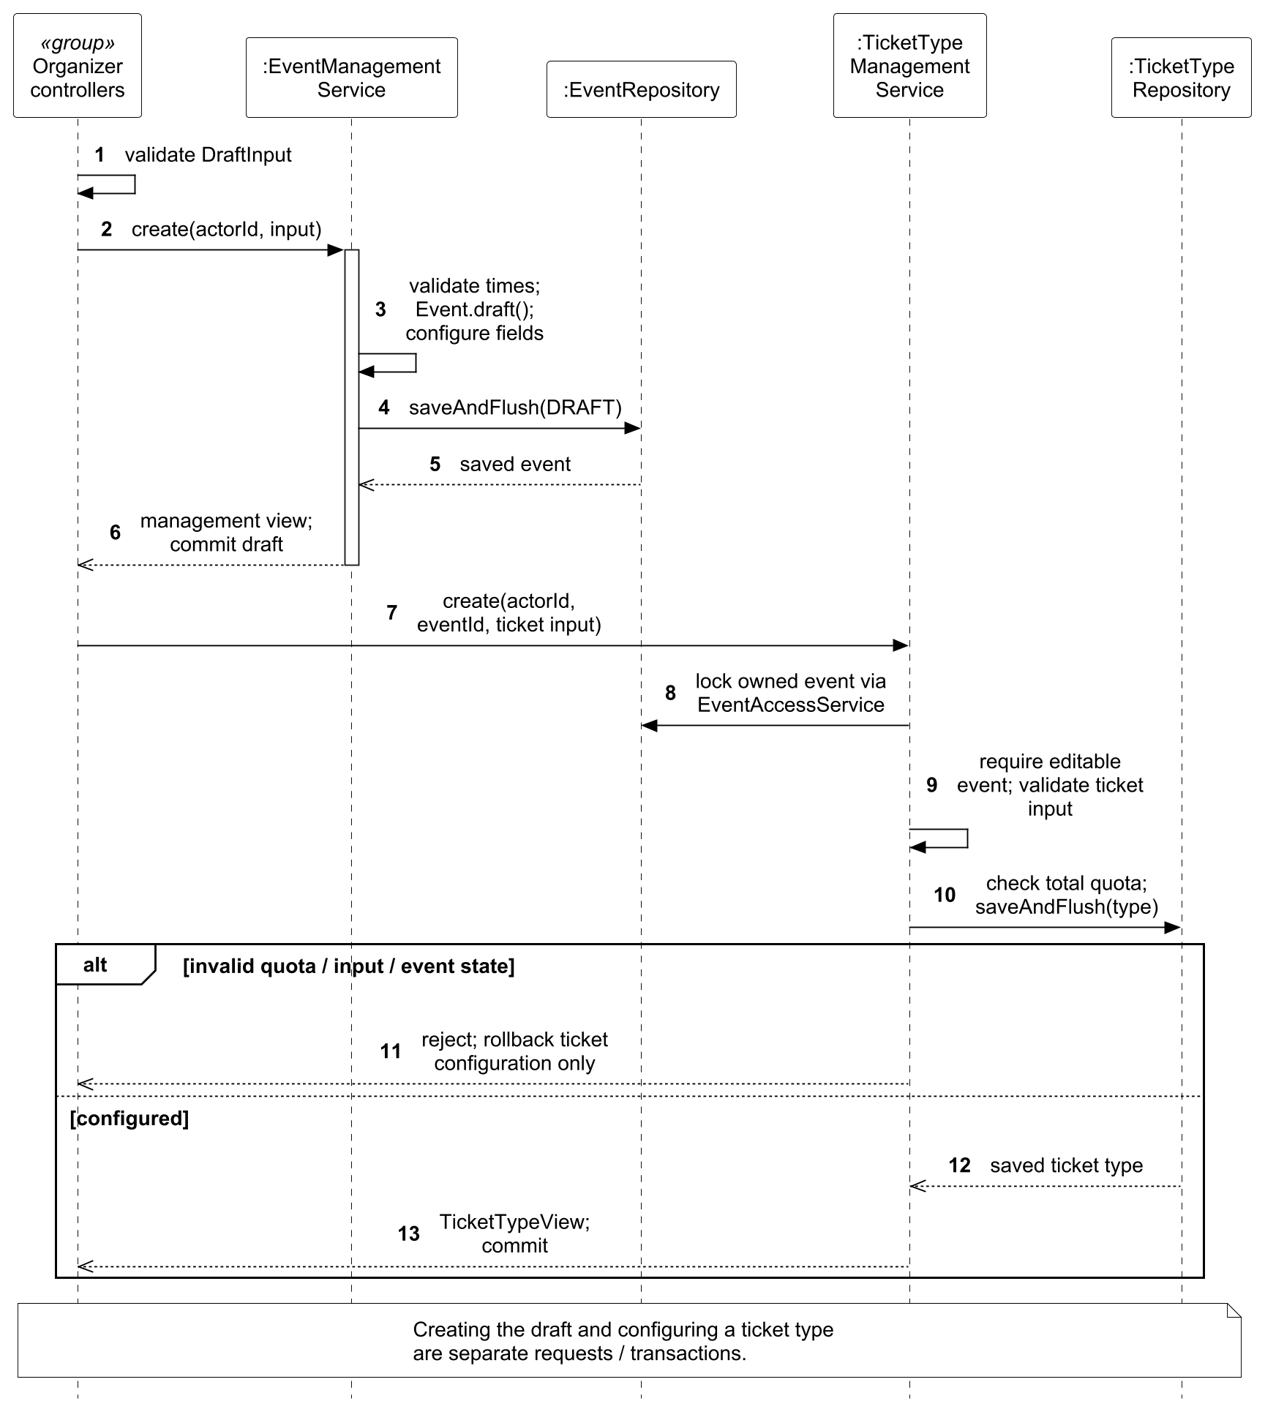
Figure 23. UC04 design sequence for creating and configuring a draft.
In Figure 24, the event is locked and ownership/version/state are checked before publication. The synchronous EventPublishing validation requires ticket configuration; failure rolls back the status update so an incomplete draft is never committed as PUBLISHED.
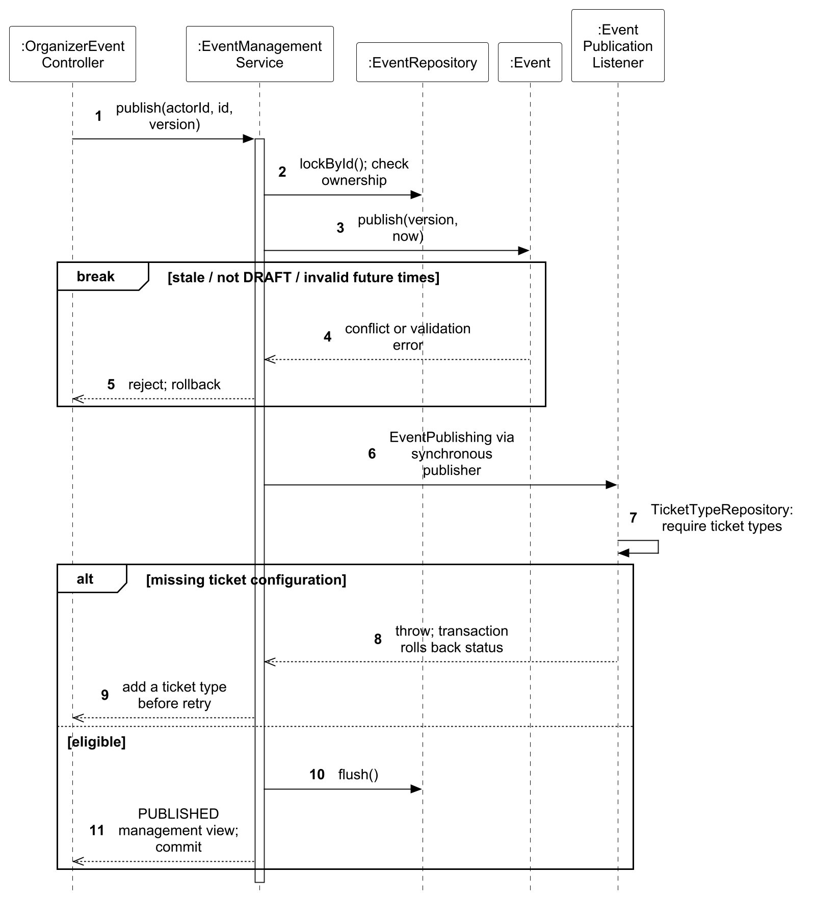
Figure 24. UC04 design sequence for publishing an event.
In Figure 25, the event lock serializes competing lifecycle writes; the submitted version detects a stale editor view. Capacity validation runs before incompatible changes are saved, and synchronous update reactions share the transaction to prevent a partially applied edit.
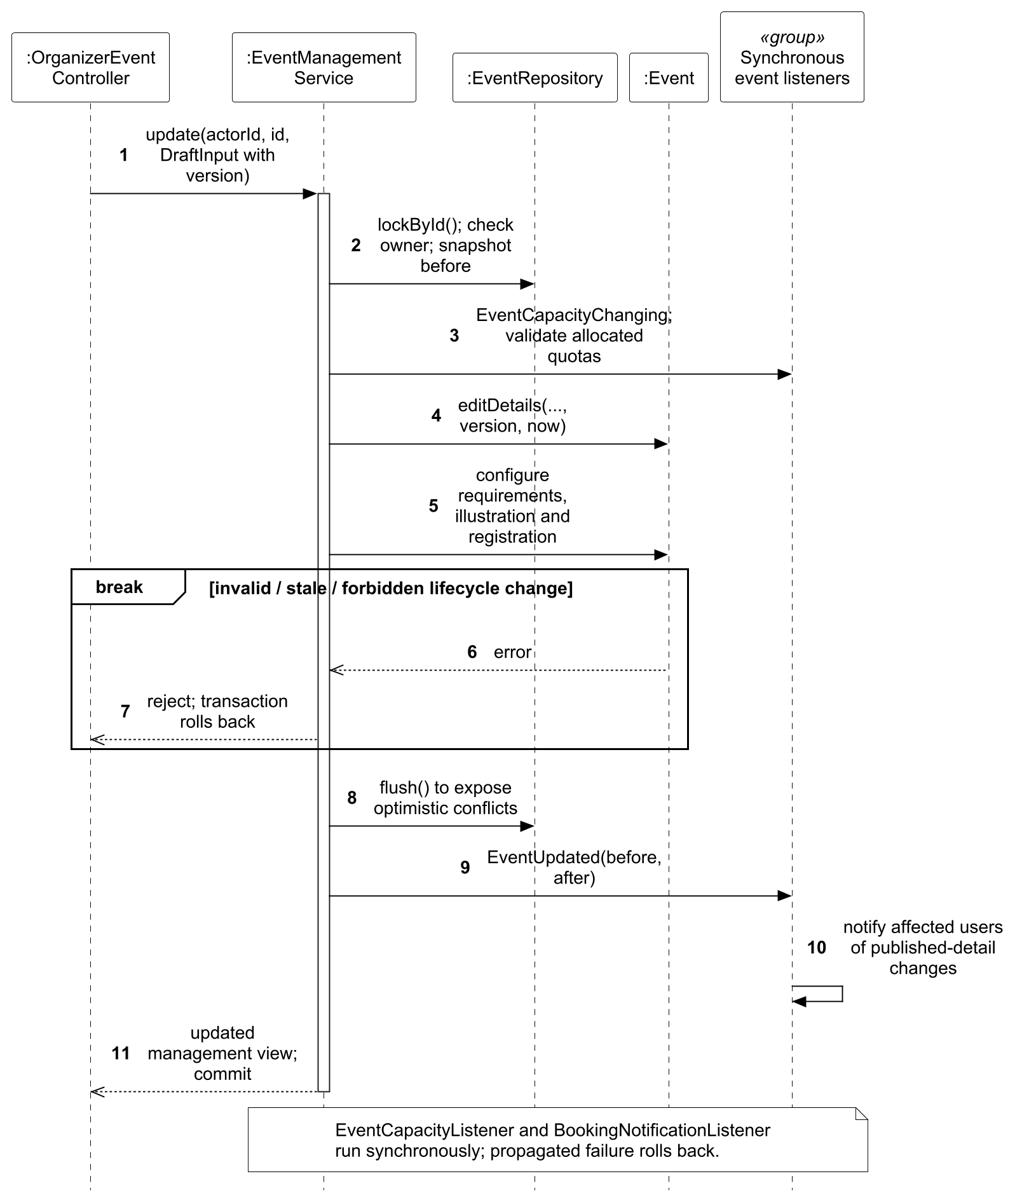
Figure 25. UC04 design sequence for editing an event.
In Figure 26, a copy receives a fresh DRAFT identity, and the listener recreates ticket definitions with fresh inventory. Booking, attendee data and check-in history are not copied. The new event and its copied configuration commit together, avoiding a partially populated duplicate.
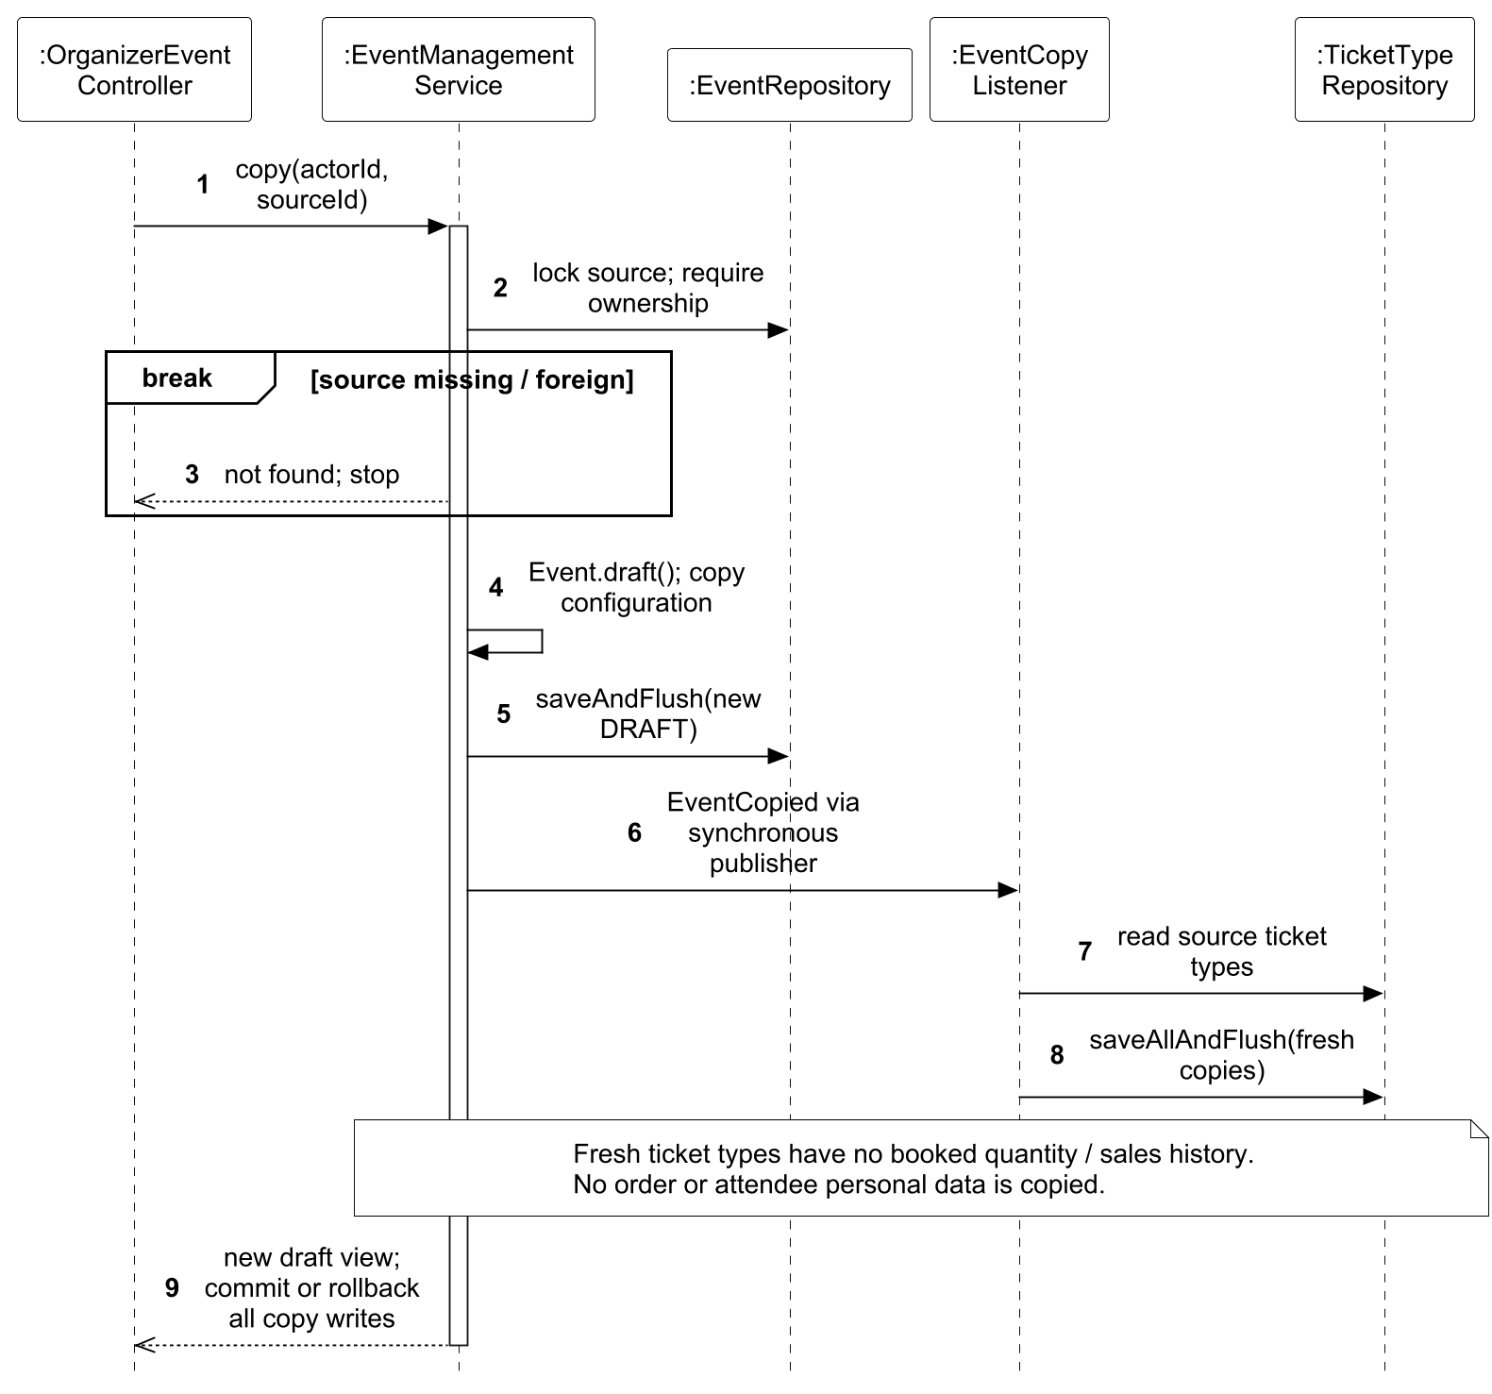
Figure 26. UC04 design sequence for copying an event.
In Figure 27, cancellation locks the current event before changing state. Booking cancellation, stock release, ticket voiding and notices join the same transaction through synchronous events; any required failure rolls back the cancellation. Historical admission records remain available.
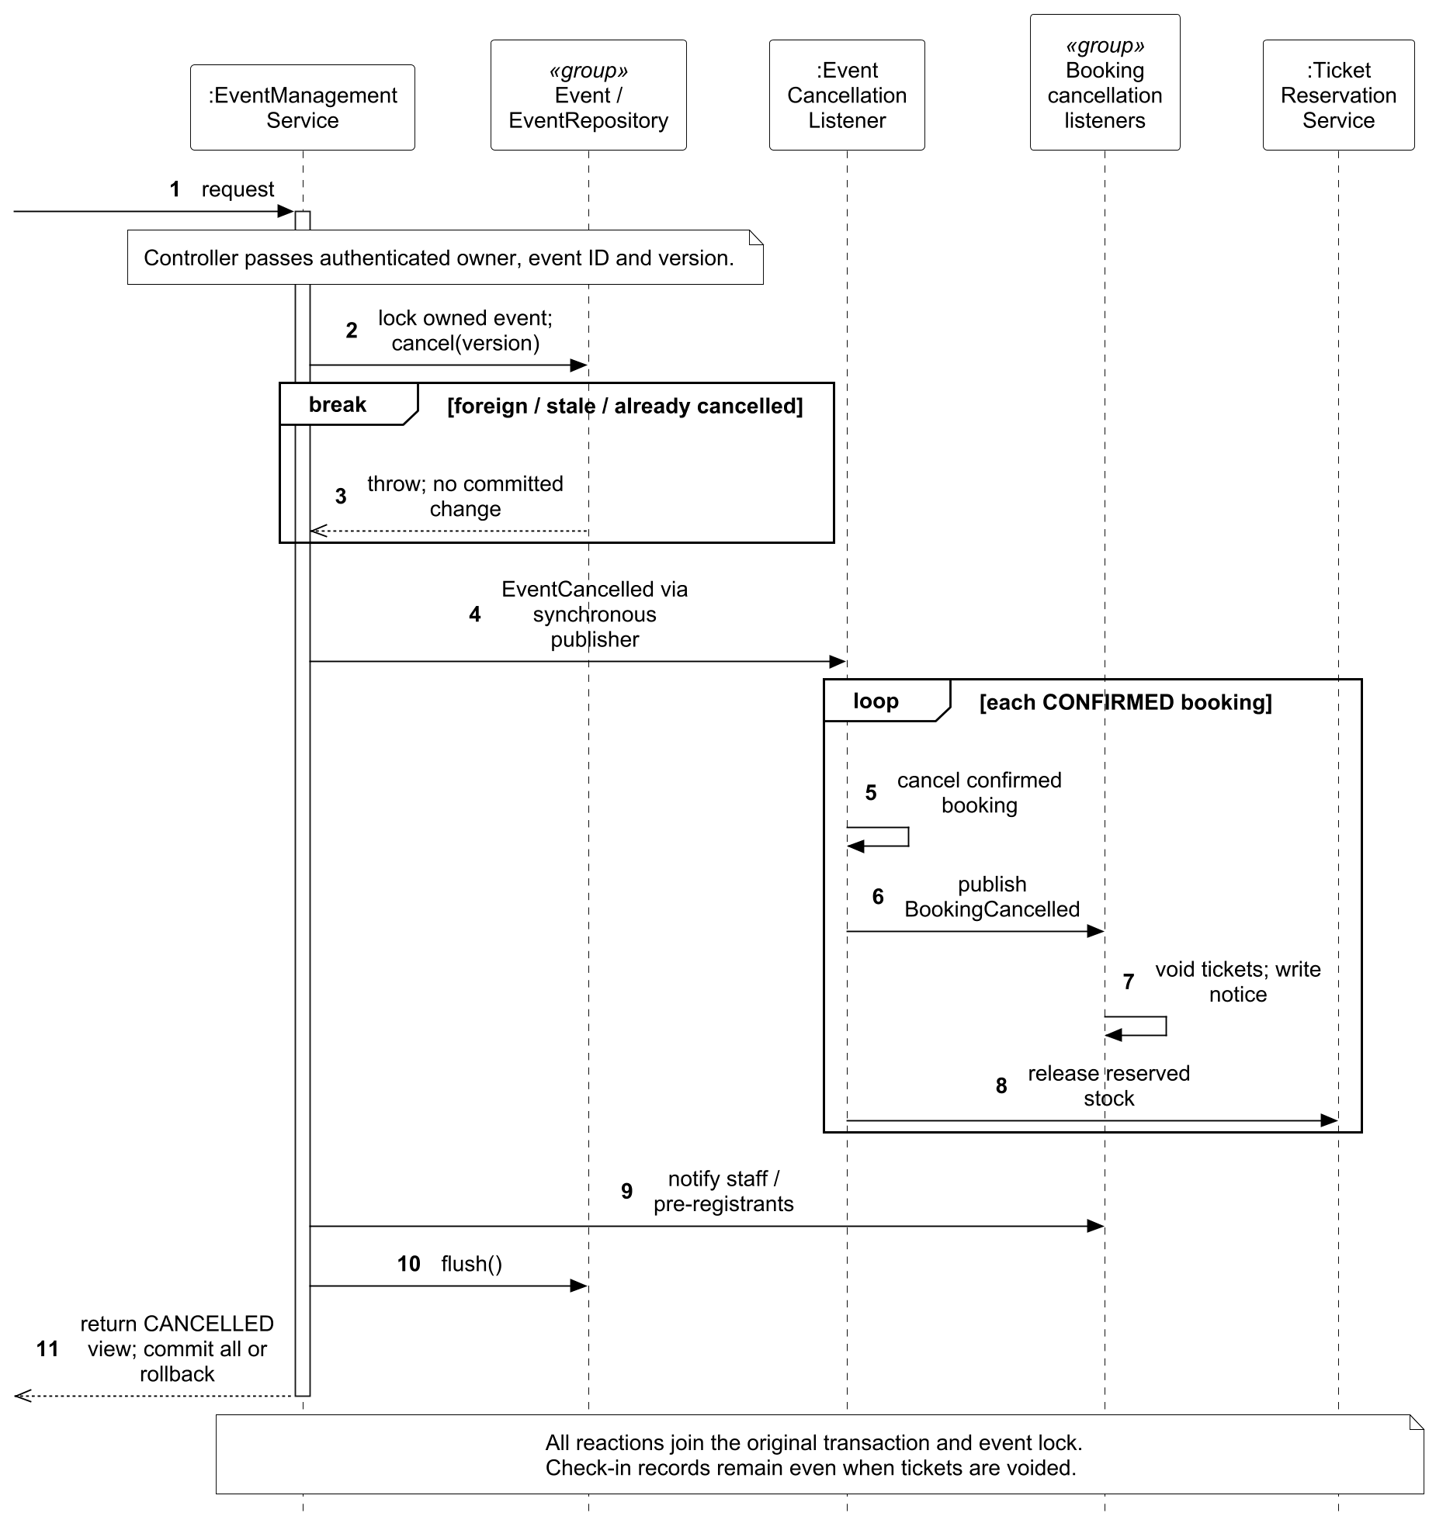
Figure 27. UC04 design sequence for cancelling an event.

3.4.5 Use Case 5 by Lu Junyi
Use case: UC05 Browse Events. The normal and relevant alternative flows are specified in Section 3.3.6.

3.4.5.1 Analysis Models
EventBrowser requests public information through BrowsingControl. Event supplies publication and schedule information; TicketType supplies current ticket options. Searching, selecting a result and reading its detail form the major browsing flow. An empty result page is valid; a selected event becoming unavailable is a separate exception.
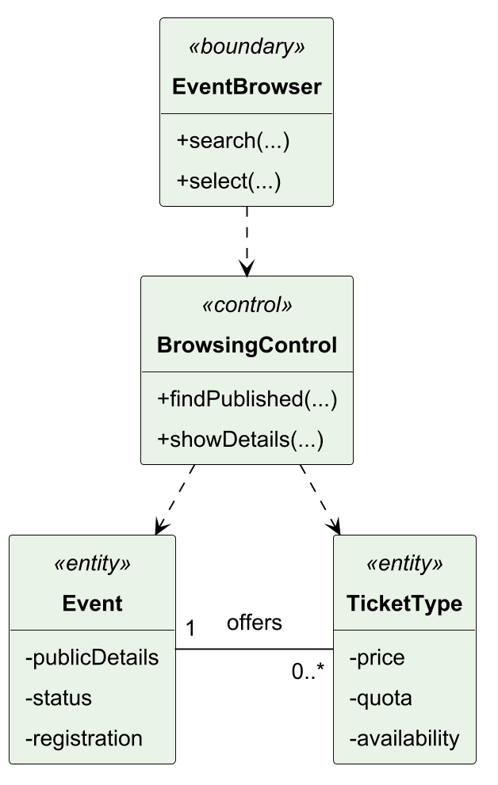
Figure 28. UC05 analysis class model.
Figure 29 connects searching the public list with selecting an event and reading its current details and ticket options. The control validates query ranges and returns a result page that may be empty. Selection rechecks visibility; an unavailable event returns an error, while a visible event yields a read-only snapshot.
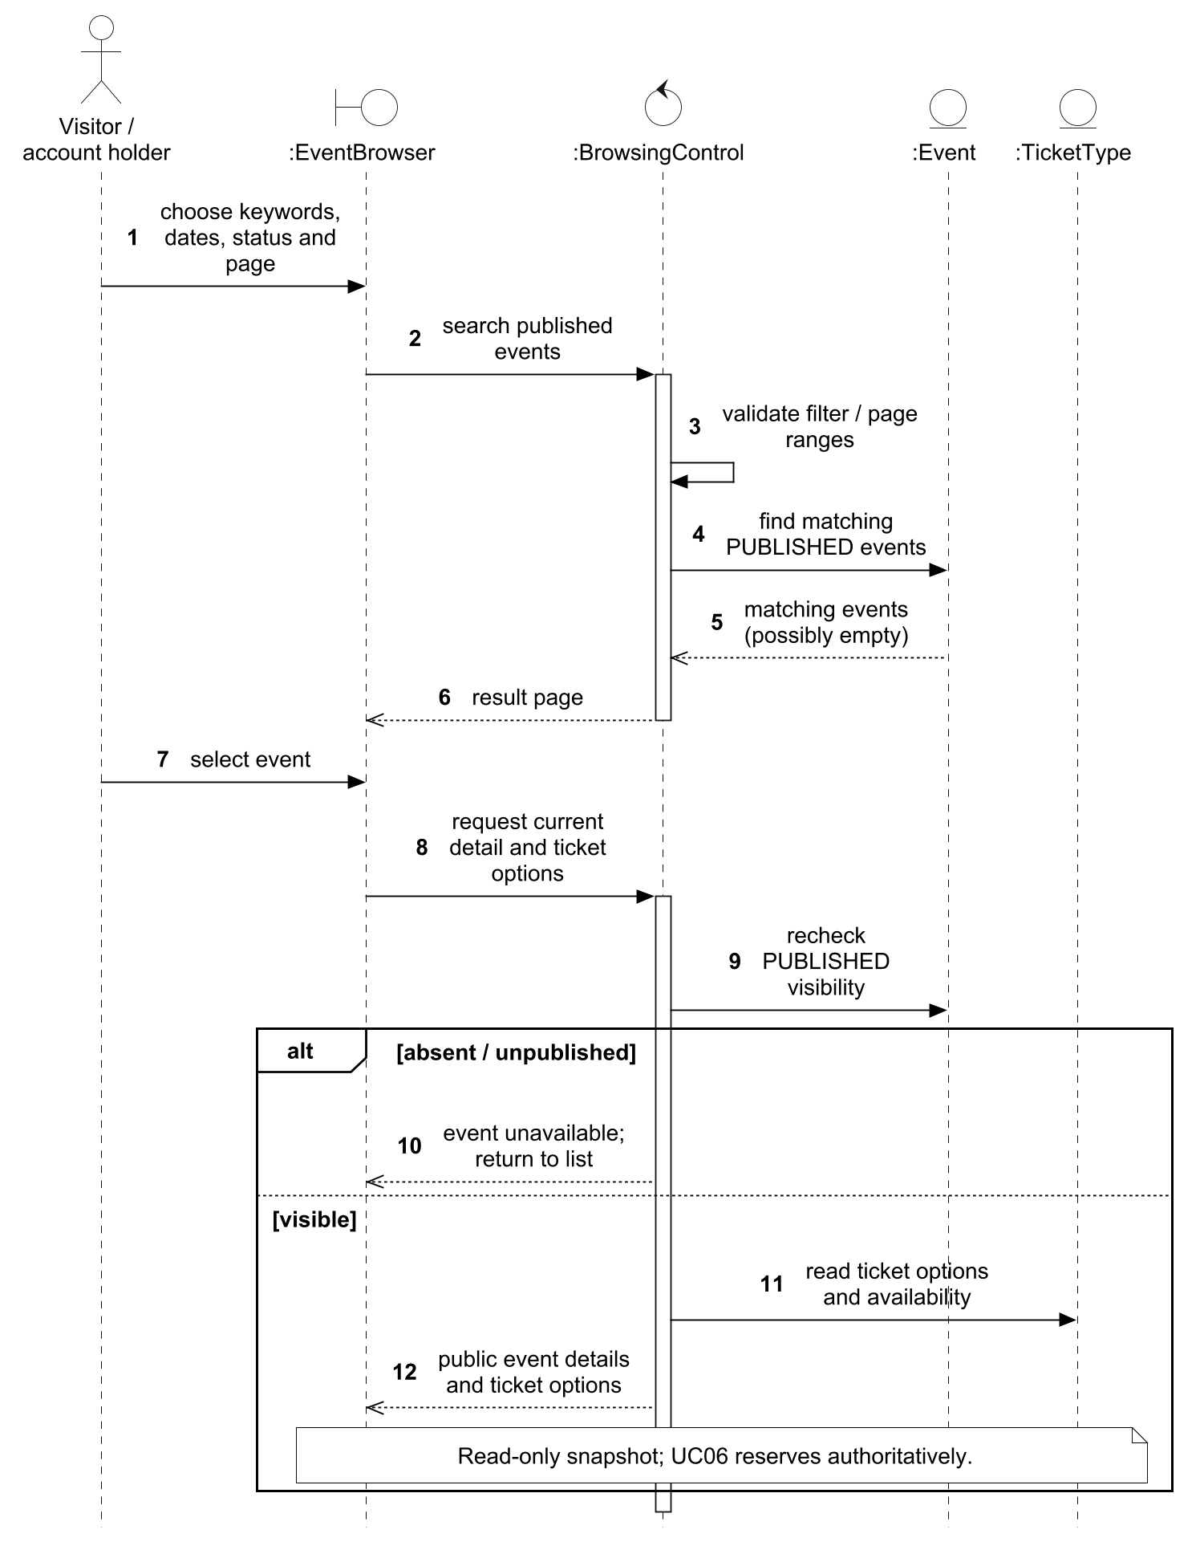
Figure 29. UC05 analysis sequence for searching and selecting event details.

3.4.5.2 Design Models
TS1 refines EventBrowser into the browser, PublicEventController and PublicTicketTypeController. BrowsingControl becomes EventBrowseService and TicketTypeBrowseService; repositories query Event/TicketType, and public view records expose the permitted response fields without returning persistence objects directly. Query validation precedes the search. Detail and ticket requests independently recheck publication because state may change after the list was read. These read-only snapshots neither reserve stock nor promise availability; UC06 performs the authoritative booking checks.
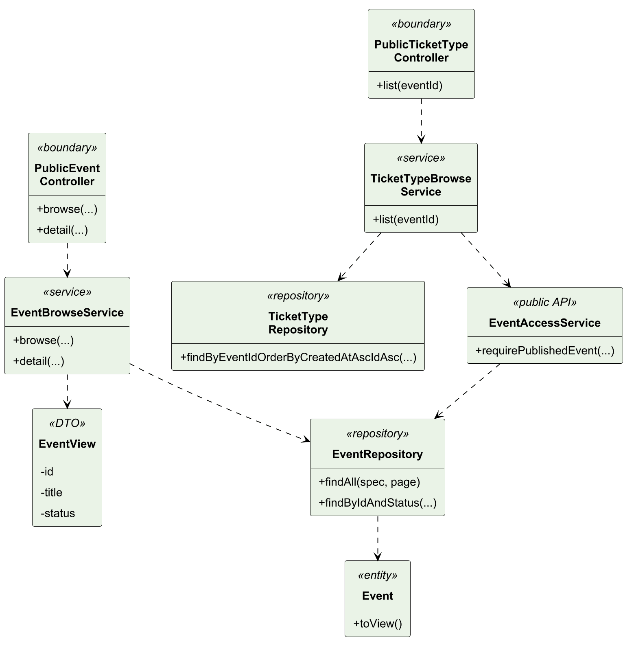
Figure 30. UC05 design class model.
In Figure 31, list, detail and ticket options are separate requests. Rechecking PUBLISHED on the later requests prevents a stale list entry from exposing an unpublished detail; an empty list succeeds, while an unavailable selected event returns not found.
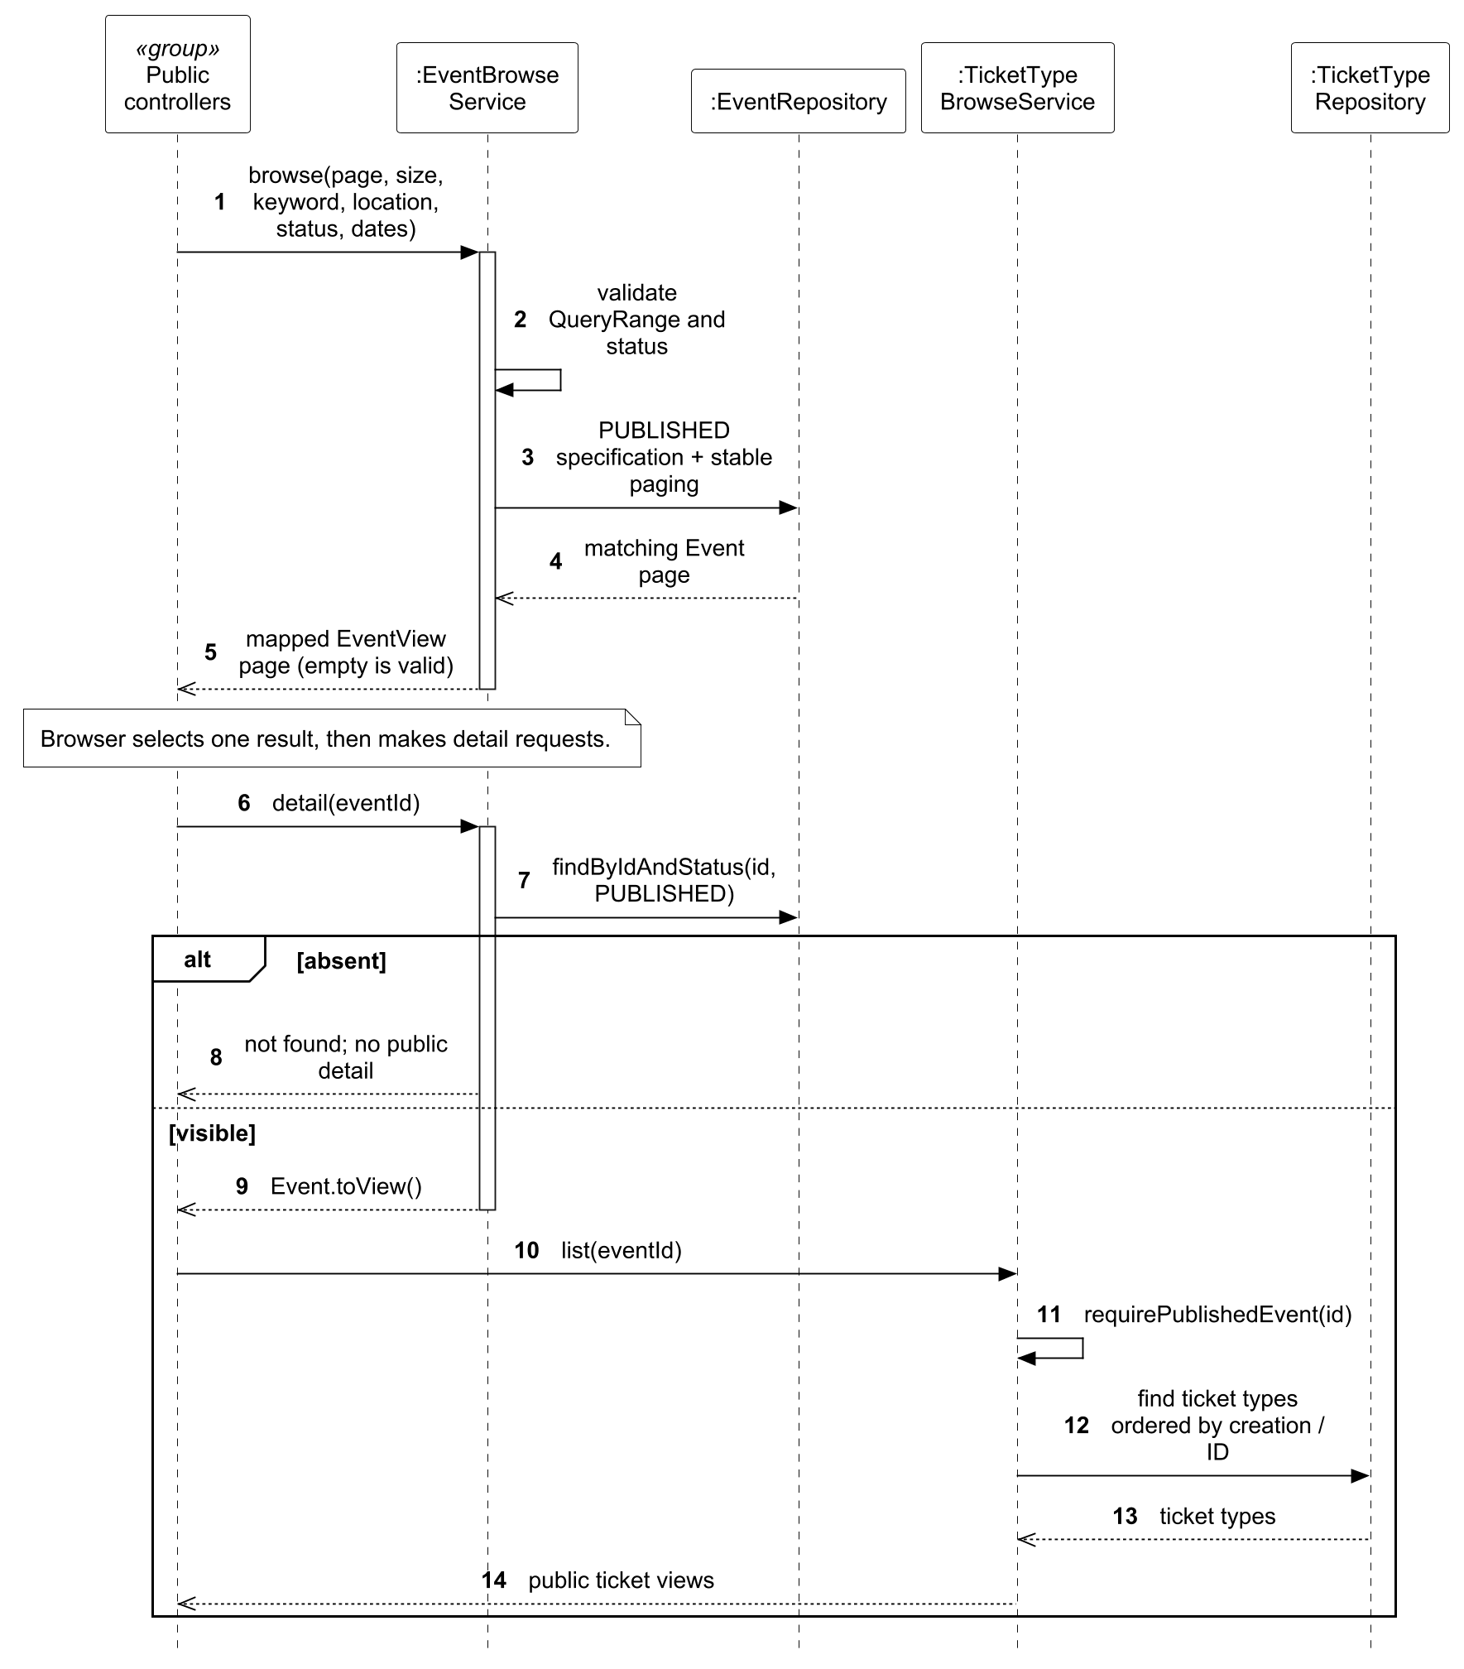
Figure 31. UC05 design sequence for searching and selecting event details.

3.4.6 Use Case 6 by Huang Haoyang
Use case: UC06 Book Tickets. The normal and relevant alternative flows are specified in Section 3.3.7.

3.4.6.1 Analysis Models
BookingForm invokes ReservationControl for booking or cancellation and PreRegistrationControl for private preferences. Booking records the request identity and confirmed quantity; AdmissionTicket represents each admission. PreRegistration stores an intention and may later link to a Booking; the current workflow links at most one preference to one booking. Event, TicketType and Notification supply eligibility, inventory and outcome information. Booking/retry, pre-registration and personal cancellation are distinct major flows.
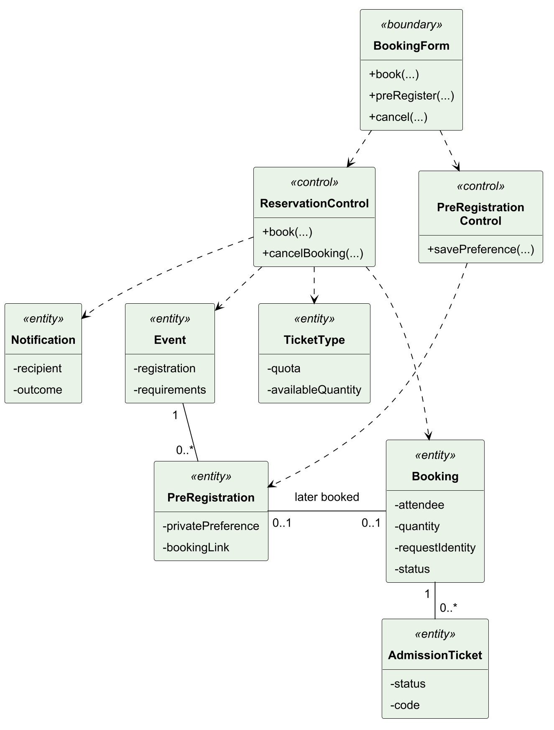
Figure 32. UC06 analysis class model.
Figure 33 distinguishes request replay from a new reservation. An earlier request with the same details returns its existing outcome; different details under the same identity produce a conflict. A new request validates eligibility, information and stock before reserving places, recording the booking, issuing tickets and creating the confirmation notice.
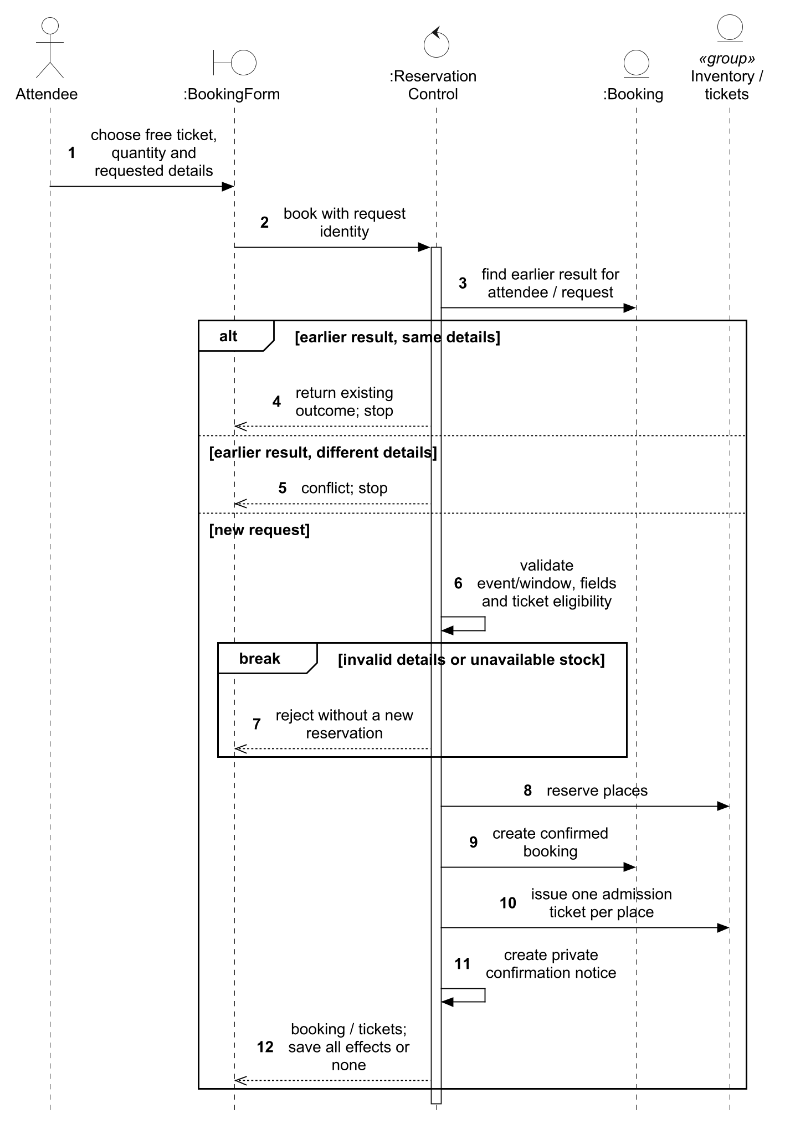
Figure 33. UC06 analysis sequence for booking and retry outcomes.
Figure 34 shows an attendee saving a private preference before registration opens. The control checks the published event, scheduled opening, free ticket type, quantity and required details. Rejection permits correction or formal booking; an eligible preference is saved without reserving stock or issuing admission tickets.
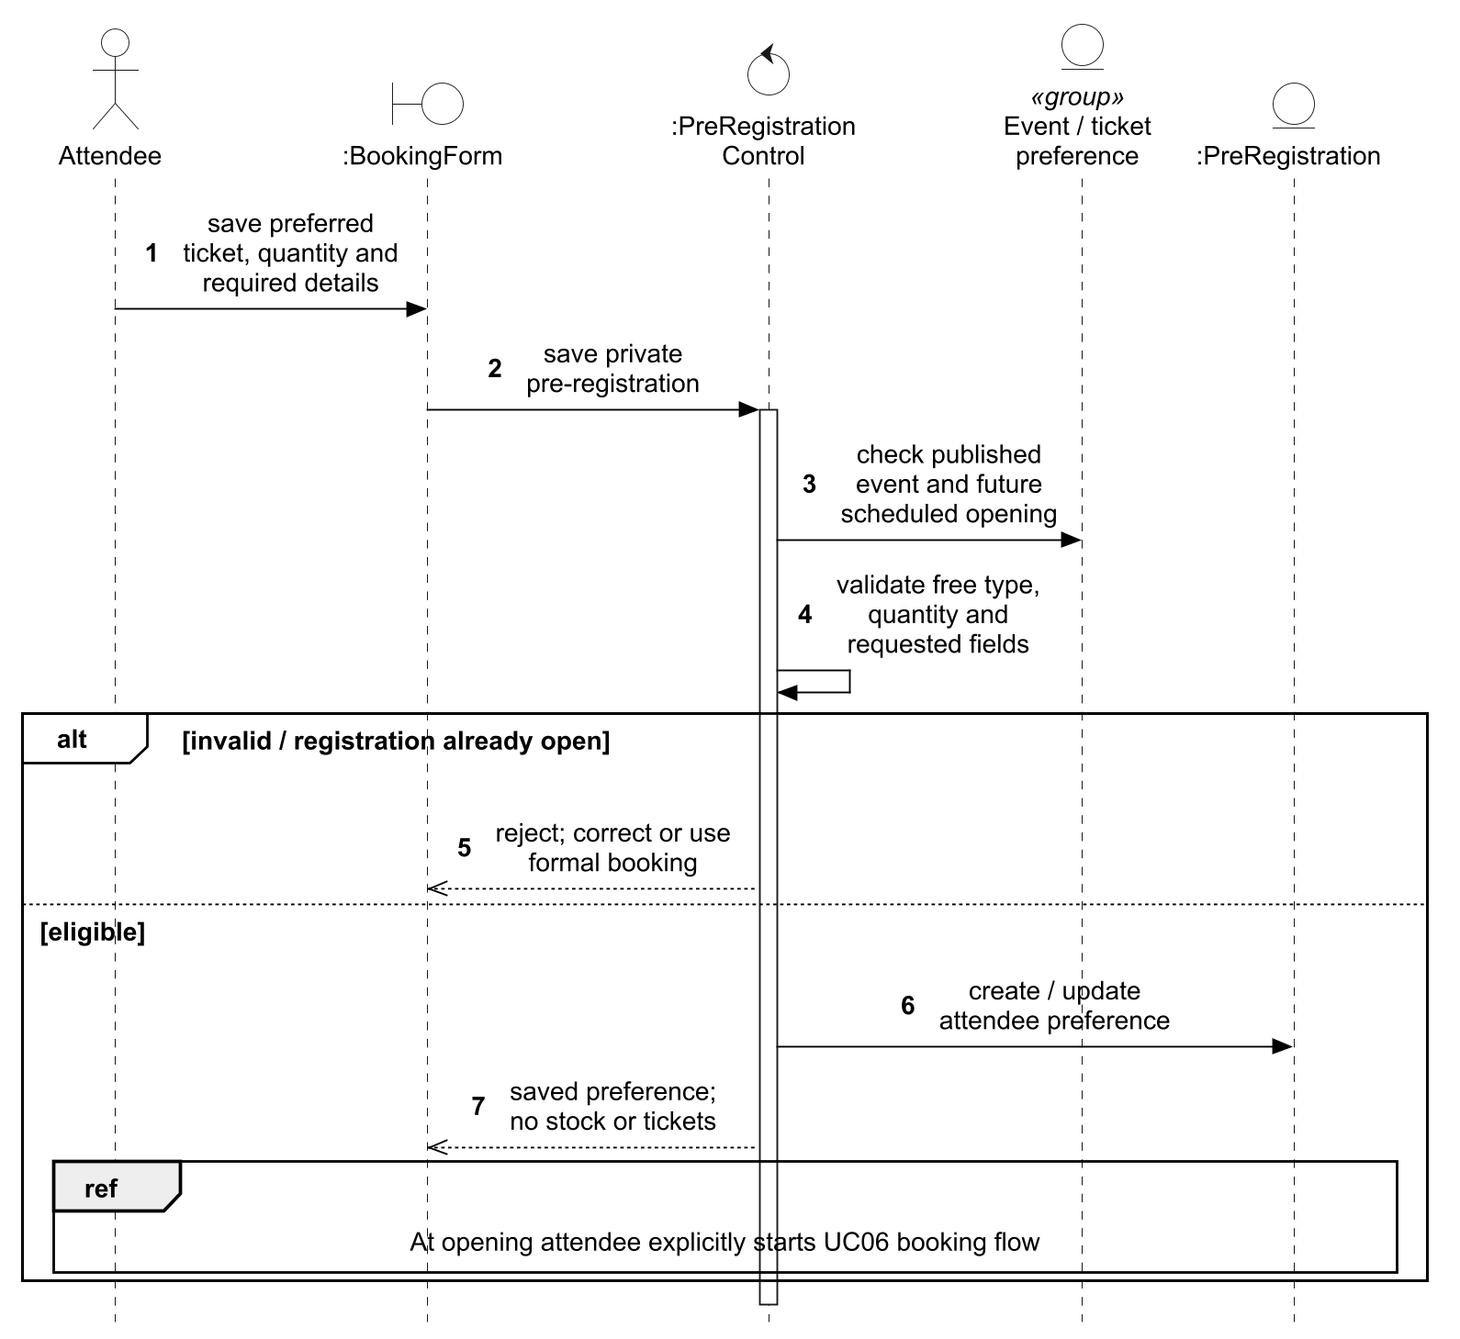
Figure 34. UC06 analysis sequence for private pre-registration.
Figure 35 follows cancellation of the attendee’s selected booking. A missing or foreign booking returns not found, and an already-cancelled booking returns its existing outcome. An active booking is cancellable only before the event starts and when no ticket has been used; accepted cancellation releases places once and creates the notice.
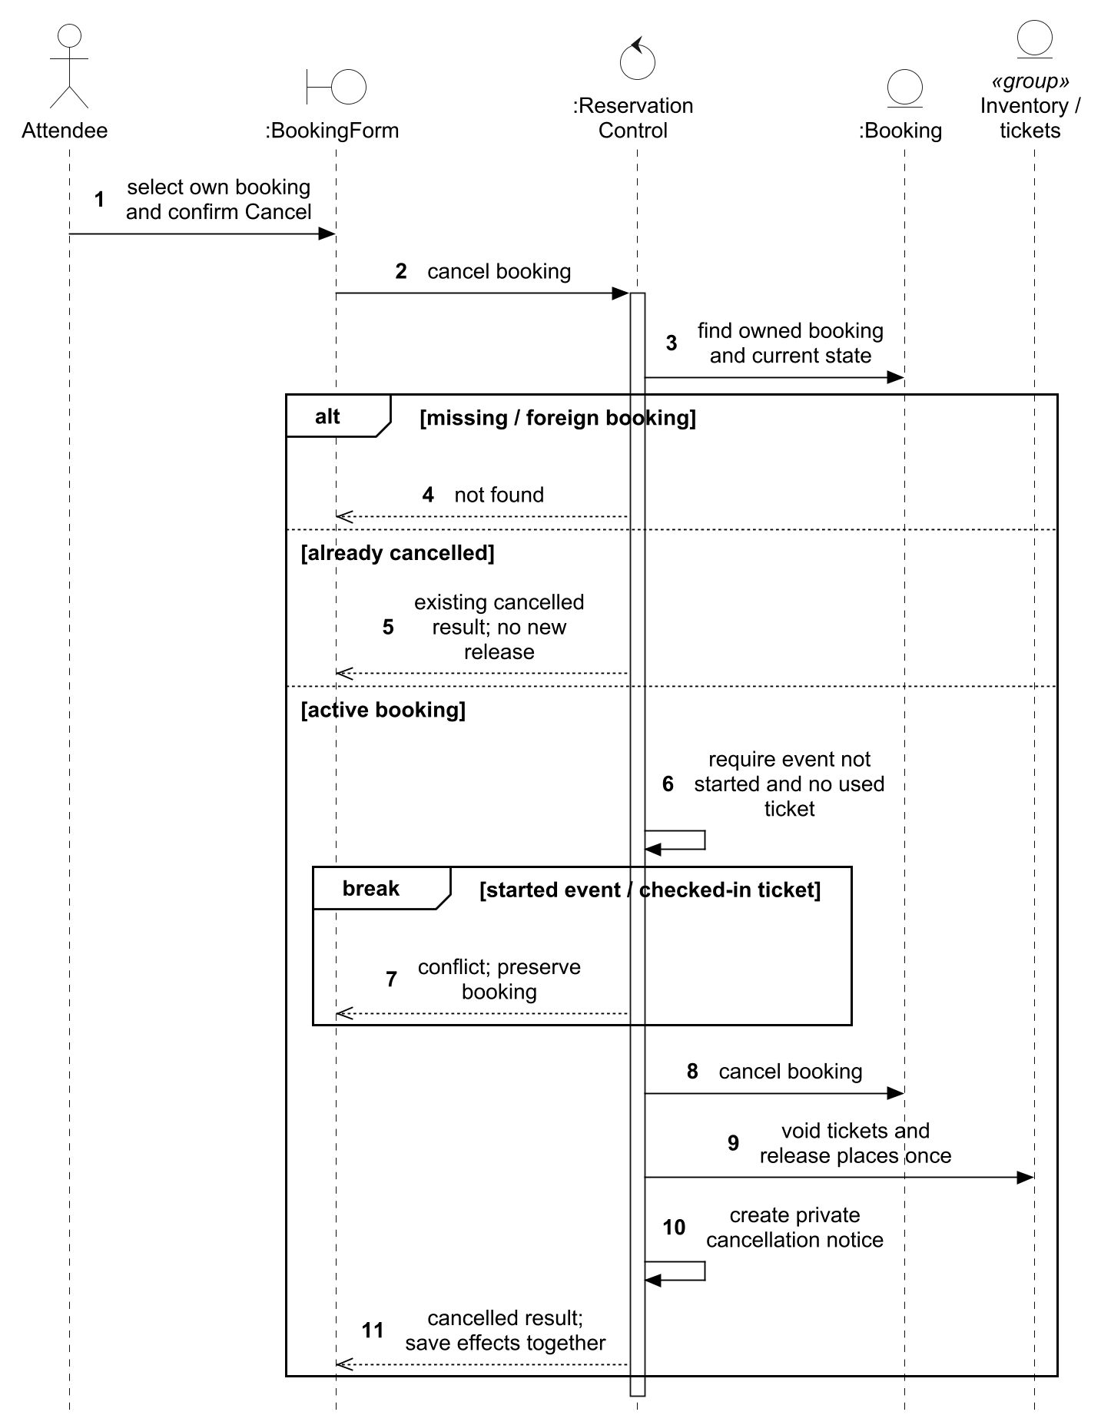
Figure 35. UC06 analysis sequence for cancelling an owned booking.

3.4.6.2 Design Models
TS1 maps ReservationControl to BookingService and PreRegistrationControl to PreRegistrationService, each behind its own controller. Booking and PreRegistration remain separate entities and repositories because an intention does not consume inventory. TS3 checks ATTENDEE and ownership. TS2 serializes the user/request key before locking the event: the first protects request identity, the second protects eligibility and stock. Database uniqueness backs the request identity, and matching replay exits before reservation. TS4 keeps confirmation/cancellation listeners synchronous. TS5 shares BookingInfoValidator field strategies with pre-registration. In Figure 37, the persistence group is BookingRequestLock, BookingRepository and PreRegistrationRepository; public APIs are EventAccessService and TicketReservationService; listeners are BookingConfirmationListener and BookingNotificationListener. UC07 and Section 3.5 expand ticket-state and notification internals.
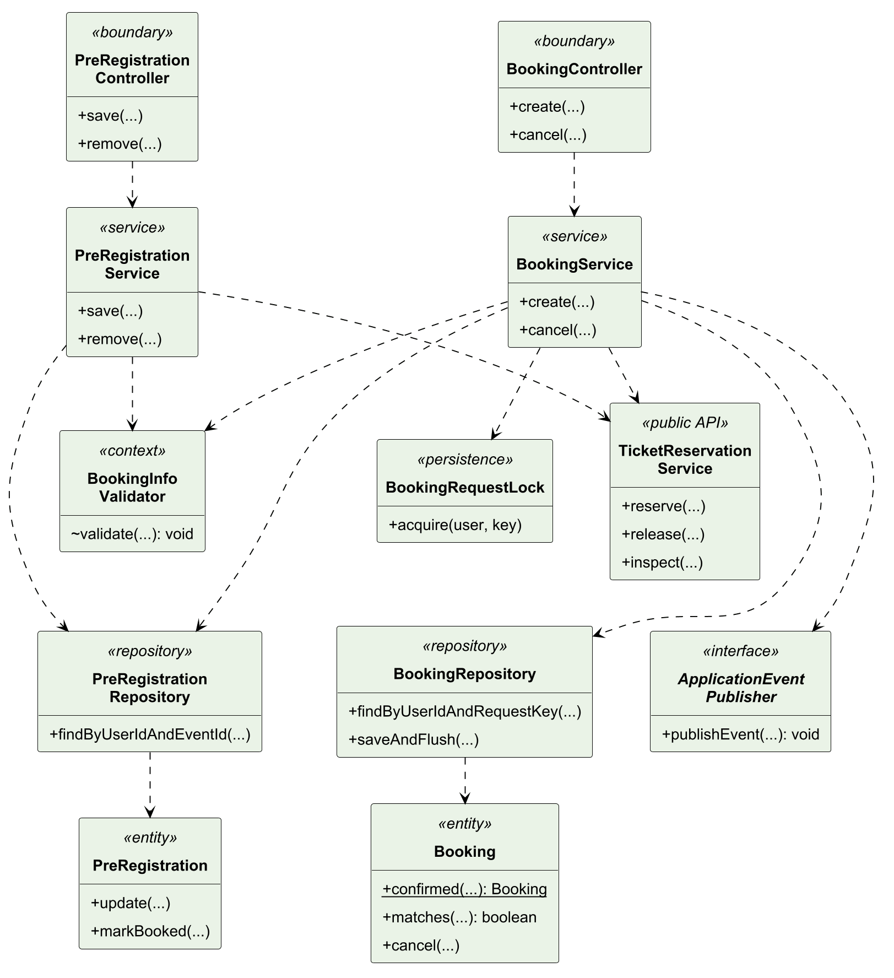
Figure 36. UC06 design class model.
In Figure 37, a matching request key returns the prior outcome before any stock mutation; a conflicting payload stops. A new request locks the event, validates attendee fields, reserves eligible free stock and saves the booking before synchronous issuance/notification. Required side-effect failure rolls back the related writes.
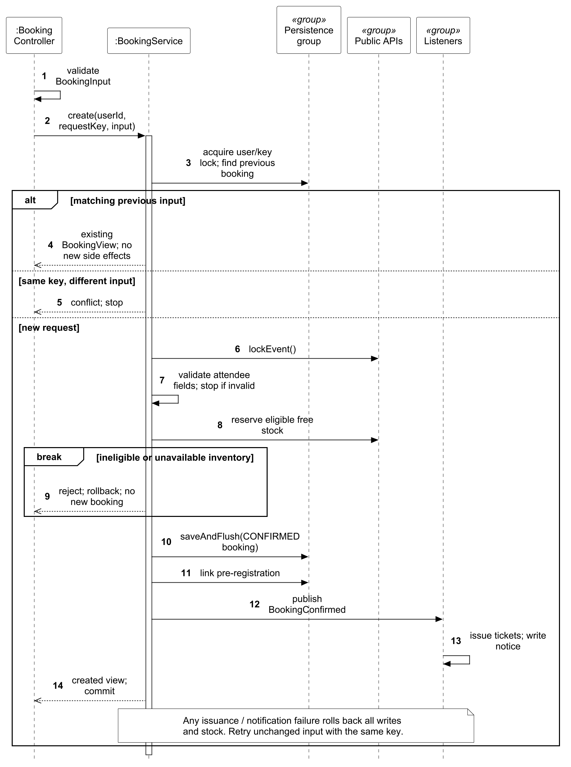
Figure 37. UC06 design sequence for booking and idempotent retries.
In Figure 38, the service validates a published event whose registration has not opened, its ticket eligibility and attendee fields, then upserts the private preference. It neither reserves stock nor issues tickets. Formal booking must revalidate current conditions and may then link the saved preference.
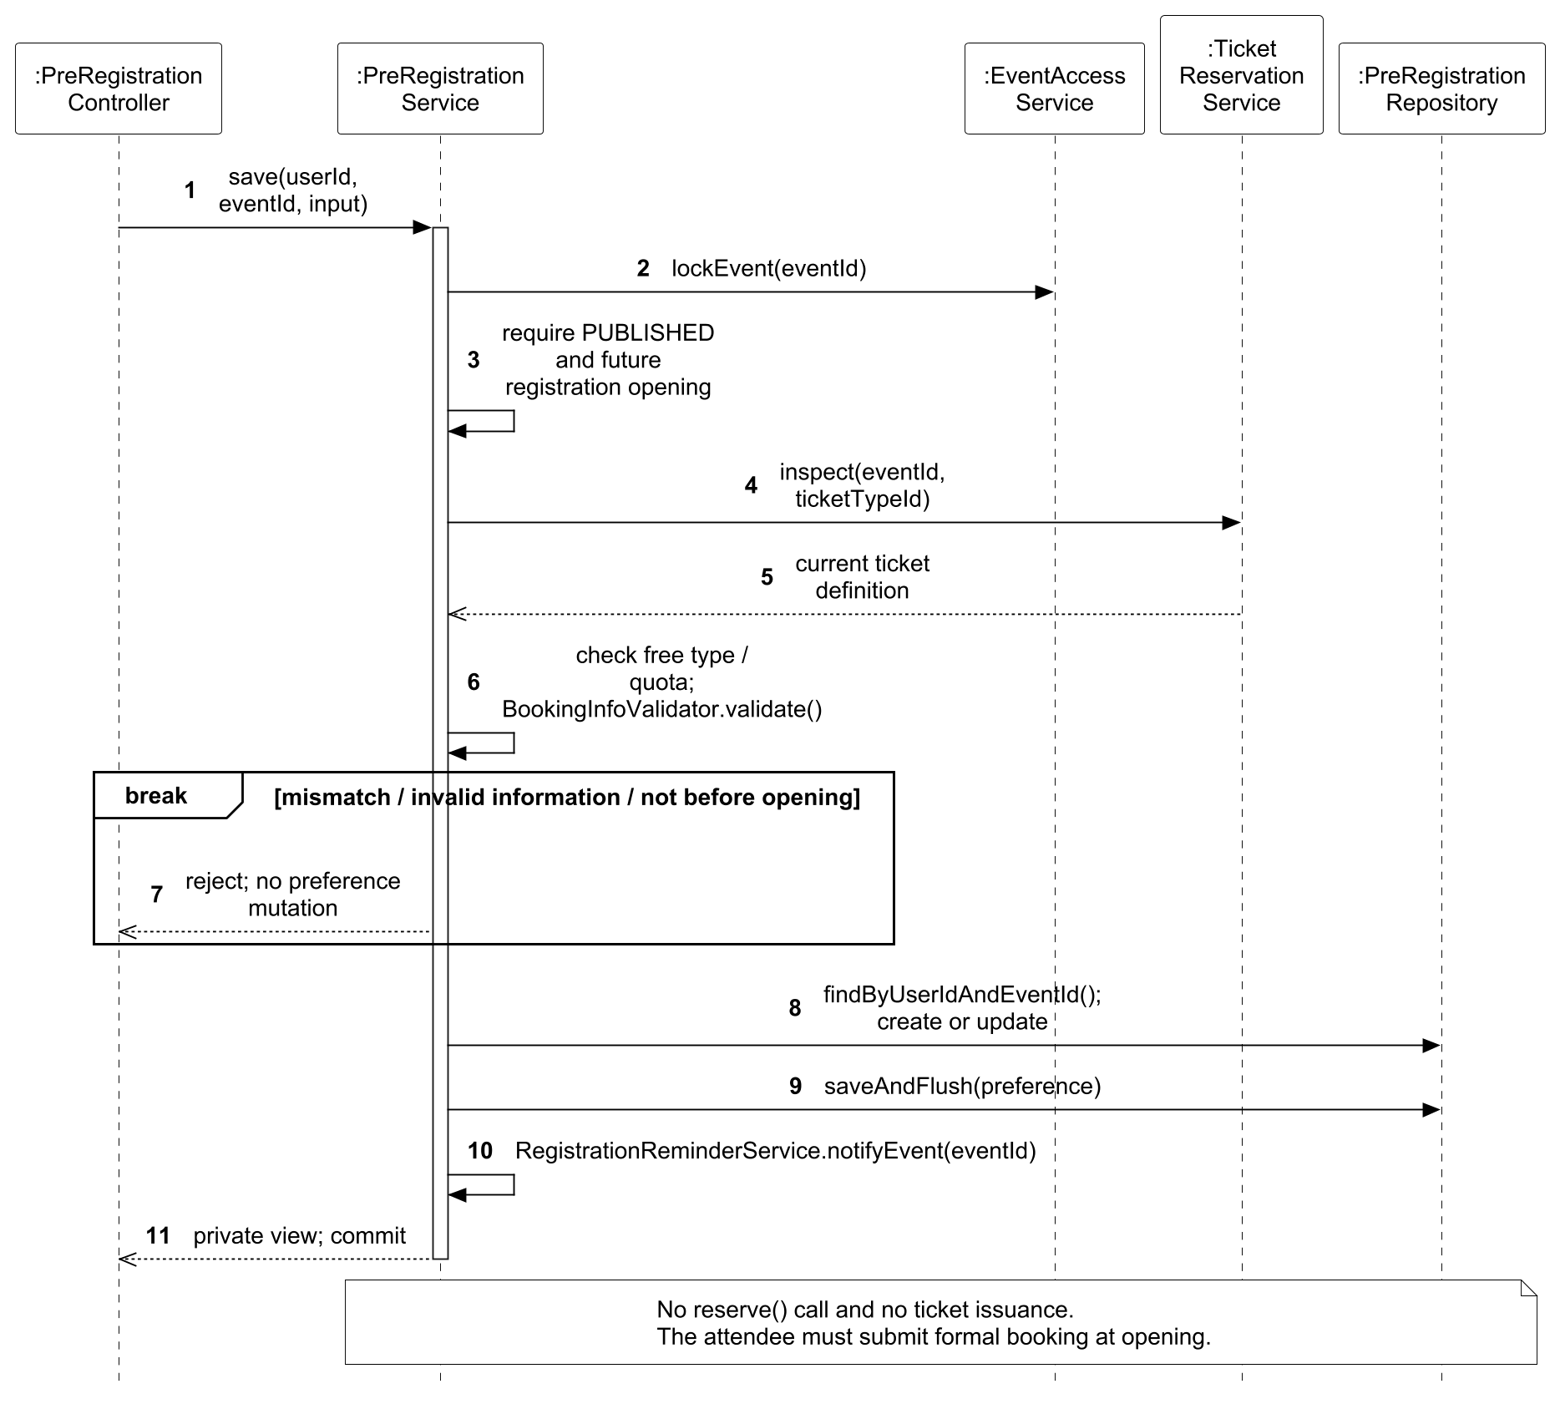
Figure 38. UC06 design sequence for private pre-registration.
In Figure 39, ownership is checked before an already-cancelled request returns its existing result. That early return precedes current cancellation eligibility, allowing a harmless retry after the time window has passed. A fresh cancellation rejects a started event or checked-in ticket and releases stock only once within the transaction.
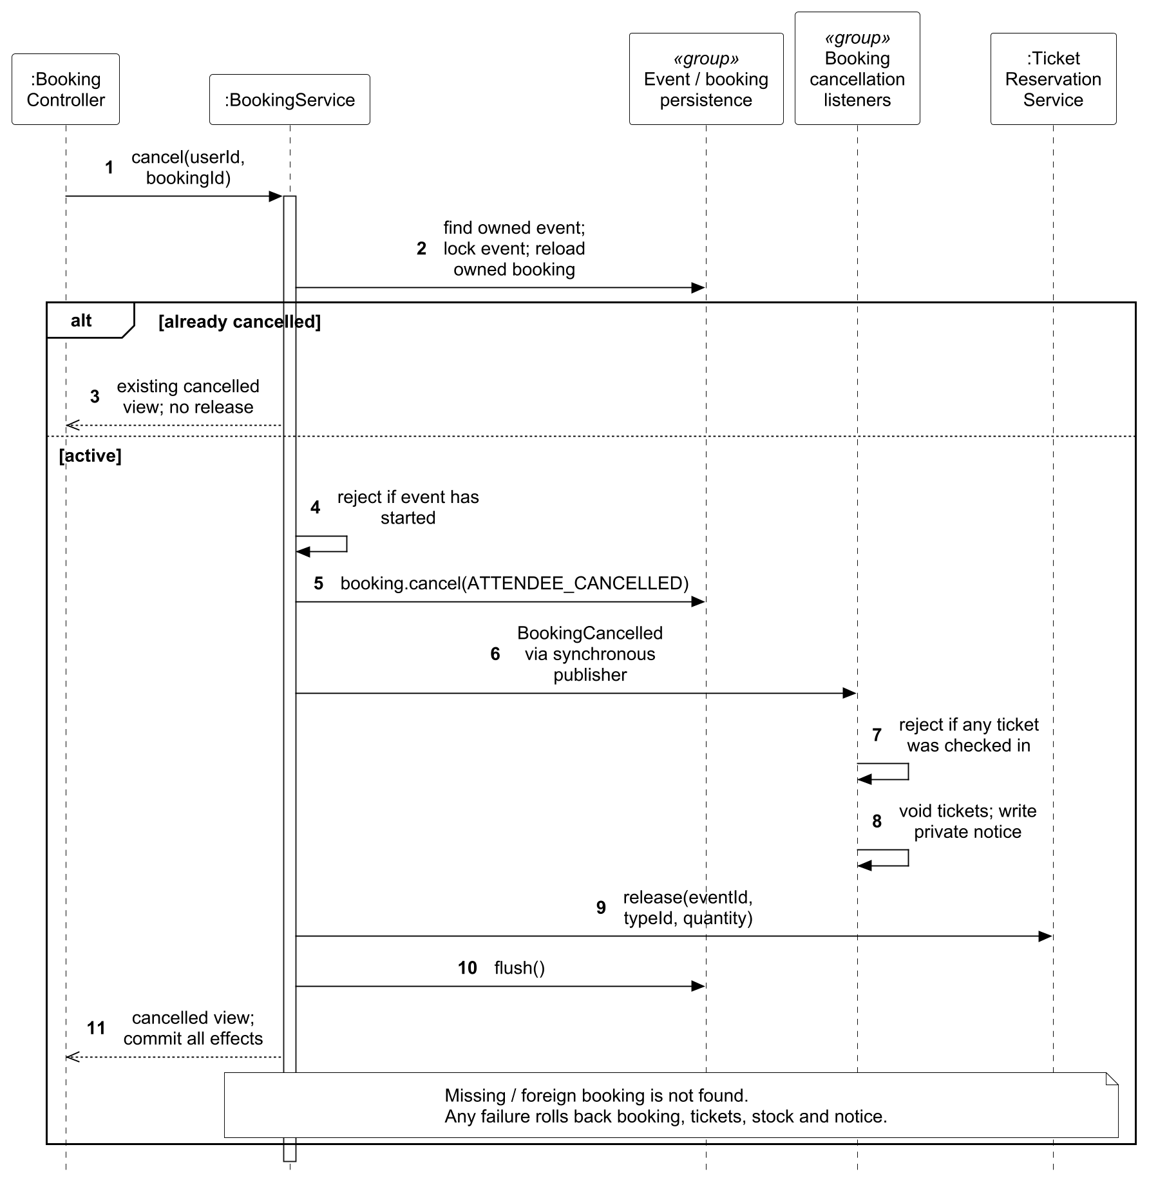
Figure 39. UC06 design sequence for cancelling an owned booking.
Table 12 compares the same booking responsibility at the two abstraction levels. Figure 33 names the attendee, boundary, reservation control and business information; Figure 37 adds the concrete request-key, event-lock and synchronous side-effect mechanisms. This distinction links the use-case flow to the design and its integration tests.
Business step | Analysis responsibility | Implemented design decision
Accept a booking | BookingForm passes an attendee request to ReservationControl. | BookingController adapts HTTP input; BookingService coordinates the use case.
Handle a retry | Find an earlier booking outcome before reserving again. | BookingRequestLock serializes the user/request key; a matching result returns before inventory changes.
Confirm availability | Check eligibility and available stock. | Lock the event, check registration and ticket eligibility, validate attendee information, then reserve stock through TicketReservationService.
Complete the order | Return a confirmed booking and admission tickets. | Save CONFIRMED, publish BookingConfirmed, and run ticket/notification listeners synchronously in the originating transaction.
Reject unsafe outcomes | Return rejection without an invalid business result. | Conflicting replay input is rejected; listener failures roll back booking, stock, tickets and notification writes.
Table 12. Booking responsibilities and their implementation mechanisms

3.4.7 Use Case 7 by Luo Runzhou
Use case: UC07 Check In Ticket. The normal and relevant alternative flows are specified in Section 3.3.8.

3.4.7.1 Analysis Models
CheckInScreen invokes AdmissionControl for verification and admission. StaffAssignment and Event determine current access and the admission window; Ticket and Booking determine eligibility. CheckInRecord records operator and time. The two sequences separate reading the current ticket status from changing it and writing an audit record.
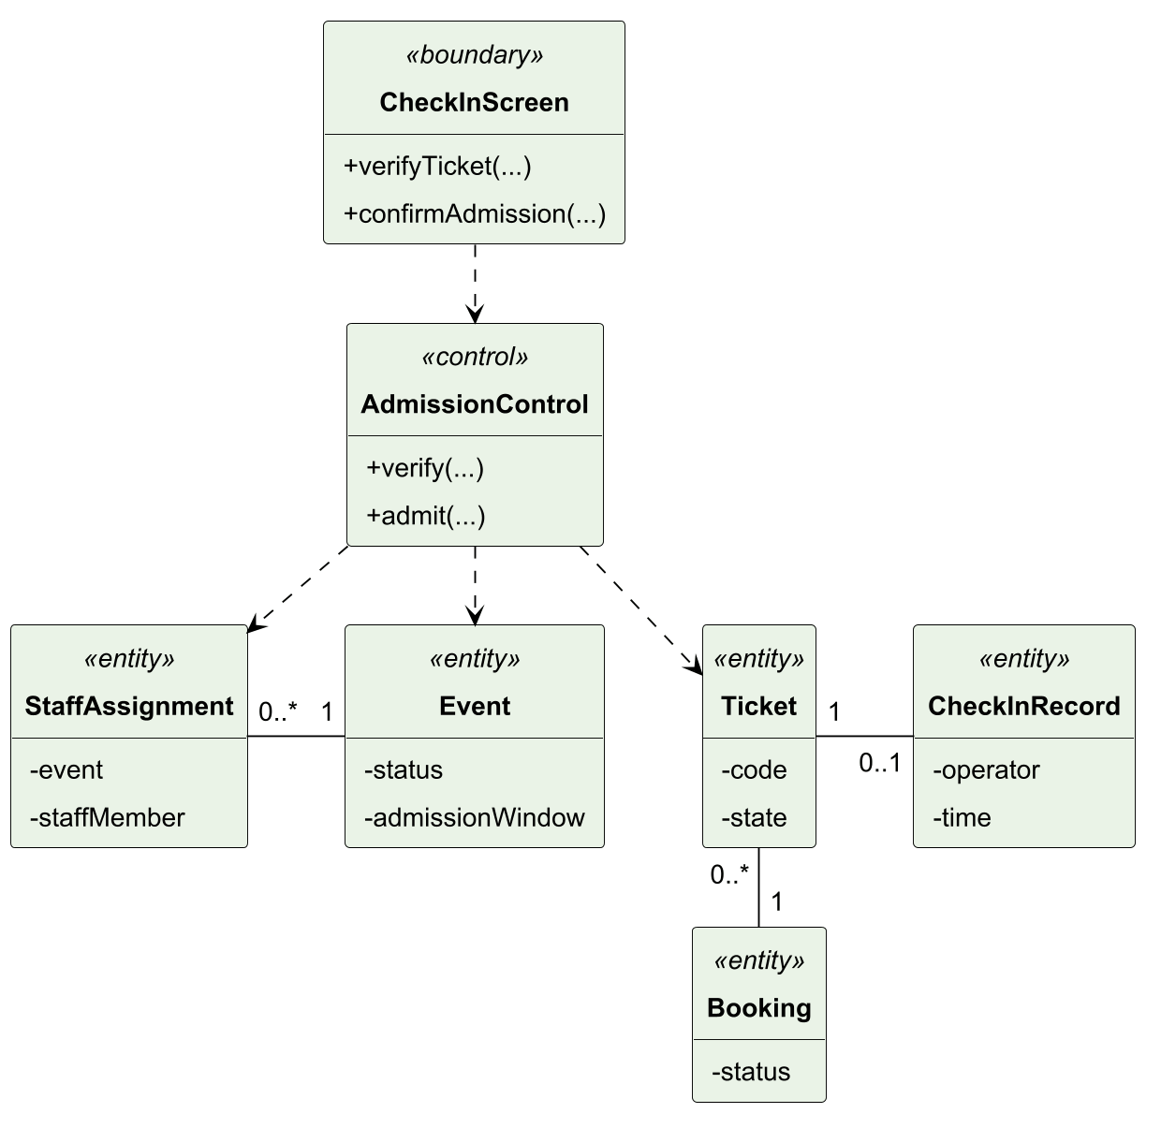
Figure 40. UC07 analysis class model.
Figure 41 shows staff selecting an event and verifying a scanned or entered code. Assignment, publication and the admission window are checked before the selected-event ticket lookup. Invalid access, timing or code returns an error; a found ticket returns its current status without changing it or creating an admission record.
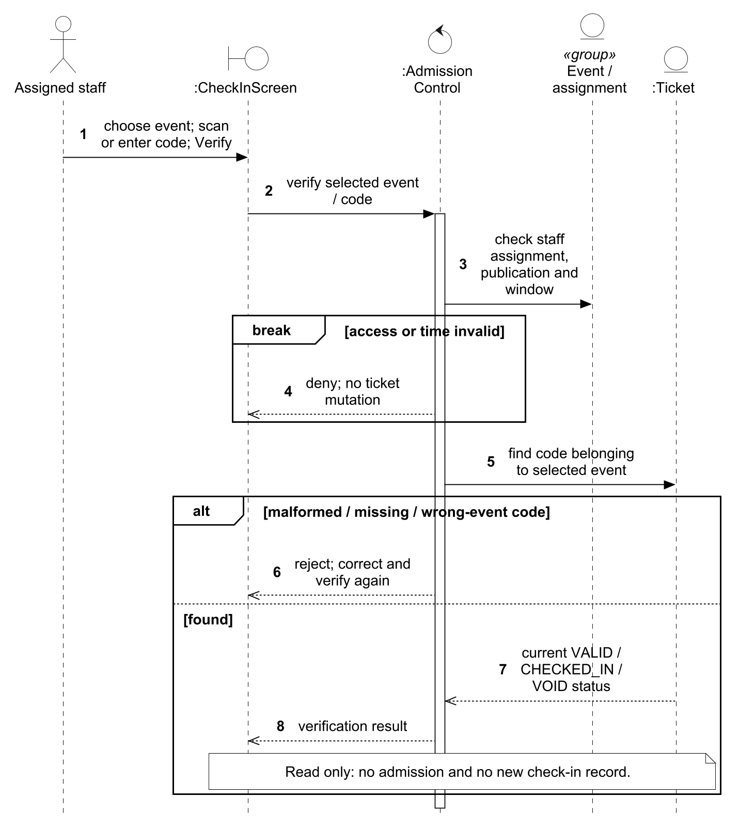
Figure 41. UC07 analysis sequence for verifying ticket status.
Figure 42 shows confirmation of admission with fresh permission, assignment, timing and ticket-eligibility checks. Lost access, an inactive booking or an invalid or already-used ticket produces rejection. An eligible ticket becomes CHECKED_IN and receives one operator-and-time record, with both changes saved together.
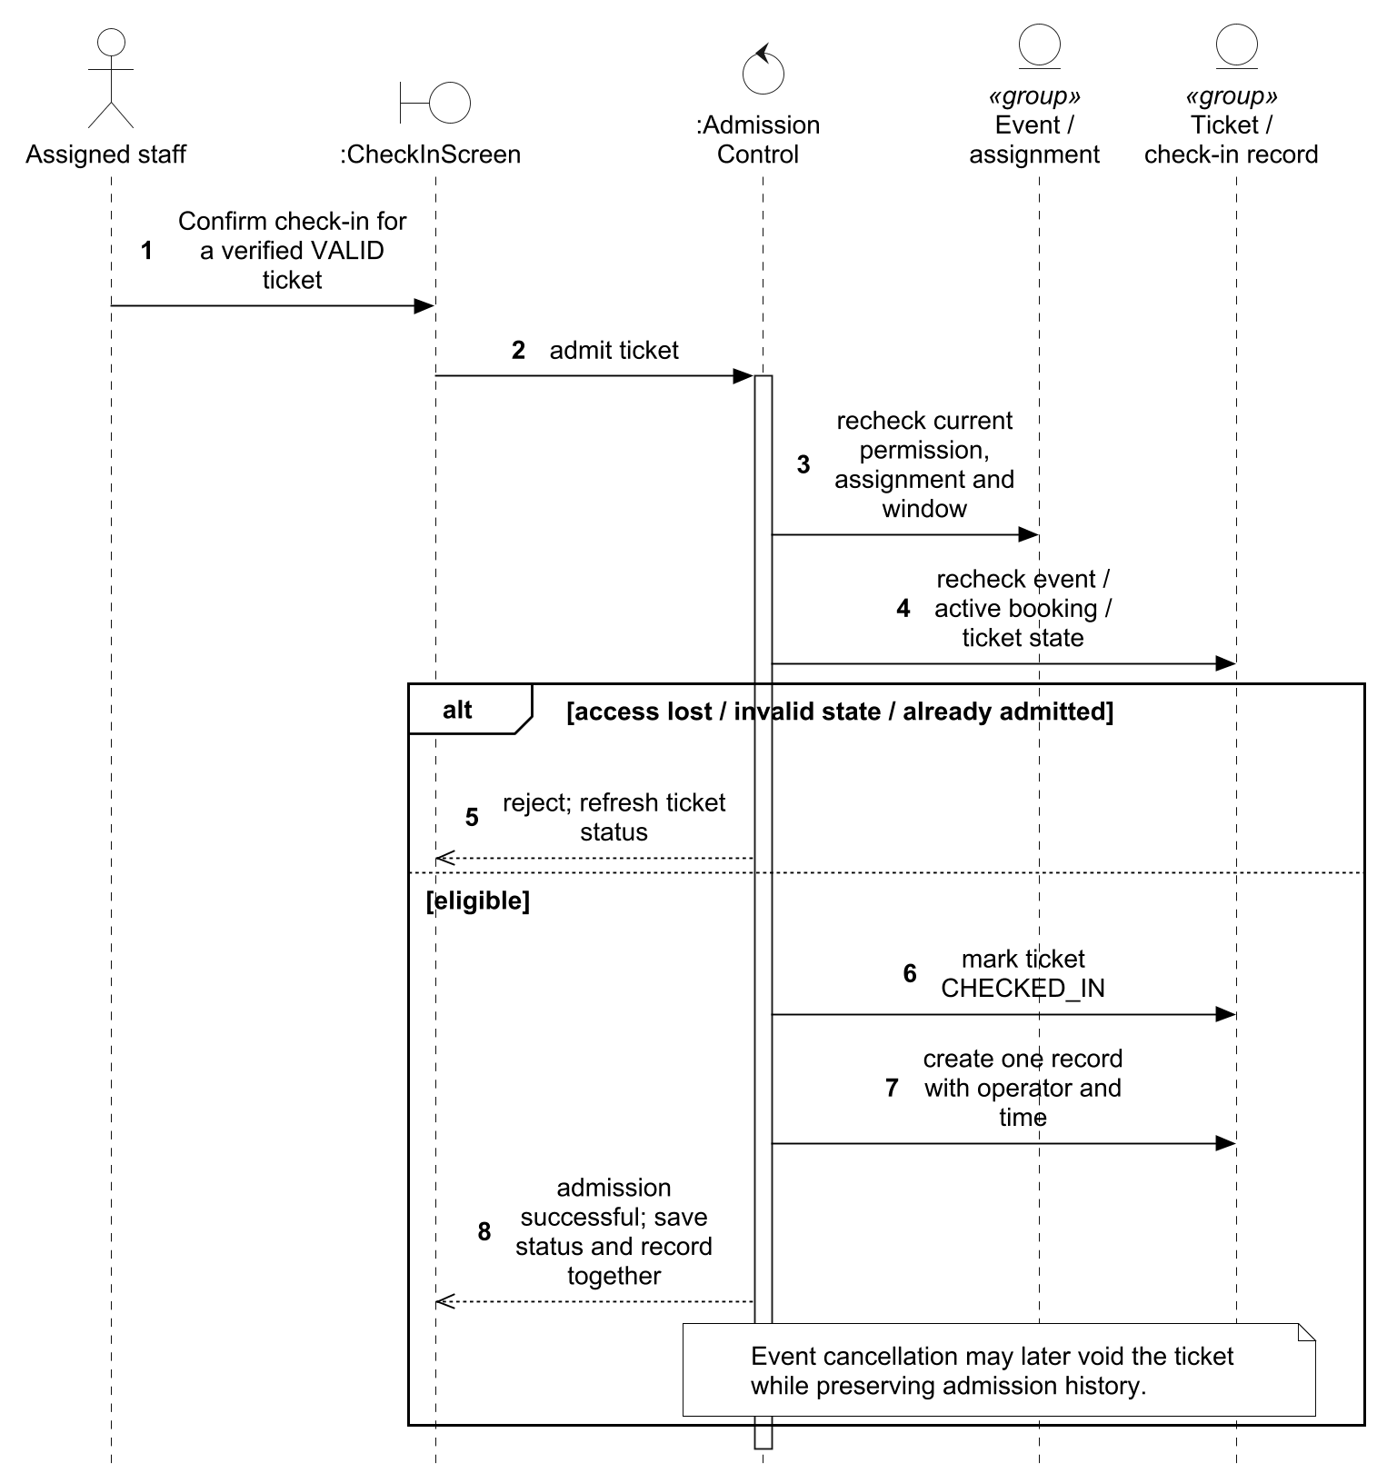
Figure 42. UC07 analysis sequence for confirming admission.

3.4.7.2 Design Models
TS1 maps CheckInScreen to the browser and CheckInController. Ticket becomes IssuedTicket, with TS5 delegating state-dependent operations to TicketState. StaffAssignment and CheckInRecord are realized by current JdbcTemplate queries/inserts rather than independent entity services. CheckInController retains transaction orchestration and cross-table SQL, the documented TS1 separation exception. TS3 combines effective STAFF with current assignment and the admission window. Under TS2, verification takes the event lock to read eligibility consistently with event cancellation; it writes no admission or audit. Admission repeats the guards because an earlier verification cannot authorize a later mutation, then commits the state change and unique audit record together. Later cancellation retains audit history.
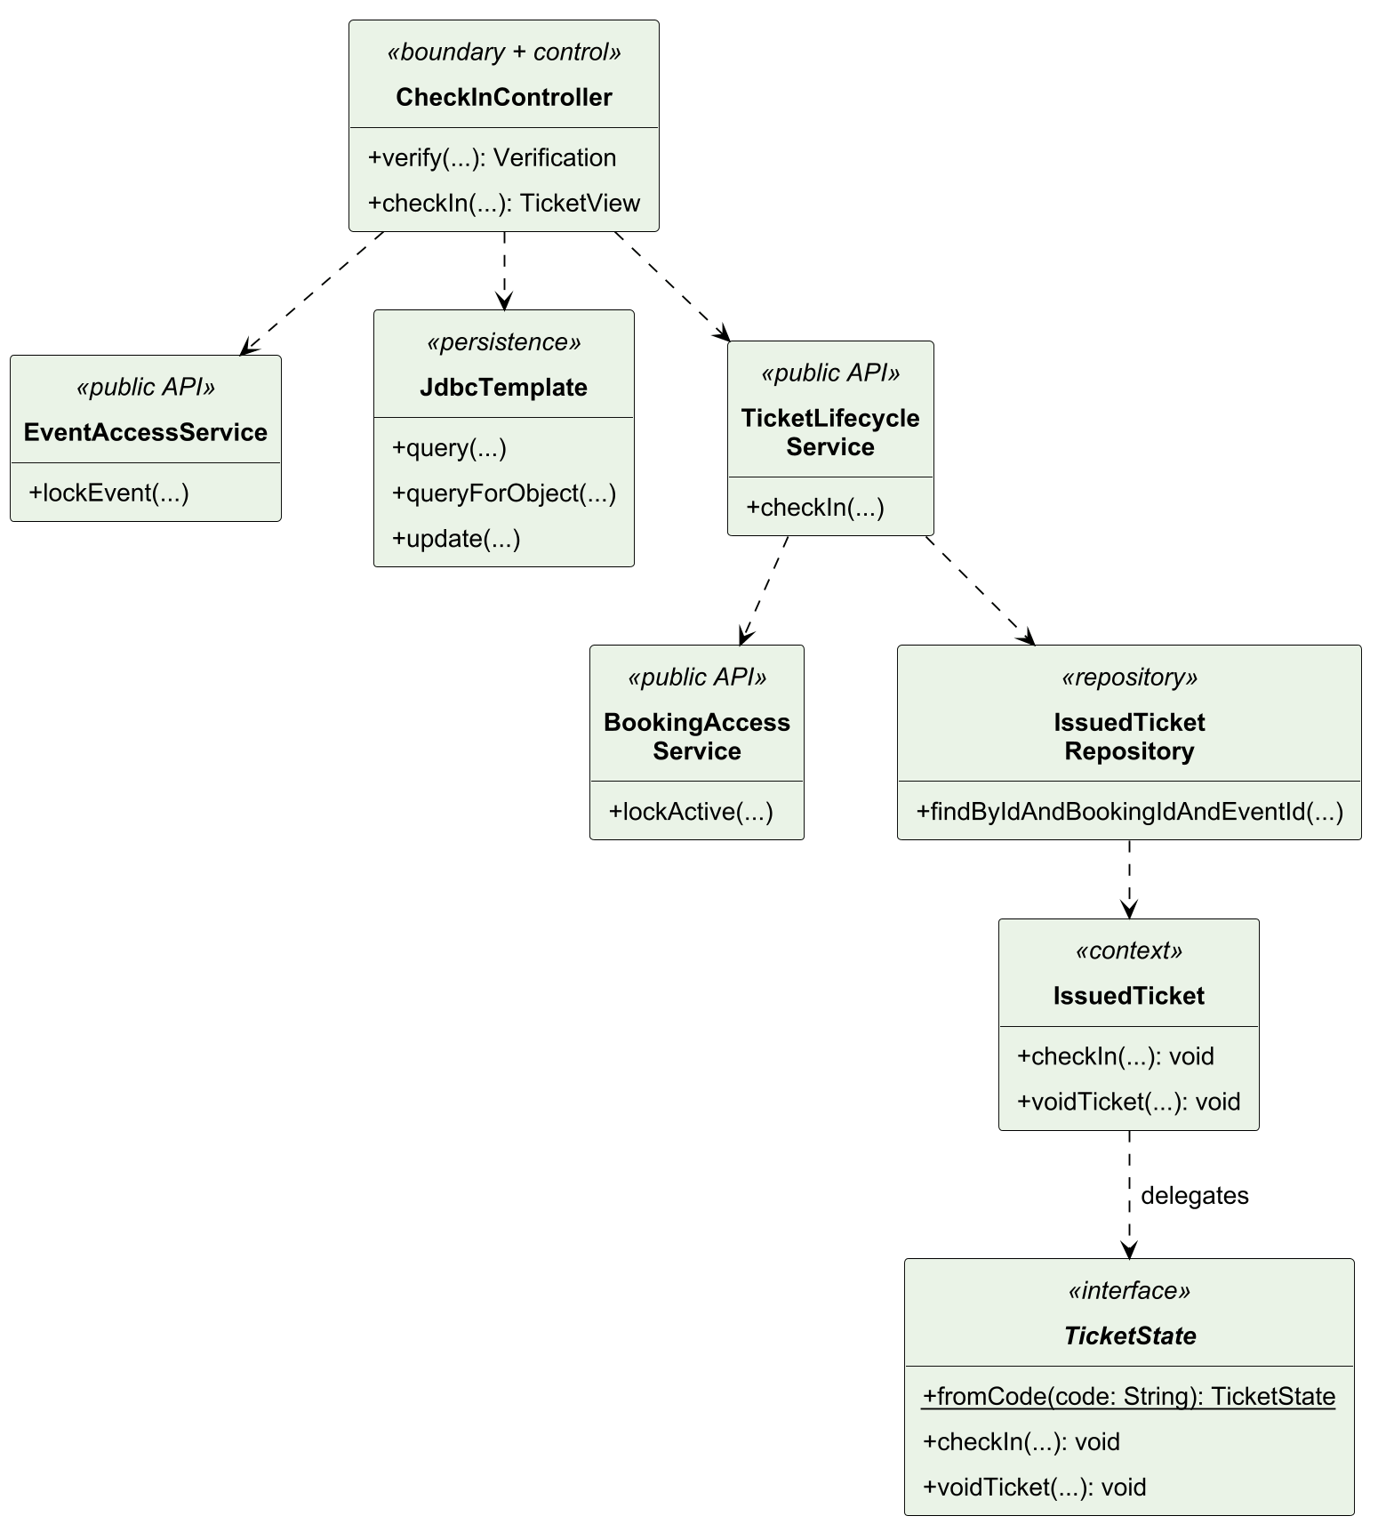
Figure 43. UC07 design class model.
In Figure 44, current role, assignment and admission-window guards precede the selected-event code lookup. Verification returns VALID, CHECKED_IN or VOID as current status and creates no audit record; a successful response is a snapshot rather than permission to skip admission checks.
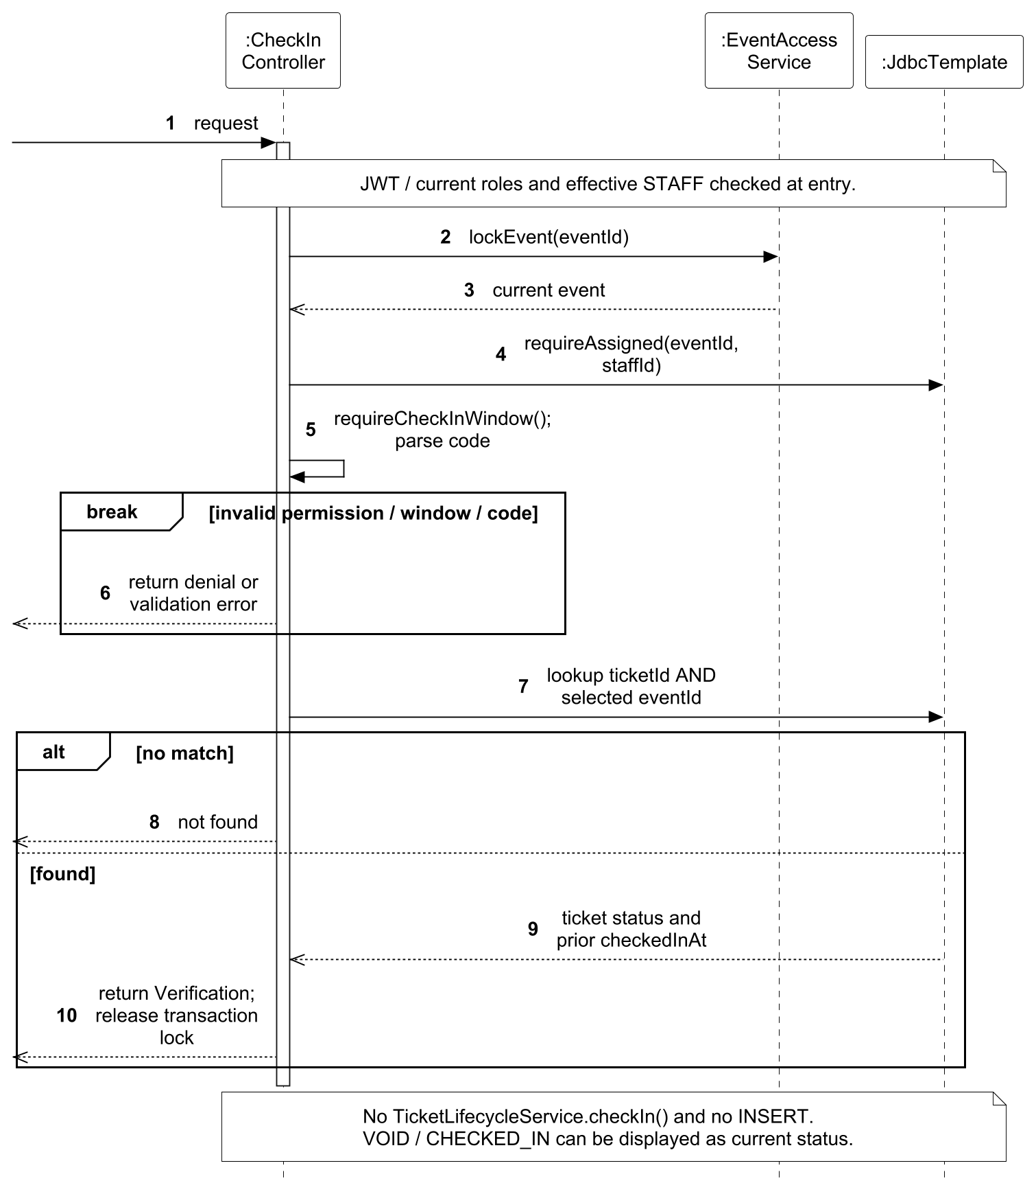
Figure 44. UC07 design sequence for read-only verification.
In Figure 45, admission obtains fresh event/booking/ticket guards before TicketState changes the issued ticket. A missing or inactive booking, VOID state or repeated admission stops before a new audit insert. Flushing the ticket change and inserting the unique record in one transaction prevents a committed state/audit mismatch.
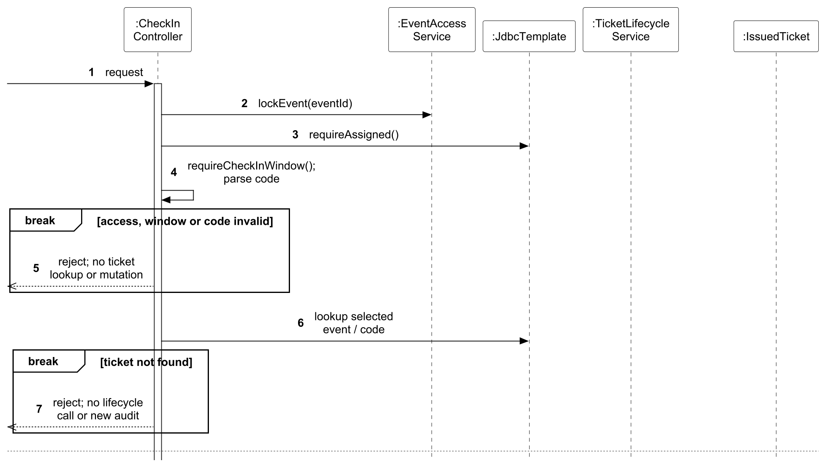
Figure 45. UC07 design sequence for admission and its audit Part 1 of 2.
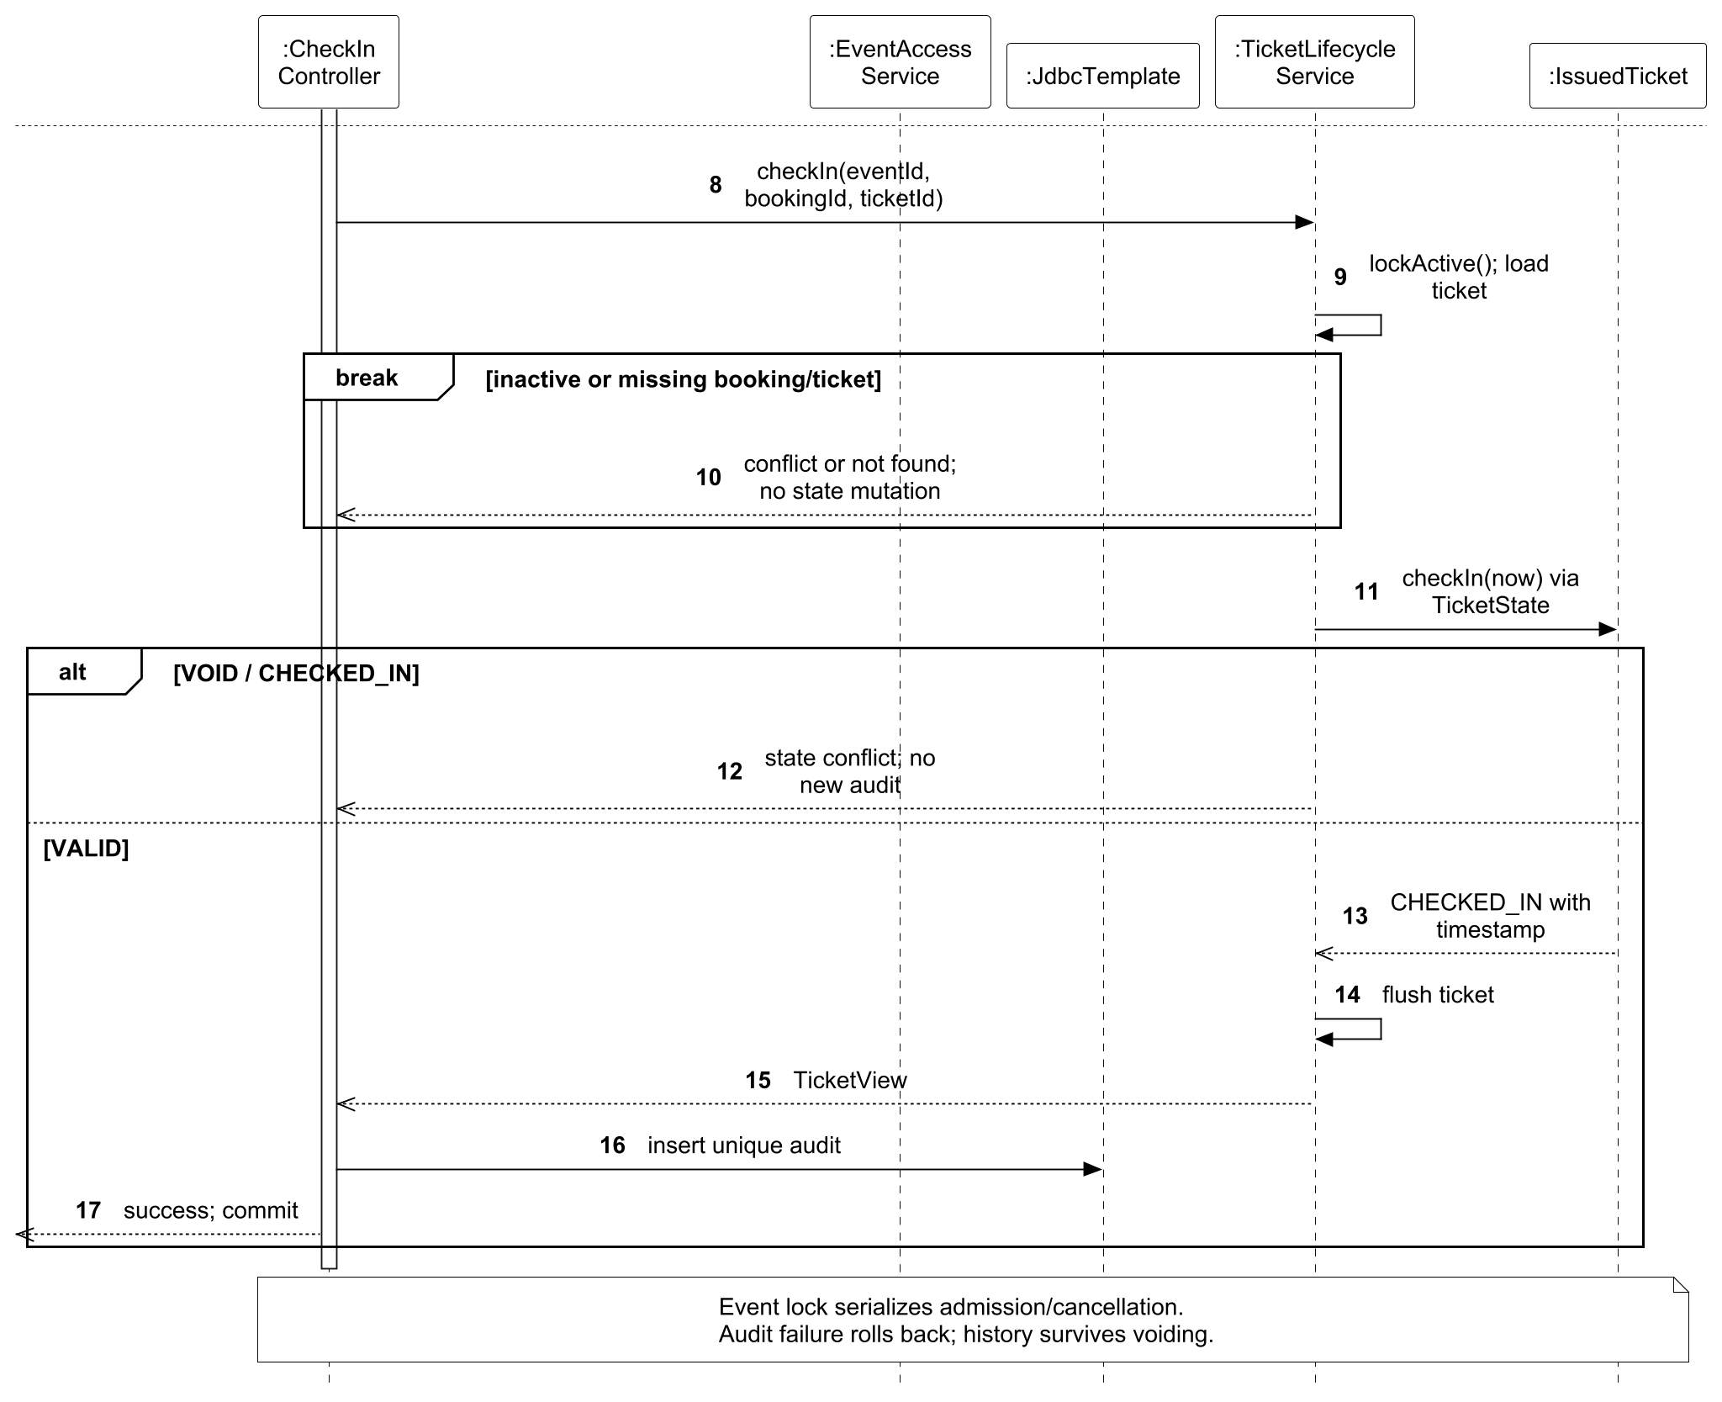
Figure 45 (continued). UC07 design sequence for admission and its audit Part 2 of 2.
The common authorization entry in Figures 46 and 47 precedes protected use-case dispatch. It complements UC07’s domain models and is also referenced by UC02, UC03, UC04 and UC06: token validity, current effective role and access to the requested resource are separate guards. A failed guard stops the later operation.
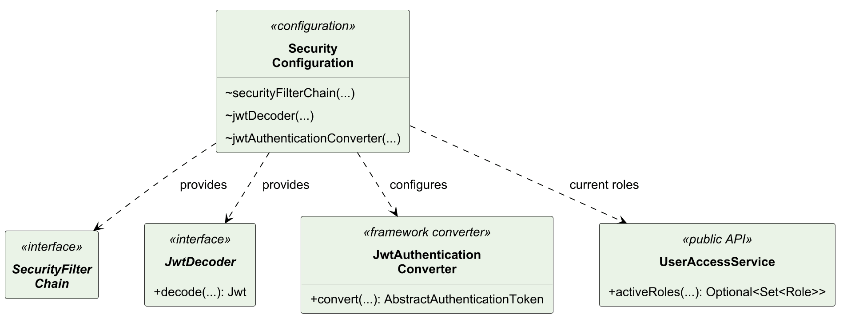
Figure 46. Selected authorization-entry dependencies configured by SecurityConfiguration.
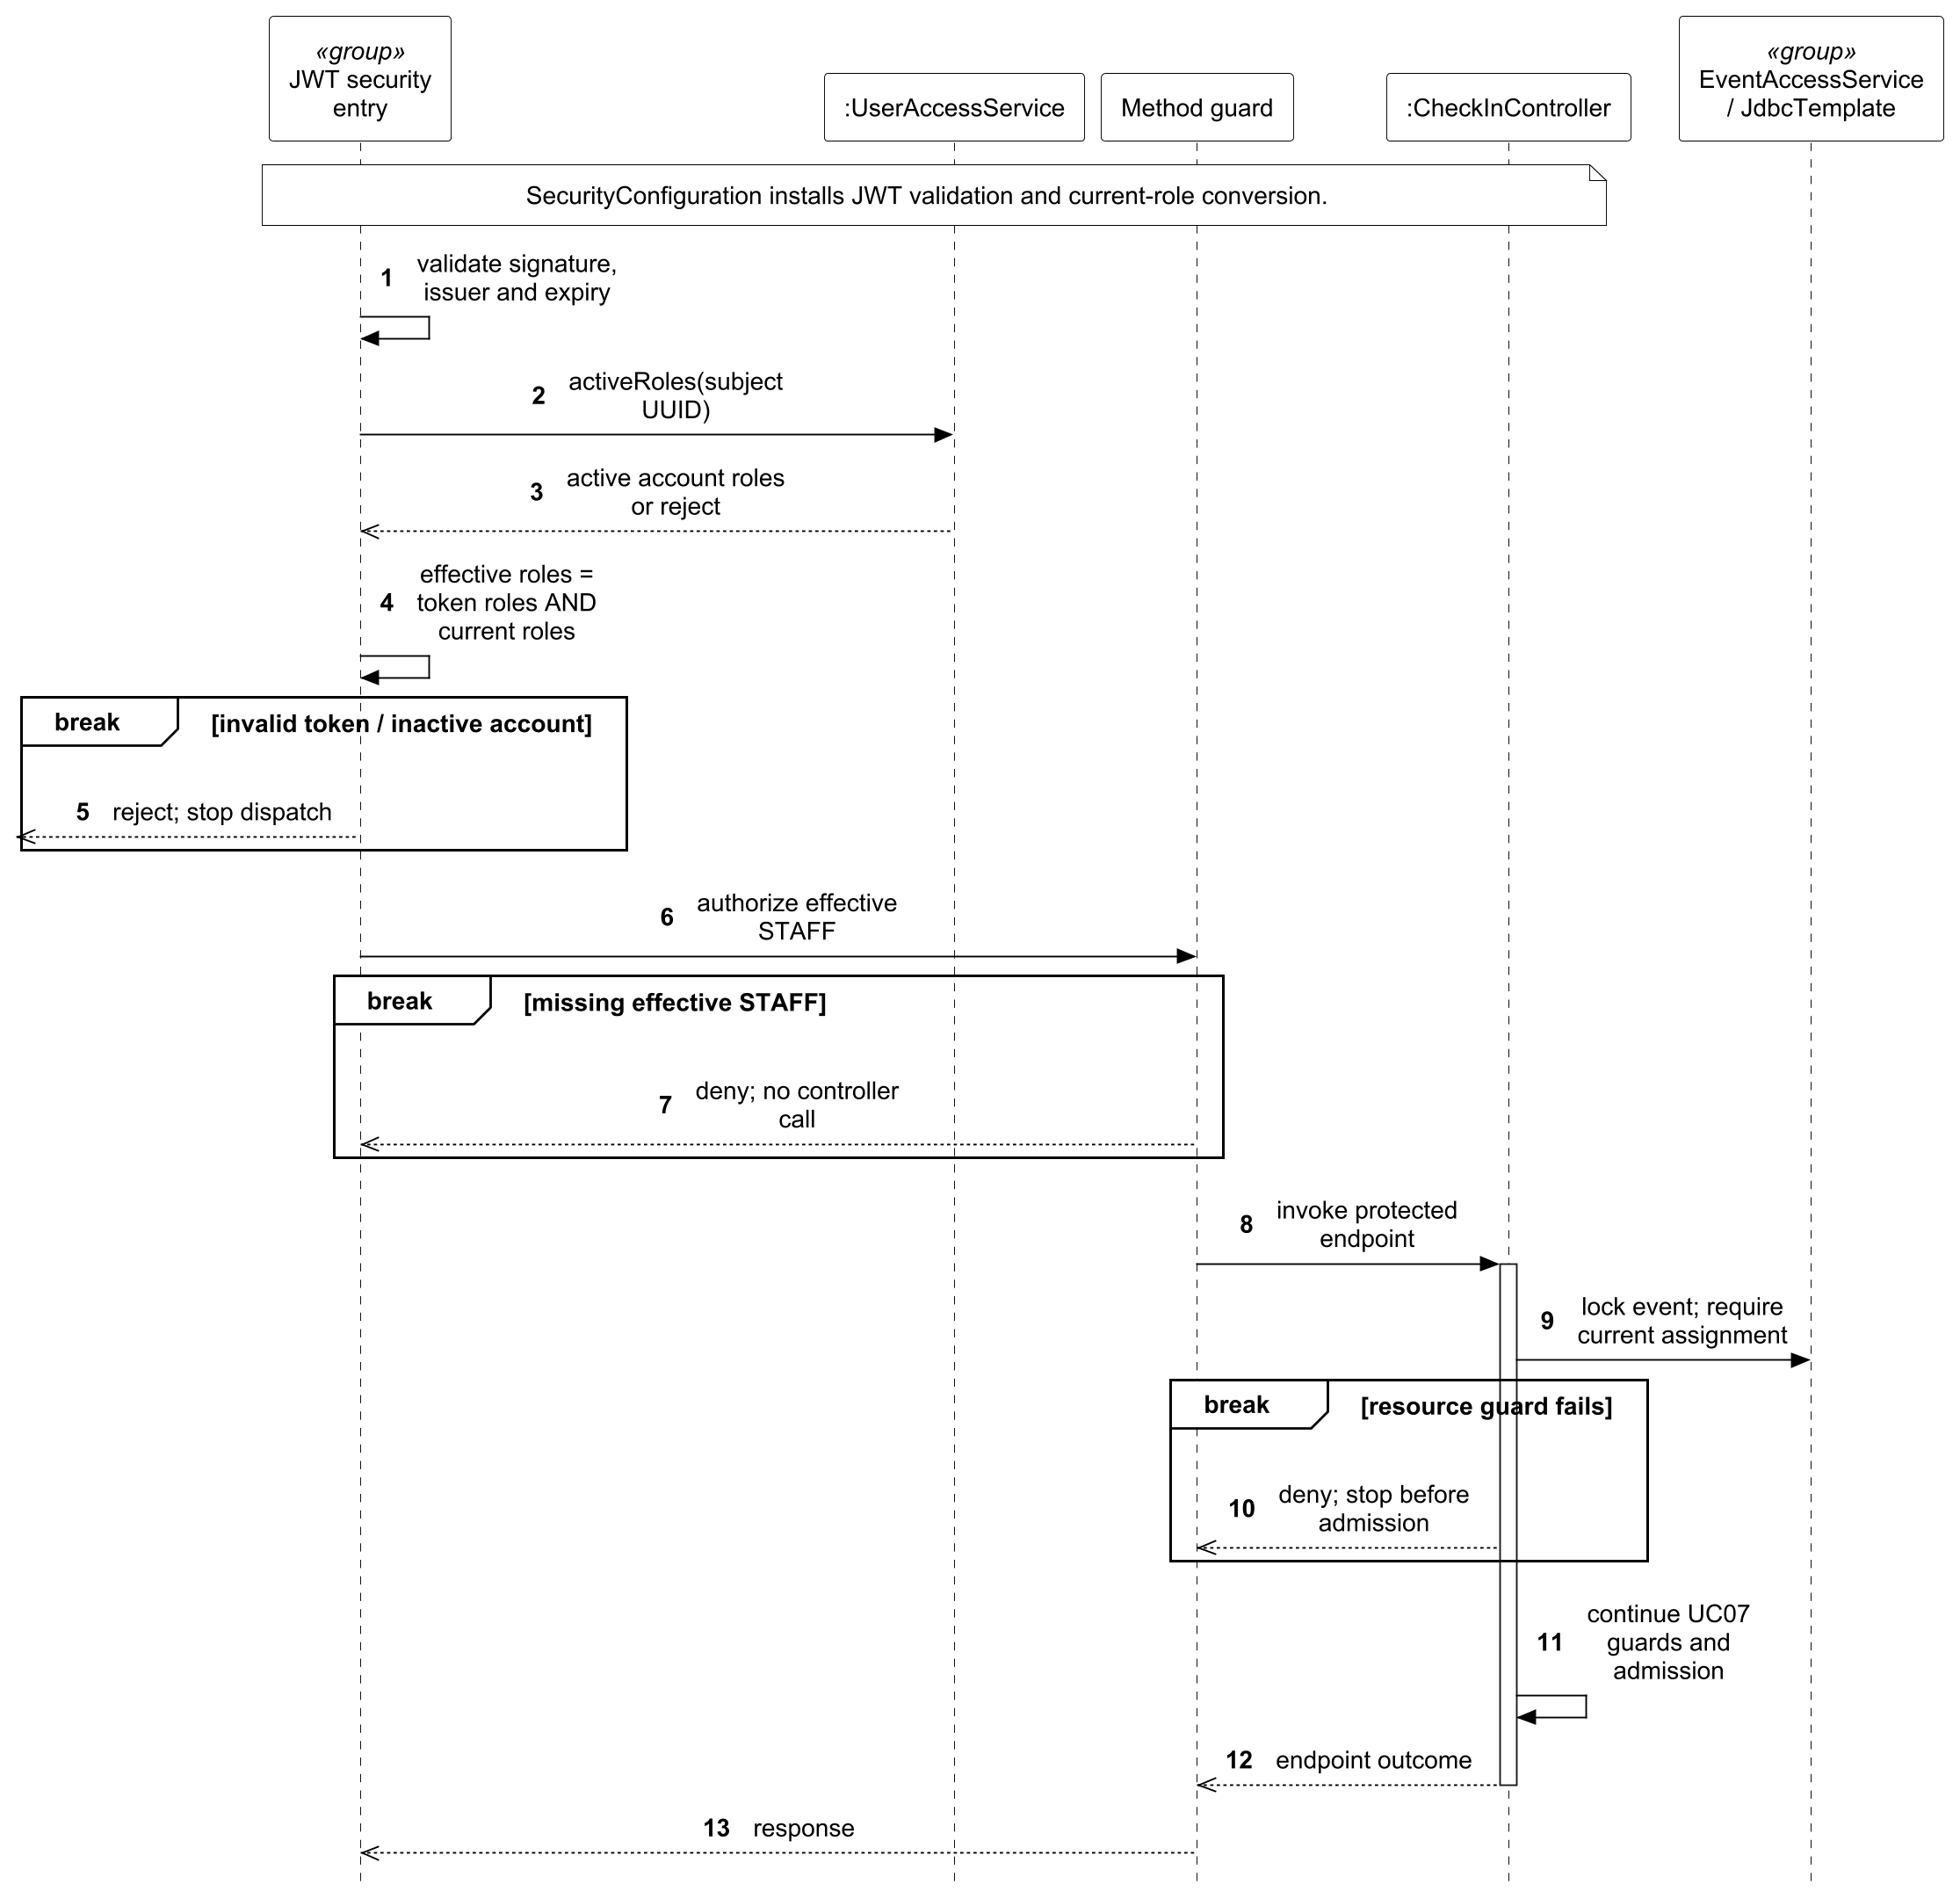
Figure 47. Authorization entry before admission; method guards and resource policy are separate checks.

3.5 Design Problems and Patterns
Five named design problems connect implemented code to design choices. Before diagrams show a brute-force alternative used to explain coupling and duplicated decisions; they are not claims that those alternatives were deployed. After diagrams model the selected implementation. The cases use three pattern families, with Observer and Strategy reused in distinct business contexts.
Each case states the problem, alternatives, selection rationale, implementation decisions and verification. Transaction isolation, authorization and database constraints remain separate mechanisms. They are not relabelled as GoF patterns.
Problem | Member | Selected pattern
DP01 Event cancellation collaboration | Lu Junyi | Observer
DP02 Replaceable credential verification | Hu Jia | Strategy through PasswordEncoder
DP03 Role-change notification separation | Chai Muyang | Observer
DP04 Booking information validation | Huang Haoyang | Strategy
DP05 Ticket lifecycle behaviour | Luo Runzhou | State
Table 13. Design problems and selected patterns
Observer reduces direct knowledge of dependent modules but makes the synchronous execution path less visible. Strategy isolates interchangeable algorithms behind an interface. State assigns different behaviour to the current lifecycle state. None of these patterns alone guarantees authorization, concurrency safety or exactly-once processing.

3.5.1 DP01 Event cancellation collaboration by Lu Junyi
Cancelling an event affects its bookings, inventory, tickets and notifications. Putting every repository update in the event service would couple the event module to several persistence models and make new side effects costly to add. Figure 48 shows this brute-force dependency structure; Figure 49 traces the direct booking, ticket and notification updates that the service would have to coordinate.
The candidate patterns are Observer and Mediator. Observer through synchronous Spring application events is selected because each dependent module can handle its own reaction without exposing its persistence details to the event service. A Mediator would centralize the same cross-module knowledge. Direct calls remain a simpler alternative for a fixed set of reactions; asynchronous publish/subscribe would require durable delivery and compensation beyond the current local transaction.
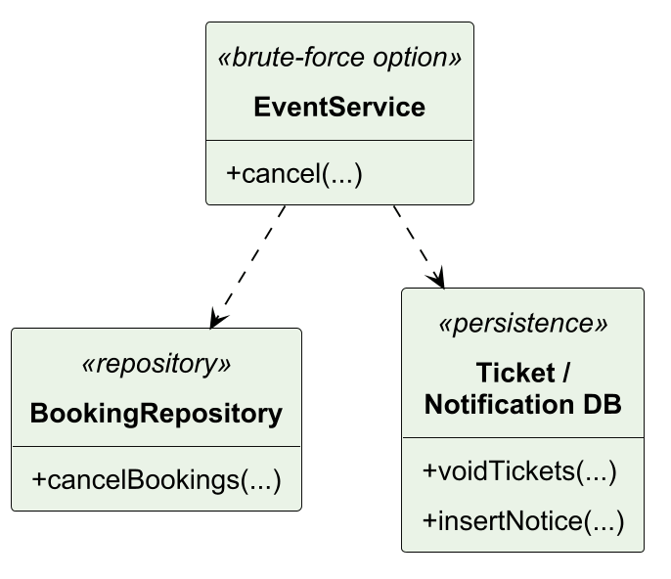
Figure 48. DP01 before class model: brute-force design alternative.
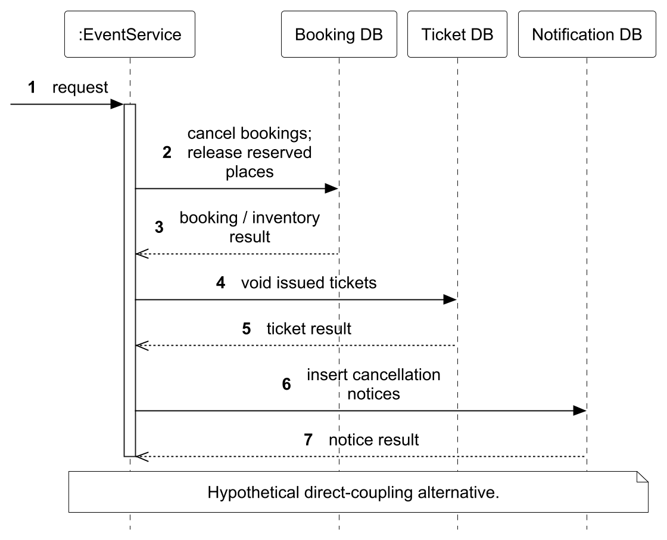
Figure 49. DP01 before sequence: direct coupling or repeated branches.
Figure 50 replaces the direct storage dependencies with an event publisher and listeners. EventManagementService publishes EventCancelled; EventCancellationListener cancels each booking and publishes BookingCancelled to trigger ticket invalidation and notification handling, then releases the reserved stock. Figure 51 shows the nested synchronous publication and return paths. Listeners require an existing transaction, so required listener failures roll back the originating operation. The event lock serializes cancellation with booking and check-in, while admission history is retained. Observer separates the reactions; the database transaction supplies atomicity.
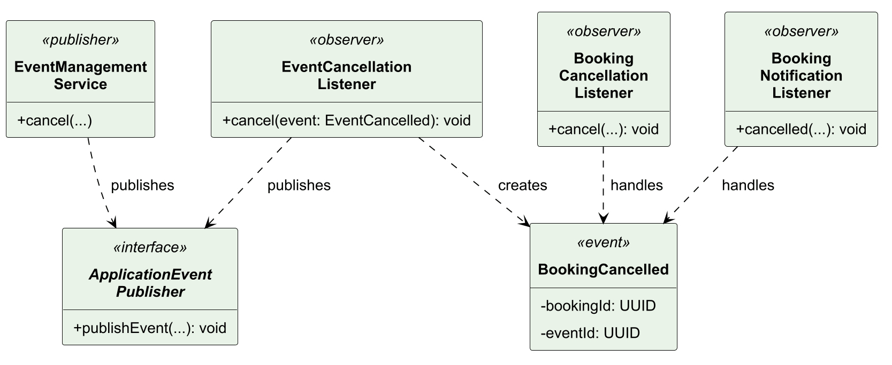
Figure 50. DP01 selected class collaboration.
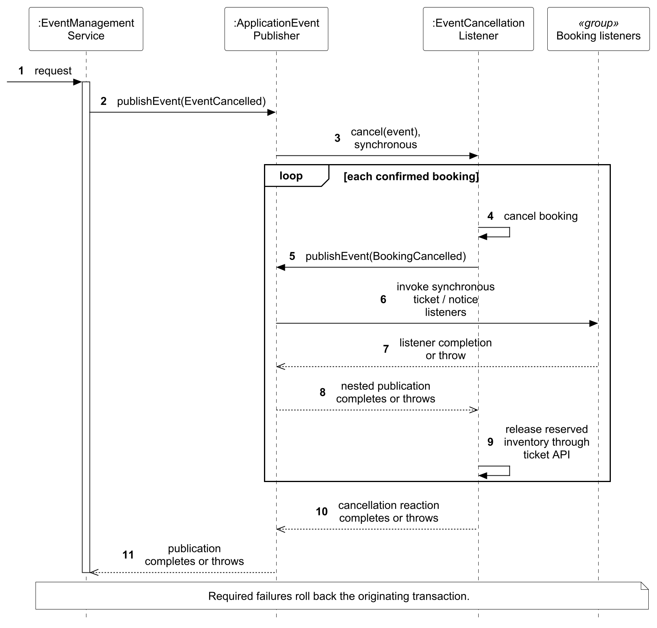
Figure 51. DP01 selected interaction sequence.
Verification: BookingIntegrationTest covers cancellation/booking races and listener rollback. StaffCheckInIntegrationTest and cloud acceptance cover retained check-in audit after cancellation.

3.5.2 DP02 Replaceable credential verification by Hu Jia
Authentication needs password hashing and verification without embedding a concrete algorithm in every registration/login path. A hard-coded implementation couples authentication policy to the hash representation and makes isolation in tests harder. Figures 52 and 53 show the brute-force alternative: AuthService depends directly on BCryptPasswordEncoder and invokes that concrete implementation during login.
The candidate patterns are Strategy and Template Method. Strategy is selected through the Spring Security PasswordEncoder interface because constructor injection lets AuthService use a shared registration/login contract independently of the concrete algorithm. Template Method would require inheritance of the authentication service. A static utility would be simpler but would retain concrete coupling.
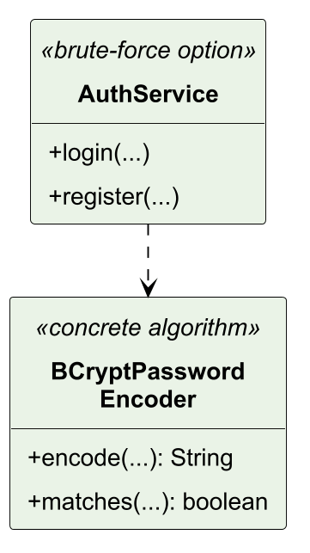
Figure 52. DP02 before class model: brute-force design alternative.
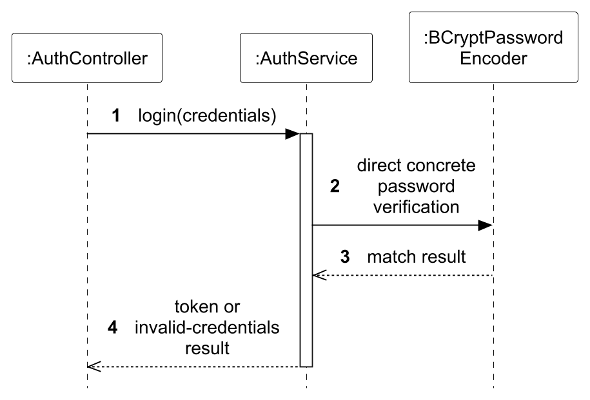
Figure 53. DP02 before sequence: direct coupling or repeated branches.
Figure 54 shows AuthService depending on PasswordEncoder, with BCryptPasswordEncoder as the concrete strategy. AuthService calls encode during registration and matches during login. SecurityConfiguration injects BCryptPasswordEncoder with strength 12; TokenService remains separate from password verification. Figure 55 uses login to show strategy invocation and token issuance only after successful checks. Registration uses the same strategy contract through encode, as shown in Figure 7. The implementation uses the framework-provided interface and BCrypt implementation; replacing the encoder requires compatibility with stored hashes and an explicit migration policy.
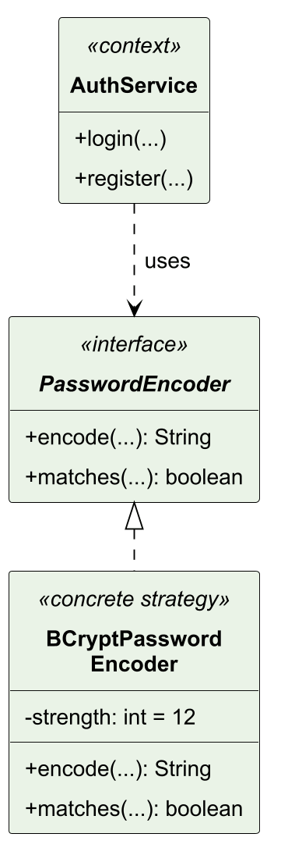
Figure 54. DP02 selected class collaboration.
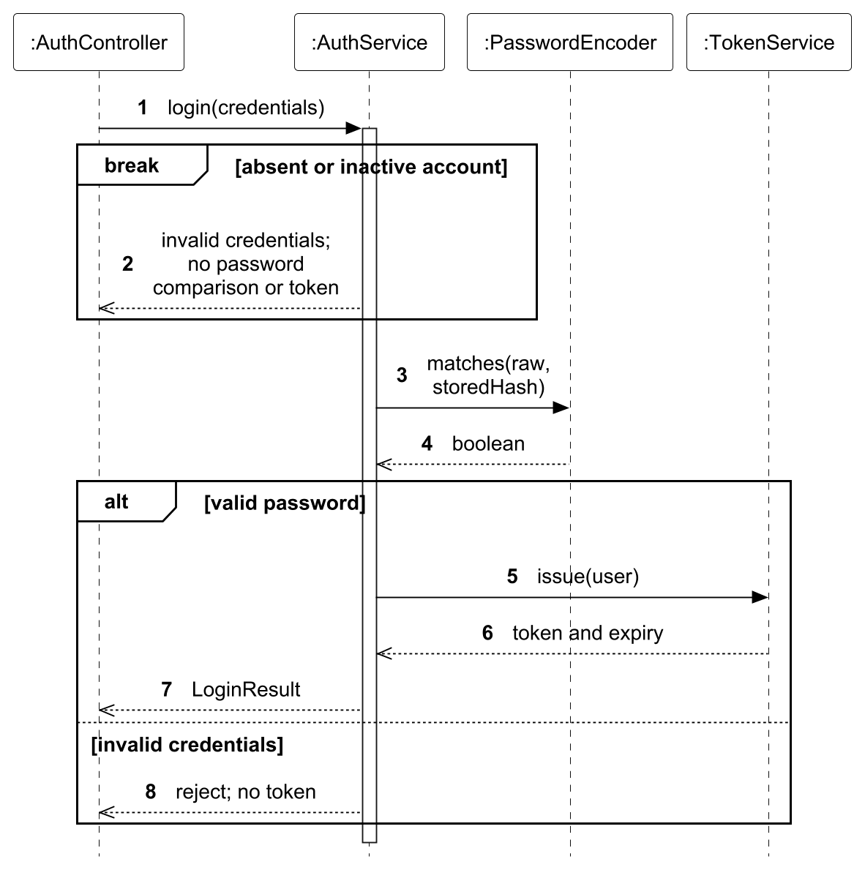
Figure 55. DP02 selected interaction sequence.
Verification: Authentication tests verify valid/invalid credentials and disabled accounts. Constructor-injected collaborators isolate authentication logic. Role-revocation checks belong to protected-request authorization rather than the password strategy.

3.5.3 DP03 Role-change notification separation by Chai Muyang
A role change must notify the affected account, but user administration should not depend on notification storage and formatting. Sending from the UI would miss non-UI updates and could report a change that did not commit. Figures 56 and 57 show the brute-force alternative, in which UserAdministrationService updates the account and also formats and writes the private notice.
The candidate patterns are Observer and Mediator. Observer via UserRolesChanged is selected because role policy can publish a change while notification handling remains in its own module. A Mediator would introduce a central coordinator for a single notification reaction without a more complex coordination workflow to justify it. Direct calls would be acceptable for one dependent action but expose notification details to the identity module; an asynchronous queue is unnecessary for the current transactional inbox.
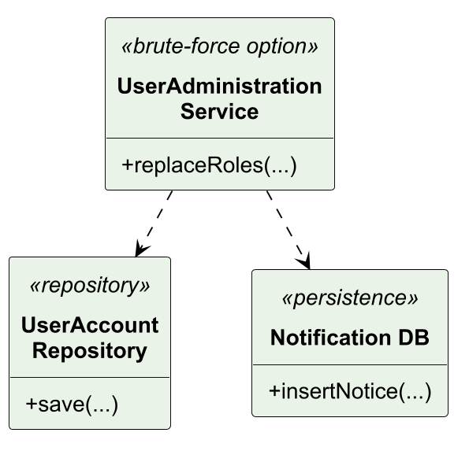
Figure 56. DP03 before class model: brute-force design alternative.
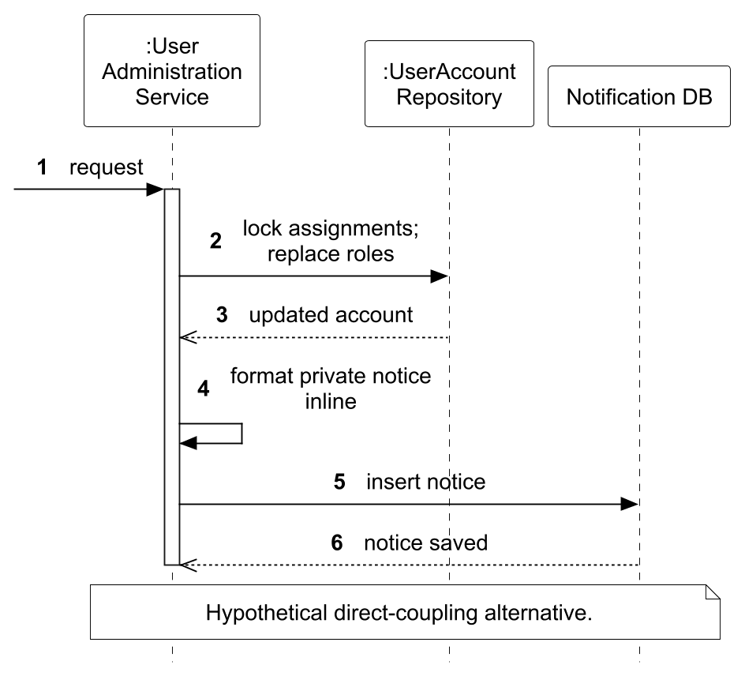
Figure 57. DP03 before sequence: direct coupling or repeated branches.
Figure 58 separates UserAdministrationService from UserRolesChangedListener and NotificationDeliveryService. The service locks role assignments, protects the last active administrator and compares old/new sets. Figure 59 shows that it publishes UserRolesChanged only for a real change, so a no-op replacement emits no duplicate event. The listener and delivery service require transaction participation, committing the role change and private notice together. Role validity and resource ownership remain separate authorization rules.
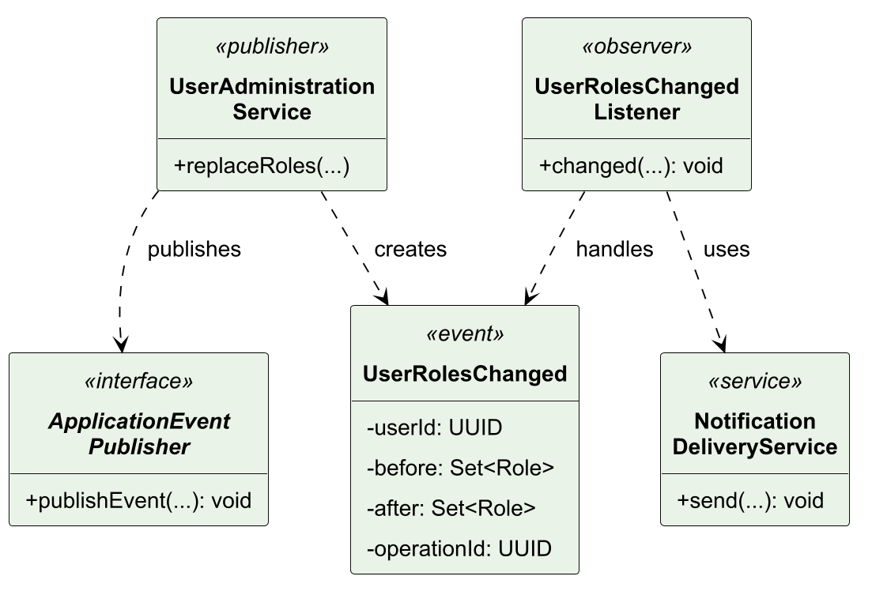
Figure 58. DP03 selected class collaboration.
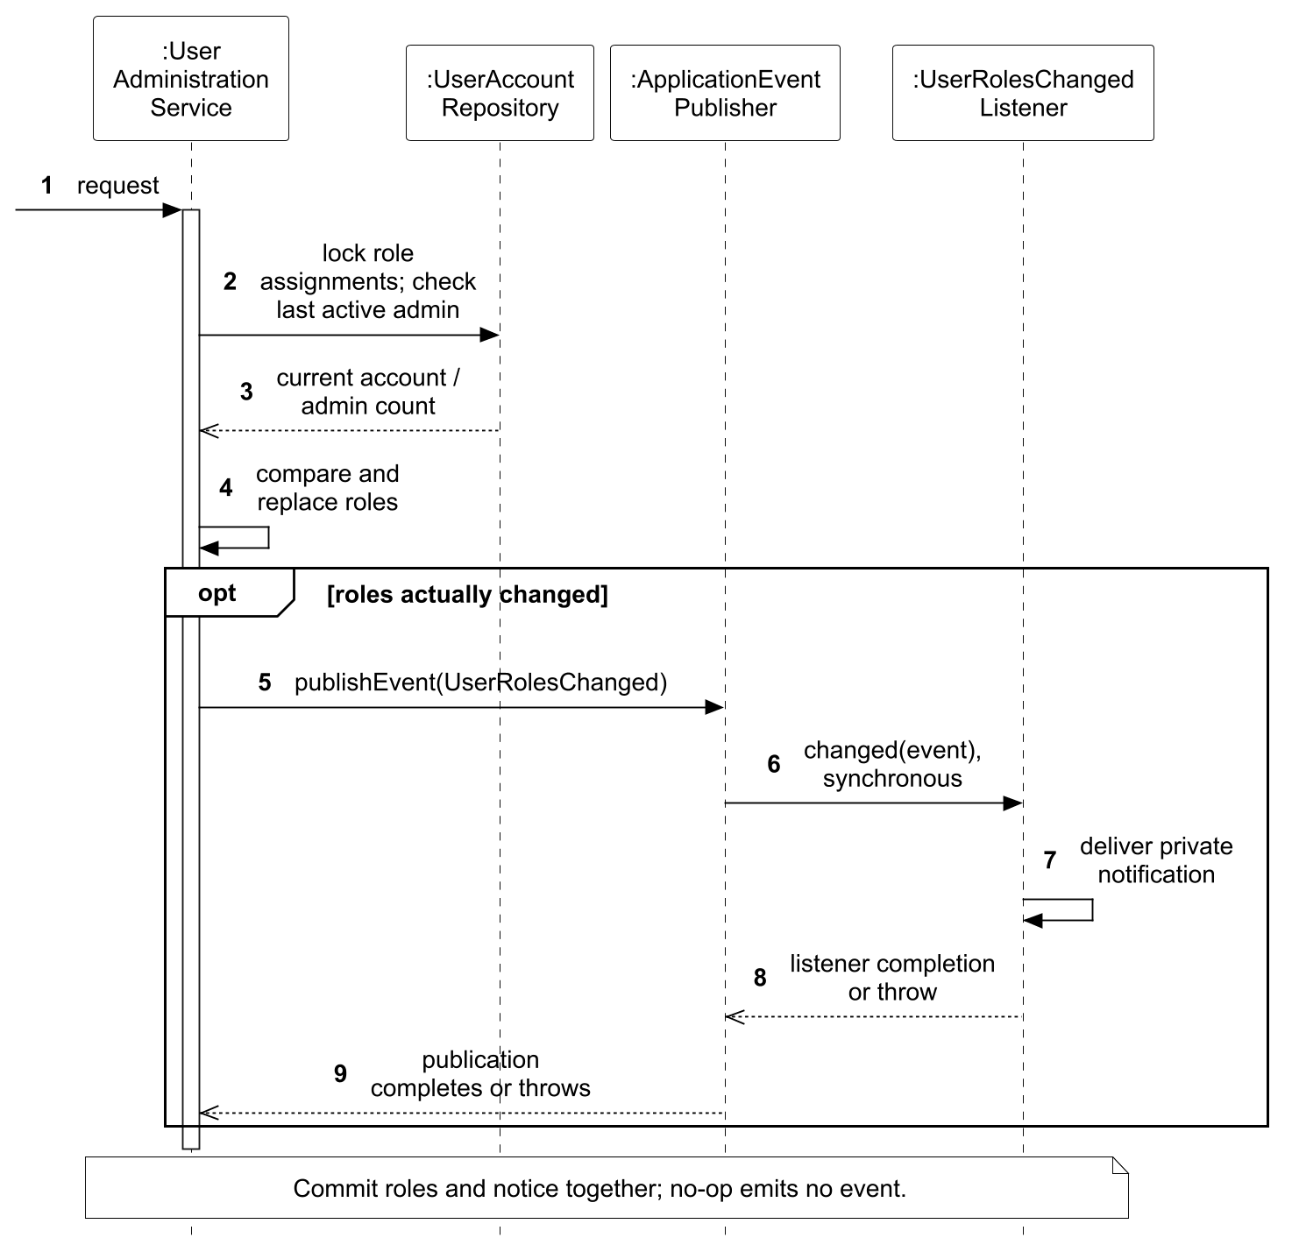
Figure 59. DP03 selected interaction sequence.
Verification: Role-change integration checks cover last-admin protection, real-change notification and unchanged-role behaviour. This design is a second Observer application to a different business invariant, not a claim of a fourth distinct pattern.

3.5.4 DP04 Booking information validation by Huang Haoyang
Events request different combinations of attendee fields. Booking and pre-registration must share validation, including direct service calls that bypass HTTP Bean Validation. Repeated branches would drift as fields are added. Figure 60 shows the duplicated checks in both services; Figure 61 follows inline booking validation before inventory reservation.
The candidate patterns are Strategy and Chain of Responsibility. Strategy is selected because each field has an assigned format rule: BookingInfoValidator can invoke that rule through a common interface while retaining presence and privacy policy in the context. Chain of Responsibility would search or pass control among handlers even though the field-to-rule mapping is already known. A single switch would use fewer classes but combine these responsibilities and make shared validation harder to extend.
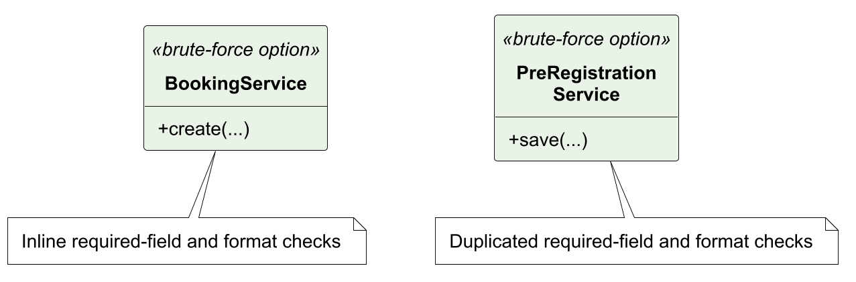
Figure 60. DP04 before class model: brute-force design alternative.
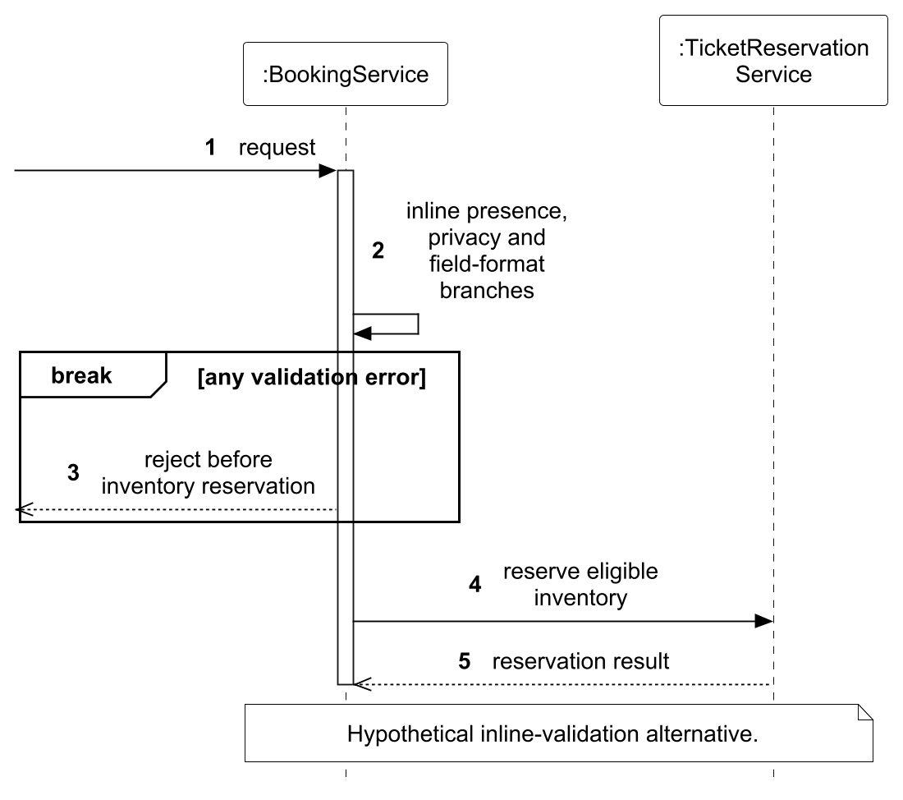
Figure 61. DP04 before sequence: direct coupling or repeated branches.
Figure 62 shows BookingInfoValidator and its field-specific strategies. The context checks required fields and rejects unsolicited personal data before applying TextFieldValidationStrategy, EmailFieldValidationStrategy or PhoneFieldValidationStrategy. Figure 63 shows validation rejecting an invalid value before stock reservation. Both BookingService and PreRegistrationService share the context, as shown in Figure 36; Figure 38 traces its use during pre-registration without reserving stock. Ordinary text is limited to 100 characters and the custom answer to 500. Email reuses Jakarta constraints; phone shares the existing 5–30-character rule. DTO validation remains at the HTTP boundary.
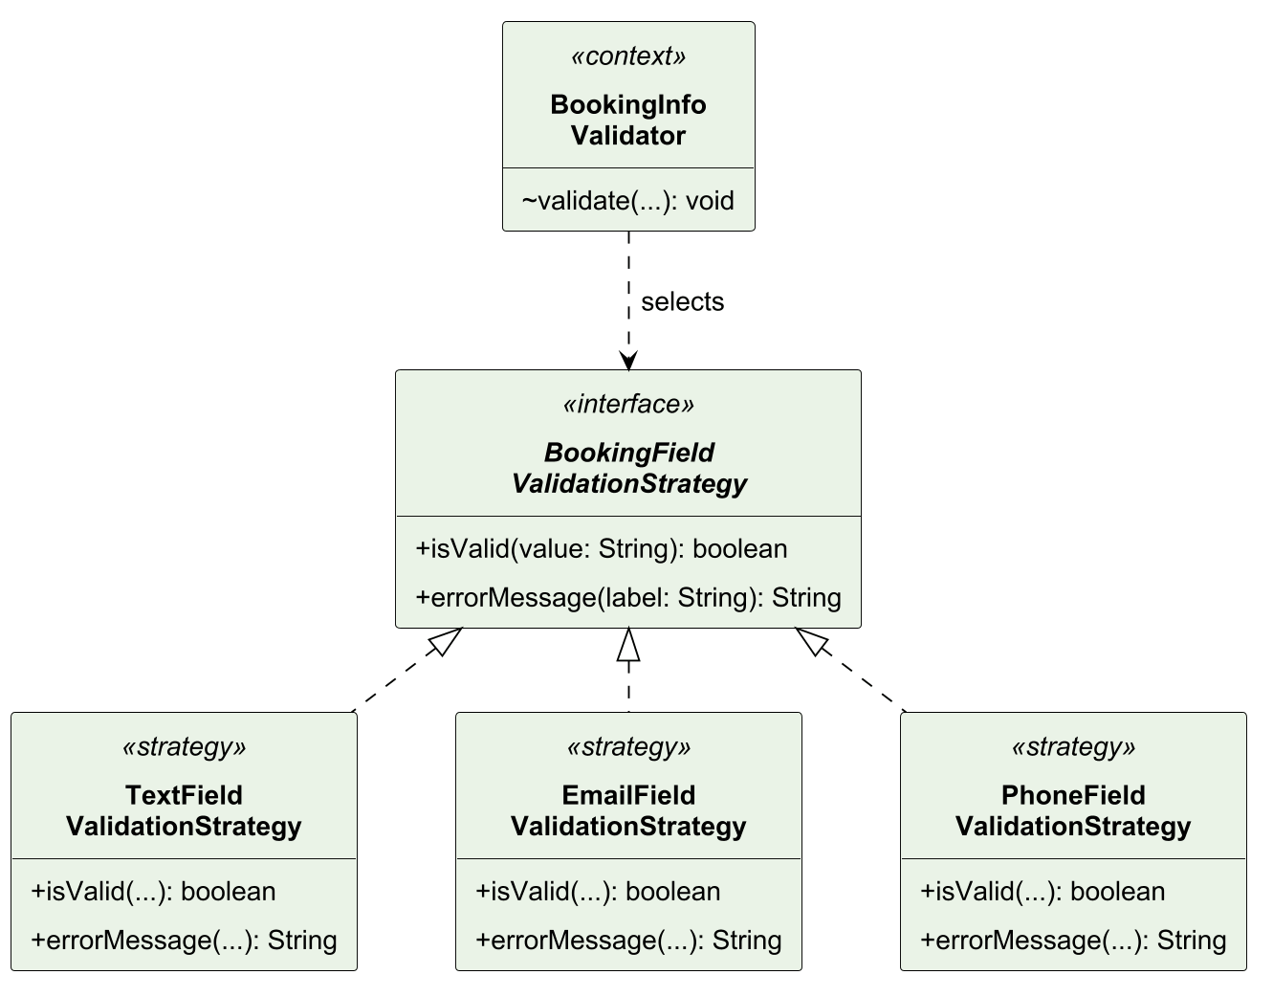
Figure 62. DP04 selected class collaboration.
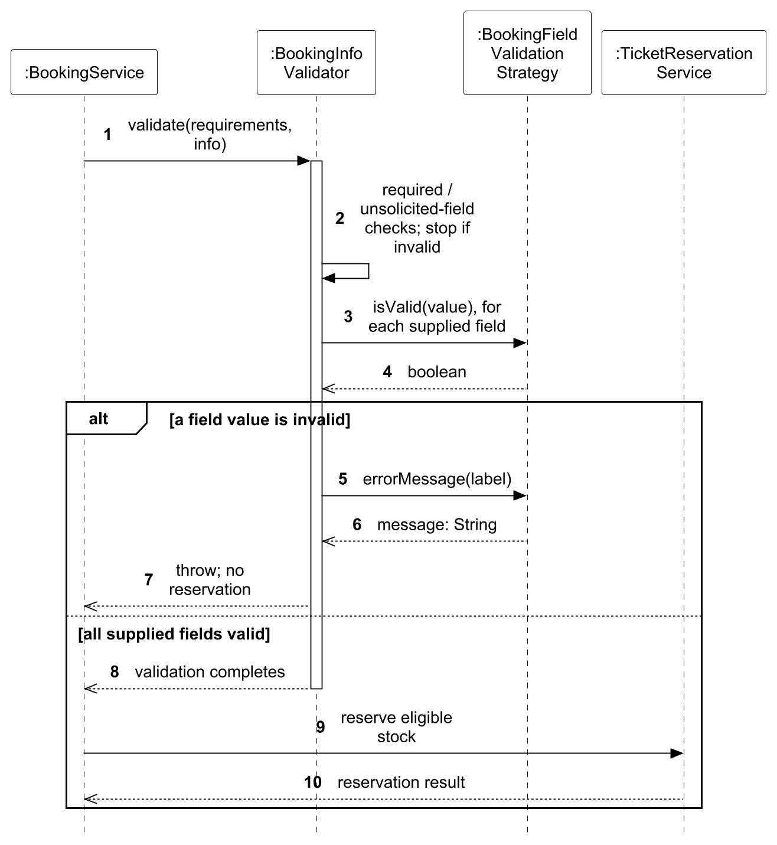
Figure 63. DP04 selected interaction sequence.
Verification: BookingInfoValidatorTest checks strategy boundaries. BookingServiceTest.malformedEmailFromNonHttpCallerNeverReservesInventory proves service-level rejection before stock reservation. HTTP validation alone cannot demonstrate this path.

3.5.5 DP05 Ticket lifecycle behaviour by Luo Runzhou
Check-in and voiding behave differently for VALID, CHECKED_IN and VOID tickets. Repeating status branches in each operation risks inconsistent duplicate admission, timestamp and cancellation behaviour. Figure 64 shows the brute-force entity with status-dependent operations; Figure 65 uses checkIn to illustrate branching inside that entity.
The candidate patterns are State and Strategy. State is selected because the stored ticket state determines which behaviour is valid. It moves that behaviour into ValidTicketState, CheckedInTicketState and VoidTicketState. Strategy would select an algorithm independently of the lifecycle. An enum/switch is simpler for a small model but concentrates every transition decision in the context.
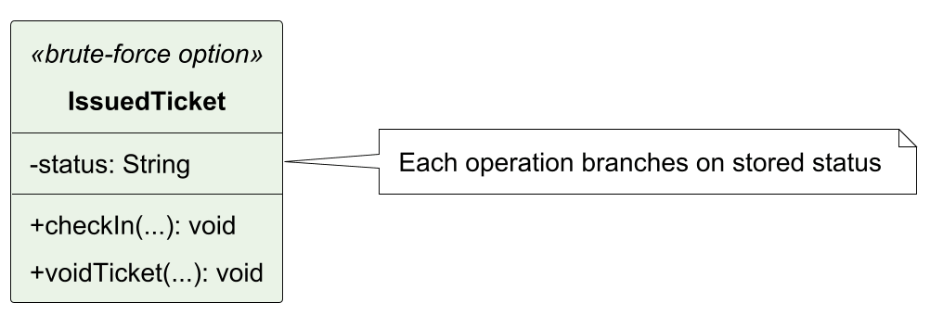
Figure 64. DP05 before class model: brute-force design alternative.
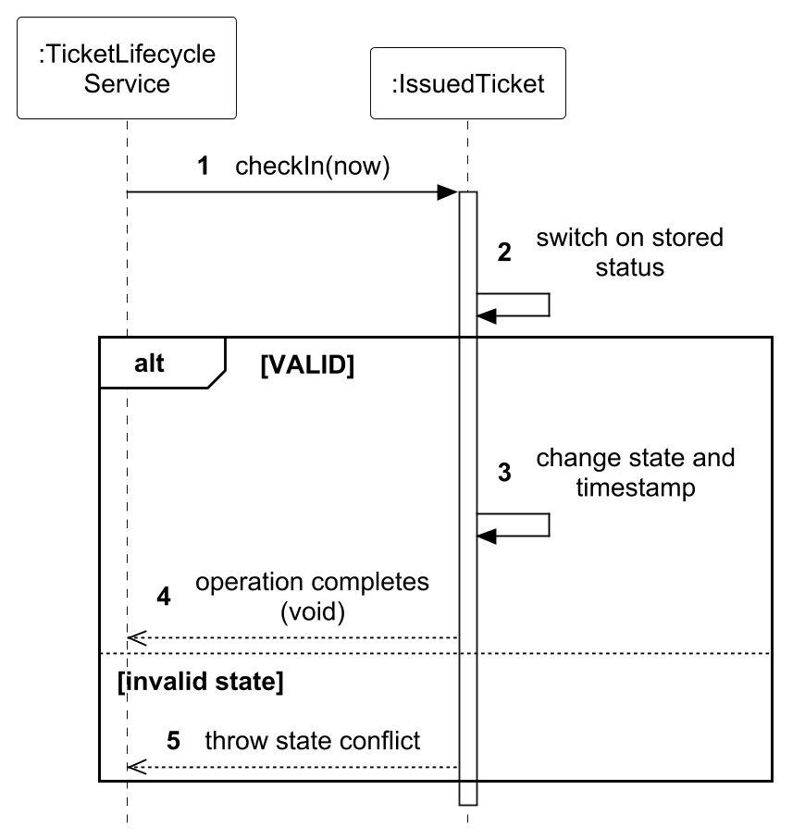
Figure 65. DP05 before sequence: direct coupling or repeated branches.
Figure 66 shows IssuedTicket delegating checkIn and voidTicket to TicketState. The static fromCode operation maps the stored string to a reusable stateless state object. Figure 67 selects checkIn as the representative interaction, showing state resolution, delegation and rejection of used or voided tickets. voidTicket uses the same dispatch structure: VALID can become VOID; CHECKED_IN may become VOID on event cancellation; an existing VOID preserves its first void time and admission history. VALID can also check in once. Service authorization, time windows and locks remain outside State.
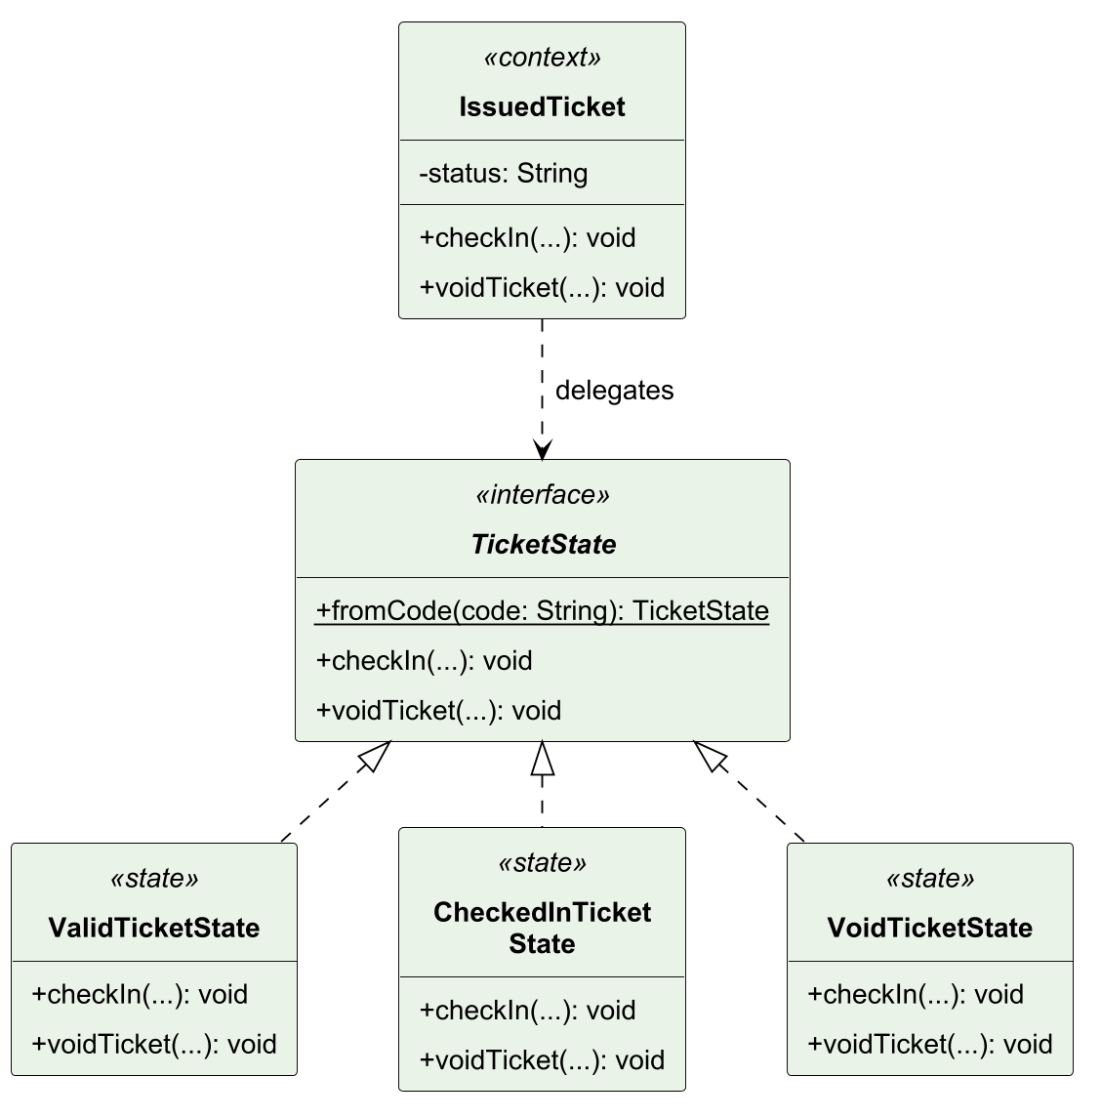
Figure 66. DP05 selected class collaboration.
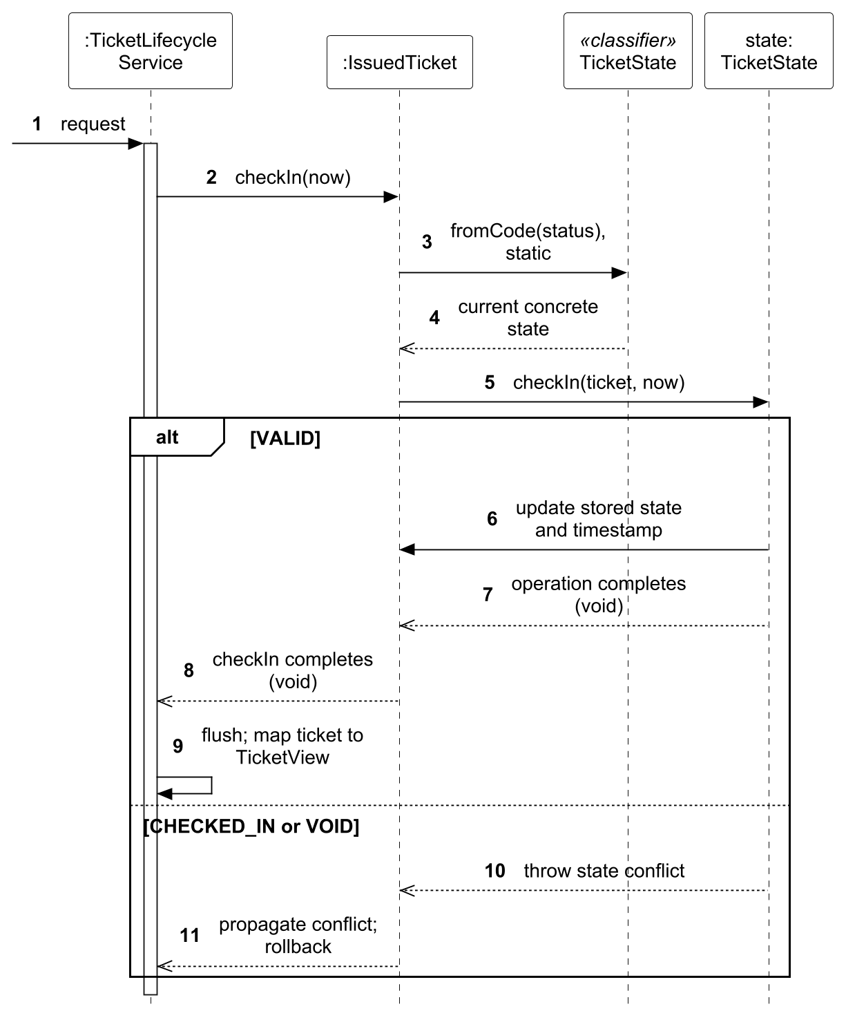
Figure 67. DP05 selected interaction sequence.
Verification: IssuedTicketTest covers the transition matrix and timestamps. BookingIntegrationTest covers persisted tickets and cancellation races. StaffCheckInIntegrationTest adds authorization, admission-window and audit coverage.

3.6 Database Schemas
PostgreSQL contains 11 application tables and the Flyway schema-history table, with 14 recorded migrations. The schema below separates identity/event/order data from admission and messaging. PK means primary key, FK foreign key and UQ uniqueness. Cardinality tables state every declared relationship, including composite references.
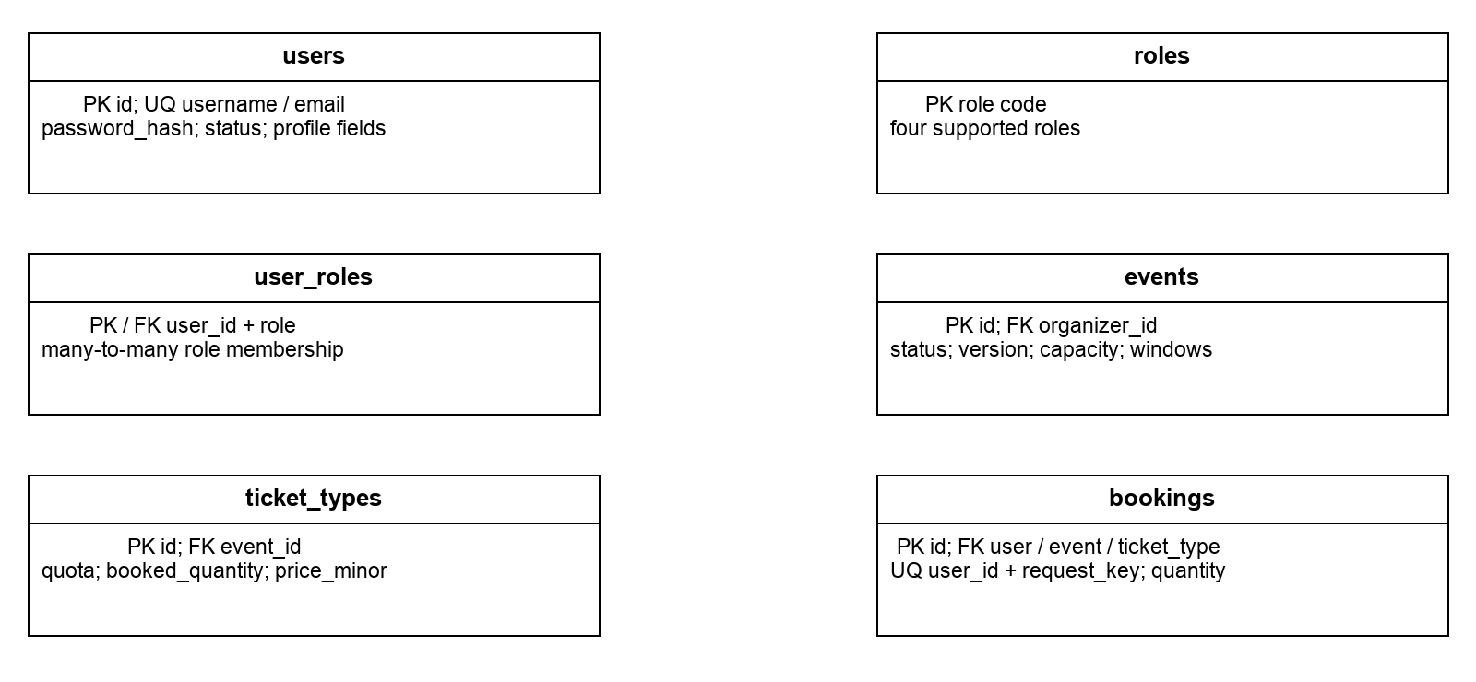
Figure 68. Core schema entities and selected keys. Relationship cardinalities follow below.
Table 14 specifies the cardinalities for the core entities in Figure 68.
Parent | Child | Cardinality
users / roles | user_roles | Each parent 1 to 0..* membership rows
users | events | 1 organizer to 0..* events
events | ticket_types | 1 event to 0..* ticket types
users / events / ticket_types | bookings | Each parent 1 to 0..* bookings
Table 14. Core schema relationships

3.6.1 Admission and Supporting Data
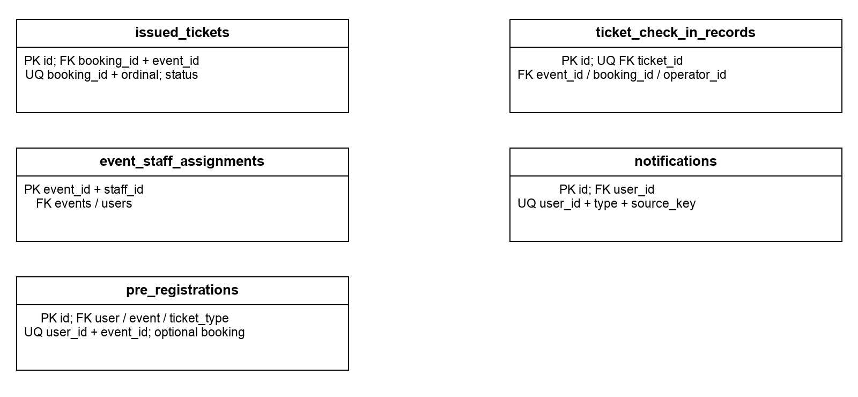
Figure 69. Admission, notification and pre-registration entities. Context IDs in notifications are not foreign keys.
Table 15 completes the schema relationships for admission, staff assignment, notifications and private pre-registration.
Relationship | Cardinality / meaning
bookings → issued_tickets | 1 to 0..*; composite (booking_id, event_id) enforces same-event ownership.
issued_tickets → check-in record | 1 to 0..1; ticket_id uniqueness prevents duplicate audit.
events / bookings / users → audit | Each parent 1 to 0..* records; user is the operator.
events / users → staff assignment | Each parent 1 to 0..* rows; composite assignment key.
users → notifications | 1 to 0..* private messages. Other context IDs have no FK.
users / events / ticket_types → pre-registration | Each parent 1 to 0..*; optional linked booking 0..1 per entry.
Table 15. Admission and supporting data relationships

3.6.2 Constraints and Transaction Design
The invariants in Table 16 distinguish database-enforced constraints from rules requiring application authorization, locking or transaction control.
Invariant | Database / application realization
Identity uniqueness | Unique username/email; race-safe conflict handling on insert.
Capacity and booking | Positive quota; booked quantity from 0 to quota; event lock coordinates all supported inventory writers. Booking quantity is 1–10.
Retry safety | Unique (user_id, request_key) plus transaction advisory serialization. Same key with changed input conflicts.
Ticket issuance | Unique (booking_id, ordinal); composite booking/event FK prevents cross-event issuance.
Lifecycle | VALID / CHECKED_IN / VOID and timestamp checks. Event cancellation preserves historical check-in records.
Admission authorization | Current STAFF role, assignment and time window are application checks; they are not SQL CHECK constraints.
Private messages | Recipient FK and unique operation/source key. The target API still enforces access for contextual navigation IDs.
Migration integrity | New timestamped Flyway files, immutable applied migrations, Hibernate validate, empty-schema and upgrade tests.
Table 16. Consistency constraints and implementation
Order and attendee details are snapshots. Later profile edits do not rewrite booking history. Pre-registration JSONB is private to its owner and is copied into an actual booking only after an explicit booking action. Event copying creates new ticket types and zero booked quantity, without copying orders or personal data.
No separate reporting table exists. Reporting queries the operational schema and distinguishes currently valid attendance from historical check-in audits. A cancelled event may retain an audit while its valid attendance becomes zero.

3.6.3 Complete Entity Relationship Diagram
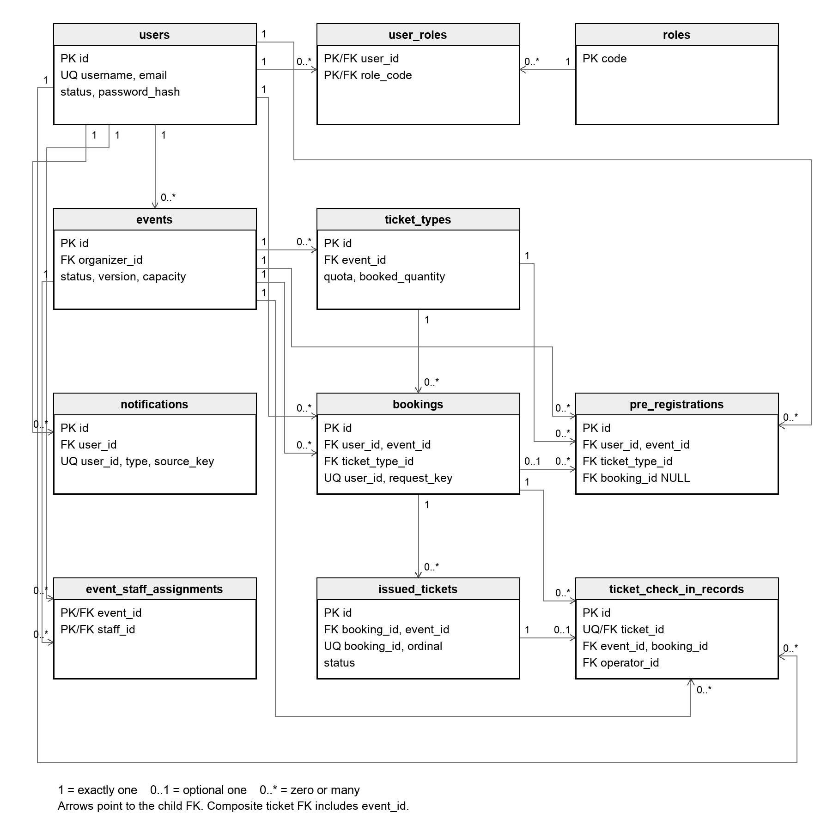
Figure 70. Complete application ERD with declared foreign keys, selected keys and relationship cardinalities.
Figure 70 connects all 11 application tables. Arrows point from parent records to the child holding the foreign key; endpoint labels give the number of related records. A pre-registration may have no linked booking, and an issued ticket has at most one check-in audit. The ticket-to-booking reference includes event_id as a composite foreign key. Notifications have only a recipient foreign key; their other context identifiers are not schema relationships. Table 14 and Table 15 give the corresponding relationship details.

4. DevSecOps and Development Lifecycle

4.1 Source Control Strategy
The project uses the GitHub repository seventh720/SWE5006-SEMS. The repository holds the React frontend, Spring Boot backend, database migrations, deployment/CI scripts, architecture decisions and sanitized acceptance evidence. Feature work is integrated through pull requests into main. Historical sprint DoD requires another member’s review and resolution of review discussions before merge.
Table 17 locates implementation, automation and supporting records within the repository.
Repository area | Controlled artifact
backend/ | Java source, tests, Maven build and Flyway SQL migrations.
frontend/ | React/TypeScript source, component tests and npm lock file.
.github/workflows/ | CI and main-branch release/deployment workflow.
scripts/ | Lint, security, container checks, performance and delivery scripts.
docs/ | Architecture, API/schema contracts, acceptance records and evidence index.
Table 17. Repository structure
Developers use authorized GitHub accounts for repository access. Automation starts with read-only contents permission and grants package-write permission to the image publication job. Deployment uses a dedicated SSH key and a trusted host fingerprint stored in environment secrets. Credentials and runtime environment files are excluded from source control.
Local raw reports and recordings are retained outside tracked source where appropriate. Sanitized JSON and selected screenshots provide durable evidence in docs/acceptance. The report identifies each measurement’s release baseline so results are not silently transferred to a later build.
Applied Flyway migrations remain immutable. A schema change adds a new migration and must pass empty-database and upgrade checks. Source and deployment manifests bind a release to its commit and tested image digests.

4.2 Continuous Integration
Pull requests and pushes to main trigger the CI workflow. Lint, backend unit/integration tests and frontend verification feed the image stage; static security checks depend on the backend build. Runtime images reuse the tested JAR and frontend distribution. Only main pushes publish and deploy the release.
Table 18 identifies the checks and build outputs passed between CI stages. Figure 71 shows how successful checks permit image creation and deployment.
Job | Checks and output
lint | Frontend/backend lint scripts and retained reports.
backend | Maven clean verify, unit tests, JaCoCo and tested backend JAR.
backend-integration | Real PostgreSQL/Testcontainers integration tests and result artifacts.
frontend | Type checking, Vitest coverage and production build distribution.
security | SAST, dependency and secret scans using the backend artifact.
images | Waits for required checks; builds/scans images and runs smoke tests. Main publishes immutable release information.
deploy / dast | Main-only delivery and public endpoint security baseline.
notify | Outcome notification; not a quality gate.
Table 18. CI jobs and outputs
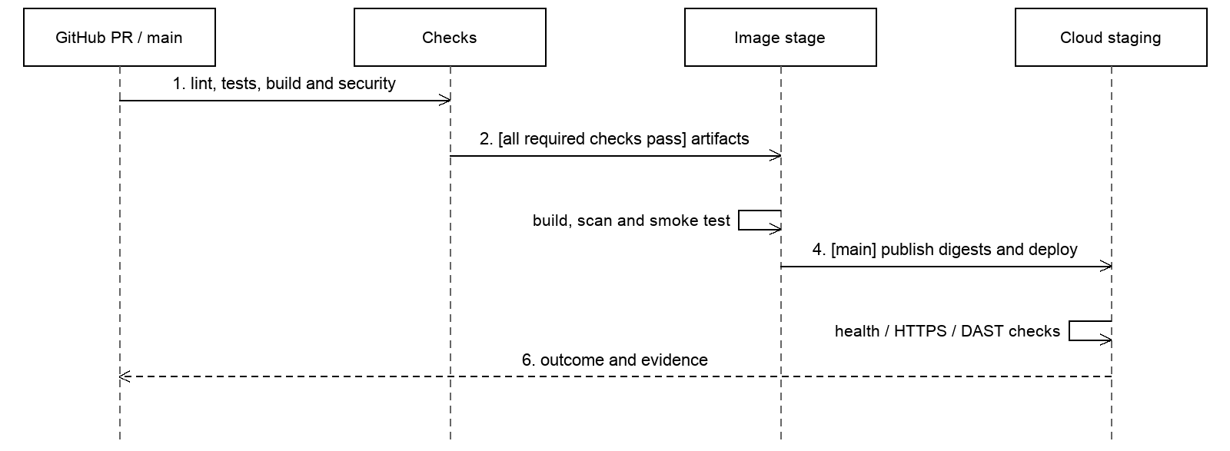
Figure 71. CI/CD control flow. Failed required checks prevent promotion to the image/deployment stage.

4.2.1 Test Strategy and Functional Results
Domain and service unit tests isolate rules. PostgreSQL integration tests exercise real constraints, locks, transaction rollback and migration behaviour. Frontend component tests commonly mock APIs, while browser acceptance independently checks the deployed user journey. Full browser E2E is not a CI gate.
Table 19 reports functional results, coverage and operational checks against their recorded baselines.
Evidence | Recorded result | Baseline / interpretation
Backend functional tests | 215 passed; 1 skipped | PR #50 / 82060f5; 216 total; optional query comparison skipped.
Frontend tests | 244 passed across 32 files | PR #50 / 82060f5; component/logic tests, commonly using mocked APIs.
Backend line / branch coverage | 94.59% / 81.56% | 1330/1406 lines; 429/526 branches; fresh combined run.
Frontend line / branch coverage | 92.75% / 83.51% | 1332/1436 lines; 1723/2063 branches; fresh run.
Cloud acceptance | Booking, issuance, admission, cancellation, reporting | 270c2b8 on 20 October 2026.
Restore | 12 tables, 14 migrations | Includes Flyway table; nonempty business data in isolated restore.
Table 19. Functional tests and validation results
Critical tests cover last-ticket contention, same-key replays and conflicts, failed-side-effect rollback, owner isolation, staff assignment revocation, duplicate admission, cancellation races and last-active-admin protection. A successful happy-path test alone would not establish these guarantees.
Coverage measures exercised code, not completeness of behavioural verification. The automated-test and coverage rows in Table 19 use PR #50: checkout 82060f5, branch head 8cfc17d. Cloud acceptance and restore retain their historical baselines. This run does not deploy the branch. Earlier 270c2b8 backend coverage was 94.58% line / 81.68% branch. No minimum coverage-percentage gate is configured.

4.2.2 Performance Evaluation
The 21 October 2026 cloud measurements used deployment 037720b on a shared 2-vCPU host with 3832 MiB memory. Read traffic requests event lists/details and own profile/orders with one second of think time. Mixed traffic adds booking, ticket reads and cancellation every five iterations across ten events. Inventory contention is a separate one-attempt workload.
A workload passes only when overall and endpoint p95 remain below three seconds and all state and content checks pass. Table 20 compares the measured outcomes against these criteria.
Scenario | Requests | p95 s | Hold | Outcome
Read 500 VU | 21,048 | 2.056 | 30 s | Pass
Mixed 500 VU | 23,092 | 1.923 | 30 s | Pass
Read 1000 VU | 95,360 | 2.938 | 180 s | Pass
Mixed 1000 VU | 83,164 | 3.509 | 180 s | Latency fail
Contention 1000 planned VU | 1,000 | 4.100 | One attempt | Latency / connection fail
Table 20. Cloud performance results
Read and mixed-traffic p95 values are measured during the hold stage; request counts include ramp-up and completion. Contention p95 covers its full stage, so these scenarios cannot be treated as an interchangeable capacity series.
Contention reached a sampled peak of 983 VU against 100 tickets. It produced 100 successful bookings, 899 expected inventory conflicts and one refused TCP connection. The database audit found booked stock, confirmed quantity and valid tickets all equal to 100, with no duplicate ticket sequence or overselling.
The connection refusal has no confirmed root cause. No OOM, container restart or health-protection interruption was observed. All planned phases ran, but the full acceptance criteria did not pass. The recorded STOPPED outcome must therefore not be reported as an all-pass suite.
These short API workloads establish the measured outcomes above. They do not establish maximum capacity, equivalent browser-user capacity or long-term stability. The 1,000-user objective remains only partially achieved.

4.2.3 Security and Operational Verification
Static checks cover SAST, dependencies and secrets; images receive their own scan and smoke checks. The recorded DAST baseline reported 0 high, 0 medium, 0 low and 4 informational alert types. It was passive and unauthenticated, so it covers public surfaces rather than every authenticated business path.
Two scoped Spring MVC dependency exceptions remain open until 17 November 2026. Their applicability assessment excludes XSLT views and SSE view fragments in this application. The exceptions are not claims that the underlying dependencies are fixed.
Protected-request authorization intersects JWT roles with current database roles. Resource checks add organizer ownership, attendee scope or event staff assignment. Tests cover role revocation and concurrent last-admin protection. Passwords use a BCrypt strategy with strength 12, and tokens default to a one-hour lifetime.
Operational validation includes a nonempty isolated PostgreSQL restore with 12 tables including Flyway history and 14 migrations. The recorded small-backup operation took 2.34 seconds, which is not a production RTO. The test did not rebuild the complete host or restore external services.
Operational investigation also corrected reverse-proxy Host handling. Later performance work reduced authentication lookup fields and adjusted Nginx upstream connection reuse and connection/file limits. Local regression checks observed one upstream connection across 20 requests and a separate 1,200-connection configuration scenario. These local checks explain the changes; the cloud measurements in Section 4.2.2 establish their observed end-to-end result.

4.2.4 Verification Artifacts and Provenance
The 27 October verification is GitHub Actions run 40445034465 for PR #50. GitHub checks out the temporary merge commit 82060f508b98b86b6e4804e98d01e46701591b76, combining branch head 8cfc17d157c493a1c1bc0fff423a097a278a8e7f with main. The branch contains the prepared Vite/Vitest patch updates; application source and database migrations are unchanged. All six verification jobs passed. Deployment and DAST were skipped by the pull-request workflow.
Check | Actual artifact and result | Measurement baseline
Lint | lint-report.zip: eight checks PASS, including ESLint, Checkstyle and actionlint. | 27 October; CI 40445034465; checkout 82060f5.
Automated tests | backend-unit-coverage.zip; backend-combined-coverage.zip; frontend-coverage.zip and frontend job log. Combined backend: 215 passed, 1 optional skip. Frontend: 244 passed. | Same fresh CI run. Unit-only and combined results are separate executions.
SAST and dependencies | sast-report.zip: 0 findings, 0 scan errors, 207 scanned files. dependency-secret-reports.zip: 0 unsuppressed HIGH/CRITICAL findings or secrets; 2 scoped Java exceptions. | Same fresh CI run; Semgrep and Trivy JSON retained.
Container scanning | image-security-reports.zip: backend, frontend and PostgreSQL scans passed; 0 unsuppressed HIGH/CRITICAL findings or secrets. Smoke tests passed. | Same fresh CI run; image IDs and JSON retained.
DAST | Original ZAP HTML/JSON, scan log, coverage metadata and summary: High/Medium/Low 0; 4 informational alert types. | 20 October business baseline 270c2b8; CI 39311200552.
Performance | Original k6 scenario JSON, outcome.json and fixture-audit.json: 500 VU read/mixed pass; 1000 VU mixed/contention fail; no overselling. | 21 October capacity baseline 037720b.
Table 21. Verification artifacts and their measurement baselines
Appendix A reproduces result excerpts. The companion SEMS_Verification_Evidence_20261027.zip preserves the original CI ZIPs and the saved DAST/performance files. Its manifest records SHA-256 hashes, original filenames, run IDs and commit identities so each displayed result can be checked offline. GitHub artifact retention varies; the downloaded copies preserve the evidence independently of its expiry.
Fresh CI artifacts are under evidence/ci-40445034465/. Historical DAST and capacity results are under evidence/dast-270c2b8/ and evidence/capacity-037720b/. The public source index is docs/acceptance/report-evidence-2026-10-27/README.md. A new PR test run does not establish a new deployed DAST or capacity result.

4.3 Continuous Delivery
A successful main pipeline publishes tested images, records their digests and deploys the same run’s release manifest to the staging environment. The deployment script verifies commit/image identities, transfers committed deployment files over SSH, takes a PostgreSQL backup, updates services and verifies health/public HTTPS. Passive DAST follows.
PR #50 was merged as 2583b59 on 27 October 2026. Main run 40448082772 passed the verification jobs, staging deployment with HTTPS checks, and passive DAST. Appendix A retains the earlier PR artifacts and separately dated DAST and capacity measurements; their numerical results are not transferred to this deployment.
Table 22 distinguishes development and CI contexts from the single cloud staging target, and records the controls used for promotion and failure handling.
Environment / decision | Delivery policy
Local development | Developer-run application and database for implementation and troubleshooting.
Ephemeral CI | Isolated build/test containers and databases; not a persistent promoted deployment.
Cloud staging | One configured main-branch target, using pinned release images.
Promotion trigger | Main push after the integration workflow; obsolete runs have latest-release checks.
Approval boundary | Peer review is the integration control. The workflow contains no explicit separate human approval job; staging secret/access policy is configured outside YAML.
Verification | Manifest validation, image smoke checks, database backup, service health, public HTTPS and passive DAST.
Failure handling | Pipeline status and retained evidence identify failure. Automatic rollback is not implemented.
Table 22. Deployment environments and delivery controls
The deployment key is separate from the other coursework key but authenticates to a Docker/sudo-capable account; it does not create a separate operating-system privilege boundary. Secrets are held in GitHub environment/repository secret storage and private runtime configuration, not in the report.
Database backups and isolated restore checks support a manual recovery path. They do not constitute full-host disaster recovery. Telegram notification reports outcomes and remains non-blocking.

4.3.1 Deployed Workflow Evidence
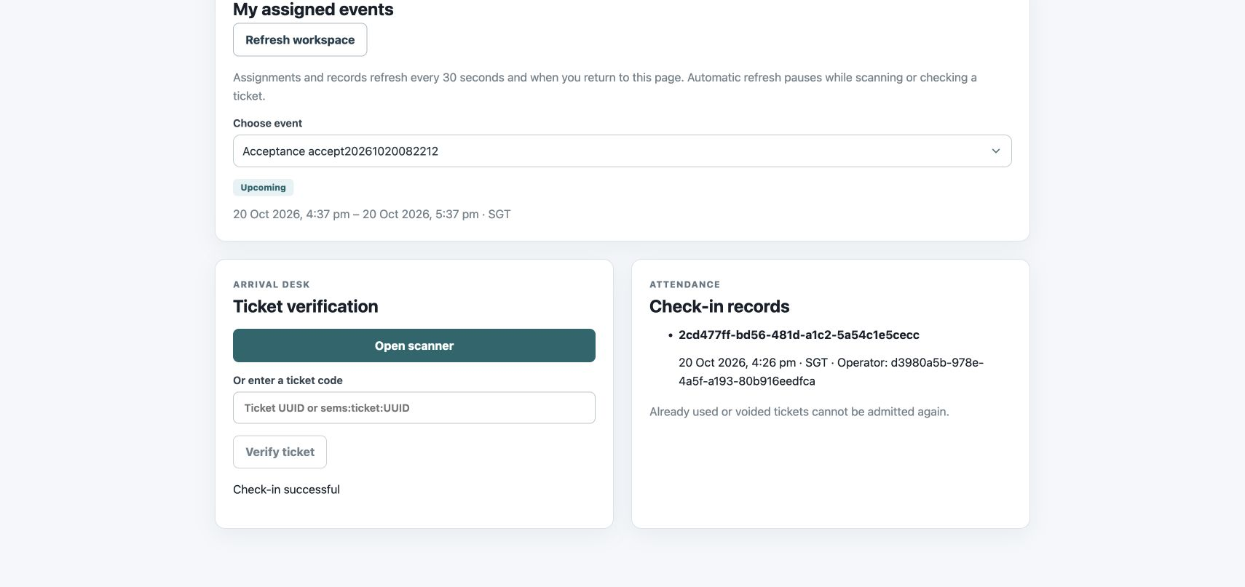
Figure 72. Recorded cloud check-in acceptance, 20 October 2026, baseline 270c2b8.
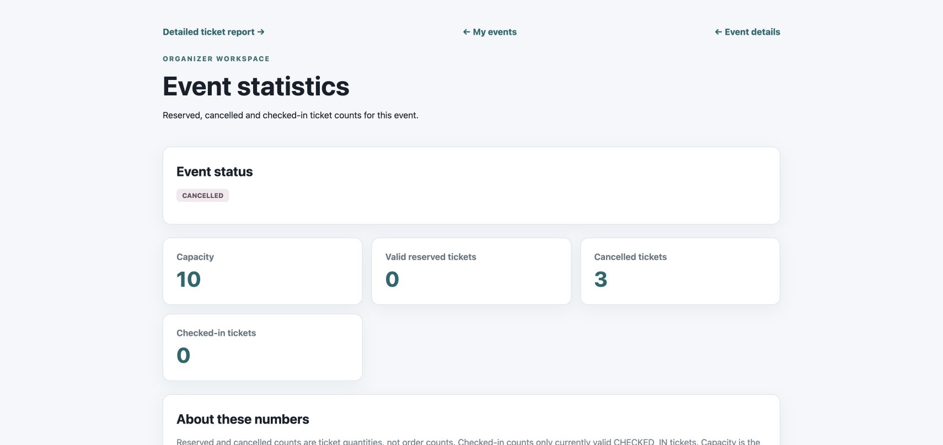
Figure 73. Recorded cancellation/reporting outcome. Historical audit and valid attendance have distinct meanings.
The screenshot baseline differs from the later release and capacity baselines. The system demonstration uses 565f08b material; the CI/CD video explains identified historical runs. Recordings support the presentation, while the assertions, logs and database audit support the report conclusions.
Evidence baselines: release 565f08b — 21 October 2026, GitHub Actions run 39566477705; business and coverage 270c2b8 — 20 October, run 39311200552; capacity 037720b — 21 October, run 39475238673. Run links use https://github.com/seventh720/SWE5006-SEMS/actions/runs/ followed by the run ID.

5. Individual Members Activity Contribution Summary
The summaries below connect each member’s principal responsibility to the report model, design problem and verification work. Actual effort through Sprint 4 is reproduced in Section 2.3. The shared system integrates these contributions into one deployed workflow.

5.1 Lu Junyi
Lu Junyi recorded 165.6 hours through Sprint 4. He is responsible for UC04 event management and supporting UC05 browsing, and coordinates lifecycle rules, project conduct and integration evidence. His DP01 analysis explains cancellation through synchronous Observer collaboration across booking, ticketing and notification. He covers event models, delivery milestones and cancellation rationale in this report.

5.2 Hu Jia
Hu Jia recorded 106.6 hours through Sprint 4. He is responsible for UC02 login and supporting UC01 registration. His DP02 analysis explains credential verification through the framework PasswordEncoder Strategy, alongside architecture and current-role authorization. He covers identity models, architecture and result interpretation in this report.

5.3 Chai Muyang
Chai Muyang recorded 81.6 hours through Sprint 4. He is responsible for UC03 user and role management, including concurrent protection of the last active administrator and the distinction between roles and resource ownership. His DP03 analysis explains the role-change Observer. He covers authorization and testing in this report.

5.4 Huang Haoyang
Huang Haoyang recorded 54.6 hours through Sprint 4. He is responsible for UC06 booking and its boundary, control and entity analysis, transaction design, idempotency and synchronous confirmation effects. His DP04 analysis explains the booking-field validation Strategy. He covers booking models, exception flows and pattern trade-offs in this report.

5.5 Luo Runzhou
Luo Runzhou recorded 67.6 hours through Sprint 4. He is responsible for UC07 ticket check-in, including assigned-staff eligibility, audit preservation and schema constraints. His DP05 analysis explains ticket lifecycle behaviour through State. He covers admission models, state behaviour and database relationships in this report.

5.6 Team Reflection and Conclusion
SEMS demonstrates a complete free-ticket event lifecycle backed by a coherent data model and a repeatable delivery workflow. The main design achievement is consistency across roles and modules: retries return one booking result, inventory does not oversell, confirmed orders produce individual tickets, and cancellation preserves audit history while invalidating admission.
The strongest implementation lessons concern boundaries. JWT role claims alone are insufficient after a role is revoked. Ticket state alone is insufficient without staff assignment and event locking. Observer alone does not guarantee atomicity; synchronous transaction participation supplies that property. Coverage and low-load success alone do not prove the original capacity target.
The next iteration should address the measured 1,000-VU mixed-traffic latency, encapsulate check-in orchestration and shared JDBC access, review expiring security exceptions and formalize recovery beyond the isolated database restore. Paid checkout requires a separate payment/refund design and remains outside the delivered free-ticket scope.
We will apply the retrospective actions during consolidation: freeze optional scope earlier, reserve integration time and retain evidence as tasks finish. This provides a concrete basis for the next review and for deciding whether further functionality is ready to deliver.

Appendix A Verification Artifacts
This appendix presents actual output excerpts and identifies the original files in the companion evidence archive. The fresh CI artifacts belong to checkout 82060f5 in run 40445034465 on 27 October 2026. Historical DAST and capacity measurements keep their own dates and application commits.

A.1 Lint and Automated Test Output
CI artifact lint-report / summary.txt
Lint report
Commit: 82060f508b98b86b6e4804e98d01e46701591b76
UTC: 2026-10-27T03:35:58Z
eslint: PASS
checkstyle: PASS
actionlint: PASS
shell-syntax: PASS
release-validation: PASS
dast-gate: PASS
capacity-watch: PASS
capacity-run: PASS
The unit-only Surefire XML totals are 202 discovered tests: 62 executed successfully and 140 skipped with container tests disabled. The separate PostgreSQL-enabled run totals 216 tests: 215 passed and one optional query comparison skipped. These executions are not added together. Selected original Surefire output follows.
backend-unit-coverage / com.team10.sems.booking.internal.application.BookingInfoValidatorTest.txt (result-line excerpt)
Test set: com.team10.sems.booking.internal.application.BookingInfoValidatorTest
Tests run: 21, Failures: 0, Errors: 0, Skipped: 0, Time elapsed: 0.959 s
backend-combined-coverage / com.team10.sems.BookingIntegrationTest.txt (result-line excerpt)
Test set: com.team10.sems.BookingIntegrationTest
Tests run: 58, Failures: 0, Errors: 0, Skipped: 0, Time elapsed: 20.19 s
backend-combined-coverage / com.team10.sems.StaffCheckInIntegrationTest.txt (result-line excerpt)
Test set: com.team10.sems.StaffCheckInIntegrationTest
Tests run: 15, Failures: 0, Errors: 0, Skipped: 0, Time elapsed: 3.043 s
Frontend job log, selected lines; columns are statements / branches / functions / lines
2026-10-27T03:36:17.7004749Z Test Files 32 passed (32)
2026-10-27T03:36:17.7029631Z Tests 244 passed (244)
2026-10-27T03:36:17.7148608Z All files | 88.76 | 83.51 | 89.33 | 92.75 |
Original JaCoCo and frontend HTML reports are included in the corresponding CI ZIPs. The combined backend counters are 1330/1406 lines and 429/526 branches; frontend counters are 1332/1436 lines and 1723/2063 branches. Functional results, coverage and the mocked-API limitation are summarized in Table 19.

A.2 Static Security and Container Results
The fresh static-security job passed. Semgrep reports zero findings and zero scan errors across 207 scanned files. The following JSON fields are reproduced from the parsed original semgrep.json; the full file is retained in sast-report.zip.
semgrep.json, selected original fields
{
"version": "1.181.0",
"results": [],
"errors": []
}
Artifact | Unignored H/C vulnerabilities | Secrets | Ignored vulnerability findings
trivy-source.json | 0 | 0 | 0
trivy-java.json | 0 | Not requested by JAR scan | 2
backend.json | 0 | 0 | 2
frontend.json | 0 | 0 | 0
postgres.json | 0 | 0 | 0
Table 23. Counts read from original Trivy JSON artifacts
H/C means HIGH or CRITICAL, the severity filter configured for these scans. Zero refers to findings remaining after the configured exceptions; it does not claim that every dependency is free of vulnerabilities. trivy-java.json and backend.json retain ExperimentalModifiedFindings for CVE-2026-47884 and CVE-2026-47890, both scoped to spring-webmvc 6.2.19 and expiring on 17 November 2026.
image-security-reports / smoke.txt, complete output
PASS /
PASS /events
PASS /healthz
PASS /actuator/health
PASS /api/v1/events
PASS registration and login through HTTPS-origin proxy headers
The image artifact also retains backend.id, frontend.id and postgres.id, linking the scans and smoke checks to the built images. These PR images were verified against an isolated database; they were not promoted to cloud staging. The repository scan scripts and exception file are preserved with the evidence.

A.3 Saved DAST Results
The saved ZAP artifact was generated against public HTTPS pages and GET APIs on application baseline 270c2b8. Its run metadata records 19 October 2026 at 19:33 UTC, which is 20 October at 03:33 SGT, and a clean configuration working tree. The scan is a passive unauthenticated baseline. It does not cover authenticated transactions or constitute an active penetration test.
dast-270c2b8 / summary.md, complete original output
# DAST baseline
Unauthenticated public pages and GET APIs; passive scan.
- Informational · 10109 · Modern Web Application
- Informational · 10049 · Non-Storable Content
- Informational · 10015 · Re-examine Cache-control Directives
- Informational · 10049 · Storable and Cacheable Content
Alert types: High=0, Medium=0, Low=0, Informational=4
Gate: fail on High/Medium or scanner/coverage errors. Low/Informational remain visible.
run.json, selected original fields
{
"startedAt": "2026-10-19T19:33:37.464433+00:00",
"configurationCommit": "270c2b87322f89555d54222b825da82e0694fa54",
"workingTreeDirty": false,
"scope": "Unauthenticated public pages and GET APIs; passive baseline, no active attack scan"
}
The original zap.html, zap.json, zap.md, coverage.json, scan.log and image-digests.json are retained alongside this summary. Four informational alert types cover 17 instances and did not trigger the configured high/medium severity gate. The fresh PR #50 workflow skipped DAST, so these results retain their historical baseline.

A.4 Performance Results and Stock Audit
The following complete outcome.json comes from the 21 October cloud capacity run on 037720b. Scenario JSON and fixture-audit.json accompany it. The experiment used a shared 2-vCPU host with 3832 MiB memory; read/mixed p95 uses the hold stage, whereas contention p95 covers its full stage.
capacity-037720b / outcome.json, complete original output
{
"applicationCommit": "037720bf57031063ea30ee2a55827d8f8d67b03b",
"allPlannedStagesExecuted": true,
"allThresholdsPassed": false,
"read500Passed": true,
"mixed500Passed": true,
"read1000": {
"passed": true,
"holdSeconds": 180,
"requests": 95360,
"errors": 0,
"holdP95Ms": 2937.7527307499995
},
"mixed1000": {
"passed": false,
"holdSeconds": 180,
"requests": 83164,
"errors": 0,
"holdP95Ms": 3508.9287636999984,
"reason": "Overall and endpoint p95 exceed 3 seconds"
},
"contention1000": {
"passed": false,
"configuredVUs": 1000,
"observedPeakVUs": 983,
"attempts": 1000,
"successfulBookings": 100,
"expectedSoldOut": 899,
"connectionFailures": 1,
"p95Ms": 4099.7734722,
"reason": "One refused TCP connection and p95 exceeds 3 seconds"
},
"inventory": {
"quota": 100,
"confirmedQuantity": 100,
"validTickets": 100,
"duplicateTicketOrdinals": 0,
"oversold": false
},
"healthGuardTriggered": false,
"containerRestartOrOOMObserved": false,
"serverUpgraded": false,
"cleanupAndRecoveryPassed": true
}
All planned stages executed, but all thresholds did not pass. Read at 1000 VU passed; mixed traffic exceeded three seconds; contention exceeded latency and recorded one connection refusal. The stock audit showed confirmed ticket quantity 100 and valid tickets 100 against quota 100, with no duplicate ordinals or overselling. Stock correctness does not change the failed latency and connection verdict.

