Business Requirements Specification

(First Phase)

Table of Contents

1. User Management 3

1) Sign up 3

i. Admin version 3

ii. New member 3

2) User login 5

3) User logout 6

4) Manage user profile 6

I. Modify user password 6

II. Edit user profile 6

III. Delete the user 6

2. Order Entry 7

3. Autoship 11

# User Management

# Sign up

# Admin version

If some one calls, and requests to sign up, and he/she did not sign up on line by himself

The following is what is needed to fill up by Admin:

Company name (if it’s a company), sponsor name (user ID),

Name, Address, Email address, Country, zip code, place order as a distributor (member) or as a Customer

Sign up date.

Submit

# New member

Autoship

|  |
| --- |
|  |

Yes,

|  |  |
| --- | --- |
| I want to enroll as an Associate and participate in the Autoship Program for an annual fee of $28, which will provide valuable benefits such as…  Reward Pricing. Get the absolute lowest price on all products including the special paks  Maintain active status and capture all group order volume within your organization  Stay qualified to participate in the compensation program  Participate in special and exclusive promotions  Get scheduled delivery of your favorite products, paks |  |
| No thanks, please show me other options. |  |

If choose Yes, then go this page

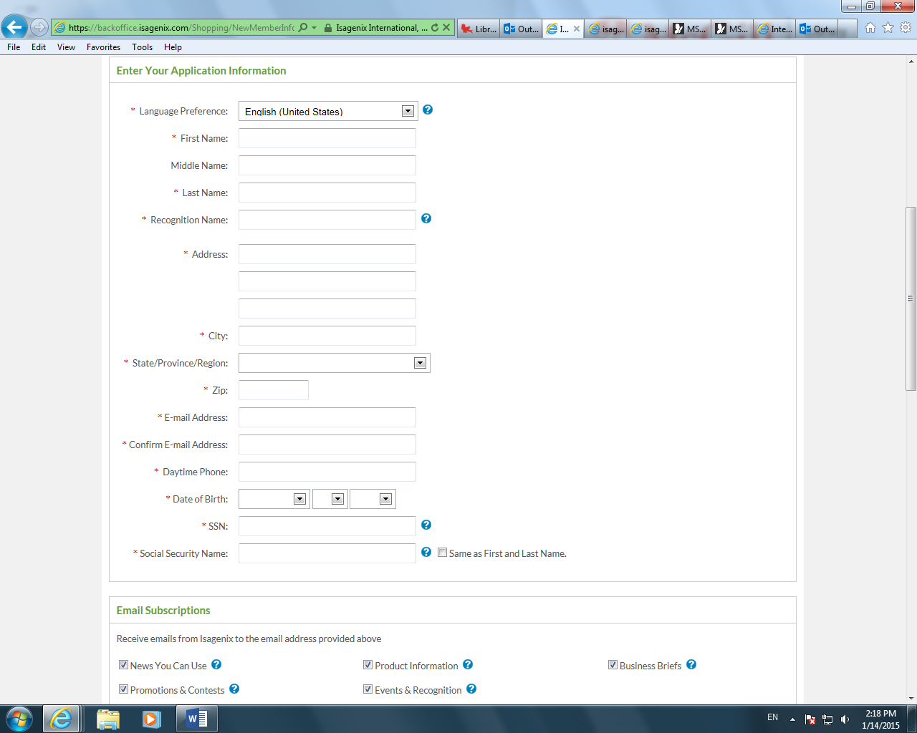

We do not need Language Preference, do not need Middle name, Recongnition name. Social security number does not have to be red. Also donot need Email Subscriptions.

Add:

Company Information, if sign up as a company

Company Name:

Type of Company

Referred By:

( ) I agree to the policies and procedures.

(To view the policies and procedures…..Click here)

Submit

If choose No on the first page

Then there are the following options

Select An Account



Associate Account (with Autoship) $28 Annual Membership Cost - If you like to have the lowest possible product pricing and have the possibility to make a substantial income in the process then this is the best choice for you! Get scheduled delivery of your favorite products, paks at our lowest prices, which reflect special rewards pricing on select items. Also, enjoy the benefits of our generous Compensation Plan and exclusive special promotions.





Preferred Customer Account (with Autoship) $28 Annual Membership Cost - If you’re not interested in the income opportunity but still want scheduled delivery of your favorite products at wholesale prices, then this is a good choice for you! Should you decide that you don’t want to pass up the chance to earn some extra cash, then upgrade to Associate Status at no additional cost anytime within your first two years.



Preferred Customer Account (without Autoship) $38 Annual Membership Cost If you’re not interested in the income opportunity but want to enjoy wholesale prices on products when you place your order each month, then this is the choice for you! Should you decide that you don’t want to pass up the chance to earn some extra cash, then upgrade to Associate Status at no additional cost anytime within your first two years.

**Preferred not to pay Annual Membership Cost, want to buy product in retail price.**

# User login

User input user id and password on the login page of software system , then the system will check if the user's id and password is correct, if it is correct, allow user login the system and forward to homepage.

# User logout

When user click "logout" button on the menu, the user will logout the system and quit the system page. After that , the user could not do any business in the system until user login system again.

# Manage user profile

### Modify user password

User input old password and new password(twice), if the old password is correct , change the user password from old to new password.

### Edit user profile

Edit user profile , such as: user name, email, telephone number ...

### Delete the user

Delete the user from software system.

# Order Entry

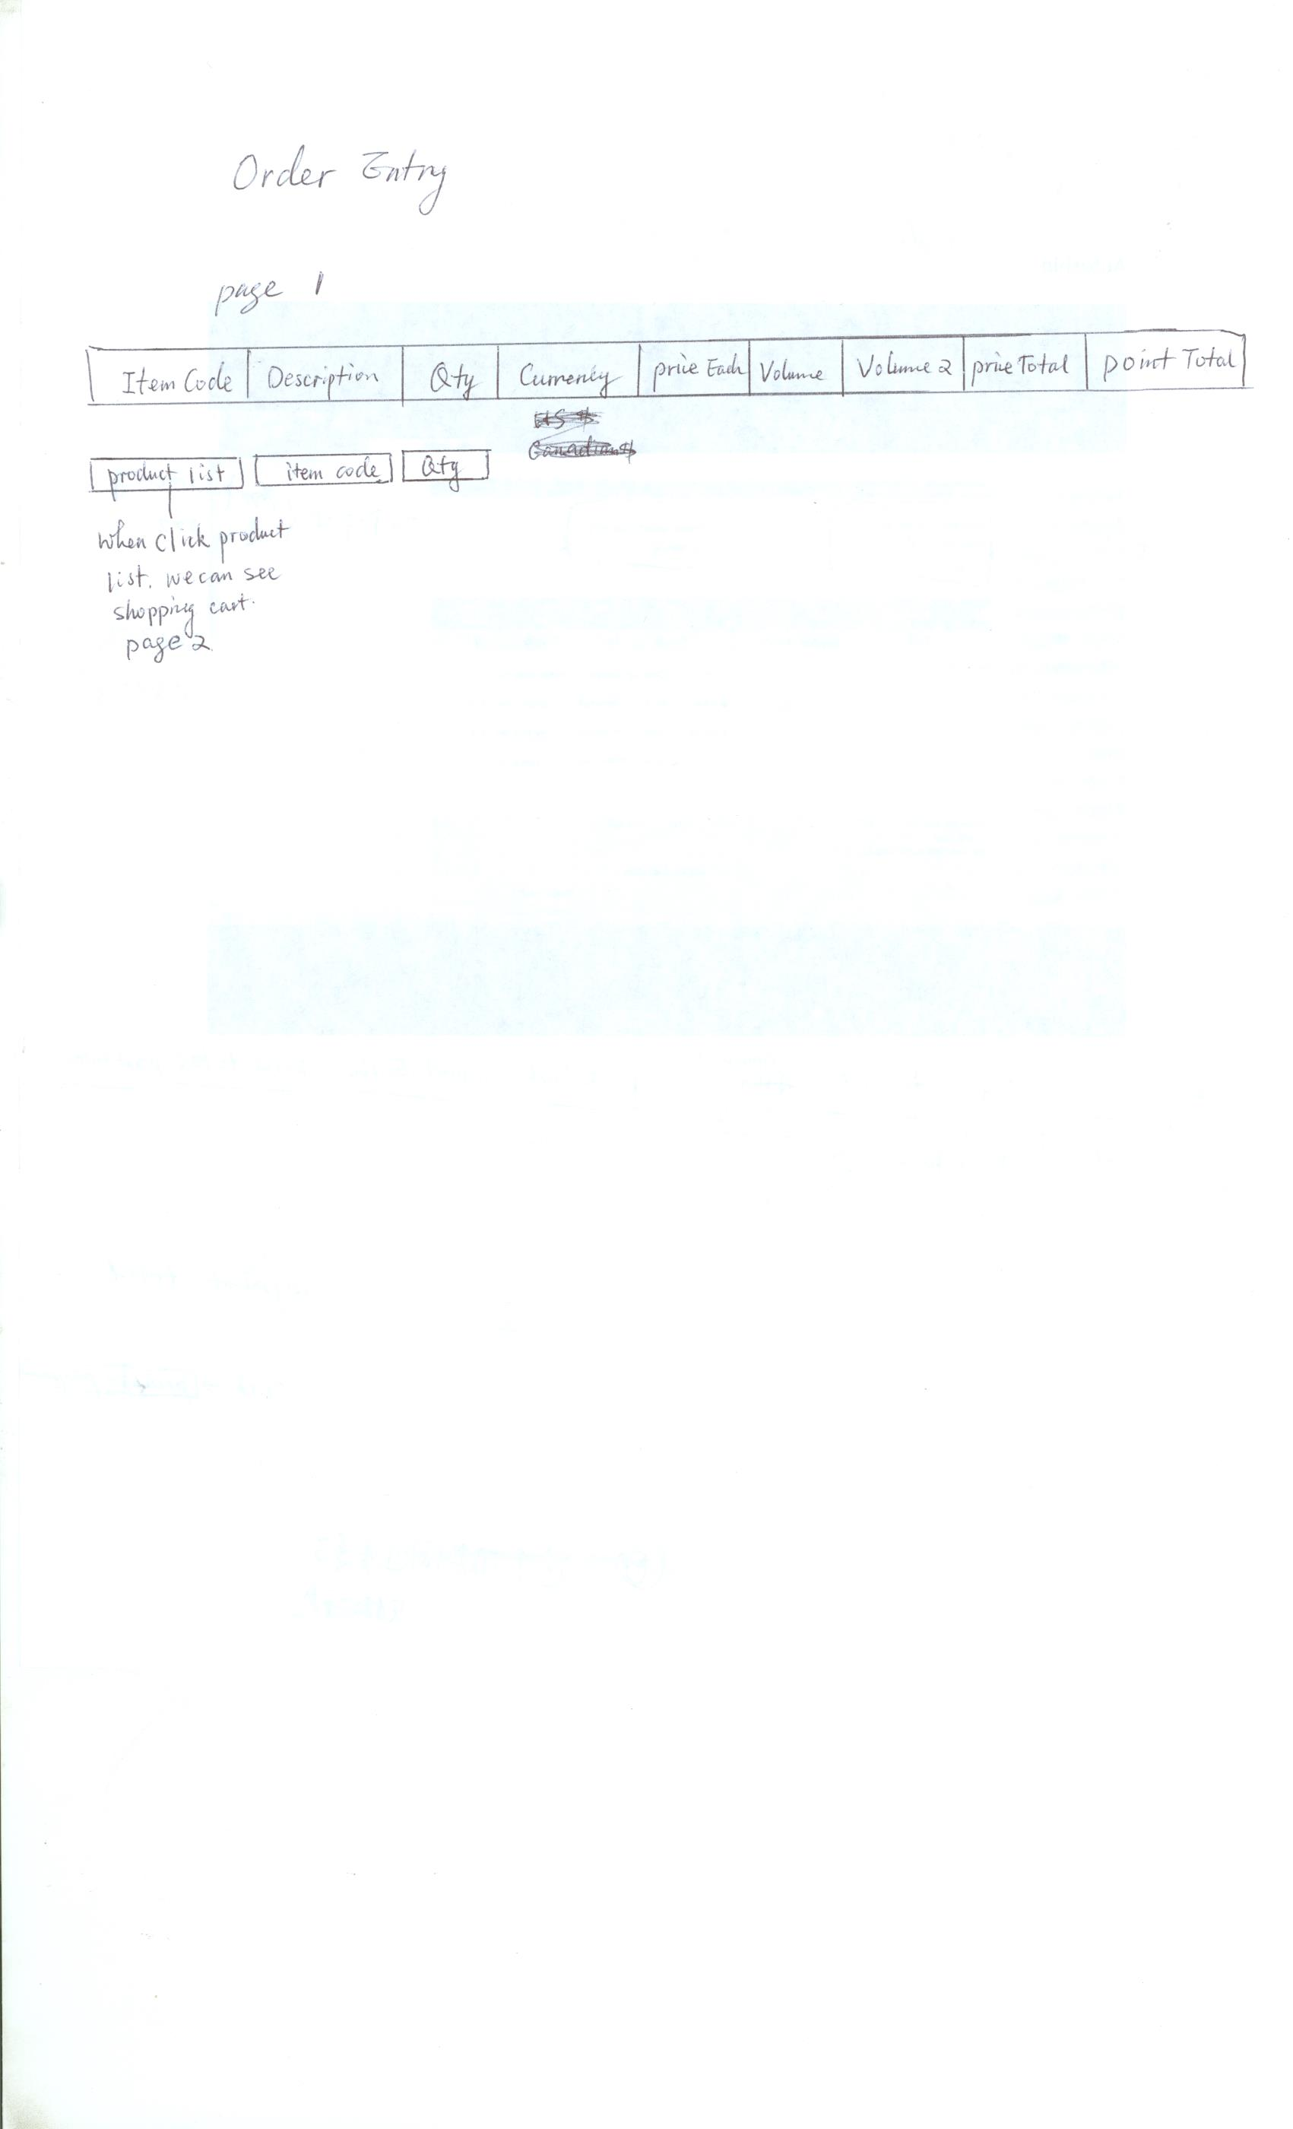

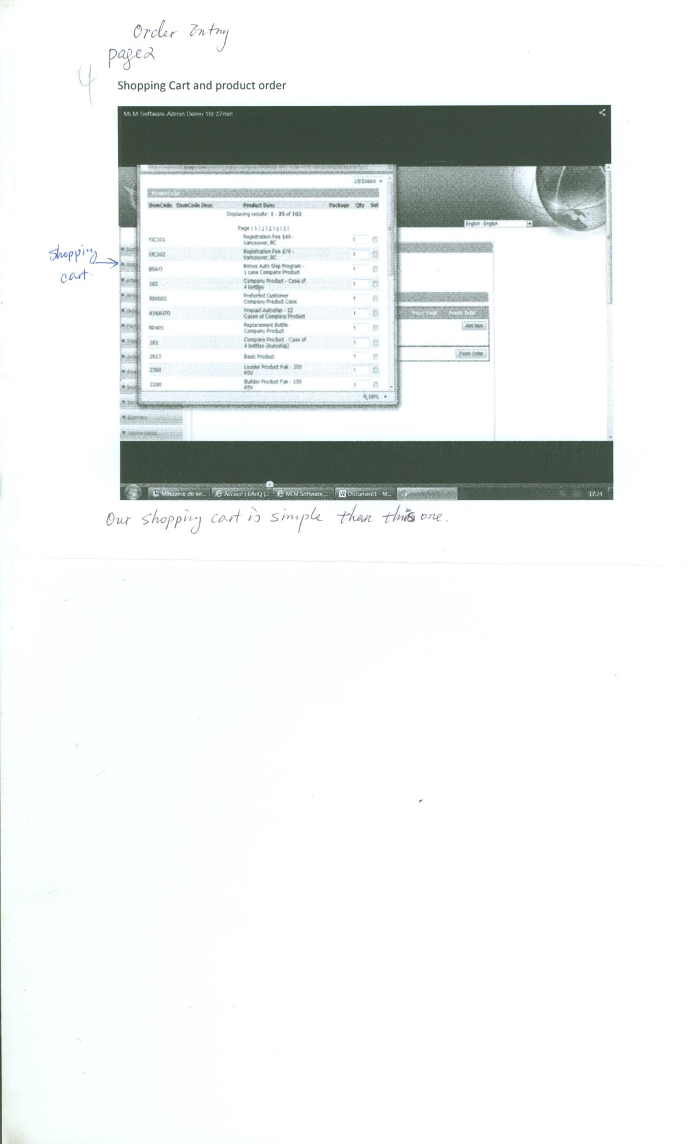

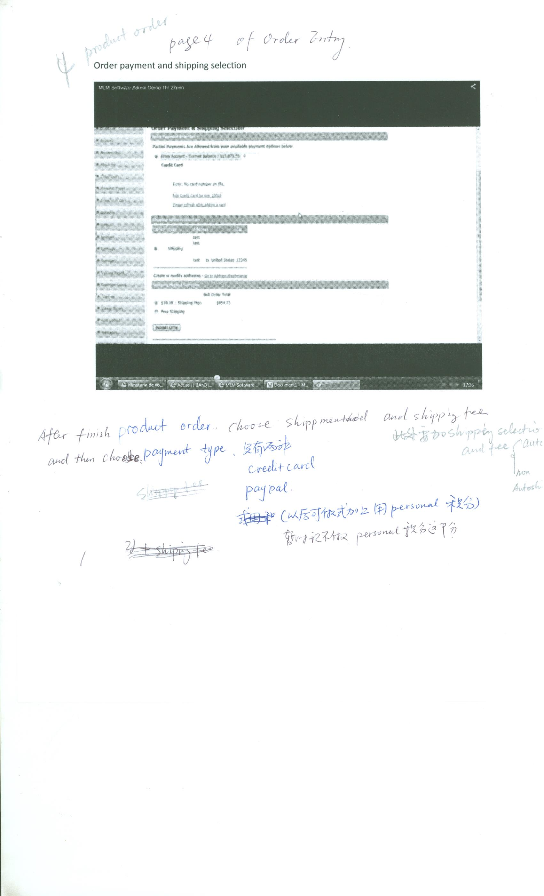

# Autoship

