# ReadME: Full-Stack Application (Grazioso Salvare)

## Project Introduction

The Grazioso Salvare Dashboard is a full-stack application designed to provide interactive data visualisations of the Austin Animal Centre Outcomes dataset. The dashboard enables users to filter data based on rescue type and dynamically updates the data table, geolocation map, and pie chart widgets in response to the user's selections.

## Project Features

* **Interactive Data Table:** Users can interact with the components present within the table. These interactions include sorting through and dividing into different pages.
* **Filter Options:** Users can filter the breeds of dogs based on their best deployment cases, such as mountain rescue and wilderness rescue, giving the dogs the best chance at utilising their traits and talents for the betterment of society.
* **Geolocation map:** The dogs can be tracked by their location based on coordinates offered in their data.

The interface includes a logo and some minor personalisation to make it my own.

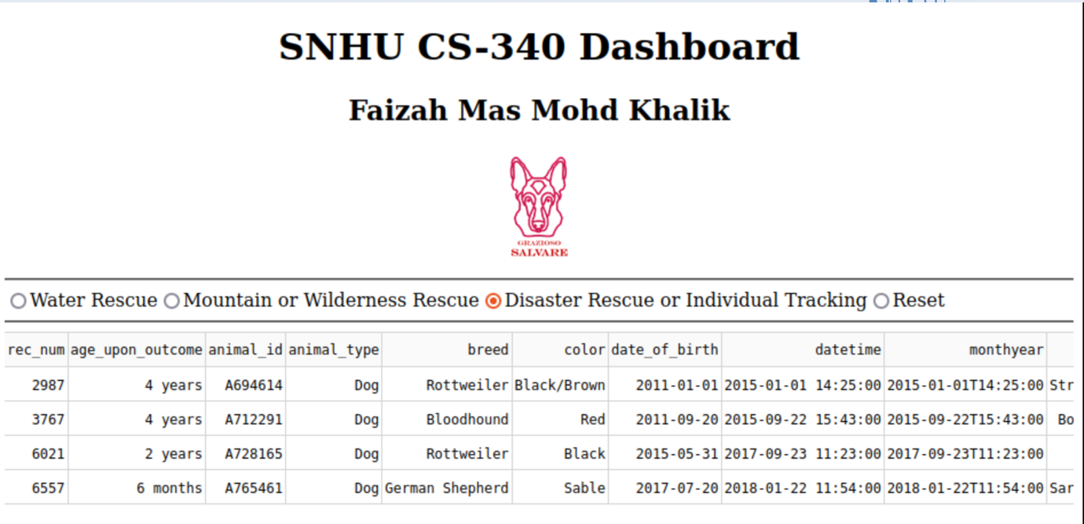

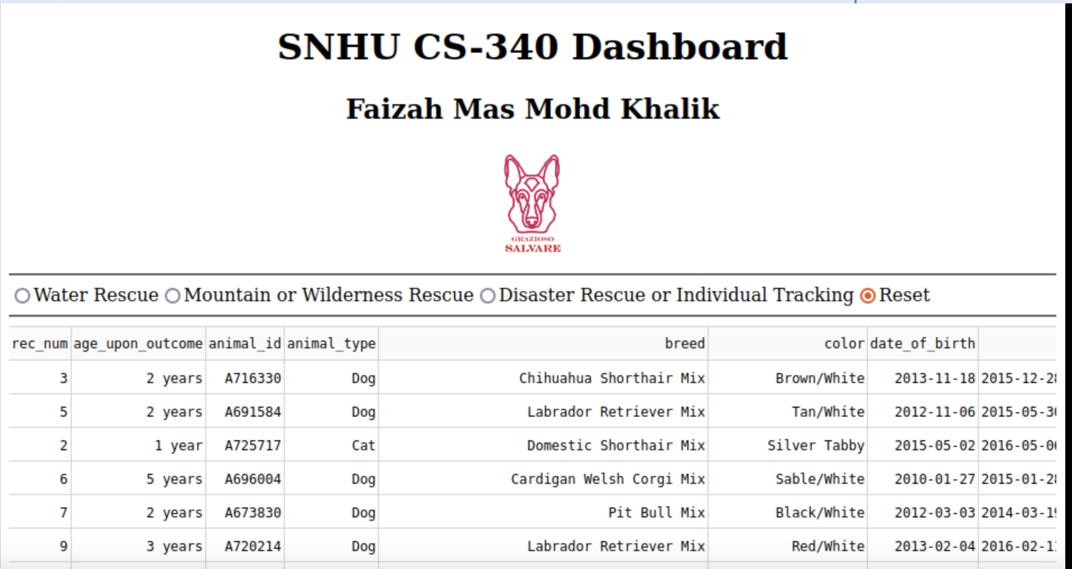

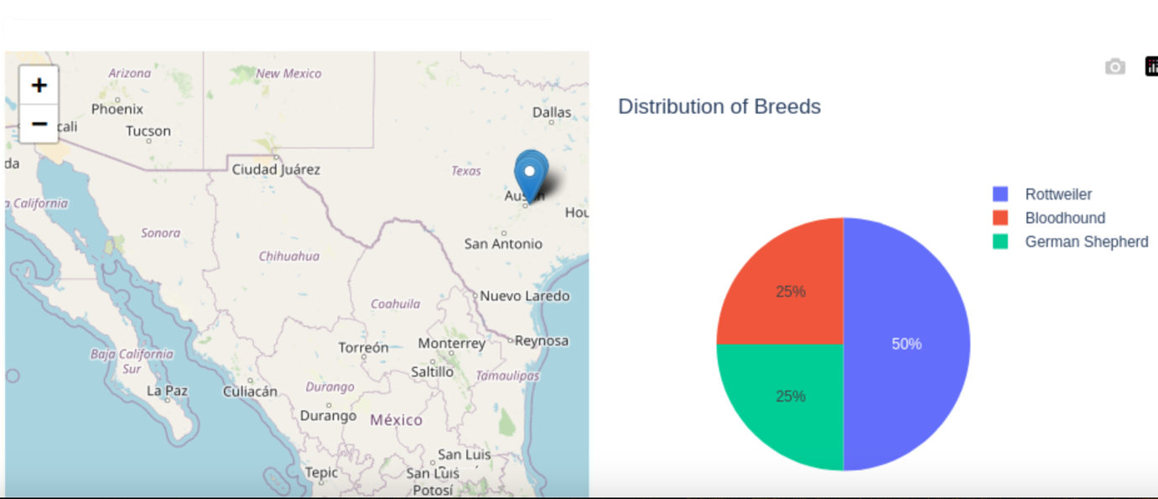

## Tools used

* **MongoDB:** It is a flexible tool with unstructured data and powerful querying capabilities. Its integration with Python through the *PyMongo* library allows for seamless data manipulation and retrieval.
* **Dash Framework:** For interactive components and the controller logic within the web application. It is easy to use, and therefore is an excellent choice for app developers who want to use Python for their work.
* **JupyterDash:** For the development of the dashboard within a Jupyter Notebook environment, allowing for iterative testing and visualisation.

## Give it a go! – How to set this up

1. Ensure that you have Python and all the required libraries set up.
2. Set up a MongoDB instance and populate it with the Austin Animal Centre (AAC) dataset.
3. Run ProjectTwoDashboard.ipynb to launch the dashboard.
4. Navigate through the dashboard using the interactive interface to verify its functionality.

## Challenges in development

Aside from the fact that I was completing this project in an area with a very unstable internet connection, which sometimes prevented my project from working the way I needed it to when I tested it, the challenges I faced were that I needed to tweak the HTML elements to make sure that my dashboard did not look like it fell out of a blender (for clean design). I also found it a challenge to keep the pie chart clean when no filters were being applied.