# http://i.stack.imgur.com/LcBvQ.gifJavascript & jQuery Selektoren

document.getElementById(id)  
document.getElementsByTagName("p")  
document.getElementsByClassName("classname")  
$("#id .class p").hide()

# PHP-Dateizugriff

fopen("datei", "w" );  
fread($handle, filesize("datei");  
while(($line = fgets($handle)) !== false) {echo $line;}  
fwrite($handle, "inhalt");  
fclose($handle);

# Kontrollstukturen

foreach($array as $key => $value) {}  
if(){} else if{} else {}  
for($i;$i<10;$i++){}  
while(){}

# Arrays

array(1, 3, "Vier", 5.0);  
array("key" => $value, "test" => "string") ;

# Cookies

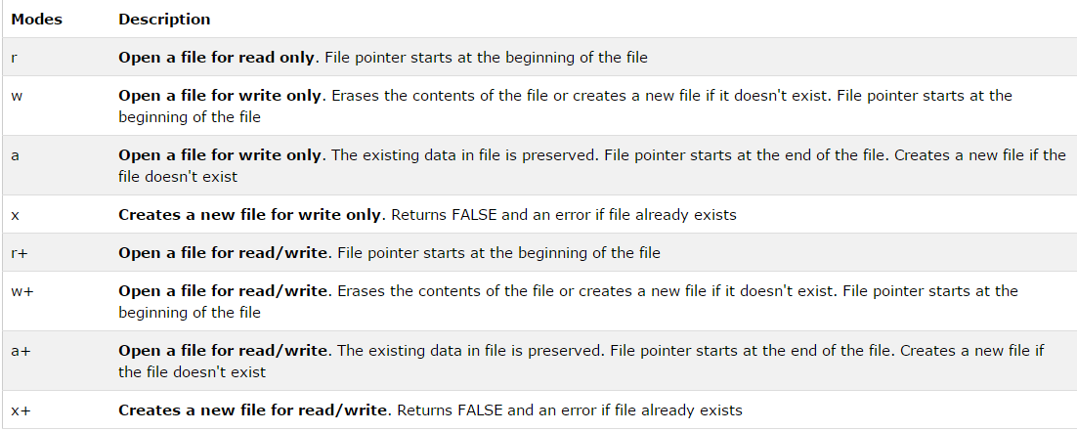setcookie("cookiename", $value);  
echo $_COOKIE["cookiename"];  
//Cookie löschen  
unset($_COOKIE["cookiename"];  
setcookie("cookiename", "", time()-3600);