Chapter 6
Snapshots
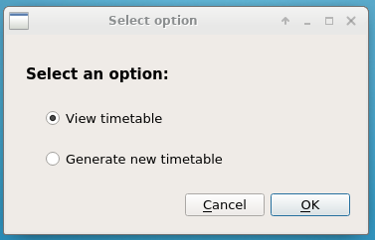

Fig 6.1 Main Window

Main window for selecting option either to generate a new timetable or to view the existing timetable.

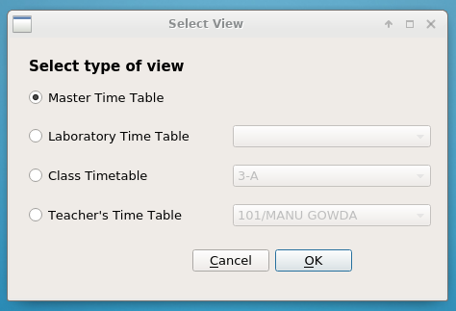

Fig 6.2. Choose View Window

Choose view window options to view master timetable or laboratory timetable or class timetable or teacher’s timetable by selecting a specific lab/class/teacher name from the drop down menu corresponding to it.

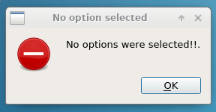

Fig 6.3 Error Dialog

Error dialog shown if no option are entered either in main window or in the choose view window.

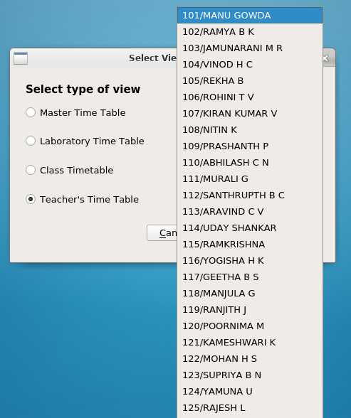

Fig 6.4 Drop Down Combo Box for Teacher’s View

Choose view window where Teacher’s Time table view is selected and corresponding teacher name is being selected for viewing the timetable of the specified teacher.

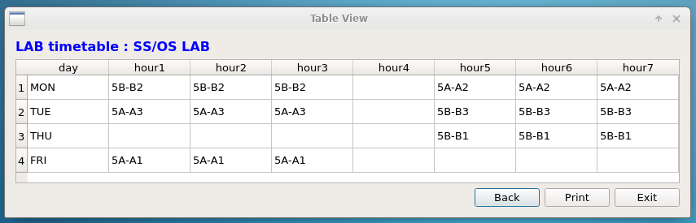

Fig 6.5 Table View for Laboratory timetable

Table View window showing the timetable of the SS/OS Laboratory.

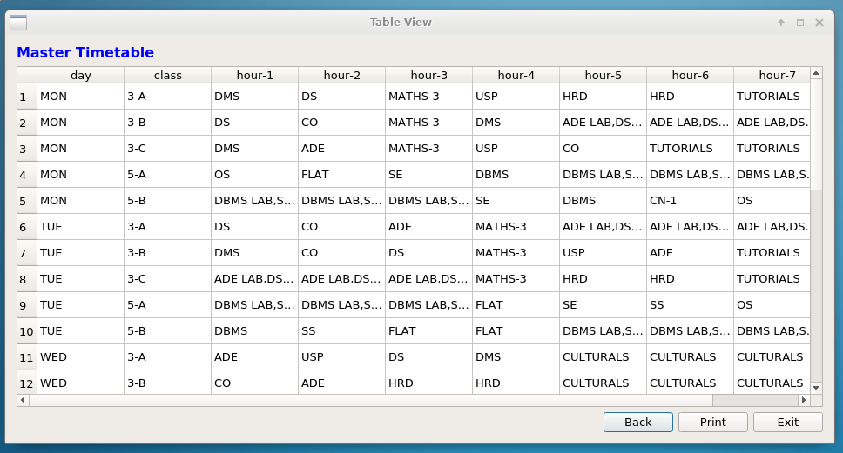

Fig 6.6 Table View for Master timetable

Table View window showing the Master timetable of classes 3A,3B,3C,5A and 5B.

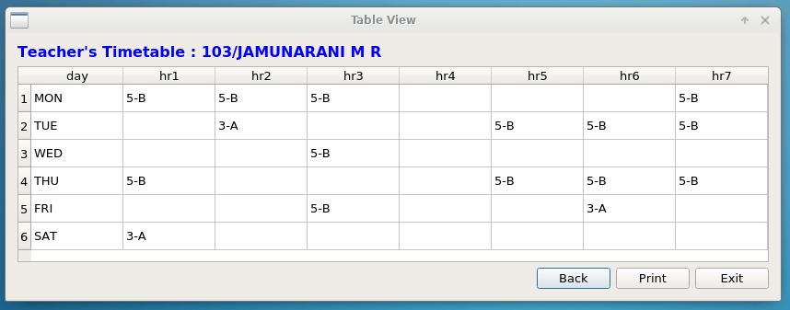

Fig 6.7 Table View for Teacher’s timetable

Table View window showing the timetable of a specified teacher selected from the drop down menu.

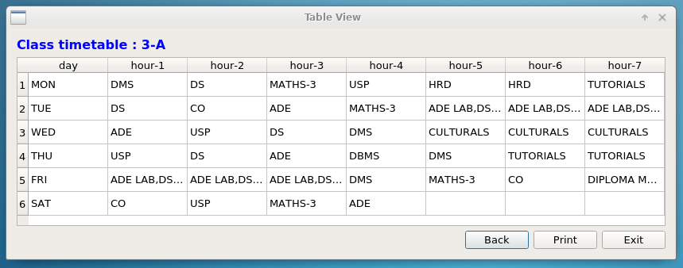

Fig 6.7 Table View for Class timetable

Table View window showing the timetable of a specified class selected from the drop down menu.

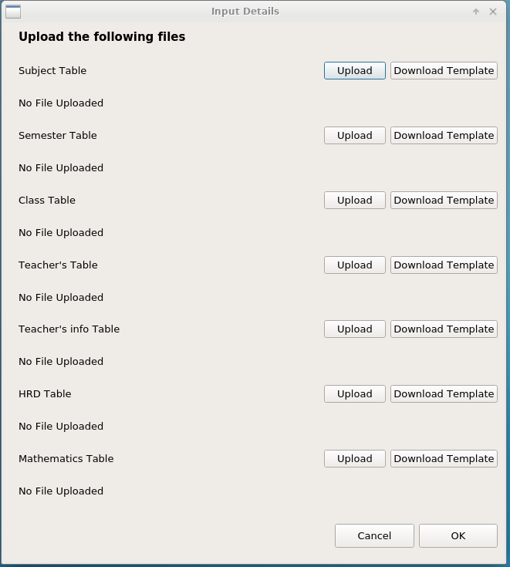

Fig 6.7 Input Window for uploading user data

Input window showing user dialog for downloading spreadsheet templates and filling the templates with the required data and uploading the spreadsheet files for specified tables in the database.

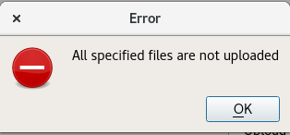

Fig 6.8 Error Dialog for input window

Error Dialog shown if the user has not uploaded all the required spreadsheet files.

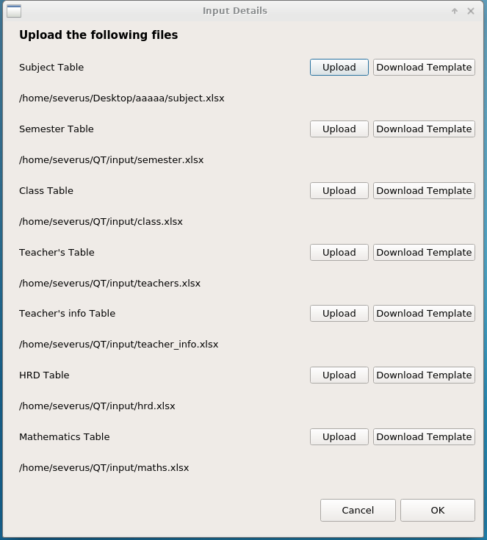

Fig 6.9 Input Window for uploading user data

Input window showing user dialog for downloading spreadsheet templates and filling the templates with the required data and uploading the spreadsheet files for specified tables in the database after uploading the user files.

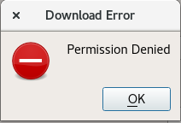

Fig 6.10 Error Dialog

Error Dialog shown if the user has specified an invalid destination for downloading templates.

