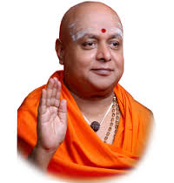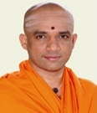
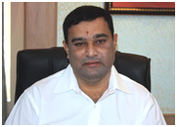
ACKNOWLEDGEMENT

We would like to express our profound thanks to His Divine Soul Padmabhushan Sri Sri Sri Dr. Balagangadharanatha Maha Swamiji and His Holiness Jagadguru Sri Sri Sri Dr. Nirmalanandanatha Maha Swamiji for providing us an opportunity to pursue our academics in this esteemed institution.

We would also like to express our profound thanks to Revered Sri Sri Prakashnath Swamiji, Managing Director, SJB Institute of Technology, for his continuous support in providing amenities to carry out this mini project in this admired institution.

We express our gratitude to Dr. Puttaraju, Principal, SJB Institute of Technology, for providing an excellent facilities and academic ambience; which have helped us in satisfactory completion of mini project work.

We extend our sincere thanks to Dr. Mohan H S, Head of the Department, Information Science and Engineering; for providing an invaluable support throughout the period of mini project work.

We wish to express heartfelt gratitude to our guide, Ramya B K , for her valuable guidance, suggestions and cheerful encouragement during the entire period of this work.

We express our truthful thanks to Rekha B, Mini Project Coordinator, Dept ISE for her valuable support.

Finally, we take this opportunity to extend our earnest gratitude and respect to our parents, Teaching & Non-teaching staffs of the department, the library staff and all our friends, who have directly or indirectly supported us during the period of this mini project work.

Regards,
Vishwa Prakash H V (1JB14IS118)
Shreyas P V (1JB14IS092)

