Financial Literacy Programme for Rural Youth
A COMMUNITY PROJECT REPORT
Submitted in partial fulfillment of the requirements for the award of the degree of
Bachelor of Technology
in
COMPUTER SCIENCE AND ENGINEERING
BY
PITTA VENKATA SURI REDDY [Batch Leader]  24331A05N4 | PONTAPALLI ROHITH  24331A05N6
PENTAKOTA LALITH LAKSHYA  24331A05M8 | POLAKI LIKITHA  25335A0520
Under the Guidance of
Dr. P. Rama Santosh Naidu
Project In-Charge, Department of CSE
&
Mr. R. Ravi Kumar
Project In-Charge, Department of CSE



DEPARTMENT OF COMPUTER SCIENCE AND ENGINEERING
MAHARAJ VIJAYARAM GAJAPATHI RAJ COLLEGE OF ENGINEERING
(Autonomous)
(Approved by AICTE, New Delhi, and permanently affiliated to JNTUGV, Vizianagaram),
Listed u/s 2(f) & 12(B) of UGC Act 1956.
Vijayaram Nagar Campus, Chintalavalasa, Vizianagaram-535005, Andhra Pradesh
OCTOBER, 2026

CERTIFICATE

This is to certify that the project report entitled “Financial Literacy Programme for Rural Youth” being submitted by PITTA VENKATA SURI REDDY (24331A05N4), PONTAPALLI ROHITH (24331A05N6), PENTAKOTA LALITH LAKSHYA (24331A05M8), and POLAKI LIKITHA (25335A0520), in partial fulfillment of the requirements for the award of the degree of Bachelor of Technology in Computer Science and Engineering, is a record of bona fide work carried out by them under our supervision during the academic year 2024–2028.

Dr. P. Rama Santosh Naidu  Project In-Charge,  Department of CSE,  MVGR College of Engineering (A), Vizianagaram.  Mr. R. Ravi Kumar  Project In-Charge,  Department of CSE,  MVGR College of Engineering (A), Vizianagaram. | Dr. Aruna Srinivas  Professor & Head,  Department of CSE,  MVGR College of Engineering (A), Vizianagaram.

DECLARATION
We hereby declare that the work presented in this report entitled “Financial Literacy Programme for Rural Youth” has been carried out by us and submitted in partial fulfilment for the award of credits in Bachelor of Technology in Computer Science and Engineering of MVGR College of Engineering (Autonomous), affiliated to JNTUGV, Vizianagaram. The contents incorporated in this report have not been submitted for the award of any degree of any other institution or university.
PITTA VENKATA SURI REDDY (24331A05N4)
PONTAPALLI ROHITH (24331A05N6)
PENTAKOTA LALITH LAKSHYA (24331A05M8)
POLAKI LIKITHA (25335A0520)

ACKNOWLEDGEMENTS
We express our sincere gratitude to the Project In-Charges, Dr. P. Rama Santosh Naidu and Mr. R. Ravi Kumar, for their guidance and supervision throughout the Community Project. We also thank the Department of Computer Science & Engineering and the management of MVGR College of Engineering (Autonomous) for providing the academic framework and support required to complete this work. We are grateful to Govt. Junior College, Vizianagaram Town, for permitting the field activity and to the participating Class XII students for their active involvement.

PITTA VENKATA SURI REDDY (24331A05N4)
PONTAPALLI ROHITH (24331A05N6)
PENTAKOTA LALITH LAKSHYA (24331A05M8)
POLAKI LIKITHA (25335A0520)

ABSTRACT
The Financial Literacy Programme for Rural Youth (PS090) is a community project under the Education domain implemented by BATCH-13D (Section D), Department of CSE, MVGR College of Engineering (A). The programme aimed to improve the financial knowledge and digital-payment safety awareness of Class XII students at Govt. Junior College, Vizianagaram Town.
A structured four-module, single-day financial literacy session was delivered to 37 Class XII students on 26-09-2026 covering (1) Savings & Banking, (2) UPI & Digital Payments Safety, (3) Insurance & Govt. Schemes, and (4) Financial Planning & Budgeting. A 15-mark printed MCQ pre-test was administered before the session and an identical post-test was administered after the session.
The community partner was Govt. Junior College, Vizianagaram Town (College Code: 02197, U-DISE: 28122800110). The pre-test average was 5.1/15 (34%), while the post-test average was 12.9/15 (86%). All 37 students improved, and 29 students (78%) scored in the 80–100% range in the post-test.
Keywords: financial literacy, rural youth, Class XII students, savings, UPI, digital payments, insurance, financial planning, community project, MVGR CSE, PS090, Vizianagaram

TABLE OF CONTENTS
Section | Page No.
Certificate | 2
Declaration | 3
Acknowledgements | 3
Abstract | 3-4
List of Abbreviations | 4
List of Figures | 4
List of Tables | 4
1. Introduction | 5
1.1 Background | 5
1.2 Need for the Project | 5
1.3 Target Community | 5
1.4 Motivation | 5
2. Problem Identification & Proposal | 6
2.1 Baseline Assessment | 6
2.2 Finalised Problem Statement | 6
2.3 Project Objectives | 6
3. Planning & Strategy | 6
3.1 Stakeholders | 6
3.2 Team Roles & Responsibilities | 6
3.3 Schedule & Timeline | 6
3.4 Resources Required | 7
4. Execution & Community Engagement | 7
5. Data Collection & Impact Assessment | 8-9
5.1 Key Performance Indicators | 8
5.2 Findings & Outcomes | 8-9
6. Conclusion | 9-10
7. Future Work | 10
References | 10
Appendices | 10
Appendix A — Survey Form / Data Collection Instrument | 10
Appendix B — Raw Data / Response Summary | 10
Appendix C — Field Visit Photographs | 10
Appendix D — Community Certificate | 10

LIST OF ABBREVIATIONS
Abbreviation | Full Form
CERT-In | Indian Computer Emergency Response Team
MCQ | Multiple-Choice Question
MVGR | Maharaj Vijayaram Gajapathi Raj College of Engineering
NPCI | National Payments Corporation of India
PS | Problem Statement
RBI | Reserve Bank of India
SEBI | Securities and Exchange Board of India
UPI | Unified Payments Interface
2FA | Two-Factor Authentication
JNTUGV | Jawaharlal Nehru Technological University Gurajada Vizianagaram

LIST OF FIGURES
Fig. No. | Title / Description | Page No.
4.1 | Govt. Junior College, Vizianagaram Town - entrance gate | 7
4.2 | Financial Literacy session in progress - team presenting on the smart board | 8
4.3 | Students during the Financial Literacy awareness session | 8
5.1 | Score distribution - before vs after | 9
5.2 | Class average - pre-test vs post-test | 9
5.3 | Individual pre-test vs post-test scores for all 37 students | 9

LIST OF TABLES
Table No. | Title / Description | Page No.
3.1 | Team Roles & Responsibilities | 6
3.2 | Implementation Schedule | 6
4.1 | Field Visit Activity Log | 7
5.1 | Key Performance Indicators | 8

1. INTRODUCTION
Financial literacy is increasingly important as young people begin to interact with savings accounts, digital payments, insurance products, government schemes and other financial services. The project focuses on rural Class XII students because they are approaching a transition point where they may enter higher education, employment or family responsibilities. The team identified the need for structured, practical financial education that can help students make safer and more informed financial decisions.
The Review 1 presentation identifies the central problem as a lack of structured exposure to how banks, UPI, insurance and government financial schemes work. It also notes that smartphone and UPI adoption has grown quickly while financial education may not have kept pace. The project therefore proposes a four-session awareness programme supported by baseline and post-intervention assessment.

Background
The community partner for this project is Government Junior College, Vizianagaram Town (College Code: 02197, U-DISE Code: 28122800110). The institution serves rural Class XII students preparing for higher education. A pre-test conducted before the session confirmed that the students had minimal prior financial knowledge, with a class average of only 5.1 out of 15 marks (34%).
India's digital payment ecosystem (UPI, mobile banking) has reached rural communities rapidly, but financial and cyber-safety literacy has not kept pace — creating an important gap. This project directly addresses that gap by delivering structured financial literacy education to rural Class XII students before they enter financial independence.

Need for the Project
- Students may enter financial independence without adequate understanding of savings, digital payments, insurance and financial planning.
- Limited awareness of digital-payment safety can increase exposure to unsafe transactions and financial fraud.
- Class XII is a practical final shared classroom opportunity to provide structured financial-awareness education before students move into different education, employment or family pathways.

Target Community
- Primary beneficiaries: Class XII students at the Govt. Junior College, Vizianagaram Town.
- Secondary beneficiaries: Teachers and parents who may support continued financial-awareness discussions.
- Wider community: Families and the surrounding rural community that may benefit indirectly when students share safer financial practices.

Motivation
The team selected this problem because financial decisions increasingly involve digital tools, while young people may not receive enough practical guidance before becoming financially independent. The project aims to make financial literacy understandable, practical and measurable through structured sessions and pre-test/post-test assessment.

2. Problem Identification & Proposal

Baseline Assessment
A 15-mark printed MCQ pre-test was administered to all 37 students before the financial literacy session to establish baseline knowledge. The assessment covered four areas:
- Understanding of basic saving habits and responsible money management.
- Awareness of UPI and safe digital-payment practices.
- Knowledge of insurance and relevant government schemes.
- Ability to plan spending, saving and financial goals.
Pre-test results confirmed a low baseline: the class average was 5.1/15 (34%), 59% of students scored below 40%, and no student scored above 80%. After the session, the post-test average rose to 12.9/15 (86%), a gain of 7.8 marks and a 152% relative increase over the baseline average. All 37 students improved.

Finalised Problem Statement
Rural Class XII students often finish school without being taught how banks, UPI, insurance or government financial schemes actually work, leaving them exposed to fraud and poor money decisions when they begin to need financial independence.

Project Objectives
- Deliver four structured learning modules covering saving habits, UPI and digital payments, insurance and schemes, and financial planning.
- Improve awareness of cyber-safe digital transactions, fraud prevention and responsible money management.
- Measure knowledge gain using matched pre-test and post-test scores.
- Reached 37 Class XII students at Govt. Junior College, Vizianagaram Town on 26-09-2026 (approved non-working day).
- Obtained formal permission from Govt. Junior College, Vizianagaram Town before the session date.

3. Planning & Strategy

Stakeholders
- Class XII students — primary beneficiaries and participants.
- Govt. Junior College, Vizianagaram Town - community partner and venue for implementation.
- Teachers/Principal — permission, coordination and support for student participation.
- Parents/guardians — potential secondary beneficiaries and participants in feedback.
- Project In-Charges — academic supervision and approval of project activities.
- Student project team — planning, data collection, delivery, documentation and assessment.

Team Roles & Responsibilities
Table 3.1 — Team Roles & Responsibilities
Team Member | Role & Responsibility
PITTA VENKATA SURI REDDY | Batch Leader & Module 1 Delivery - leads the team, delivers Savings & Banking, and coordinates project documentation.
PONTAPALLI ROHITH | Session Lead & Technical Support - delivers UPI & Digital Payments Safety, supports demonstrations, and handles Q&A.
PENTAKOTA LALITH LAKSHYA | Community Engagement & Module 3 Lead - delivers Insurance & Govt. Schemes and coordinates student participation.
POLAKI LIKITHA | Data Analysis Lead & Module 4 Delivery - delivers Financial Planning & Budgeting, administers pre/post tests, and analyses scores.

Schedule & Timeline
Table 3.2 — Implementation Schedule
Phase | Activity | Timeframe
Preparation | Community partner confirmation, permission, assessment design, and module preparation. | Before 26-09-2026
Field activity | Pre-test, four-module financial literacy session, Q&A, post-test, and handout distribution. | 26-09-2026
Post-activity | Score verification, analysis, documentation, and final report preparation. | After 26-09-2026
Field activity was conducted on the approved non-working day, 26-09-2026, after formal permission from Govt. Junior College, Vizianagaram Town. Secondary references from RBI, NPCI, CERT-In and other official sources were used to prepare the learning modules.

Resources Required
- Printed pre-test and post-test MCQ sheets and attendance records.
- Session PPTs and learning materials for the four modules.
- Printed financial-literacy handouts for students.
- Laptop, smart-board presentation setup and mobile devices for demonstrations where required.
- Attendance records and photographic documentation.
- Official/secondary reference material from RBI, NPCI, CERT-In and government sources.

4. Execution & Community Engagement
The programme was executed as a single field visit at Govt. Junior College, Vizianagaram Town on 26-09-2026. The team administered a baseline pre-test, delivered all four financial literacy modules interactively, conducted Q&A, administered the identical post-test, and distributed the financial literacy handout to all 37 participating students.

Table 4.1 — Field Visit Activity Log
Date | Location | Activity Carried Out
26-09-2026 | Govt. Junior College, Vizianagaram Town | Pre-test followed by four-module financial literacy session, Q&A, post-test, and handout distribution to 37 Class XII students.

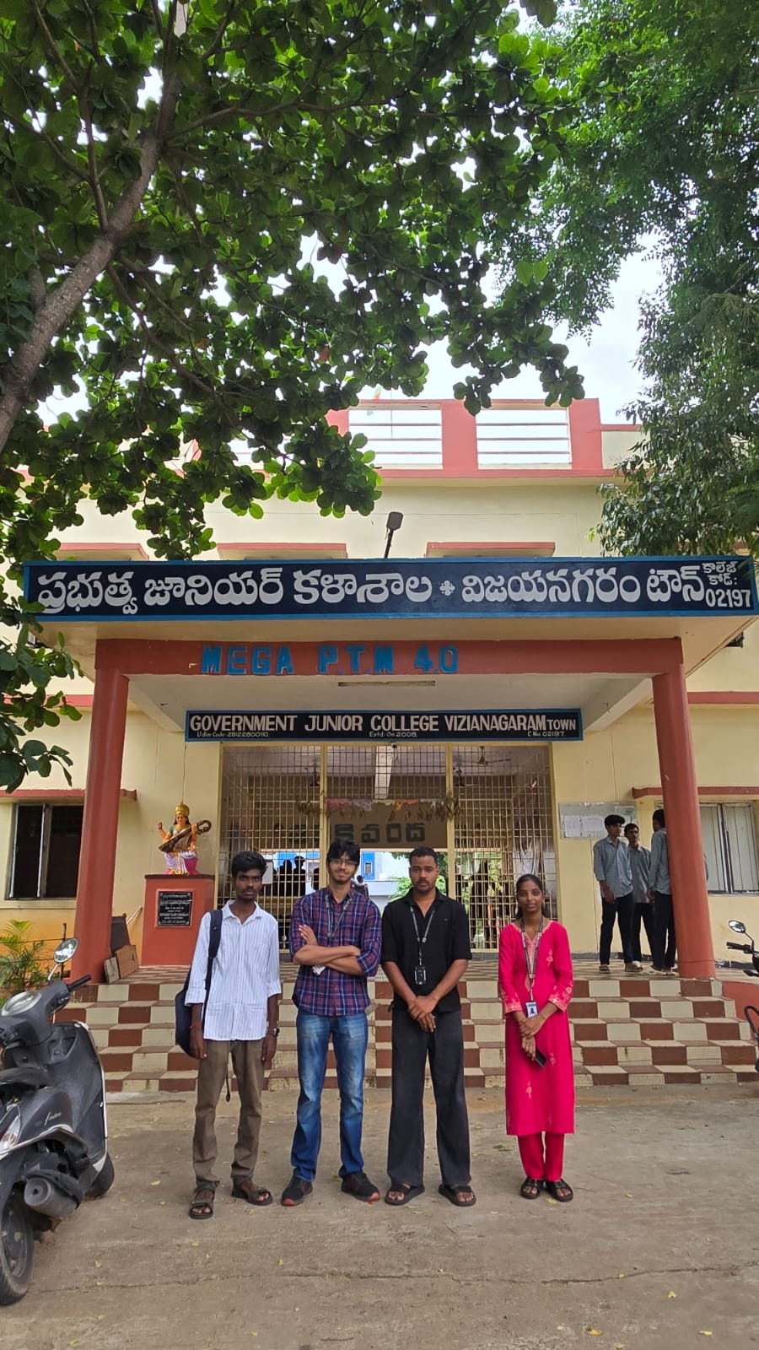
Figure 4.1: Govt. Junior College, Vizianagaram Town — entrance gate (26-09-2026)
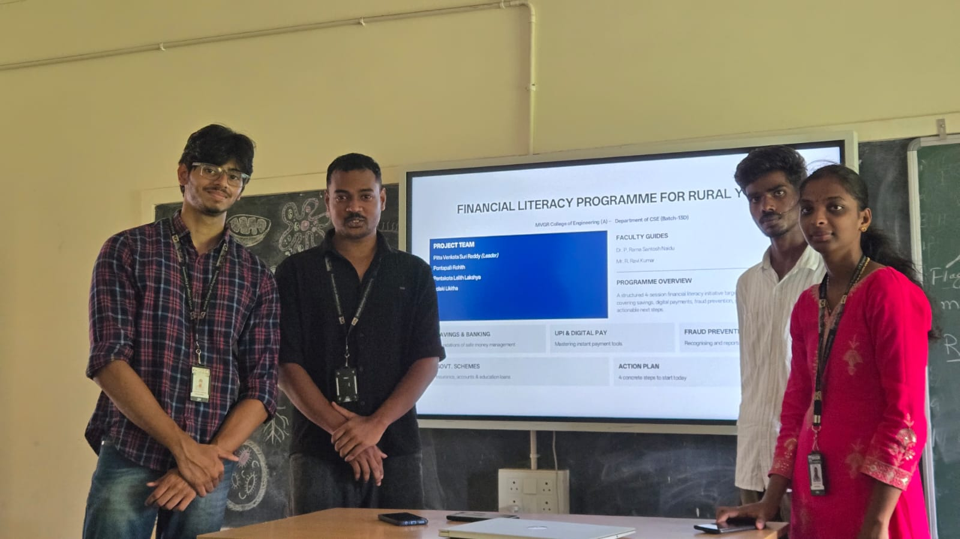
Figure 4.2: Team presenting Financial Literacy session on the smart board
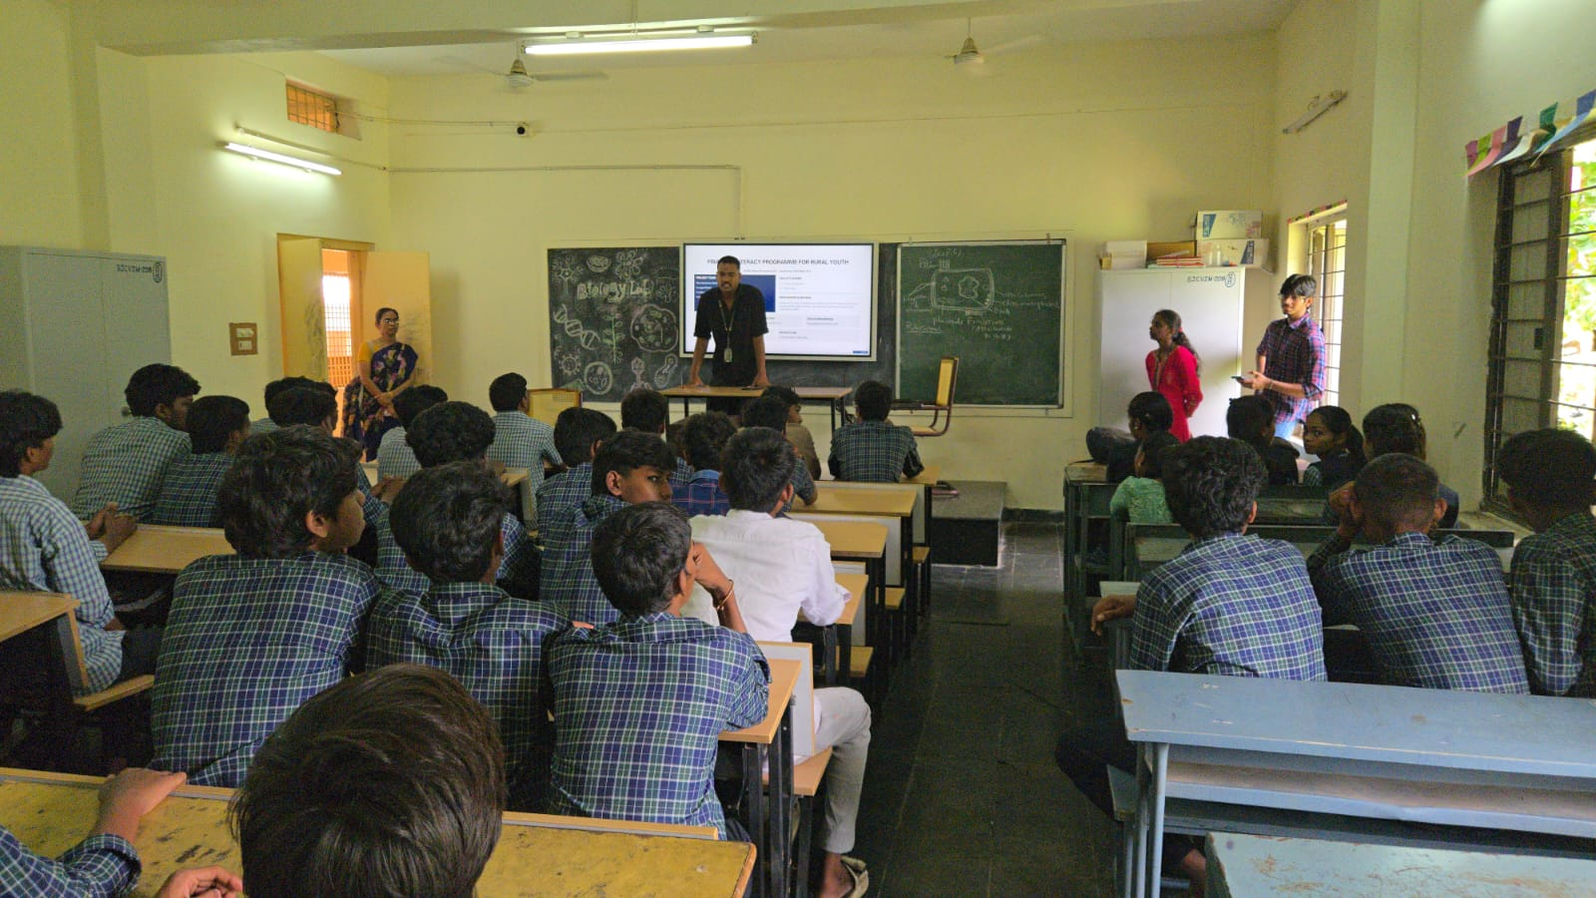
Figure 4.3: Students during the Financial Literacy awareness session

5. Data Collection & Impact Assessment

Impact was measured through matched pre-test and post-test responses covering all 4 module topics. 37 students (100%) completed both tests. The pre-test established baseline knowledge; the post-test measured knowledge gain after the session.

Table 5.1 — Key Performance Indicators
KPI Area | Indicator | Baseline (Before) | Target / Achieved
Reach | Students trained | 0 | 37 students
Assessment | Matched responses | 0 / 37 | 37 / 37 (100%)
Average score | Class average | 5.1 / 15 (34%) | 12.9 / 15 (86%)
High-score | Students >80% | 0 / 37 (0%) | 29 / 37 (78%)
Individual improvement | Students improved | 0 / 37 | 37 / 37 (100%)
Deliverable | Handouts distributed | Not distributed | 37 / 37 students

Findings & Outcomes
The programme was conducted on 26-09-2026 at Govt. Junior College, Vizianagaram Town. All 37 participants completed both assessments, providing a 100% matched response rate. The class average increased from 5.1/15 (34%) to 12.9/15 (86%), a gain of 7.8 marks and a 152% relative increase over the baseline average.
- Number of students reached/trained: 37
- Number of valid matched pre-test/post-test responses: 37/37 (100% response rate)
- Average pre-test score: 5.1 / 15 (34%)
- Average post-test score: 12.9 / 15 (86%)
- Average score improvement: +7.8 marks (+152% relative increase)
- Learning materials/handouts delivered: 37 financial-literacy handouts
Score charts — Figures 5.1 to 5.3:
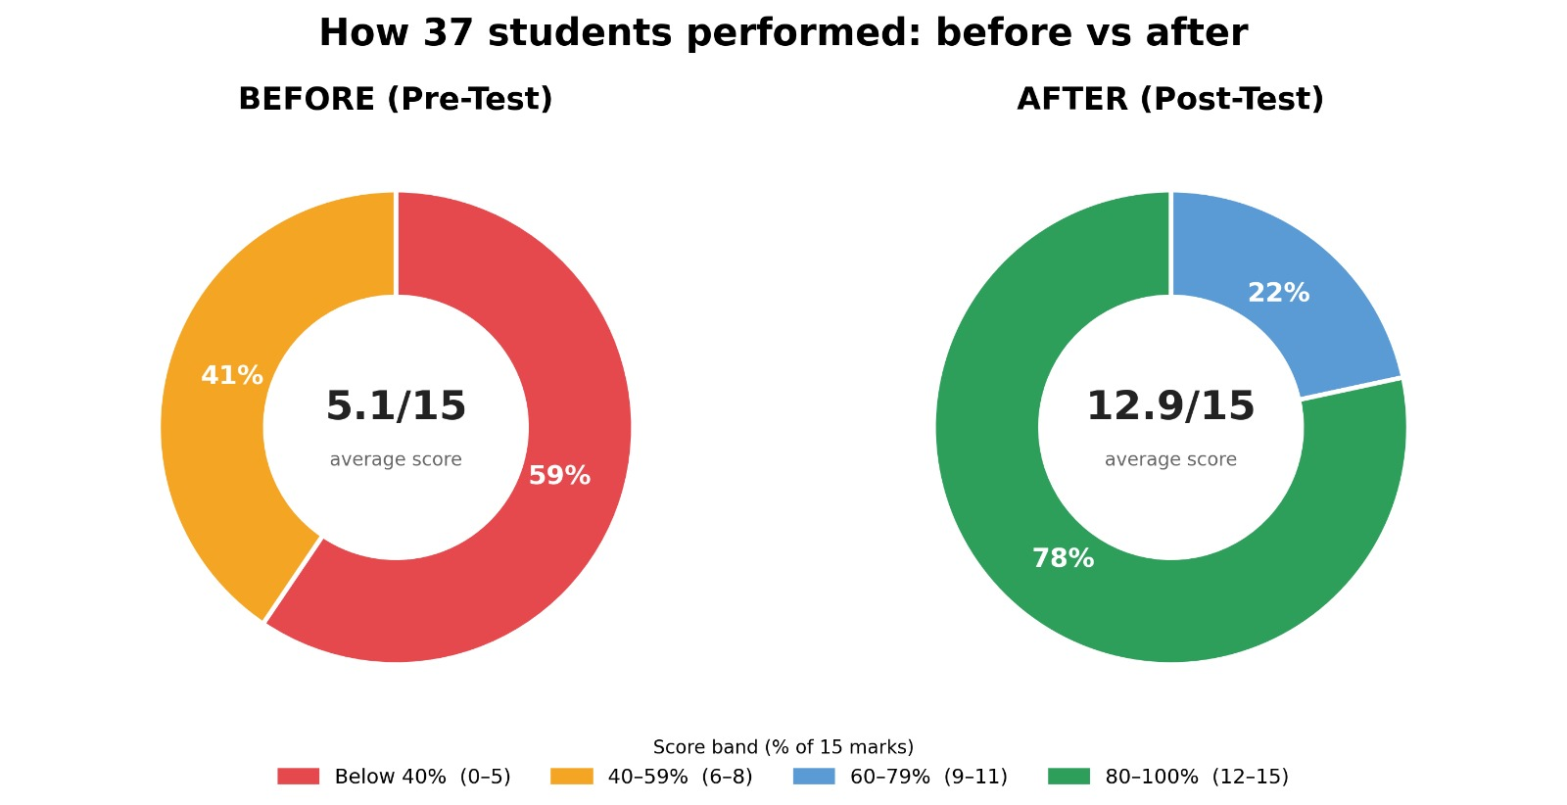
Figure 5.1: Score distribution — before: 59% below 40%; after: 78% in 80-100% band
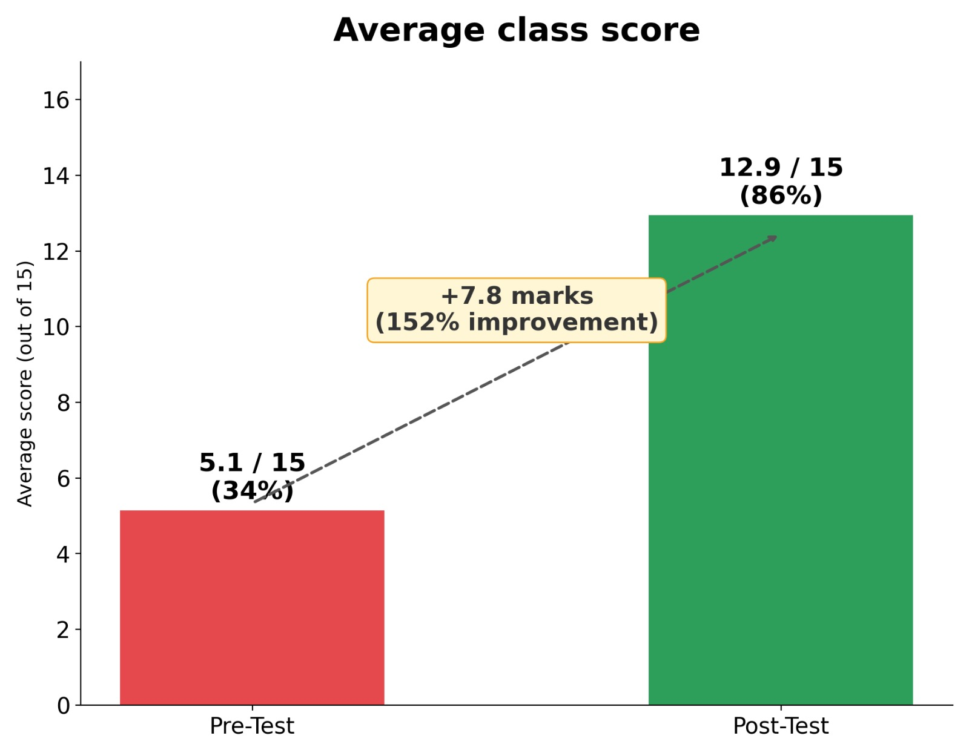
Figure 5.2: Class average — Pre-test 5.1/15 (34%) → Post-test 12.9/15 (86%), +7.8 marks (+152%)
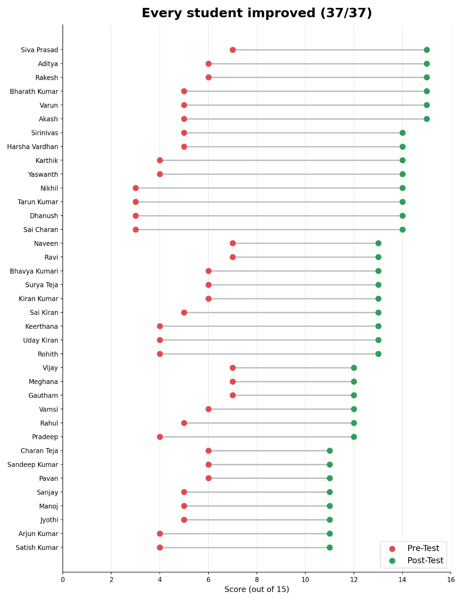
Figure 5.3: Lollipop chart — all 37 students improved individually (pre vs post, each bar)

6. Conclusion
The Financial Literacy Programme for Rural Youth (PS090) has successfully addressed a practical educational need among rural Class XII students at Govt. Junior College, Vizianagaram Town. The programme delivered structured financial literacy education across 4 modules — Savings & Banking, UPI & Digital Payments Safety, Insurance & Govt. Schemes, and Financial Planning & Budgeting — to 37 Class XII students on 26-09-2026.
The pre-test average was 5.1/15 (34%). After the session, the post-test average was 12.9/15 (86%) — a gain of +7.8 marks (+152%). Every single student (37/37) showed individual improvement. 78% of students scored in the 80–100% range post-session. The financial literacy handout ensures students can apply their learning after the session.
The project demonstrated clear and substantial short-term improvement in measured financial-literacy knowledge following the session. Formal permission was obtained from the institution, the field activity was documented, and all 37 students completed both assessments.

7. Future Work
- Conduct periodic financial-awareness sessions for new student batches.
- Encourage the partner institution to incorporate basic financial-safety awareness into suitable student activities.
- Repeat a follow-up assessment after several months to examine retention of knowledge and practical application.
- Scale the four-session programme to other rural junior colleges after evaluating the results of the pilot implementation.

References

- Reserve Bank of India (RBI) — Financial Literacy Week Materials and RBI Financial Literacy Guide for School Students. Available at: https://www.rbi.org.in
- National Payments Corporation of India (NPCI) — UPI Safety Guidelines and Awareness Resources. Available at: https://www.npci.org.in
- CERT-In — Cyber Safety Advisories for Digital Payments and UPI. Available at: https://www.cert-in.org.in

Appendices
Appendix A — Data Collection Instrument
The final printed 15-mark pre-test and post-test questionnaires used for the programme may be attached here as the data-collection instrument.
Appendix B — Raw Data / Response Summary
An anonymised response summary and the score calculations used for the impact assessment may be attached here.
Appendix C — Field Visit Photographs
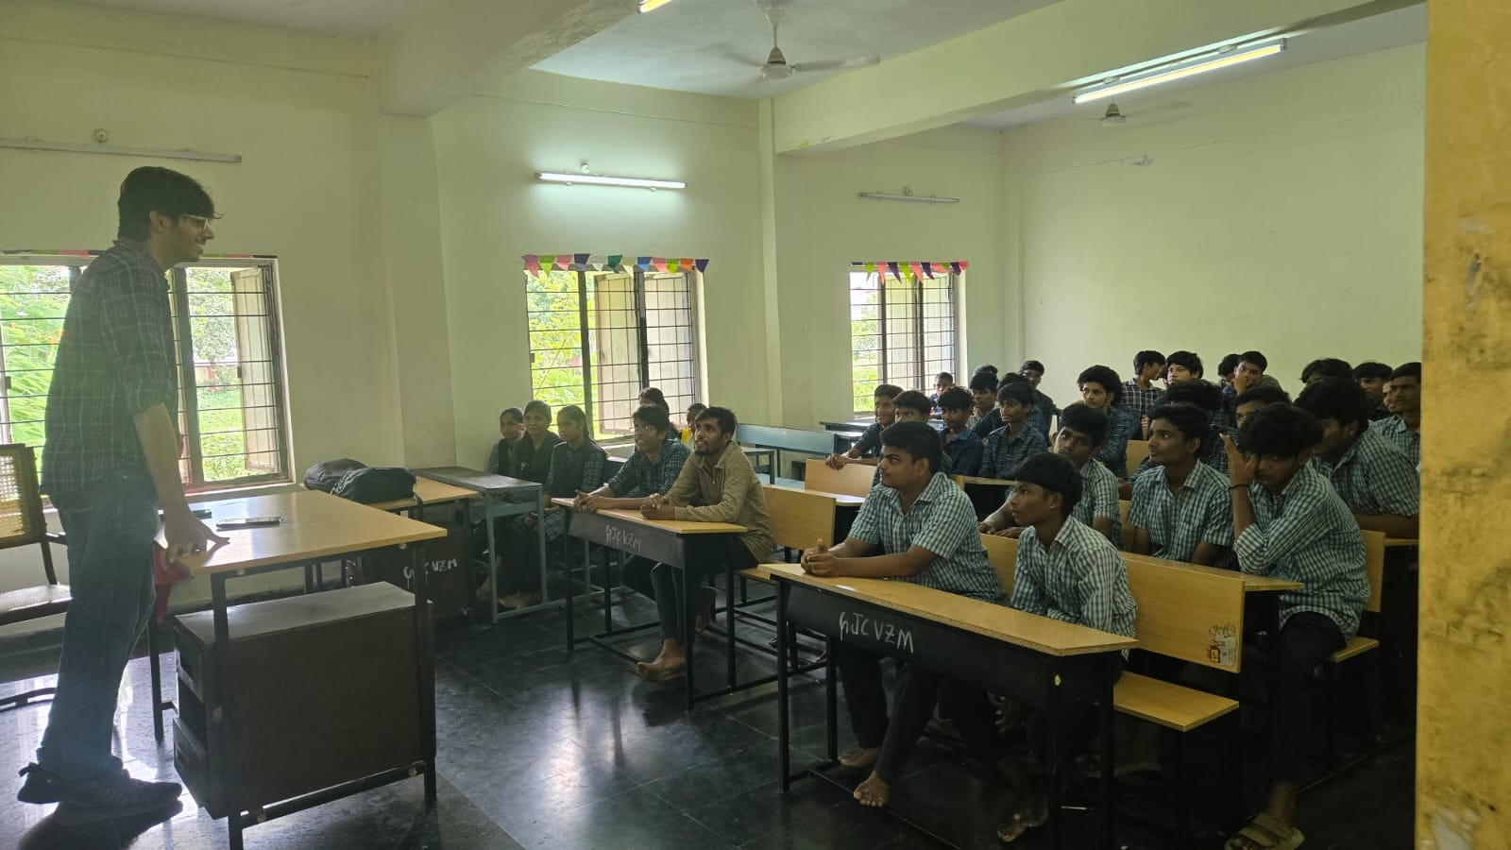
Session in progress — student engagement during Q&A
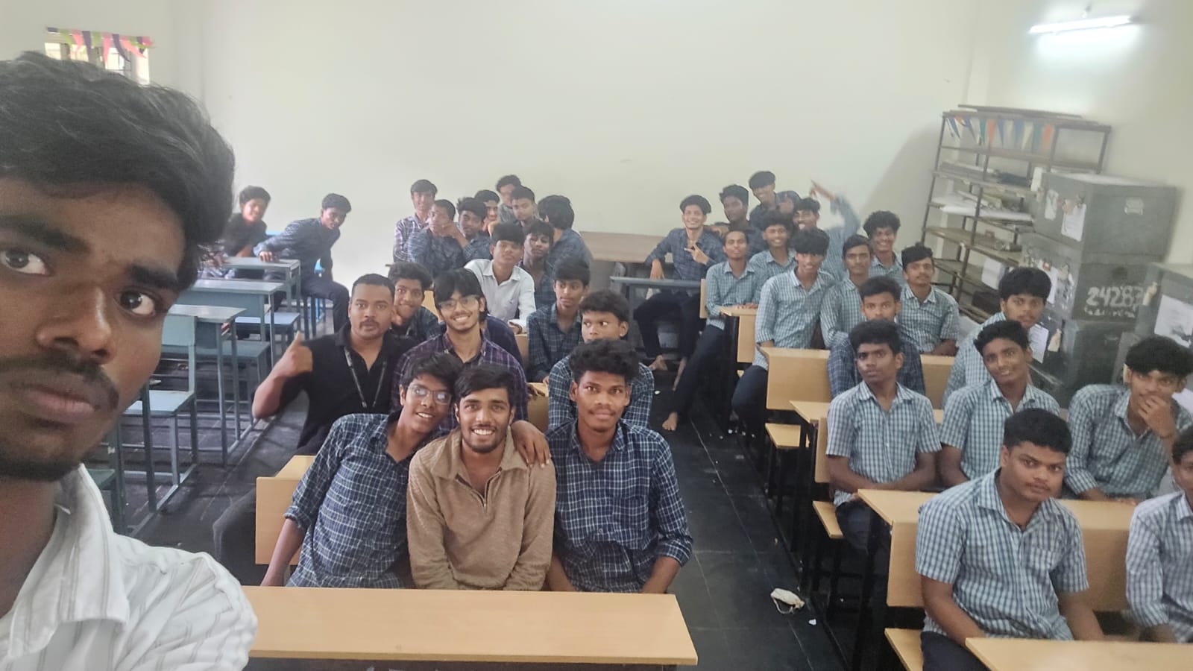
Group photograph with all 37 participating students — 26-09-2026
The dated field photographs in this appendix document the community partner site, programme delivery, student participation and group activity.
Appendix D — Community Certificate
Community certificate: To be attached to the final submission when issued by the community partner.

