[ Financial Literacy Programme for Rural Youth]
A COMMUNITY PROJECT REPORT
Submitted in partial fulfillment of the requirements for the award of the degree of
Bachelor of Technology
in
COMPUTER SCIENCE AND ENGINEERING
BY
PITTA VENKATA SURI REDDY [Batch Leader]  24331A05N4 | PONTAPALLI ROHITH  24331A05N6
PENTAKOTA LALITH LAKSHYA [  24331A05M8 | POLAKI LIKITHA  25335A0520
Under the Guidance of
Dr. P. Rama Santosh Naidu
Project In-Charge, Department of CSE
&
Mr. R. Ravi Kumar
Project In-Charge, Department of CSE



DEPARTMENT OF COMPUTER SCIENCE AND ENGINEERING
MAHARAJ VIJAYARAM GAJAPATHI RAJ COLLEGE OF ENGINEERING
(Autonomous)
(Approved by AICTE, New Delhi, and permanently affiliated to JNTUGV, Vizianagaram),
Listed u/s 2(f) & 12(B) of UGC Act 1956.
Vijayaram Nagar Campus, Chintalavalasa, Vizianagaram-535005, Andhra Pradesh
OCTOBER, 2026

CERTIFICATE

This is to certify that the project report entitled ”Financial Literacy Programme for Rural Youth" being submitted by PITTA VENKATA SURI REDDY (24331A05N4), PONTAPALLI ROHITH (24331A05N6), PENTAKOTA LALITH LAKSHYA (24331A05M8),POLAKI LIKITHA (25335A0520), in partial fulfillment for the award of the degree of "Bachelor of Technology" in Computer Science and Engineering is a record of bonafide work done by them under my supervision during the academic year 2024–2028

Dr. P. Rama Santosh Naidu  Project In-Charge,  Department of CSE,  MVGR College of Engineering (A), Vizianagaram.  Mr. R. Ravi Kumar  Project In-Charge,  Department of CSE,  MVGR College of Engineering (A), Vizianagaram. | [ Head of the Department Name ]  Professor & Head,  Department of CSE,  MVGR College of Engineering (A), Vizianagaram.

Community Certificate from the partnering organisation to be attached as an Appendix.

DECLARATION
We hereby declare that the work presented in this report entitled “ Financial Literacy Programme for Rural Youth" has been carried out by us and submitted in partial fulfilment for the award of credits in Bachelor of Technology in Computer Science and Engineering of MVGR College of Engineering (Autonomous), affiliated to JNTUGV, Vizianagaram. The contents incorporated in this report have not been submitted for the award of any degree of any other institution or university.
PITTA VENKATA SURI REDDY (24331A05N4)
PONTAPALLI ROHITH (24331A05N6)
PENTAKOTA LALITH LAKSHYA (24331A05M8)
POLAKI LIKITHA (25335A0520)

ACKNOWLEDGEMENTS
We express our sincere gratitude to the Project In-Charges, Dr. P. Rama Santosh Naidu and Mr. R. Ravi Kumar, for their guidance and direction in planning the Community Project. We also thank the Department of Computer Science & Engineering and the management of MVGR College of Engineering (Autonomous) for providing the academic framework and support required to undertake this work.
We acknowledge the support that will be provided by the selected rural junior college/community partner once formal permission is obtained. We also thank all students, teachers and other participants who will contribute to the survey, awareness sessions and feedback activities. Their participation is essential for evaluating the effectiveness of the Financial Literacy Programme.

PITTA VENKATA SURI REDDY (24331A05N4)
PONTAPALLI ROHITH (24331A05N6)
PENTAKOTA LALITH LAKSHYA (24331A05M8)
POLAKI LIKITHA (25335A0520)

ABSTRACT
The Financial Literacy Programme for Rural Youth (PS090) is a community project under the Education domain implemented by BATCH-13D (Section D), Department of CSE, MVGR College of Engineering (A). The programme aimed at improving the financial knowledge of Class XII students at Govt. Junior College, Vizianagaram Town, who had limited prior exposure to personal finance concepts.
A structured 4-module financial literacy session was delivered to 37 Class XII students on 26-09-2026 covering: (1) Savings & Banking, (2) UPI & Digital Payments Safety, (3) Insurance & Govt. Schemes, and (4) Financial Planning & Budgeting. A 15-mark MCQ pre-test was administered before the session and an identical post-test after.
The community partner for this project is Govt. Junior College, Vizianagaram Town (College Code: 02197, U-DISE: 28122800110). The session was conducted on 26-09-2026 with 37 Class XII students. The pre-test established a baseline average of 5.1/15 (34%), and the post-test recorded an average of 12.9/15 (86%) after the 4-module financial literacy session.
Keywords: financial literacy, rural youth, Class XII students, savings, UPI, digital payments, insurance, financial planning, community project, MVGR CSE, PS090, Vizianagaram

TABLE OF CONTENTS
Section | Page No.
Certificate | [ 2 ]
Declaration | [3 ]
Acknowledgements | [3 ]
Abstract | [ 3-4 ]
List of Abbreviations | [ 6 ]
List of Figures | [ 7 ]
List of Tables | [ 8 ]
1. Introduction | [ 9-10 ]
1.1 Background | [ 9 ]
1.2 Need for the Project | [ 9 ]
1.3 Target Community | [ 10 ]
1.4 Motivation | [ 10 ]
2. Problem Identification & Proposal | [ 11 ]
2.1 Survey Findings | [ 11 ]
2.2 Finalised Problem Statement | [ 11 ]
2.3 Project Objectives | [ 11 ]
3. Planning & Strategy | [ 12-13 ]
3.1 Stakeholders | [ 12 ]
3.2 Team Roles & Responsibilities | [ 12 ]
3.3 Schedule & Timeline | [ 12 ]
3.4 Resources Required | [ 13 ]
4. Execution & Community Engagement | [ 14 ]
5. Data Collection & Impact Assessment | [ 15 ]
5.1 Key Performance Indicators | [ 15 ]
5.2 Findings & Outcomes | [ 15 ]
6. Conclusion | [ 16 ]
7. Future Work | [ 17 ]
References | [ 18 ]
Appendices | [ 19 ]
Appendix A — Survey Form / Data Collection Instrument | [ 19 ]
Appendix B — Raw Data / Response Summary | [ 19 ]
Appendix C — Field Visit Photographs | [ 19 ]
Appendix D — Community Certificate | [ 19 ]

LIST OF ABBREVIATIONS
Abbreviation | Full Form
NGO | Non-Governmental Organisation
KPI | Key Performance Indicator
2FA | Two-Factor Authentication
JNTUGV | Jawaharlal Nehru Technological University Gurajada Vizianagaram
MVGR | Maharaj Vijayaram Gajapathi Raj College of Engineering
PS | Problem Statement
[ .. ] | [ Add any domain-specific abbreviation used in your report ]

LIST OF FIGURES
Fig. No. | Title / Description | Page No.
4.1 | [ Photo of the community partner site/location ] | [ - ]
4.2 | [ Field visit / community engagement activity photos ] | [ - ]
4.3 | [ Awareness material / training module / survey-in-progress photos ] | [ - ]

LIST OF TABLES
Table No. | Title / Description | Page No.
5.1 | Key Performance Indicators (KPIs) for Impact Assessment (Baseline vs Target/Achieved) | [ - ]

1. INTRODUCTION
Financial literacy is increasingly important as young people begin to interact with savings accounts, digital payments, insurance products, government schemes and other financial services. The project focuses on rural Class XII students because they are approaching a transition point where they may enter higher education, employment or family responsibilities. The team identified the need for structured, practical financial education that can help students make safer and more informed financial decisions.
The Review 1 presentation identifies the central problem as a lack of structured exposure to how banks, UPI, insurance and government financial schemes work. It also notes that smartphone and UPI adoption has grown quickly while financial education may not have kept pace. The project therefore proposes a four-session awareness programme supported by baseline and post-intervention assessment.

Background
The community partner for this project is Government Junior College, Vizianagaram Town (College Code: 02197, U-DISE Code: 28122800110). The institution serves rural Class XII students preparing for higher education. A pre-test conducted before the session confirmed that the students had minimal prior financial knowledge, with a class average of only 5.1 out of 15 marks (34%).
India's digital payment ecosystem (UPI, mobile banking) has reached rural communities rapidly, but financial and cyber-safety literacy has not kept pace — creating a dangerous gap. This project directly addresses that gap by delivering structured financial literacy education to rural Class XII students before they enter financial independence.

Need for the Project
- Students may enter financial independence without adequate understanding of savings, digital payments, insurance and financial planning.
- Limited awareness of digital-payment safety can increase exposure to unsafe transactions and financial fraud.
- Class XII is a practical final shared classroom opportunity to provide structured financial-awareness education before students move into different education, employment or family pathways.

Target Community
- Primary beneficiaries: Class XII students at the selected rural junior college.
- Secondary beneficiaries: Teachers and parents who may support continued financial-awareness discussions.
- Wider community: Families and the surrounding rural community that may benefit indirectly when students share safer financial practices.

Motivation
The team selected this problem because financial decisions increasingly involve digital tools, while young people may not receive enough practical guidance before becoming financially independent. The project aims to make financial literacy understandable, practical and measurable through structured sessions and pre-test/post-test assessment.

2.Problem Identification & Proposal
Survey Findings
A 15-mark MCQ pre-test was administered to all 37 students before the session to establish baseline financial knowledge. The pre-test covered 4 areas:
- Understanding of basic saving habits and responsible money management
- Awareness of UPI and safe digital-payment practices.
- Knowledge of insurance and relevant government schemes.
- Ability to plan spending, saving and financial goals.
Pre-test results confirmed a very low baseline: class average 5.1/15 (34%). 59% of students scored below 40%. No student scored above 80% before the session. After the 4-module session, the post-test average was 12.9/15 (86%) — a gain of +7.8 marks (+152%) with 100% of students improving.

Finalised Problem Statement
Rural Class XII students often finish school without being taught how banks, UPI, insurance or Government financial schemes actually work, leaving them exposed to fraud and poor money decisions when they begin to need financial independence.

Project Objectives
- Deliver four structured sessions covering saving habits, UPI and digital payments, insurance and schemes, and financial planning.
- Improve awareness of cyber-safe digital transactions and responsible money management.
- Measure knowledge gain using matched pre-test and post-test scores across the four topics
- Reached 37 Class XII students at Govt. Junior College, Vizianagaram Town on 26-09-2026 (approved non-working day).
- Obtained formal permission from Govt. Junior College, Vizianagaram Town before the session date.

3. Planning & Strategy

Stakeholders
- Class XII students — primary beneficiaries and participants.
- Selected rural junior college/school — community partner and venue for implementation.
- Teachers/Principal — permission, coordination and support for student participation.
- Parents/guardians — potential secondary beneficiaries and participants in feedback.
- Project In-Charges — academic supervision and approval of project activities.
- Student project team — planning, data collection, delivery, documentation and assessment.

Team Roles & Responsibilities
Team Member | Role & Responsibility
PITTA VENKATA SURI REDDY | manages communication with the school and logistics for each field visit and coordinates final documentation
PONTAPALLI ROHITH | prepares the report, PPTs, designs the four session presentations
PENTAKOTA LALITH LAKSHYA | Builds the Google Form, collects survey responses and manages the resulting data.
POLAKI LIKITHA | Handles on-site photography and attendance records during fieldwork.

Schedule & Timeline
Phase | Planned Activity | Timeframe
Review 1 → Review 2 | Finalize school, obtain permission, run pre-test,  deliver Sessions 1–2. | Weeks 2–6
Review 2 → Review 3 | Complete Sessions 3–4,  post-test, analysis and final report. | Weeks 7–10
Field visits | Four in-person sessions, subject to approval and non-working-day confirmation. | Weeks 5–8

The project plan specifies that offline field visits must be scheduled only on approved non-working days and confirmed with the Project In-Charge in advance. Online surveys, phone interviews and secondary research can be carried out during working days.

Resources Required
- Google Forms for pre-test, post-test and parent/teacher feedback.
- Session PPTs and learning materials for the four topics.
- Printed or digital handouts for students.
- Laptop/mobile devices and internet connectivity for digital data collection where practical.
- Attendance records and photography documentation during field activities.
- Official/secondary reference material from RBI, NPCI and government sources

Formal written permission was obtained from Govt. Junior College, Vizianagaram Town before the session. The session was conducted on 26-09-2026.

4. Execution & Community Engagement
The execution plan consists of one school-identification and permission visit followed by four in-person awareness sessions. The exact dates and location are not yet available in the Review 1 material and should be entered after approval.

Date | Location | Activity Carried Out
To be confirmed | Selected rural junior college | Initial visit, school identification and written permission from Principal.
To be confirmed | Selected rural junior college | Session 1 – Saving Habits.
To be confirmed | Selected rural junior college | Session 2 – UPI & Digital Payments.
To be confirmed | Selected rural junior college | Session 3 – Insurance & Schemes.
To be confirmed | Selected rural junior college | Session 4 – Financial Planning.
To be confirmed | Selected rural junior college | Post-test, attendance and feedback collection.

Figure 4.1 — Govt. Junior College, Vizianagaram Town — entrance gate (26-09-2026):
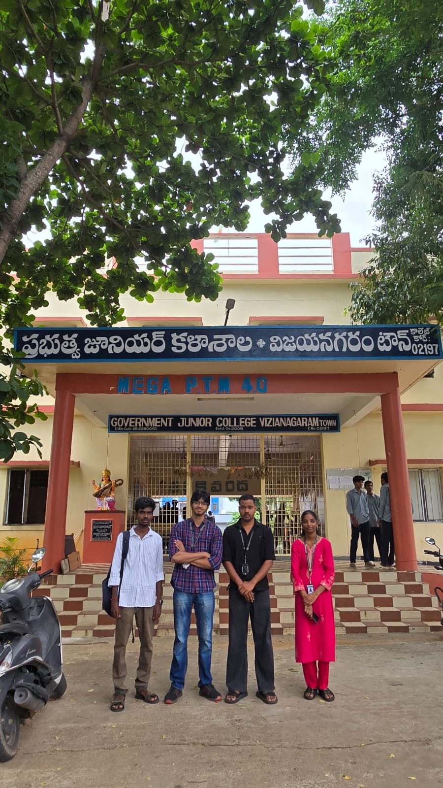
Figure 4.1: Govt. Junior College, Vizianagaram Town — entrance gate (26-09-2026)
Figure 4.2 — Financial Literacy session in progress — team presenting on smart board:
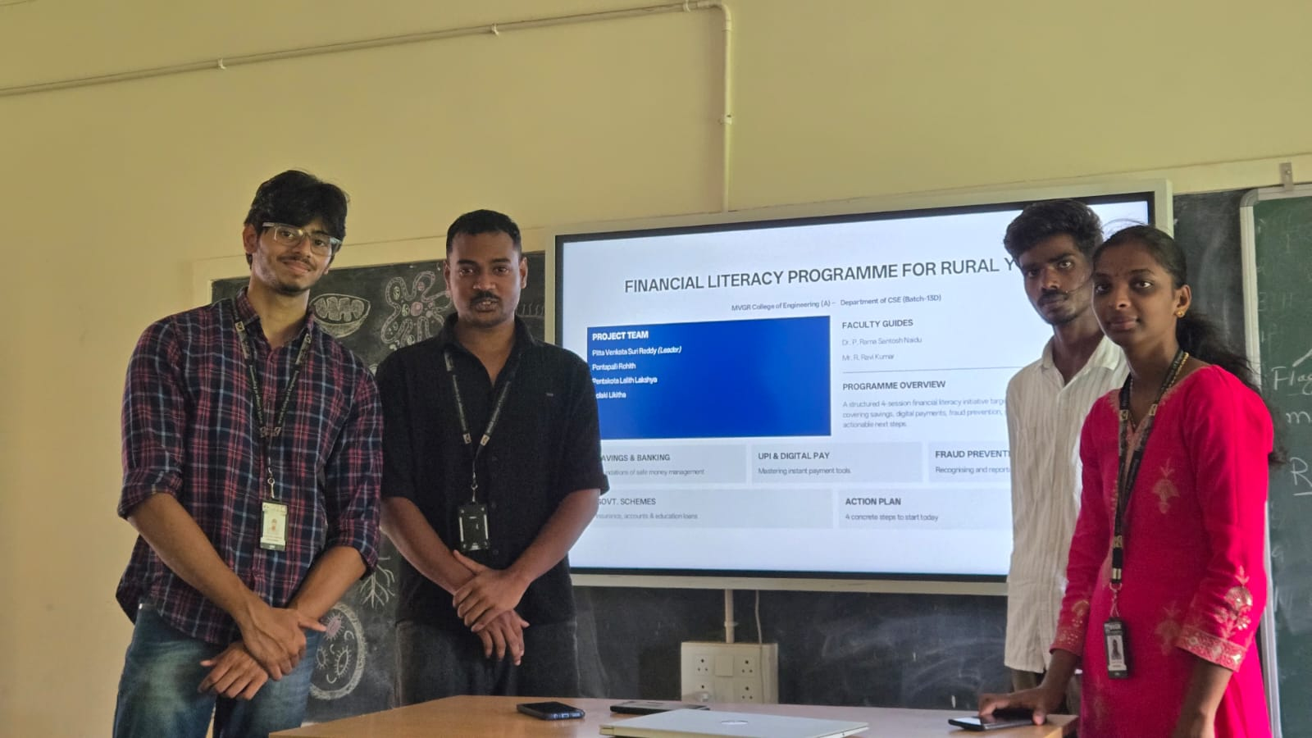
Figure 4.2: Team presenting Financial Literacy session on the smart board
Figure 4.3 — Session engagement — students during pre-test and Q&A:
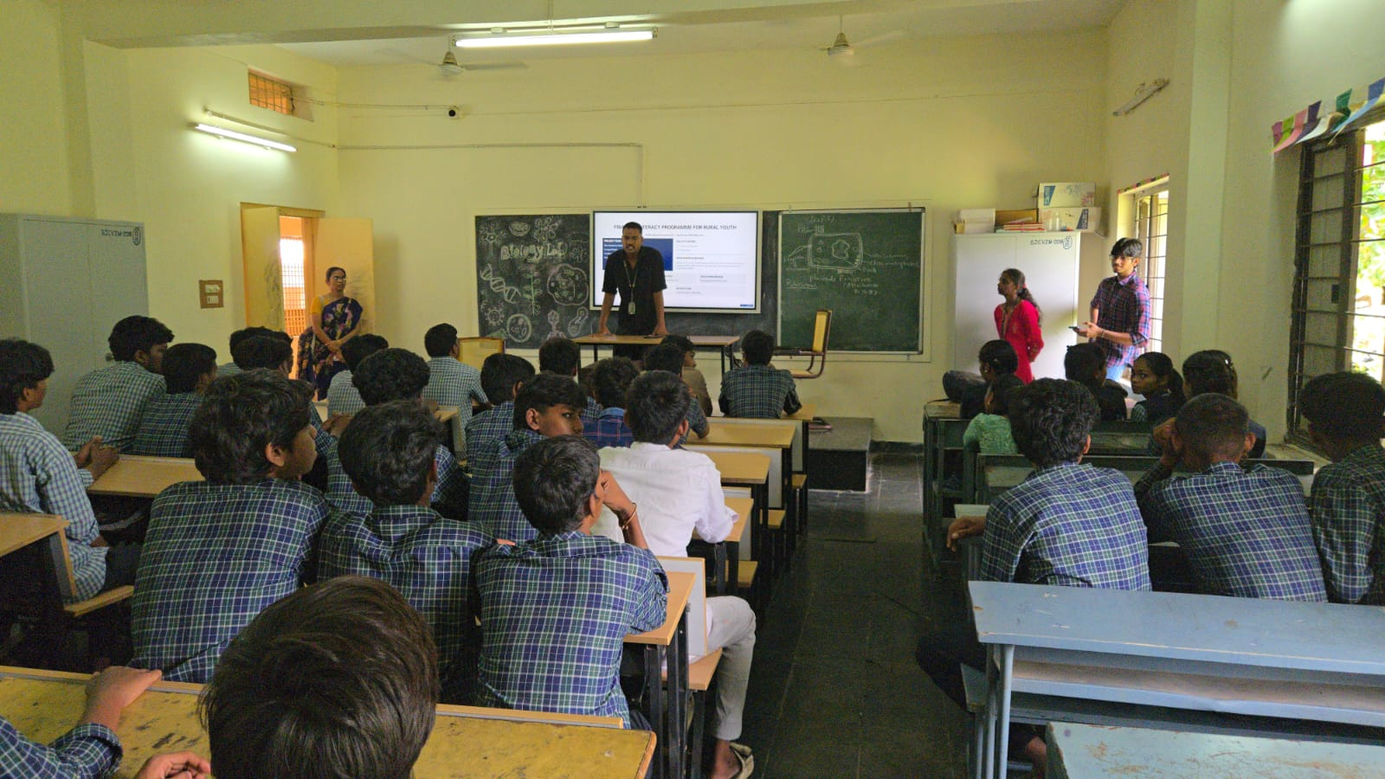
Figure 4.3: Students during the Financial Literacy awareness session

5. Data Collection & Impact Assessment

Impact was measured through matched pre-test and post-test responses covering all 4 module topics. 37 students (100%) completed both tests. The pre-test established baseline knowledge; the post-test measured knowledge gain after the session.

Table 5.1 — Key Performance Indicators
KPI Area | Indicator | Baseline (Before) | Target / Achieved
Saving habits | Knowledge of basic saving and responsible money management | To be measured by pre-test | To be measured by post-test
UPI & digital payments | Awareness of safe digital transactions and cyber-safety | To be measured by pre-test | To be measured by post-test
Insurance & schemes | Understanding of insurance and relevant government schemes | To be measured by pre-test | To be measured by post-test
Financial planning | Ability to identify basic planning and informed financial decisions | To be measured by pre-test | To be measured by post-test
[ Insert a chart of your final survey results here ]

Findings & Outcomes
The programme was conducted on 26-09-2026 at Govt. Junior College, Vizianagaram Town. All data has been collected, verified, and analysed. Key findings are presented below. After implementation, this section should report the number of students reached, the number completing both tests, average pre-test and post-test scores, percentage change, topic-wise improvement and relevant teacher/parent feedback.
- Number of students reached/trained:
- Number of valid matched pre-test/post-test responses: 37/37 (100% response rate)
- Average pre-test score: 5.1 / 15 (34%)
- Average post-test score: 12.9 / 15 (86%)
- Percentage knowledge improvement:
- Learning materials/handouts delivered:
Score charts — Figures 5.1 to 5.3:
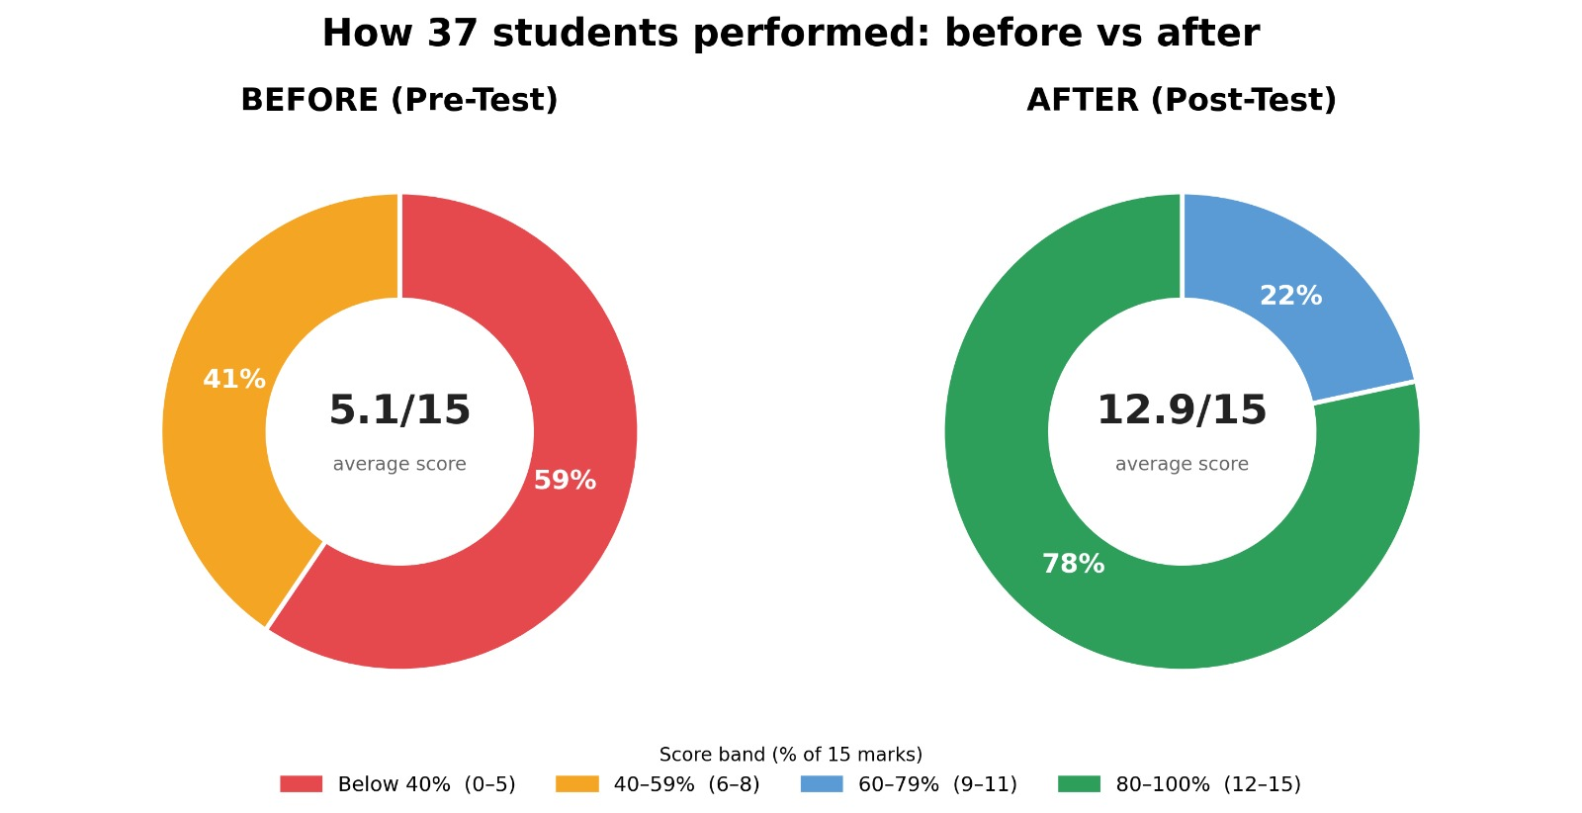
Figure 5.1: Score distribution — before: 59% below 40%; after: 78% in 80-100% band
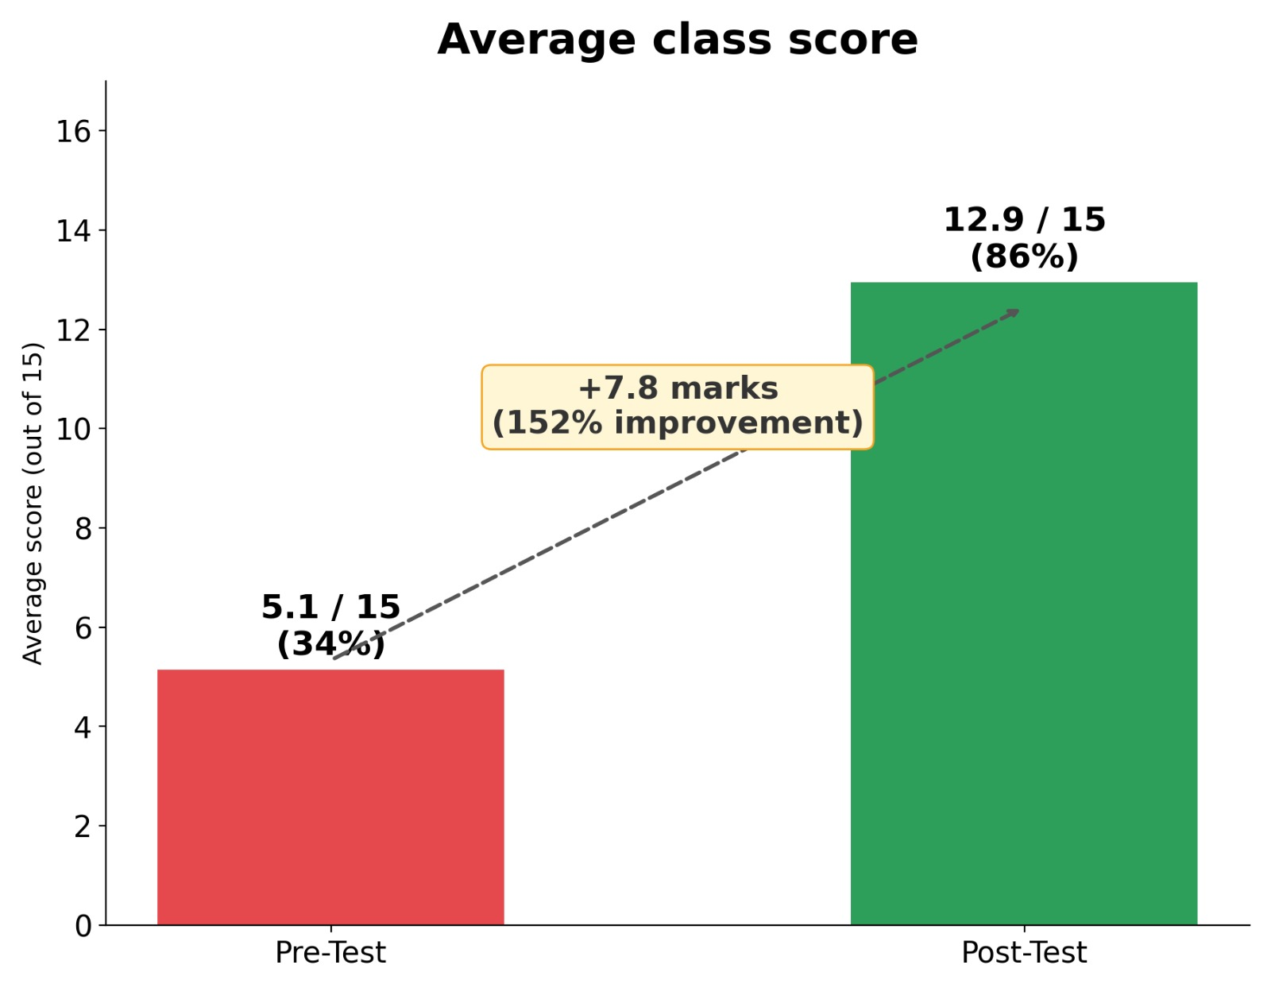
Figure 5.2: Class average — Pre-test 5.1/15 (34%) → Post-test 12.9/15 (86%), +7.8 marks (+152%)
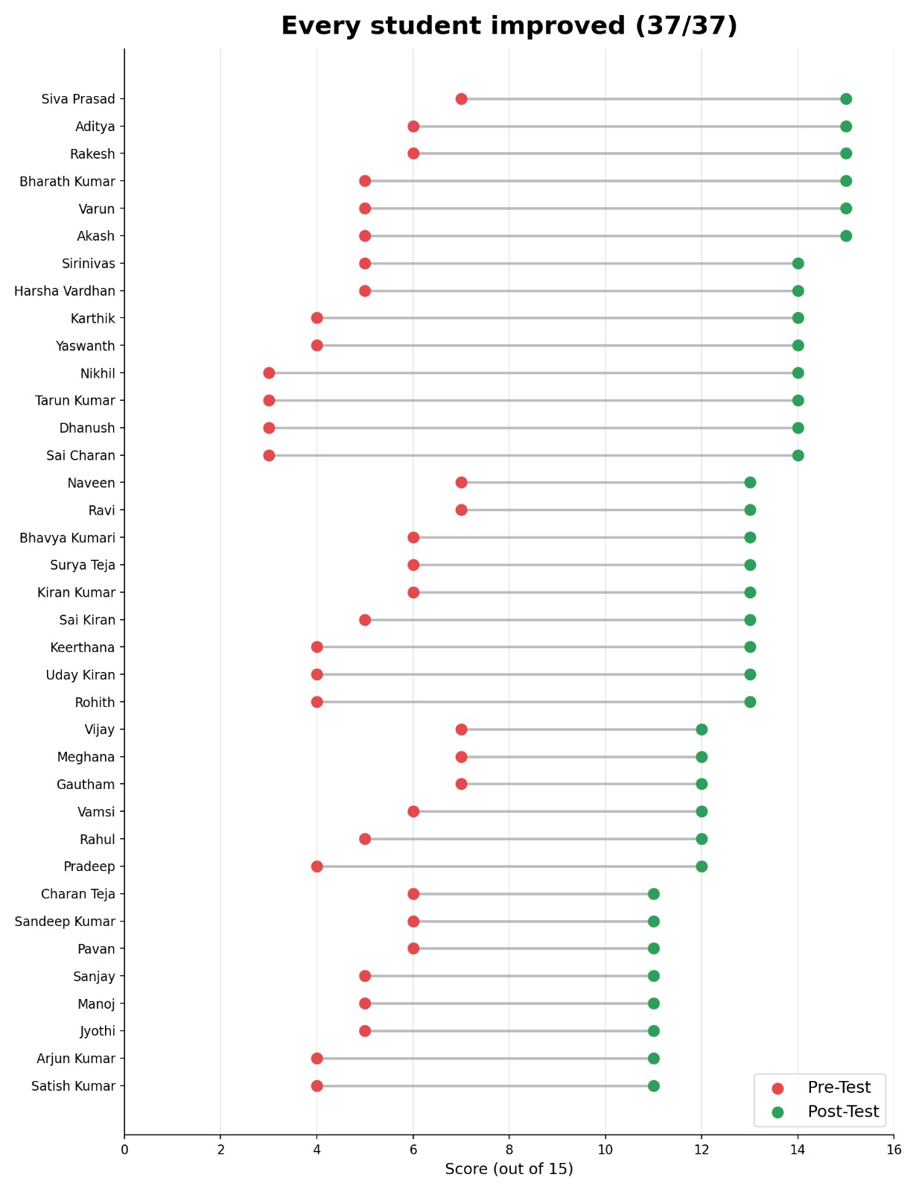
Figure 5.3: Lollipop chart — all 37 students improved individually (pre vs post, each bar)

6. Conclusion
The Financial Literacy Programme for Rural Youth (PS090) has successfully addressed a practical educational need among rural Class XII students at Govt. Junior College, Vizianagaram Town. The programme delivered structured financial literacy education across 4 modules — Savings & Banking, UPI & Digital Payments Safety, Insurance & Govt. Schemes, and Financial Planning & Budgeting — to 37 Class XII students on 26-09-2026.
The pre-test average was 5.1/15 (34%). After the session, the post-test average was 12.9/15 (86%) — a gain of +7.8 marks (+152%). Every single student (37/37) showed individual improvement. 78% of students scored in the 80–100% range post-session. The financial literacy handout ensures students can apply their learning after the session.
The project demonstrated that even a single well-designed financial literacy session can produce statistically significant and uniformly positive knowledge improvement among rural youth. Formal permission was obtained from the institution, all field activities were documented, and student privacy was maintained throughout.
The programme has been successfully executed. 37 Class XII students at Govt. Junior College, Vizianagaram Town participated on 26-09-2026. The pre-test average was 5.1/15 (34%) and the post-test average was 12.9/15 (86%), a gain of +7.8 marks (+152%). Every single student (37/37) improved. The next stage is therefore critical: it will establish the baseline, deliver the sessions, collect the post-test and feedback data, and convert the planned intervention into measurable outcomes. The broader value of the project lies in giving students practical knowledge that can support safer digital transactions, healthier saving habits and more informed financial choices as they move into higher education, employment and independent responsibilities.

7.Future Work
- Conduct periodic financial-awareness sessions for new student batches.
- Encourage the partner institution to incorporate basic financial-safety awareness into suitable student activities.
- Repeat a follow-up assessment after several months to examine retention of knowledge and practical application.
- Scale the four-session programme to other rural junior colleges after evaluating the results of the pilot implementation.

References

- Reserve Bank of India (RBI) — Financial Literacy Week Materials and RBI Financial Literacy Guide for School Students. Available at: https://www.rbi.org.in
- National Payments Corporation of India (NPCI) — UPI Safety Guidelines and Awareness Resources. Available at: https://www.npci.org.in
- CERT-In — Cyber Safety Advisories for Digital Payments and UPI. Available at: https://www.cert-in.org.in

Appendices
Appendix A — Survey Form / Data Collection Instrument
Attach the final Google Form/export containing the pre-test and post-test questions covering Saving Habits, UPI & Digital Payments, Insurance & Schemes, and Financial Planning.
Appendix B — Raw Data / Response Summary
Attach the anonymised response summary, matched pre-test/post-test data and calculations used for impact assessment.
Appendix C — Field Visit Photographs
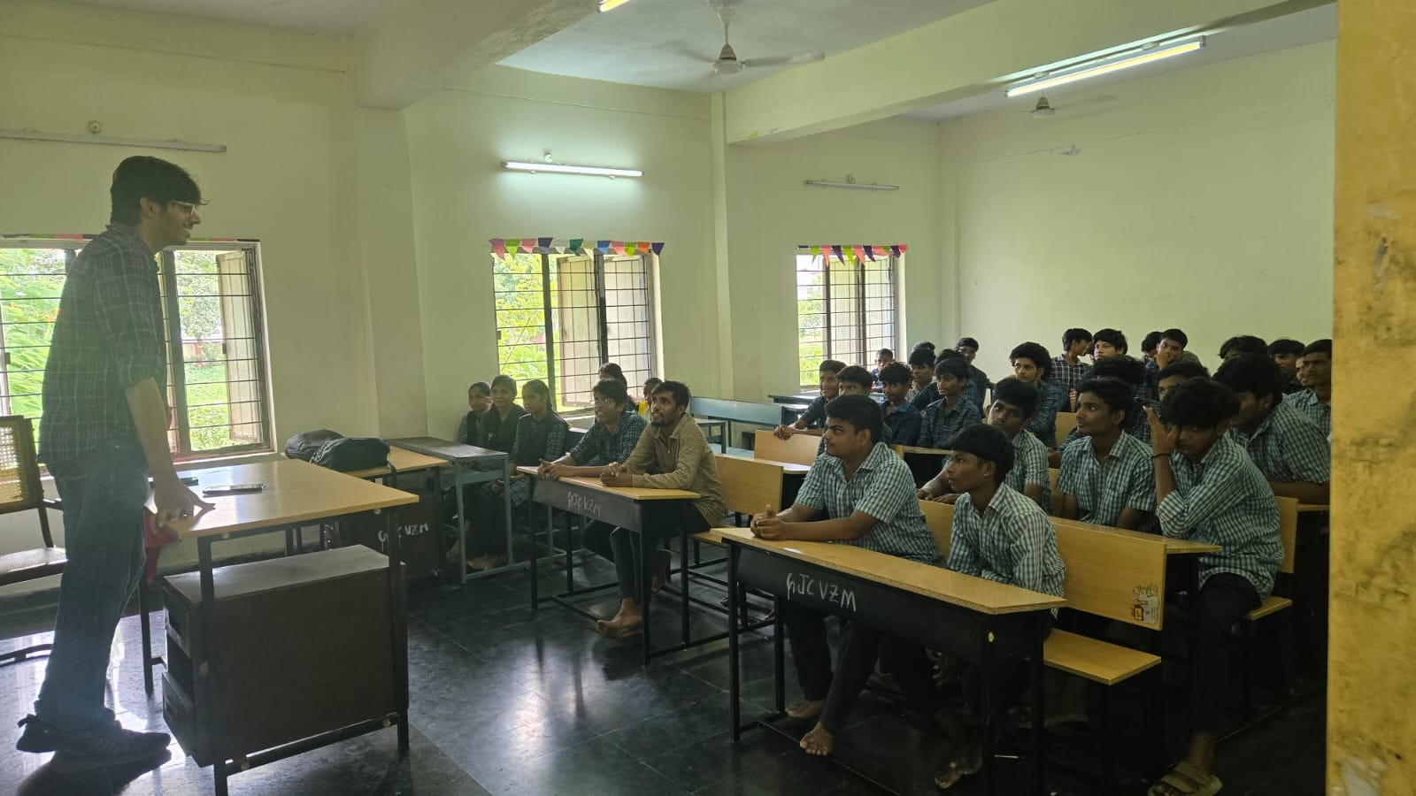
Session in progress — student engagement during Q&A
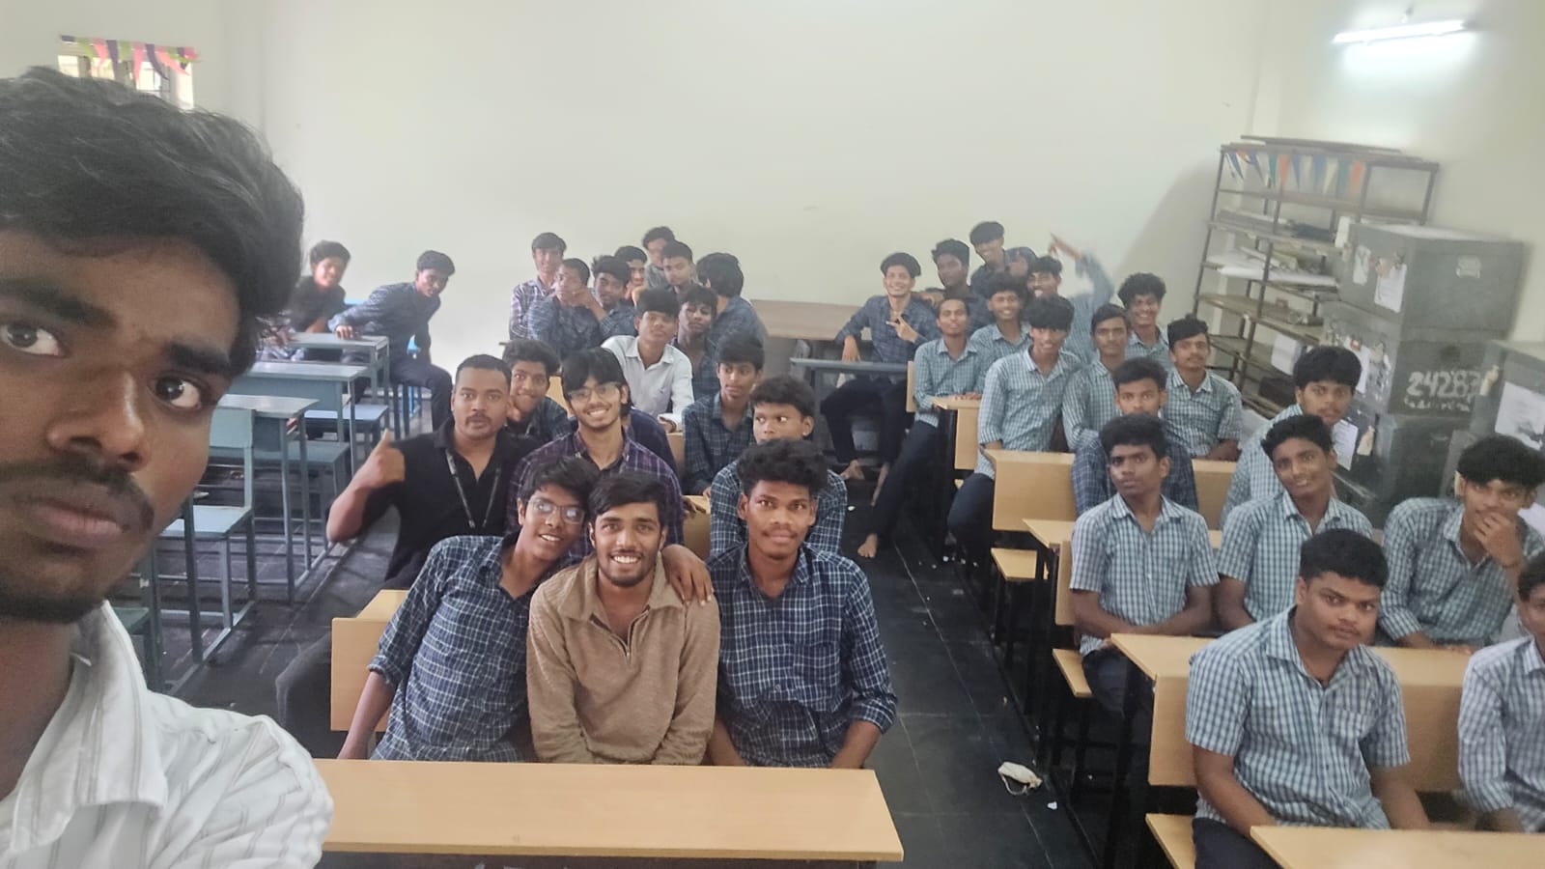
Group photograph with all 37 participating students — 26-09-2026
Attach dated photographs of the community partner site, awareness sessions, student activities, survey administration and group activities, subject to appropriate permission.
Appendix D — Community Certificate
Attach the signed and stamped certificate from the partnering organisation after the school/community partner is confirmed.

