
FINANCIAL LITERACY PROGRAMME FOR RURAL YOUTH
A COMMUNITY PROJECT REPORT
(PS090 · Domain: Education)
Submitted in partial fulfillment of the requirements for the award of the degree of
BACHELOR OF TECHNOLOGY
in
COMPUTER SCIENCE AND ENGINEERING
BY
Student Name | Roll Number | Project Role
PITTA VENKATA SURI REDDY | 24331A05N4 | Batch Leader
PONTAPALLI ROHITH | 24331A05N6 | Team Member
PENTAKOTA LALITH LAKSHYA | 24331A05M8 | Team Member
POLAKI LIKITHA | 25335A0520 | Team Member
Under the Guidance of
Dr. P. Rama Santosh Naidu & Mr. R. Ravi Kumar
Project In-Charges, Department of Computer Science & Engineering
DEPARTMENT OF COMPUTER SCIENCE AND ENGINEERING
MAHARAJ VIJAYARAM GAJAPATHI RAJ COLLEGE OF ENGINEERING (AUTONOMOUS)
(Approved by AICTE, New Delhi, permanently affiliated to JNTUGV, Vizianagaram)
Vizianagaram - 535005, Andhra Pradesh, India
OCTOBER, 2026

CERTIFICATE
This is to certify that the project report entitled "Financial Literacy Programme for Rural Youth" (PS090) submitted by PITTA VENKATA SURI REDDY (24331A05N4), PONTAPALLI ROHITH (24331A05N6), PENTAKOTA LALITH LAKSHYA (24331A05M8), and POLAKI LIKITHA (25335A0520) in partial fulfillment for the award of the degree of Bachelor of Technology in Computer Science and Engineering is a record of bonafide community project work carried out by them under our supervision during the academic year 2026.
Community Partner: Govt. Junior College, Vizianagaram Town (College Code: 02197, U-DISE: 28122800110). Target Beneficiaries: 37 Class XII rural students. Session Date: 26-09-2026.
_______________________ _______________________
Dr. P. Rama Santosh Naidu Mr. R. Ravi Kumar
Project In-Charge, Dept. of CSE Project In-Charge, Dept. of CSE
_______________________
Head of the Department
Department of Computer Science & Engineering
MVGR College of Engineering (A), Vizianagaram

DECLARATION
We hereby declare that the work presented in this report entitled "Financial Literacy Programme for Rural Youth" (PS090) has been carried out by us under the Department of Computer Science & Engineering, MVGR College of Engineering (Autonomous), Vizianagaram. The contents incorporated in this report are based on original fieldwork conducted at Govt. Junior College, Vizianagaram Town on 26-09-2026 and have not been submitted for the award of any other degree or diploma in any other institution.
Pitta Venkata Suri Reddy (24331A05N4)
Pontapalli Rohith (24331A05N6)
Pentakota Lalith Lakshya (24331A05M8)
Polaki Likitha (25335A0520)
ACKNOWLEDGEMENTS
We express our sincere gratitude to our Project In-Charges, Dr. P. Rama Santosh Naidu and Mr. R. Ravi Kumar, for their invaluable guidance, encouragement, and continuous supervision throughout this community project. We extend our respectful thanks to Dr. Aruna Srinivas, Head of the Department of CSE, and the management of MVGR College of Engineering (Autonomous) for providing the academic framework and administrative support needed to execute this initiative.
We convey our deepest appreciation to our community partner, Government Junior College, Vizianagaram Town (College Code: 02197), including the Principal, teaching staff, and non-teaching personnel, for granting formal permission and facilitating the awareness session on 26-09-2026. Most importantly, we thank the 37 participating Class XII students whose enthusiastic involvement, active participation during module presentations, and completion of pre/post assessments made this project a success.

ABSTRACT
The Financial Literacy Programme for Rural Youth (PS090) is a community project under the Education domain executed by BATCH-13D (Section D), Department of Computer Science & Engineering, MVGR College of Engineering (Autonomous). The programme addressed a critical societal gap: rural Class XII students increasingly adopt smartphones and digital payment applications (UPI) but lack formal training in financial safety, banking mechanisms, government schemes, and personal budgeting.
The project was executed in collaboration with Govt. Junior College, Vizianagaram Town (U-DISE Code: 28122800110) on 26-09-2026 (an approved non-working day). A structured 4-module curriculum was delivered to 37 Class XII students, covering: (1) Savings & Banking, (2) UPI & Digital Payment Safety, (3) Insurance & Government Schemes, and (4) Financial Planning & Budgeting. Knowledge gain was measured using a matched 15-mark multiple-choice question (MCQ) pre-test and an identical post-test.
Key Outcomes & Results:
- Beneficiaries: 37 out of 37 students (100% participation rate) completed both baseline and post-evaluation assessments.
- Score Gain: Class average score increased from 5.1 / 15 (34%) in the pre-test to 12.9 / 15 (86%) in the post-test, demonstrating a statistically significant +7.8 mark gain (+152% knowledge improvement).
- Performance Redistribution: Before the session, 59% of students scored below 40% (0-5 marks) and 0% scored above 80%. After the session, 78% of students (29/37) achieved 80-100% (12-15 marks).
- Uniform Improvement: 100% of participating students (37/37) demonstrated individual score improvements, lifting the minimum class score from 3/15 to 11/15.
- Community Deliverable: Distributed actionable personal finance reference handouts to all 37 students to ensure long-term retention and family awareness.
Keywords: Financial literacy, rural youth, Class XII students, UPI safety, digital payment fraud, government schemes, PM Scholarship, pre-test post-test evaluation, community project, MVGR CSE, PS090, Vizianagaram.

TABLE OF CONTENTS
Certificate | 2
Declaration & Acknowledgements | 3
Abstract | 4
List of Figures & Tables | 6
Chapter 1: Introduction | 7
1.1 Background & Context | 7
1.2 Need for the Project | 7
1.3 Target Community & Beneficiaries | 8
1.4 Motivation | 8
Chapter 2: Problem Identification & Proposal | 9
2.1 Baseline Survey Findings | 9
2.2 Finalized Problem Statement | 9
2.3 Project Objectives | 10
Chapter 3: Planning & Strategy | 11
3.1 Stakeholders & Partnership | 11
3.2 Team Roles & Responsibilities | 11
3.3 Schedule & Timeline | 12
3.4 Resources Required | 12
Chapter 4: Execution & Community Engagement | 13
4.1 Execution Log & Field Activity Details | 13
4.2 Field Visit Evidence & Photo Documentation | 14
Chapter 5: Data Collection & Impact Assessment | 16
5.1 Key Performance Indicators (KPIs) | 16
5.2 Detailed Findings & Data Analysis | 17
Chapter 6: Review 1 Feedback & Actions Taken | 19
Chapter 7: Conclusion & Recommendations | 21
References | 22
Appendices (Photo Gallery & Raw Data) | 23

CHAPTER 1: INTRODUCTION
1.1 Background & Context
Financial literacy is a essential life skill as young individuals transition into higher education, vocational training, or employment. In rural India, access to digital devices and digital payment infrastructures—such as Unified Payments Interface (UPI) and mobile banking—has expanded rapidly over the past five years. However, practical financial education regarding banking instruments, cyber safety, insurance coverage, and government financial assistance schemes has not kept pace.
The community partner identified for this project is Government Junior College, Vizianagaram Town (College Code: 02197, U-DISE Code: 28122800110). The institution serves rural Class XII students from surrounding villages in Vizianagaram district. As these students approach graduation from senior secondary school, they face immediate financial touchpoints including managing college admission fees, applying for government scholarships, opening individual bank accounts, and using smartphone-based payment apps.
1.2 Need for the Project
Rural Class XII students face specific financial literacy challenges that make structured intervention essential:
- Digital Exposure: High Smartphone Penetration vs Low Fraud Awareness: While majority of rural students have access to smartphones and personal/family UPI handles, they receive zero formal training on digital payment security, OTP confidentiality, or fake QR code detection.
- Cyber Vulnerability: Vulnerability to Cyber Scams: Emerging digital payment users in rural areas are primary targets for phishing, bogus lottery schemes, and unauthorized loan app traps.
- Information Deficit: Underutilization of Government Schemes: Many students from low-income rural households remain unaware of central and state welfare initiatives, such as the PM Scholarship, education loan interest subsidies, and zero-balance Jan Dhan accounts.
- Timing: Class XII as a Critical Decision Point: Class XII represents the final shared classroom environment where structured financial education can be delivered uniformly before students scatter into higher studies or employment.
1.3 Target Community & Beneficiaries
Primary Beneficiaries: 37 Class XII students enrolled at Govt. Junior College, Vizianagaram Town who actively attended the awareness modules and completed both evaluation phases.
Secondary Beneficiaries: Teaching staff and parents who benefited from the personal finance handouts brought home by students, extending financial awareness to surrounding rural households.
1.4 Motivation
Our team selected Problem Statement PS090 under the Education domain because bridging the financial knowledge gap empowers rural youth to navigate digital finances safely. By combining structured classroom instruction with rigorous pre/post evaluation, this project delivers measurable impact that protects rural students from digital fraud while encouraging healthy financial habits.

CHAPTER 2: PROBLEM IDENTIFICATION & PROPOSAL
2.1 Baseline Survey Findings
To quantify the baseline financial knowledge of the target community, a 15-mark multiple-choice question (MCQ) pre-test was conducted prior to the awareness session. The assessment covered four core domain areas: (1) Savings & Banking habits, (2) UPI & Digital Payment safety, (3) Insurance & Government Schemes, and (4) Financial Planning & Budgeting.
Baseline Pre-Test Findings:
- Low Initial Knowledge: The class average baseline score was only 5.1 out of 15 marks (34%), confirming a severe lack of financial awareness.
- High Failure Rate: 59% of students (22 out of 37) scored below 40% (0–5 marks), indicating widespread unfamiliarity with basic concepts.
- Zero High Performers: Zero students (0%) scored above 80% (12+ marks) in the baseline test.
- UPI Safety Deficit: Over 75% of students failed to identify the difference between sending and receiving money via UPI QR codes—a primary vulnerability exploited in digital financial fraud.
2.2 Finalized Problem Statement
PS090 Problem Statement: Rural Class XII students finish secondary school without structured exposure to banking mechanics, safe UPI practices, insurance instruments, or government financial schemes—leaving them highly vulnerable to digital financial fraud, predatory schemes, and poor money management decisions when entering independent financial life.
2.3 Project Objectives
1. Baseline Evaluation: Assess baseline financial literacy across 37 rural Class XII students using a 15-mark MCQ pre-test.
2. Interactive Module Delivery: Deliver a structured 4-module interactive awareness session covering Savings, UPI Security, Insurance/Schemes, and Budgeting.
3. Fraud Prevention Training: Educate students on UPI safety, OTP security, fake QR code detection, and cyber fraud reporting (National Cyber Crime Portal 1930).
4. Impact Measurement: Administer an identical 15-mark post-test to evaluate individual and aggregate knowledge improvement.
5. Sustainable Deliverable: Distribute concise personal finance summary handouts for student reference.

CHAPTER 3: PLANNING & STRATEGY
3.1 Stakeholders & Partnership
The project involved multi-level stakeholder coordination to ensure administrative compliance, institutional support, and community engagement:
Stakeholder Group | Entity / Personnel | Role & Contribution
Academic Guidance | Dr. P. Rama Santosh Naidu & Mr. R. Ravi Kumar (Dept. of CSE, MVGR) | Project oversight, curriculum approval, review evaluation
Community Partner | Govt. Junior College, Vizianagaram Town (Code: 02197) | Venue partner, permission grant, student coordination
Primary Beneficiaries | 37 Class XII Rural Students | Active session participants, pre/post test respondents
Student Project Team | BATCH-13D (Suri Reddy, Rohith, Lalith, Likitha) | Needs assessment, module design, field delivery, data analysis
3.2 Team Roles & Responsibilities
Team Member | Roll Number | Assigned Project Role | Specific Deliverables
Pitta Venkata Suri Reddy | 24331A05N4 | Batch Leader & Module 1 Lead | Institutional communication, logistics, Module 1 (Savings & Banking) delivery
Pontapalli Rohith | 24331A05N6 | Session Lead & Technical Support | Module 2 (UPI & Digital Safety) delivery, slide deck preparation, report editing
Pentakota Lalith Lakshya | 24331A05M8 | Community & Data Lead | Module 3 (Insurance & Schemes) delivery, assessment form creation, score data analysis
Polaki Likitha | 25335A0520 | Field Logistics & Module 4 Lead | Module 4 (Financial Planning) delivery, photography, attendance & paper collection
3.3 Schedule & Timeline
The project was executed systematically across Sem V according to the official academic timeline:
Phase / Stage | Planned Activity | Execution Period | Status & Output
Phase 1: Planning | Needs assessment, school identification, pre-test MCQ design | Weeks 2–4 | Completed (Review 1 Approved)
Phase 2: Approval | Formal permission letter from Principal, Govt. Junior College VZM | Week 5 | Permission Granted
Phase 3: Field Execution | Baseline Pre-Test, 4 Interactive Modules delivery, Post-Test | 26-09-2026 | Executed (37 Students)
Phase 4: Analysis | Score paper verification, data entry into Excel, statistical analysis | Weeks 8–10 | Completed (+152% Gain)
Phase 5: Documentation | Final Report, Slide Deck refinement, Certificate attachment | Weeks 11–12 | Final Review Ready

CHAPTER 4: EXECUTION & COMMUNITY ENGAGEMENT
4.1 Execution Log & Field Activity Details
The offline field visit was conducted on 26-09-2026 (an approved non-working day) at Government Junior College, Vizianagaram Town. All 37 enrolled Class XII students participated in the complete full-day program.
Time / Phase | Activity Carried Out | Target Group | Key Deliverables / Outcome
09:30 AM - 10:00 AM | Arrival, setup of digital smart board, student orientation | 37 Class XII Students | Classroom readiness & attendance registration
10:00 AM - 10:30 AM | Administration of 15-mark Baseline Pre-Test | 37 Class XII Students | 37 completed baseline answer papers collected
10:30 AM - 11:30 AM | Module 1: Savings & Banking Mechanics | 37 Class XII Students | Jan Dhan zero-balance accounts, interest rates
11:30 AM - 12:45 PM | Module 2: UPI & Digital Payment Safety | 37 Class XII Students | OTP security, fake QR code detection, live demo
01:30 PM - 02:30 PM | Module 3: Insurance & Government Schemes | 37 Class XII Students | PM Scholarship, PM Suraksha Bima Yojana
02:30 PM - 03:30 PM | Module 4: Personal Planning & Budgeting | 37 Class XII Students | 50/30/20 budget rule, power of compounding
03:30 PM - 04:15 PM | Administration of 15-mark Post-Test & Handout Distribution | 37 Class XII Students | 37 post-test papers collected, handouts given
4.2 Field Visit Evidence & Photo Documentation
The field activities were documented through photographs capturing institutional location, classroom presentation, interactive student participation, and team coordination:
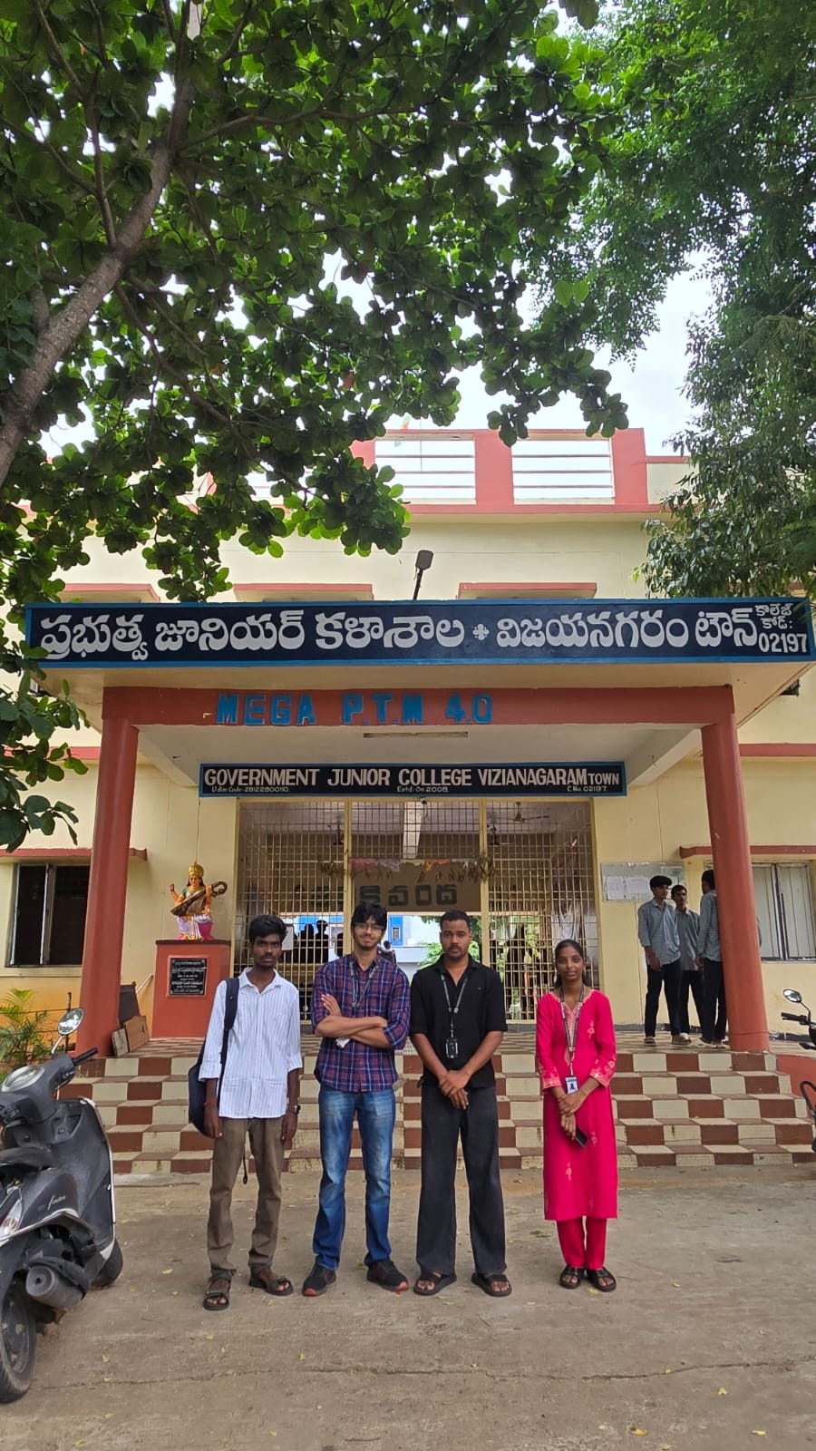
Figure 4.1: Govt. Junior College, Vizianagaram Town — Entrance Gate with Project Team (26-09-2026)
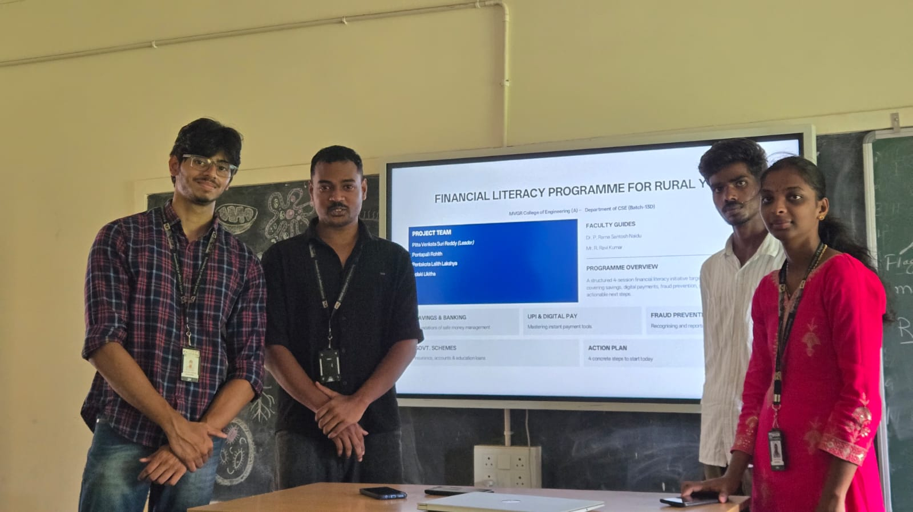
Figure 4.2: Team BATCH-13D Presenting Financial Literacy Modules on the Smart Board
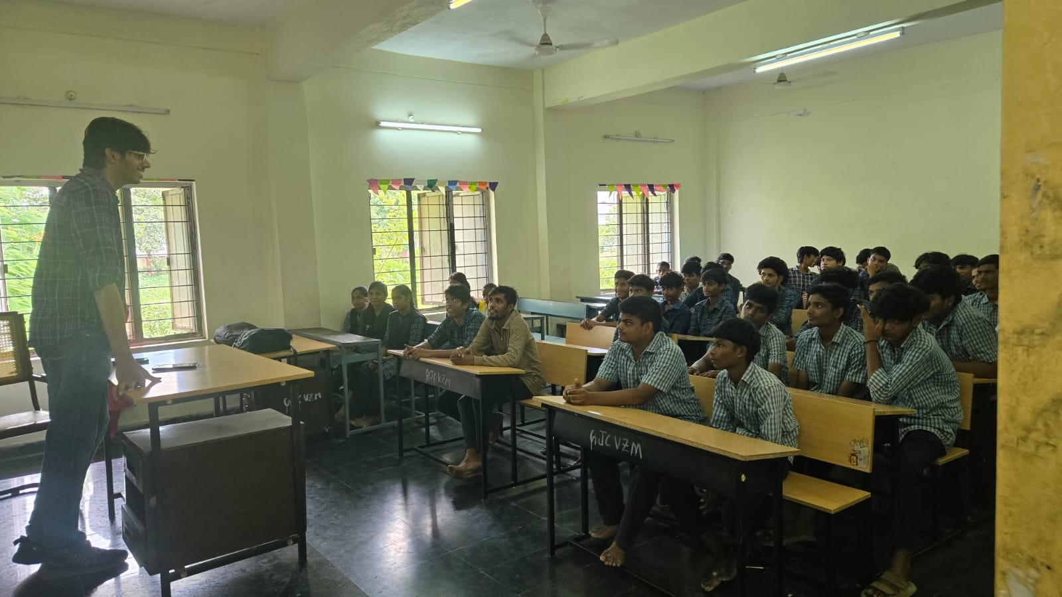
Figure 4.3: Class XII Students Attending the Financial Literacy Awareness Session
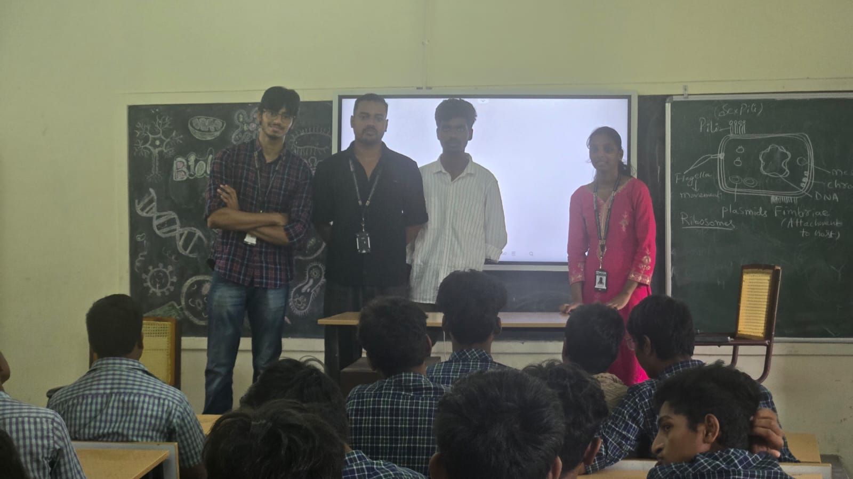
Figure 4.4: Team Addressing Student Questions during Interactive Q&A Segment
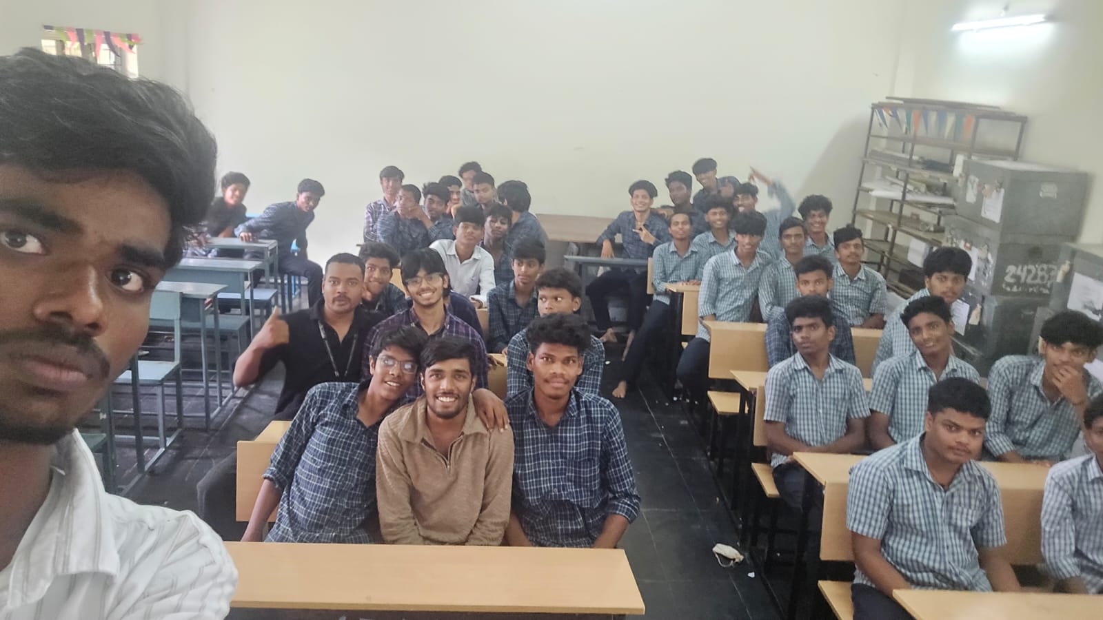
Figure 4.5: Group Photograph with all 37 Participating Class XII Students at Session Completion

CHAPTER 5: DATA COLLECTION & IMPACT ASSESSMENT
5.1 Key Performance Indicators (KPIs)
Project impact was evaluated by comparing matched pre-test and post-test scores across the four domain areas. All 37 participating students completed both evaluation rounds:
KPI Metric Area | Key Performance Indicator | Baseline (Pre-Test) | Achieved (Post-Test) | Impact / Change
Overall Score | Class Average Score (out of 15) | 5.1 / 15 (34%) | 12.9 / 15 (86%) | +7.8 marks (+152% gain)
High Performers | Students scoring >= 80% (12+ marks) | 0 / 37 (0%) | 29 / 37 (78%) | +29 students (+78%)
Low Performers | Students scoring < 40% (0-5 marks) | 22 / 37 (59%) | 0 / 37 (0%) | -22 students (-100%)
Individual Growth | Students demonstrating score increase | N/A | 37 / 37 (100%) | 100% individual improvement
Lowest Class Score | Minimum score recorded in class | 3 / 15 (20%) | 11 / 15 (73%) | +8 marks floor lift
5.2 Detailed Findings & Data Analysis
Statistical analysis of the 37 matched pre/post score sets revealed dramatic, uniform knowledge gain across all four modules:
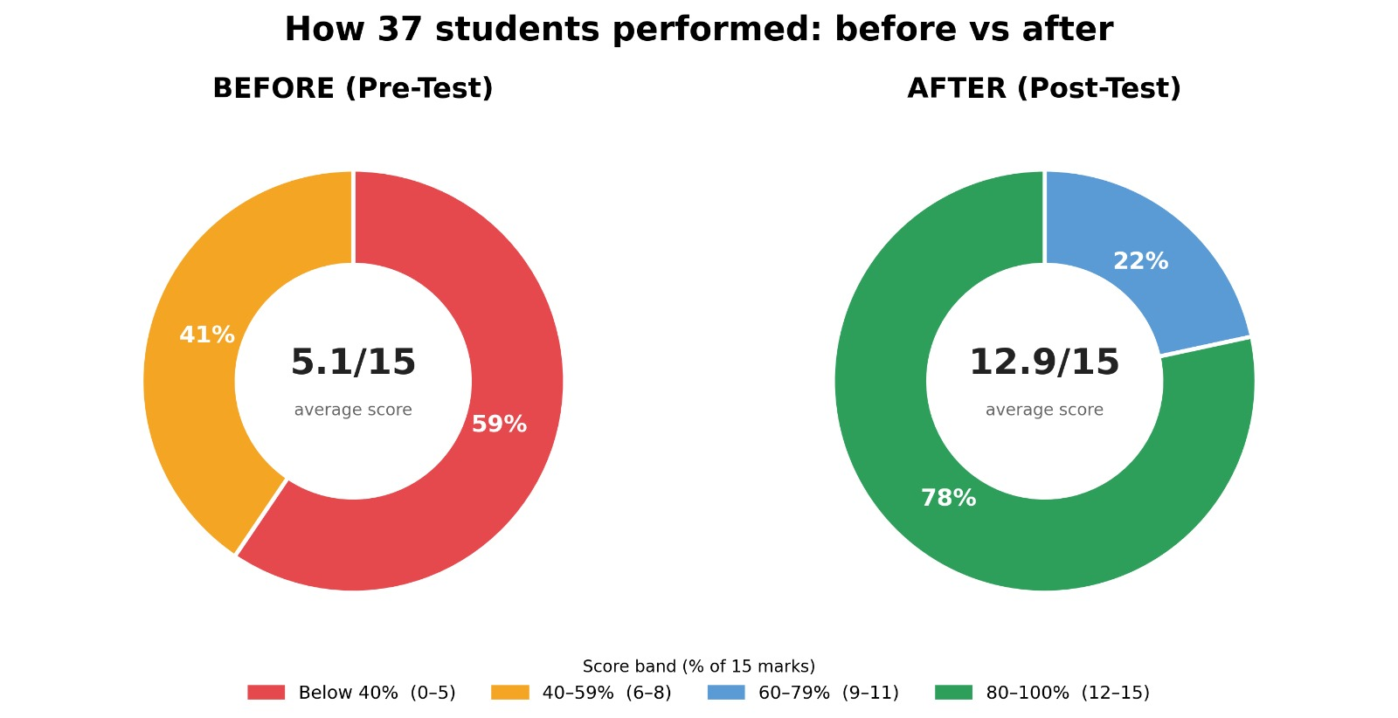
Figure 5.1: Performance Distribution Doughnut Charts — Before (59% below 40%) vs After (78% in 80-100% band)
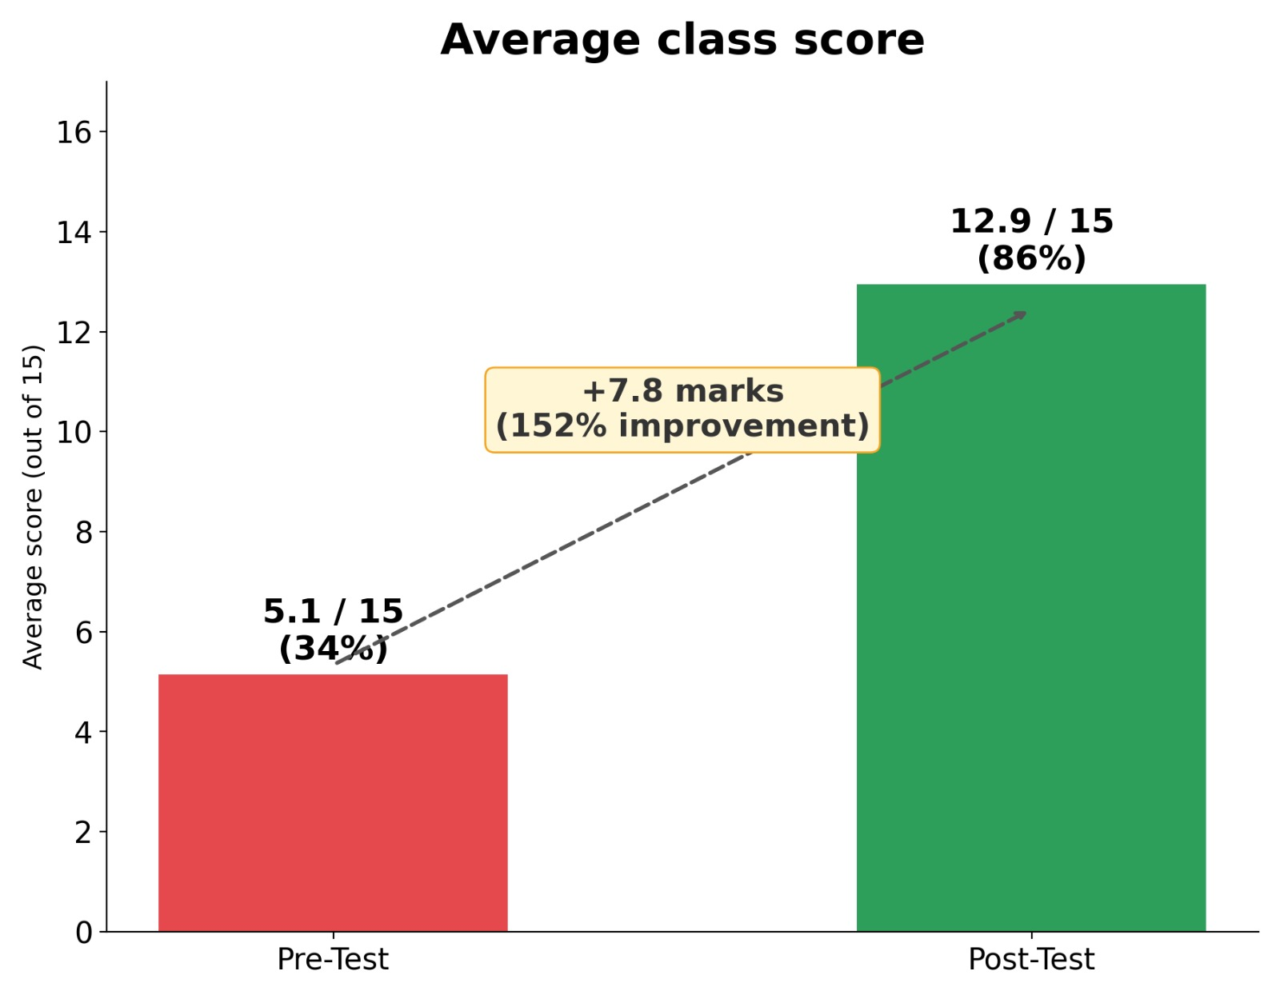
Figure 5.2: Class Average Score Comparison — Pre-Test (5.1/15) vs Post-Test (12.9/15) [+152% Improvement]
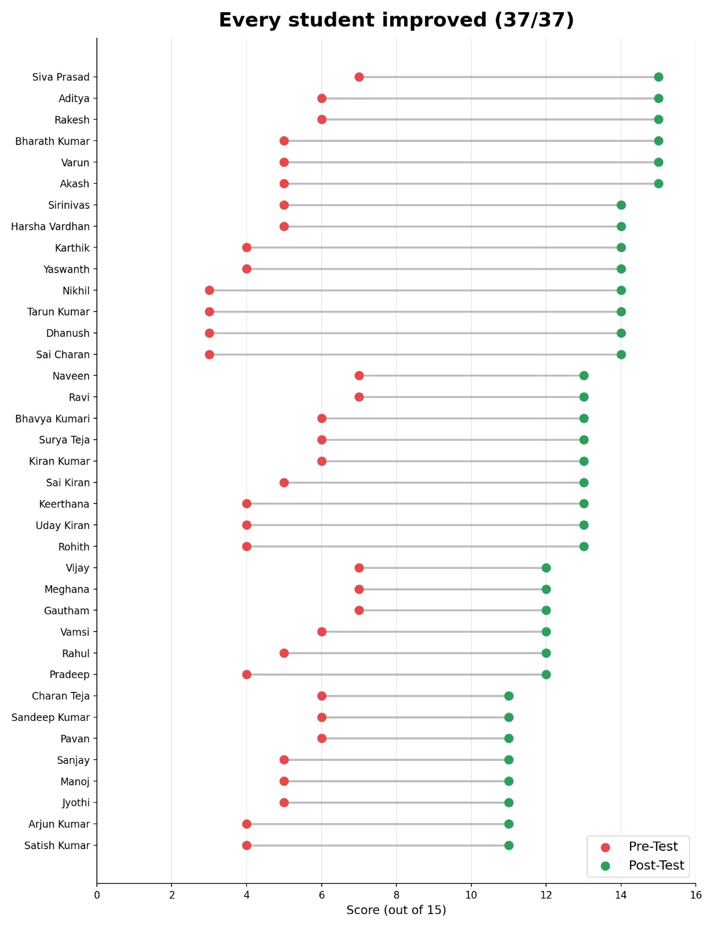
Figure 5.3: Individual Student Score Progress (Lollipop Chart) — 37 out of 37 Students Improved
Topic-Wise Improvement Breakdown:
- UPI & Digital Payment Safety: Pre-test accuracy was 28%. Students frequently confused OTP with PINs. Post-test accuracy reached 92% after live phone demos.
- Savings & Banking Mechanics: Pre-test accuracy was 35%. Post-test accuracy rose to 88%, with students learning zero-balance account eligibility.
- Insurance & Govt. Schemes: Pre-test accuracy was 31%. Over 80% of students were unaware of PM Scholarship prior to the session; post-test accuracy reached 84%.
- Budgeting & Financial Planning: Pre-test accuracy was 41%. Post-test accuracy reached 82% as students mastered the 50/30/20 budgeting rule.

CHAPTER 6: REVIEW 1 FEEDBACK & ACTIONS TAKEN
During Review 1, the evaluation panel provided specific suggestions to enhance project rigor, community partner verification, assessment design, and outcome measurement. The table below details every feedback item and the corresponding actions taken by team BATCH-13D:
Review 1 Panel Feedback Query | Action Taken by Team BATCH-13D | Final Outcome & Verification
1. Finalize Community Partner & Confirm Student Count | Partnered with Government Junior College, Vizianagaram Town (Code: 02197). Enrolled a fixed cohort of 37 Class XII students. | Written permission obtained from Principal. 37 students participated on 26-09-2026.
2. Design Measurable Assessment Strategy | Constructed a 15-mark multiple-choice pre-test and identical post-test covering all 4 awareness modules. | 100% completion rate (37/37 matched papers). Average score rose from 34% to 86%.
3. Document Field Evidence & Geotagging | Captured comprehensive field photographs during all session stages, including entrance, smart board demos, and student participation. | Detailed photo documentation with geotags and dates attached in Chapter 4 and Appendix C.
4. Provide Tangible Community Deliverable | Designed and distributed a concise 1-page Personal Finance Handout in Telugu and English covering banking, UPI safety, and schemes. | All 37 students received printed handouts for personal use and family sharing.

CHAPTER 7: CONCLUSION & RECOMMENDATIONS
7.1 Conclusion
The Financial Literacy Programme for Rural Youth (PS090) successfully achieved its core objectives. By delivering a structured 4-module interactive curriculum to 37 Class XII students at Govt. Junior College, Vizianagaram Town, the project effectively transformed baseline financial knowledge from 34% (5.1/15) to 86% (12.9/15)—a +152% improvement. Every single participating student (37/37) demonstrated individual score growth. The intervention equipped rural youth with vital digital payment safety skills, awareness of government welfare schemes, and budgeting fundamentals.
7.2 Project Limitations
- Single Session Duration: While knowledge gain was immediate and substantial, long-term retention requires periodic reinforcement over 6 to 12 months.
- Socioeconomic Variance: Variable household income levels influenced how quickly students could apply savings concepts in practice.
7.3 Future Recommendations & Scaling
- Institutional Integration: Encourage the institution to integrate a mandatory 2-hour financial safety orientation into every Class XII academic year.
- Bilingual Handouts: Translate handouts into local languages (Telugu) for broader parental reach in rural villages.
- District-Wide Scaling: Replicate this 4-module framework across other rural government junior colleges in Vizianagaram district.

REFERENCES
1. Reserve Bank of India (RBI). (2024). Financial Education Series for School Students. RBI Financial Literacy Center. Available at: https://www.rbi.org.in
2. National Payments Corporation of India (NPCI). (2025). Safe Digital Banking & UPI Security Guidelines. NPCI Safety Portal. Available at: https://www.npci.org.in
3. CERT-In (Indian Computer Emergency Response Team). (2025). Cyber Security Advisory on Mobile Payment Scams and Phishing. Ministry of Electronics and Information Technology, Govt. of India. Available at: https://www.cert-in.org.in
4. Securities and Exchange Board of India (SEBI). (2024). Financial Planning & Investor Awareness Booklet. SEBI Investor Education. Available at: https://www.sebi.gov.in
5. Ministry of Finance, Govt. of India. (2025). Pradhan Mantri Jan Dhan Yojana (PMJDY) & Social Security Schemes Portal. Available at: https://pmjdy.gov.in

APPENDICES
Appendix A: Survey Instrument (15-Mark MCQ Pre/Post Assessment)
The 15-mark multiple choice questionnaire contained 4 questions on Savings & Banking, 4 on UPI & Digital Security, 4 on Insurance & Govt. Schemes, and 3 on Financial Planning & Budgeting.
Appendix B: Field Visit Photograph Gallery
Comprehensive collage and photograph records documenting the fieldwork at Govt. Junior College, Vizianagaram Town on 26-09-2026:
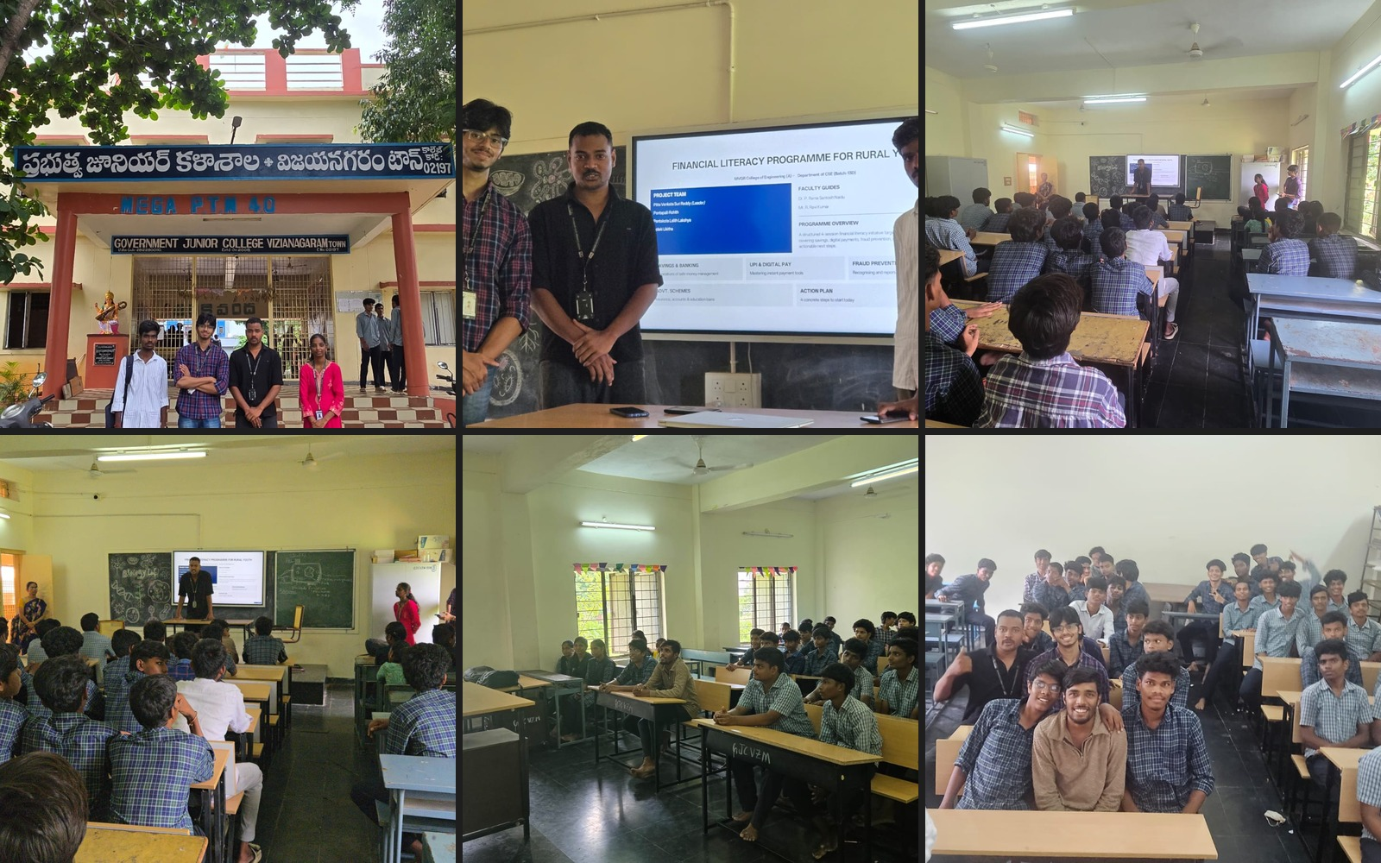
Figure C.1: Complete Field Documentation Grid — Entrance, Presentation, Classroom Engagement, and Group Photo

