Asking with a prompt, what type of item they are interested in? I will be choosing item 2, dirt devil, vacum currently the quantity is 11. And the customer wants to buy 3.

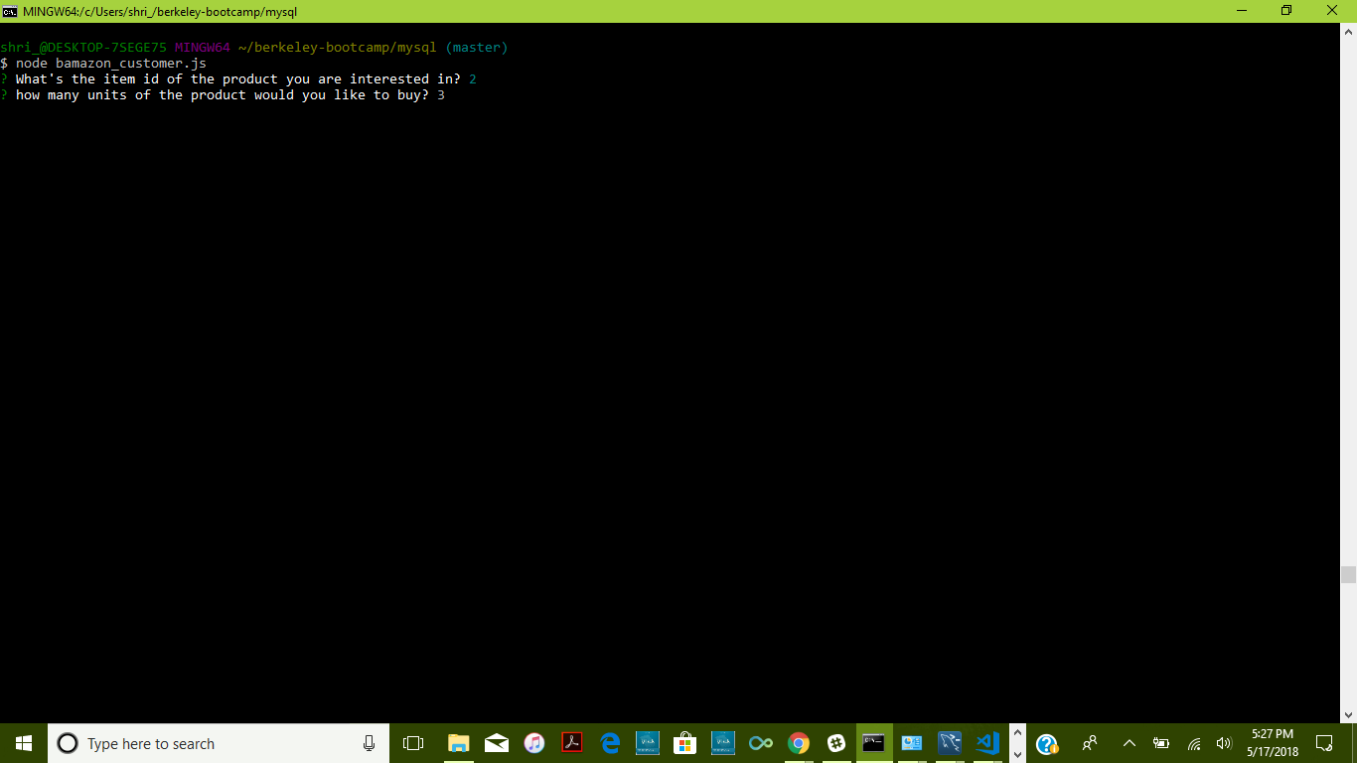

The user chooses 3, at a price of 75 which is 225. The prompt lets the user know that the product exists and the purchase is approved. The quantity asked by user is approved due to the amount lower then 11.

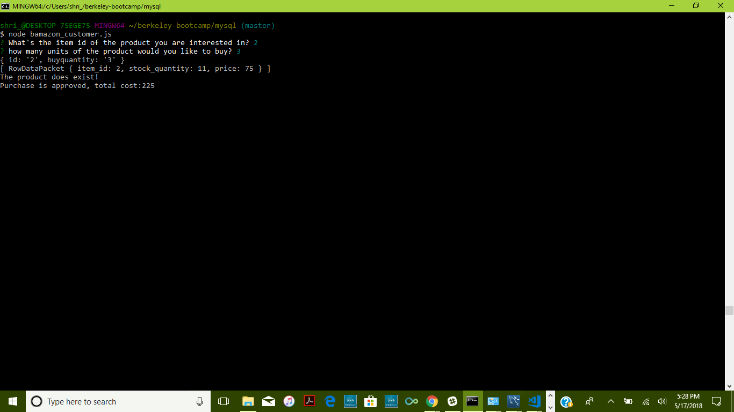

As you can see, the stock_quantity was at 11, but updated to 8, after the purchase by the user.

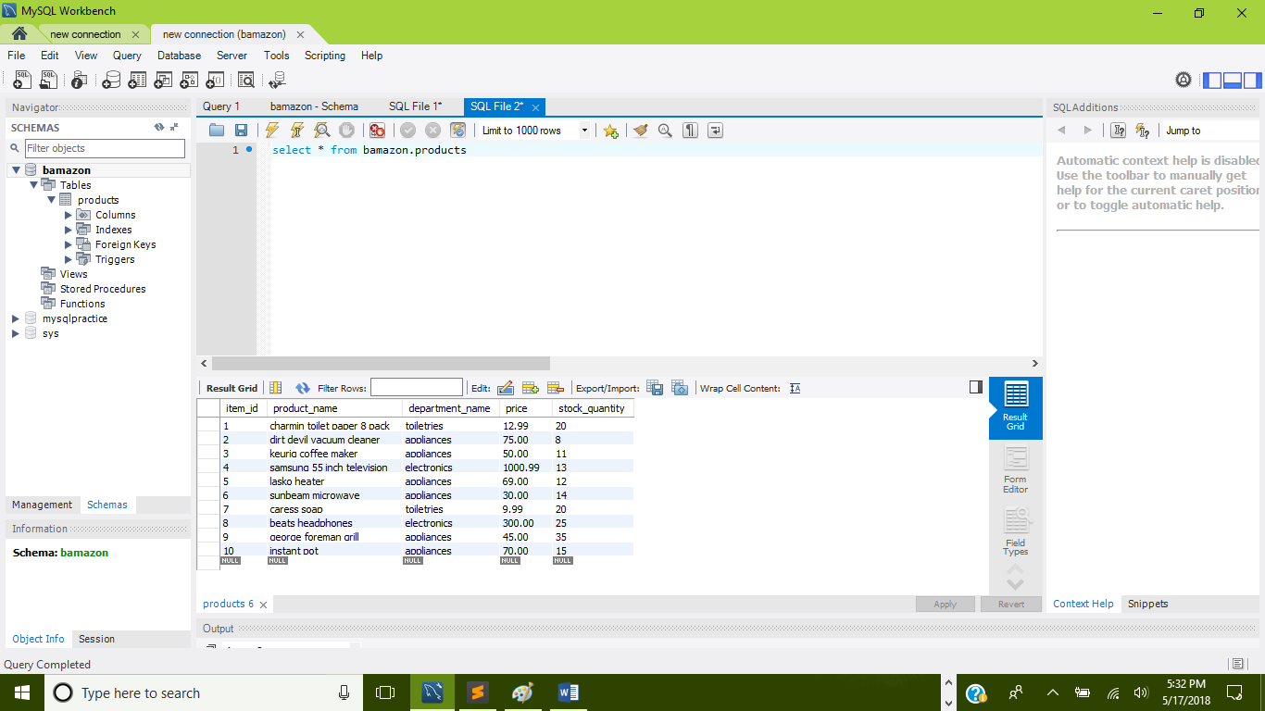

In the second scenario, I asked for item 3, but in this case asked for 50 units. It exceeded the total quantity amount which was 11. It gives the user a prompt letting them know the product exists, but the product cannot be given due to the shortage of quantity for the product.

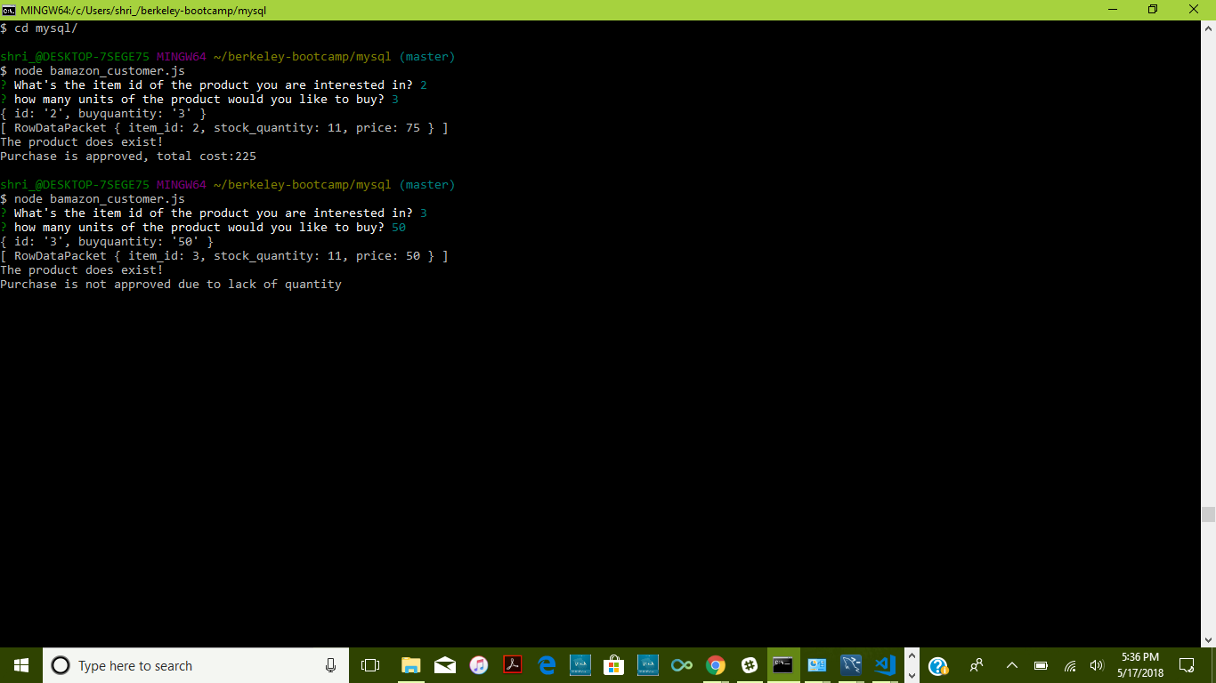

There were no new changes when refreshing the table, the quantity of 11 stayed the same.

