ADA LAB-2

1. **BFS:**

CODE:

#include<stdio.h> void bfs(int);

int a[10][10],vis[10],n;// a is adjescency matrix ,n is no vertices void main()

{

int i,j,start;

printf("\nEnter the number of vertices:"); scanf("%d",&n);

printf("\nEnter the node to start from:"); scanf("%d",&start);

printf("\nEnter adjacency matrix:"); for(i=1;i<=n;i++)

{

for(j=1;j<=n;j++)

{

scanf("%d",&a[i][j]);

}

}

//initialise all vertices to 0-not visited initially for(i=1;i<=n;i++)

{

vis[i]=0;

}

bfs(start);//call function bfs

}

void bfs(int v)

{

int q[10],f=0,r=0,u,i; vis[v]=1;

q[r]=v;

printf("\nNodes reachable from node %d:",v); while(f<=r)

{

u=q[f]; printf("%d\t",u); for(i=1;i<=n;i++)

{

if(a[u][i]==1&&vis[i]==0)

{

r=r+1; q[r]=i;

vis[i]=1;

}

}

f=f+1;

}

} OUTPUT:

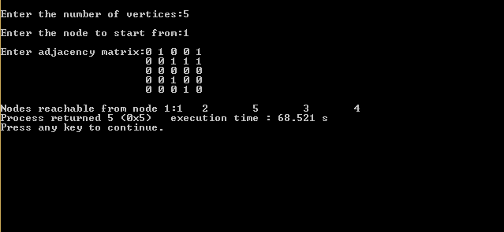

1. **TOPOLOGICAL SORTING:**

CODE:

#include<stdio.h> #include<conio.h>

int a[10][10],n,exp[10],vis[10],J=0; void dfs(int);

void main()

{

int m,u,v,i,j;

printf("\nEnter the number of vertices:"); scanf("%d",&n);

for(i=1;i<=n;i++)

{

for(j=1;j<=n;j++)

{

a[i][j]=0;

}

}

printf("\nEnter the number of edges:"); scanf("%d",&m);

for(i=1;i<=m;i++)

{

printf("\nEnter an edge:"); scanf("%d%d",&u,&v);

a[u][v]=1;

}

for(i=1;i<=n;i++)

{

vis[i]=0;

}

for(i=1;i<=n;i++)

{

if(vis[i]==0)

{

dfs(i);

}

}

printf("\nTopological Order:"); for(i=n-1;i>=0;i--)

{

printf("%d\t",exp[i]);

}

getch();

}

void dfs(int v)

{

int i; vis[v]=1;

for(i=1;i<=n;i++)

{

if(a[v][i]==1&&vis[i]==0)

{

dfs(i);

}

}

exp[J++]=v;

}//dfs function OUTPUT:

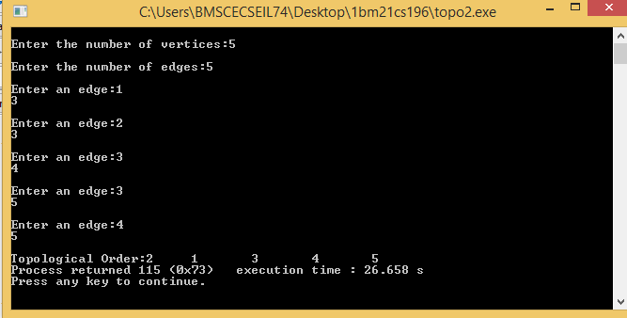

BY,

Sevitha N

1BM21CS195

D sec