COMPUTER NETWORKS LAB 1

Create a topology consisting of two or more end devices connected with the help of hub and switch and simulate a simple PDU.

# Hub

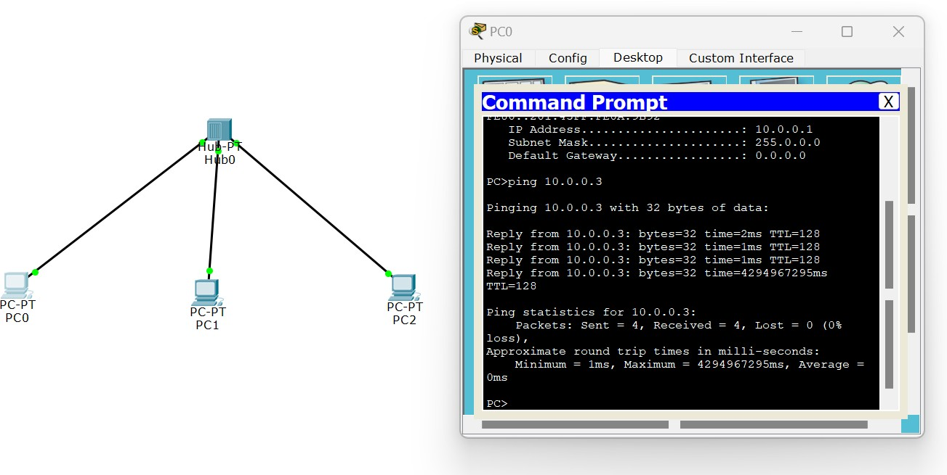

**SIMULATION:**

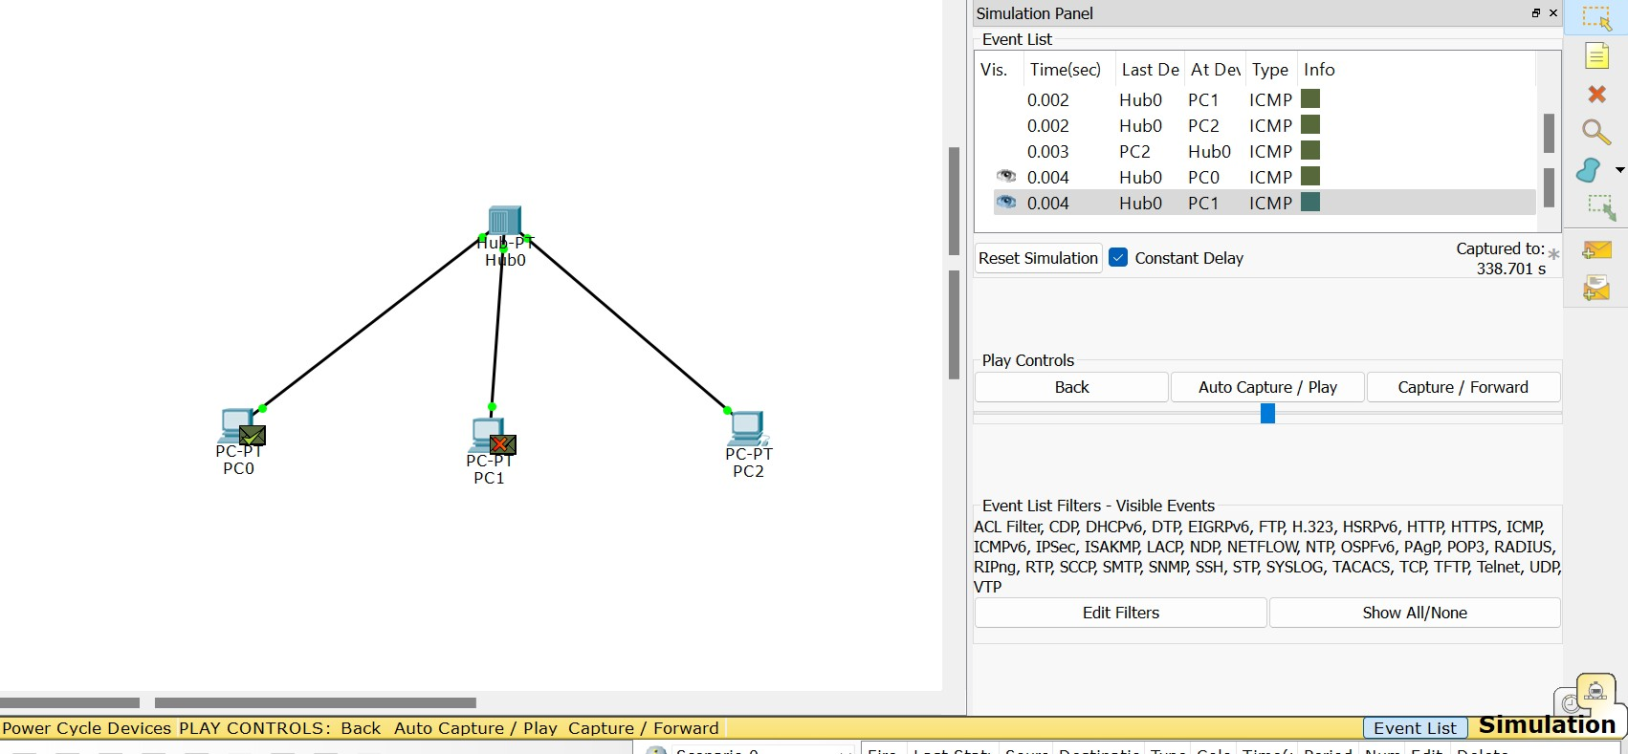

# SWITCH

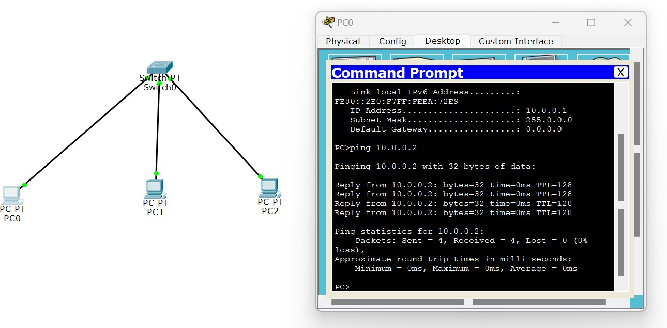

**Simulation:**

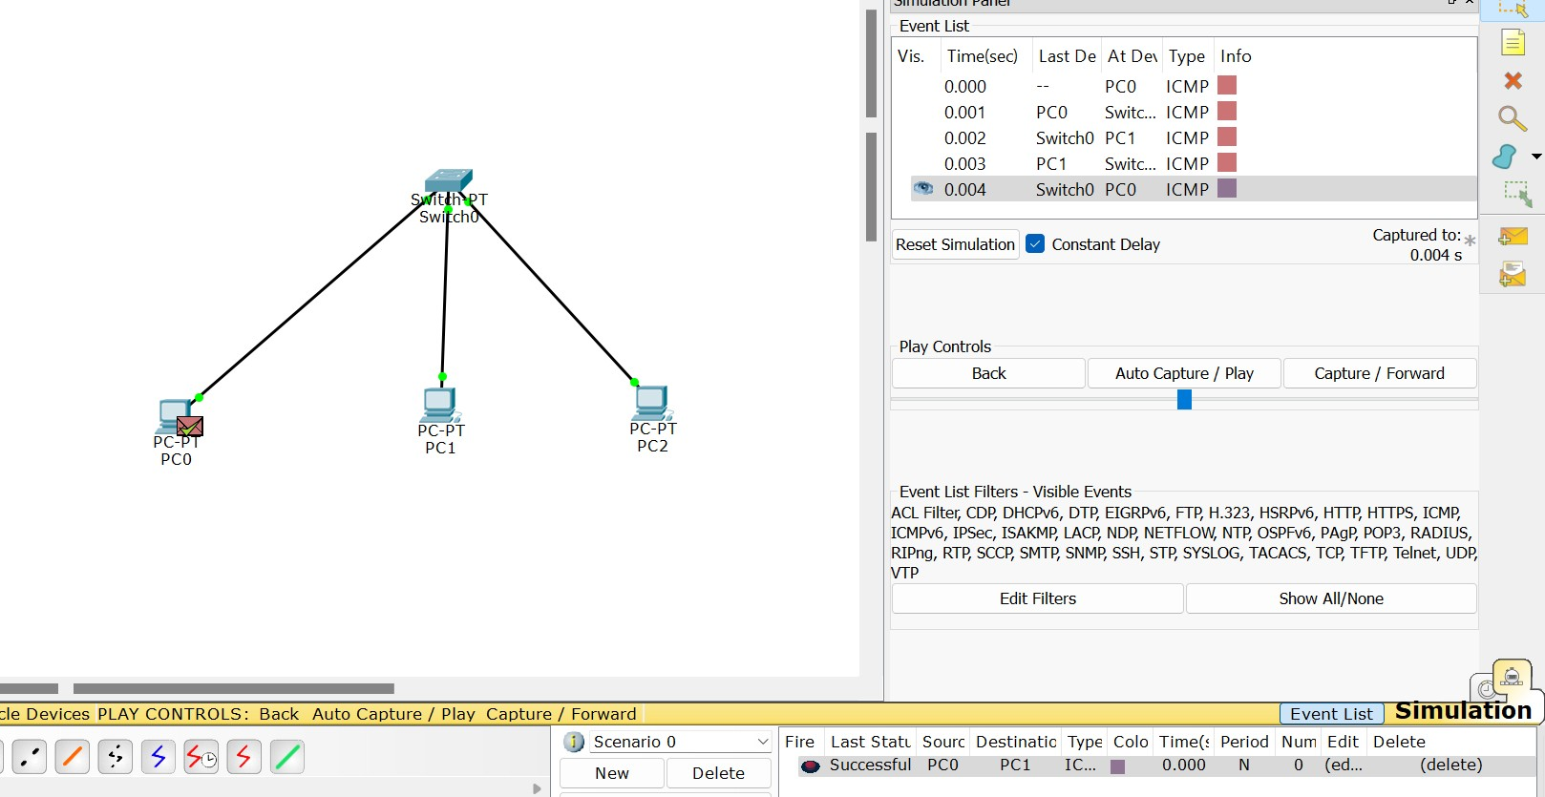

# Switch and Hub Hybrid

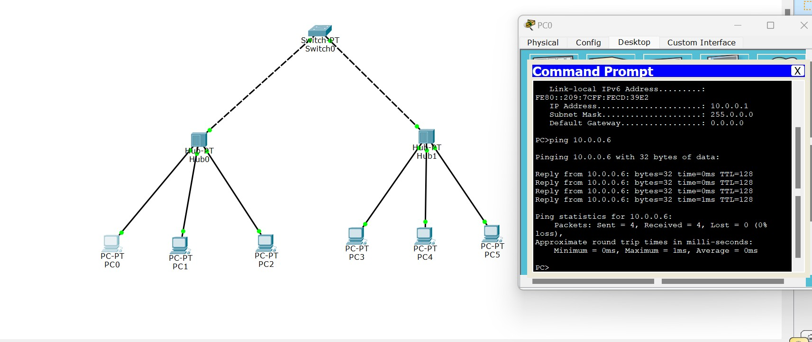

**Simulation:**

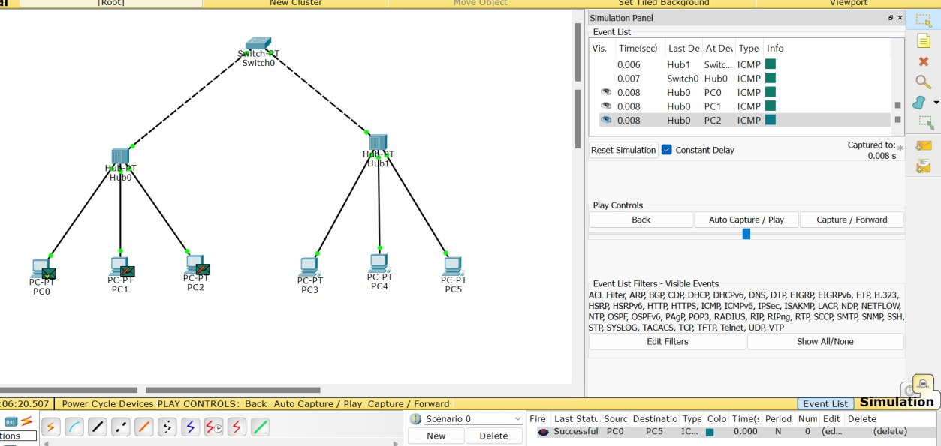

# OUTCOMES:

## Outcome with Hub:

By,

When using a hub, in real-time scenarios, such as when we issue a ping command, we observe that the response is received from the destination. A hub operates at the physical layer of the OSI model. When it receives a PDU from one device, it broadcasts it to ALL the connected devices in the network. In the case of the ping command, the hub forwards the ping request to all devices, including the

destination. In simulation, each device on the network receives the PDU, but only the destination device processes the request and sends back a response. Other devices connected to the hub ignore the PDU since it is not intended for them. This broadcast nature of a hub can cause network congestion and inefficient bandwidth usage because all devices receive all traffic, regardless of whether they are the

intended recipients.

## Outcome with Switch:

When using a switch, specifically in simulation mode, the behaviour is different from that of a hub. A switch operates at the data link layer of the OSI model. When it

receives a PDU, it examines the destination address within the PDU's header. Instead of broadcasting the PDU to all connected devices, the switch only transmits or forwards the PDU to the specific end device. This targeted forwarding helps improve network efficiency since only the intended recipient receives the PDU. Other devices connected to the switch do not receive the PDU, reducing unnecessary traffic on the network.

## Outcome with Hybrid:

In a hybrid network configuration, where both hubs and switches are used, the outcomes combine elements of both previous scenarios. When a PDU is received by the hub in simulation mode, it broadcasts the PDU to all the connected devices,

including the switch. However, unlike in a pure hub network, the switch in the hybrid configuration doesn't forward the PDU to all connected devices. Instead, it examines the destination address and forwards the PDU only to the specified destination

device, just like in a pure switch network. This way, the hub helps propagate the PDU to all devices, including the switch, while the switch ensures that the PDU reaches the intended destination. This configuration strikes a balance between network

reachability and efficient data transmission by leveraging the broadcast capabilities of a hub and the selective forwarding of a switch.

Shana Diya Sujit 1BM21CS196

4D