**CN LAB 2**

**Sevitha N- 1BM21CS195**

Configure IP address to routers in packet tracer. Explore the following messages: ping responses, destination unreachable, request timed out, reply.

**TOPOLOGY:**

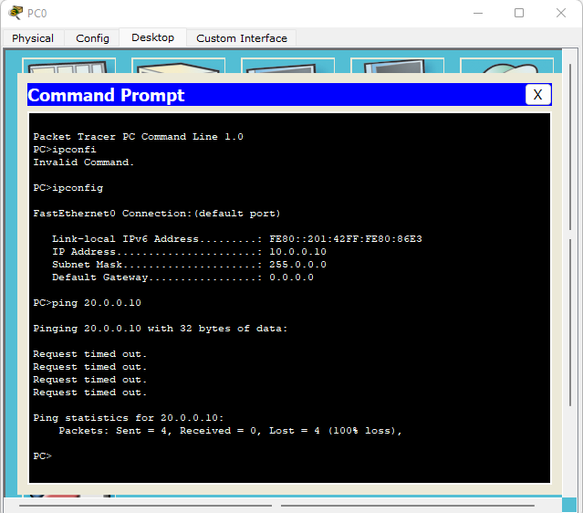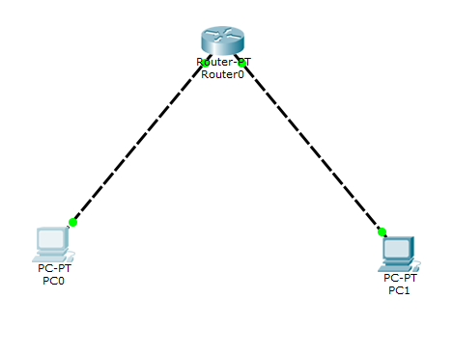

**OUTPUT WITHOUT SETTING DEFAULT GATEWAY**:

**OUTPUT AFTER SETTING DEFAULT GATEWAY:** 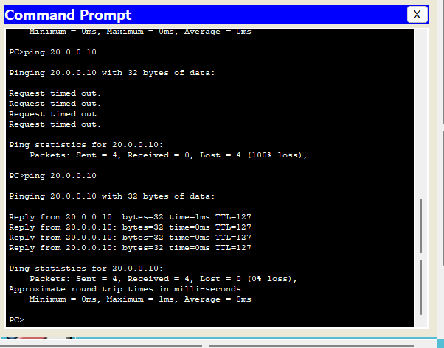

**OUTCOMES:**

1.Ping Responses: The configured IP address of the destination device is correct and the network connection is functioning properly thus, we receive a successful ping response. This indicates that the destination device is reachable and responsive.

2.Without setting default gateway for the end devices : Request Timed Out-

"Request Timed Out" message : thus-the router sent a request but did not receive a response within a specific time frame.

3.After setting default gateway for end devices- Reply from: 4 “Reply from..32 bytes” messages are seen. Router has received a valid message or request and thus it generates a reply to acknowledge the receipt. A reply message confirms that the communication is established and the router is functioning properly.