**CN LAB 5**

**Configure http and DNS server**

1.End Device PC and a server

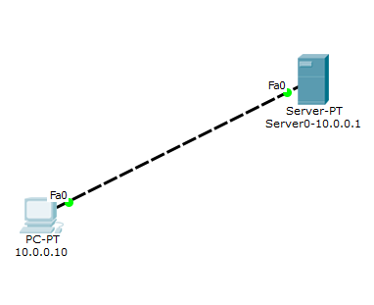

2.Go to server

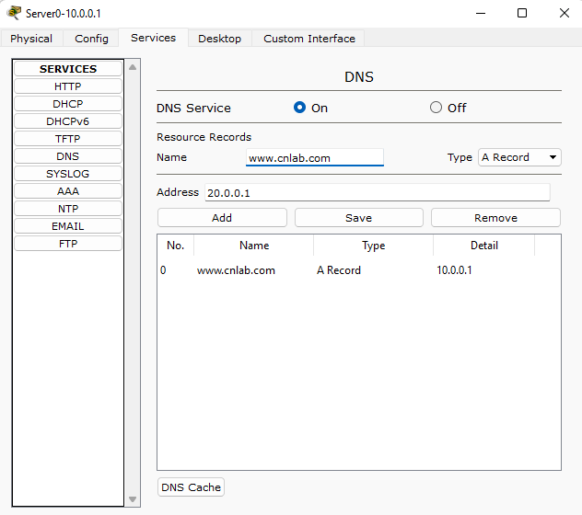

3.Edit index.html

Server->Services->index.html->edit

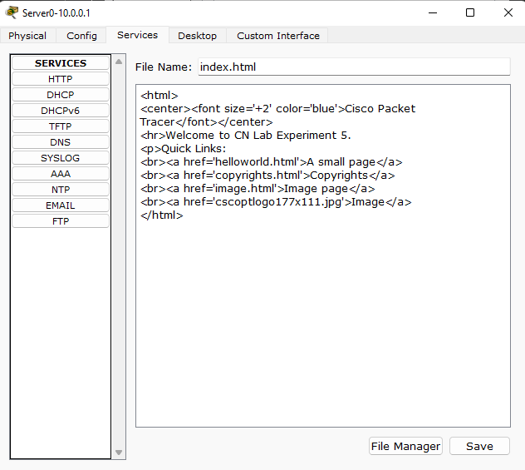

4.Go to end device.

->Desktop->Web Browser

Type [www.cnlab.com](http://www.cnlab.com) ->Go

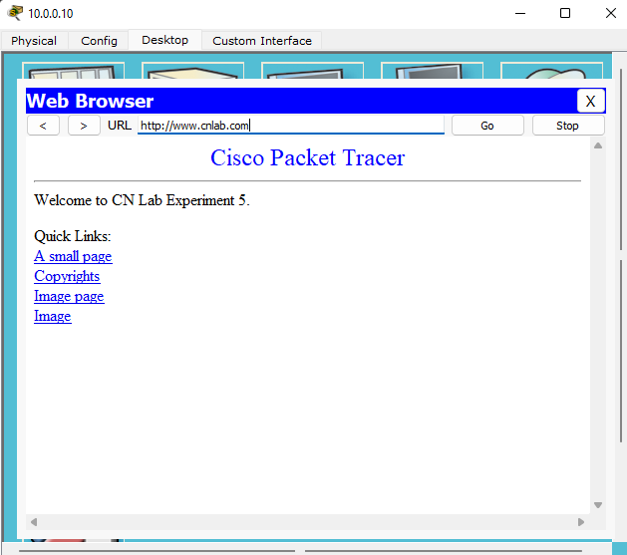

**Configure DHCP within a LAN**

1. Two end devices, a switch , router and a Server.

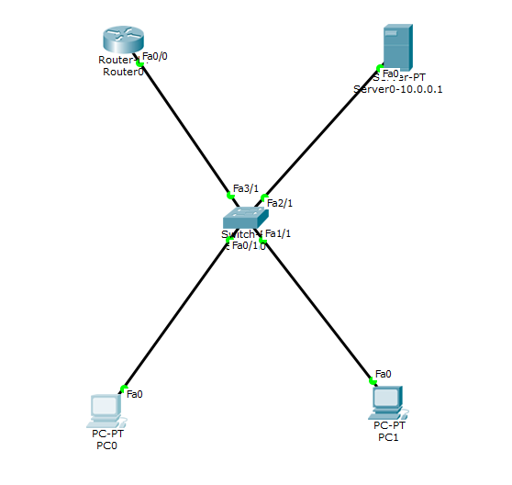

1. Configure ip addres pf router using CLI
2. Configure ip address of server using Server->Desktop->IP Configuration

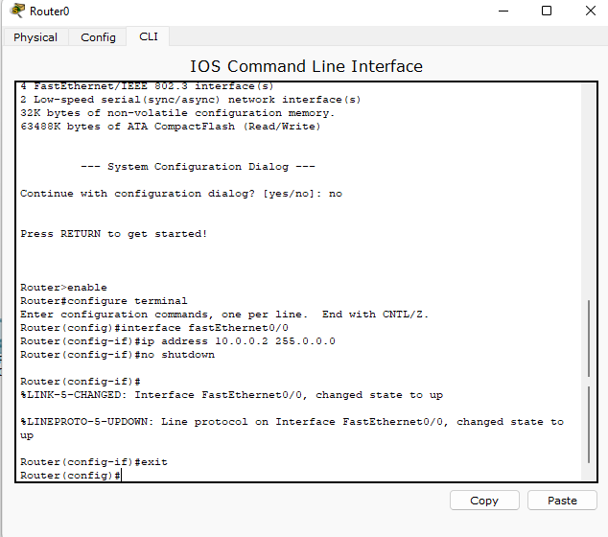

1. Server->Services

Set the pool name, default gateway=IP address of the router, TFTP Server=IP address of the Server

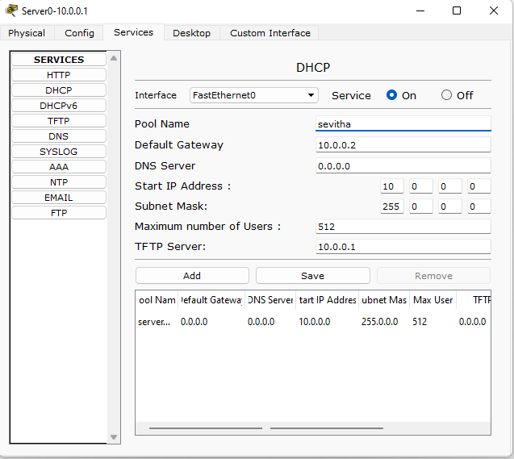

1. The ip address of the end devices gets assigned automatically

Goto PC0->Desktop->IP Configuration->select DHCP{IPv4}

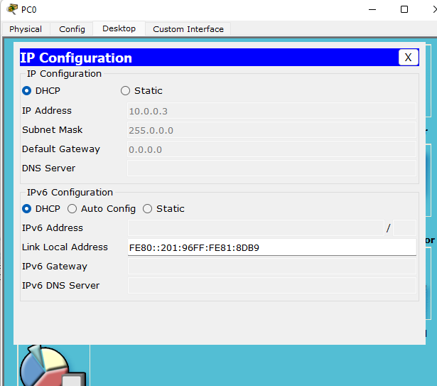

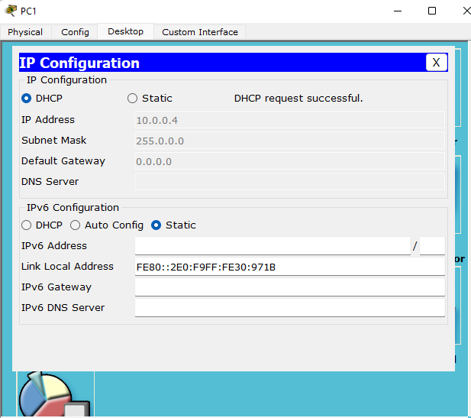

**Configure DHCP outside a LAN**

1. Two end devices, a switch, router and a server.

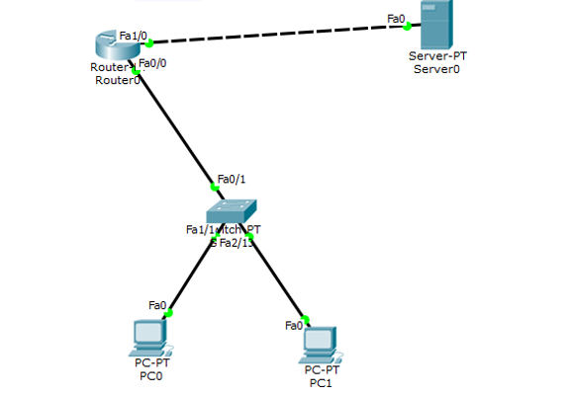

1. Router CLI

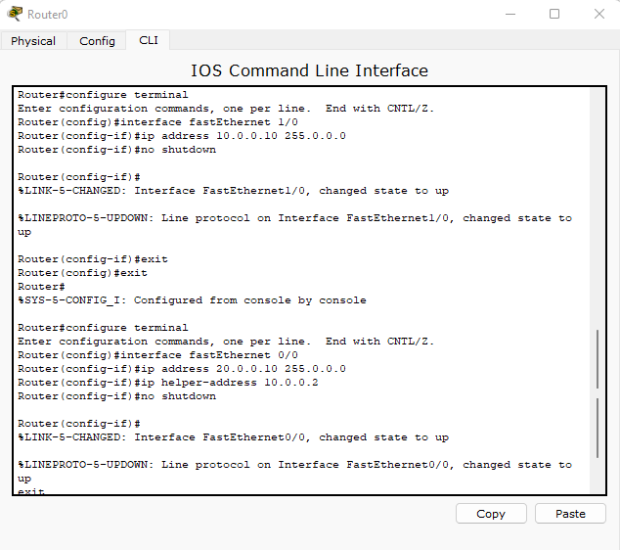

1. Server->Services

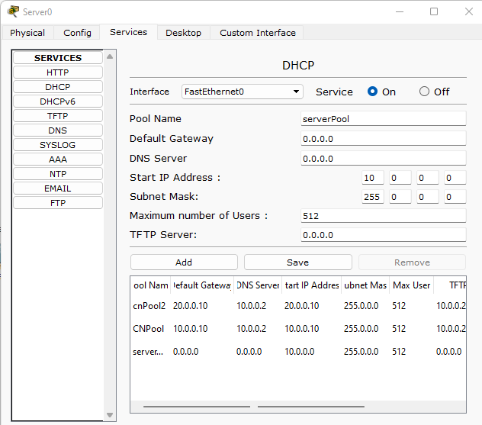

1. End devices

