**E-Commerce**

**Presentation 2 / Date: 16.11.2016**

**Classes**

* **Edge (Micro-Datacenters)**
  + - Number of PM’s *(number of running PM’s differs due to the workload)*
    - Coordinates
      * Edges are placed in a grid *(at most one edge can be placed at a position in a grid)*
      * The distance between to edges is defined as a Manhattan Distance between the edges
      * Network bandwidth for each connection between the edges is defined with the equation:

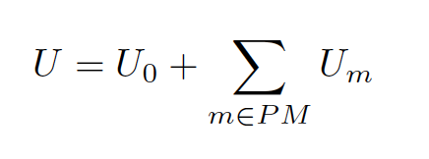

* + **PM’s (Personal Machines) – *inside the micro-datacenters (edge)***
    - Size
    - Consumed memory
    - Consumed CPU
    - Consumed network bandwidth
    - Energy signature

$$U=U_{0}+W_{cpu}*U_{cpu}+W_{mem}*U_{mem}+W_{network}*U_{network}$$

$U-total energy uilization$

$U_{0}-energy utilization in the idle state when no resources are consumed$

$U_{i}-energy utilization considering resources at the highest possible workload$

$W_{i}-workload rates$

* **VM’s (Virtual Machines) – *inside the PM’s***
  + Size
  + Consumed memory
  + Consumed CPU
  + Consumed network bandwidth *(depends on the* ***consumed memory****)*
  + Page dirtying rate *(depends linearly on the combination of the* ***utilized memory****,* ***CPU*** *and* ***network*** *bandwidth)*
  + Running time *(given by a normal distribution function)*
  + Origin of request *(the location of the user who is served by this VM)*
* **Tasks – *inside the VM’s***
* **User**