**E-Commerce**

**Presentation 2 / Date: 16.11.2016**

**Variables & Formulas**

* Energy utilization function:

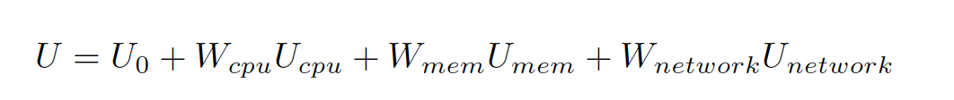

* U – total energy utilization
$U_{0}-energy utilization in the idle state when no resources are consumed$

$U_{i}-energy utilization considering resources at the highest possible workload$

$W_{i}-workload rates$

* Manhattan Distance

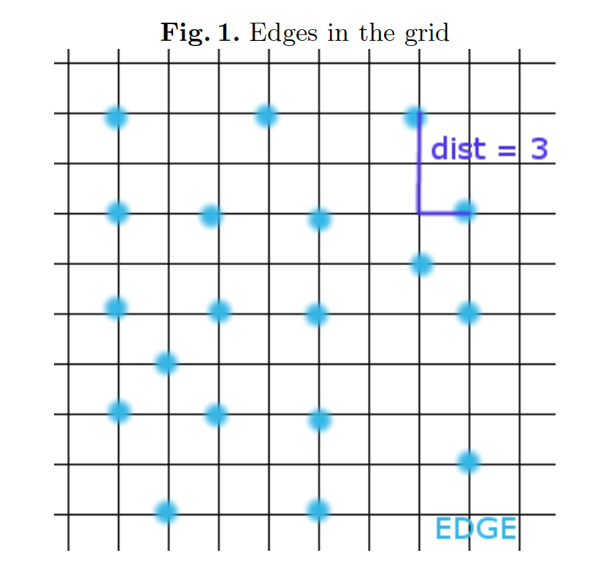

* Network bandwidth between two edges

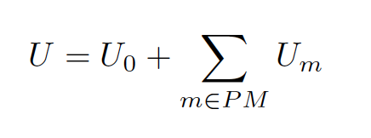

$U-total energy utilization$

$U_{0}-energy utilization when no PM^{'}s are running$

$U_{m}-running utilization of running PM m$

* SLA’s

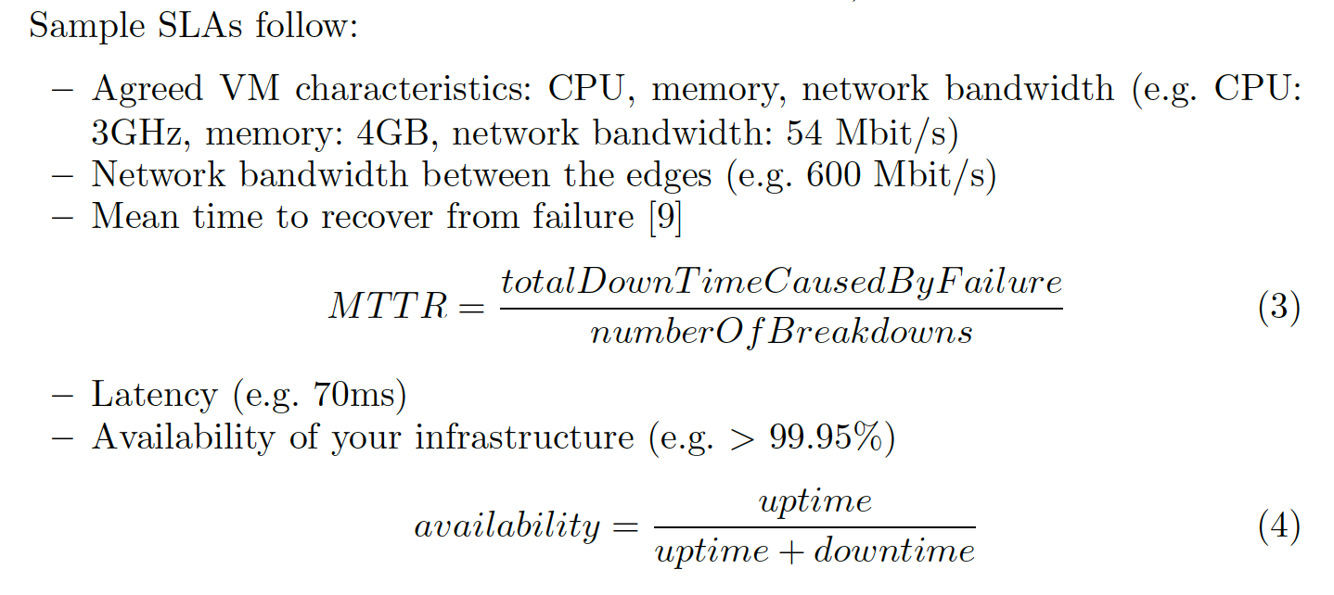

* **Migration Process**

As a baseline for VM migrations in this assignment, you can use the simplified version of pre-copying algorithm for live VM migrations:

