PROJECT REPORT

Project Name: Password Manager Student Name: Miraç Aydın , Sevdenur Özdemir Department:Computer Engineering Lesson: Programming II (Section 2) Delivery Date: 25 May 2025 GitHub Link: [ https://github.com/mxrrage] , [https://github.com/sevsaylight]

## 1. Project Purpose

This project is a user registration and login system prepared using the Java programming language and JavaFX library. Our goal is to enable users to register and log in to the system and to display existing user information through a visual interface. In addition, the information is structured to be saved and loaded to a local file.

## 2. Technologies Used

- Language:Java - GUI Framework:JavaFX  
- Data Recording: Reading/writing data from file (File I/O)  
- Visual Elements: TextField, PasswordField, TableView, Button

## 3. Main Features of the Application

- Users can enter a new username and password into the system via the Register screen. - The user can log in to the system via the Login screen. -Current users are listed in a table on a screen similar to the admin panel. -Users can be added or deleted via this interface. - All user data is stored in the local file, loaded when the program is started.

## 4. Features That Differentiate the Project

- A simple, understandable and user-friendly interface is presented. - Screens prepared with JavaFX are modern and interactive. - When the application is opened, user information is automatically loaded from the file. - User deletion and addition operations are reflected live on the table.

Miraç Aydın Sevdenur Özdemir

24040102028 23040102035

## 5. Screenshots

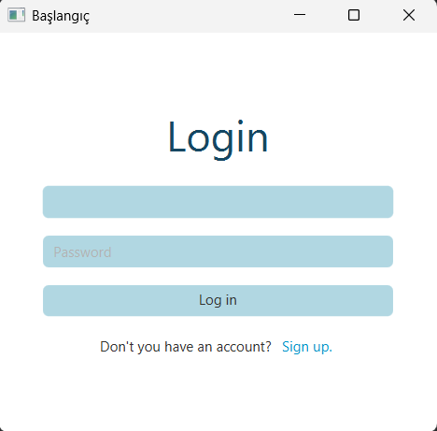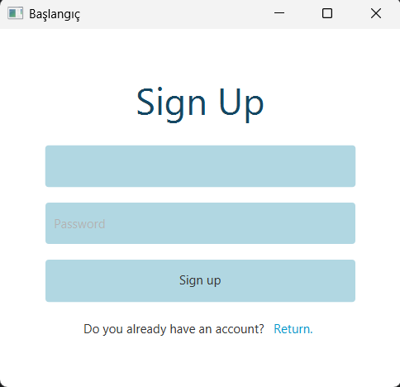

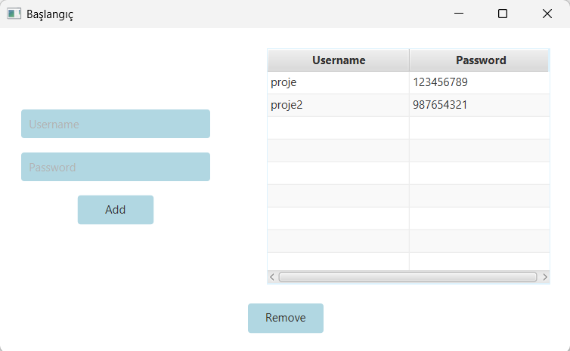

|  |  |  |
| --- | --- | --- |
| Feature | Successfully Implemented (Yes/No) | Source Code File Name |
| Basic functionality | Yes | Main.java, LoginController.java |
| Authentication (Login/SignUp) | Yes | LoginController.java RegisterController.java PasswordEntry.java |
| File processing | Yes | DatabaseConnection.java |
| Additional feature: User deletion | Yes | DashboardController.java |
| Additional feature: Table interface | Yes | dashboard.fxml |