Predicting Introvert vs. Extrovert Personality Types Using Behavioral Data
Group Members:
- Berfin Turan - 202311075
- Şevval Akkaya – 202311005

- Introduction
Personality traits play a crucial role in shaping how individuals think, behave, and interact in their daily lives. Our personality significantly influences the way we form habits and respond to our surroundings.
This project aims to explore whether common behavioral patterns such as sleep duration, social participation, confidence levels, and stage fear can serve as indicators of personality type. Using behavioral data, we will apply preprocessing, feature encoding, and machine learning techniques to classify individuals as introverts or extroverts. Better understanding the differences between extrovert and introvert personality types can help us improve workplace dynamics, mental health, marketing strategies and personalized recommendation systems.

- Dataset Description

- Data source: https://www.kaggle.com/datasets/rakeshkapilavai/extrovert-vs-introvert-behavior-data
- Number and types of features: 'Time_spent_Alone' (numeric), 'Stage_fear' (categorical), 'Social_event_attendance' (numeric), 'Going_outside' (numeric), 'Drained_after_socializing' (categorical), 'Friends_circle_size' (numeric), 'Post_frequency', 'Personality' (categorical).
- Size of the dataset: 2900 samples with 8 features.

- Data Preprocessing & Cleaning

- Duplicates: 380 duplicate rows were removed to prevent model overfitting.
- Missing Values:
  - Numeric columns were imputed with median.
  - Binary categorical features (Drained_after_socializing, Stage_fear) were encoded into 0 and 1 and imputed using KNN Imputer to preserve relationships among features.
- Inconsistency Check: Logical inconsistencies (e.g. unrealistic combinations like Time_spent_Alone ≥ 24 & Social_event_attendance > 0) were checked; none were critical.

- Exploratory Data Analysis (EDA)

- Univariate Analysis:
- Outliers Check: No outliers were found.
- Numeric variables were examined using histograms and skewness metrics, revealing well-behaved distributions.
- Categorical variables were visualized through bar plots, and class frequencies were found to be balanced.

- Feature Correlation Analysis:
- Feature Selection: A correlation heatmap revealed that a strong correlation between Stage_fear and Drained_after_socializing therefore to avoid multicollinearity, we dropped Stage_fear feature.
Dimensionality reduction was not performed intentionally to avoid unnecessary information loss and better interpretation from a psychological stand-point in a small feature space.

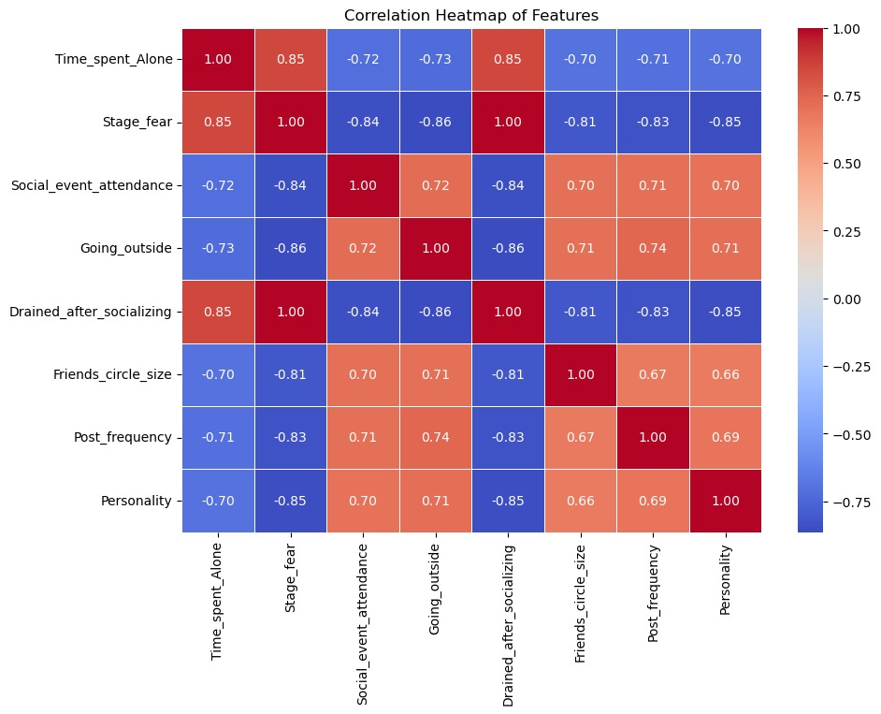

- Feature Engineering

- Label Encoding:
- Binary categorical features were mapped as No = 0, Yes = 1.
- Target variable mapped as Introvert = 0, Extrovert = 1.
- Scaling:
- Numerical columns were normalized using StandardScaler (Z-score).

- Sampling

- Stratified Sampling: Since the Extrovert/Introvert classes had a mild imbalance (56.4% to 43.6%), stratified sampling was used to preserve the class distribution in both training and test sets, preventing bias and ensuring better evaluation.

- Model Selection

We used 10-fold cross-validation to reduce information loss and obtain more reliable model performance estimates.
- KNN (k=3, k=5, k=7): KNN depended heavily on the choice of k and less stable across folds, making it less reliable than Logistic Regression.
- SVM: SVM had same results as Logistic Regression but requires more hyperparameter tuning and It is less interpretable because you can't clearly see which feature the model uses and how, making it a worse choice.
- Decision Tree: Had the lowest CV accuracy and F1-score. Overfits easily with small feature sets like ours making it a worse choice than other models.
- Naive Bayes: Naive Bayes assumes feature independence, which is violated in this dataset (strong correlations exist). Despite good accuracy, it was less reliable.
- Logistic Regression: Although other models showed close results Logistic Regression was chosen because for binary classification problems, logistic regression is one of the most reliable and frequently preferred models, offering high accuracy, low complexity, and strong interpretability.

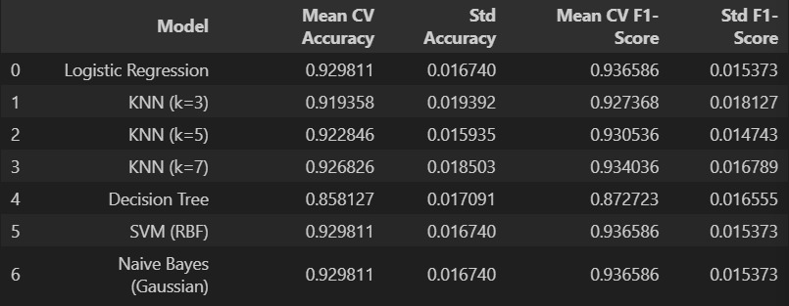

8. Final Model Evaluation
After selecting Logistic Regression (≈0.930) as the best-performing model, it was retrained on the full 80% stratified training set and evaluated on the 20% test set.
The model achieved a test accuracy of 0.917, demonstrating strong generalization to unseen data.
The model's ROC-AUC score was 0.954. This indicates that our model can differentiate between classes with a very high level of accuracy.
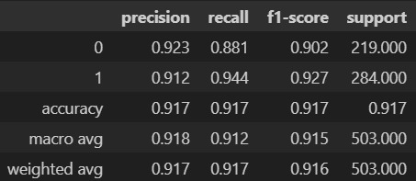
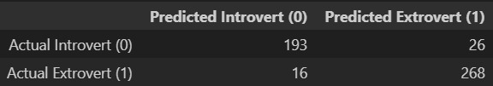

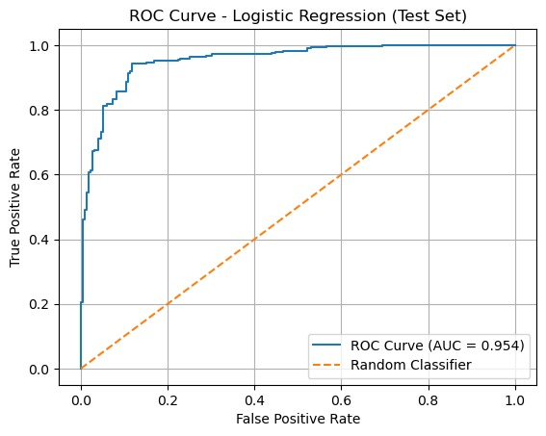

9. Visualizations
The project includes the following visualizations:
- Distribution plots for numeric features
- Bar plots for binary categorical features
- Correlation heatmap
- ROC Curve
- Confusion Matrix

10. References
- Kapilavai, R. (2025). Extrovert vs Introvert Behavior Data [Data set]. Kaggle. https://www.kaggle.com/datasets/rakeshkapilavai/extrovert-vs-introvert-behavior-data

