***NAME:*** Şevval ***SURNAME:*** Baş ***STUDENT NUMBER:*** 23040102047

***PROJECT (GAME) NAME*:** Guess Number Game ***LANGUAGE USED:*** Java ***GUI FRAMEWORK:*** JavaFX ***GitHub LINK:*** <https://github.com/sevvalbas/GuessNumberGame>

**Project Overview:** Guess the Number is a guessing game with user authentication. Players enter their guesses of numbers between 1-100 on the game screen and try to guess the random number with the computer's guidance. They have 40 seconds to do this. They are given 100 points and 5 points are deducted for each guess. The player is given one hint right, if they use the hint 10 points are deducted. At the end of the game, the player's points in their hand are added to the total score if they win, or subtracted from the total score if they lose.Also, if the player's score is negative, this score is added to the total score as a penalty. At the end of the game, the point scores are added to the total score. The player's goal is to collect the highest score.

**Key Features:**

1. The game has a user authentication feature where each player's own scores are kept. Thus, user information is recorded.
2. The game has been enriched with various animations.
3. The game has been added to the game by adding a score system to the game, adding dynamism to the game.
4. Various buttons have been provided so that the user can easily switch between pages.

**The Codes Structures Used Are:**

**userAuth** was used to manage user authentication, registration and encrypted data storage. Also, **userManage**r was used to personalize the user experience in multi-user systems, which allows each user to act according to their own information and increases the security of the application.

**UI elements** were used to allow the user to enter information, receive information and interact with the application.

With **ScaleTransition**, a component in JavaFX was scaled along the x and/or y axes to provide highlight and animation effects. With **FadeTransition**, a visual fade and appear effect that changes the opacity of a component over time was added to JavaFX.

A **sceneHistory** was kept in the application to increase the user experience and to provide the ability to return to previous scenes when switching between scenes. Java's **Stack** data structure was used for this purpose.

Layout components such as **VBox, HBox**, **BorderPane**, **GridPane, StackPane** etc. were used to provide a good layout for the user interface components.

With **KeyFrame**, one or more operations that are desired to occur at a specific time in an animation timeline are defined. In other words, what will happen at what moment during the animation is specified.

***REFERENCES***: <https://muratoner.net/online-araclar/html-renk-kodlari-color-codes-and-names>

: <https://www.youtube.com/watch?v=20l6ColnkhE>

: <https://github.com/Mnour3593/JFXMaze>

: <https://chatgpt.com/>

: <https://docs.yemreak.com/arsiv/java/javafx/gui-tasarimi>

: <https://onexyazilim.com/html-renk-kodlari/>

***SCREENSHOOTS:***

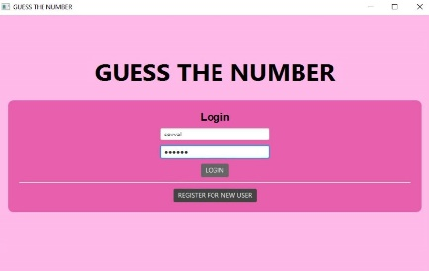 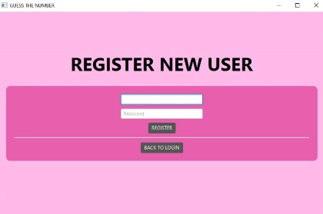 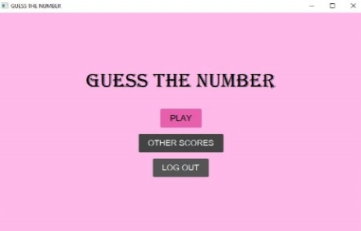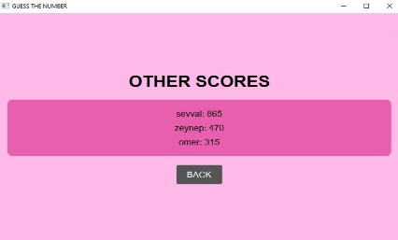 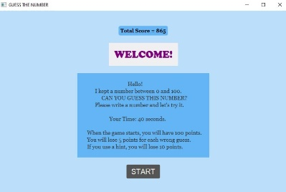 

  

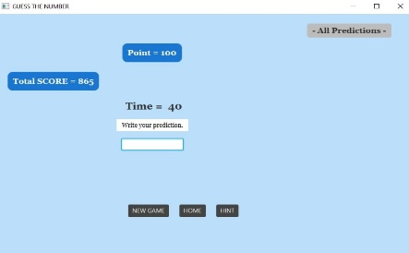 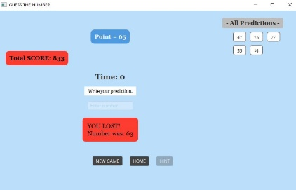 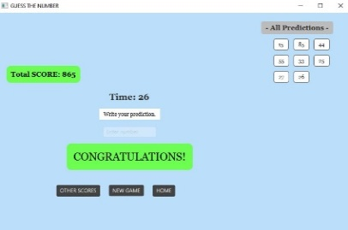

***FEATURES TABLE:***

|  |  |  |
| --- | --- | --- |
| **Feature** | **Successfully realized (Yes or No)** | **Source code file names** |
| Basic functionality | YES | RandomAndGuess.java |
| Authentication | YES | UserAuth.java - UserManager.java |
| File processing | YES | UserManager.java - RandomAndGuess.java |
| 1st Additional feature: Animations and Effects | YES | RandomAndGuess.java |
| 2nd Additional feature: Countdown Timer | YES | RandomAndGuess.java |
| 3rd Additional feature: Guess History | YES | RandomAndGuess.java |
| 4th Additional feature: Score Tracking | YES | RandomAndGuess.java |

***SIGNATURE:***

*ŞEVVAL BAŞ :*