Bilkent University

Department of Computer Engineering

Object Oriented Software Engineering Project

Project short-name: Mr.&Mrs. Pac-Man Ext.

Analysis Report

Ecem İlgün, Aziz Osman Kozhan, Başak Şevval Ekici, Talha Şeker

Supervisor: Prof. Dr. Uğur Doğrusöz

Progress Report

Oct 7, 2017

This report is submitted to the Department of Computer Engineering of Bilkent University in partial fulfillment of the requirements of the Object Oriented Software Engineering Project course CS319/2.

Contents

1. Introduction1

2. Overview1

**2.1 Pac-Mans2**

**2.2 Ghosts2**

2.2.1 Blinky2

2.2.1 Pinky2

2.2.1 Inky2

2.2.1 Clyde2

**2.3 Food2**

2.3.1 Basic Food2

2.3.2 Big Basic Food3

2.3.3 Green Food3

2.3.4 Yellow Food3

**2.4 Shields3**

2.4.1 Copper Shield3

2.4.2 Silver Shield3

2.4.3 Gold Shield3

3. Functional Requirements3

4. Non-Functional Requirements 4

5. Pseudo-Functional Requirements 4

6. System Models 4

**6.1 Use-Case Model4**

6.1.1 Use-Case Scenarios4

6.1.2 Use-Case Diagram6

**6.2 Dynamic Models7**

6.2.1 Sequence Diagram7

6.2.2 Activity Diagram17

**6.3 Object and Class Model19**

**6.4 User Interface20**

6.4.1 Navigational Path20

6.4.2 Screen Mock-Ups20

1. Introduction

Mr. & Mrs. Pac-Man Extended is a platform game which is similar to conventional Pac-Man arcade game. However, extended version provides playing with two players. They can control their own Pac-Man by using arrows and W, A, S, D combination. In the map, there will be enemies (ghosts), basic food and some special food. Player’s aim will be eating all the food in the map without hitting ghosts. In this way, they can pass levels and get the highest score. Additionally, extended version gives opportunity to design your own map.

2. Overview

By double clicking desktop icon of the game, player will see main menu which contains single player, two players, create map, load game, load map, highscore and help options. After selecting single player or two players, game will start from level 1. The game consists of three levels. At the end of each level, a pop up panel that shows various shields will appear. These shields make the Pac-Man faster and it gains resistance against ghosts according to shield’s features. Player can buy a shield by spending his/her scores. If player hits a ghost, the player loses the shield. Player’s scores will increase by eating food and ghosts. If player spends all lives, game will be over and program will ask for a name if s/he reached a high score.

In the create-map mode, player can design his/her own map and can state location and number of ghosts. The player will create his/her own challenge and if the use wants to keep the level that he created, he can save the map for another use. The gap between the bricks will let the user to escape across the map and the user is also able to determine the place and amount of food.

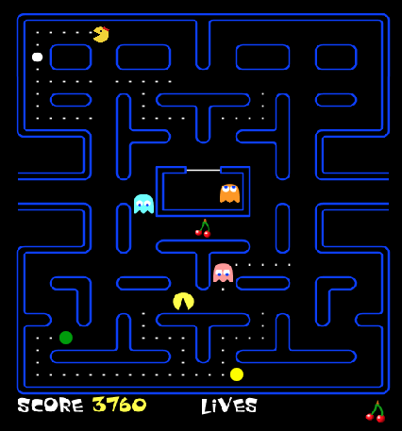

A view from the game

**2.1 Pac-Mans**

Both Mr. & Mrs. Pac-Man will have the same features in terms of their abilities. Differences are their appearance and controllers -the players that play them- . Mr. Pac-Man can be managed by using up, down, right and left arrows and Mrs. Pac-Man can be managed by using W, A, S, D.

 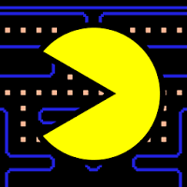

**2.2 Ghosts**

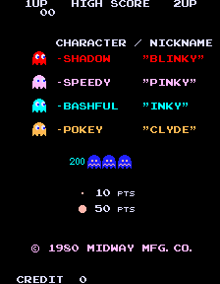The ghost types of the classical Pac-Man game will be used in our version.

**2.2.1 Blinky**

It is the red ghost, known as the leader ghost of the group. It is following the Pac-Man from behind.

**2.2.2 Pinky**

It is the pink ghost and it positions in front of Pac-Man all the time.

**2.2.3 Inky**

It is the blue ghost which has a fickle mood. It is unpredictable.

**2.2.4 Clyde**

It is the orange ghost which is considered to be stupid. It chases Pac-Man with the lead of Blinky but it wanders off to its home corner when he gets too close.

**2.3 Food**

**2.3.1 Basic Food**

This kind of food does not give any new ability to pacmans. Player has to eat all basic food to pass the next level. When a basic food is eaten, player will get ten points.

**2.3.2 Big Basic Food**

This kind of food gives pacman opportunity to eat ghosts for five seconds and this food gives forty points.

**2.3.3 Green Food**

Green food is new type of food. This food provides passing through walls for five seconds and gives fifty points.

**2.3.4 Yellow Food**

Yellow food is also new type of food. This food provides passing through ghosts for five seconds and gives fifty points.

**2.4 Shields**

**2.4.1 Copper Shield **

Copper shield is the cheapest and weakest shield of the game. If player buys this copper shield, player’s pacman will obtain chance of hitting a ghost once without dying. Cost of copper shield is 3000 points.

**2.4.2 Silver Shield **

Silver shield provides hitting a ghost once without dying and increases speed by 5%. Cost of silver shield is 6000 points.

**2.4.3 Gold Shield **

Gold shield is the most powerful and expensive shield of the game. This shield provides hitting a ghost twice without dying and increases speed by 10%. After hitting ghosts twice, the player will automatically lose the shield. Cost is 9000 points.

3. Functional Requirements

* Player can close or open sound by clicking speaker icon on the main menu.
* Player can choose number of players.
* First player can move by using arrows. Second player can move by using W, A, S, D combination.
* Player can access the help menu by clicking question mark on the main menu.
* Player can see high score list.
* Player can design a map.
* Player can both load and save a game.
* Player can both load and save a map.
* Player can pause the game.

4.Non-Functional Requirements

* Throughout the project, object-oriented design concerns will be considered.
* User interface will have good and smooth looking.
* Our goal is to have high fps and to prevent input lags as much as possible.
* We will try to design our program with good class structure. In this way, program will be easy to add new features.

5. Pseudo-Functional Requirements

* This project will be implemented by using Java.
* Game images will be created by using photoshop programs. In need, web sources will be scanned.

6. System Models

**6.1 Use-Case Model**

**6.1.1 Use-Case Scenarios**

Use-Case-1

Play Game

Primary Actor: Player(s)

Main success scenario

1. Player starts the game by choosing game type.

2. Game starts from level 1.

3. After three seconds countdown, Pac-Man(s) are ready to move.

4. Players pass all levels.

5. The score is at top three scores.

6. The system asks for a name for the score gained.

7. Player enters the name.

8. Players quit the game.

Alternate Flow:

4.a Players lose all lives at any level.

4.a.1 Game over screen appears.

4.a.2 The system redirects player to step 5.

Alternate Flow:

5.a The score is not at top three scores.

5.a.1 The system redirects player to step 8.

Alternate Flow:

8.a Return to main menu

Use-Case-2

Create Map

Primary Actor: Player

Create Map Scenario

1. Player selects create map option.

2. Player designs a map.

3. Player starts the game with this map.

Alternate flow:

3.a Player returns to main menu without saving the map.

Alternate flow:

3.b Player returns to main menu after saving the map.

Use-Case-3

Pause Game

Primary Actor: Player

Main Success Scenario

1. Player presses ESC.

2. The system displays pause menu.

3. Player continues the game.

4. The game continues.

Alternate Flow

3.a Player change settings during pause.

3.a.1 The system redirects player to the settings menu.

Use-Case-4

Continue Next Level

Primary Actor: Player

Main Success Scenario

1. Player successfully passes one of levels except last level.

2. The system displays new equipment menu for next level.

3. Player buy one of the shields with scores.

4. Player continues with next level.

Alternate Flow

3.a Player does not buy shields and saves scores.

3.a.1 Player goes to step 4.

Use-Case-5

View Help

Primary Actor: Player

Main Success Scenario

1. Player chooses to view help.

2. The system displays information about gameplay and controls.

3. Player quits viewing help.

Use-Case-6

View High Scores

Primary Actor: Player

Main Success Scenario

1. Player chooses to view high scores.

2. The system displays top ten high scores.

3. Player quits viewing high scores.

**6.1.2 Use-Case Diagram**

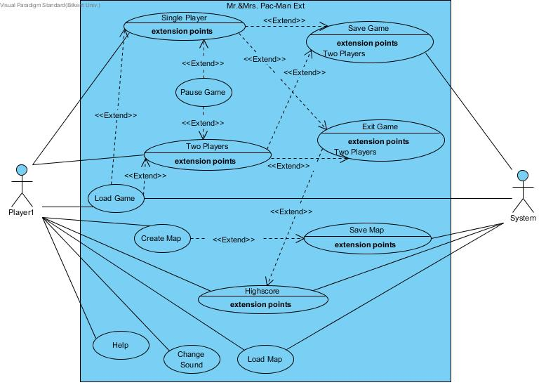

**6.2 Dynamic Models**

In this section, some possible scenarios will be explained.

-Play Single Player: Choose single player mode and play the game by yourself.

-Use Shied: After completing first or second level, buy a shield.

-Eat Food: Eat special food and obtain new abilities.

-Play Two Player: Choose two player mode and enjoy with your friend.

-Create and Save Map: Design your own map and save it.

-Create Map and One Player Option: Design your own map and directly play it by yourself.

-Help&High Score&Sound Options: Go to help screen and learn about items and back to menu. Next, look at high score list and back to menu. Finally, disable sound by clicking speaker icon.

-Pause Game: View pause menu and resume game.

-Load Map: Play a game with saved map.

-Load Game: Play a game with saved game.

**6.2.1 Sequence Diagram**

Scenario #1: Play Single Player

Actor: Aziz

Aziz opens the game by double clicking desktop icon. Then, main menu appears on the screen and he selects single player mode. Next, first level starts and he sees ghosts, food and his character, Pac-man. After three seconds countdown, ghosts start to move. He eats food and tries to keep away from ghosts. He eats all the food and passes to the second level.

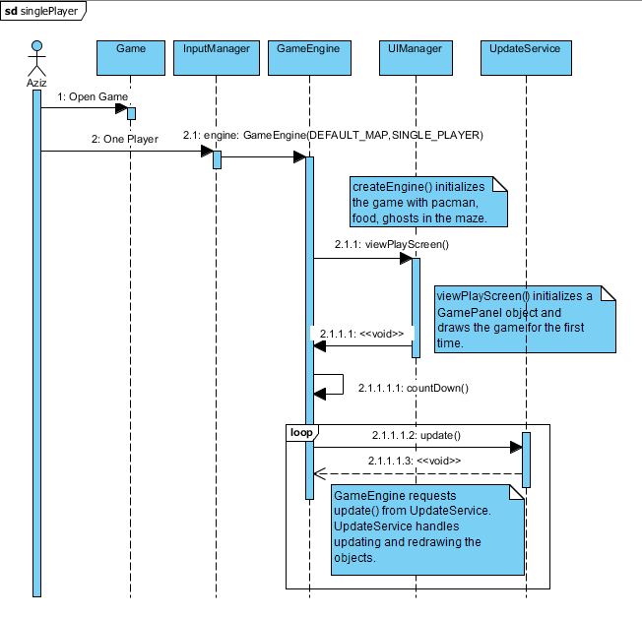

Scenario #2: Use Shield

Actor: Aziz

Aziz achieves eating all food and finishes level 1. Shield panel appears on the screen as pop-up and he buys silver shield with 6000 points. With the help of silver shield, Pac-man’s live and speed increase. Pac-man’s appearance also changes according to color of shield.

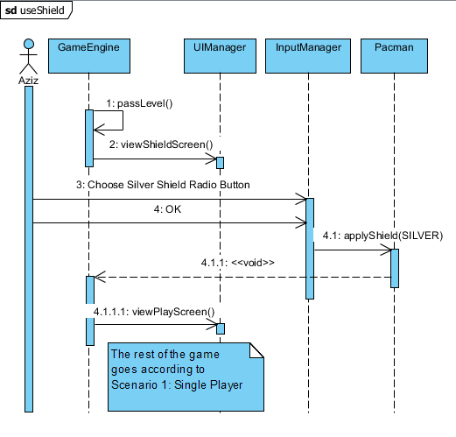

Scenario #3: Eat Food

Actor: Talha

        Talha starts to play the game after countdown. The ghosts start to chase after him and he starts to eat the basic food. The score points start to increase ten points by each basic food. Then he sees a big basic food and eats it. Talha now has the ability to eat ghosts and he eats one. The points increase 40 points. 10 seconds later, Pacman loses the ability to eat ghosts and starts to escape from them again.

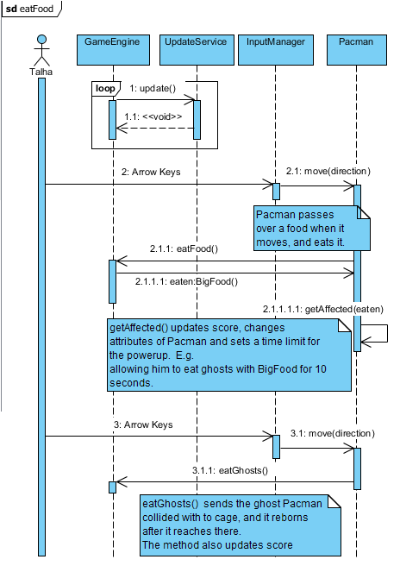

Scenario #4: Play Two Players

Actor: Ecem, Şevval

        Ecem opens the game by double clicking desktop icon. Then, main menu appears on the screen and she selects two player mode. Ecem enters the first level with Şevval. After the countdown, the ghosts started to come after both Pacmans. They start to eat the food and escape from ghosts.

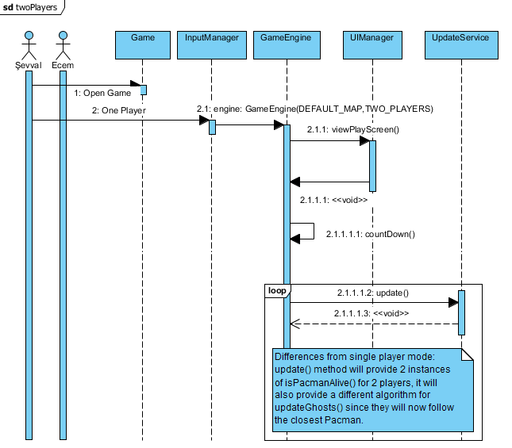

Scenario #5: Create and Save Map

Actor: Aziz

        Aziz opens main menu and selects create map this time to design his own map. He marks locations of walls and food. He also selects number of ghosts and marks their locations. After that he decides to save the map and returns to main menu.

Scenario #6: Create Map and One Player Option

Actor: Şevval

        Şevval opens the game and in the main menu, she selects the Create Map option. She starts designing her own map. She determines the locations for walls and she puts the food to the places she wants. She decides the number of ghosts and she locates them. She doesn’t save the map. She presses the play button and immediately starts to play her map in single player option.

Scenario #7: Help&High Score&Sound Options

Actor: Şevval

        Şevval opens the game and the main menu comes to the screen. She selects the option “help” to get some information about the game features. She reads that there are four types of food and each of them has different effects to the game. She also learns about the shields and the level of protection they give to Pacman.  She quits from the help screen and returns to the main menu again. She wants to check out the high scores so she chooses the option “high score”. The list of the highest 5 scores comes to the screen. The lists include the information of the player’s name and the number of points she scored. Şevval returns to the main menu with the button which is located under the score table. She comes back to the main menu and decides to turn off the sound of the game. She presses the sound icon and turns of the sound.

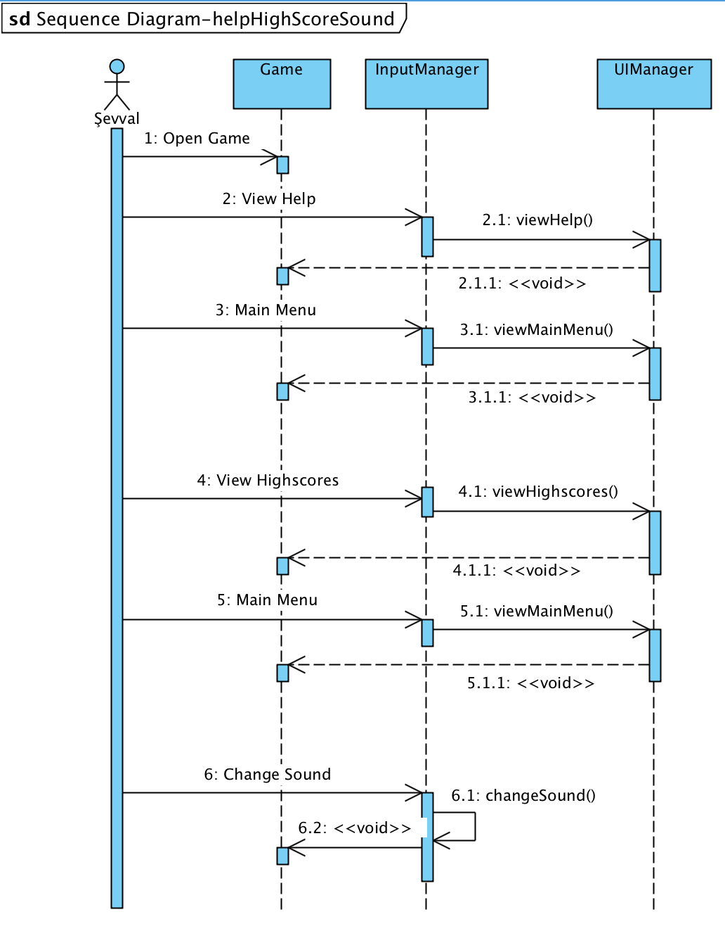

Scenario #8: Pause Game

Actor: Talha

        While playing the game, Talha needs to check his phone so he presses the ESC button of the keyboard. A pause game pop up comes with the options for “resume”, “save game” and “exit game”. After checking his phone, Talha presses the resume game button and continue the game.

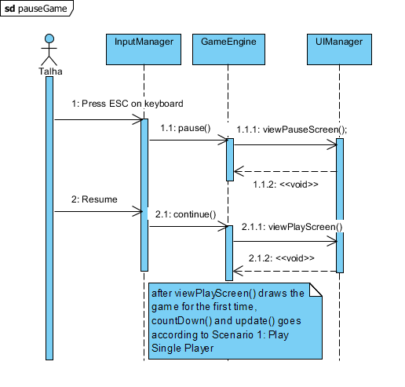

Scenario #9: Load Map

Actor: Ecem

        Ecem opens the game and main menu comes to the screen. She presses the Load Map button to play on a previously built map. Saved Maps screen comes and it includes a table which has the map name and single or double player option. She decides the map that she wants to play and selects the single player radio button. Then she presses play game button and starts to play.

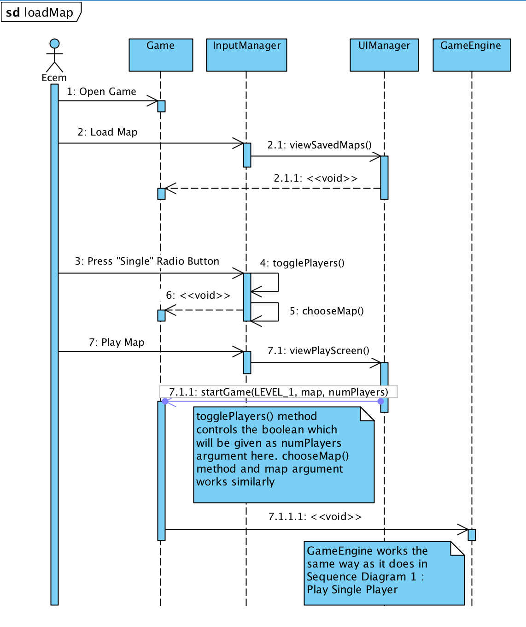

 Scenario #10: Load Game

Actor: Şevval

Şevval opens the game and she enters the main menu. She presses the Load Game button to see the saved games. A list of all saved games comes to the screen. She chooses which game she wants to continue and then she presses the load game button and gets into the saved game.

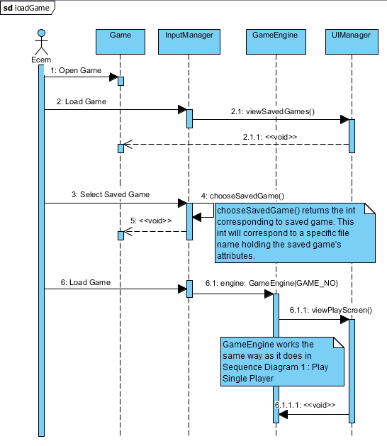

**6.2.2 Activity Diagram**

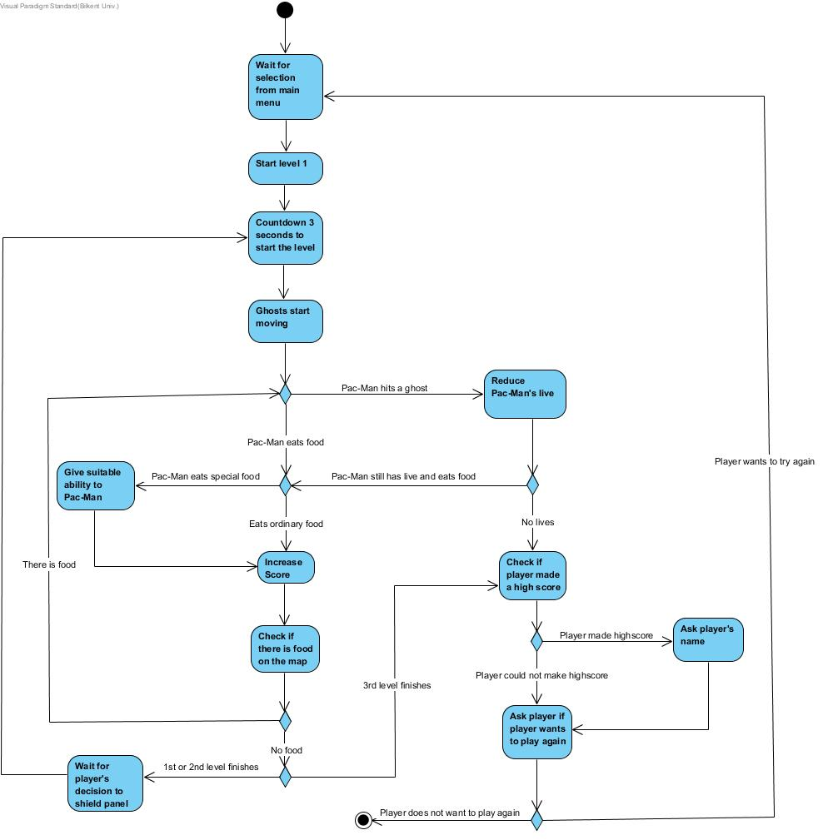

Description

Main menu waits for player’s selection and the player selects single player mode. After that, system prepares level 1 which is given by the game. After three seconds countdown, ghosts start moving and player has ability to direct Pac-Man. Player starts eating food. If this food is special food, Pac-Man gains a new ability and player’s score increases. If eaten food is ordinary food, just player’s score increases without gaining any ability. After score is increased, system will check whether there is food on the map. If there is food, it means that level did not finish yet; therefore, loop continues until all food finishes or Pac-Man dies. If player hits a ghost, Pac-Man’s live is reduced and system checks if live remained or not. As long as Pac-Man has live, system goes back to level loop. Otherwise, Pac-Man dies and system controls if the score is high score. If it is, player will be asked for a name. However, if player completes first or second level, shield panel appears and system waits for a selection. After selection, game prepares next level. When player completes third level, system checks if score is high score. If it is not, without asking a name, player is asked for making decision about trying again.

**6.3 Object and Class Model**

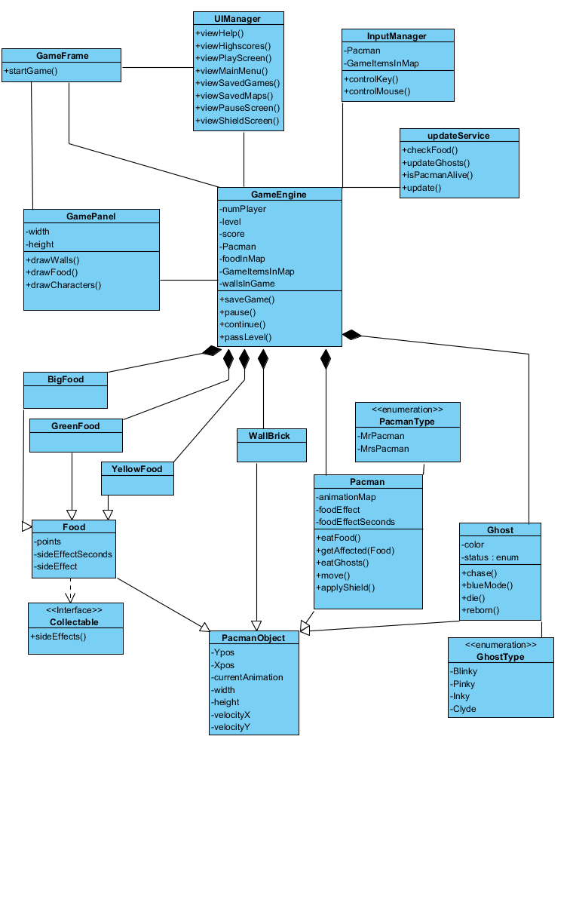

**6.4 User Interface**

**6.4.1 Navigational Path**

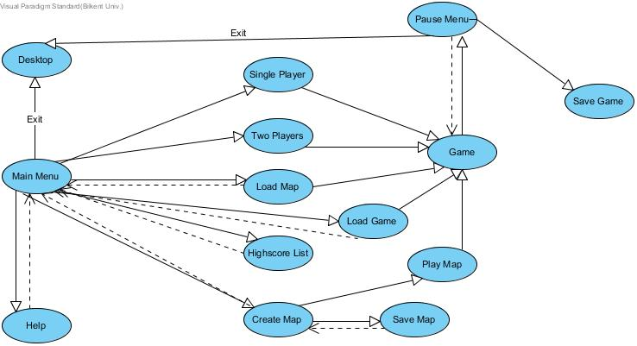

Dashed lines represent back button or resume button.

**6.4.2 Screen Mock-Ups**

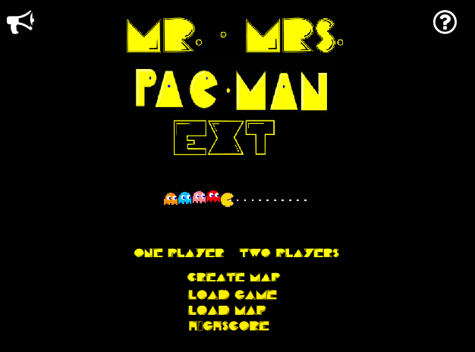

Main Menu

Figure above is main menu that player will see when s/he double clicks the game icon. From main menu, player will be able to access different pages of the game.

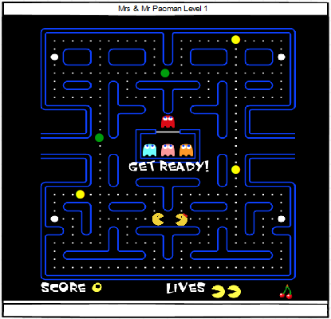

Initial Beginning

This is initial beginning of the game. In two players option Pac-mans will be located like above. Score and lives will be shown at the bottom of page.

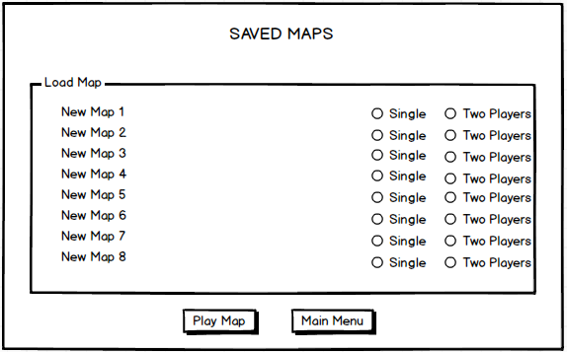

Load Map

When player selects load map option from main menu, this pop-up will appear on the screen. Player is directly can choose number of players from this pop-up.

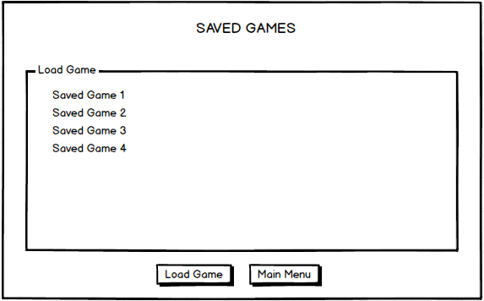

Load Game

Load Game option also works like load map option.

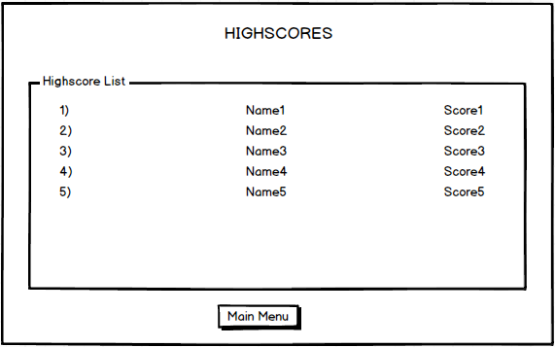

Player can see high score list from this screen by clicking highscores option.

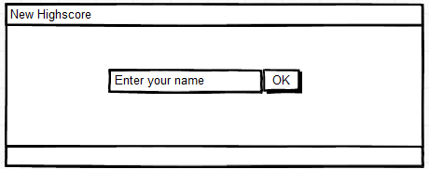

If player obtains a new high score, this panel will appear.

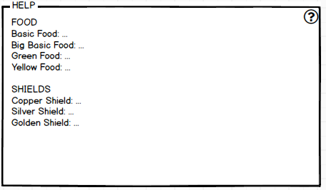

By clicking question mark on the main menu, player will see this help screen which tells features of items.

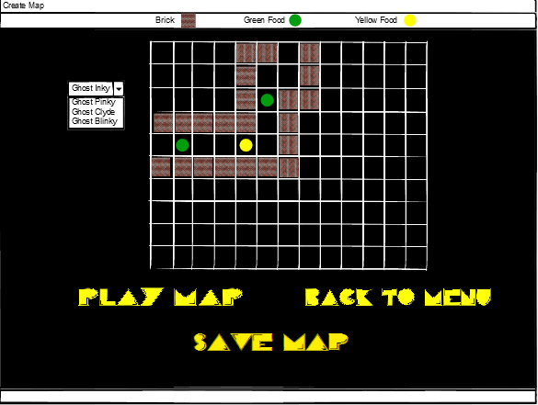

On create map screen player can design his own map by selecting items. Item bar is at top of the screen and ghosts can be selected from combo box at left side. Player can directly play the map or save it.

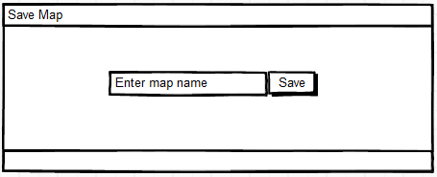

After creating the map, if user clicks save map button, this panel appears.

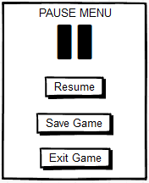

At any time of the game, player can stop game and save it.

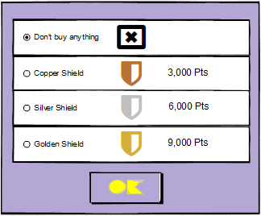

If player achieves finishing first or second level, this shield panel will be seen on the screen and player will be able to choose what s/he wants to do by clicking one of radio buttons.

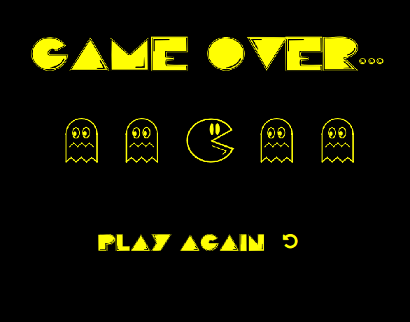

If player loses all lives, game over screen will appear and there will be play again option. If player obtained a high score, this screen will appear with high score saving panel.