|  |  |
| --- | --- |
| **Topic** | Hazelcast |
| **Document Name** | HAZELCAST-EX-02 |
|  |  |

|  |  |  |  |
| --- | --- | --- | --- |
| **Document Difficulty Level** | | | |
| **Beginner** | **Junior** | **Senior** | **Expert** |
| □ | ■ | □ | □ |

# Document History

|  |  |  |  |
| --- | --- | --- | --- |
| Date | Author | Ver | Comments |
| 05.03.2025 | Mennan Tekbir | 1.0 | Initial Draft |
| 05.03.2025 | Mehmet Erdem Önal | 1.1 | Revisions |

# Hazelcast

## Exercise HAZELCAST-EX-02:

**Definiton:** Please pull & run hazelcast and man-center conatiners in your local machine. You may use the following Docker commands:

docker pull hazelcast/hazelcast:latest

docker run hazelcast/hazelcast:latest

docker pull hazelcast/management-center:latest

docker run --rm -p 8080:8080 hazelcast/management-center:latest

**Docker Hub Repo for Hazelcast:** <https://hub.docker.com/r/hazelcast/hazelcast>

**Docker Hub Repo for Hazelcast Management Center:** <https://hub.docker.com/r/hazelcast/management-center>

Please provide screenshots to show your work once the installation is complete.

## HAZELCAST -EX-02 Solution:

**Your Answer:**

You may provide screenshots here to show your work…

# HAZELCAST -EX-02 Solution

## 1. Management Center Arayüzü

Aşağıda görülen ekran, http://localhost:8080 adresinden ulaşılan Hazelcast Management Center arayüzüdür.

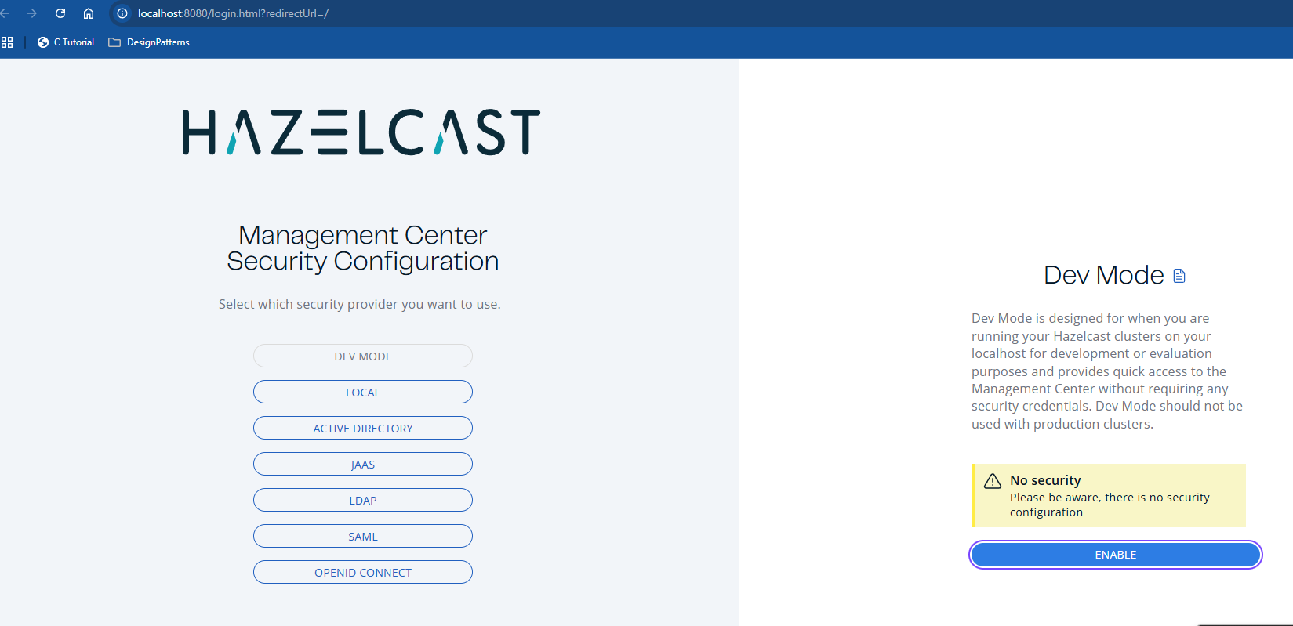

## 2. Hazelcast Container Durumu (docker ps)

Terminalde çalışan container listesinde hazelcast container’ı başarıyla çalışıyor olarak görünmektedir.

