USER MANUAL

FOR

WIMEA-ICT AWS SETUP GUIDE

# 1 Introduction

This is a user manual for the WIMEA-ICT AWS Set up guide system used to learn about the different components of the automatic weather stations and how they can be connected.

# 2 General Information

The AWS setup guide is a simulator designed to enable the different teams of WIMEA-ICT and metrological organizations that carry out deployment of the automatic weather stations learn more about the connections of the different components. The main service provided by the simulator is automatic assembly of the different nodes of the automatic weather stations.

## 2.1 System overview

The WIMEA-ICT AWS Set up guide provides the following functionalities:

* Automatic simulation of an AWS node.
* Simulating environment to assist in emulating the WIMEA-ICT AWS.
* Enabling users to choose the AWS node or LPG to be assembled.
* Loading of the different components of the selected node.
* Drag and drop of components to assemble a node.
* Award points to the user after manual assembly of the nodes.
* Indicate the wrong connections made in case of any.
* Controls for automatic simulation which may include play, pause, resume.
* Audio to provides more information about the connections and how they are made.
* Viewing of different properties of the different components.

## 2.2 Contact

Request for access and inquiries on the use if the system, the design and functionalities of the system should be sent to the dedicated email [mnsabagwa@cit.mak.ac.ug](mailto:mnsabagwa@cit.mak.ac.ug).

# 3 Getting Started

## 3.1 How to access the system

The user can obtain a fresh copy of the system by downloading it from the WIMEA-ICT github repository[1].

Simply the user has to;

1. *Copy the zipped folder of the system;* ***aws_setup_guide.zip*** *to and paste it to any preferred directory*
2. *Extract the aws_setup_guide.zip folder. This creates* ***aws_setup_guide*** *folder and a Firefox browser installer file.*
3. *You may or may not install the Firefox browser depending on your choice.*
4. *Open the* ***aws_setup_guide.hml*** *file in the browser (ensure the chosen browser is set to enable CORS, otherwise open using Firefox browser).*

*That is all you have to do to have the system running.*

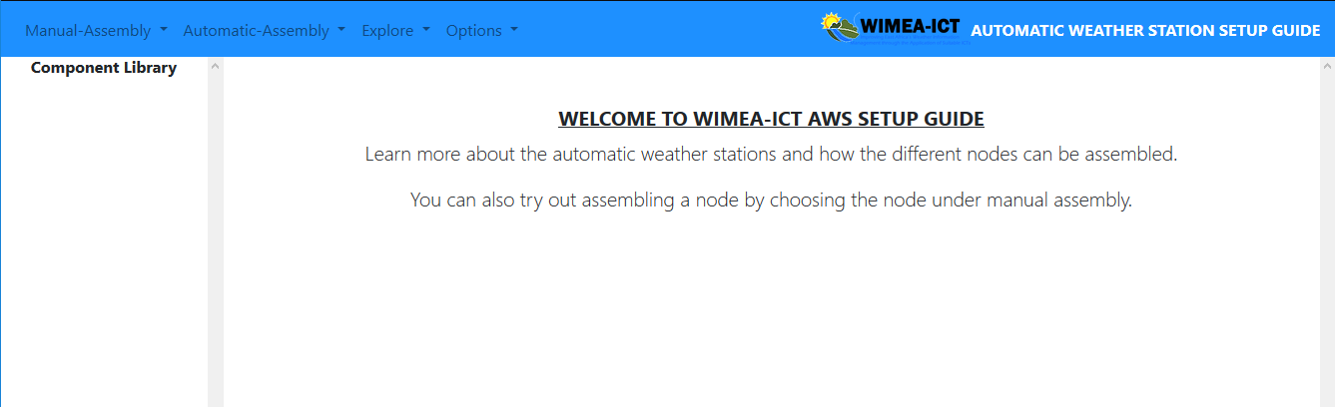

*Figure 3. 1 welcome page of the simulator.*

## 3.2 Choose a node to be assembled.

Once the system loads, you can now choose the node you want to assemble either automatically or manually, or even the AWS node you would like to explore.

To choose a node, click on the mode, for example, manual assembly and select a node from the drop-down menu.

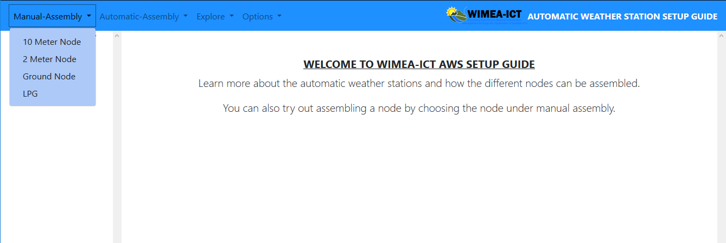Figure 3. 2 choose a node to be assembled or explored from the drop-down menu.

## 3.3 View Loaded components for a node

Once the node to be assembled or explored has been selected, you are able to view the components required for the node on the left side menu of the simulator. You are also provided with a layout which shows the order in which the components can be assembled.

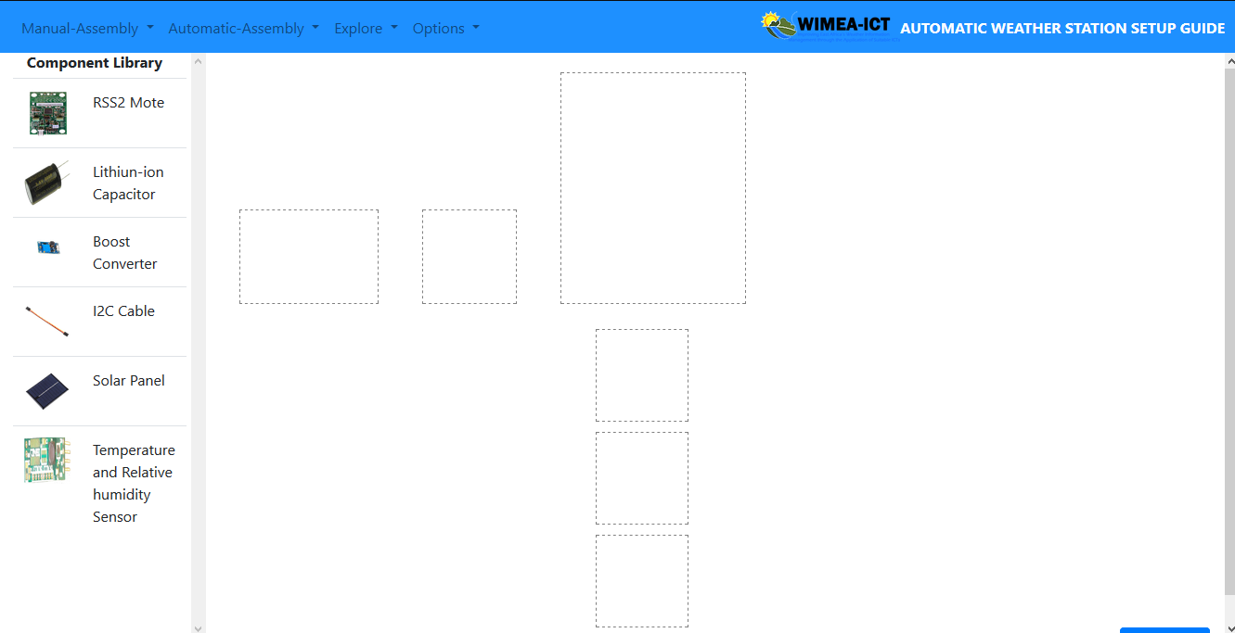

Figure 3. 3 Loaded components and layout for the 2-meter node.

## 3.4 Drag and drop of the components.

To assemble a node, you are required to drag and drop the components to the appropriate position on the layout of the node.

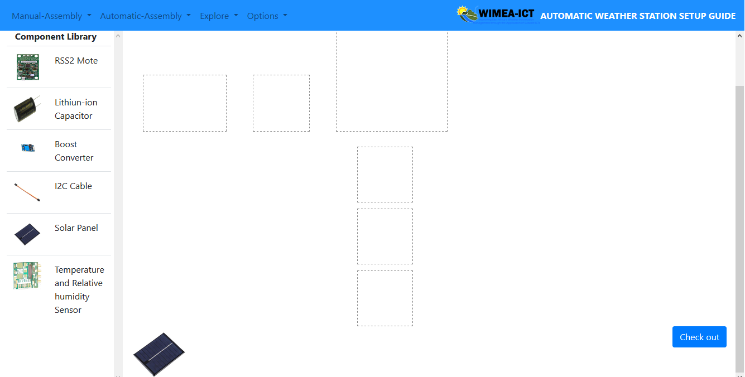Figure 3. 4 the selected component appears on the simulation environment.

While pressing down your mouse, move the selected component to its location on the layout of the node being assembled.

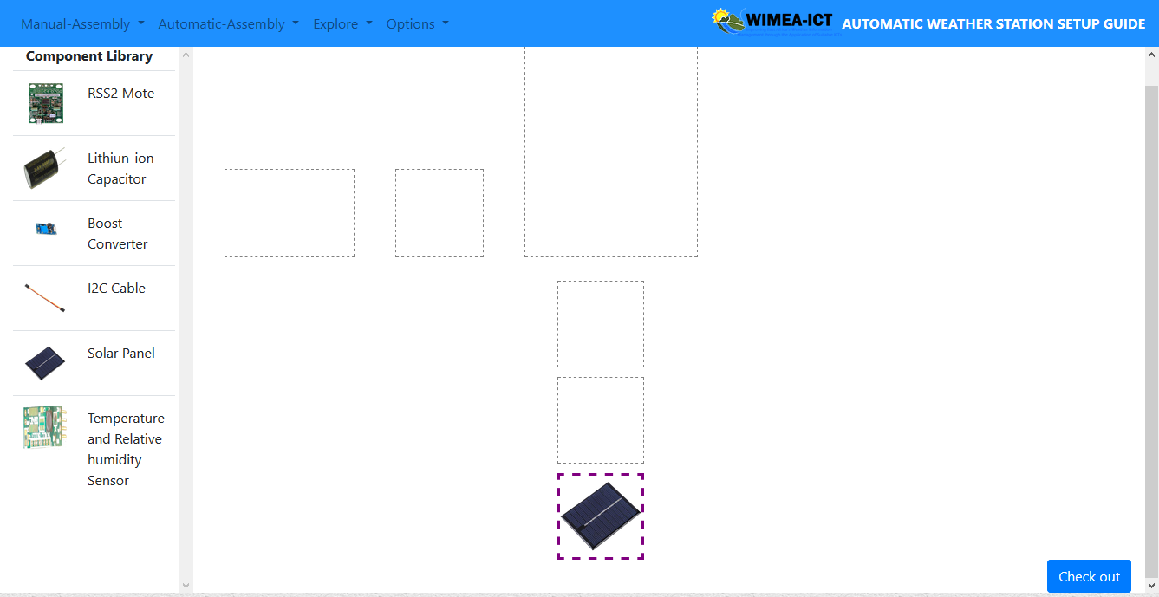

Figure 3. 5 The component is placed or dropped in its appropriate location.

## 3.5 Award points for each connection made.

Once you have finished placing or assembling the different components for a node, select the check-out button at the bottom of the simulating environment.

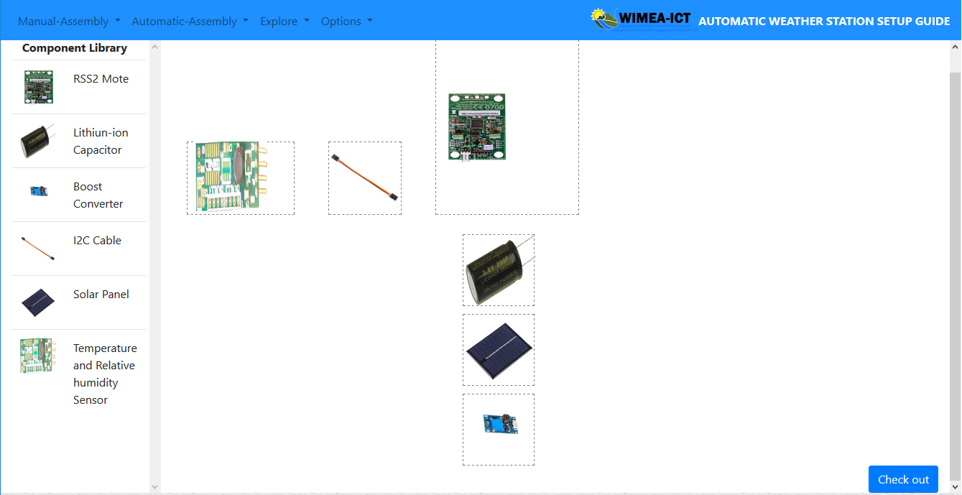

Figure 3. 6 All components assembled in the layout.

Check out button in the right bottom corner of the simulating environment.

Once the button has been clicked, you able to see your scores with the number for right connects and number of wrong connections. If all the connections are wright, all the borders of the layouts for the components with be highlighted green to show wright connections.

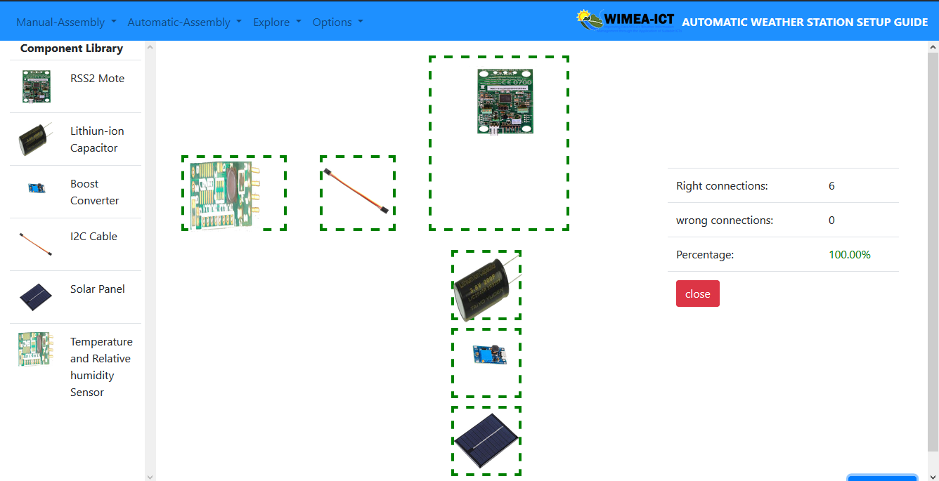

Figure 3. 7 layout borders highlighted green for the wright connection.

Incase of any wrong connection, the border of the layouts with wrong connections, will be highlighted red.

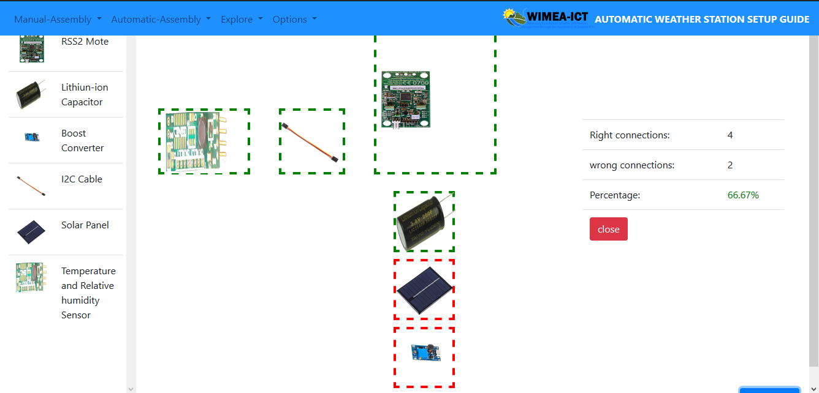

Figure 3. 8 Wrong connections highlighted red.

## 3.6 View component information in Explore.

Once the node to be explored has been selected under the explore drop-down menu, you can select a component and information will be displayed for that particular component. For example, in figure 3.9 below the boost converter was selected

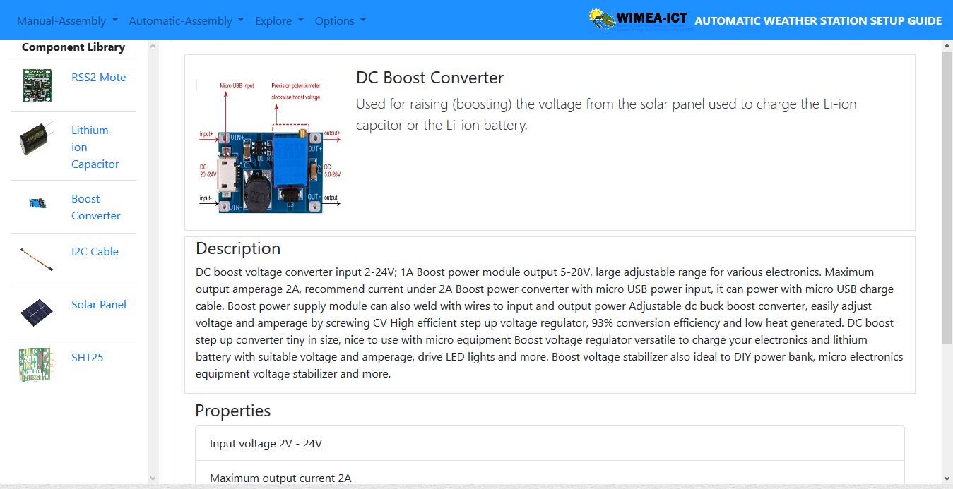

Figure 3. 9 Boost convertor Explore mode

## 3.7 Control the automatic simulation.

To start the automatic simulation, you are required to click the play button and the simulation starts. You can be able to pause, resume, stop, forward or rewind the simulation.



Figure 3. 10 Play simulation