**THE SCHEMATIC**

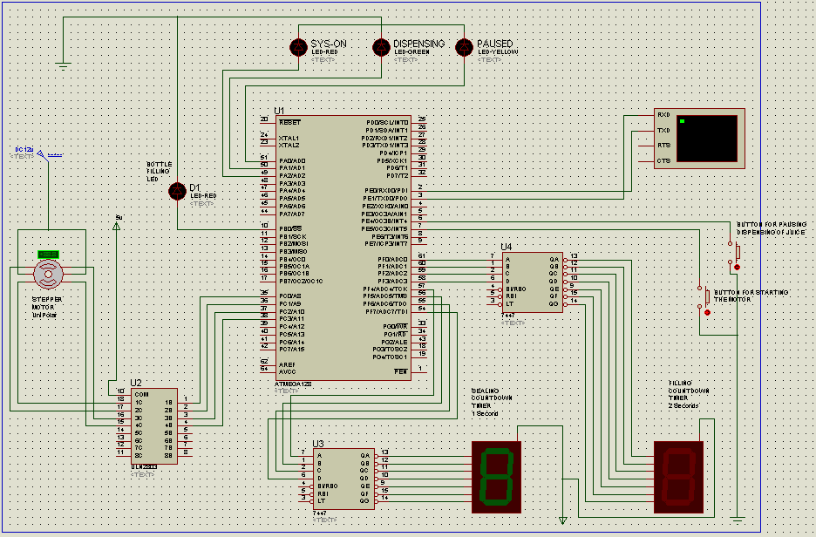

**Buttons**

Button on INT4 is used to pause and resume the system

Button on INT5 is used to start the motor operation during dispensing juice

**7 segment displays**

**Green** for countdown timer for sealing the bottle of 1 second (counts from 1 to 0)

**Red** for countdown timer for filling the bottle of 2 seconds (counts from 2 to 0)

**LEDs**

**Red** lights on showing system is started. (SYS-ON)

**Green** lights when dispensing juice is on and button for starting the motor should be on

**Yellow** blinks when the system is in paused state when button for pausing dispensing of juice is on

**LIMITATIONS**

* On entry of strings from the virtual terminal backspace button erases the typed values but they are actually already received.
* The number of fruits is limited to size of integer **unsigned int** (from 0 to 65535), otherwise the system rejects them and throws an error on the virtual terminal.
* Settings are saved after each bottle has been completely dispensed.
* The motor begins by driving the empty bottle to the filling stage which is the same time (two motor rotations) that taking the sealed bottle to the storage area requires, so these occur at the same time since the bottles are on the same conveyor belt. This means that the last bottle to be sealed will be left at the sealing point given any number of bottles to dispense.