CPE301 – SPRING 2025

Design Assignment 5

Student Name: Ryan Sewell

Student #: 8000473785

Student Email: sewelr2@unlv.nevada.edu

Primary Github address: https://github.com/sewelr2

Directory: DA-Submissions/DA5

Video Playlist: <https://youtube.com/playlist?list=PLt45mEFhRV6ffOYRcGHhoI5aDeP3Zgqt5&feature=shared>

The core objective of this lab is to build a single AVR‐based motor‐control demo in Atmel Studio 7 that:

1. Reads a potentiometer on ADC0 (0–1023) and maps it to an 8-bit PWM duty (0–255) on OC0A to drive your DC motor.
2. Measures the actual motor speed using the Timer/CCP input-capture (ICP1) hardware.
3. Overrides the pot-based setpoint via a simple UART “GUI,” streaming out CSV pairs of (set-value, measured-speed) so you can live-plot both traces in a PC tool.
4. **COMPONENTS LIST AND CONNECTION BLOCK DIAGRAM w/ PINS**

Microchip Studio Atmega328PB-Xmini PC Multi-Function Shield Tauno Serial Plotter

- Assembler - Polulu md08a - Potentiometer

- Simulator - DC Motor

- Debugger

1. **INITIAL/MODIFIED/DEVELOPED CODE OF TASK 1/A**

#define F_CPU 16000000UL /* Define CPU Frequency e.g. here its 8MHz */

#include "uart.h"

#include <avr/interrupt.h>

#include <avr/io.h>

#include <avr/pgmspace.h>

#include <stdio.h>

#include <util/delay.h>

// capture Flag

volatile uint8_t Flag;

volatile uint8_t Direction = 0;

volatile uint32_t revTickAvg;

void ADC_Init() /* ADC Initialization function */

{

DDRC = 0x00; /* Make ADC port as input */

ADCSRA = 0x87; /* Enable ADC, with freq/128 */

ADMUX = 0x40; /* Vref: Avcc, ADC channel: 0 */

}

int ADC_Read(char channel) /* ADC Read function */

{

ADMUX = 0x40 | (channel & 0x07); /* set input channel to read */

ADCSRA |= (1 << ADSC); /* Start ADC conversion */

while (!(ADCSRA & (1 << ADIF)))

; /* Wait until end of conversion by polling ADC interrupt flag */

ADCSRA |= (1 << ADIF); /* Clear interrupt flag */

_delay_us(1); /* Wait a little bit */

return ADCW; /* Return ADC word */

}

// INT0 interrupt

ISR(INT0_vect) {

// Use for Motor direction one trigger for forward, another for reverse

}

// INT1 interrupt

ISR(INT1_vect) {

// Use for Motor direction one trigger for stop and go

}

volatile uint32_t revTick; // Ticks per revolution

volatile uint32_t revCtr; // Total elapsed revolutions

volatile uint16_t T1Ovs2; // Overflows for small rotations

// Initialize timer

void InitTimer1(void) {

// Set PB0 as input

DDRB &= ~(1 << DDB0);

PORTB |= (1 << DDB0);

// Set Initial Timer value

TCNT1 = 0;

////First capture on rising edge

TCCR1A = 0;

TCCR1B = (0 << ICNC1) | (1 << ICES1);

TCCR1C = 0;

// Interrupt setup

// ICIE1: Input capture

// TOIE1: Timer1 overflow

TIFR1 = (1 << ICF1) | (1 << TOV1); // clear pending

TIMSK1 = (1 << ICIE1) | (1 << TOIE1); // and enable

}

void StartTimer1(void) {

// Start timer without pre-scaler

TCCR1B |= (1 << CS10);

// Enable global interrupts

sei();

}

volatile uint32_t tickv, ticks;

// capture ISR

ISR(TIMER1_CAPT_vect) {

tickv = ICR1; // save duration of last revolution

revTickAvg = (uint32_t)(tickv) + ((uint32_t)T1Ovs2 * 0x10000L);

revCtr++; // add to revolution count

TCNT1 = 0; // restart timer for next revolution

T1Ovs2 = 0;

}

// Overflow ISR

ISR(TIMER1_OVF_vect) {

// increment overflow counter

T1Ovs2++;

}

int main(void) {

char outs[72];

USART_Init(9600);

USART_SendString("Connected!\r\n"); // we're alive!

InitTimer1();

StartTimer1();

USART_SendString("TIMER1 ICP Running \r\n");

/* set PD2 and PD3 as input */

DDRD &= ~(1 << DDD2); /* Make INT0 pin as Input */

DDRD &= ~(1 << DDD3); /* Make INT1 pin as Input */

PORTD |= (1 << DDD2) | (1 << DDD3); // turn On the Pull-up

DDRD |= (1 << DDD6) | (1 << DDD4) | (1 << DDD5); /* Make OC0 pin as Output */

// We are manually setting the direction

PORTD |= (1 << DDD5); // CW Direction Set

PORTD &= ~(1 << DDD4); // CW Direction Set

EIMSK |= (1 << INT0) | (1 << INT1); /* enable INT0 and INT1 */

MCUCR |= (1 << ISC01) | (1 << ISC11) |

(1 << ISC10); /* INT0 - falling edge, INT1 - raising edge */

sei(); /* Enable Global Interrupt */

// WE are not using the ADC for speed - just manually setting the value

ADC_Init(); /* Initialize ADC */

TCNT0 = 0; /* Set timer0 count zero */

TCCR0A |= (1 << WGM00) | (1 << WGM01) | (1 << COM0A1);

TCCR0B |=

(1 << CS00) | (1 << CS02); /* Set Fast PWM with Fosc/64 Timer0 clock */

OCR0A = 30;

/* ready start value */

while (1) {

// Convert ticks to RPM

// send Speed value to LCD or USART

USART_SendString("Tick;Period;Frequency ");

snprintf(outs, sizeof(outs), "%f ", (float)revTickAvg); // print it

USART_SendString(outs);

USART_SendString(" \r\n");

}

}

1. **DEVELOPED/MODIFIED CODE OF TASK 2/A from TASK 1/A**

void pwm0_init()

{

// Fast PWM, non-inverting on OC0A, prescaler at 64

TCCR0A = (1 << WGM01) | (1 << WGM00) | (1 << COM0A1);

TCCR0B = (1 << CS01) | (1 << CS00);

DDRD |= (1 << PIND6); // PD6 (OC0A) as output

}

void icp1_init()

{

TCCR1A = 0;

// Noise cancel, rising edge, prescaler = 8

TCCR1B = (1 << ICES1) | (1 << ICNC1) | (1 << CS11);

TIMSK1 = (1 << ICIE1); // ICP interrupt

sei(); // Enable global interrupts

}

ISR(TIMER1_CAPT_vect)

{

uint16_t now = ICR1;

per = now - lastCapt;

lastCapt = now;

newPer = 1;

}

void usart_init(uint16_t ubrr)

{

UBRR0H = ubrr >> 8;

UBRR0L = ubrr;

UCSR0B = (1 << RXEN0) | (1 << TXEN0) | (1 << RXCIE0);

UCSR0C = (1 << UCSZ01) | (1 << UCSZ00);

}

ISR(USART0_RX_vect)

{

char buffer[4];

uint8_t idx = 0;

char c = UDR0;

if (c >= '0' && c <= '9' && idx < 3 )

{

buffer[idx++] = c;

}

else if ((c == '\r' || c == '\n') && idx > 0)

{

buffer[idx] = 0;

setPoint = (uint16_t)atoi(buffer);

override = 1;

idx = 0;

}

}

void uart_print(uint16_t s, uint16_t m)

{

char tmp[32];

int n = snprintf(tmp, sizeof(tmp), "%u,%u\n", s, m);

for (int i = 0; i < n; i++)

{

while (!(UCSR0A & (1 << UDRE0)));

UDR0 = tmp[i];

}

}

int main(void)

{

uint16_t raw;

uint8_t duty;

uint16_t meas_rpm = 0;

// Initialization

adc_init();

pwm0_init();

icp1_init();

usart_init((F_CPU/16/9600)-1);

// Clear flags

setPoint = 0;

override = 0;

for(;;)

{

// Compute PWM duty cycle

if (override)

{

duty = (setPoint > 255) ? 255 : (uint8_t)setPoint;

}

else

{

raw = adc_read(); // 0 to 1023

duty = raw >> 2; // Shift to 0 to 255

}

OCR0A = duty;

// Measure RPM if after new capture

if (newPer)

{

newPer = 0;

meas_rpm = (uint16_t)((F_CPU/8.0 * 60.0) / per); // Calculate ticks/sec

}

// Send measurement for plotting

uart_print(duty, meas_rpm);

_delay_ms(50); // Print every 50ms

}

}

1. **SCHEMATICS**

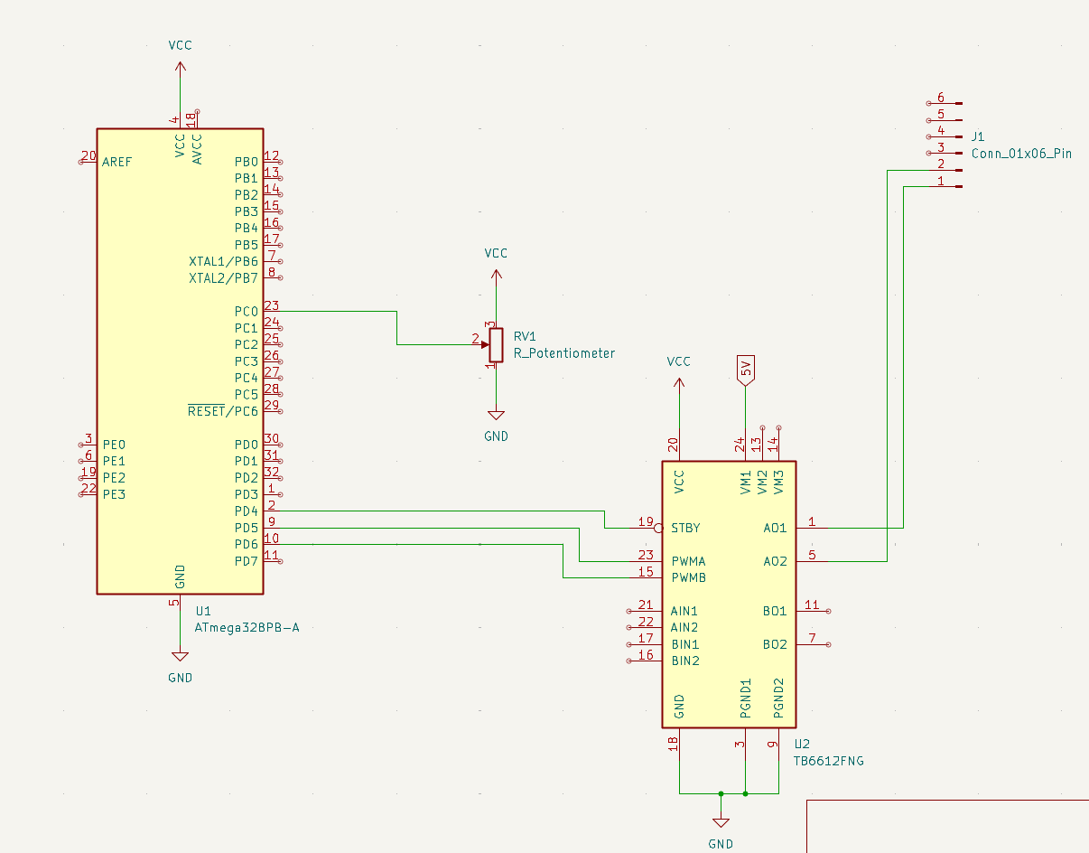

1. **SCREENSHOTS OF EACH TASK OUTPUT (ATMEL STUDIO OUTPUT)**

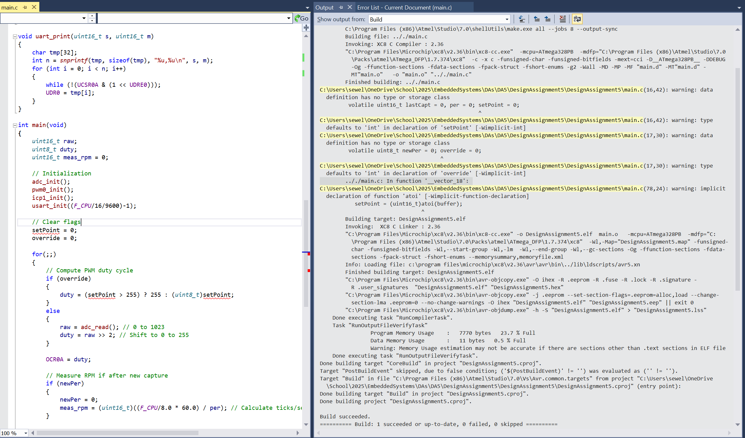

1. **SCREENSHOT OF EACH DEMO (BOARD SETUP)**

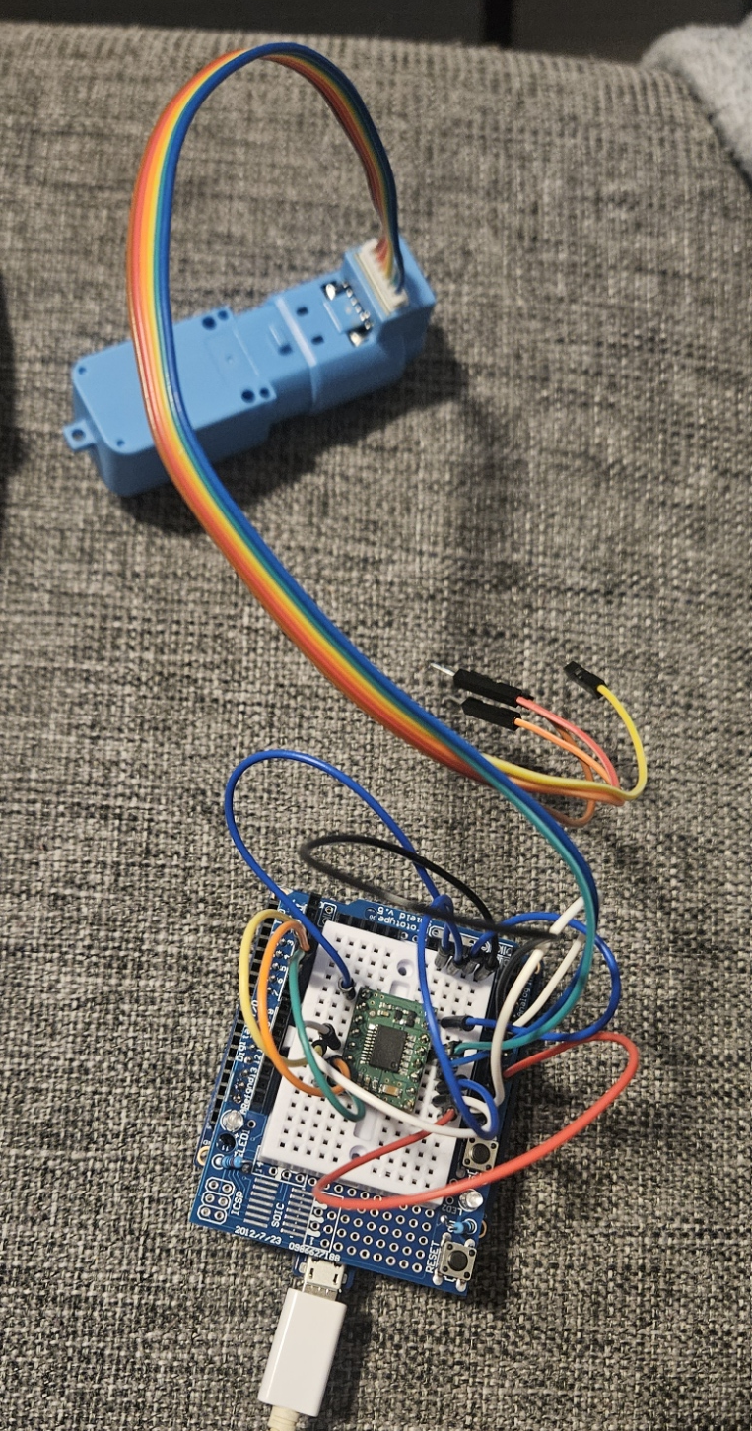 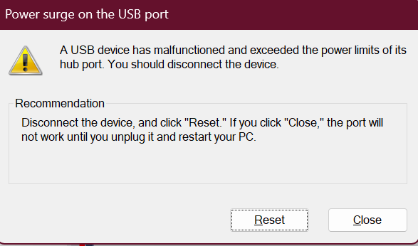

**Kept receiving this error, switched ports, tried on different computer, checked connections, and tried different hat. Problem still persisted. Encoder may be broken**

1. **VIDEO LINKS OF EACH DEMO**

Task 1:

Task 2:

…

1. **GITHUB LINK OF THIS DA**

Task 1:

Task 2:

…

**Student Academic Misconduct Policy**

<http://studentconduct.unlv.edu/misconduct/policy.html>

“This assignment submission is my own, original work”.

Ryan Sewell