CPE301 – SPRING 2024

Design Assignment 2

Student Name: Ryan Sewell

Student #: 8000473785

Student Email: sewelr2@unlv.nevada.edu

Primary Github address: https://github.com/sewelr2/

Directory: DA-Submissions

Video Playlist: https://youtube.com/playlist?list=PLt45mEFhRV6ffOYRcGHhoI5aDeP3Zgqt5&feature=shared

The goal of the assignment is use GPIO, delays, and Interrupts:

1. Design a delay subroutine to generate a delay of 0.15 sec.
2. Connect a switch to PORTC.1 to poll for an event to turn on the led at PORTB.5 for 1.5 sec after the event.
3. Continue with task 2, connect a switch to INT0 (PD2 pin) (active high - turn on the pull up transistor) and using an interrupt mechanism turn on the led at PORTB.5 for 3 sec after the event.
4. Submit codes and demos for three tasks, one for (2), another for (3), and another for (2 & 3) working together. Verify the delays using simulation and logic analyzer.
5. **COMPONENTS LIST AND CONNECTION BLOCK DIAGRAM w/ PINS**

Microchip Studio Atmega328PB-Xmini PC Multi-Function Shield Logic Analyzer

* Assembler - Switches
* Simulator - LEDs
* Debugger

Port Pins used for DA2 Task 2 & 4

Port Pins used for DA2 Task 3 & 4

1. **INITIAL/MODIFIED/DEVELOPED CODE OF TASK 2/A**

Assembly Code for Task 2

C Code for Task 2

#define F_CPU 16000000UL // set CPU clock freq

#include <avr/io.h>

#include <util/delay.h>

// 150ms delay subroutine

void delay_150ms()

{

_delay_ms(150);

}

int main(void)

{

DDRB |= (1 << 5); // Set PB5 as output

PORTB |= (1 << 5); // LED initially off

DDRC &= (0 << 1); // Set PC1 as input

PORTC |= (1 << 1); // Enable PC1 pull-up resistor

while(1)

{

// Poll for switch press (active low)

if(!(PINC & (1 << PINC1))) // Check for PC1 input

{

PORTB ^= (1 << 5); // Turn on LED at PB5

// Loop 150ms delay subroutine 10 times for 1.5 sec delay

for (int i = 0; i < 10; i++) // Loop 10 times

{

delay_150ms(); // Call 150ms delay function

}

PORTB ^= (1 << 5); // Turn off LED

}

}

return 0;

}

Assembly Code for Task 3

C Code for Task 3

#define F_CPU 16000000UL // set CPU clock freq

#include <avr/io.h>

#include <util/delay.h>

#include <avr/interrupt.h>

// 150ms delay subroutine

void delay_150ms()

{

_delay_ms(150);

}

int main(void)

{

DDRB |= (1 << 5); // Set PB5 as output

PORTB |= (1 << 5); // LED initially off

DDRD &= (0 << 2); // Set PD2 as input

PORTD |= (1 << 2); // Enable PD2 pull-up

// Configure INT0 interrupt

EICRA |= (1 << ISC01) | (1 << ISC00); // Trigger on rising edge

EIMSK |= (1 << INT0); // Enable INT0

sei(); // Enable global interrupts

while(1)

{

}

return 0;

}

ISR(INT0_vect)

{

PORTB ^= (1 << 5); // Turn on PB5 LED

// Loop 150ms delay subroutine 20 times for 3 sec delay

for(int i = 0; i < 20; i++) // Loop 20 times

{

delay_150ms(); // Call 150ms delay subroutine

}

PORTB ^= (1 << 5); // Turn off LED

}

1. **DEVELOPED/MODIFIED CODE OF TASK 2/A from TASK 1/A**

Assembly Code for Task 2 & 3

C Code for Task 2 & 3

/*

* main.c

*

* Created: 03/09/25 20:05:58

* Author: sewel

*/

#define F_CPU 16000000UL // set CPU clock freq

#include <avr/io.h>

#include <util/delay.h>

#include <avr/interrupt.h>

// 150ms delay subroutine

void delay_150ms()

{

_delay_ms(150);

}

int main(void)

{

DDRB |= (1 << 5); // Set PB5 as output

PORTB |= (1 << 5); // LED initially off

DDRC &= (0 << 1); // Set PC1 as input

PORTC |= (1 << 1); // Enable PC1 pull-up resistor

DDRD &= (0 << 2); // Set PD2 as input

PORTD |= (1 << 2); // Enable PD2 pull-up

// Configure INT0 interrupt

EICRA |= (1 << ISC01) | (1 << ISC00); // Trigger on rising edge

EIMSK |= (1 << INT0); // Enable INT0

sei(); // Enable global interrupts

while(1)

{

// Poll for switch press (active low)

if(!(PINC & (1 << PINC1))) // Check for PC1 input

{

PORTB ^= (1 << 5); // Turn on LED at PB5

// Loop 150ms delay subroutine 10 times for 1.5 sec delay

for (int i = 0; i < 10; i++) // Loop 10 times

{

delay_150ms(); // Call 150ms delay function

}

PORTB ^= (1 << 5); // Turn off LED

}

}

return 0;

}

ISR(INT0_vect)

{

PORTB ^= (1 << 5); // Turn on PB5 LED

// Loop 150ms delay subroutine 20 times for 3 sec delay

for(int i = 0; i < 20; i++) // Loop 20 times

{

delay_150ms(); // Call 150ms delay subroutine

}

PORTB ^= (1 << 5); // Turn off LED

}

1. **SCHEMATICS**

1. **SCREENSHOTS OF EACH TASK OUTPUT (ATMEL STUDIO OUTPUT)**

Task 2:

Task 3

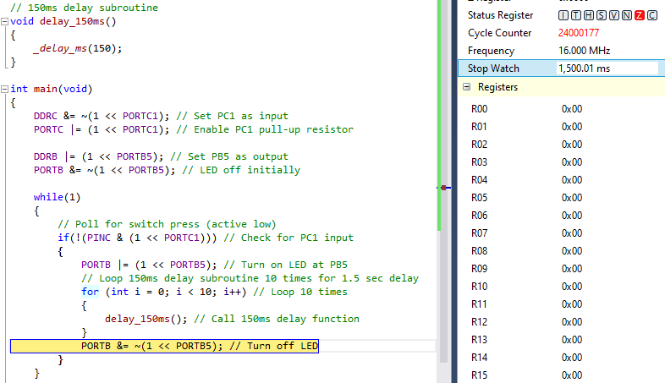

Task 4

The Logic Analyzer connected to PB5, to measure and verify the amount of time the LED is ON and OFF.

1. **SCREENSHOT OF EACH DEMO (BOARD SETUP)**

Task 1:

Task 2:

…

1. **VIDEO LINKS OF EACH DEMO**

Task 1:

Task 2:

…

1. **GITHUB LINK OF THIS DA**

Task 1:

Task 2:

…

**Student Academic Misconduct Policy**

<http://studentconduct.unlv.edu/misconduct/policy.html>

“This assignment submission is my own, original work”.

NAME OF THE STUDENT