GENIUS BOOKSHOP
Code Explanation & Test Case Documentation
C++ Console Application

1. Document Purpose
This document explains the structure, functionality, file handling, and testing approach of the Genius Bookshop C++ console application. It is written so a lecturer, reviewer, recruiter, or internship evaluator can understand how the program is organized and how the main features are tested.
The current implementation keeps a simple function-based C++ style and uses text files for persistent data instead of a database. The application supports three user modes: Guest, Seller, and Buyer.

2. Project Overview
Genius Bookshop is a console-based bookstore management system. The system allows customers to browse books, search for books, add books to a shopping cart, and complete purchases. Sellers can view the catalogue, add new books, update book information, delete seller-added books, and review sales records.

Main Objectives
- Provide a simple menu-driven bookstore system.
- Separate customer, seller, and guest operations.
- Store book and transaction information in TXT files.
- Support book searching by ID and complete book name.
- Provide cart and purchasing functionality.
- Support basic seller CRUD operations for seller-added books.
- Provide a basic sales management report.

Technologies Used
Technology | Purpose | Usage in Project
C++ | Application development | Core programming language
iostream | Console input/output | Menus, prompts, messages
string | Text handling | Book titles, authors, file parsing
fstream | File handling | Read/write TXT files
TXT files | Data persistence | Catalogue, seller books, cart, sales

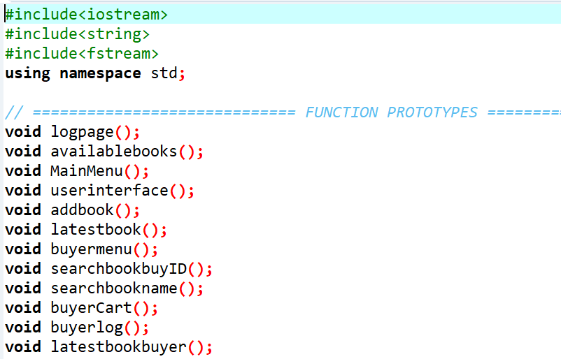

3. System Roles and Main Features
Role | Access | Main Functions | Authentication
Guest | Read-only | Browse categories, view books, view company details | Not required
Seller | Management | Add, update, delete seller books; view sales | Username/password
Buyer | Shopping | Browse, search, cart, purchase | Username/password
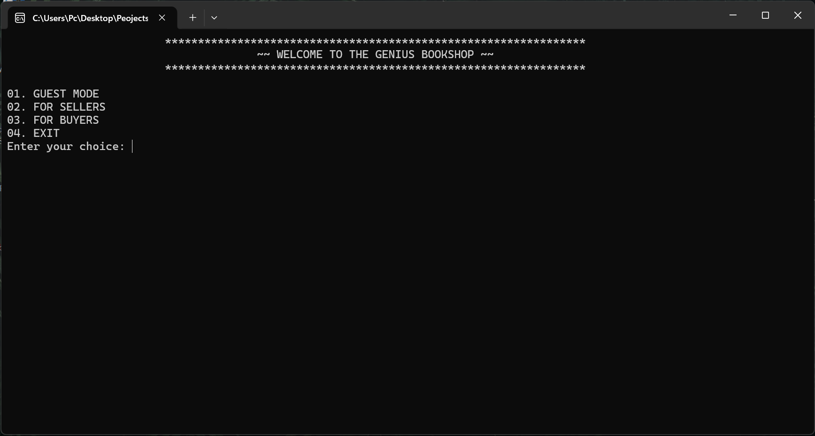

4. Project File Structure
GeniusBookshop_Final.cpp
availablebook.txt
addbook.txt
cart.txt
sales.txt
The TXT files are used as follows:
File | Purpose | Data Format
availablebook.txt | Stores the default catalogue and category data | CATEGORY|ID|TITLE|PRICE|AUTHOR
addbook.txt | Stores books added by sellers | ID|TITLE|PRICE|AUTHOR
cart.txt | Stores books currently selected by the buyer | ID|TITLE|PRICE|AUTHOR
sales.txt | Stores completed purchase line items | ID|TITLE|PRICE|AUTHOR|QUANTITY|TOTAL
Why the pipe (|) delimiter is used: Book titles and author names can contain spaces. Using | as a field separator allows the program to read the complete title and author correctly.

5. Code Structure Explanation

5.1 Header Files
#include<iostream>
#include<string>
#include<fstream>
Only three standard headers are used. iostream handles console input/output, string handles text values, and fstream handles text-file operations.

5.2 Function-Based Design
The program uses separate functions for major features instead of placing all logic inside main(). This keeps the program easier to read and lets each menu operation be maintained independently.

5.3 Function-by-Function Explanation
Function | Purpose | Main Logic | Files Used
main() | Starts the program | Calls logpage() and returns when the application exits | None
logpage() | Main role selection | Shows Guest, Seller, Buyer and Exit options | None
userinterface() | Seller login | Checks username/password and opens MainMenu() | None
buyerlog() | Buyer login | Checks username/password and opens buyermenu() | None
MainMenu() | Seller dashboard | Provides catalogue, CRUD, company, sales and logout options | Multiple
buyermenu() | Buyer dashboard | Provides browsing, buying, cart and logout options | Multiple
guesscateagories() | Guest menu | Allows browsing and protects seller operations behind login | None / catalogue
availablebooks() | Seller catalogue view | Reads selected categories from availablebook.txt | availablebook.txt
availablebuy() | Buyer catalogue view | Reads selected categories and prices from availablebook.txt | availablebook.txt
geussavailablebooks() | Guest catalogue view | Reads categories without exposing shopping actions | availablebook.txt
displayCategoryBooks() | Shared category display helper | Filters records by category and prints book details | availablebook.txt
getCategoryName() | Category mapping helper | Converts numeric menu choice to category text | None
readAvailableBook() | Catalogue parser | Splits a pipe-delimited line into category, ID, title, price and author | None
readSimpleBook() | Simple book parser | Splits ID, title, price and author fields | None
findBookByID() | Book search by ID | Searches default and seller-added catalogue records | availablebook.txt, addbook.txt
findBookByName() | Book search by title | Searches the complete title in both catalogue sources | availablebook.txt, addbook.txt
bookInCart() | Duplicate-cart check | Checks whether a book ID already exists in cart.txt | cart.txt
addBookToCart() | Cart insertion | Appends a selected book to cart.txt | cart.txt
buyerCart() | Cart and purchase processing | Displays cart, collects quantities, confirms purchase and writes sales | cart.txt, sales.txt
Deletecartbook() | Cart deletion | Rebuilds cart.txt without the selected book | cart.txt
buybook() | Buyer search menu | Routes buyer to ID search, name search or cart | None
latestbook() | Seller latest-book view | Reads seller-added books from addbook.txt | addbook.txt
latestbookbuyer() | Buyer latest-book view | Reads seller-added books for buyers | addbook.txt
addbook() | Add seller book | Accepts book details and appends a new record | addbook.txt
updatebook() | Update seller book | Finds an ID and rewrites the updated record set | addbook.txt
Deletebook() | Delete seller book | Removes one matching record and rewrites the file | addbook.txt
salesManagement() | Sales report | Reads sales records and calculates total sales value | sales.txt
company() | Company details | Displays contact information | None

6. Important Code Logic

6.1 Reading a Book Record
A catalogue record is stored in the following structure:
MARTIN WICKRAMASINGHE|3001|Gamperaliya|1200|Martin Wickramasinghe

6.2 Book Search Flow
1. The buyer enters a Book ID or the complete Book Name.
2. The program first checks whether the book already exists in cart.txt.
3. The program searches the default catalogue in availablebook.txt.
4. If not found, it searches seller-added books in addbook.txt.
5. When found, the program displays the record and asks whether to add it to the cart.

6.3 Cart and Purchase Flow
1. The buyer opens the cart and all cart records are displayed.
2. The buyer chooses to purchase, delete a book, continue shopping, or return.
3. During purchase, a quantity is entered for each cart item.
4. The program calculates line total = price × quantity.
5. The user confirms the purchase.
6. Only after confirmation, sales records are appended to sales.txt.
7. After a successful purchase, cart.txt is cleared.

6.4 Seller CRUD Flow
Operation | Input | Result
Create | Book ID, title, price, author | Record appended to addbook.txt
Read | Category or latest-books menu | Records displayed from TXT file
Update | Existing Book ID + new details | Updated file is rewritten
Delete | Existing Book ID | Matching record is removed and remaining records are rewritten

7. Test Cases

ID | Test Area | Test Input / Action | Expected Result | Status
TC-001 | Application start | Run the program | Login/role selection page appears without a crash | Compile: Passed; Runtime: To Execute
TC-002 | Guest mode access | Select 1 at login page | Guest menu is displayed | Runtime execute
TC-003 | Guest category browse | Select Available Books and category 1 | Martin Wickramasinghe books load from TXT file | Runtime execute
TC-004 | Guest educational category | Select category 6 then subject category | Educational records display from catalogue data | Runtime execute
TC-005 | Guest invalid menu choice | Enter an unsupported number | Invalid choice message is shown and menu remains usable | Runtime execute
TC-006 | Seller login - valid | Username shehan, password 1234 | Seller Main Menu opens | Runtime execute
TC-007 | Seller login - invalid password | Correct username + incorrect password | Error message appears and login can be retried | Runtime execute
TC-008 | Seller login - invalid username | Incorrect username | Error message appears and login can be retried | Runtime execute
TC-009 | Add new book | Enter valid ID, title with spaces, price and author | Record is appended to addbook.txt and success message appears | Runtime execute
TC-010 | View latest seller books | Open Latest Books after TC-009 | Newly added book appears with full title/author | Runtime execute
TC-011 | Update book | Enter existing seller book ID and new details | Record is rewritten with updated values | Runtime execute
TC-012 | Update missing book | Enter an ID not in addbook.txt | Book ID not found message appears | Runtime execute
TC-013 | Delete book | Enter existing seller book ID | Matching seller-added record is removed | Runtime execute
TC-014 | Delete missing book | Enter unknown seller book ID | Book ID not found message appears | Runtime execute
TC-015 | Buyer login - valid | Username shehan, password 1234 | Buyer menu opens | Runtime execute
TC-016 | Search book by ID | Enter existing ID such as 3001 | Book details are displayed | Runtime execute
TC-017 | Search book by name | Enter complete title with spaces | Correct book is found and displayed | Runtime execute
TC-018 | Search missing book ID | Enter an unknown ID | Book ID not found message appears | Runtime execute
TC-019 | Search missing book name | Enter unknown title | Book name not found message appears | Runtime execute
TC-020 | Add item to cart | Search an existing book and answer y | Book is appended to cart.txt | Runtime execute
TC-021 | Duplicate cart prevention | Search the same Book ID again | Program reports that the book is already in the cart | Runtime execute
TC-022 | Delete cart item | Open cart and delete an existing cart Book ID | Selected item is removed from cart.txt | Runtime execute
TC-023 | Cart empty handling | Open cart when cart.txt is empty | Cart is reported as empty without crashing | Runtime execute
TC-024 | Purchase calculation | Add item, purchase quantity 2 | Line total equals price × 2 and grand total is shown | Runtime execute
TC-025 | Purchase cancellation | Enter n at purchase confirmation | Sales are not written and cart remains available | Runtime execute
TC-026 | Purchase confirmation | Enter y at purchase confirmation | Sales record is saved and cart is cleared | Runtime execute
TC-027 | Sales management | Open seller Sales Management after a completed purchase | Sale details display and total sales are calculated | Runtime execute
TC-028 | Company details | Open Company Details | Company information is displayed | Runtime execute
TC-029 | Logout | Select logout from seller/buyer menu | User returns to the application login page | Runtime execute
TC-030 | Exit | Select Exit from login page | Program ends cleanly | Runtime execute

Test Case Evidence
