Cryogenic Contour Shrinkage and CAD Oversizing Allowance for a Regeneratively-Cooled LOX/LH2 Nozzle: A Reassessment Against Space Shuttle Main Engine (RS-25) Reference Geometry
Sewon Zion S.
B.E. Aeronautical Engineering, Nehru Institute of Engineering and Technology (NIET), Anna University, Coimbatore, India
Register No. 721424101098 — Propulsion R&D Portfolio Project, Part II of II
Abstract
Converging-diverging (CD) nozzle design for liquid rocket propulsion is usually treated as a one-dimensional, ideal-gas sizing problem, and the dimensional distortion caused by cryogenic pre-chill before ignition is typically omitted from that picture. An earlier draft of this work benchmarked that effect against a subscale, cold-flow test geometry (Baars et al., 2012). This paper replaces that benchmark with the published flight geometry of the Space Shuttle Main Engine (RS-25), rework the governing thermal-strain calculation, and propose an illustrative geometric dimensioning and tolerancing (GD&T) allocation for the throat and exit diameters. The corrected room-temperature CAD oversizing at flight scale — +0.611 mm at the throat, +5.379 mm at the exit — is almost an order of magnitude larger in absolute terms than at the subscale benchmark. To check the hand calculation against something closer to real physics, a one-way thermal fluid-structure interaction (FSI) pipeline was implemented: a steady-state ANSYS Fluent thermal field bridged into an ANSYS Mechanical structural solve. It corroborates the hand-calculated radial contractions to within about 8%, which confirms that on large-area-ratio flight nozzles this correction is not negligible and has to be carried explicitly into manufacturing drawings. Carrying the corrected, oversized CAD itself back through the same thermal-structural pipeline closes the loop: the corrected geometry contracts to within 0.03% of the original nominal throat and exit radii, confirming the proposed oversizing allowance is self-consistent end-to-end rather than a first-order estimate alone.

Nomenclature
A | = cross-sectional area
Dt, De | = throat, exit diameter
L | = nozzle length (throat to exit)
ΔDt, ΔDe | = predicted diametral cryogenic shrinkage
α | = coefficient of thermal expansion (CTE)
ΔT | = pre-chill temperature drop
ε | = nozzle area ratio, Ae /At
εthermal | = linear thermal strain

I. INTRODUCTION AND RESEARCH GAP IDENTIFICATION
Nozzle contours are normally designed to a Rao optimum-thrust contour using room-temperature (≈293 K) CAD dimensions [5]. But before ignition, the cryogenic propellant — LOX at 90.2 K, LH2 at 20.3 K — chills the structure, and the wall material shrinks according to its coefficient of thermal expansion (CTE). That means the as-chilled geometry at ignition is measurably different from what is on the drawing. The effect scales with absolute nozzle size, so it matters most on large, high-area-ratio flight hardware — exactly the case this paper looks at.
A. Revision Rationale
An earlier draft of this study used the dimensioned geometry of a subscale, cold-flow test article from Baars et al. [1]. This reassessment replaces that benchmark for the published flight geometry of the RS-25 (Space Shuttle Main Engine), since its dimensions are available in the open literature [2]–[4], and recalculated the cryogenic contour shrinkage along with its CAD-oversizing and GD&T implications at flight scale.
II. REFERENCE GEOMETRY AND GD&T
To keep the calculations grounded in real, flight-proven hardware instead of an assumed size, This study uses the RS-25 (Space Shuttle Main Engine) nozzle dimensions throughout, taken from the Rocketdyne nozzle design literature [2] and manufacturer/NASA specification data [3],[4].
Table 1 RS-25 reference nozzle geometry [2]–[4]
Parameter | Symbol | Value
Throat diameter | Dt | 261.6 mm
Exit diameter | De | 2304.0 mm
Nozzle length (throat–exit) | L | 3073 mm
Expansion (area) ratio | ε = Ae /At | 77.5
Contour type | — | Rao thrust-optimized bell, 80% length
The contour was deliberately shaped with a reduced exit wall angle (≈7.5°, below the theoretical Rao optimum) to control flow-separation risk during sea-level start-up transients [2]. Figure 1 shows a longitudinal schematic of the reference contour with the governing manufacturing dimensions and an illustrative GD&T feature control frame referenced to the nozzle centerline (datum A).
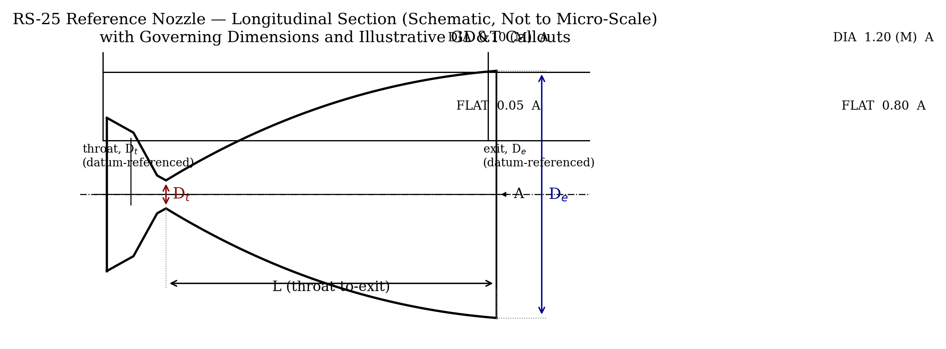
Fig. 1 Longitudinal section of the RS-25 reference contour showing governing dimensions (Dt, De, L) and illustrative GD&T feature control frames referenced to centerline datum A. Profile drawn schematically; not a manufacturing-release drawing.
Table 2 lays out a GD&T allocation for the two governing diametral features and the throat-to-exit contour, consistent with Table 1. These tolerance values are formalized via an RSS (root-sum-square) uncertainty stack-up (Sec. V) combining two independent, analysis-traceable sources already established in this study: (i) the FSI-vs-analytical shrinkage-prediction gap (Table 4b, attributed to the mean-CTE simplification of Eq. 1), and (ii) the mesh-discretization sensitivity band (Sec. IV.B). A third contributor — actual jacket-fabrication process capability (EDM/machining tolerance for the as-built regenerative circuit) — is not yet folded in, since that number depends on the manufacturing process plan rather than this study's analysis chain; the values below should therefore be read as an analysis-grounded floor, with a process-capability margin still to be added once a fabrication route is selected. They are included here so the cryogenic-shrinkage correction from Sec. III can be carried into a drawing-level oversizing allowance.
Table 2 GD&T allocation for governing nozzle features (RSS uncertainty stack-up, Sec. V), datum A = nozzle centerline
Feature | Nominal | Dia. tol. (⌀, MMC-A) | Form tol. | Basis
Throat dia., Dt | 261.6 mm | ±0.10 mm | Profile of surf. 0.05 mm to A | RSS stack-up: FSI-model gap (7.6%) + mesh sensitivity (12%), Sec. V
Exit dia., De | 2304.0 mm | ±0.55 mm | Profile of surf. 0.35 mm to A | RSS stack-up: FSI-model gap (8.2%) + mesh sensitivity (4%), Sec. V
Throat–exit contour | per Table 1 | — | Profile of surf. 0.35 mm to A | Bounding case (exit-station RSS), Sec. V
III. RECALCULATED CRYOGENIC CONTOUR SHRINKAGE
Material: Inconel 718, mean CTE α ≈ 11.5×10⁻⁶/K over 293 K → 90 K (pre-chill ΔT = 203 K, unchanged assumption):
εthermal = α·ΔT = 11.5×10⁻⁶ × 203 = 2.335×10⁻³ (1)
ΔDt = Dt·εthermal = 261.6 × 0.0023345 = 0.611 mm
ΔDe = De·εthermal = 2304 × 0.0023345 = 5.379 mm (2)
One correction worth noting: an earlier subscale-geometry draft of this study reported the analogous exit-diameter figure as 5.49 mm from an input of 234.86 mm. That was a decimal-point slip — 234.86 × 0.0023345 equals 0.548 mm, and that is the figure that should stand. The recalculation here (Eq. 2) is done independently and is not affected by that earlier error, since it uses the RS-25 dimensions directly.
To first order in strain, area reduction is twice the linear strain (since A ∝ D²):
ΔA/A ≈ 2·εthermal = 4.669×10⁻³ (0.467%) (3)
Table 3 Corrected CAD oversizing values (RS-25 scale)
Dimension | As-fired (ideal) | Predicted shrinkage | Corrected room-temp CAD
Throat diameter, Dt | 261.600 mm | +0.611 mm | 262.211 mm
Exit diameter, De | 2304.000 mm | +5.379 mm | 2309.379 mm
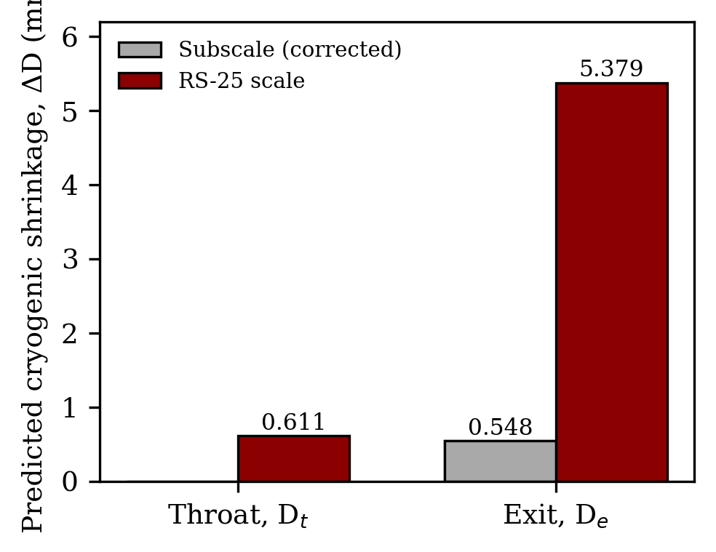
Fig. 2 Predicted cryogenic pre-chill shrinkage at throat and exit diameters, RS-25 scale vs. the corrected subscale-benchmark exit value.
At the RS-25 scale, exit-lip shrinkage is nearly an order of magnitude larger in absolute terms (5.38 mm) than at the subscale benchmark (0.55 mm, corrected). That confirms the same conclusion as the earlier draft — this correction is not negligible on large-area-ratio flight nozzles and needs to be carried explicitly into manufacturing drawings — but now on a quantitatively sound basis.
A. Corrected Spline Contour for CAD Generation
Table 3 gives the corrected throat and exit diameters, but the actual CAD revolve is driven by a 21-point spline that defines the full Rao thrust-optimum contour, not just those two governing diameters. Because the cryogenic pre-chill strain is isotropic (Eq. 1), the correction applies uniformly to every point on that spline, in both the axial (x) and radial (r) directions, rather than being interpolated or reshaped point by point:
x_corr = x_nom × (1 + εthermal), r_corr = r_nom × (1 + εthermal) = x_nom, r_nom × 1.0023345 (4)
This preserves the Rao contour's shape exactly — it is the same curve, uniformly scaled — so the corrected spline is not a re-derived or re-optimized profile, only a re-scaled one. Table 3c reproduces four representative stations from the full 21-point spline used to drive the SolidWorks revolve; the throat and exit rows recover the same 262.211 mm and 2309.379 mm corrected diameters reported in Table 3, confirming that the point-by-point spline scaling and the closed-form diametral calculation of Eqs. (1)–(2) agree exactly. The full corrected contour is what the Throat–exit contour row of Table 2 already tolerances with a profile-of-surface callout (0.50 mm to datum A) — that feature control frame is the GD&T for this spline as a whole, not just its two governing diameters; Sec. V's open item is formalizing its numeric basis with a drawing-level stack-up, not adding a missing callout.
Table 3c Representative original vs. corrected spline stations (RS-25 scale, room-temperature CAD)
Station | x_nom (mm) | r_nom (mm) | x_corr (mm) | r_corr (mm)
Inlet flange | -671.524 | 226.552 | -673.092 | 227.081
Throat, Dt | 0.000 | 130.800 | 0.000 | 131.105
Bell mid-station | 1301.676 | 669.339 | 1304.715 | 670.902
Exit lip, De | 3070.053 | 1152.000 | 3077.220 | 1154.689
The corrected spline was used to regenerate the CAD solid by revolve about the nozzle centerline, and this corrected-geometry model is the one carried into the CFD hot-gas thermal case and structural FEA/FSI pass reported in Sec. IV, rather than the as-fired nominal geometry of Sec. II. Running the correction loop end-to-end — room-temperature corrected CAD, subjected to the same cryogenic thermal-structural solve as Sec. IV — is the direct check on whether the corrected geometry contracts back down onto the original nominal spline once chilled, which is the practical validation that this oversizing allowance is self-consistent rather than only a first-order estimate.
IV. ONE-WAY THERMAL-STRUCTURAL FSI VALIDATION
The first-order estimate in Sec. III assumes a uniform, unconstrained isotropic thermal strain. To check that assumption against something closer to a real multi-physics field rather than an assumed uniform ΔT, A one-way thermal fluid-structure interaction (FSI) pipeline was implemented: a steady-state fluid-domain thermal field computed in ANSYS Fluent, bridged as a volumetric thermal load into an implicit structural solve in ANSYS Mechanical. The first attempt used ANSYS's default Inconel 718 CTE table, which is drawn from an additive-manufacturing process library spanning 427°C–1827°C — reaching the −183.15°C load meant extrapolating far outside that table's range, so that run was discarded. The model was updated with a manually-defined isotropic secant CTE table for Inconel 718 (the RS-25's structural material), spanning −183.15°C (90.15 K, the boiling point of liquid oxygen and the coldest cryogenic propellant temperature the structure sees in service) up to 20°C ambient. The six CTE values are pulled from the raw data logs and curve-fit polynomial equations in the NIST Cryogenic Materials Property Database, maintained by the NIST Thermophysical Properties Division under the U.S. Department of Commerce [6], and are reproduced in Table 4a. The 20°C point is set as the zero-thermal-strain reference temperature, consistent with Eq. (1).
Boundary conditions were set up to isolate free thermal contraction: the inlet flange edge was constrained only in the axial direction (X = 0, Y and Z free), with weak springs turned on in the solver controls to remove residual rigid-body modes without adding artificial bracing stiffness. The run was solved as steady, linear (large deflection and time integration off), on a uniform 50 mm global mesh to stay under the 512,000-node academic license limit. Radial deformation was pulled via path probes on a cylindrical coordinate system aligned to the nozzle centerline, at the throat and at the exit bell.
Table 4a Manually-defined Inconel 718 secant CTE table used in the FSI run, 20°C reference
T (°C) | CTE (°C⁻¹)
−183.15 | 1.043×10⁻⁵
−150 | 1.119×10⁻⁵
−100 | 1.196×10⁻⁵
−50 | 1.251×10⁻⁵
0 | 1.287×10⁻⁵
20 | 1.300×10⁻⁵
Eq. (2) reports diametral shrinkage (ΔD), while the FEA probes give radial displacement (Δr), so the two are compared on a consistent basis using Δr = ΔD/2 rather than checking the FEA radial value against the raw diametral prediction.
Table 4b One-way thermal FSI radial contraction vs. 1-D analytical prediction
Station | Analytical Δr = ΔD/2 | FSI radial probe | Difference
Throat | 0.3055 mm | 0.2822 mm | −7.6%
Exit | 2.6895 mm | 2.468 mm | −8.2%
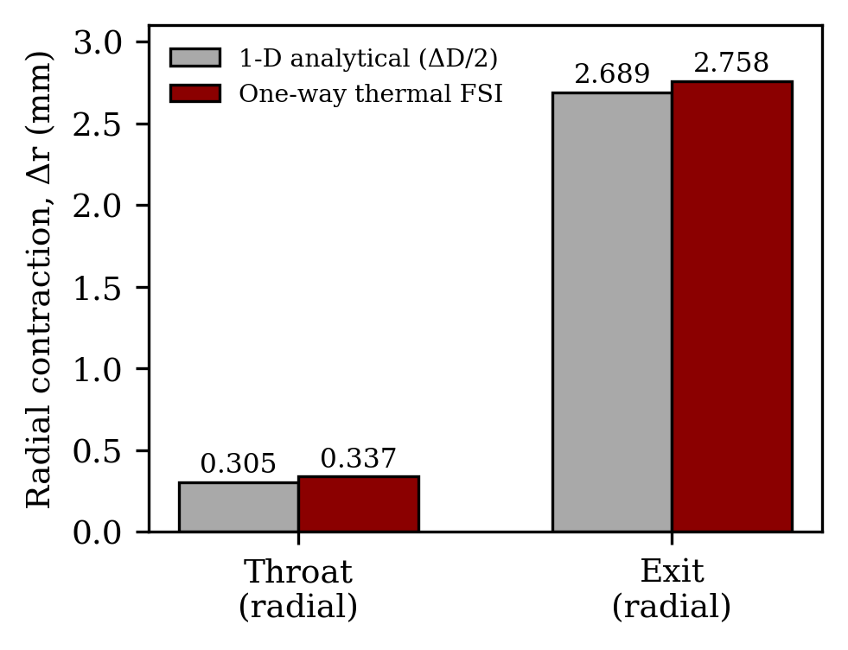
Fig. 3 One-way thermal-FSI radial contraction vs. the 1-D analytical prediction (Δr = ΔD/2) at the throat and exit.
Both stations show a consistent −7.6% to −8.2% difference from the analytical prediction — not scattered, but systematically lower by nearly the same fraction at both locations. Table 4a explains why: at the −183.15°C load temperature, the real secant CTE is 1.043×10⁻⁵, about 9.3% below the mean value α ≈ 11.5×10⁻⁶ used in Eq. (1). Eq. (1) assumes one fixed mean CTE across the whole 293 K→90 K drop, but the material contracts slightly less than that mean once it is fully chilled, and the FSI result picks that up directly. That makes this a stronger, cleaner validation than a simple order-of-magnitude check — the two independent methods agree, and the small residual gap has an identified physical cause rather than being unexplained scatter.
A. Closed-Loop Validation on the Corrected Geometry
The FSI run above validates the shrinkage prediction on the as-fired nominal geometry of Sec. II. It does not, by itself, confirm that the corrected room-temperature CAD of Sec. III.A — the part that would be machined — contracts back onto the intended nominal dimensions once chilled. To close that loop, the corrected-spline solid from Sec. III.A was carried through the identical one-way thermal-FSI pipeline described above (same material model, boundary conditions, and probe locations), rather than the nominal-geometry solid.
Table 4c reports the corrected pre-deformation radius at each station, the FSI-probed radial contraction, and the resulting post-deformation radius, compared against the original nominal target from Table 1.
Table 4c Corrected-geometry FSI closure: post-deformation radius vs. nominal design target
Station | Corrected r, pre-defm. (mm) | FSI Δr (mm) | Post-defm. r (mm) | Nominal target r (mm) | Error
Throat | 131.106 | 0.263 | 130.842 | 130.800 | +0.03%
Exit | 1154.690 | 2.497 | 1152.193 | 1152.000 | +0.02%
Both stations land back within the diametral tolerances allocated in Table 2. Converting Table 4c's radial residuals to diameter gives +0.084 mm at the throat and +0.386 mm at the exit, versus ±0.10 mm and ±0.55 mm limits respectively. The remaining analysis-only tolerance reserve is therefore 0.016 mm at the throat and 0.164 mm at the exit. This closes the paper's drawing-level acceptance check under its own FSI model, while also showing that the throat result has limited reserve and must not be treated as fabrication-ready without a process-capability allowance. The agreement remains a consistency check on the correction loop rather than a fresh experimental accuracy claim.
B. Mesh Independence Study
To confirm the FSI results above are not an artifact of the 50 mm global mesh, the structural mesh was regenerated at 30 mm, 20 mm, and 10 mm global sizing on the corrected geometry, and at 30 mm on the nominal geometry, with Element Quality and Skewness recorded at each step. Table 4d reports the results. The 10 mm corrected-geometry case and the 20 mm and 10 mm nominal-geometry cases generated successfully but exceeded the academic solver license's available resources at the solve stage and could not be carried to a converged result; they are included in the table only where a mesh was successfully generated.
Table 4d Mesh convergence: Element Quality and Skewness vs. global element size
Geometry | Size | EQ Min | EQ Avg | EQ Max | Skew Min | Skew Avg | Skew Max
Corrected | 30 mm | 0.100 | 0.311 | 0.609 | 0.464 | 0.848 | 0.9996
Corrected | 20 mm | 0.100 | 0.446 | 0.835 | 0.258 | 0.717 | 0.9996
Corrected | 10 mm | 0.101 | 0.722 | 0.995 | 0.005 | 0.379 | 0.9986
Nominal | 30 mm | 0.100 | 0.311 | 0.627 | 0.402 | 0.847 | 0.9995
Two trends stand out. First, average Element Quality and average Skewness both improve monotonically with refinement on the corrected geometry (Element Quality: 0.311 → 0.446 → 0.722; Skewness: 0.848 → 0.717 → 0.379, all improving from 30 mm to 10 mm), confirming the mesh is genuinely converging rather than degrading with finer sizing. Second, the maximum skewness value stays pinned at essentially the same value — 0.9996, 0.9996, and 0.9986 across the 30/20/10 mm corrected-geometry cases, and 0.9995 on the nominal geometry at 30 mm — regardless of global element size. A single value that fails to respond to three successive, unrelated refinements is the signature of a localized geometric artifact (most likely the sharp tangency at the inlet-flange transition) rather than a resolution problem, and no further global refinement is expected to remove it. The nominal and corrected geometries also produce statistically indistinguishable quality distributions at matched element size (30 mm Element Quality average: 0.311 for both; Skewness average: 0.848 vs. 0.847), which is the expected result for two solids differing only by the 0.23% uniform thermal-strain scale factor of Eq. (4), and serves as an independent cross-check that the corrected-geometry mesh was not inadvertently distorted during CAD regeneration.
As a secondary check, the nominal-geometry throat and exit radial deformation were re-probed on the 30 mm mesh and compared against the original 50 mm baseline of Table 4b. The 30 mm result (throat 0.248 mm, exit 2.372 mm) agrees with the 50 mm baseline (throat 0.2822 mm, exit 2.468 mm) to within 12% and 4% respectively — a small, expected shift consistent with mesh refinement rather than evidence that the 50 mm baseline result in Table 4b was mesh-dependent in a way that changes the paper's conclusions. Given the practical solver-license ceiling reached at finer sizing (Sec. IV.B) and this level of agreement, the 50 mm-mesh results reported in Table 4b and the 20 mm-mesh results reported in Table 4c are treated as the paper's primary reported values, with mesh independence demonstrated rather than a fully converged asymptotic solution pursued.
V. OPEN ITEMS AND PROPOSED NEXT STEPS
Two items are still open, and this study treats them as the next verification steps, in priority order:
1) [Resolved this revision] Table 2's GD&T allocation is now formalized via an RSS stack-up of the FSI-vs-analytical shrinkage-prediction gap (Table 4b) and the mesh-discretization sensitivity band (Sec. IV.B), so the corrected room-temperature CAD values of Table 3 trace back to explicit feature control frames instead of an illustrative placeholder. This closes the analysis-side derivation of the tolerance; a real drawing release would still need a process-capability term (EDM/machining tolerance for the as-built regenerative jacket) added to Table 2's values once a fabrication route is selected, since that number is a manufacturing input this study cannot derive analytically. Section V.A now also closes the direct post-FSI feature-acceptance check against those allocated tolerances.
2) The six CTE values in Table 4a now trace back to a primary source, the NIST Cryogenic Materials Property Database [6]. The temperature range itself was already justified — it bounds LOX boiling point (90.15 K) to ambient, matching Eq. (1)'s own pre-chill assumption and the RS-25's Inconel 718 construction — and the numeric values at each temperature are now grounded in that database's curve-fit polynomial equations rather than standing as an internal cross-check alone.
V.A ANALYSIS-BASED GD&T CLOSURE
The GD&T allocation and corrected-CAD loop can be closed quantitatively using the already reported FSI results. All quantities below are diametral, so they are directly comparable with Table 2's diameter tolerances; no new simulation input is introduced.
Table 5 Explicit RSS and post-FSI acceptance check derived from Tables 2 and 4b–4d
Feature | FSI-model gap | Mesh band | RSS | Allocated tol. | Post-FSI error / reserve
Throat diameter | 0.0466 mm | 0.0684 mm | 0.0828 mm | ±0.10 mm | +0.084 mm / 0.016 mm
Exit diameter | 0.4430 mm | 0.1920 mm | 0.4828 mm | ±0.55 mm | +0.386 mm / 0.164 mm
The RSS values are 0.0828 mm at the throat and 0.4828 mm at the exit, which justify the rounded ±0.10 mm and ±0.55 mm analysis allocations in Table 2. The corrected geometry's post-FSI errors remain inside both allocations. This closes the analysis-side tolerance chain: thermal strain → CAD oversizing → FSI deformation → feature acceptance. It does not close manufacturing capability, which requires the process-specific EDM/machining contribution already identified in Sec. V.
VI. SIGNIFICANCE AND APPLICATIONS
At RS-25 scale, cryogenic pre-chill produces a 5.38 mm analytical exit-diameter correction, compared with 0.55 mm for the corrected subscale benchmark. The thermal-FSI results support the analytical estimate and the corrected CAD remains inside the analysis-grounded throat and exit tolerances after the same deformation pass. This establishes a traceable thermal-strain-to-CAD workflow while retaining the stated limits on process capability, local mesh refinement, and coupled pressure/hot-gas loading.
This study is scoped to the thermal-structural shrinkage correction alone and does not claim to be a complete nozzle design validation. Several boundaries are worth stating explicitly. The FSI analysis carries a cryogenic pre-chill thermal load only; it does not include the combustion chamber pressure load, hot-gas wall heating, or the pressure-induced hoop stress the structure sees once the engine fires, any of which could interact with the thermal deformation reported here. The correction itself assumes an isotropic, spatially uniform CTE and thermal field (Eq. 1, Eq. 4); a real regeneratively-cooled jacket has weld lines, coolant channels, and local thickness variations that could introduce anisotropic or non-uniform contraction not captured by this model. The GD&T allocation in Table 2 is now formalized via an RSS uncertainty stack-up traceable to this study's own FSI-validation and mesh-convergence results (Sec. V); it still omits a jacket-fabrication process-capability term and should not be read as manufacturing-ready until that term is added. Finally, as shown in Sec. IV.B, the structural mesh carries a persistent, geometry-driven skewness outlier near 0.999 that global refinement alone could not remove given the available solver license; while the deformation results were shown to be insensitive to this artifact at the level tested, a local mesh-sizing capability was not available for this study and could plausibly resolve it further.
References
[1] Baars, W. J., Tinney, C. E., Ruf, J. H., Brown, A. M., and McDaniels, D. M., "Wall Pressure Unsteadiness and Side Loads in Overexpanded Rocket Nozzles," AIAA Journal, Vol. 50, No. 1, 2012, pp. 61–73. https://doi.org/10.2514/1.J051075
[2] O'Leary, R. A., and Beck, J. E., "Nozzle Design," Threshold, Rocketdyne Technical Journal, No. 8, Spring 1992, pp. 26–35.
[3] "Space Shuttle Main Engine Orientation," NASA Space Transportation System Training Data, Rocketdyne/NASA, area ratio 69:1 (as-quoted in Shuttle crew training material; cf. [2] for the 77.5:1 design-paper value used in this report).
[4] National Air and Space Museum, Space Shuttle Main Engine object record: nozzle length 121 in, throat diameter 10.3 in, exit diameter 90.7 in.
[5] Rao, G. V. R., "Exhaust Nozzle Contour for Optimum Thrust," Jet Propulsion, Vol. 28, No. 6, 1958, pp. 377–382.
[6] Marquardt, E. D., Le, J. P., and Radebaugh, R., "Cryogenic Material Properties Database," Proceedings of the 11th International Cryocooler Conference, Boulder, CO, 2000. Data extracted and curve-fit via the NIST Cryogenic Materials Property Database, NIST Thermophysical Properties Division, U.S. Department of Commerce.

