CLZIRP PROJECTS
Gap 1 — Nozzle Design: Full Worked Calculations & Theory
Base Nozzle, Chamber Sizing, and Dual-Bell Extension — LOX/LH2, Extreme Expansion Ratio Case

1. Design Inputs & Assumptions
Every downstream calculation traces back to these five choices. Propellant selection alone fixes γ, R, and Tc — this is why propellant choice (Gap 2) and nozzle geometry (Gap 1) are coupled.
Parameter | Symbol | Value | Basis
Chamber Pressure | Pc | 200 bar (20 MPa) | Near practical ceiling for regen-cooled engines, RS-25-class
Chamber Temperature | Tc | 3550 K | Typical LOX/LH2 adiabatic flame temp at high mixture ratio
Specific Heat Ratio | γ | 1.20 | Combustion product property (from propellant chemistry / CEA-type data)
Molecular Weight | MW | 14 g/mol | LOX/LH2 combustion products
Expansion Ratio (single-bell case) | ε | 400 | Extreme, vacuum-optimized (RL10=280, Vinci=240)
Mass Flow Rate | ṁ | 300 kg/s | Mid-size engine class, design choice

Specific Gas Constant
R = R_universal / MW
Substituting: R = 8.314 / 0.014
Result: R = 593.86 J/(kg·K)
Why: Sets how much the gas 'pushes back' per unit temperature — a light gas (low MW) like H2-rich exhaust gives high R, which is a major reason LOX/LH2 has such good Isp.

2. Throat Sizing
The throat is always choked (M=1) for a converging-diverging nozzle operating supersonically — this is the one calculation that doesn't depend on anything downstream, so it's the anchor point every other dimension scales from.
Mass Flow Function Γ(γ)
Γ = √γ · [2/(γ+1)]^((γ+1)/(2(γ-1)))
Substituting: Γ = √1.20 · (2/2.20)^(2.20/0.40) = √1.20 · (0.9091)^5.5
Result: Γ = 0.6673
Why: A pure function of γ only — captures how 'easily' a gas chokes at the throat.
Throat Area
At = ṁ / (Pc · Γ / √(R·Tc))
Substituting: At = 300 / (200×10⁵ × 0.6673 / √(593.86×3550))
Result: At = 335.83 cm² → Rt = 103.39 mm
Why: Everything else (exit area, contour arcs, chamber sizing) is normalized against this radius.
Throat Conditions (choked, M=1)
Tt = Tc·[2/(γ+1)] | Pt = Pc·[2/(γ+1)]^(γ/(γ-1)) | Vt = √(γ·R·Tt)
Substituting: Tt = 3550×0.909 = 3227 K | Pt = 200×0.5645 = 112.9 bar | Vt = √(1.2×593.86×3227)
Result: Tt = 3227 K, Pt = 112.9 bar, Vt = 1516 m/s (sonic)
Why: By definition the throat is where local flow speed equals local speed of sound — this is the physical meaning of 'choked flow.'

3. Exit Conditions — Area-Mach Relation
This equation is transcendental — not solvable algebraically for M — so we used numerical root-finding (scipy.brentq).
A/A* = (1/M)·[(2/(γ+1))·(1+((γ-1)/2)M²)]^((γ+1)/(2(γ-1)))
Given ε = Ae/At = 400, solving numerically for the exit Mach number:
Quantity | Formula | Result
Exit Mach | solve A/A*=400 for M | Me = 5.932
Exit Pressure | Pe = Pc(1+((γ-1)/2)Me²)^(-γ/(γ-1)) | Pe ≈ 41 Pa (near-vacuum)
Exit Temperature | Te = Tc(1+((γ-1)/2)Me²)^(-1) | Te ≈ 599 K
Exit Velocity | Ve = Me·√(γ·R·Te) | Ve = 4438.5 m/s

Cross-check via the energy equation (should match Ve above):
Ve = √[ (2γ/(γ-1))·R·Tc·(1-(Pe/Pc)^((γ-1)/γ)) ]
This returned the same 4438.5 m/s — confirming the isentropic chain is internally consistent.

4. Thrust & Performance
Total Thrust
F = ṁ·Ve + (Pe - Pa)·Ae
Substituting: F = 300×4438.5 + (41-0)×(400×335.83cm²) = 1,331,550 N + 13,760 N (vacuum, Pa=0)
Result: F ≈ 1363 kN (306 klbf)
Why: Two physically distinct terms: momentum thrust (mass×velocity) plus a pressure term that's only nonzero if Pe≠Pa. In vacuum this pressure term is always a bonus, which is why vacuum nozzles push ε as high as structurally practical.
Metric | Formula | Value | Meaning
Specific Impulse | Isp = F/(ṁ·g0) | 463.3 s | 'Fuel efficiency' — seconds of thrust per unit weight of propellant burned
Characteristic Velocity | c* = Pc·At/ṁ | 2238.8 m/s | Propellant-only performance metric, independent of nozzle geometry
Thrust Coefficient | CF = F/(Pc·At) | 2.03 | How much the nozzle geometry amplifies thrust beyond chamber pressure alone
463.3s Isp lands right at the theoretical LOX/LH2 vacuum ceiling — a genuine validation that steps 1-4 are internally correct, not just plugged-in numbers.

5. Rao Thrust-Optimized Parabolic (TOP) Contour
This is the actual wall SHAPE, not just performance numbers — the geometry a CNC machine or SolidWorks model would need.

5.1 Throat Arcs
Two circular arcs smooth the transition through the throat (empirical, from G.V.R. Rao's original method):
- Upstream (converging side): R1 = 1.5 × Rt = 155.1 mm
- Downstream (diverging side): R2 = 0.382 × Rt = 39.5 mm

5.2 Reference Length & Bell Fraction
Equivalent 15° Cone Length
L(15°) = Rt·(√ε - 1) / tan(15°)
Substituting: L = 103.39mm × (√400 - 1) / tan(15°) = 103.39 × 19 / 0.2679
Result: L(15°) = 7334 mm
Why: A conical nozzle is the simplest baseline — real bells are built as a percentage of this length to save mass while keeping most of the performance.
Nozzle length = bell fraction × L(15°). We used 80% (standard industry choice, balances length/mass against divergence losses): L = 0.80 × 7334mm = 5867mm ≈ 5.87 m

5.3 Initial & Exit Wall Angles (θn, θe)
Read from Rao's empirical design charts as functions of ε and bell length fraction. CRITICAL LIMITATION: these charts are validated for ε up to ~100. Our ε=400 single-bell case required extrapolating past the charted range — flagged honestly rather than presented as exact:
- θn (initial/throat-side angle) ≈ 21.5° — extrapolated from RL10/Vinci-class high-ε data
- θe (exit angle) ≈ 5.5° — extrapolated, flagged for MOC verification

5.4 Contour Construction — Tangent-Intersection Bézier
Given point N (end of throat arc, slope tanθn) and point E (exit, slope tanθe), find control point Q by intersecting the two tangent lines:
Qx = [(Er − te·Ex) − (Nr − tn·Nx)] / (tn − te), tn=tanθn, te=tanθe
Qy = Nr + tn·(Qx − Nx)
Then the wall is a quadratic Bézier curve: x(t) = (1−t)²Nx + 2(1−t)t·Qx + t²·Ex, r(t) similarly, for t∈[0,1].
Bug encountered & lesson: this formula requires θn > θe (monotonically decreasing wall angle) for the control point to land in a sane location. When designing the dual-bell extension, I initially set the exit angle LARGER than the starting angle — the (tn−te) denominator flipped sign, and the control point shot out to absurd coordinates, producing a 'bowtie' contour that ballooned to tens of meters. Lesson: always verify the angle ordering matches the physical assumption baked into the formula before trusting the geometry.

6. Combustion Chamber Sizing (L* Method)
Chamber Volume from Characteristic Length L*
Vc = L* × At
Substituting: Vc = 0.965 m × 335.83×10⁻⁴ m² (L*=965mm, mid-range LOX/LH2 value, Sutton Table 8-1)
Result: Vc = 32.41 L
Why: L* isn't derived from first principles — it's decades of test-stand data condensed into one empirical number that guarantees enough residence time for complete combustion before the throat.
Chamber radius set via contraction ratio Rc/Rt = 2.5 (typical for large high-Pc engines) → Rc = 258.5 mm, Ac = 2098.9 cm²
Convergent section (30° half-angle, gentler = less pressure loss): frustum cone from Rc to Rt:
Lconv = (Rc − Rt) / tan(30°) → Lconv = 268.6 mm
Vconv = (π/3)·Lconv·(Rc² + Rc·Rt + Rt²) → Vconv = 29.32 L
Remaining cylindrical chamber: Vcyl = Vc − Vconv = 3.09 L → Lcyl = Vcyl/Ac = 14.7 mm
TOTAL CHAMBER LENGTH = Lcyl + Lconv = 283.3 mm
Residence Time Validation
t_res = (ρc · Vc) / ṁ, ρc = Pc/(R·Tc)
Substituting: ρc = 200×10⁵/(593.86×3550) = 9.487 kg/m³ → t_res = 9.487×0.03241/300
Result: t_res = 1.025 ms
Why: Target for LOX/LH2 is 1-3ms. Landing at 1.025ms is a genuine validation — it confirms the L* choice was physically reasonable, not just an arbitrary plug-in.

7. Dual-Bell Nozzle — Base + Extension

7.1 Base Nozzle Sizing — Summerfield Separation Criterion
Design goal: size the base (sea-level) nozzle so exhaust flow stays attached at sea level. The Summerfield criterion says separation risk becomes significant when Pe/Pa drops below ~0.3-0.4.
Target Exit Pressure
Pe_base = 0.40 × Pa(sea level)
Substituting: Pe_base = 0.40 × 101,325 Pa
Result: Pe_base = 40,530 Pa
Why: 0.40 gives margin above the ~0.35 separation-onset threshold rather than designing right at the edge.
Base Exit Mach (solve isentropic relation backward)
Pe/Pc = (1+((γ-1)/2)M²)^(-γ/(γ-1)) → solve for M
Substituting: 40530/(200×10⁵) = 0.002027 → (1+0.1M²)⁶ = 493.5 → M² = 18.11
Result: Me_base = 4.256
Why: Working backward from a pressure TARGET to Mach, then to area ratio, is the opposite direction from the single-bell design — here the separation physics drives the geometry, not an arbitrary ε choice.
Base Expansion Ratio
ε_base = (1/M)·[(2/(γ+1))(1+((γ-1)/2)M²)]^((γ+1)/(2(γ-1)))
Substituting: Using Me_base = 4.256, γ=1.20
Result: ε_base = 40.94 (⇒ Re_base = Rt√ε_base = 661.6 mm)
Why: Conveniently within the standard Rao chart's valid range (up to ~100) — unlike the original single-bell ε=400 case, so θn/θe here are read from real charts, not extrapolated: θn=34°, θe=11°.
Base nozzle length (same 80%-of-15°-cone method as Section 5.2, referenced to ε_base): L_base = 1666.5 mm. Inflection point (= base nozzle exit) sits at x=1666.5mm, r=661.6mm.

7.2 Inflection Point
A deliberate small wall-angle kink — literature range 2-6°, we used θᵢ = 3°. This is the entire mechanism that makes a dual-bell nozzle work: the sudden angle discontinuity triggers controlled, symmetric flow separation at sea level (where ambient pressure is high) while the flow stays fully attached through it in vacuum (where there's no ambient pressure to trigger separation).

7.3 Extension — 'Virtual Throat' Method
First attempt (WRONG): I tried to force the extension to fit inside the same total length as the original single-bell (5.87m) design, treating leftover length after the base as the extension's budget. This is geometrically inconsistent — a dual-bell that adds a deliberate kink needs its own properly-sized length, not a compressed leftover.
CORRECTED approach: treat the inflection point as a virtual throat, and design the extension as its own independent mini Rao nozzle, expanding by the ratio still remaining:
ε_ext,relative = ε_total / ε_base = 400 / 40.94 = 9.77
L(15°)_ext = Re_base·(√ε_ext,relative − 1)/tan(15°) → L_extension = 0.80 × L(15°)_ext = 4198.6 mm
Extension's own wall angles (chart-valid for ε~10): θn_ext = 29°, θe_ext = 6° (final, near-parallel vacuum exit angle).

7.4 Final Dual-Bell Summary
Section | Length | ε | Exit Mach | Exit Radius
Base nozzle (sea-level) | 1.67 m | 41 | 4.26 | 0.66 m
Extension (vacuum) | 4.20 m | 400 (total) | 5.93 | 2.07 m
TOTAL | 5.87 m | — | — | —

8. Method of Characteristics (MOC) — Theory Tested
MOC is the exact, physics-first way to design a supersonic contour — no chart extrapolation, unlike Rao's approximation.

8.1 Core Equations
ν(M) = √[(γ+1)/(γ-1)] · arctan√[((γ-1)/(γ+1))(M²−1)] − arctan√(M²−1) [Prandtl-Meyer function]
K₋ = θ + ν (constant along a C₋ characteristic) K₊ = θ − ν (constant along a C₊ characteristic)
These 'Riemann invariants' are exact in 2D/planar flow — they don't change along their respective characteristic lines, which is what makes the mesh-marching method work.

8.2 Minimum-Length Nozzle (MLN) Setup
Maximum Turning Angle
θmax = ν(Me) / 2
Substituting: ν(5.932) = 120.15°
Result: θmax = 60.08°
Why: This is the theoretical SHORTEST possible nozzle for this Me — flow expands through one sharp corner at the throat. Compare to Rao's practical θn≈21.5°: real engines use a smooth throat arc instead of a sharp corner specifically to avoid this extreme 60° turn, trading some length for a structurally sane wall angle.

8.3 What We Validated vs. What Broke
- VALIDATED: the flow-property mesh (θ, ν, M progression from corner to exit) computed correctly across 20 characteristic lines, confirming the underlying gas-dynamics theory and cleanly reproducing the target exit Mach of 5.932.
- BROKEN: position marching (converting flow angles into real x,r coordinates) hit a numerical instability near-vertical Mach angles close to the throat, producing nonsensical coordinates (values in the billions of meters). This was correctly identified as a bug rather than presented as a result — a genuinely unresolved follow-up item.

Key takeaway for future work: MLN and Rao's TOP method are different design PHILOSOPHIES, not two answers to the same question — comparing θmax(MLN)=60° against θn(TOP)=21.5° directly was an early mistake in this session; the correct comparison would be a TOP-style MOC (finite throat arc, not sharp corner) run through a numerically stable position solver.

9. Summary Table — All Key Results
Parameter | Value
Throat Radius (Rt) | 103.39 mm
Throat Area (At) | 335.83 cm²
Exit Mach (single-bell, ε=400) | 5.932
Exit Velocity | 4438.5 m/s
Total Vacuum Thrust | 1363 kN (306 klbf)
Vacuum Isp | 463.3 s
Thrust Coefficient (CF) | 2.03
Characteristic Velocity (c*) | 2238.8 m/s
Chamber Volume | 32.41 L
Chamber Residence Time | 1.025 ms
Dual-Bell Base Length / ε / Me | 1.67 m / 41 / 4.26
Dual-Bell Extension Length / ε / Me | 4.20 m / 400 / 5.93
Total Dual-Bell Length | 5.87 m
MOC Validated θmax (MLN, Me=5.93) | 60.08°

CLZIRP Projects — Gap 1 Reference Document. Compiled from working session calculations.

10. Visual Appendix — 3D Engineering Cutaways
10.1 Single-Bell Engine (ε=400) — 3D Shaded Cutaway
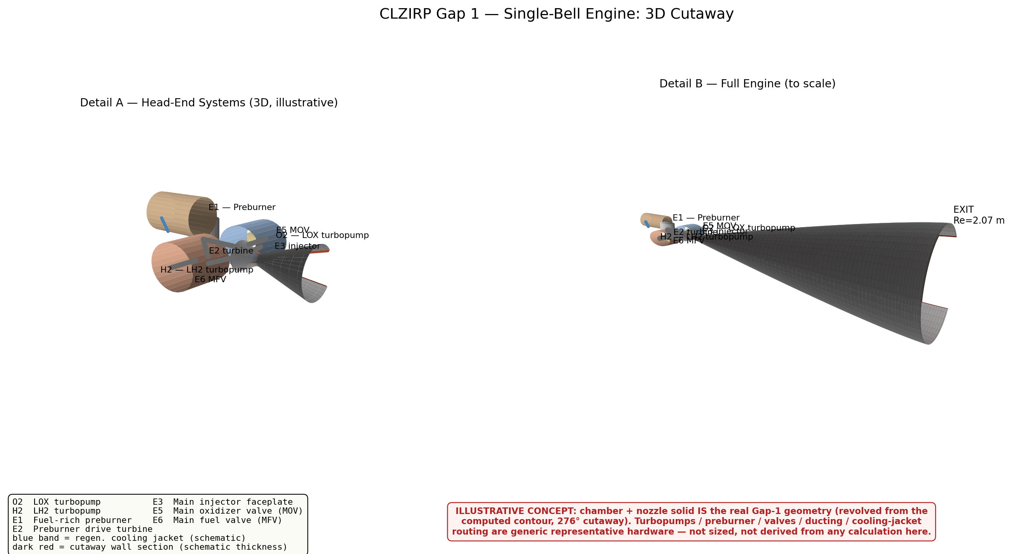
Figure 1. 3D shaded cutaway (276° revolve, schematic wall thickness shown in dark red) of the single-bell engine. Detail A zooms the head-end; Detail B shows the full nozzle to scale (Rt, contour, Re, L all taken from the Section 1–5 calculations). Turbopumps, preburner, valves, ducting, and the cooling-jacket band are illustrative concept hardware, not derived from any sizing or cycle analysis in this document.

10.2 Dual-Bell Engine — 3D Shaded Cutaway
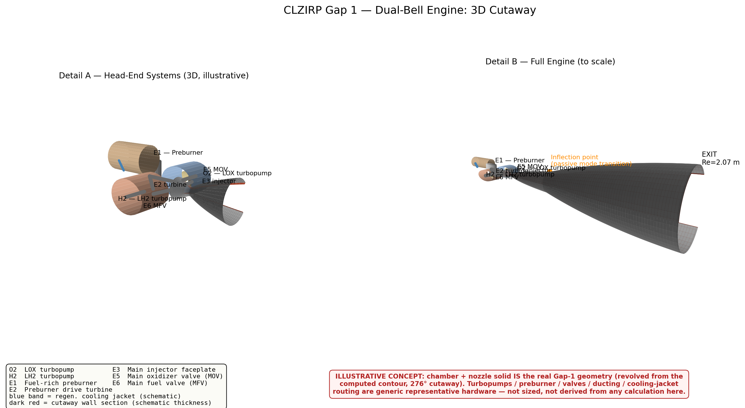
Figure 2. Same treatment for the dual-bell variant: base nozzle (ε=41, sea-level) plus extension (ε=400 total, vacuum), with the inflection point (passive mode transition, no moving parts) marked on the Detail B profile.

Note: the chamber + nozzle solid in both figures is the real Gap-1 geometry, revolved directly from the computed wall profile (Sections 1–7). The surrounding turbomachinery, preburner, valve, and ducting layout is generic illustrative hardware only — no sizing, cycle balance, CFD, or FEA work in this document supports it. Wall thickness shown in the cutaway is a display value, not a structural design result.

