Assessment of Stellar Contamination and False Biosignatures in Exoplanet Transmission Spectroscopy
A Simulated-Spectrum and Machine-Learning Study of the Transit Light Source Effect
Sewon Zion S.
Nehru Institute of Engineering and Technology (NIET), Coimbatore, India

Abstract
Transmission spectroscopy is one of the main tools used to search for atmospheric biosignature gases on exoplanets, but the measured spectrum also carries contributions from the host star's own spots and faculae — the transit light source effect. This study builds a simplified, fully synthetic transmission-spectrum model for an Earth-radius planet orbiting an M8V-type dwarf, injects stellar contamination as a wavelength-dependent multiplicative factor derived from blackbody photosphere/spot/faculae ratios, adds observational noise at controlled SNR, and retrieves gas abundances with a clean-star-assumption linear fit, as an analyst who does not correct for contamination would. Under a fiducial 500 K spot-photosphere temperature contrast, mean retrieval error for H2O grows from 0.4% (quiet star) to 31.1% (10% spot coverage), and the false-positive rate for an absent O2 biosignature rises from 0% at low activity to 99.3% at 10% coverage. A dedicated sensitivity sweep over spot-photosphere temperature contrast (200-1000 K) shows this false-positive behavior is confined to a narrow band (roughly 400-500 K); outside that band the same contamination mechanism instead suppresses (masks) genuine features rather than fabricating false ones. A machine-learning classifier (random forest, logistic regression) trained on retrieved-spectrum features to distinguish genuine from false O2 detections substantially outperforms a standard 3-sigma threshold detector (99.8% and 93.4% accuracy respectively, versus 55.8% for the naive threshold), primarily by weighting the retrieved O2 amplitude alongside co-retrieved H2O/CH4/CO2 amplitudes and a continuum-slope proxy. These results are a simulation study of an illustrative system and retrieval pipeline, not a reproduction of any specific published exoplanet observation or validated radiative-transfer result.

Nomenclature
Rp, Rs = planetary, stellar radius
δ = transit depth
H = atmospheric pressure scale height
T, μ, g = atmospheric temperature, mean molecular weight, surface gravity
T_phot = quiet-photosphere effective temperature
ΔT_spot, ΔT_fac = spot cooling, facula heating relative to photosphere
fs, ff = disk-integrated spot, facula coverage fraction
D(λ) = wavelength-dependent contamination (transit light source) factor
SNR = signal-to-noise ratio, referenced to the H2O 1.4 μm feature amplitude
ppm = parts per million

1. Introduction and Research Gap
Transmission spectroscopy studies an exoplanet's atmosphere by measuring how the transit depth — the fractional dimming of a star as its planet crosses in front of it — changes with wavelength. Because starlight grazing the planetary limb is filtered by the atmosphere, molecular absorption bands imprint themselves on the transit depth as small, wavelength-dependent excursions above a featureless baseline. The difficulty is that the star itself is not spectrally uniform: unocculted spots (cooler, darker regions) and faculae (hotter, brighter regions) that are never directly covered by the transiting planet still change the disk-integrated stellar spectrum used to normalize the light curve. This is commonly called the transit light source effect, and it can imitate, weaken, or distort genuine atmospheric absorption features in ways that are difficult to distinguish from real molecular signals without independent stellar characterization.
NASA's Exoplanet Exploration Program science-gap list identifies stellar contamination in transmission spectroscopy, atmospheric retrieval methodology, and the inventory of biosignatures and false positives as current, active gaps in exoplanet science [1], [2]. This is especially pressing for small, temperate, potentially habitable planets, which are preferentially found around M-dwarfs — stars with a higher incidence of spot and faculae coverage than the Sun, and for which the planet-to-star radius ratio (and therefore the raw transit-depth signal) is comparatively favorable even as the contamination risk grows.
This study asks a narrow, computationally tractable version of that broader question: for a simplified but physically motivated model of an Earth-radius planet transiting an active M-dwarf, how does stellar contamination bias retrieved gas abundances and the apparent presence of an oxygen biosignature, how does that bias depend on the assumed stellar spot properties, and can a machine-learning classifier trained on retrieval-pipeline outputs distinguish genuine from false detections better than a conventional threshold-based detection criterion?

1.1 Scope and Assumptions
This is a simulation study built entirely from simplified physical models, not a re-analysis of real telescope data or a validated radiative-transfer retrieval. Four simplifications are made explicit from the outset and are revisited in Sec. 7: (1) atmospheric absorption is represented by fixed-shape Gaussian bands with amplitudes set by an assumed number of scale heights per gas, not a line-by-line radiative-transfer calculation; (2) stellar photosphere, spot, and facula spectra are represented as blackbodies, not empirical or model stellar spectra; (3) the retrieval pipeline is a simple linear least-squares fit that assumes no contamination correction, representative of a naive or first-pass analysis rather than a state-of-the-art joint stellar-planetary retrieval; and (4) noise is independent, Gaussian, and wavelength-uncorrelated. These choices trade physical completeness for a fast, fully reproducible pipeline capable of the Monte Carlo repetition (thousands of realizations) needed to characterize false-positive rates and to generate a machine-learning training set.

2. Reference System and Physical Model
The reference system is an Earth-radius planet (Rp = 6371 km) transiting an M8V-type dwarf with stellar radius Rs = 0.12 R☉ = 83,561 km, broadly representative of ultracool dwarf hosts such as TRAPPIST-1, but not a reconstruction of any specific published system or retrieval. The photosphere is assigned an effective temperature T_phot = 2600 K.
δbase = (Rp/Rs)² = 5813 ppm (1)
The atmosphere is Earth-like in bulk composition for the purpose of setting a scale height: T = 288 K, mean molecular weight μ = 28.97, g = 9.81 m/s², giving:
H = kBT/(μmHg) ≈ 8.36 km (2)
Four gases are modeled with idealized Gaussian absorption bands, each assigned an illustrative number of scale heights of effective absorption height (nH) rather than a computed opacity; these are simplifications flagged in Sec. 1.1 and are not claimed to reproduce a validated radiative-transfer spectrum.
Gas | Band centers (μm) | Assumed nH | Band amplitude (ppm)
H2O | 1.40, 1.90 | 5.0, 4.0 | 76.3, 61.1
CO2 | 1.60, 2.00 | 3.0, 3.0 | 45.8, 45.8
CH4 | 1.70, 2.30 | 3.0, 3.0 | 45.8, 45.8
O2 | 0.76 | 1.0 | 15.3
Table 1 Idealized absorption-band assumptions and resulting clean-spectrum amplitudes (Eq. 3)
Δδgas = 2Rp(nH·H)/Rs² (3)
The clean, contamination-free spectrum used throughout this study is the sum of the baseline (Eq. 1) and each gas's Gaussian band(s) (Table 1), evaluated on a 401-point wavelength grid spanning 0.5-2.5 μm.

2.1 Stellar Contamination Model
Unocculted spots and faculae are represented as blackbody patches at temperatures offset from the photosphere by an assumed contrast ΔT_spot (cooler) and ΔT_fac (hotter). The disk-integrated stellar flux actually observed is a coverage-weighted blend of the three components, and the ratio between the quiet-photosphere flux and this blended flux gives a wavelength-dependent contamination factor that multiplies the true transit depth — the transit light source effect:
D(λ) = Fphot(λ) / [(1−fs−ff)Fphot(λ) + fsFspot(λ) + ffFfac(λ)] (4)
δobs(λ) = δtrue(λ)·D(λ) (5)
Because Fspot and Ffac are blackbody curves at different temperatures than Fphot, D(λ) is not flat: it imparts a wavelength-dependent slope and curvature onto the observed spectrum that depends on the assumed spot/facula coverage fractions (fs, ff) and, critically, on the assumed temperature contrasts ΔT_spot and ΔT_fac. A fiducial ΔT_spot = 500 K and ΔT_fac = +150 K is adopted for the main results (Secs. 4-5); Sec. 6 sweeps ΔT_spot explicitly, since it turns out to control not just the magnitude but the sign of the resulting bias in retrieved gas abundances.

2.2 Noise and Retrieval
Independent Gaussian noise is added at each wavelength point, with standard deviation set relative to a chosen signal-to-noise ratio (SNR) referenced to the H2O 1.4 μm band amplitude (σ = 76.3 ppm / SNR), so that SNR has an intuitive meaning as the detection significance of the strongest atmospheric feature in a noiseless, uncontaminated spectrum.
Retrieval is performed by linear least-squares regression of the noisy observed spectrum against a design matrix built from a free continuum offset plus the same seven fixed Gaussian band shapes used to build the clean spectrum (Table 1) — i.e., the retrieval pipeline assumes a clean star and does not attempt to model or correct for D(λ). This represents a plausible “naive” or first-pass analysis pipeline, deliberately simple enough to run thousands of Monte Carlo realizations, rather than a full joint stellar-activity/atmosphere retrieval framework.

3. Methodology Summary
1. Build the clean transmission spectrum (Eqs. 1-3) for the reference system, with all four gases present at Earth-like strength.
2. Build an abiotic-control spectrum identical to the above but with the O2 band amplitude set to zero, used to measure false-positive rates for a biosignature that is not actually present.
3. Apply the contamination factor D(λ) (Eq. 4-5) for a chosen spot/facula coverage and temperature contrast.
4. Add Gaussian noise at a chosen SNR (Sec. 2.2).
5. Retrieve gas-band amplitudes via clean-star-assumption linear least squares.
6. Repeat steps 3-5 for 300 independent noise realizations per configuration (Monte Carlo) to obtain stable mean retrieval error and false/true detection rates.
7. Generate a randomized 4,000-sample dataset spanning spot coverage, facula coverage, spot temperature contrast, SNR, and true/absent O2, and train machine-learning classifiers to distinguish genuine from false O2 detections from retrieval-pipeline outputs alone.

4. Results: Retrieval Error and Detection Confidence
Table 2 reports the Monte Carlo mean absolute retrieval error for H2O, CH4, and CO2, and the O2 false-detection rate for the abiotic control spectrum (true O2 = 0), across four stellar-activity cases at a fixed SNR = 50 and the fiducial ΔT_spot = 500 K. All four gases and both spot/facula fractions are matched per case, following the activity levels suggested for this class of study.
Stellar condition | H2O error (%) | CH4 error (%) | CO2 error (%) | O2 false-detect rate (%)
Quiet star | 0.41 | 0.60 | 0.62 | 0.00
Low activity (1%) | 2.97 | 0.72 | 2.11 | 0.00
Medium activity (5%) | 15.14 | 2.26 | 10.79 | 0.33
High activity (10%) | 31.09 | 4.98 | 21.80 | 99.33
Table 2 Monte Carlo (N=300) retrieval error and O2 false-detection rate vs. stellar activity, SNR = 50, ΔT_spot = 500 K
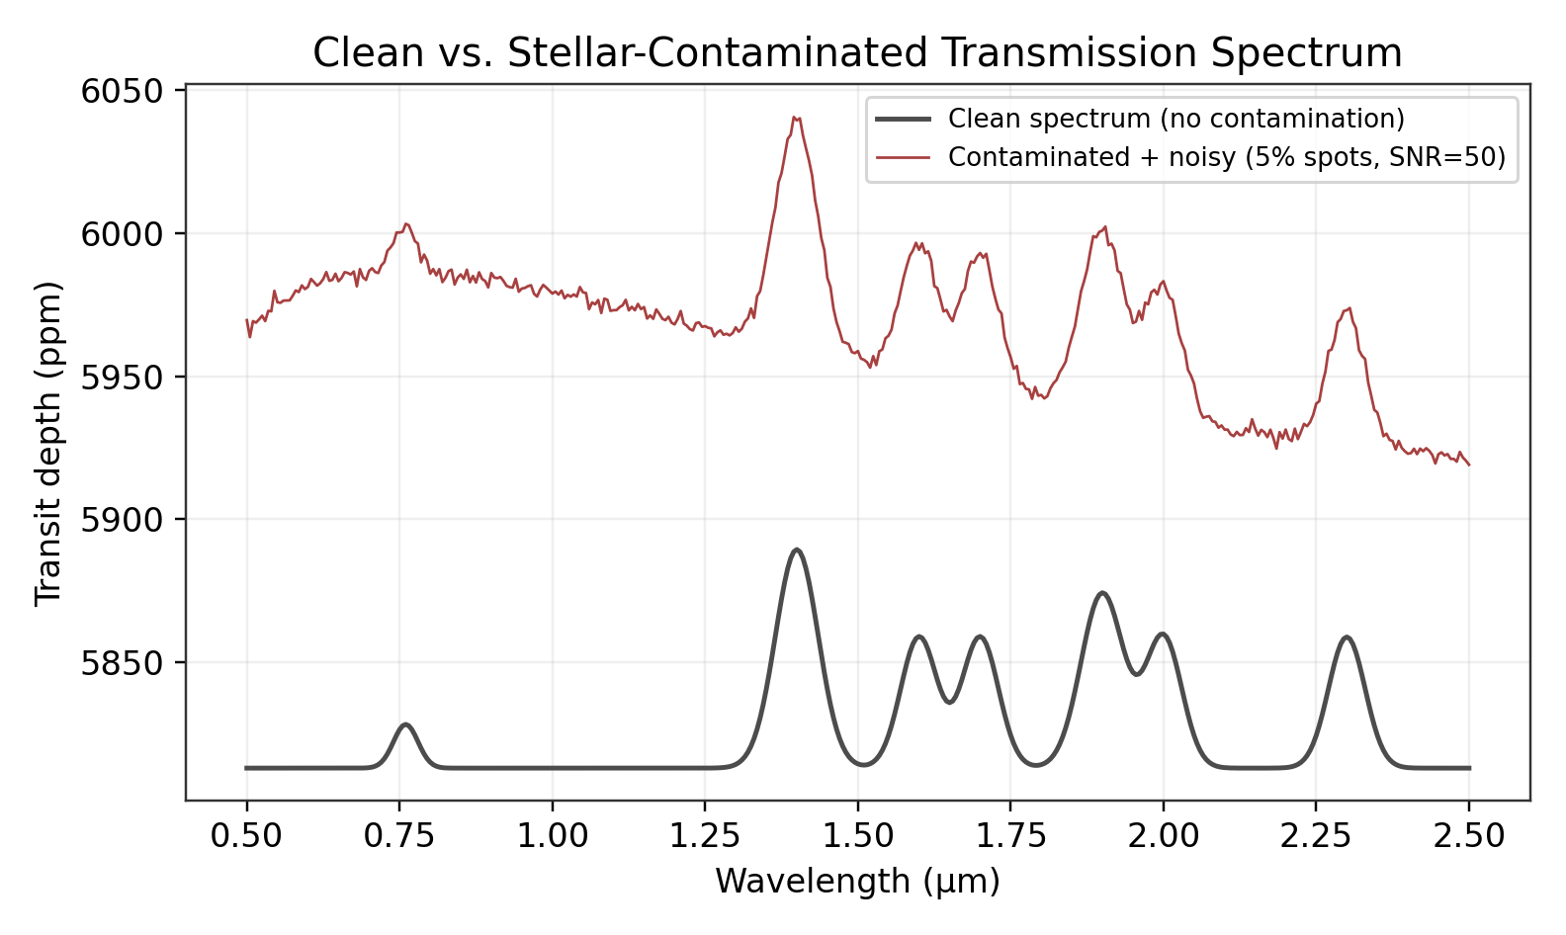
Fig. 1 Representative clean vs. contaminated-and-noisy transmission spectrum (5% spot/2.5% facula coverage, SNR = 50). Contamination imparts both an overall offset and wavelength-dependent slope on top of the genuine molecular bands.
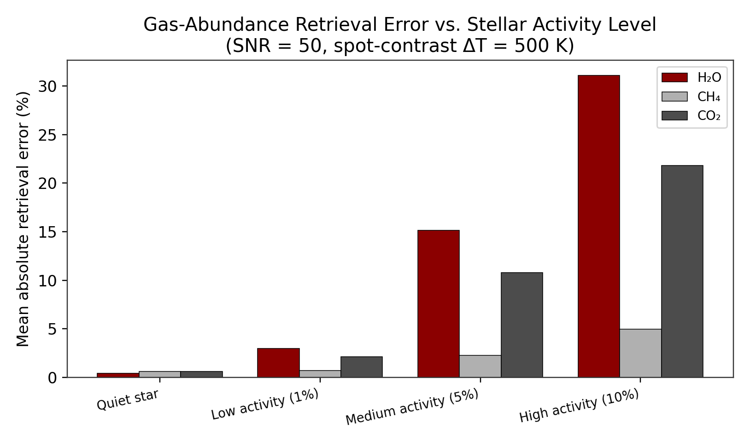
Fig. 2 Mean absolute gas-abundance retrieval error vs. stellar activity level (Table 2).
Retrieval error grows sharply and non-linearly with activity level for all three gases, but not uniformly: CH4's two bands (1.7, 2.3 μm) sit in a region where D(λ) happens to be comparatively flat at the fiducial contrast, so its error stays under 5% even at 10% coverage, while H2O and CO2 exceed 20-31% error at the same activity level. This is a reminder that contamination-driven bias is band-position-dependent, not a single global correction factor.
Table 2's rightmost column shows the false-detection rate for O2 jumping from 0% to 99.3% between the medium- and high-activity cases — a sharp, almost step-like transition rather than a gradual one. Fig. 3 resolves this transition on a finer spot-coverage grid.
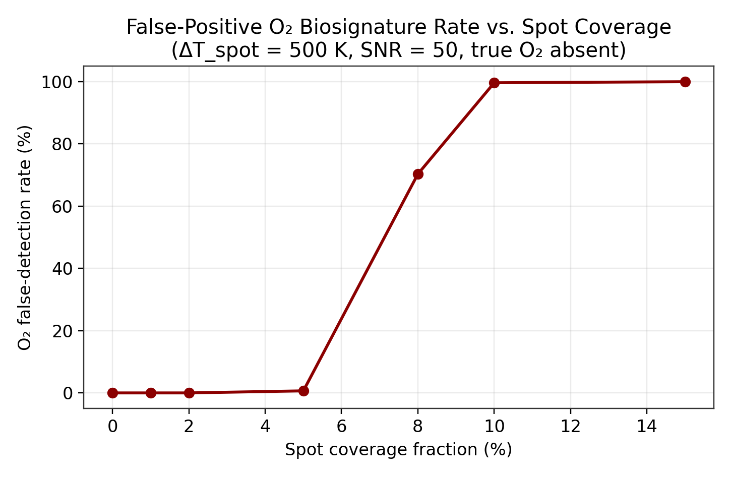
Fig. 3 O2 false-detection rate vs. spot coverage fraction (ΔT_spot = 500 K, SNR = 50, true O2 absent). The transition from negligible to near-certain false detection occurs between roughly 5% and 10% coverage.
Separately, Fig. 4 confirms that in the absence of contamination-driven bias considerations, higher SNR straightforwardly improves genuine detection confidence for a real O2 signal, saturating near 100% by SNR = 20 at 5% spot coverage — underscoring that the false-positive problem in Fig. 3 is a systematic-bias effect, not a noise-floor effect, since it grows with activity level at fixed SNR rather than with noise itself.
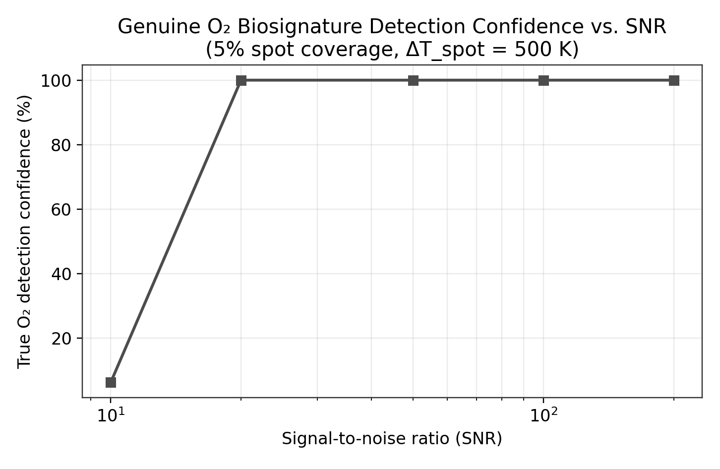
Fig. 4 Genuine O2 detection confidence vs. SNR at fixed 5% spot coverage. Detection saturates quickly once SNR exceeds roughly 20.

5. Sensitivity to Spot-Photosphere Temperature Contrast
Because D(λ) is built from the ratio of blackbody curves at different temperatures, its shape near any given absorption band depends on where that band's wavelength sits relative to the crossing points of the photosphere, spot, and facula Planck curves — and those crossing points shift as ΔT_spot changes. Table 3 sweeps ΔT_spot from 200 K to 1000 K at fixed 10% spot coverage, reporting both the noiseless systematic bias in retrieved O2 amplitude and the resulting Monte Carlo false-detection rate.
ΔT_spot (K) | Noiseless O2 bias (ppm) | Bias direction | False-detect rate (%) @10% spots
200 | −30.06 | Masking (−) | 0.00
300 | −5.33 | Masking (−) | 0.00
400 | +6.09 | False-positive-like (+) | 99.33
500 | +6.16 | False-positive-like (+) | 99.67
600 | −2.73 | Masking (−) | 0.00
700 | −17.94 | Masking (−) | 0.00
800 | −36.94 | Masking (−) | 0.00
1000 | −77.58 | Masking (−) | 0.00
Table 3 Systematic O2 retrieval bias and false-detection rate vs. assumed spot-photosphere temperature contrast, 10% spot coverage
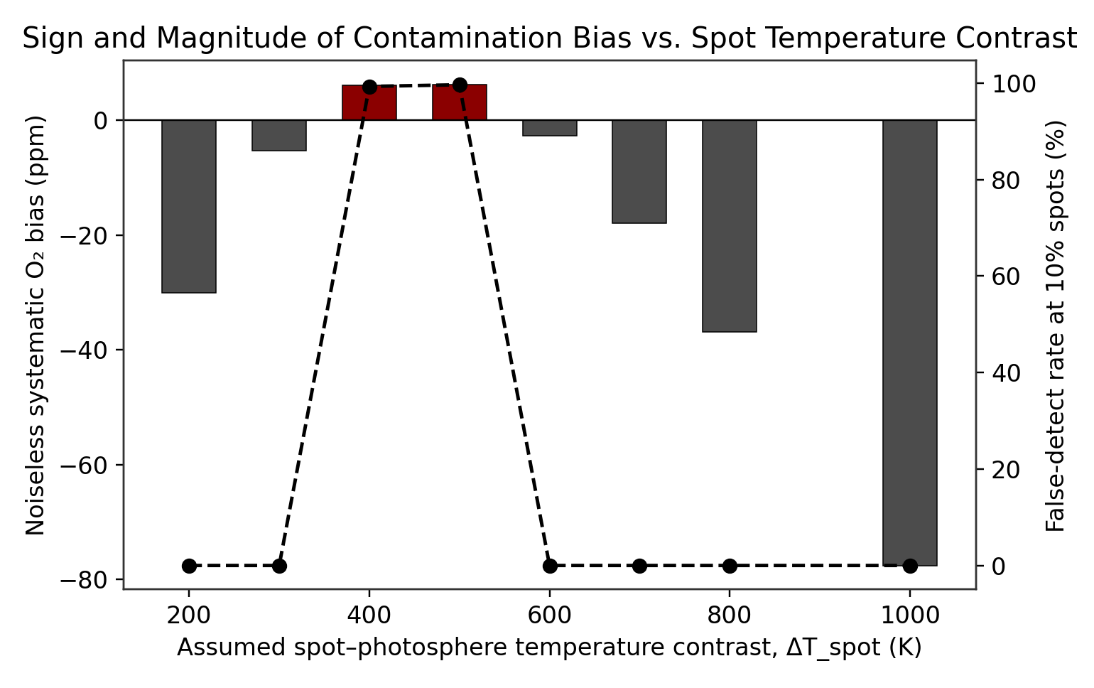
Fig. 5 Sign and magnitude of the noiseless O2 bias (bars, left axis) and Monte Carlo false-detection rate (dashed line, right axis) vs. assumed spot-photosphere temperature contrast. False positives are confined to a narrow band around 400-500 K; outside it, contamination masks rather than fabricates the O2 signal.
This is the most consequential single result of this study: the risk posed by stellar contamination is not simply “more activity is worse.” For most of the tested temperature-contrast range, contamination biases the retrieved O2 amplitude negative, which suppresses or masks a genuine biosignature rather than fabricating a false one — arguably a less alarming failure mode for a discovery claim, since it produces missed detections rather than false announcements, but still a serious concern for completeness of any exoplanet biosignature survey. Only in a comparatively narrow band of assumed spot temperature contrast (roughly 400-500 K in this model) does the bias flip positive and the false-positive rate become near-certain at moderate-to-high activity. Because real M-dwarf spot temperature contrasts reported in the literature span a wide range (roughly 200-1000+ K depending on stellar type and activity level), this result argues that independent characterization of a host star's actual spot temperature contrast is at least as important as knowing its spot coverage fraction when assessing the credibility of a claimed atmospheric biosignature.

6. Machine-Learning Classification of Genuine vs. False Detections
A dataset of 4,000 randomized simulated observations was generated, varying spot coverage (0-15%), correlated facula coverage, spot-photosphere temperature contrast (200-1000 K), SNR (10, 20, 50, 100, 200), and whether the O2 biosignature is genuinely present (uniform random 50/50). For each sample, the retrieval pipeline (Sec. 2.2) was run once and six features were extracted: the retrieved O2, H2O, CO2, and CH4 band amplitudes, the noise level σ, and a simple blue-red continuum slope proxy (mean depth in the 2.1-2.2 μm band minus the 0.55-0.65 μm band). A 70/30 train-test split was used (stratified on the true-O2 label).
Three detectors were compared: (i) a naive 3σ threshold on the retrieved O2 amplitude alone, representing a conventional single-feature detection criterion; (ii) a logistic regression classifier on the standardized six-feature set; and (iii) a random forest classifier (300 trees, max depth 6) on the raw six-feature set.
Method | Accuracy | Precision | Recall | F1
Naive 3σ threshold | 0.558 | 0.533 | 0.917 | 0.674
Logistic Regression | 0.998 | 1.000 | 0.995 | 0.997
Random Forest | 0.934 | 0.921 | 0.950 | 0.935
Table 4 Held-out test-set performance (N=1200), naive threshold vs. machine-learning classifiers
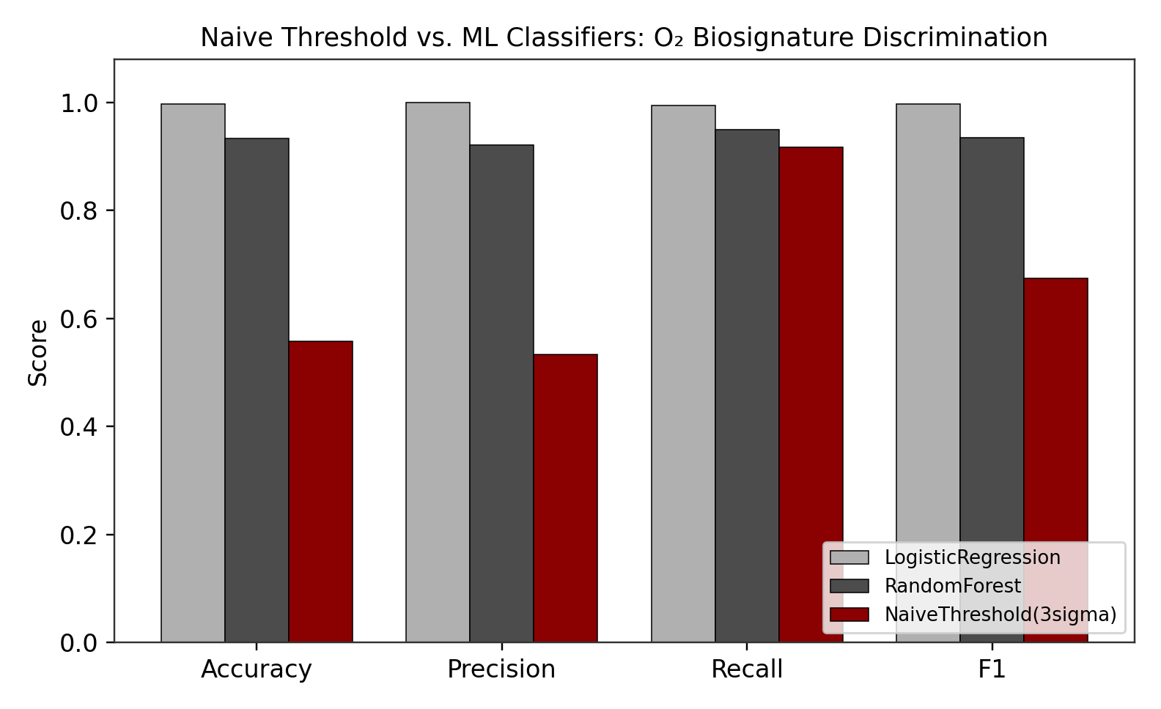
Fig. 6 Naive threshold vs. ML classifier performance on held-out data (Table 4).
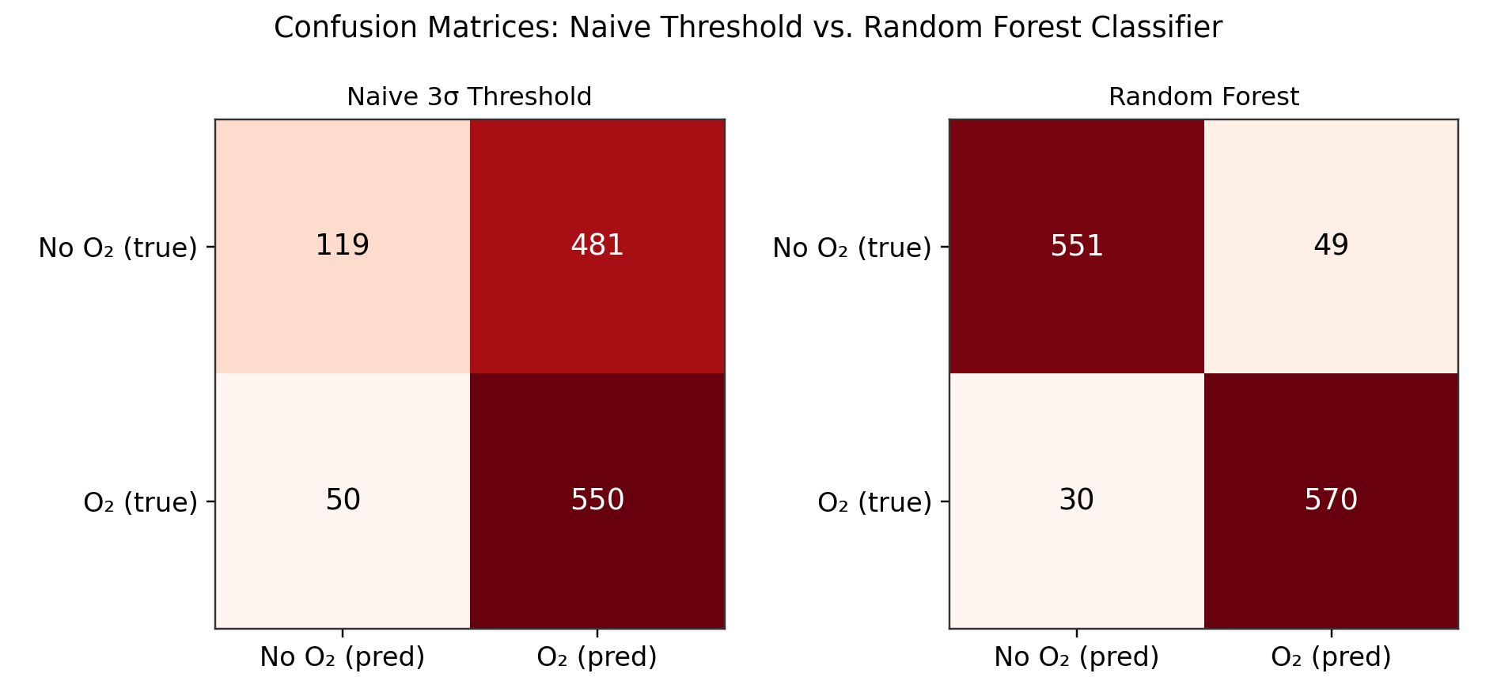
Fig. 7 Confusion matrices for the naive 3σ threshold (left) and random forest classifier (right). The naive detector produces 481 false positives out of 600 true-negative cases in the test set; the random forest produces 49.
The naive single-feature threshold performs only slightly better than chance at overall accuracy (55.8%) despite reasonable recall, because — consistent with Sec. 5 — a positive contamination-driven bias in the retrieved O2 amplitude alone is indistinguishable from a genuine signal without additional context. Both ML classifiers correct this dramatically by also weighting the co-retrieved H2O/CH4/CO2 amplitudes and the continuum-slope proxy, which carry information about the star's contamination state that the O2 amplitude alone does not. Logistic regression's near-perfect performance on this dataset should be read as a property of this particular synthetic generative model and simplified linear retrieval pipeline — where the relationship between contamination state and the six extracted features is close to linear and the noise model is well-behaved Gaussian — rather than a claim that a comparably simple classifier would perform this well on real telescope data with more complex, correlated, and non-Gaussian systematics.
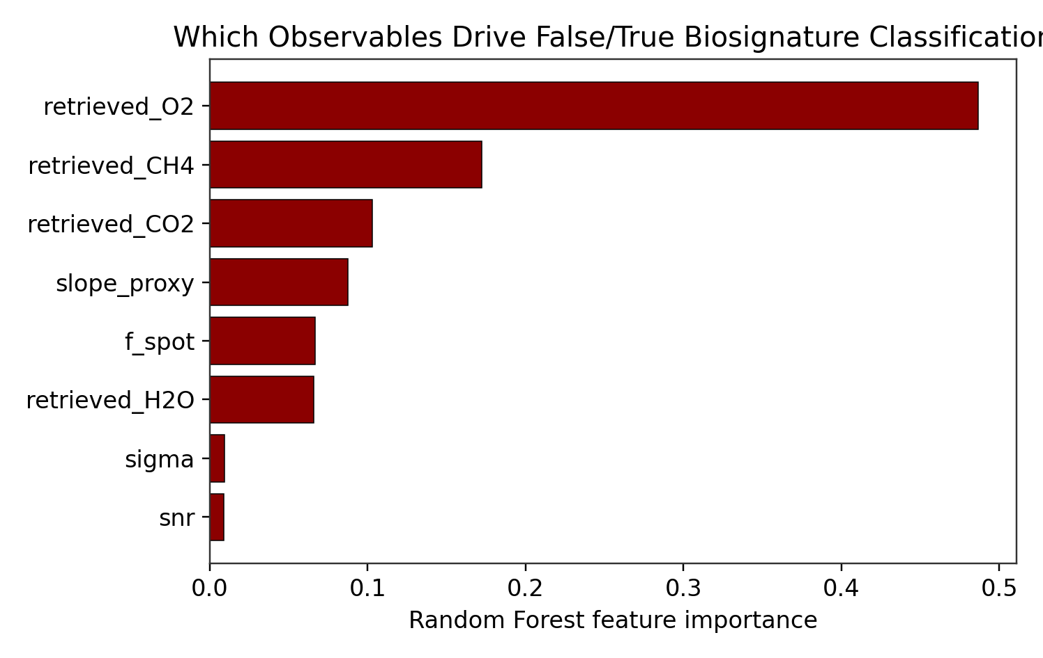
Fig. 8 Random forest feature importance for genuine-vs-false O2 classification.
Feature-importance ranking from the random forest (Fig. 8) shows the retrieved O2 amplitude itself remains the single most informative feature (48.7% importance), as expected, but the co-retrieved CH4 amplitude (17.2%) and CO2 amplitude (10.3%) together carry substantial discriminating power, followed by the continuum-slope proxy (8.7%) and spot coverage fraction (6.7%). Notably, SNR and the noise level σ rank lowest (under 1% combined) — consistent with Sec. 4's finding that the false-positive problem here is systematic-bias-driven rather than noise-floor-driven, so knowing the noise level alone does little to flag a contamination-induced false detection. This directly answers the study's methodological question: which observational conditions produce false biosignature detections is better read off the pattern across multiple co-retrieved gas bands and the spectral continuum than off the noise properties of the observation.

7. Limitations and Future Work
1. Idealized Gaussian absorption bands with an assumed number of scale heights stand in for a genuine line-by-line radiative-transfer calculation; real molecular bands have structured, overlapping, pressure- and temperature-dependent shapes not captured here.
2. Photosphere, spot, and facula spectra are modeled as blackbodies. Real M-dwarf spectra carry molecular opacity (e.g., TiO, VO, H2O) that produces contamination signatures blackbody curves cannot reproduce, particularly in the near-infrared where several of this study's gas bands sit.
3. The retrieval pipeline is a simple linear least-squares fit with a free continuum offset and no attempt at joint stellar-contamination correction; real analyses increasingly attempt to fit for or independently constrain fs, ff, and stellar temperatures simultaneously with the atmosphere.
4. Noise is treated as independent, Gaussian, and wavelength-uncorrelated; real instrumental and astrophysical noise (e.g., correlated systematics, granulation, flares) is not represented.
5. Spot and facula temperature contrasts and coverage fractions are assumed rather than fit to any specific observed star; Sec. 5's sensitivity sweep is illustrative of the qualitative sign-flip behavior, not a prediction for any particular real M-dwarf.
6. The machine-learning classifiers are trained and evaluated entirely on this study's own synthetic data distribution; their strong performance does not, by itself, establish that the same feature set and model would generalize to real observations or to contamination mechanisms not represented in this generative model.
Future work follows directly: replace the Gaussian band model with a validated radiative-transfer package for the clean spectrum; replace blackbody stellar components with empirical or model M-dwarf spectra including molecular opacity; implement a joint retrieval that fits for stellar contamination parameters simultaneously with atmospheric composition, and compare its false-positive rate against this study's naive baseline; and test the trained classifiers' generalization on independently simulated data using a different generative model or, longer term, on real transmission-spectroscopy datasets with known ground truth (e.g., planets with well-characterized host-star activity).

8. Conclusion
This study built a simplified, fully synthetic transmission-spectroscopy pipeline to quantify how stellar contamination biases retrieved atmospheric gas abundances and the apparent presence of an oxygen biosignature for an Earth-radius planet around an active M-dwarf. Under a fiducial 500 K spot-photosphere temperature contrast, retrieval error for H2O grows from under 1% for a quiet star to over 31% at 10% spot coverage, and the O2 false-detection rate for an abiotic control planet rises from 0% to 99.3% over the same range. A dedicated sensitivity sweep shows this false-positive behavior is confined to a narrow band of assumed spot temperature contrast (roughly 400-500 K); at most other tested contrasts, the same contamination mechanism instead masks genuine signals. A machine-learning classifier trained on retrieval-pipeline outputs — critically, including the co-retrieved amplitudes of other gas bands and a continuum-slope proxy, not just the O2 amplitude itself — improves detection accuracy from 55.8% (naive threshold) to 93-99.8%, depending on classifier choice. Taken together, these results support treating stellar contamination as a first-order, sign-uncertain systematic that can either mask or fabricate exoplanet biosignatures depending on stellar properties that are not always independently well constrained, and suggest that multi-feature statistical or machine-learning discrimination is a promising, low-cost complement to purely physical contamination-correction methods. As a simulation study built on idealized band shapes, blackbody stellar components, and a synthetic training distribution, these findings motivate but do not replace validation against radiative-transfer models, empirical stellar spectra, and real observational datasets.

References
[1] NASA Exoplanet Exploration Program (ExEP) Science Gap List, arXiv:2507.18665, 2025.
[2] NASA Exoplanet Exploration Program, "ExEP Science Gap List 2026," https://assets.science.nasa.gov/content/dam/science/astro/programs/exep/science/documents/ExEP_Science_Gap_List_2026.pdf
[3] Rackham, B. V., Apai, D., and Giampapa, M. S., "The Transit Light Source Effect: False Spectral Features and Incorrect Densities for M-Dwarf Transiting Planets," The Astrophysical Journal, Vol. 853, No. 2, 2018.
[4] Pedregosa, F., et al., "Scikit-learn: Machine Learning in Python," Journal of Machine Learning Research, Vol. 12, 2011, pp. 2825-2830.
[5] phys.org, "NASA defines gaps in exoplanet science," 2025. https://phys.org/news/2025-07-nasa-gaps-exoplanet-science.html

Appendix A: Simulation Code Structure
The full simulation (physical model, Monte Carlo experiments, machine-learning pipeline, and figure generation) is implemented in Python using numpy, pandas, matplotlib, and scikit-learn, organized as five scripts: model.py (physical model, spectrum generation, contamination, noise, retrieval), exp1_activity_snr.py (Table 2 and the SNR/spot-coverage curves), exp2_spot_contrast.py (Table 3, the temperature-contrast sensitivity sweep), exp3_ml.py (dataset generation, classifier training and evaluation), and make_figs.py (all figures). All Monte Carlo results use fixed random seeds for reproducibility.

