## Expt. No. : 1 Date :

**Reg. No. :**

## Develop an application to change the font and color of the text and display toast message when the user presses the button

**AIM:**

To Develop an application to change the font and color of the text and display toast message

when the user presses the button.

## PROCEDURE:

**Step 1:** File → NewProject

Provide the application name and Click “Next”

**Step 2:** Select the target android devices,

Select the minimum SDK to run the application. Click “Next”.

**Step 3:** Choose the activity for the application (By default choose “Blank Activity). Click “Next”.

**Step 4:** Enter activity name and click "Finish".

**Step 5:** Edit the program.

**Step 6:** Run the application, 2-ways to run the application

1. Running through emulator
2. Running through mobile device

pg. 1

## PROGRAM:

**AndroidManifest.xml**

<?xml version="1.0" encoding="utf-8"?>

<manifest xmlns:android="[http://schemas.android.com/apk/res/android"](http://schemas.android.com/apk/res/android) package="com.example. it17611_exptno_1">

<application android:allowBackup="true" android:icon="@mipmap/ic_launcher" android:label="@string/app_name"

android:roundIcon="@mipmap/ic_launcher_round" android:supportsRtl="true" android:theme="@style/AppTheme">

<activity android:name=".MainActivity">

<intent-filter>

<action android:name="android.intent.action.MAIN" />

<category android:name="android.intent.category.LAUNCHER" />

</intent-filter>

</activity>

</application>

</manifest>

## activity_main.xml

<?xml version="1.0" encoding="utf-8"?>

<RelativeLayout xmlns:android="[http://schemas.android.com/apk/res/android"](http://schemas.android.com/apk/res/android) xmlns:app="[http://schemas.android.com/apk/res-auto"](http://schemas.android.com/apk/res-auto) xmlns:tools="<http://schemas.android.com/tools>" android:layout_width="match_parent" android:layout_height="match_parent"

tools:context=".MainActivity">

<TextView android:layout_width="wrap_content" android:layout_height="wrap_content" android:text="Font" android:typeface="serif" android:textSize="40px" android:layout_marginLeft="25dp" android:layout_marginTop="60dp" android:id="@+id/T1" />

<TextView android:layout_width="wrap_content" android:layout_height="wrap_content"

pg. 2

android:text="Color" android:typeface="serif" android:textSize="40px" android:layout_marginLeft="25dp" android:layout_marginTop="160dp" android:id="@+id/T2" />

<Button

android:layout_width="wrap_content" android:layout_height="wrap_content" android:text="Change Font" android:layout_marginLeft="200dp" android:layout_marginTop="50dp" android:id="@+id/B1" />

<Button

android:layout_width="wrap_content" android:layout_height="wrap_content" android:text="Change Color" android:layout_marginLeft="200dp" android:layout_marginTop="150dp" android:id="@+id/B2" />

</RelativeLayout>

## MainActivity.java

package com.example. it17611_exptno_1;

import androidx.appcompat.app.AppCompatActivity; import android.os.Bundle;

import android.graphics.Color; import android.view.View; import android.widget.Button; import android.widget.TextView; import android.widget.Toast;

pg. 3

public class MainActivity extends AppCompatActivity { TextView T1,T2;

Button B1,B2;

@Override

protected void onCreate(Bundle savedInstanceState) { super.onCreate(savedInstanceState); setContentView(R.layout.activity_main);

T1=(TextView)findViewById(R.id.T1); T2=(TextView)findViewById(R.id.T2); B1=(Button)findViewById(R.id.B1); B2=(Button)findViewById(R.id.B2);

B1.setOnClickListener(new View.OnClickListener() { @Override

public void onClick(View v) { T1.setTextSize(40); Toast.makeText(getApplicationContext(),

"Font Size Changed",Toast.LENGTH_LONG).show();

}

});

B2.setOnClickListener(new View.OnClickListener() { @Override

public void onClick(View v) { T2.setTextColor(Color.RED); Toast.makeText(getApplicationContext(),

"Font Color Changed", Toast.LENGTH_LONG ).show();

}

});

}

}

pg. 4

## OUTPUT:

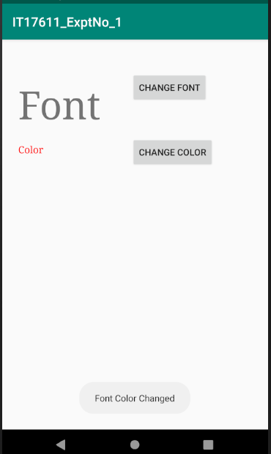

**RESULT:**

Thus, an android application to change the font and color of the text and display toast message when the user presses the button was successfully developed.

pg. 5

## Expt. No. : 2 Date :

**Reg. No. :**

## Develop a scientific calculator to perform arithmetic and mathematical functions using Math class. [Your scientific calculator should contain +, *, /, -, cos, sin, tan, pow, sqrt, log, lan and mod].

**AIM:**

To develop an android application for a scientific calculator to perform arithmetic and

mathematical functions using Math class.

## PROCEDURE:

**Step 1:** File → NewProject

Provide the application name and Click “Next”

**Step 2:** Select the target android devices,

Select the minimum SDK to run the application. Click “Next”.

**Step 3:** Choose the activity for the application (By default choose “Blank Activity). Click “Next”.

**Step 4:** Enter activity name and click "Finish".

**Step 5:** Edit the program.

**Step 6:** Run the application, 2-ways to run the application

1. Running through emulator
2. Running through mobile device

pg. 6

## PROGRAM:

**AndroidManifest.xml**

<?xml version="1.0" encoding="utf-8"?>

<manifest xmlns:android="[http://schemas.android.com/apk/res/android"](http://schemas.android.com/apk/res/android) package="com.example. it17611_exptno_3">

<application android:allowBackup="true" android:icon="@mipmap/ic_launcher" android:label="@string/app_name"

android:roundIcon="@mipmap/ic_launcher_round" android:supportsRtl="true" android:theme="@style/AppTheme">

<activity android:name=".MainActivity">

<intent-filter>

<action android:name="android.intent.action.MAIN" />

<category android:name="android.intent.category.LAUNCHER" />

</intent-filter>

</activity>

</application>

</manifest>

## activity_main.xml

<?xml version="1.0" encoding="utf-8"?>

<LinearLayout xmlns:android="[http://schemas.android.com/apk/res/android"](http://schemas.android.com/apk/res/android) xmlns:app="[http://schemas.android.com/apk/res-auto"](http://schemas.android.com/apk/res-auto) xmlns:tools="<http://schemas.android.com/tools>" android:layout_width="match_parent" android:layout_height="match_parent"

android:background="#FCF8F8" android:orientation="vertical" tools:context=".MainActivity">

<LinearLayout android:layout_width="match_parent" android:layout_height="wrap_content" android:layout_weight="0.3" android:orientation="vertical">

<TextView android:id="@+id/input"

android:layout_width="match_parent" android:layout_height="match_parent" android:textSize="30sp" />

</LinearLayout>

<LinearLayout android:layout_width="match_parent" android:layout_height="wrap_content"

pg. 7

android:layout_weight="0.3"

android:orientation="vertical" android:background="#EEF2F3">

<TextView android:id="@+id/display"

android:layout_width="match_parent" android:layout_height="match_parent" android:textSize="30sp" />

</LinearLayout>

<LinearLayout android:layout_width="match_parent" android:layout_height="wrap_content" android:layout_weight="0.2" android:orientation="horizontal">

<Button

android:id="@+id/buttonclr" android:layout_width="wrap_content" android:layout_height="match_parent" android:layout_margin="1dp" android:layout_weight="0.25" android:text="Clear" android:textSize="20sp" />

<Button

android:id="@+id/buttoneql" android:layout_width="wrap_content" android:layout_height="match_parent" android:layout_margin="1dp" android:layout_weight="0.25" android:text="=" android:textSize="30sp" />

</LinearLayout>

<LinearLayout android:layout_width="match_parent" android:layout_height="wrap_content" android:layout_weight="0.2" android:orientation="horizontal">

<Button

android:id="@+id/buttoncos" android:layout_width="wrap_content" android:layout_height="match_parent" android:layout_margin="1dp" android:layout_weight="0.25" android:text="cos" android:textSize="20sp" />

pg. 8

<Button

android:id="@+id/buttonsin" android:layout_width="wrap_content" android:layout_height="match_parent" android:layout_margin="1dp" android:layout_weight="0.25" android:text="sin" android:textSize="20sp" />

<Button

android:id="@+id/buttontan" android:layout_width="wrap_content" android:layout_height="match_parent" android:layout_margin="1dp" android:layout_weight="0.25" android:text="tan" android:textSize="20sp" />

<Button

android:id="@+id/buttonsqrt" android:layout_width="wrap_content" android:layout_height="match_parent" android:layout_margin="1dp" android:layout_weight="0.25" android:text="sqrt" android:textSize="20sp" />

</LinearLayout>

<LinearLayout android:layout_width="match_parent" android:layout_height="wrap_content" android:layout_weight="0.2" android:orientation="horizontal">

<Button

android:id="@+id/buttonsq" android:layout_width="wrap_content" android:layout_height="match_parent" android:layout_margin="1dp" android:layout_weight="0.25" android:text="x^2" android:textSize="20sp" />

<Button

android:id="@+id/buttonpow" android:layout_width="wrap_content" android:layout_height="match_parent" android:layout_margin="1dp" android:layout_weight="0.25" android:text="x^y"

pg. 9

android:textSize="20sp" />

<Button

android:id="@+id/buttonlog" android:layout_width="wrap_content" android:layout_height="match_parent" android:layout_margin="1dp" android:layout_weight="0.25" android:text="log" android:textSize="20sp" />

<Button

android:id="@+id/buttonexp" android:layout_width="wrap_content" android:layout_height="match_parent" android:layout_margin="1dp" android:layout_weight="0.25" android:text="e^x" android:textSize="20sp" />

</LinearLayout>

<LinearLayout android:layout_width="match_parent" android:layout_height="wrap_content" android:layout_weight="0.2" android:orientation="horizontal">

<Button

android:id="@+id/button7" android:layout_width="wrap_content" android:layout_height="match_parent" android:layout_margin="1dp" android:layout_weight="0.25" android:text="7" android:textSize="20sp" />

<Button

android:id="@+id/button8" android:layout_width="wrap_content" android:layout_height="match_parent" android:layout_margin="1dp" android:layout_weight="0.25" android:text="8" android:textSize="20sp" />

pg. 10

<Button

android:id="@+id/button9" android:layout_width="wrap_content" android:layout_height="match_parent" android:layout_margin="1dp" android:layout_weight="0.25" android:text="9"

android:textSize="20sp" />

<Button

android:id="@+id/buttondiv" android:layout_width="wrap_content" android:layout_height="match_parent" android:layout_margin="1dp" android:layout_weight="0.25" android:text="/" android:textSize="30sp" />

</LinearLayout>

<LinearLayout android:layout_width="match_parent" android:layout_height="wrap_content" android:layout_weight="0.2" android:orientation="horizontal">

<Button

android:id="@+id/button4" android:layout_width="wrap_content" android:layout_height="match_parent" android:layout_margin="1dp" android:layout_weight="0.25" android:text="4" android:textSize="20sp" />

<Button

android:id="@+id/button5" android:layout_width="wrap_content" android:layout_height="match_parent" android:layout_margin="1dp" android:layout_weight="0.25" android:text="5" android:textSize="20sp" />

<Button

android:id="@+id/button6" android:layout_width="wrap_content" android:layout_height="match_parent" android:layout_margin="1dp" android:layout_weight="0.25" android:text="6" android:textSize="20sp" />

pg. 11

<Button

android:id="@+id/buttonmul" android:layout_width="wrap_content" android:layout_height="match_parent" android:layout_margin="1dp" android:layout_weight="0.25" android:text="*"

android:textSize="30sp" />

</LinearLayout>

<LinearLayout android:layout_width="match_parent" android:layout_height="wrap_content" android:layout_weight="0.2" android:orientation="horizontal">

<Button

android:id="@+id/button1" android:layout_width="wrap_content" android:layout_height="match_parent" android:layout_margin="1dp" android:layout_weight="0.25" android:text="1" android:textSize="20sp" />

<Button

android:id="@+id/button2" android:layout_width="wrap_content" android:layout_height="match_parent" android:layout_margin="1dp" android:layout_weight="0.25" android:text="2" android:textSize="20sp" />

<Button

android:id="@+id/button3" android:layout_width="wrap_content" android:layout_height="match_parent" android:layout_margin="1dp" android:layout_weight="0.25" android:text="3" android:textSize="20sp" />

<Button

android:id="@+id/buttonsub" android:layout_width="wrap_content" android:layout_height="match_parent" android:layout_margin="1dp" android:layout_weight="0.25" android:text="-" android:textSize="30sp" />

</LinearLayout>

<LinearLayout android:layout_width="match_parent" android:layout_height="wrap_content" android:layout_weight="0.2" android:orientation="horizontal">

pg. 12

<Button

android:id="@+id/buttondot"

android:layout_width="wrap_content" android:layout_height="match_parent" android:layout_margin="1dp" android:layout_weight="0.25" android:text="." android:textSize="20sp" />

<Button

android:id="@+id/button0" android:layout_width="wrap_content" android:layout_height="match_parent" android:layout_margin="1dp" android:layout_weight="0.25" android:text="0" android:textSize="20sp" />

<Button

android:id="@+id/buttonrem" android:layout_width="wrap_content" android:layout_height="match_parent" android:layout_margin="1dp" android:layout_weight="0.25" android:text="%" android:textSize="30sp" />

<Button

android:id="@+id/buttonadd" android:layout_width="wrap_content" android:layout_height="match_parent" android:layout_margin="1dp" android:layout_weight="0.25" android:text="+" android:textSize="30sp" />

</LinearLayout>

</LinearLayout>

## MainActivity.java

package com.example.it17611_exptno_3;

import androidx.appcompat.app.AppCompatActivity; import android.os.Bundle;

import android.view.View; import android.widget.Button; import android.widget.TextView;

pg. 13

public class MainActivity extends AppCompatActivity {

double input1 = 0, input2 = 0; TextView edt1,edt2;

boolean Add, Sub, Mul, Div, Rem, dec, cos, sin, tan, pow, sq, sqrt, log, exp;

Button button0, button1, button2, button3, button4, button5, button6, button7, button8, button9, buttonAdd, buttonSub, buttonMul, buttonDiv, buttonEqual, buttonClr, buttonDot, buttonRem, buttonCos, buttonSin, buttonTan, buttonPow, buttonSq, buttonSqrt, buttonLog, buttonExp;

@Override

protected void onCreate(Bundle savedInstanceState) { super.onCreate(savedInstanceState); setContentView(R.layout.activity_main);

button0 = (Button) findViewById(R.id.button0); button1 = (Button) findViewById(R.id.button1); button2 = (Button) findViewById(R.id.button2); button3 = (Button) findViewById(R.id.button3); button4 = (Button) findViewById(R.id.button4); button5 = (Button) findViewById(R.id.button5); button6 = (Button) findViewById(R.id.button6); button7 = (Button) findViewById(R.id.button7); button8 = (Button) findViewById(R.id.button8); button9 = (Button) findViewById(R.id.button9); buttonDot = (Button) findViewById(R.id.buttondot); buttonAdd = (Button) findViewById(R.id.buttonadd); buttonSub = (Button) findViewById(R.id.buttonsub); buttonMul = (Button) findViewById(R.id.buttonmul); buttonDiv = (Button) findViewById(R.id.buttondiv); buttonRem = (Button) findViewById(R.id.buttonrem);

buttonCos = (Button) findViewById(R.id.buttoncos); buttonSin = (Button) findViewById(R.id.buttonsin); buttonTan = (Button) findViewById(R.id.buttontan); buttonSqrt = (Button) findViewById(R.id.buttonsqrt); buttonPow = (Button) findViewById(R.id.buttonpow); buttonLog = (Button) findViewById(R.id.buttonlog); buttonExp = (Button) findViewById(R.id.buttonexp); buttonSq = (Button) findViewById(R.id.buttonsq);

buttonClr = (Button) findViewById(R.id.buttonclr); buttonEqual = (Button) findViewById(R.id.buttoneql); edt1 = (TextView) findViewById(R.id.input);

edt2 = (TextView) findViewById(R.id.display);

pg. 14

button1.setOnClickListener(new View.OnClickListener() { @Override

public void onClick(View v) { edt1.setText(edt1.getText() + "1");

}

});

button2.setOnClickListener(new View.OnClickListener() { @Override

public void onClick(View v) { edt1.setText(edt1.getText() + "2");

}

});

button3.setOnClickListener(new View.OnClickListener() { @Override

public void onClick(View v) { edt1.setText(edt1.getText() + "3");

}

});

button4.setOnClickListener(new View.OnClickListener() { @Override

public void onClick(View v) { edt1.setText(edt1.getText() + "4");

}

});

button5.setOnClickListener(new View.OnClickListener() { @Override

public void onClick(View v) { edt1.setText(edt1.getText() + "5");

}

});

button6.setOnClickListener(new View.OnClickListener() { @Override

public void onClick(View v) { edt1.setText(edt1.getText() + "6");

}

});

button7.setOnClickListener(new View.OnClickListener() { @Override

public void onClick(View v) { edt1.setText(edt1.getText() + "7");

}

});

pg. 15

button8.setOnClickListener(new View.OnClickListener() { @Override

public void onClick(View v) { edt1.setText(edt1.getText() + "8");

}

});

button9.setOnClickListener(new View.OnClickListener() { @Override

public void onClick(View v) { edt1.setText(edt1.getText() + "9");

}

});

button0.setOnClickListener(new View.OnClickListener() { @Override

public void onClick(View v) { edt1.setText(edt1.getText() + "0");

}

});

buttonAdd.setOnClickListener(new View.OnClickListener() { @Override

public void onClick(View v) {

if (edt1.getText().length() != 0) {

input1 = Float.parseFloat(edt1.getText() + ""); Add = true;

dec = false; edt1.setText(null);

}

}

});

buttonSub.setOnClickListener(new View.OnClickListener() { @Override

public void onClick(View v) {

if (edt1.getText().length() != 0) {

input1 = Float.parseFloat(edt1.getText() + ""); Sub = true;

dec = false; edt1.setText(null);

}

}

});

buttonMul.setOnClickListener(new View.OnClickListener() { @Override

public void onClick(View v) {

if (edt1.getText().length() != 0) {

input1 = Float.parseFloat(edt1.getText() + ""); Mul = true;

dec = false; edt1.setText(null);

}

}

});

pg. 16

buttonDiv.setOnClickListener(new View.OnClickListener() {

@Override

public void onClick(View v) {

if (edt1.getText().length() != 0) {

input1 = Float.parseFloat(edt1.getText() + ""); Div = true;

dec = false; edt1.setText(null);

}

}

});

buttonRem.setOnClickListener(new View.OnClickListener() { @Override

public void onClick(View v) {

if (edt1.getText().length() != 0) {

input1 = Float.parseFloat(edt1.getText() + ""); Rem = true;

dec = false; edt1.setText(null);

}

}

});

buttonCos.setOnClickListener(new View.OnClickListener() { @Override

public void onClick(View v) {

if (edt1.getText().length() != 0) { input1=Float.parseFloat(edt1.getText() + ""); cos = true;

dec = false; edt1.setText(null);

}

}

});

buttonSin.setOnClickListener(new View.OnClickListener() { @Override

public void onClick(View v) {

if (edt1.getText().length() != 0) { input1=Float.parseFloat(edt1.getText() + ""); sin = true;

dec = false; edt1.setText(null);

}

}

});

buttonTan.setOnClickListener(new View.OnClickListener() { @Override

public void onClick(View v) {

if (edt1.getText().length() != 0) { input1=Float.parseFloat(edt1.getText() + "");

pg. 17

tan = true; dec = false;

edt1.setText(null);

} }

});

buttonPow.setOnClickListener(new View.OnClickListener() { @Override

public void onClick(View v) {

if (edt1.getText().length() != 0) {

input1 = Float.parseFloat(edt1.getText() + ""); pow = true;

dec = false; edt1.setText(null);

}

}

});

buttonSq.setOnClickListener(new View.OnClickListener() { @Override

public void onClick(View v) {

if (edt1.getText().length() != 0) {

input1 = Float.parseFloat(edt1.getText() + ""); sq = true;

dec = false; edt1.setText(null);

}

}

});

buttonSqrt.setOnClickListener(new View.OnClickListener() { @Override

public void onClick(View v) {

if (edt1.getText().length() != 0) {

input1 = Float.parseFloat(edt1.getText() + ""); sqrt = true;

dec = false; edt1.setText(null);

}

}

});

pg. 18

buttonLog.setOnClickListener(new View.OnClickListener() { @Override

public void onClick(View v) {

if (edt1.getText().length() != 0) {

input1 = Float.parseFloat(edt1.getText() + ""); log = true;

dec = false; edt1.setText(null);

}

}

});

buttonExp.setOnClickListener(new View.OnClickListener() { @Override

public void onClick(View v) {

if (edt1.getText().length() != 0) {

input1 = Float.parseFloat(edt1.getText() + ""); exp = true;

dec = false; edt1.setText(null);

}

}

});

buttonDot.setOnClickListener(new View.OnClickListener() { @Override

public void onClick(View v) { if (dec) {

//do nothing or you can show the error

} else {

edt1.setText(edt1.getText() + "."); dec = true;

}

}

});

buttonClr.setOnClickListener(new View.OnClickListener() { @Override

public void onClick(View v) { edt1.setText("");

edt2.setText(""); input1 = 0.0;

input2 = 0.0;

}

});

buttonEqual.setOnClickListener(new View.OnClickListener() { @Override

public void onClick(View v) {

if (Add || Sub || Mul || Div || Rem || pow) { input2 = Float.parseFloat(edt1.getText() + "");

}

if (Add) { edt1.setText((int)input1+"+"+(int)input2); double radd=input1+input2; edt2.setText((int)radd+"");

Add = false;

}

pg. 19

if (Sub) {

edt1.setText((int)input1+"-"+(int)input2); double rsub=input1-input2;

edt2.setText((int)rsub+""); Sub = false;

}

if (Mul) { edt1.setText((int)input1+"*"+(int)input2); double rmul=input1*input2; edt2.setText((int)rmul+"");

Mul = false;

}

if (Div) { edt1.setText((int)input1+"/"+(int)input2); double rdiv=input1/input2; edt2.setText(rdiv+"");

Div = false;

}

if (Rem) { edt1.setText((int)input1+"%"+(int)input2); double rrem=input1%input2; edt2.setText((int)rrem+"");

Rem = false;

}

if(cos){

edt1.setText("cos("+(int)input1+")");

double ceql=Math.cos(Math.toRadians(input1)); edt2.setText(ceql+"");

cos = false;

}

if(sin){

edt1.setText("sin("+(int)input1+")");

double seql=Math.sin(Math.toRadians(input1)); edt2.setText(seql+"");

sin = false;

}

if(tan){

edt1.setText("tan("+(int)input1+")");

double teql=Math.tan(Math.toRadians(input1)); edt2.setText(teql+"");

tan = false;

}

pg. 20

if(sqrt){

edt1.setText("sqrt("+(int)input1+")"); double sqrteql=Math.sqrt(input1); edt2.setText(sqrteql+"");

sqrt = false;

}

if(sq){

edt1.setText((int)input1+"^2");

double sqeql=input1 * input1; edt2.setText(sqeql+"");

log = false;

}

if(pow){ edt1.setText((int)input1+"^"+(int)input2); double peql=Math.pow(input1,input2); edt2.setText(peql+"");

pow = false;

}

if(log){

edt1.setText("log("+(int)input1+")"); double lgeql=Math.log10(input1); edt2.setText(lgeql+"");

log = false;

}

if(exp){

edt1.setText("e^"+(int)input1); double expeql=Math.exp(input1); edt2.setText(expeql+"");

exp = false;

}

}

});

}

}

pg. 21

## OUTPUT:

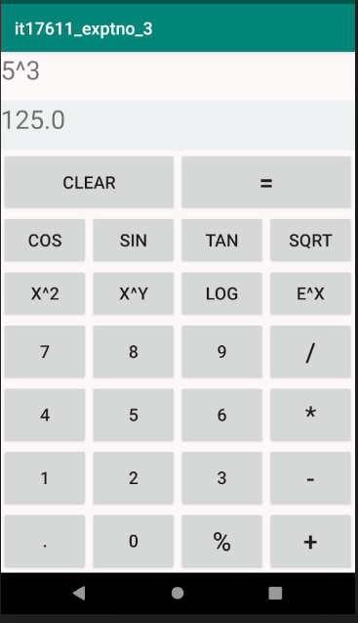

**RESULT:**

Thus, an android application that as a scientific calculator to perform arithmetic and mathematical functions using Math class was developed successfully.

pg. 22

## Expt. No. : 3 Date :

**Reg. No. :**

# Develop an android application to draw the circle, ellipse, rectangle and some text using Android Graphical primitives

## AIM:

To develop an android application to draw the circle, ellipse, rectangle and some text using

Android Graphical primitives.

## PROCEDURE:

**Step 1:** File → NewProject

Provide the application name and Click “Next”

**Step 2:** Select the target android devices,

Select the minimum SDK to run the application. Click “Next”.

**Step 3:** Choose the activity for the application (By default choose “Blank Activity). Click “Next”.

**Step 4:** Enter activity name and click "Finish".

**Step 5:** Edit the program.

**Step 6:** Run the application, 2-ways to run the application

1. Running through emulator
2. Running through mobile device

pg. 23

## PROGRAM:

**AndroidManifest.xml**

<?xml version="1.0" encoding="utf-8"?>

<manifest xmlns:android="[http://schemas.android.com/apk/res/android"](http://schemas.android.com/apk/res/android) package=" com.example.it17611_exptno_4 ">

<application android:allowBackup="true" android:icon="@mipmap/ic_launcher" android:label="@string/app_name"

android:roundIcon="@mipmap/ic_launcher_round" android:supportsRtl="true" android:theme="@style/AppTheme">

<activity android:name=".MainActivity">

<intent-filter>

<action android:name="android.intent.action.MAIN" />

<category android:name="android.intent.category.LAUNCHER" />

</intent-filter>

</activity>

</application>

</manifest>

## activity_main.xml

<?xml version="1.0" encoding="utf-8"?>

<LinearLayout xmlns:android="[http://schemas.android.com/apk/res/android"](http://schemas.android.com/apk/res/android) xmlns:app="[http://schemas.android.com/apk/res-auto"](http://schemas.android.com/apk/res-auto) xmlns:tools="<http://schemas.android.com/tools>" android:layout_width="match_parent" android:layout_height="match_parent"

android:orientation="vertical" tools:context=".MainActivity">

<LinearLayout android:layout_width="match_parent" android:layout_height="50dp" android:orientation="horizontal" android:layout_gravity="bottom">

<TextView android:layout_width="match_parent" android:layout_height="match_parent" android:text="Graphical Primitives" android:textSize="30dp"/>

</LinearLayout>

<com.example.it17611_exptno_4.TouchScreen android:id="@+id/t1" android:layout_width="fill_parent" android:layout_height="fill_parent"

pg. 24

android:layout_weight="1" />

<LinearLayout android:layout_width="match_parent" android:layout_height="50dp" android:orientation="horizontal" android:layout_gravity="bottom">

<Button

android:id="@+id/b1" android:layout_width="wrap_content" android:layout_height="wrap_content" android:text="Circle/Ellipse" android:singleLine="false"/>

<Button

android:id="@+id/b2" android:layout_width="wrap_content" android:layout_height="wrap_content" android:text="Square/Rect"/>

<Button

android:id="@+id/b3" android:layout_width="wrap_content" android:layout_height="wrap_content" android:text="Text"/>

<Button

android:id="@+id/b4" android:layout_width="wrap_content" android:layout_height="wrap_content" android:text="Clear"/>

</LinearLayout>

</LinearLayout>

## MainActivity.java

package com.example.it17611_exptno_4;

import androidx.appcompat.app.AppCompatActivity; import android.os.Bundle;

import android.view.View; import android.widget.Button;

public class MainActivity extends AppCompatActivity { TouchScreen t1;

Button b1,b2,b3,b4; @Override

protected void onCreate(Bundle savedInstanceState) { super.onCreate(savedInstanceState); setContentView(R.layout.activity_main); t1=(TouchScreen)findViewById(R.id.t1); b1=(Button)findViewById(R.id.b1); b2=(Button)findViewById(R.id.b2); b3=(Button)findViewById(R.id.b3); b4=(Button)findViewById(R.id.b4);

b1.setOnClickListener(new View.OnClickListener() {

pg. 25

@Override

public void onClick(View v) { t1.setDrawint(0);}

});

b2.setOnClickListener(new View.OnClickListener() { @Override

public void onClick(View v) { t1.setDrawint(1);

}

});

b3.setOnClickListener(new View.OnClickListener() { @Override

public void onClick(View v) { t1.setDrawint(2);

}

});

b4.setOnClickListener(new View.OnClickListener() { @Override

public void onClick(View v) { t1.startDrawing();

}

});

}

}

## TouchScreen.java

package com.example.it17611_exptno_4; import android.content.Context;

import android.graphics.Canvas; import android.graphics.Color; import android.graphics.Paint; import android.graphics.Path; import android.graphics.RectF; import android.util.AttributeSet; import android.view.MotionEvent; import android.view.View;

public class TouchScreen extends View { Paint paint=new Paint();

Path path=new Path(); float x,y,x1,y1;

int flag;

public TouchScreen(Context context, AttributeSet attributeSet)

{

super(context,attributeSet); paint.setColor(Color.RED); paint.setAntiAlias(true); paint.setStrokeJoin(Paint.Join.ROUND); paint.setStyle(Paint.Style.STROKE); paint.setStrokeWidth(5f);

}

@Override

public void onDraw(Canvas canvas)

pg. 26

{canvas.drawPath(path,paint);

}

@Override

public boolean onTouchEvent(MotionEvent event)

{

if(flag==2) {

float X = event.getX(); float Y = event.getY(); switch (event.getAction())

{

case MotionEvent.ACTION_DOWN: path.moveTo(X, Y);

return true;

case MotionEvent.ACTION_MOVE: path.lineTo(X, Y);

break;

case MotionEvent.ACTION_UP: break;

default:

return false;

}

}

if(flag == 0 || flag == 1){ switch (event.getAction()) {

case MotionEvent.ACTION_DOWN: x = event.getX();

y = event.getY(); return true;

case MotionEvent.ACTION_MOVE: break;

case MotionEvent.ACTION_UP: x1 = event.getX();

y1 = event.getY();

RectF rectF = new RectF(x, y, x1, y1); if(flag == 0)

path.addOval(rectF, Path.Direction.CCW); if(flag == 1)

path.addRect(rectF, Path.Direction.CCW); break;

default:

return false;

}

}

invalidate(); return true;

}

public void setDrawint(int F)

{

flag=F;

}

public void startDrawing()

{

pg. 27

path.rewind(); invalidate();

}

}

## OUTPUT:

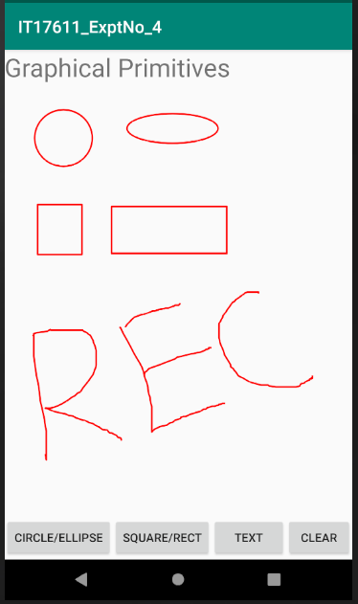

**RESULT:**

Thus, an android application to draw the circle, ellipse, rectangle and some text using Android Graphical primitives was developed successfully.

pg. 28

## Expt. No. : 4 Date :

**Reg. No. :**

# Develop an android application to create Two activity named as StudentBasicDetailsActivity (name, age, address) and StudentMarkActivity (Marks, Total, Grade, Status). Write an android code to combine these two activities in single screen using android fragment.

## AIM:

To develop an android application to combine two activities in single screen using android

fragment.

## PROCEDURE:

**Step 1:** File → NewProject

Provide the application name and Click “Next”

**Step 2:** Select the target android devices,

Select the minimum SDK to run the application. Click “Next”.

**Step 3:** Choose the activity for the application (By default choose “Blank Activity). Click “Next”.

**Step 4:** Enter activity name and click "Finish".

**Step 5:** Edit the program.

**Step 6:** Run the application, 2-ways to run the application

1. Running through emulator
2. Running through mobile device

pg. 29

## PROGRAM:

**AndroidManifest.xml**

<?xml version="1.0" encoding="utf-8"?>

<manifest xmlns:android="[http://schemas.android.com/apk/res/android"](http://schemas.android.com/apk/res/android) package="com.example.it17611_expt_16">

<application android:allowBackup="true" android:icon="@mipmap/ic_launcher" android:label="@string/app_name"

android:roundIcon="@mipmap/ic_launcher_round" android:supportsRtl="true" android:theme="@style/AppTheme">

<activity android:name=".MainActivity">

<intent-filter>

<action android:name="android.intent.action.MAIN" />

<category android:name="android.intent.category.LAUNCHER" />

</intent-filter>

</activity>

</application>

</manifest>

## activity_main.xml

<?xml version="1.0" encoding="utf-8"?>

<LinearLayout xmlns:android="[http://schemas.android.com/apk/res/android"](http://schemas.android.com/apk/res/android) xmlns:app="[http://schemas.android.com/apk/res-auto"](http://schemas.android.com/apk/res-auto) xmlns:tools="<http://schemas.android.com/tools>" android:layout_width="match_parent" android:layout_height="match_parent"

android:orientation="vertical" tools:context=".MainActivity">

<TextView android:layout_width="wrap_content" android:layout_height="wrap_content"

android:text="Students Details using Fragment" android:layout_marginLeft="50dp" android:layout_marginTop="20dp" android:textSize="20dp" android:textStyle="bold" android:textColor="@color/colorAccent"/>

<LinearLayout android:layout_width="match_parent" android:layout_height="match_parent" android:layout_marginTop="30dp">

<fragment android:id="@+id/fragment1"

android:name="com.example.it17611_expt_16.StudentBasicDetailsActivity"

pg. 30

android:layout_width="0px"

android:layout_height="match_parent" android:layout_weight="1" />

<fragment android:id="@+id/fragment2"

android:name="com.example.it17611_expt_16.StudentMarkActivity" android:layout_width="0px"

android:layout_height="match_parent" android:layout_weight="1" />

</LinearLayout>

</LinearLayout>

## fragment_student_basic_details.xml

*<?*xml version="1.0" encoding="utf-8"*?>*

<FrameLayout xmlns:android="[http://schemas.android.com/apk/res/android"](http://schemas.android.com/apk/res/android) xmlns:tools="<http://schemas.android.com/tools>" android:layout_width="match_parent" android:layout_height="match_parent" tools:context=".StudentBasicDetailsActivity">

<TextView android:layout_width="wrap_content" android:layout_height="wrap_content" android:text="Basic Details" android:layout_marginTop="20dp" android:layout_marginLeft="40dp" android:textStyle="bold" android:textSize="15dp" android:textColor="@color/colorPrimary"/>

<TextView android:layout_width="wrap_content" android:layout_height="wrap_content" android:text="Name : Aravind" android:layout_marginTop="90dp" android:layout_marginLeft="20dp"/>

<TextView android:layout_width="wrap_content" android:layout_height="wrap_content" android:text="Roll No : 2017101" android:layout_marginTop="150dp" android:layout_marginLeft="20dp"/>

<TextView android:layout_width="wrap_content" android:layout_height="wrap_content" android:text="Age : 22" android:layout_marginTop="210dp" android:layout_marginLeft="20dp"/>

pg. 31

<TextView android:layout_width="wrap_content" android:layout_height="wrap_content" android:text="Address : Chennai" android:layout_marginTop="270dp" android:layout_marginLeft="20dp"/>

</FrameLayout>

## fragment_student_mark.xml

<?xml version="1.0" encoding="utf-8"?>

<FrameLayout xmlns:android="[http://schemas.android.com/apk/res/android"](http://schemas.android.com/apk/res/android) xmlns:tools="[http://schemas.android.com/tools"](http://schemas.android.com/tools) android:layout_width="match_parent" android:layout_height="match_parent" tools:context=".StudentMarkActivity">

<TextView android:layout_width="wrap_content" android:layout_height="wrap_content" android:text="Mark Details" android:layout_marginTop="20dp" android:layout_marginLeft="40dp" android:textStyle="bold" android:textSize="15dp" android:textColor="@color/colorPrimary"/>

<TextView android:layout_width="wrap_content" android:layout_height="wrap_content" android:text="Mark 1 : 95" android:layout_marginTop="90dp" android:layout_marginLeft="20dp"/>

<TextView android:layout_width="wrap_content" android:layout_height="wrap_content" android:text="Mark 2 : 89" android:layout_marginTop="150dp" android:layout_marginLeft="20dp"/>

<TextView android:layout_width="wrap_content" android:layout_height="wrap_content" android:text="Mark 3 : 91" android:layout_marginTop="210dp" android:layout_marginLeft="20dp"/>

<TextView android:layout_width="wrap_content" android:layout_height="wrap_content" android:text="Total : 275"

pg. 32

android:layout_marginTop="270dp" android:layout_marginLeft="20dp"/>

<TextView android:layout_width="wrap_content" android:layout_height="wrap_content" android:text="Grade : S" android:layout_marginTop="330dp" android:layout_marginLeft="20dp"/>

<TextView android:layout_width="wrap_content" android:layout_height="wrap_content" android:text="Status : Pass" android:layout_marginTop="400dp" android:layout_marginLeft="20dp"/>

</FrameLayout>

## MainActivity.java

package com.example.it17611_expt_16;

import androidx.appcompat.app.AppCompatActivity; import android.os.Bundle;

public class MainActivity extends AppCompatActivity { @Override

protected void onCreate(Bundle savedInstanceState) { super.onCreate(savedInstanceState); setContentView(R.layout.activity_main);

}

}

## StudentBasicDetailsActivity.java

package com.example.it17611_expt_16; import android.os.Bundle;

import androidx.annotation.NonNull;

import androidx.annotation.Nullable; import androidx.fragment.app.Fragment; import android.view.LayoutInflater; import android.view.View;

import android.view.ViewGroup;

public class StudentBasicDetailsActivity extends Fragment { public static StudentBasicDetailsActivity newInstance() {

return new StudentBasicDetailsActivity();

}

@Override

public View onCreateView(@NonNull LayoutInflater inflater, @Nullable ViewGroup container, @Nullable Bundle savedInstanceState) {

return inflater.inflate(R.layout.fragment_student_basic_details, container, false);

pg. 33

}

}

**StudentMarkActivity.java**

package com.example.it17611_expt_16; import android.os.Bundle;

import androidx.annotation.NonNull; import androidx.annotation.Nullable; import androidx.fragment.app.Fragment; import android.view.LayoutInflater; import android.view.View;

import android.view.ViewGroup;

public class StudentMarkActivity extends Fragment { public static StudentMarkActivity newInstance() {

return new StudentMarkActivity();

}

@Override

public View onCreateView(@NonNull LayoutInflater inflater, @Nullable ViewGroup container, @Nullable Bundle savedInstanceState) {

return inflater.inflate(R.layout.fragment_student_mark, container, false);

}

}

pg. 34

## OUTPUT:

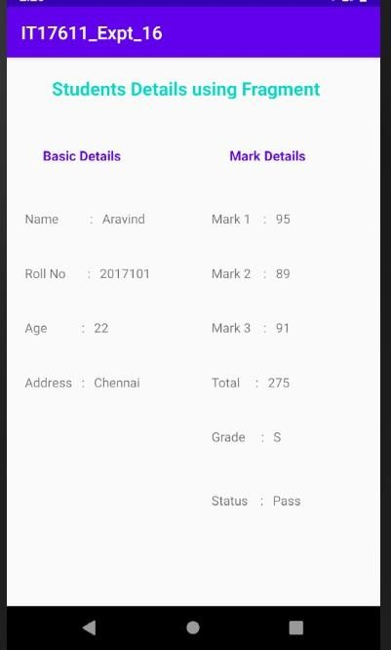

**RESULT:**

Thus, an android application to combine the two activities in single screen using android fragment was developed successfully.

pg. 35

## Expt. No. : 5 Date :

**Reg. No. :**

# Create a Database table with the following structure using SQLite: Student (Name, roll no, Marks). Develop an android application to perform the following operation (1. Insert student Details 2. Update the student Record 3. Delete the student record by Roll no 4. View the details)

## AIM:

To Create a Database table with the following structure using SQLite: Student (Name, roll

no, Marks). Develop an android application to perform the following operation (1. Insert student Details 2. Update the student Record 3. Delete the student record by Roll no 4. View the details).

## PROCEDURE:

**Step 1:** File → NewProject

Provide the application name and Click “Next”

**Step 2:** Select the target android devices,

Select the minimum SDK to run the application. Click “Next”.

**Step 3:** Choose the activity for the application (By default choose “Blank Activity). Click “Next”.

**Step 4:** Enter activity name and click "Finish".

**Step 5:** Edit the program.

**Step 6:** Run the application, 2-ways to run the application

1. Running through emulator
2. Running through mobile device

pg. 36

## PROGRAM:

**AndroidManifest.xml**

<?xml version="1.0" encoding="utf-8"?>

<manifest xmlns:android="[http://schemas.android.com/apk/res/android"](http://schemas.android.com/apk/res/android) package=" com.example.it17611_exptno_5">

<application android:allowBackup="true" android:icon="@mipmap/ic_launcher" android:label="@string/app_name"

android:roundIcon="@mipmap/ic_launcher_round" android:supportsRtl="true" android:theme="@style/AppTheme">

<activity android:name=".MainActivity">

<intent-filter>

<action android:name="android.intent.action.MAIN" />

<category android:name="android.intent.category.LAUNCHER" />

</intent-filter>

</activity>

</application>

</manifest>

## activity_main.xml

<?xml version="1.0" encoding="utf-8"?>

<AbsoluteLayout xmlns:android="[http://schemas.android.com/apk/res/android"](http://schemas.android.com/apk/res/android) xmlns:app="[http://schemas.android.com/apk/res-auto"](http://schemas.android.com/apk/res-auto) xmlns:tools="<http://schemas.android.com/tools>" android:layout_width="match_parent" android:layout_height="match_parent"

tools:context=".MainActivity">

<TextView android:text="Student Details" android:layout_x="150dp" android:layout_y="20dp"

android:layout_width="wrap_content" android:layout_height="wrap_content"/>

<TextView

android:text="Enter Roll No." android:layout_x="30dp" android:layout_y="60dp" android:layout_width="wrap_content" android:layout_height="wrap_content"/>

<EditText android:id="@+id/editRollno" android:inputType="number" android:layout_x="150dp" android:layout_y="50dp"

pg. 37

android:layout_width="150dp" android:layout_height="40dp"/>

<TextView android:text="Enter Name" android:layout_x="30dp" android:layout_y="120dp"

android:layout_width="wrap_content" android:layout_height="wrap_content"/>

<EditText android:id="@+id/editName" android:inputType="text" android:layout_x="150dp" android:layout_y="110dp" android:layout_width="150dp" android:layout_height="40dp"/>

<TextView android:text="Enter Marks" android:layout_x="30dp" android:layout_y="180dp"

android:layout_width="wrap_content" android:layout_height="wrap_content"/>

<EditText android:id="@+id/editMarks" android:inputType="number" android:layout_x="150dp" android:layout_y="160dp" android:layout_width="150dp" android:layout_height="40dp"/>

<Button

android:id="@+id/btnInsert" android:text="Insert" android:layout_x="30dp" android:layout_y="250dp" android:layout_width="100dp" android:layout_height="40dp"/>

<Button

android:id="@+id/btnUpdate" android:text="Update" android:layout_x="140dp" android:layout_y="250dp" android:layout_width="100dp" android:layout_height="40dp"/>

<Button

android:id="@+id/btnDelete" android:text="Delete" android:layout_x="250dp"

pg. 38

android:layout_y="250dp" android:layout_width="100dp"

android:layout_height="40dp"/>

<Button

android:id="@+id/btnView" android:text="View Single Record" android:layout_x="30dp" android:layout_y="350dp" android:layout_width="100dp" android:layout_height="40dp"/>

<Button

android:id="@+id/btnViewAll" android:text="View All Record" android:layout_x="140dp" android:layout_y="350dp" android:layout_width="100dp" android:layout_height="40dp"/>

</AbsoluteLayout>

## MainActivity.java

package com.example.it17611_exptno_5;

import androidx.appcompat.app.AppCompatActivity; import android.os.Bundle;

import android.app.AlertDialog.Builder; import android.content.Context;

import android.database.Cursor;

import android.database.sqlite.SQLiteDatabase; import android.view.View;

import android.view.View.OnClickListener; import android.widget.Button;

import android.widget.EditText;

public class MainActivity extends AppCompatActivity implements OnClickListener

{

EditText editRollno,editName,editMarks;

Button btnInsert,btnUpdate, btnDelete,btnView,btnViewAll; SQLiteDatabase db;

@Override

public void onCreate(Bundle savedInstanceState)

{

super.onCreate(savedInstanceState); setContentView(R.layout.activity_main);

editRollno=(EditText)findViewById(R.id.editRollno); editName=(EditText)findViewById(R.id.editName); editMarks=(EditText)findViewById(R.id.editMarks);

pg. 39

btnInsert=(Button)findViewById(R.id.btnInsert); btnUpdate=(Button)findViewById(R.id.btnUpdate); btnDelete=(Button)findViewById(R.id.btnDelete);

btnView=(Button)findViewById(R.id.btnView); btnViewAll=(Button)findViewById(R.id.btnViewAll);

btnInsert.setOnClickListener(this); btnUpdate.setOnClickListener(this); btnDelete.setOnClickListener(this); btnView.setOnClickListener(this); btnViewAll.setOnClickListener(this);

db=openOrCreateDatabase("StudentDB", Context.MODE_PRIVATE, null); db.execSQL("CREATE TABLE IF NOT EXISTS student(rollno VARCHAR,name

VARCHAR,marks VARCHAR);");

}

public void onClick(View view)

{

if(view==btnInsert)

{

if(editRollno.getText().toString().trim().length()==0|| editName.getText().toString().trim().length()==0||

editMarks.getText().toString().trim().length()==0)

{

showMessage("Error", "Please enter all values"); return;

}

db.execSQL("INSERT INTO student VALUES('"+editRollno.getText()+"','"+editName.getText()+ "','"+editMarks.getText()+"');");

showMessage("Success", "Record added"); clearText();

}

if(view==btnUpdate)

{

if(editRollno.getText().toString().trim().length()==0)

{

showMessage("Error", "Please enter Rollno"); return;

}

Cursor c=db.rawQuery("SELECT * FROM student WHERE rollno='"+editRollno.getText()+"'", null);

if(c.moveToFirst())

{

db.execSQL("UPDATE student SET name='"+editName.getText()+"',marks='"+editMarks.getText()+

"' WHERE rollno='"+editRollno.getText()+"'"); showMessage("Success", "Record Modified");

}

else

{

showMessage("Error", "Invalid Rollno");

}

pg. 40

clearText();

}

if(view==btnDelete)

{

if(editRollno.getText().toString().trim().length()==0)

{

showMessage("Error", "Please enter Rollno"); return;

}

Cursor c=db.rawQuery("SELECT * FROM student WHERE rollno='"+editRollno.getText()+"'", null);

if(c.moveToFirst())

{

db.execSQL("DELETE FROM student WHERE rollno='"+editRollno.getText()+"'"); showMessage("Success", "Record Deleted");

}

else

{

showMessage("Error", "Invalid Rollno");

}

clearText();

}

if(view==btnView)

{

if(editRollno.getText().toString().trim().length()==0)

{

showMessage("Error", "Please enter Rollno"); return;

}

Cursor c=db.rawQuery("SELECT * FROM student WHERE rollno='"+editRollno.getText()+"'", null);

if(c.moveToFirst())

{

editName.setText(c.getString(1)); editMarks.setText(c.getString(2));

}

else

{

showMessage("Error", "Invalid Rollno"); clearText();

}

}

if(view==btnViewAll)

{

Cursor c=db.rawQuery("SELECT * FROM student", null); if(c.getCount()==0)

{

showMessage("Error", "No records found"); return;

}

StringBuffer buffer=new StringBuffer();

pg. 41

while(c.moveToNext())

{

buffer.append("Rollno: "+c.getString(0)+"\n"); buffer.append("Name: "+c.getString(1)+"\n");

buffer.append("Marks: "+c.getString(2)+"\n\n");

}

showMessage("Student Details", buffer.toString());

}

}

public void showMessage(String title,String message)

{

Builder builder=new Builder(this); builder.setCancelable(true); builder.setTitle(title); builder.setMessage(message); builder.show();

}

public void clearText()

{

editRollno.setText(""); editName.setText(""); editMarks.setText(""); editRollno.requestFocus();

}

}

pg. 42

## OUTPUT:

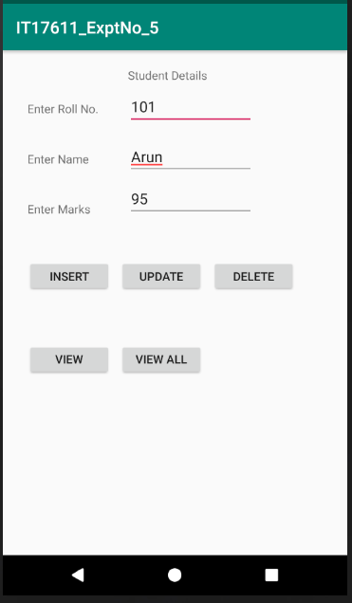

**RESULT:**

Thus, an android application to Create a Database table with the following structure using SQLite: Student (Name, roll no, Marks). was developed successfully.

pg. 43

## Expt. No. : 6 Date :

**Reg. No. :**

# Design an android activity with a text box (username) where the user can enter a name and another text box (ID) where the user enters only four-digit ID NO and a button “validate”. Validate the entered username and ID field for the following using android code. i) Both the fields should not be empty, ii) Name field should have alphabets, iii) ID field should have numeric

## AIM:

To implement an android application to Validate the entered username and ID field.

## PROCEDURE:

**Step 1:** File → NewProject

Provide the application name and Click “Next”

**Step 2:** Select the target android devices,

Select the minimum SDK to run the application. Click “Next”.

**Step 3:** Choose the activity for the application (By default choose “Blank Activity). Click “Next”.

**Step 4:** Enter activity name and click "Finish".

**Step 5:** Edit the program.

**Step 6:** Run the application, 2-ways to run the application

1. Running through emulator
2. Running through mobile device

pg. 44

## PROGRAM:

**AndroidManifest.xml**

<?xml version="1.0" encoding="utf-8"?>

<manifest xmlns:android="[http://schemas.android.com/apk/res/android"](http://schemas.android.com/apk/res/android) package=" com.example.it17611_exptno_7">

<application android:allowBackup="true" android:icon="@mipmap/ic_launcher" android:label="@string/app_name"

android:roundIcon="@mipmap/ic_launcher_round" android:supportsRtl="true" android:theme="@style/AppTheme">

<activity android:name=".MainActivity">

<intent-filter>

<action android:name="android.intent.action.MAIN" />

<category android:name="android.intent.category.LAUNCHER" />

</intent-filter>

</activity>

</application>

</manifest>

## activity_main.xml

<?xml version="1.0" encoding="utf-8"?>

<AbsoluteLayout xmlns:android="[http://schemas.android.com/apk/res/android"](http://schemas.android.com/apk/res/android) xmlns:app="[http://schemas.android.com/apk/res-auto"](http://schemas.android.com/apk/res-auto) xmlns:tools="<http://schemas.android.com/tools>" android:layout_width="match_parent" android:layout_height="match_parent"

tools:context=".MainActivity">

<TextView android:text="User Name" android:layout_x="30dp" android:layout_y="60dp"

android:layout_width="wrap_content" android:layout_height="wrap_content"/>

<EditText android:id="@+id/editUName"

android:layout_x="150dp" android:layout_y="50dp" android:layout_width="150dp" android:layout_height="40dp"/>

<TextView android:text="ID NO" android:layout_x="30dp"

android:layout_y="120dp"

pg. 45

android:layout_width="wrap_content" android:layout_height="wrap_content"/>

<EditText android:id="@+id/editIDNo"

android:layout_x="150dp" android:layout_y="110dp" android:layout_width="150dp" android:layout_height="40dp"/>

<Button

android:id="@+id/btnValidate" android:text="Validate" android:layout_x="30dp" android:layout_y="250dp" android:layout_width="150dp" android:layout_height="40dp"/>

</AbsoluteLayout>

## MainActivity.java

package com.example.it17611_exptno_7;

import androidx.appcompat.app.AppCompatActivity; import android.os.Bundle;

import android.view.View; import android.widget.Button; import android.widget.EditText; import android.widget.Toast;

public class MainActivity extends AppCompatActivity { EditText editUName, editIDNo;

Button btnValidate;

@Override

protected void onCreate(Bundle savedInstanceState) { super.onCreate(savedInstanceState); setContentView(R.layout.activity_main);

editUName=(EditText)findViewById(R.id.editUName); editIDNo=(EditText)findViewById(R.id.editIDNo); btnValidate=(Button)findViewById(R.id.btnValidate);

pg. 46

btnValidate.setOnClickListener(new View.OnClickListener(){ @Override

public void onClick(View view) { if(editUName.getText().toString().matches("[a-zA-Z ]+") &&

(editIDNo.getText().toString().matches("[\\d]+")&& editIDNo.getText().toString().trim().length()==4))

Toast.makeText(getApplicationContext(), "Validation Successful", Toast.LENGTH_LONG).show();

if(editUName.getText().toString().trim().length()==0 ||

editIDNo.getText().toString().trim().length()==0) Toast.makeText(getApplicationContext(),"Please enter allvalues", Toast.LENGTH_LONG).show();

if(!(editUName.getText().toString().trim().matches("[a-zA-Z ]+"))) Toast.makeText(getApplicationContext(),"Please enter only alphabets",Toast.LENGTH_LONG).show();

}

});

}

}

if(!(editIDNo.getText().toString().trim().matches("[\\d ]+")) || editIDNo.getText().toString().trim().length()!=4)

Toast.makeText(getApplicationContext(),"Please enter only four digit number", Toast.LENGTH_LONG).show();

pg. 47

## OUTPUT:

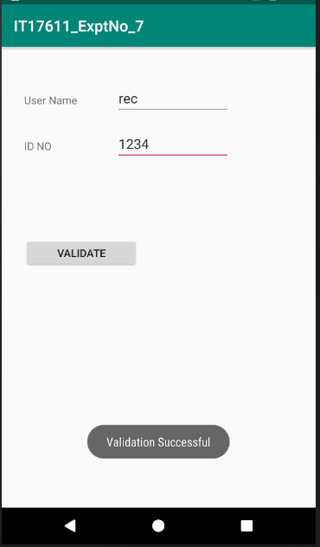

**RESULT:**

Thus, an android application that Validate the entered username and ID field was developed successfully.

pg. 48

## Expt. No. : 7 Date :

**Reg. No. :**

# Develop an application to get the Latitude, Longitudes of the current location using android Location Manager and also convert the Latitude/Longitude to address format using Geocoder Class.

## AIM:

To develop a native application to get the Latitude, Longitudes of the current location using

Geocoder Class.

## PROCEDURE:

**Step 1:** File → NewProject

Provide the application name and Click “Next”

**Step 2:** Select the target android devices,

Select the minimum SDK to run the application. Click “Next”.

**Step 3:** Choose the activity for the application (By default choose “Blank Activity). Click “Next”.

**Step 4:** Enter activity name and click "Finish".

**Step 5:** Edit the program.

**Step 6:** Run the application, 2-ways to run the application

1. Running through emulator
2. Running through mobile device

pg. 49

## PROGRAM:

**AndroidManifest.xml**

<?xml version="1.0" encoding="utf-8"?>

<manifest xmlns:android="[http://schemas.android.com/apk/res/android"](http://schemas.android.com/apk/res/android) package="com.example.it17611_expt_8">

<uses-permission android:name="android.permission.ACCESS_FINE_LOCATION"/>

<uses-permission android:name="android.permission.ACCESS_COARSE_LOCATION"/>

<application android:allowBackup="true" android:icon="@mipmap/ic_launcher" android:label="@string/app_name"

android:roundIcon="@mipmap/ic_launcher_round" android:supportsRtl="true" android:theme="@style/AppTheme">

<activity android:name=".MainActivity">

<intent-filter>

<action android:name="android.intent.action.MAIN" />

<category android:name="android.intent.category.LAUNCHER" />

</intent-filter>

</activity>

</application>

</manifest>

## activity_main.xml

<?xml version="1.0" encoding="utf-8"?>

<RelativeLayout xmlns:android="[http://schemas.android.com/apk/res/android"](http://schemas.android.com/apk/res/android) xmlns:app="[http://schemas.android.com/apk/res-auto"](http://schemas.android.com/apk/res-auto) xmlns:tools="<http://schemas.android.com/tools>" android:layout_width="match_parent" android:layout_height="match_parent"

tools:context=".MainActivity">

<TextView android:layout_width="wrap_content" android:layout_height="wrap_content" android:layout_centerHorizontal="true" android:layout_marginTop="50dp" android:text="GPS Location" android:textStyle="bold"/>

<TextView android:layout_width="wrap_content" android:layout_height="wrap_content" android:layout_marginLeft="20dp" android:layout_marginTop="120dp" android:text="Longitude and Latitude" android:textStyle="bold"/>

<TextView android:layout_width="wrap_content"

pg. 50

android:layout_height="wrap_content"

android:layout_marginLeft="180dp" android:layout_marginTop="120dp" android:text="" android:id="@+id/t1" android:padding="5dp"/>

<TextView android:layout_width="wrap_content" android:layout_height="wrap_content" android:layout_marginLeft="20dp" android:layout_marginTop="200dp" android:text="GPS Location Address" android:textStyle="bold" />

<TextView android:layout_width="wrap_content" android:layout_height="wrap_content" android:layout_marginLeft="180dp" android:layout_marginTop="200dp" android:text=""

android:id="@+id/t2" android:padding="5dp"/>

<Button

android:layout_width="wrap_content" android:layout_height="wrap_content" android:layout_centerHorizontal="true" android:layout_marginTop="300dp" android:text="Get Location" android:id="@+id/b1"/>

</RelativeLayout>

## MainActivity.java

package com.example.it17611_expt_8;

import androidx.appcompat.app.AppCompatActivity; import androidx.core.app.ActivityCompat;

import androidx.core.content.ContextCompat;

import android.content.Context; import android.location.Address; import android.location.Geocoder; import android.os.Bundle;

import android.content.pm.PackageManager; import android.location.Location;

import android.location.LocationListener; import android.location.LocationManager; import android.view.View;

import android.widget.Button;

pg. 51

import android.widget.TextView; import android.widget.Toast;

import java.util.List; import java.util.Locale;

public class MainActivity extends AppCompatActivity implements LocationListener{ TextView t1, t2;

Button b1; LocationManager LM;

@Override

protected void onCreate(Bundle savedInstanceState) { super.onCreate(savedInstanceState); setContentView(R.layout.activity_main);

t1 = (TextView)findViewById(R.id.t1); t2 = (TextView)findViewById(R.id.t2); b1 = (Button)findViewById(R.id.b1);

if (ContextCompat.checkSelfPermission(getApplicationContext(), android.Manifest.permission.ACCESS_FINE_LOCATION) != PackageManager.PERMISSION_GRANTED &&

ActivityCompat.checkSelfPermission(getApplicationContext(),android.Manifest.permission.ACCES S_COARSE_LOCATION) != PackageManager.PERMISSION_GRANTED)

{

ActivityCompat.requestPermissions(this, new String[]{android.Manifest.permission.ACCESS_FINE_LOCATION,

android.Manifest.permission.ACCESS_COARSE_LOCATION}, 101);

}

b1.setOnClickListener(new View.OnClickListener() { @Override

public void onClick(View v) { getLocation();

pg. 52

}

});

}

void getLocation() { try {

LM = (LocationManager) getSystemService(Context.LOCATION_SERVICE);

LM.requestLocationUpdates(LocationManager.NETWORK_PROVIDER, 5000,5, this);

}

catch(SecurityException e) { e.printStackTrace();

}

}

@Override

public void onLocationChanged(Location location) {

t1.setText("Latitude: " + location.getLatitude() + "\nLongitude: " + location.getLongitude()); try {

Geocoder geocoder = new Geocoder(this, Locale.getDefault()); List<Address> addresses = geocoder.getFromLocation(location.getLatitude(),

location.getLongitude(), 1); t2.setText(addresses.get(0).getAddressLine(0)+","+

addresses.get(0).getAddressLine(1)+","+addresses.get(0).getAddressLine(2));

//t1.getText() + "\n" +

}catch(Exception e)

{

}

}

@Override

public void onProviderDisabled(String provider) { Toast.makeText(MainActivity.this, "Please Enable GPS and Internet",

Toast.LENGTH_SHORT).show();

}

@Override

public void onStatusChanged(String provider, int status, Bundle extras) {

}

@Override

public void onProviderEnabled(String provider) {

}

}

pg. 53

## OUTPUT:

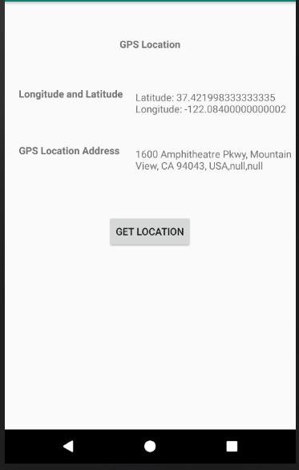

**RESULT:**

Thus, a native application that uses GPS location information using android studio and sdk was developed successfully.

pg. 54

## Expt. No. : 8 Date :

**Reg. No. :**

# Implement an application to write the name and marks to SD card in text file format.

## AIM:

To implement an android application that writes data (name and marks) to the SD card in text

file format using android studio and sdk.

## PROCEDURE:

**Step 1:** File → NewProject

Provide the application name and Click “Next”

**Step 2:** Select the target android devices,

Select the minimum SDK to run the application. Click “Next”.

**Step 3:** Choose the activity for the application (By default choose “Blank Activity). Click “Next”.

**Step 4:** Enter activity name and click "Finish".

**Step 5:** Edit the program.

**Step 6:** Run the application, 2-ways to run the application

1. Running through emulator
2. Running through mobile device

pg. 55

## PROGRAM:

**AndroidManifest.xml**

<?xml version="1.0" encoding="utf-8"?>

<manifest xmlns:android="[http://schemas.android.com/apk/res/android"](http://schemas.android.com/apk/res/android) package="com.example.it17611_expt_9">

<application android:allowBackup="true" android:icon="@mipmap/ic_launcher" android:label="@string/app_name"

android:roundIcon="@mipmap/ic_launcher_round" android:supportsRtl="true" android:theme="@style/AppTheme">

<activity android:name=".MainActivity">

<intent-filter>

<action android:name="android.intent.action.MAIN" />

<category android:name="android.intent.category.LAUNCHER" />

</intent-filter>

</activity>

</application>

</manifest>

## activity_main.xml

<?xml version="1.0" encoding="utf-8"?>

<RelativeLayout xmlns:android="[http://schemas.android.com/apk/res/android"](http://schemas.android.com/apk/res/android) xmlns:app="[http://schemas.android.com/apk/res-auto"](http://schemas.android.com/apk/res-auto) xmlns:tools="<http://schemas.android.com/tools>" android:layout_width="match_parent" android:layout_height="match_parent"

tools:context=".MainActivity">

<TextView android:layout_width="wrap_content" android:layout_height="wrap_content" android:layout_centerHorizontal="true" android:textSize="40px"

android:text="Read and Write Data in SD Card" android:id="@+id/textView" />

<EditText android:layout_width="match_parent" android:layout_height="200dp" android:layout_marginTop="30dp" android:id="@+id/E1" />

<Button

android:text="Save" android:layout_width="75dp" android:layout_height="wrap_content" android:layout_marginLeft="0dp" android:layout_marginTop="230dp" android:id="@+id/B1" />

pg. 56

<Button

android:text="Read" android:layout_width="75dp" android:layout_height="wrap_content" android:layout_marginLeft="80dp" android:layout_marginTop="230dp" android:id="@+id/B2" />

<Button

android:text="Clear" android:layout_width="75dp" android:layout_height="wrap_content" android:layout_marginLeft="160dp" android:layout_marginTop="230dp" android:id="@+id/B3" />

</RelativeLayout>

## MainActivity.java

package com.example.it17611_expt_9;

import androidx.appcompat.app.AppCompatActivity; import android.os.Bundle;

import android.view.View; import android.widget.Button; import android.widget.EditText; import android.widget.Toast; import java.io.FileInputStream; import java.io.FileOutputStream;

public class MainActivity extends AppCompatActivity { EditText E1;

Button B1,B2,B3; String data;

String filename="mydata.txt";

@Override

protected void onCreate(Bundle savedInstanceState) { super.onCreate(savedInstanceState); setContentView(R.layout.activity_main);

E1 = (EditText) findViewById(R.id.E1); B1 = (Button) findViewById(R.id.B1); B2 = (Button) findViewById(R.id.B2); B3 = (Button) findViewById(R.id.B3); E1.setHint("Enter Some Text Here");

B1.setOnClickListener(new View.OnClickListener() { @Override

public void onClick(View view) { writeData();

pg. 57

}

});

B2.setOnClickListener(new View.OnClickListener() { @Override

public void onClick(View view) { readData();

}

});

B3.setOnClickListener(new View.OnClickListener() { @Override

public void onClick(View view) { E1.setText("");

}

});

}

public void writeData()

{

String data=E1.getText().toString();try

{

FileOutputStream fos=openFileOutput(filename,MODE_PRIVATE); fos.write(data.getBytes());

fos.close(); Toast.makeText(getApplicationContext(),"File Saved: "

+ filename,Toast.LENGTH_LONG).show();

}

catch (Exception e)

{

Toast.makeText(getApplicationContext(),e.getMessage(), Toast.LENGTH_LONG).show();

}

}

public void readData()

{

int c;

String temp=""; try

{

FileInputStream fis=openFileInput(filename); while((c=fis.read())!=-1)

{

temp=temp+Character.toString((char)c);

}

E1.setText(temp); Toast.makeText(getApplicationContext(), "File Read: "

+ filename, Toast.LENGTH_LONG).show();

}

catch (Exception e)

{

Toast.makeText(getApplicationContext(), e.getMessage(), Toast.LENGTH_LONG).show();

}

}

}

pg. 58

## OUTPUT:

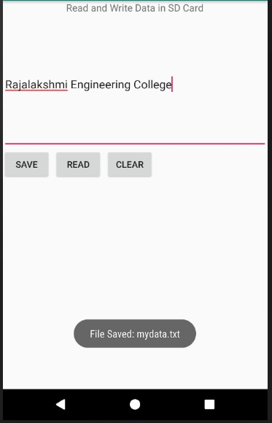

**RESULT:**

Thus, an android application to writes data to the SD card using android studio and sdk was implemented successfully.

pg. 59

## Expt. No. : 9 Date :

**Reg. No. :**

# Implement an application to display the alert box message when your application receives the SMS.

## AIM:

To implement an android application to display the alert box message when your application

receives the SMS.

## PROCEDURE:

**Step 1:** File → NewProject

Provide the application name and Click “Next”

**Step 2:** Select the target android devices,

Select the minimum SDK to run the application. Click “Next”.

**Step 3:** Choose the activity for the application (By default choose “Blank Activity). Click “Next”.

**Step 4:** Enter activity name and click "Finish".

**Step 5:** Edit the program.

**Step 6:** Run the application, 2-ways to run the application

1. Running through emulator
2. Running through mobile device

pg. 60

## PROGRAM:

**AndroidManifest.xml**

<?xml version="1.0" encoding="utf-8"?>

<manifest xmlns:android="[http://schemas.android.com/apk/res/android"](http://schemas.android.com/apk/res/android) package="com.example.it17611_expt_10">

<application android:allowBackup="true" android:icon="@mipmap/ic_launcher" android:label="@string/app_name"

android:roundIcon="@mipmap/ic_launcher_round" android:supportsRtl="true" android:theme="@style/AppTheme">

<activity android:name=".MainActivity">

<intent-filter>

<action android:name="android.intent.action.MAIN" />

<category android:name="android.intent.category.LAUNCHER" />

</intent-filter>

</activity>

<activity android:name=".SmsAlert"></activity>

</application>

</manifest>

## activity_main.xml

<?xml version="1.0" encoding="utf-8"?>

<RelativeLayout xmlns:android="[http://schemas.android.com/apk/res/android"](http://schemas.android.com/apk/res/android) xmlns:app="[http://schemas.android.com/apk/res-auto"](http://schemas.android.com/apk/res-auto) xmlns:tools="<http://schemas.android.com/tools>" android:layout_width="match_parent" android:layout_height="match_parent"

tools:context=".MainActivity">

<TextView android:layout_width="wrap_content" android:layout_height="wrap_content" android:text="Alert Box" android:layout_centerHorizontal="true" android:layout_marginTop="50dp" android:textSize="30sp"/>

<TextView android:layout_width="wrap_content" android:layout_height="wrap_content" android:layout_marginLeft="20dp" android:layout_marginTop="150dp" android:text=" Type Message" android:textSize="20sp" />

pg. 61

<EditText android:id="@+id/editText"

android:layout_width="match_parent" android:layout_height="wrap_content" android:layout_marginLeft="20dp" android:layout_marginTop="200dp" android:singleLine="true" android:textSize="20sp" />

<Button

android:id="@+id/button" android:layout_width="wrap_content" android:layout_height="wrap_content" android:layout_marginLeft="20dp" android:layout_marginTop="300dp" android:text="Alert" android:textSize="20sp"/>

</RelativeLayout>

## activity_sms_aler.xml

<?xml version="1.0" encoding="utf-8"?>

<RelativeLayout xmlns:android="[http://schemas.android.com/apk/res/android"](http://schemas.android.com/apk/res/android) xmlns:app="[http://schemas.android.com/apk/res-auto"](http://schemas.android.com/apk/res-auto) xmlns:tools="<http://schemas.android.com/tools>" android:layout_width="match_parent" android:layout_height="match_parent"

tools:context=".SmsAlert">

<TextView android:layout_width="wrap_content" android:layout_height="wrap_content" android:layout_marginLeft="50dp" android:layout_marginTop="150dp" android:text="" android:id="@+id/showmsg" android:textSize="20sp" />

</RelativeLayout>

pg. 62

## MainActivity.java

package com.example.it17611_expt_10;

import androidx.appcompat.app.AppCompatActivity; import android.app.AlertDialog;

import android.content.DialogInterface; import android.os.Bundle;

import android.content.Intent; import android.view.View; import android.widget.Button; import android.widget.EditText; import android.widget.Toast;

public class MainActivity extends AppCompatActivity

{

Button notify; EditText sms;

AlertDialog.Builder builder; @Override

protected void onCreate(Bundle savedInstanceState)

{

super.onCreate(savedInstanceState); setContentView(R.layout.activity_main);

notify= (Button) findViewById(R.id.button); sms= (EditText) findViewById(R.id.editText); builder = new AlertDialog.Builder(this);

notify.setOnClickListener(new View.OnClickListener() { @Override

public void onClick(View v) {

final String message = sms.getText().toString(); if(message != "") {

builder.setMessage(message).setTitle("New Message"); builder.setMessage(message)

.setCancelable(false)

.setPositiveButton("OK", new DialogInterface.OnClickListener() { public void onClick(DialogInterface dialog, int id) {

Intent smsIntent = new Intent(MainActivity.this, SmsAlert.class); smsIntent.putExtra("sms", message);

startActivity(smsIntent); finish();

}

});

AlertDialog alert = builder.create(); alert.setTitle("New Message"); alert.show();

}

pg. 63

else{

Toast.makeText(getApplicationContext(),

"Type Message in Message Box",Toast.LENGTH_LONG).show();

}

}

});

}

}

## SmsAlert.java

package com.example.it17611_expt_10;

import androidx.appcompat.app.AppCompatActivity; import android.os.Bundle;

import android.widget.TextView;

public class SmsAlert extends AppCompatActivity { TextView showmsg;

@Override

protected void onCreate(Bundle savedInstanceState) { super.onCreate(savedInstanceState); setContentView(R.layout.activity_sms_alert); showmsg = findViewById(R.id.showmsg);

Bundle extras = getIntent().getExtras(); showmsg.setText(extras.getString("sms"));

}

}

pg. 64

## OUTPUT:

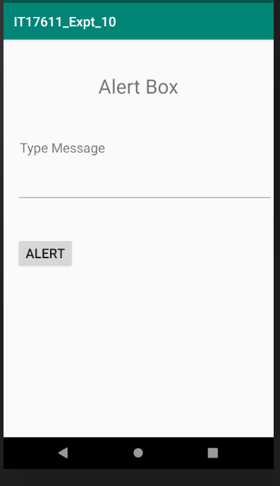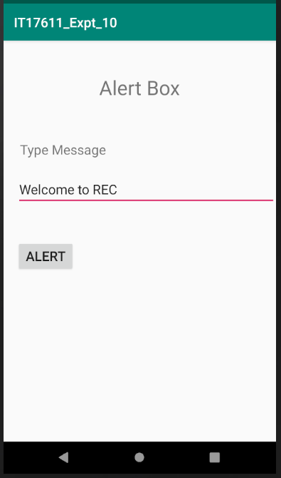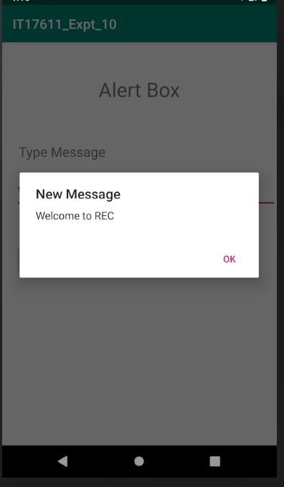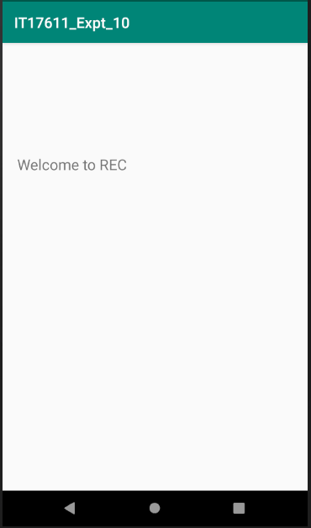

**RESULT:**

Thus, an android application to display the alert box message when your application receives the SMS was implemented successfully.

pg. 65

## Expt. No. : 10 Date :

**Reg. No. :**

# Write a mobile application to set the alarm using android Alarm Manager class and also snooze the alarm after every 10 minutes.

## AIM:

To develop an android application to set the alarm using android Alarm Manager class and

also snooze the alarm after every 10 minutes.

## PROCEDURE:

**Step 1:** File → NewProject

Provide the application name and Click “Next”

**Step 2:** Select the target android devices,

Select the minimum SDK to run the application. Click “Next”.

**Step 3:** Choose the activity for the application (By default choose “Blank Activity). Click “Next”.

**Step 4:** Enter activity name and click "Finish".

**Step 5:** Edit the program.

**Step 6:** Run the application, 2-ways to run the application

1. Running through emulator
2. Running through mobile device

pg. 66

## PROGRAM:

**AndroidManifest.xml**

<?xml version="1.0" encoding="utf-8"?>

<manifest xmlns:android="[http://schemas.android.com/apk/res/android"](http://schemas.android.com/apk/res/android) package="com.example.it17611_expt_11">

<application android:allowBackup="true" android:icon="@mipmap/ic_launcher" android:label="@string/app_name"

android:roundIcon="@mipmap/ic_launcher_round" android:supportsRtl="true" android:theme="@style/AppTheme">

<activity android:name=".MainActivity">

<intent-filter>

<action android:name="android.intent.action.MAIN" />

<category android:name="android.intent.category.LAUNCHER" />

</intent-filter>

</activity>

<receiver android:name=".AlarmReceiver" />

</application>

</manifest>

## activity_main.xml

<?xml version="1.0" encoding="utf-8"?>

<RelativeLayout xmlns:android="[http://schemas.android.com/apk/res/android"](http://schemas.android.com/apk/res/android) xmlns:app="[http://schemas.android.com/apk/res-auto"](http://schemas.android.com/apk/res-auto) xmlns:tools="<http://schemas.android.com/tools>" android:layout_width="match_parent" android:layout_height="match_parent"

tools:context=".MainActivity">

<TimePicker android:id="@+id/timePicker" android:layout_width="wrap_content" android:layout_height="wrap_content" android:layout_gravity="center" />

<Button

android:id="@+id/btnSet" android:layout_width="wrap_content" android:layout_height="wrap_content" android:layout_gravity="center" android:layout_marginTop="400dp" android:layout_marginLeft="60dp" android:text="Set Alaram"/>

<Button

android:id="@+id/btnStop"

pg. 67

android:layout_width="wrap_content" android:layout_height="wrap_content"

android:layout_gravity="center" android:layout_marginTop="400dp" android:layout_marginLeft="230dp" android:text="Stop Alaram"/>

</RelativeLayout>

## MainActivity.java

package com.example.it17611_expt_11; import android.app.Activity;

import android.app.AlarmManager;

import android.app.PendingIntent; import android.content.Intent; import android.os.Bundle;

import android.view.View; import android.widget.Button;

import android.widget.TimePicker; import android.widget.Toast;

import androidx.appcompat.app.AppCompatActivity; import java.util.Calendar;

public class MainActivity extends AppCompatActivity

{

TimePicker alarmTimePicker; PendingIntent pendingIntent; AlarmManager alarmManager; Button btnSet, btnStop;

@Override

protected void onCreate(Bundle savedInstanceState)

{

super.onCreate(savedInstanceState); setContentView(R.layout.activity_main);

alarmTimePicker = (TimePicker) findViewById(R.id.timePicker); btnSet = (Button)findViewById(R.id.btnSet);

btnStop = (Button)findViewById(R.id.btnStop);

alarmManager = (AlarmManager) getSystemService(ALARM_SERVICE);

btnSet.setOnClickListener(new View.OnClickListener() { @Override

public void onClick(View view) { long time;

Toast.makeText(MainActivity.this, "ALARM ON", Toast.LENGTH_SHORT).show(); Calendar calendar = Calendar.getInstance();

calendar.set(Calendar.HOUR_OF_DAY, alarmTimePicker.getCurrentHour()); calendar.set(Calendar.MINUTE, alarmTimePicker.getCurrentMinute());

pg. 68

time=(calendar.getTimeInMillis()-(calendar.getTimeInMillis()%60000));

//time = calendar.getTimeInMillis() + 600000;

AlarmManager am = (AlarmManager) getSystemService(Activity.ALARM_SERVICE); Intent intent = new Intent(MainActivity.this, AlarmReceiver.class);

pendingIntent = PendingIntent.getBroadcast(MainActivity.this, 1, intent, 0);

//alarmManager.setRepeating(AlarmManager.RTC_WAKEUP, time, 10000, pendingIntent);

alarmManager.set(AlarmManager.RTC_WAKEUP, time, pendingIntent);

}

});

btnStop.setOnClickListener(new View.OnClickListener() { @Override

public void onClick(View view) { alarmManager.cancel(pendingIntent);

Toast.makeText(MainActivity.this, "ALARM OFF", Toast.LENGTH_SHORT).show();

}

});

}

}

## AlarmReceiver.java

package com.example.it17611_expt_11;

import android.content.BroadcastReceiver; import android.content.Context;

import android.content.Intent; import android.media.Ringtone;

import android.media.RingtoneManager; import android.net.Uri;

import android.widget.Toast;

public class AlarmReceiver extends BroadcastReceiver { @Override

public void onReceive(Context context, Intent intent) {

Toast.makeText(context, "Alarm! Wake up! Wake up!", Toast.LENGTH_LONG).show(); Uri alarmUri = RingtoneManager.getDefaultUri(RingtoneManager.TYPE_ALARM);

if (alarmUri == null)

{

alarmUri = RingtoneManager.getDefaultUri(RingtoneManager.TYPE_NOTIFICATION);

}

Ringtone ringtone = RingtoneManager.getRingtone(context, alarmUri); ringtone.play();

}

}

pg. 69

## OUTPUT:

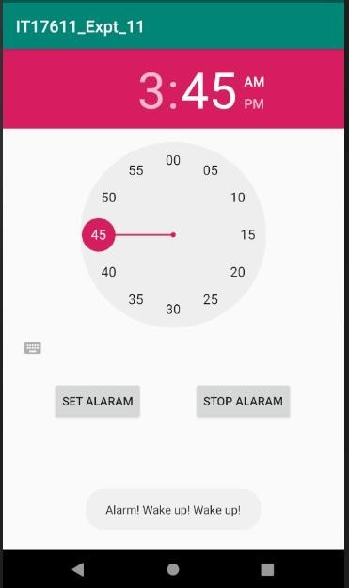

**RESULT:**

Thus, an android application to set the alarm using android Alarm Manager class and also snooze the alarm after every 10 minutes was developed successfully.

pg. 70

## Expt. No. : 11 Date :

**Reg. No. :**

# Develop an android application to display the information of the telephony services.

## Date:

**AIM:**

To develop an android application to set the alarm using android Alarm Manager class and

also snooze the alarm after every 10 minutes.

## PROCEDURE:

**Step 1:** File → NewProject

Provide the application name and Click “Next”

**Step 2:** Select the target android devices,

Select the minimum SDK to run the application. Click “Next”.

**Step 3:** Choose the activity for the application (By default choose “Blank Activity). Click “Next”.

**Step 4:** Enter activity name and click "Finish".

**Step 5:** Edit the program.

**Step 6:** Run the application, 2-ways to run the application

1. Running through emulator
2. Running through mobile device

pg. 71

## PROGRAM:

**AndroidManifest.xml**

<?xml version="1.0" encoding="utf-8"?>

<manifest xmlns:android="[http://schemas.android.com/apk/res/android"](http://schemas.android.com/apk/res/android) package="com.example.it17611_expt_15">

<uses-permission android:name="android.permission.INTERNET"/>

<uses-permission android:name="android.permission.READ_PHONE_STATE"/>

<application android:allowBackup="true" android:icon="@mipmap/ic_launcher" android:label="@string/app_name"

android:roundIcon="@mipmap/ic_launcher_round" android:supportsRtl="true" android:theme="@style/AppTheme">

<activity android:name=".MainActivity">

<intent-filter>

<action android:name="android.intent.action.MAIN" />

<category android:name="android.intent.category.LAUNCHER" />

</intent-filter>

</activity>

<service

android:name=".MyService" android:enabled="true" android:exported="true"/>

</application>

</manifest>

## activity_main.xml

<?xml version="1.0" encoding="utf-8"?>

<RelativeLayout xmlns:android="[http://schemas.android.com/apk/res/android"](http://schemas.android.com/apk/res/android) xmlns:app="[http://schemas.android.com/apk/res-auto"](http://schemas.android.com/apk/res-auto) xmlns:tools="<http://schemas.android.com/tools>" android:layout_width="match_parent" android:layout_height="match_parent"

tools:context=".MainActivity">

<TextView android:layout_width="wrap_content" android:layout_height="wrap_content" android:layout_alignParentLeft="true" android:layout_alignParentTop="true" android:layout_centerHorizontal="true" android:layout_marginLeft="125dp" android:layout_marginTop="20dp" android:text="Telephony Service" android:textSize="20dp"

pg. 72

android:textStyle="bold" />

<TextView android:id="@+id/textView1" android:layout_width="wrap_content" android:layout_height="wrap_content" android:layout_alignParentLeft="true" android:layout_alignParentTop="true" android:layout_centerHorizontal="true" android:layout_marginLeft="50dp" android:layout_marginTop="150dp" android:text="Phone Details:" />

<Button

android:layout_width="wrap_content" android:layout_height="wrap_content" android:id="@+id/btnPhoneDetails" android:text="Get Phone Details" android:layout_marginTop="70dp" android:layout_centerHorizontal="true" android:onClick="Start"/>

</RelativeLayout>

## MainActivity.java

package com.example.it17611_expt_15; import androidx.annotation.NonNull;

import androidx.appcompat.app.AppCompatActivity;

import androidx.core.app.ActivityCompat; import androidx.core.content.ContextCompat;

import android.Manifest;

import android.content.pm.PackageManager; import android.os.Bundle;

import android.content.Context;

import android.telephony.TelephonyManager; import android.view.View;

import android.widget.Button; import android.widget.TextView; import android.widget.Toast;

public class MainActivity extends AppCompatActivity { TextView textView1;

Button btnPhoneDetails; String info, strPhoneType = "";

static final int PERMISSION_READ_STATE = 123;

@Override

protected void onCreate(Bundle savedInstanceState) { super.onCreate(savedInstanceState); setContentView(R.layout.activity_main);

pg. 73

}

public void Start(View view) {

int permission = ContextCompat.checkSelfPermission(this, Manifest.permission.READ_PHONE_STATE);

if (permission == PackageManager.PERMISSION_GRANTED) { MyTelephonyManager();

} else {

ActivityCompat.requestPermissions(this, new String[]{Manifest.permission.READ_PHONE_STATE}, PERMISSION_READ_STATE);

}

}

@Override

public void onRequestPermissionsResult(int requestCode, @NonNull String[] permissions, @NonNull int[] grantResults) {

super.onRequestPermissionsResult(requestCode, permissions, grantResults);

switch (requestCode) {

case PERMISSION_READ_STATE: {

if (grantResults.length >= 0 && grantResults[0] == PackageManager.PERMISSION_GRANTED) {

MyTelephonyManager();

} else {

Toast.makeText(this, "You don't have required permission", Toast.LENGTH_SHORT).show();

}

}

}

}

private void MyTelephonyManager() { TelephonyManager tm = (TelephonyManager)

getSystemService(Context.TELEPHONY_SERVICE);

int phoneType = tm.getPhoneType(); switch (phoneType) {

case TelephonyManager.PHONE_TYPE_CDMA: strPhoneType = "CDMA";

break;

case TelephonyManager.PHONE_TYPE_GSM: strPhoneType = "GSM";

break;

case TelephonyManager.PHONE_TYPE_NONE: strPhoneType = "NONE";

break;

}

boolean isRoaming = tm.isNetworkRoaming();

pg. 74

String PhoneType = strPhoneType; String IMEINumber = tm.getImei();

String subscriberID=tm.getSubscriberId();

String SIMSerialNumber=tm.getSimSerialNumber(); String networkCountryISO=tm.getNetworkCountryIso(); String SIMCountryISO=tm.getSimCountryIso();

String softwareVersion=tm.getDeviceSoftwareVersion(); String voiceMailNumber=tm.getVoiceMailNumber();

info="Phone Details:\n";

info+="\n Phone Network Type:"+PhoneType; info+="\n IMEI Number:"+IMEINumber; info+="\n SubscriberID:"+subscriberID;

info+="\n Sim Serial Number:"+SIMSerialNumber; info+="\n Network Country ISO:"+networkCountryISO; info+="\n SIM Country ISO:"+SIMCountryISO; info+="\n Software Version:"+softwareVersion; info+="\n Voice Mail Number:"+voiceMailNumber; info+="\n In Roaming? :"+isRoaming;

textView1 = (TextView) findViewById(R.id.textView1); btnPhoneDetails = (Button) findViewById(R.id.btnPhoneDetails); textView1.setText(info);

}

}

pg. 75

## OUTPUT:

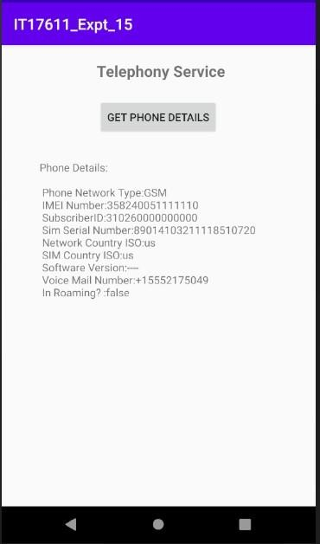

**RESULT:**

Thus, an android application to display the information of the telephony services was developed successfully.

pg. 76

## Expt. No. : 12 Date :

**Reg. No. :**

# Develop an application to display the cricket scores of the ICC world cup match Your application should update the scores automatically. Use RSS feed to implement this application.

## AIM:

To develop an android application to display the cricket scores of the ICC world cup match

that updates the scores automatically using RSS feed.

## PROCEDURE:

**Step 1:** File → NewProject

Provide the application name and Click “Next”

**Step 2:** Select the target android devices,

Select the minimum SDK to run the application. Click “Next”.

**Step 3:** Choose the activity for the application (By default choose “Blank Activity). Click “Next”.

**Step 4:** Enter activity name and click "Finish".

**Step 5:** Edit the program.

**Step 6:** Run the application, 2-ways to run the application

1. Running through emulator
2. Running through mobile device

pg. 77

## PROGRAM:

**AndroidManifest.xml**

<?xml version="1.0" encoding="utf-8"?>

<manifest xmlns:android="[http://schemas.android.com/apk/res/android"](http://schemas.android.com/apk/res/android) package="com.example.it17611_expt_20">

<uses-permission android:name="android.permission.INTERNET"/>

<application android:allowBackup="true" android:icon="@mipmap/ic_launcher" android:label="@string/app_name"

android:roundIcon="@mipmap/ic_launcher_round" android:supportsRtl="true" android:theme="@style/AppTheme">

<activity android:name=".MainActivity">

<intent-filter>

<action android:name="android.intent.action.MAIN" />

<category android:name="android.intent.category.LAUNCHER" />

</intent-filter>

</activity>

</application>

</manifest>

## activity_main.xml

<?xml version="1.0" encoding="utf-8"?>

<RelativeLayout xmlns:android="[http://schemas.android.com/apk/res/android"](http://schemas.android.com/apk/res/android) xmlns:app="[http://schemas.android.com/apk/res-auto"](http://schemas.android.com/apk/res-auto) xmlns:tools="<http://schemas.android.com/tools>" android:layout_width="match_parent" android:layout_height="match_parent"

tools:context=".MainActivity">

<TextView android:layout_width="wrap_content" android:layout_height="wrap_content" android:text="RSS FEED" android:textSize="30dp" android:textStyle="bold" android:layout_centerHorizontal="true" android:layout_marginTop="50dp"/>

<Button

android:id="@+id/btnRSSFeed" android:text="Fetch Cricket RSS Feed" android:layout_width="wrap_content" android:layout_height="wrap_content" android:layout_centerInParent="true" />

pg. 78

</RelativeLayout>

## activity_rssfeed.xml

<LinearLayout xmlns:android="[http://schemas.android.com/apk/res/android"](http://schemas.android.com/apk/res/android) xmlns:app="[http://schemas.android.com/apk/res-auto"](http://schemas.android.com/apk/res-auto) xmlns:tools="<http://schemas.android.com/tools>" android:layout_width="match_parent" android:layout_height="match_parent"

android:orientation="vertical" tools:context=".Rssfeed">

<ListView android:id="@+id/listView" android:layout_width="fill_parent"

android:layout_height="fill_parent" >

</ListView>

</LinearLayout>

## MainActivity.java

package com.example.it17611_expt_20;

import androidx.appcompat.app.AppCompatActivity; import android.content.Intent;

import android.os.Bundle; import android.view.View; import android.widget.Button;

public class MainActivity extends AppCompatActivity { Button btnRSSFeed;

@Override

protected void onCreate(Bundle savedInstanceState)

{

super.onCreate(savedInstanceState); setContentView(R.layout.activity_main); btnRSSFeed=(Button)findViewById(R.id.btnRSSFeed);

btnRSSFeed.setOnClickListener(new View.OnClickListener() { @Override

public void onClick(View v) {

Intent intent = new Intent(MainActivity.this,Rssfeed.class); startActivity(intent);

}

});

}

}

pg. 79

## Rssfeed.java

package com.example.it17611_expt_20;

import android.os.Bundle; import android.app.ListActivity; import android.content.Intent; import android.net.Uri;

import android.os.AsyncTask; import android.view.View;

import android.widget.ArrayAdapter; import android.widget.ListView; import org.xmlpull.v1.XmlPullParser;

import org.xmlpull.v1.XmlPullParserException; import org.xmlpull.v1.XmlPullParserFactory; import java.io.IOException;

import java.io.InputStream;

import java.net.MalformedURLException; import java.net.URL;

import java.util.ArrayList; import java.util.List;

public class Rssfeed extends ListActivity { List headlines;

List links;

@Override

protected void onCreate(Bundle savedInstanceState)

{

super.onCreate(savedInstanceState); new MyAsyncTask().execute();

}

class MyAsyncTask extends AsyncTask<Object,Void,ArrayAdapter>

{

@Override

protected ArrayAdapter doInBackground(Object[] params)

{

headlines = new ArrayList(); links = new ArrayList();

try

{

URL url = new URL("https://sports.ndtv.com/rss/cricket"); XmlPullParserFactory factory = XmlPullParserFactory.newInstance(); factory.setNamespaceAware(false);

XmlPullParser xpp = factory.newPullParser();

xpp.setInput(getInputStream(url), "UTF_8"); boolean insideItem = false;

int eventType = xpp.getEventType();

while (eventType != XmlPullParser.END_DOCUMENT)

pg. 80

{

if (eventType == XmlPullParser.START_TAG)

{

if (xpp.getName().equalsIgnoreCase("item"))

{

insideItem = true;

}

else if (xpp.getName().equalsIgnoreCase("title"))

{

if (insideItem)

headlines.add(xpp.nextText()); //extract the headline

}

else if (xpp.getName().equalsIgnoreCase("link"))

{

if (insideItem)

links.add(xpp.nextText()); //extract the link of article

}

}

else if(eventType==XmlPullParser.END_TAG && xpp.getName().equalsIgnoreCase("item"))

{

insideItem=false;

}

eventType = xpp.next();

}

}

catch (MalformedURLException e)

{

e.printStackTrace();

}

catch (XmlPullParserException e)

{

e.printStackTrace();

}

catch (IOException e)

{

e.printStackTrace();

}

return null;

}

protected void onPostExecute(ArrayAdapter adapter)

{

adapter = new ArrayAdapter(Rssfeed.this,

android.R.layout.simple_list_item_1, headlines);

setListAdapter(adapter);

}

}

@Override

protected void onListItemClick(ListView l, View v, int position, long id)

{

pg. 81

Uri uri = Uri.parse((links.get(position)).toString()); Intent intent = new Intent(Intent.ACTION_VIEW, uri); startActivity(intent);

}

public InputStream getInputStream(URL url)

{

try

{

return url.openConnection().getInputStream();

}

catch (IOException e)

{

return null;

}

}

}

pg. 82

## OUTPUT:

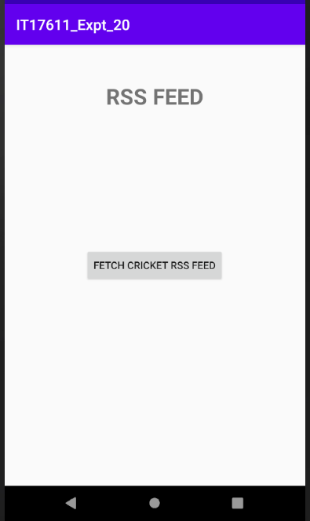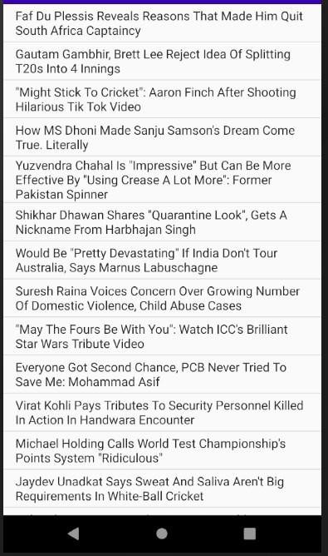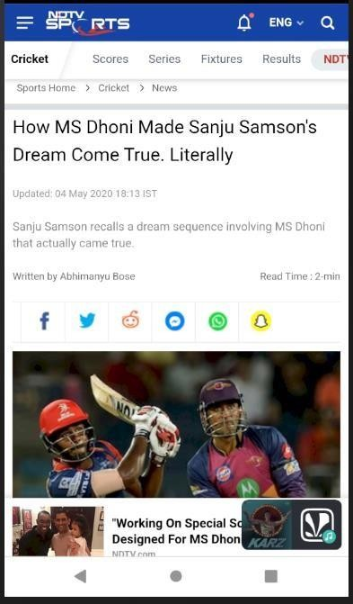

**RESULT:**

Thus, an android application to display the cricket scores of the ICC world cup match that updates the scores automatically using RSS feed.

pg. 83

## Expt. No. : 13 Date :

**Reg. No. :**

# Develop an application to send and receive messages using SMS Manger class

## AIM:

To develop an android application to send and receive messages using SMS Manger class.

## PROCEDURE:

**Step 1:** File → NewProject

Provide the application name and Click “Next”

**Step 2:** Select the target android devices,

Select the minimum SDK to run the application. Click “Next”.

**Step 3:** Choose the activity for the application (By default choose “Blank Activity). Click “Next”.

**Step 4:** Enter activity name and click "Finish".

**Step 5:** Edit the program.

**Step 6:** Run the application, 2-ways to run the application

1. Running through emulator
2. Running through mobile device

pg. 84

## PROGRAM:

**AndroidManifest.xml**

<?xml version="1.0" encoding="utf-8"?>

<manifest xmlns:android="[http://schemas.android.com/apk/res/android"](http://schemas.android.com/apk/res/android) package="com.example.it17611_expt_12">

<uses-permission android:name="android.permission.SEND_SMS" />

<uses-permission android:name="android.permission.RECEIVE_SMS" />

<application android:allowBackup="true" android:icon="@mipmap/ic_launcher" android:label="@string/app_name"

android:roundIcon="@mipmap/ic_launcher_round" android:supportsRtl="true" android:theme="@style/AppTheme">

<activity android:name=".MainActivity">

<intent-filter>

<action android:name="android.intent.action.MAIN" />

<category android:name="android.intent.category.LAUNCHER" />

</intent-filter>

</activity>

<activity android:name=".SmsReceiver"> </activity>

</application>

</manifest>

## activity_main.xml

<?xml version="1.0" encoding="utf-8"?>

<RelativeLayout xmlns:android="[http://schemas.android.com/apk/res/android"](http://schemas.android.com/apk/res/android) xmlns:app="[http://schemas.android.com/apk/res-auto"](http://schemas.android.com/apk/res-auto) xmlns:tools="<http://schemas.android.com/tools>" android:layout_width="match_parent" android:layout_height="match_parent"

tools:context=".MainActivity">

<TextView android:id="@+id/textView1" android:layout_width="wrap_content" android:layout_height="wrap_content" android:text="SMS Application" android:layout_marginTop="30dp" android:layout_centerHorizontal="true" android:textSize="30dp" />

<EditText android:layout_width="200dp" android:layout_height="wrap_content" android:id="@+id/editText" android:hint="Enter Phone Number" android:layout_marginTop="150dp"

pg. 85

android:layout_marginLeft="50dp"/>

<EditText android:layout_width="200dp" android:layout_height="wrap_content" android:id="@+id/editText2" android:hint="Enter SMS" android:layout_marginLeft="50dp" android:layout_marginTop="250dp"/>

<Button

android:layout_width="wrap_content" android:layout_height="wrap_content" android:text="Send SMS" android:id="@+id/btnSendSMS" android:layout_marginTop="350dp" android:layout_centerHorizontal="true" />

</RelativeLayout>

## activity_sms_receiver.xml

<?xml version="1.0" encoding="utf-8"?>

<RelativeLayout xmlns:android="[http://schemas.android.com/apk/res/android"](http://schemas.android.com/apk/res/android) android:layout_width="match_parent" android:layout_height="match_parent">

<TextView android:layout_width="wrap_content" android:layout_height="wrap_content" android:layout_marginTop="180dp" android:layout_marginLeft="50dp" android:text="" android:id="@+id/receiveSMS"/>

</RelativeLayout>

## MainActivity.java

package com.example.it17611_expt_12;

import androidx.appcompat.app.AppCompatActivity; import androidx.core.app.NotificationCompat;

import android.app.NotificationChannel; import android.app.NotificationManager; import android.app.PendingIntent; import android.content.Intent;

import android.os.Bundle;

import android.telephony.SmsManager; import android.view.View;

import android.widget.Button; import android.widget.EditText;

pg. 86

import android.widget.Toast;

public class MainActivity extends AppCompatActivity {

EditText txtphoneNo, txtMessage; Button sendSMS;

String phoneNo, message;

@Override

protected void onCreate(Bundle savedInstanceState) { super.onCreate(savedInstanceState); setContentView(R.layout.activity_main);

sendSMS = (Button) findViewById(R.id.btnSendSMS); txtphoneNo = (EditText) findViewById(R.id.editText); txtMessage = (EditText) findViewById(R.id.editText2);

sendSMS.setOnClickListener(new View.OnClickListener() { @Override

public void onClick(View view) {

phoneNo = txtphoneNo.getText().toString(); message = txtMessage.getText().toString(); try {

SmsManager smsManager = SmsManager.getDefault(); smsManager.sendTextMessage(phoneNo, null, message, null, null); Toast.makeText(getApplicationContext(), "SMS sent.",

Toast.LENGTH_LONG).show();

Intent smsIntent = new Intent(MainActivity.this, SmsReceiver.class); smsIntent.putExtra("address", phoneNo); smsIntent.putExtra("sms_body", message);

//startActivity(smsIntent);

NotificationManager smsnm = (NotificationManager) getSystemService(NOTIFICATION_SERVICE);

final String CHANNEL_ID = "my_channel_01";

CharSequence name = "my_notification";

NotificationChannel smsnc = new NotificationChannel(CHANNEL_ID, name, NotificationManager.IMPORTANCE_DEFAULT);

smsnc.setDescription("New Notification"); smsnm.createNotificationChannel(smsnc);

PendingIntent pi = PendingIntent.getActivity(MainActivity.this, 0, smsIntent, PendingIntent.FLAG_UPDATE_CURRENT);

smsIntent.setFlags(Intent.FLAG_ACTIVITY_NEW_TASK | Intent.FLAG_ACTIVITY_CLEAR_TASK);

NotificationCompat.Builder builder=new NotificationCompat.Builder(MainActivity.this,CHANNEL_ID)

.setContentTitle("New Message from "+phoneNo)

.setContentText(message)

.setSmallIcon(R.mipmap.ic_launcher)

.setContentIntent(pi)

pg. 87

.setAutoCancel(true); smsnm.notify(1,builder.build());

} catch (Exception e) { Toast.makeText(getApplicationContext(),

"Sending SMS failed.", Toast.LENGTH_LONG).show();

e.printStackTrace();

}

}

});

}

}

## SmsReceiver.java

package com.example.it17611_expt_12;

import androidx.appcompat.app.AppCompatActivity; import android.content.Intent;

import android.os.Bundle;

import android.widget.TextView;

public class SmsReceiver extends AppCompatActivity

{

TextView receiveSMS; @Override

protected void onCreate(Bundle savedInstanceState) { super.onCreate(savedInstanceState); setContentView(R.layout.activity_sms_receiver);

receiveSMS = (TextView)findViewById(R.id.receiveSMS);

Bundle extras = getIntent().getExtras(); this.setTitle(extras.getString("address")); receiveSMS.setText(extras.getString("sms_body"));

}

}

pg. 88

## OUTPUT:

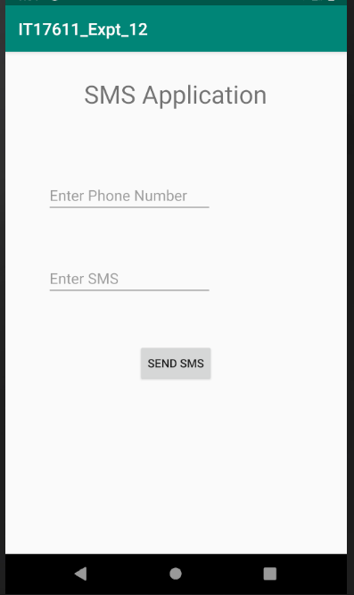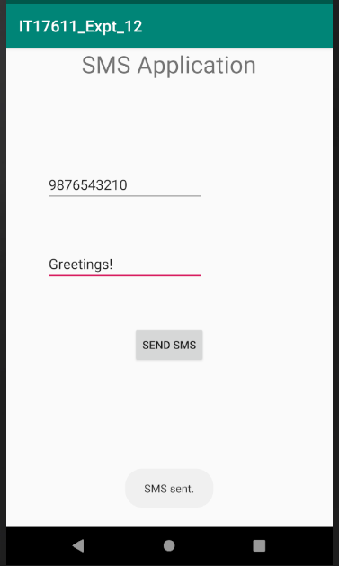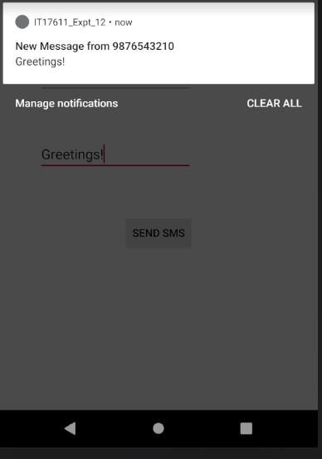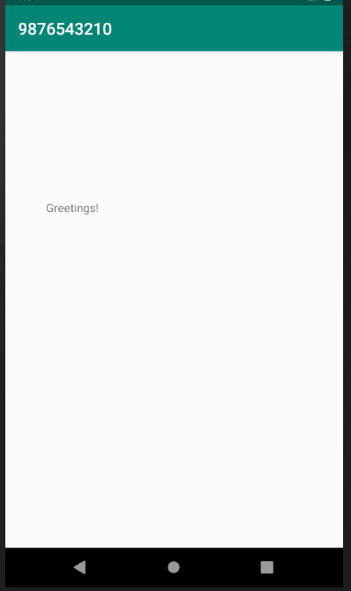

**RESULT:**

Thus, an android application to send and receive messages using SMS Manger class was developed successfully.

pg. 89

## Expt. No. : 14 Date :

**Reg. No. :**

# Develop an android application to perform the following i). Text to Speech ii).

**Speech to Text.**

## AIM:

To develop an android application to perform Text to Speech and Speech to Text.

## PROCEDURE:

**Step 1:** File → NewProject

Provide the application name and Click “Next”

**Step 2:** Select the target android devices,

Select the minimum SDK to run the application. Click “Next”.

**Step 3:** Choose the activity for the application (By default choose “Blank Activity). Click “Next”.

**Step 4:** Enter activity name and click "Finish".

**Step 5:** Edit the program.

**Step 6:** Run the application, 2-ways to run the application

1. Running through emulator
2. Running through mobile device

pg. 90

## PROGRAM:

**AndroidManifest.xml**

<?xml version="1.0" encoding="utf-8"?>

<manifest xmlns:android="[http://schemas.android.com/apk/res/android"](http://schemas.android.com/apk/res/android) package="com.example.it17611_expt_19">

<application android:allowBackup="true" android:icon="@mipmap/ic_launcher" android:label="@string/app_name"

android:roundIcon="@mipmap/ic_launcher_round" android:supportsRtl="true" android:theme="@style/AppTheme">

<activity android:name=".MainActivity">

<intent-filter>

<action android:name="android.intent.action.MAIN" />

<category android:name="android.intent.category.LAUNCHER" />

</intent-filter>

</activity>

</application>

</manifest>

## activity_main.xml

<?xml version="1.0" encoding="utf-8"?>

<RelativeLayout xmlns:android="[http://schemas.android.com/apk/res/android"](http://schemas.android.com/apk/res/android) xmlns:app="[http://schemas.android.com/apk/res-auto"](http://schemas.android.com/apk/res-auto) xmlns:tools="<http://schemas.android.com/tools>" android:layout_width="match_parent" android:layout_height="match_parent"

tools:context=".MainActivity">

<TextView android:layout_width="wrap_content" android:layout_height="wrap_content" android:layout_marginTop="20dp" android:layout_centerHorizontal="true" android:text="Text to Speech" android:textSize="30dp" android:textColor="@color/colorAccent"/>

<EditText android:id="@+id/editTextToSpeech" android:layout_width="wrap_content" android:layout_height="wrap_content" android:layout_marginLeft="20dp" android:layout_marginTop="100dp" android:ems="10" android:hint="Enter Text:">

<requestFocus />

pg. 91

</EditText>

<Button

android:id="@+id/btnTextToSpeech" android:layout_width="wrap_content" android:layout_height="wrap_content" android:layout_marginLeft="250dp" android:layout_marginTop="100dp" android:text="Text to Speech" />

<TextView android:layout_width="wrap_content" android:layout_height="wrap_content" android:layout_marginTop="250dp" android:layout_centerHorizontal="true" android:text="Speech to Text" android:textSize="30dp" android:textColor="@color/colorAccent"/>

<Button

android:id="@+id/btnSpeechToText" android:layout_width="wrap_content" android:layout_height="wrap_content" android:layout_marginLeft="20dp" android:layout_marginTop="350dp" android:text="Speech to Text" />

<TextView android:id="@+id/viewSpeechToText" android:layout_width="wrap_content" android:layout_height="wrap_content" android:layout_marginLeft="200dp" android:layout_marginTop="360dp" android:text=""

android:ems="10"/>

</RelativeLayout>

## MainActivity.java

package com.example.it17611_expt_19;

import androidx.appcompat.app.AppCompatActivity;

import android.content.ActivityNotFoundException; import android.content.Intent;

import android.os.Bundle;

import android.speech.RecognizerIntent; import android.speech.tts.TextToSpeech; import android.view.View;

import android.widget.Button; import android.widget.EditText; import android.widget.TextView; import android.widget.Toast;

pg. 92

import java.util.ArrayList; import java.util.Locale;

public class MainActivity extends AppCompatActivity{ TextToSpeech tts;

Button btnTextToSpeech, btnSpeechToText;

EditText editTextToSpeech; TextView viewSpeechToText; private final int REQ_CODE = 100;

@Override

public void onCreate(Bundle savedInstanceState) { super.onCreate(savedInstanceState); setContentView(R.layout.activity_main);

editTextToSpeech = (EditText) findViewById(R.id.editTextToSpeech); btnTextToSpeech = (Button) findViewById(R.id.btnTextToSpeech); btnSpeechToText = (Button) findViewById(R.id.btnSpeechToText); viewSpeechToText = (TextView) findViewById(R.id.viewSpeechToText);

tts = new TextToSpeech(getApplicationContext(), new TextToSpeech.OnInitListener() { @Override

public void onInit(int status) {

if (status != TextToSpeech.ERROR) { tts.setLanguage(Locale.UK);

}

}

});

btnTextToSpeech.setOnClickListener(new View.OnClickListener() { @Override

public void onClick(View arg0) {

String toSpeak = editTextToSpeech.getText().toString(); Toast.makeText(getApplicationContext(), toSpeak, Toast.LENGTH_SHORT).show(); tts.speak(toSpeak, TextToSpeech.QUEUE_FLUSH, null);

}

});

btnSpeechToText.setOnClickListener(new View.OnClickListener() { @Override

public void onClick(View v) {

Intent intent = new Intent(RecognizerIntent.ACTION_RECOGNIZE_SPEECH); intent.putExtra(RecognizerIntent.EXTRA_LANGUAGE_MODEL,

RecognizerIntent.LANGUAGE_MODEL_FREE_FORM); intent.putExtra(RecognizerIntent.EXTRA_LANGUAGE, Locale.getDefault()); intent.putExtra(RecognizerIntent.EXTRA_PROMPT, "Need to speak");

try {

startActivityForResult(intent, REQ_CODE);

} catch (ActivityNotFoundException a) { Toast.makeText(getApplicationContext(),

"Sorry! your device not supported", Toast.LENGTH_SHORT).show();

}

pg. 93

}

});

}

public void onPause(){ if(tts !=null){

tts.stop(); tts.shutdown();

}

super.onPause();

}

@Override

protected void onActivityResult(int requestCode, int resultCode, Intent data) { super.onActivityResult(requestCode, resultCode, data);

switch (requestCode) { case REQ_CODE: {

if (resultCode == RESULT_OK && null != data) { ArrayList result = data

.getStringArrayListExtra(RecognizerIntent.EXTRA_RESULTS); viewSpeechToText.setText("" + result.get(0));

}

break;

}

}

}

}

pg. 94

## OUTPUT:

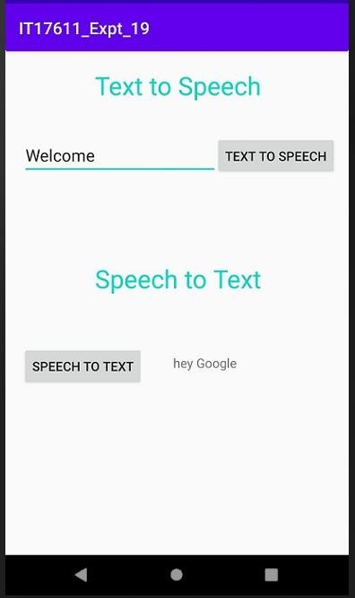

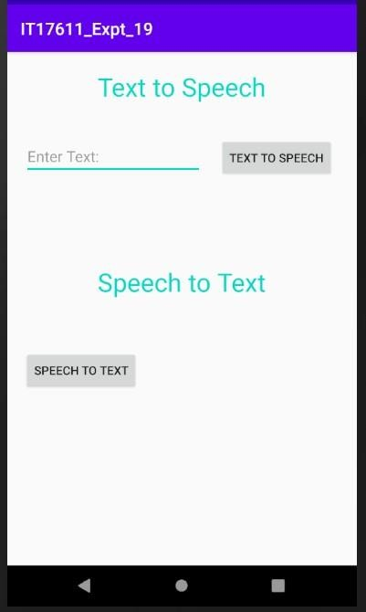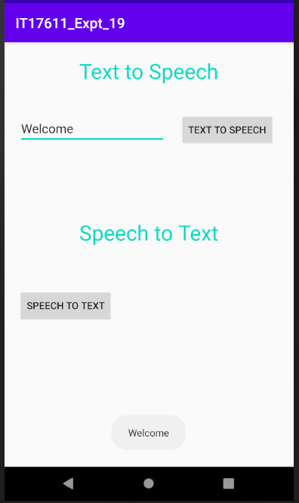

**RESULT:**

Thus, an android application to perform the Text to Speech and Speech to Text was developed successfully.

pg. 95

## Expt. No. : 15 Date :

**Reg. No. :**

# Develop an android application to capture image using camera and displaying the image using image view.

## AIM:

To develop an android application to capture image using camera and displaying the image using image view.

## PROCEDURE:

**Step 1:** File → NewProject

Provide the application name and Click “Next”

**Step 2:** Select the target android devices,

Select the minimum SDK to run the application. Click “Next”.

**Step 3:** Choose the activity for the application (By default choose “Blank Activity). Click “Next”.

**Step 4:** Enter activity name and click "Finish".

**Step 5:** Edit the program.

**Step 6:** Run the application, 2-ways to run the application

1. Running through emulator
2. Running through mobile device

pg. 96

# PROGRAM:

**androidManifest.xml**

<?xml version="1.0" encoding="utf-8"?>

<manifest xmlns:android="[http://schemas.android.com/apk/res/android"](http://schemas.android.com/apk/res/android) package="com.android_examples.captureimagecamera_android_examplescom">

<uses-permission android:name="android.permission.CAMERA" />

<application android:allowBackup="true" android:icon="@mipmap/ic_launcher" android:label="@string/app_name" android:supportsRtl="true" android:theme="@style/AppTheme">

<activity android:name=".MainActivity">

<intent-filter>

<action android:name="android.intent.action.MAIN" />

<category android:name="android.intent.category.LAUNCHER" />

</intent-filter>

</activity>

</application>

</manifest>

# activity_main.xml

<?xml version="1.0" encoding="utf-8"?>

<LinearLayout xmlns:android="[http://schemas.android.com/apk/res/android"](http://schemas.android.com/apk/res/android) xmlns:app="<http://schemas.android.com/apk/res-auto>" xmlns:tools="<http://schemas.android.com/tools>" android:id="@+id/activity_main"

android:layout_width="match_parent" android:layout_height="match_parent" android:paddingBottom="@dimen/activity_vertical_margin" android:paddingLeft="@dimen/activity_horizontal_margin" android:paddingRight="@dimen/activity_horizontal_margin" android:paddingTop="@dimen/activity_vertical_margin"

tools:context="com.android_examples.captureimagecamera_android_examplescom.MainActivity" android:orientation="vertical"

android:background="#FFF9C4">

<ImageView android:layout_width="fill_parent" android:layout_height="300dp" android:layout_centerHorizontal="true" android:id="@+id/imageView" />

<Button

pg. 97

android:text="Click here to capture image using camera" android:layout_width="match_parent" android:layout_height="wrap_content" android:id="@+id/button" />

</LinearLayout>

# MainActivity.java

import android.Manifest; import android.content.Intent;

import android.content.pm.PackageManager; import android.graphics.Bitmap;

import android.support.v4.app.ActivityCompat; import android.support.v7.app.AppCompatActivity; import android.os.Bundle;

import android.view.View; import android.widget.Button;

import android.widget.ImageView; import android.widget.Toast;

public class MainActivity extends AppCompatActivity { Button button ;

ImageView imageView ; Intent intent ;

public static final int RequestPermissionCode = 1 ;

@Override

protected void onCreate(Bundle savedInstanceState) { super.onCreate(savedInstanceState); setContentView(R.layout.activity_main);

button = (Button)findViewById(R.id.button);

imageView = (ImageView)findViewById(R.id.imageView); EnableRuntimePermission();

button.setOnClickListener(new View.OnClickListener() { @Override

public void onClick(View view) {

intent = new Intent(android.provider.MediaStore.ACTION_IMAGE_CAPTURE); startActivityForResult(intent, 7);

}

});

}

protected void onActivityResult(int requestCode, int resultCode, Intent data) {

pg. 98

if (requestCode == 7 && resultCode == RESULT_OK) { Bitmap bitmap = (Bitmap) data.getExtras().get("data");

imageView.setImageBitmap(bitmap);

}

}

public void EnableRuntimePermission(){

if (ActivityCompat.shouldShowRequestPermissionRationale(MainActivity.this, Manifest.permission.CAMERA))

{

Toast.makeText(MainActivity.this,"CAMERA permission allows us to Access CAMERA app", Toast.LENGTH_LONG).show();

} else {

ActivityCompat.requestPermissions(MainActivity.this,new String[]{ Manifest.permission.CAMERA}, RequestPermissionCode);

}

}

@Override

public void onRequestPermissionsResult(int RC, String per[], int[] PResult) { switch (RC) {

case RequestPermissionCode:

if (PResult.length > 0 && PResult[0] == PackageManager.PERMISSION_GRANTED) { Toast.makeText(MainActivity.this,"Permission Granted, Now your application can access

CAMERA.", Toast.LENGTH_LONG).show();

} else {

Toast.makeText(MainActivity.this,"Permission Canceled, Now your application cannot access CAMERA.", Toast.LENGTH_LONG).show();

}

break;

}

}

}

pg. 99

OUTPUT:

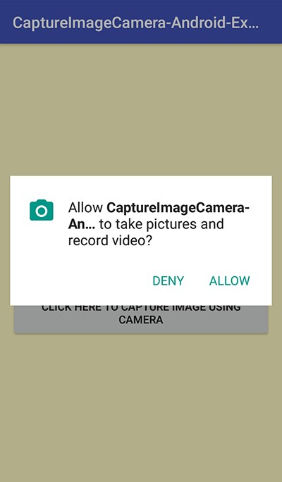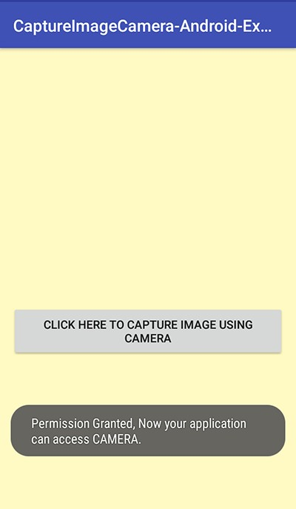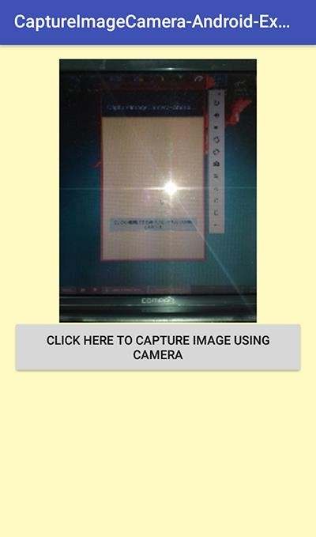

# RESULT:

Thus, an android application to capture image using camera and displaying the image using image view.

pg. 100