Review Session #1:

Review covers lectures and readings listed on syllabus

5 short answer questions & 6 multiple choice
ONLY ANSWER 4 OUT OF 5 SHORT ANSWER!
-if you don’t choose one to cross off…WE WILL

Each essay is worth 6 total points
-Midterms are worth a total of 30 points

Each multiple choice or fill in the blank is worth 1 point
Answer each question CLEARLY AND CONCISELY
-use bullet points, labeled diagrams, lists (all are acceptable)

You are graded against what a good answer is – NOT just the bare minimum
-Put down as much GOOD info as you can

READ THE QUESTIONS CAREFULLY AND ANSWER ALL PARTS OF THE QUESTION

Clear handwriting will help the grading process and will improve your sex life (maybe)

TEST TAKING TIPS:

- Write clearly! If we can’t read it, we can’t grade it

- You do not have to use paragraphs – lists are fine

- Know the proper vocabulary and use correct terminology whenever possible

- If in doubt, ask the Baldwins or a grader to clarify a question. If you still don’t know, write everything you can about everything that you believe relates to the topic at hand.

CHAPTER 2 – WOMEN’S BODIES

Vulva entire _____________________ in a woman
(See fig. 2.1 on pg. 26)

Mons 1. Often referred to as _____________
Veneris 2.
(see book for info about pubic hair on pg. 27)
3. Can be sexually stimulated – has ___________________

Labia 1. Also called _______________________
Majora 2. Extends from ____________________________________
3.

4. Contains ____________ – erotically sensitive

Labia 1. Also called _______________________
Minora 2. Lie between ___________________________
_______________________________________
3. Filled with __________________________
_______________________________________
4. During arousal, ________and ________ due to _________________________
5. Space between the left and right labia minora = ____________________________

Important Structures in THE VESTIBULE (clitoris, the urethral opening, and the vaginal opening):

Clitoris 1.
- Made up of _____________ – has internal and external portions:
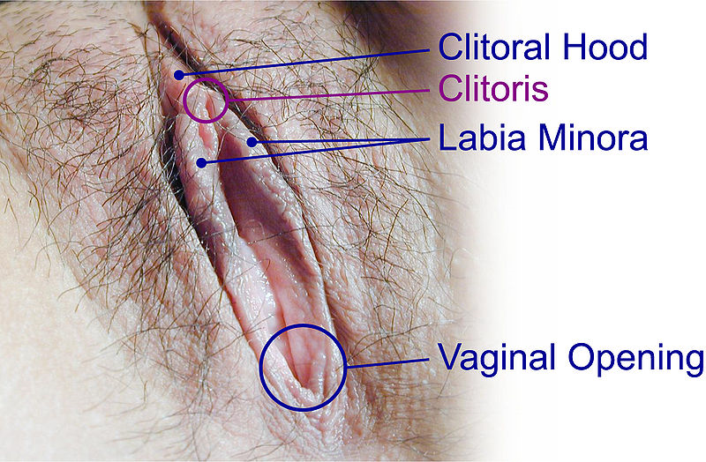
a.Glans –

b. Shaft –

- Both glans/shaft =

- Continual, proper stim. will produce orgasm

*Crura 1. ______________________________ (give entire structure a wishbone type shape)
2. About ______________ – enwrap portion of __________________________________ – area where urine is discharged out of bladder

Vestibular 1.
Bulbs 2.

3. Become erect during sexual arousal – _____________________________________

Vaginal 1. Also called _____________ – rear of vestibule
Opening 2.

Hymen 1.______________________________________
____________________________– may have many different appearances (fig. 2.5 on pg. 30)
2. No known _____________ function – but may have _____________________ (often tied to female virginity)
3. Can still be present after the loss of virginity

Perineum 1.

2. Area cut during an___________________

Pelvic 1.
Floor 2. _____________during sex stiffens vaginal
Muscles walls
3.

4. PC (or Pubococcygeus) muscle = ____________________

5. _______________ exercises ↑ tone of these muscles

FEMALE CIRCUMCISION/GENITAL MUTILATION:
READ BOX 2.1 (pg. 31)
- Sunnah –

- Clitoridectomy –

- Infibulation –

WHY?

Female Reproductive Tract (formed by vagina, cervix, body of the uterus, oviducts or fallopian tubes, and two ovaries)

Function:

Vagina 1.
2. Vaginal wall is highly elastic – ____________ ____________________________________________
3. Inhabited by large numbers of _______________
a. READ section on DOUCHING (bottom of pg. 33) – also see lecture notes
4. Physiological changes during arousal include:
a.
b.
5. Grafenberg Spot – (a.k.a G-spot)
a.

Anus 1.
2. Can be a site for ___________________ ____________________________________________
3. *See lecture notes regarding anal sex

Uterus 1. Also called ___________________
2.

3. Has three layers:
a. Endometrium –

b. Myometrium –

c. Perimetrium –

*READ section of uterine/cervical/endometrial cancer on pgs. 38-39
*READ Box 2.2 on Genital Self-Examination on pg. 37

Cervix 1.

2. OS -

Oviducts (a.k.a fallopian tubes)
- Each is about 4 in. long –

- Cilia –

- Oviduct ends in a flared opening with a fringe of __________________ (__________)

Ovaries (a.k.a gonads)

- Two distinct functions:

  - The ________________________________
__________, thus forming part of the body’s endocrine system (SEE table 2.1 on pg. 43)

Menstruation

- Varies greatly among women –

- Attitudes toward menstruation vary (see box 2.4 on pg. 46)
- READ about tampons, pads, and alternatives on pg. 47-48
- The menstrual cycle has 3 phases:
  - Menstrual phase –

  - Preovulatory phase –

  - Postovulatory phase –

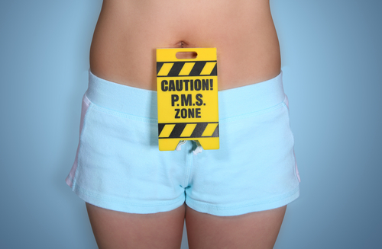
Menstrual Problems
- Menstrual cramps –

- Lower back pain, nausea, headaches
- Dysmenorrhea –

  - Primary and Secondary categories (pg. 51)
*READ about PMS (Premenstrual Syndrome) and factors that stop menstruation on pgs. 51-53

Breasts
- Have both erotic/reproductive significance

- Alveolus –

- Areola –

Breast Cancer
- 180,000 American women diagnosed each year
- 13.2% of American women will develop the disease, but not necessarily die from it
- Mastectomy –

- Factors that can ↑/↓ risk of breast cancer

- Early detection is IMPORTANT! – periodic breast exams, mammography (see box 2.6 on pg. 59 about Breast Self-Examination)
- Read about treatments and its effects on an active sex life on pg. 58-60

CHAPTER 3 - MEN’S BODIES

EXTERNAL GENETALIA (Fig. 3.1 on pg. 66)

Penis:

Structures of the Penis:
- Root –

- Shaft –

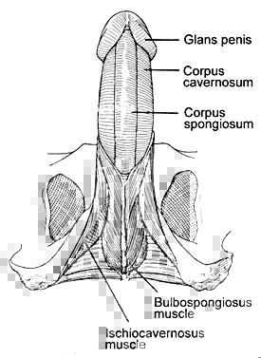
  - Contains 3 erectile structures (fig. 3.2 on pg. 68):

3. Glans (a.k.a head) –

- Corona –

- Frenulum –

c. Corona and frenulum are usually the most erotically sensitive regions
4. Foreskin –

*READ about penile medical problems on pg. 69 (Balanitis, phimosis, paraphimosis, Peyronie’s disease, and penile cancer)

Scrotum (a.k.a the Scrotal Sac)

- stimulation of the scrotum is sexually arousing to most men

Testicles

- Have two main functions (equivalent to the gonads in women)

3. See figure 3.10 on pg. 75 for internal structure of the testicle and epididymis

Epididymis
1.

Spermatic Cord (a.k.a the testicles “lifeline”)

- Vas Deferens (Vas) –

  - ______________________ – formed by the junction of the vas and duct of seminal vesicle and empties into the urethra within the prostate

Seminiferous Tubules
- Majority of the internal structure that occupy the ______________________
- Site of sperm production (process called _____________________)
- Each man produces about __________ sperm per day
- ____________________, which are involved in hormone production, lie between the tubules.

Prostate Gland
1.

2. Slightly larger than ______________
3. ___________________ (__________________) are a major component of semen

Seminal Vesicles
1.

2. _____________________, but add their own secretions

Bulbourethral Glands (a.k.a Cowper’s Glands)
1.

2. Their secretions (often called ____________) will be excreted __________ to ejaculation

*READ boxes 3.3 and 3.4 on disorders of the testicles and prostate gland (pgs. 77 and 78)

Semen
1.

2. Sperm occupy only ___________ of the total make up of semen

*Know the differences between EMISSION, EJACUALTION, and ORGASM (on pgs. 80-81)

Sex Hormones
Androgens:
1.
2. Promotes expression of _____________________
3. Responsible for maintaining the ______________
Estrogens –
Progestins –

CHAPTER 5 – ATTRACTION, SEXUAL AROUSAL AND RESPONSE (pgs. 142.7 – 160)

Sexual Arousal Has Many Roots
- Fantasy is a common mode of sexual arousal
  - Fantasy –

  - ____engage in sexual fantasy more than ___
  - Content of sexual fantasies varies greatly
  - There are some gender differences in content of fantasies (fig. 5.9 p. 144)
    - The only behavior that W fantasized more than M was _________________________
    - M are more ___________ in their fantasies

  - Gay/lesbian fantasies are __________________
________________________________________
  - M and W fantasies tend to be consistent with stereotypes about M and F sexuality

  - People who enjoy sexual fantasies without feelings of guilt __________________________
    - NOT unhealthy for a W to have sexual fantasies about ______________________ ______________ - b/c the W is “running the show” and can end it when she wants – unlike actual sexual assault.
- Arousal Occurs in Response to a Partner
  - M &W aroused by looking at partners’ _______
  - Arousal _________ as flirting, sexual negotiations, and sexual contact occurs
    - M aroused (psychologically and genitally) by erotic images _____________________
____________________________________

- Sexual Arousal is Influenced by Other Forms of Arousal
  - Misattribution of Arousal –

    - Not entirely conclusive though
- Hormones Influence Sexual Arousability
  - Do biological factors influence sexual arousal?
    - Testosterone _______________________
________________ - despite popular belief

  - Testosterone does influence arousability in adult M
    - M can be Hypogonadal –

  - READ ABOUT APHRODISIACS in BOX 5.4 on pg. 149
- Conditioning May Influence Arousal
  - Classical/Pavlovian conditioning –

    - Ex.

    - Used to explain development of fetishes/unusual sexual behavior

Sexual Arousal Follows a Response Cycle:
- Sexual response cycle –

(Fig. 5.12 on pg. 151)
- In the Excitement Phase, genital response begins
  - Response in W
    - ____________/____________/_________ in color of the labia minora/vaginal wall (vasocongestion)

    - Erection of _________________________
    - Swelling of breasts, uterus _________ and ________________
    - _____________ heart rate
  - Response in M
    - Erection of penis (takes place in under a minute – 10 seconds!)
    - Elevation of _______________
    - _______________ become erect
  - Duration of excitement phase varies (___________________)
- In the Plateau Phase, arousal is maintained (lasts 1 min – several hours)
  - Response in W
    - ______________ / ______________of the walls of the outer third of the vagina

    - ______ of clitoris goes under clitoral hood
    - Breasts swell – specifically the _________
    - “_________________” and ____________
  - Response in M
    - “___________________” secretions from bulbourethral glands
    - Erection ________ and __________ more elevated

- Orgasm is the climax of sexual arousal
  - Orgasm –

    - Felt as______________________________
____________________________________
____________________________________

    - _____________, _________________, and ______________ peak
  - In M – orgasm followed by 2 genital events:
    - emission –
    - ejaculation –

- In the Resolution Phase, arousal subsides
  - Physiological signs of arousal reverse themselves

- Some people experience _______________________

  - Much more common in ___________________
- M may experience a Refractory Period

    - Typically lasts ____________(depending on age)
    - Absolute v. relative refractory period

CHAPTER 6 – SEXUAL BEHAVIOR (pgs. 163 – 170.4)

Masturbation
1.

2. There are many different (many negative) attitudes towards masturbation (detailed on pgs. 169-170)
- demographic factors influence masturbation (see
fig. 6.1 on pg. 167)
3. The average woman is more likely to experience orgasm from __________________than through p/v sex
4. Reasons for masturbating include:

5. Women use more diverse techniques of masturbation then men
- men take about

- read up on technique specifics on pg. 168
6. _____________ masturbate more than _____________
- and, report greater __________ from masturbation

CHAPTER 10 – SEXUALITY ACROSS THE LIFESPAN (pgs. 310 – 326.8)

Childhood: A Period of Sexual Innocence?
1. The study of childhood sexuality faces practical difficulties
a. Since there is little direct observation of children by researchers, we can’t expect to reach definitive conclusions about childhood sexuality
2. Primates display a wide variety of sexual behaviors early in life
3. In contemporary western culture, children are

a. Before 19th century, children were not as insulated
4. UCLA study –

- _____________________ in children is common and normal

  - Erections in young boys can be part of a generalized arousal response – not necessarily sexually oriented (ex. Excitement from games or other non-sexual stimuli)
- _________________ sexual activity can also occur during childhood
  - Showing genitals to adults or other children
  - Attempting to view the genitals of others
  - Solitary/interpersonal sexual behavior by children seem to be harmless

- Cultures vary in their attitudes toward childhood sexuality

Children and Sexual Contact with Adults
1. About ___ of women and ____ of men report that they have had at least one childhood sexual experience involving physical contact with an adult
2. Most adult-child contacts involve _____________
_________________________________________
a.

*Read about harmful consequences and strategies to prevent adult-child sex (pgs. 318-319)

Increase Sexual Interest in Pre-Adolescence
1. Much information about sexuality is spread through __________________
2. Sex-segregated years
3. Gender norms may traumatize pre-gay children
a.

4. Pubertal growth occurs earlier in _________________
5. Visible and invisible changes occur during puberty
a. Girls:

i.

ii. Female breasts develop
iii. Onset of menstruation
  - Boys:

    - First ejaculation generally occurs at ___ (can occur during sleep or masturbation)
    - Development of underarm hair
    - Acne

What Causes Puberty
1.
a. girls: approx.
b. boys: approx.
2. Once critical body weight is reached, chemical signals initiate the _________________
3. Primary Amenorrhea –

4. Secondary Amenorrhea –

5. Gonadal steroids (see chapter 2 and 3 for steroids in women and men)
6. Precocious puberty –
- Considered too early if

7. Earlier children enter into puberty, the earlier they are likely to become _______________________

CHAPTER 13 (p. 408 – 439)

Sexual Variety is the Spice of Life

Fetishism –

What point is someone classified as a “fetishist?”
1. Opinions vary, but the book promotes that someone
can be called a fetishist even if they are not diagnosable as having a mental disorder
2. The ________________ plays a large role in “normalizing variant forms of sexual expression
a. See Box 13.1 on Rubber Fetishism and the Internet – p. 413)
- Cross Dress –

  - Practical reasons
  - Doing Drag _______________________________
___________________ – entertainment purposes
  - Transgendered Cross Dressing
    - May be a vital expression of their gender identity

  - Transvestic Fetishism or transvestism

    - Many heterosexual transvestites are _______
    - Some progress through a series of traits (see pg. 414 and Box 13.2 on pg. 415)
- Sadomasochism –

  - Sadism –
  - Masochism –
  - Can be physiological and psychological
  - ____________________ is the key erotic element
  - May include _________ (use of physical restraint) and _________________ (use of humiliation or subservience)
  - BDSM – acronym given as an all inclusive term for ______________________________________
_________________________________________
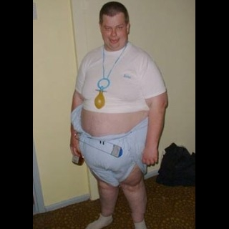
    - May be practiced with all degrees of intensity
    - Read more about on pgs. 415 – 416
    - See lecture notes
- Adult Babies –

Paraphilia
1.

2. 3 main issues to consider (although these cannot be considered an absolute criterion)

Exhibitionism –

  - In legal terms, this is the crime of____________
_______! (So, stop flashing your genitals on DP!)
  - The _________________________ are rewarding behavior to the exhibitionist (so, the best thing to do is to stay calm and walk away…)
  - ________________________ is a related behavior
  - Very common
  - Usu. _____ men who lack ___________________
_________________________________________

Voyeurism –

a. Very common

Frotteurism –

a. See Box 13.3 on pg. 422

Zoophilia –

a. _______________ – sexual contact between a person and an animal (an obsolete term)
    - May be a farm animal or a household pet!
    - Most occur during ___________________
____________________ and can hardly be considered a paraphilia
b. Majority of zoophilacs would rather have sex with an animal than a human

Necrophilia –

a. Rare
b. Some men are turned on by __________________
_______________________________________________________________________________________.

Persistent and distressing fixation on sexual violence –
a.
b. A paraphilia when _________________________
___________________________________________
  - Autoerotic asphyxia –

(see Box 13.4 on pg. 425)

Sexual Contact with Children
1. Pedophilia and Child Molestation (NOT identical)

  - Pedophile –

  - Child molester –

2. Attraction may be to ____________________________ (read more on pg. 427)
3. It is still uncertain whether pedophiles have distinctive personalities
a. We do know _______________________________
____________________________________________
4. NAMBLA (North American Man-Boy Love Association)
a. Opposes __________________________
b.

c. Raises questions of _______________ in regards to their child having sex
d. Age of legal consent varies from jurisdiction to jurisdiction

Sex Offenders Do Not Necessarily Repeat their Offenses

1. As a group, are _________________ to repeat offenses than are people convicted of many other kinds of crimes
2. Megan’s Laws (in some states only)
3. Certain factors (_______________________________ _______________) are associated with an ↑ in recidivism (______________________________________________)

Numerous Theories of Paraphilia
1. Biological factors
a.
b. May result from ___________________________
___________________________________________
c. Damage to certain specific brain regions
2. Learning Processes
a. Classical/ Pavlovian conditioning:

3. Courtship Disorder (pgs. 432 – 433)
a. Some paraphilias can be seen as a disorder of normal courtship behavior

4. May represent a sexual escape route
a. Some people may become paraphiliacs due to__________________________________________
i.

b. Not a conclusive theory
5. Cycle of Abuse
a.

b. Again, not a conclusive theory
- Paraphilias may be facilitated by other psychological traits

- Multiple Causal Factors May Interact
  - Although we still have no conclusive results

Theories of Causation Have Suggested a Variety of Treatments
1. Behavioral approaches

2. Psychotherapeutic Approaches
a. _________________________________, which attempts to correct paraphiliac’s way of thinking
b.

3. Drug Treatments (Biological Approaches)
a.

b. Some appear to be effective but have some serious side effects

4. Castration

  - May be more effective than other treatments for the prevention of sexual recidivism

