FINAL REVIEW

FORMAT OF THE FINAL EXAM (worth 60 points)

Answer all 12 multiple choice questions
Answer 8 (out of 10) essay questions

PGS. 270 – 272.8

Birth Control has a Long History
- Historically
  - “birth control” accomplished through ____________________________________________
  - Intended function of sex: _______________________
  - Most condoms were made from __________________
  - 1960s – oral contraceptives → ___________________________________________
- ______________led the campaign to legalize contraception
  - “Comstock Laws”
  - ____________________ (Read Box on 19.1)
    - _______________________________________
- _______________ has not yet solved the problem of ________________

  - Half unwanted pregnancies in the US result from ______________________________, but the other half results from ______________
__________.

CHAPTER 17 – Sex as a Commodity

Can Money buy you Love?
- Prostitution – ____________________________________
- Historically prostitution viewed as a ___________________

  - Only way in which ____________________________________________
  - Development of __________________________
- Prostitution is on the decline
  - High proportion of _______________________ prostitutes in some cities
  - ____________everywhere in U.S., except _______________________________________

There is a Hierarchy of Prostitution
- Street prostitution or “street walking”
  - Most ____________ and ________ part of the industry
  - _________ rank and charge ___________ prices

  - Majority of female prostitutes are ______________
  - Prostitution is more of a ________________ for W and has more ________________________ for W than M
  - M prostitutes tend to be ________________ where as W often work for _________________
    - Pimps –

      - Much ___________________ in recent years
- Working out of a fixed commercial location
  - I.e. _________________________________________
  - Services vary, but ________________ is most common

- Escort service prostitution –

  - Call girl –
  - Outcall vs. Incall
  - Expected to be ______________ and _____________

  - Somewhat _______ for the prostitute, but still high risk of ______________________
  - Real escorts –

    - often work for madam
  - Gigolo –

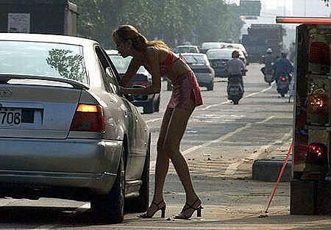
Good Pay is the Main Motive for Prostitution
- Some prostitutes have ______________ ________________ __________________
- M use prostitutes for many reasons

- The prostitutes rights movement
  - Works for decriminalization – __________________________________________
  - COYOTE – mission is to

  - _____________________________________ – prostitutes would be allowed to work in prescribed locations and under defined conditions (i.e. Nevada)

- The debate on prostitution is world wide
  - Conditions are __________________________
  - _____________________ are real for many
- ____________________________________ are global problems
  - Demand comes from __________________________________________
  - Transnational trafficking of W –

Phone Sex – ____________________________________________________
- Advantages:

Pornography Has Always Been Part of Human Culture
- Pornography –

  - Estimated to be a 13 billion-a-year industry in the U.S
  - Erotica –

- Pornography has battled censorship
  - Obscene –

- New _______________ means new kinds of pornography

- There is some pornography for W
  - Usually more ______________________________
  - _________________ (see lecture notes!)

There Are Conflicting Perspectives on the Value or Harm of Pornography
- Radical feminist perspective


- Liberal perspective
  - Downplays any _________________________
  - Protected by ________________________
- Research has ______________ the question of pornography’s effects
  - Most M are _____________________________ W by exposure to any kind of pornography
  - Some suggest that sex crimes become__________ when pornography consumption ________
- Underage pornography is widely _________________________________
  - Illegal in U.S
  - ____________underage pornography (pg. 556)
  - _________ is the world leader in production of underage pornography

Sex is Part of the Mass Media
- TV glorifies __________ and _____________ while portraying marital sex ____________________
- Sexual references on TV are __________________ (i.e. _____________________________________________)
- May be an _________________ – but is it really a good one? (pg. 558)

PGS. 326.8 – 335.8 (CHAPTER 10)

Adolescence is a Time of Sexual Exploration
- Beginning of adolescence may correspond to __________________ (menarche, first ejaculation)
- _________________ is a strong predictor of when he or she will begin to engage in partnered sex
- There are strong _______________ on teen sexual behavior
  - Adolescents are likely to initiate sexual activity early if ________________________________________________________________________________________
  - Having a significantly __________________________
  - Television
    - Teens who saw a great deal of sexual content on TV were _______________ to become pregnant
- Males ______________ more than females
  - Suggesting a more powerful _______________ in boys
  - Frequency of masturbation _______________________
- The sexual behavior of American teens has _____________
  - Social changes since 1940’s have caused teenage sexual activity to ______

  - ____________________________ in adolescent sexual activity in US in recent years
- Noncoital sex is ____________________
  - Oral sex is ______________
    - More commonly teens have first oral sex shortly _______ first vaginal sex experience
    - Thus, oral sex is usually __________, rather than a _______________ coitus
  - Ethnic differences
    - Far more _______________ adolescents engage in coitus, but ___________ to have engaged in __________________
    - Far less _________________________________ adolescents have ever engaged in coitus
Teen Sexuality is Central to Identity Development
- Don’t ignore the _____________ it can play in the growing up process!!
- Importance of developing a _______________________________
- Dating – Is it outdated?
  - Serial monogamy –

  - Casual sex seems to be becoming more __________
- Traditional social patterns have been modified
  - Nowadays, sexual relationships have a more _______________________________________
  - Changing balance of sexual power

PGS. 198.2 – 208.5 (CHAPTER 7)

Moral Judgments About Sex Depend on its Content
- The more affectionate, intimate, or committed the relationship the ___________ people are to consider sexual acts ___________________.
- _____________ __________ _________ views towards sex
- ____________________ affect sexual attitudes
  - Sex, age, education, region, race/ethnicity, religion (read on pg. 198-200)

Americans’ Attitudes Have Changed Over Time
- _________in percent of population who thinks sex before marriage is _________________________
- Public opinion towards _____________ sex has become _________

Casual Sex Has More Appeal to Men than to Woman
- M more likely to consider ____________ morally ________
- Hooking up – the new norm?
  - Many young W are becoming much more open in engaging in______ ___________________ ________________________
- Casual sex is _______________ in the gay male community
- Negotiating sex involves _____________________
  - _________ often take the first step in the interaction
  - Synchronization of ____________________.
  - At some point M takes a more ___________________
  - Studies show…_________________________
Dating Relationships are Often Short Lived
- Dating relationships usually involve some degree of ________; sexual exclusivity may be _____________

- 1st dates may follow a ___________
  - Traditional script demands ______________________
  - W takes the ______________________
- ___________________ have their own scripts
  - Usually involves _______________ which may promote more ______________________
- Dating relationships may evolve rapidly
  - If either partner believes that they are not __________________________, that partner will feel _________________ to the relationship, ________ the chances of a ______________.
  - Tendency to _____________________ (minimization of the importance of their partner’s shortcomings)
CH. 5 to PG. 142.7: COVERED IN LAST REVIEW (fair game for Final Exam)

CHAPTER 11 – Sexuality across the Lifespan: Adulthood

In Young Adulthood Conflicting Demands Moderate Sexual Expression
- Most young M and W have ______________________
  - Secondary abstinence –

Cohabitation is an Increasingly Prevalent Lifestyle
- Cohabitation –

  - ____________of young people will enter into a ___________________________________________
  - Most likely to cohabit:

- Marriages preceded by cohabitation ___________ than those that are not
  - Why?
    - Most likely that ________________________________________________________________________________
- Cohabitation has different meanings
  - About ________ of cohabiting couples have children
  - May be experienced like a ____________(or trial run!)
  - But, possibly poor management of conflicts and less overall satisfaction with the relationship
  - ____________________ is less public embarrassment
  - May be perceived as an alternative to ________ rather than ____________
  - Even some __________ cultures around the world have sanctioned _________________________ (i.e. Mut’a – ______________________________)

Marriage Takes Diverse Forms
- __________________________ of formalized sexual unions
  - Creating an environment favorable for _____________
    - Identifying _____________________
    - Bringing the couple’s ______________________
    - Intended to ______________their union
- Polygamy –

  - ______________ in many societies
  - Connected to the idea that ______________________
  - Polyandry –
    - Very ____________
- Polyamory –

  - Some are swingers –

  - Some engage in group marriage –

    - Can be open or closed ______________________
  - Its appeal may be limited by problems with _________

The Institution of Marriage is Evolving
- Western institution of marriage has evolved

  - Companionate marriage –

- Companionate marriage makes the _________________________
  - Prenuptial/postnuptial agreements ________________
  - Married people are significantly happier than unmarried
- Marriage is becoming a _________________________
  - People are marrying _________ and splitting up _____
  - % that are currently married is _________________
- Many African-American families are headed by ______________

Most Married Couples are Satisfied with their Sex Lives
- W’s physical satisfaction is ______________ in long term relationships than in ________________ relationships
- Emotional satisfaction is _________________ in marriage
- Frequency of sex ___________ during marriage – but many say, ________________________________________
  - Why? Increasing __________ with partner and dimming of ______________________
  - Biggest decline follows the _____________________
- W’s marital satisfaction ____________ during ___________
  - On the whole, wives are ________________ with their marriages than their husbands

Many Factors Bring Relationships to an End
- Four major factors:

- Overall divorce rate is ______
  - Divorce rate for people with ________________ is _______________ what it is for those without
- ____________ between husbands and wives shortens marriages
- ___________have longer marriages

Marital Disruption Can Have Negative and Positive Consequences
- Divorced M and W can suffer ____________________________

  - Children may experience a heightened risk of

- Marital disruption may also have ______________________
  - Escape from an ___________________________________________
- Most divorced people ______________
  - Associated with an ↑ in ____________________
- _________________ may be disadvantaged
  - ________________ to suffer from ________________
  - Child abuse
  - Still, majority of stepchildren ____________________________________________
- Later marriages are ___________________________
  - So, experience gained from the 1st marriage _____________________

Menopause – final cessation of menstrual cycles
- Perimenopause –

- Menopause may be caused by the depletion of _________ –

- _________hormones levels affect some W’s ____________

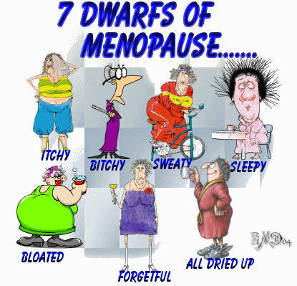
    - May lead to____________ __________________
  - Lowered _____________________

    - Osteoporosis –
- W typically experience some ↓ in __________ at menopause
  - Probably results mainly from _______________ (listed above)
  - Other factors such as ______________ ______________________ ________
- __________________ can reduce menopausal symptoms
  - Menopausal hormone therapy (MHT) (PG. 361)
- Postmenopausal hormone therapy is __________________
  - Due to possible ill-effects, has been restricted to the __________________________________________
  - ______________________ may be more valuable
  - May be given ___________ to improve sexual function

Men’s Fertility Declines Gradually With Age
- Gradual reduction in __________________________, ↑ ___________________, ↓ __________________________.
- May be referred to as male menopause (or andropause) but misleading since these changes ________________________________________________

The Sex Lives of Old people Have Generally Been Ignored
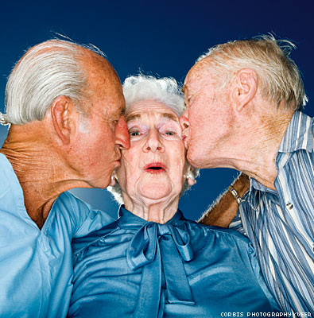
- Traditional assumption that older people are ___________
  - Younger peoples’ negative discomfort may result from ___________________________
  - Everyone continues to have ___________ into old age!!
- Aging is accompanied by ____________________ in the sexual response
  - Read top of pg.365 for specific changes
- ____________________________________ can impair the sexuality of old people

  - ______________ ________can interfere with sexual performance
  - 2 biggest factors:

  - People generally become __________________ with age!!
- Coping strategies may require flexibility
  - W may form sexual relationships ________________________
  - May practice ________________ instead
- Some old people remain sexually active
  - Plenty of old W and M ___________________
  - The more people engage in sexual behaviors ___________________ the more likely they will engage in them _______________
  - OLD PEOPLE WHO ENGAGE IN FREQUENT SEX ___________________________
- Opportunities for sexual expression by _______________________________


GOOD LUCK ON THE FINAL

