Deep Learning Supported Plant Disease Detection for Sustainable Agriculture
Şeyda İyidiler^{#1}
M.Sc. Electrical-Electronics Engineering, Konya Technical University
Konya, Turkey
258221001043@ktun.edu.tr

Abstract— In this study, a deep learning-based classification system has been developed to increase agricultural productivity and detect plant diseases at an early stage. Contrary to clean datasets taken in laboratory environments in the literature, the PlantDoc dataset containing noisy backgrounds (soil, grass, light reflection) was used in this study. Within the scope of the study, classical machine learning methods (HOG+SVM, Color Histogram+RF) and modern deep learning architectures (ResNet50, YOLOv8-cls) were analyzed comparatively. Experimental results showed that hand-crafted features were insufficient in noisy datasets (12%-35% success), whereas Transfer Learning-based models exhibited superior performance. As a result of the ablation studies, the YOLOv8n-cls model was determined as the most efficient architecture with an accuracy rate of 67.10%

Keywords— Plant Disease Detection, Deep Learning, YOLOv8, Transfer Learning, PlantDoc, Image classification.
- Introductıon
Plant diseases are one of the fundamental factors threatening global food security and causing serious losses in the agricultural economy. In traditional methods, disease diagnosis is performed by experts through visual inspection; however, this method is costly, slow, and subjective. Computer Vision techniques hold the potential to automate this process.

However, most existing studies in the literature focus on isolated leaf images and do not reflect success in real field conditions. The main purpose of this study is to develop a model suitable for running on edge devices (mobile/embedded) that works with high success on the PlantDoc dataset, which has complex backgrounds (soil, grass, light reflection) simulating real-world conditions. In this context, variations of different scales (nano, small, medium) of the current YOLOv8 architecture, which originates from object detection but operates in classification mode, were analyzed comparatively with both traditional heavy CNN architectures (ResNet50) and classical machine learning methods.
- Related Work
Studies on the detection of plant diseases have evolved from classical image processing techniques to Deep Learning-based approaches in recent years. In this section, existing studies in the literature are examined under four main headings.
- Basic Deep Learning Architectures and Comparisons
Mohanty et al. [1], one of the pioneering studies in the literature, compared AlexNet and GoogLeNet architectures on the PlantVillage dataset and achieved a high success rate of 99.35% with the Transfer Learning method. However, the authors warned that this success in the laboratory environment could drop to 31% in real field conditions, drawing attention to the "domain adaptation" problem. Similarly, Too et al. [10] proved in their study comparing VGG16, InceptionV4, ResNet50, and DenseNet121 models that the DenseNet architecture offers high performance with fewer parameters thanks to "feature reuse". Saleem et al. [3], in their review compiling studies between 2015-2020, emphasized that hyperspectral imaging is costly and therefore RGB imaging is the most accessible solution for farmers, supporting the imaging method preference of our project.
- Architectural Improvements and Visualization
In studies going beyond standard CNN models, efforts to understand the decision mechanism of the model and increase sensitivity stand out. Sladojevic et al. [2] achieved 96.3% accuracy with their unique CNN architecture and analyzed which region of the leaf affected the decision using visualization techniques. Hassan et al. [4] proposed a hybrid structure combining Inception and ResNet blocks, capturing high sensitivity even in early stages where disease symptoms are very small, and overcoming the vanishing gradient problem. As a more current approach, a study conducted in 2023 [5] compared Vision Transformer (ViT) architectures with CNN models; it was concluded that ViTs learn the global context better in big data, but CNNs are still more efficient in small datasets.
- Solutions for Data Challenges (Imbalance and Background)
Working on class imbalance, one of the biggest problems in real-world data, Zhao et al. [6] produced synthetic leaf images using DCGAN and increased the detection success (Recall) of rare diseases by 5-7% with this method. This approach serves as an important reference against possible data insufficiencies in our project. Regarding complex backgrounds, another challenge, Abbas et al. [9] used Conditional-GAN (C-GAN) on tomato leaves to clean the background and increased the success of the DenseNet121 model to 98.12%.
- Mobile and Real-Time Detection
At the point of carrying laboratory success to the field, Chen et al. [7] showed that lightweight architectures like MobileNetV2 reduce processor load by 90% with minimum compromise on accuracy. Liu and Wang [8] went beyond classification and performed object detection with the YOLOv5 algorithm, emphasizing the importance of real-time detection, especially in wide-angle images taken with drones.
- The Difference of This Work
While the vast majority of the studies mentioned above use the PlantVillage dataset with a homogeneous background, this study focuses on the PlantDoc dataset containing noisy backgrounds. Furthermore, unlike YOLOv5 studies in the literature, in this project, YOLOv8, one of the most current versions of the YOLO architecture, is analyzed not in object detection mode but in classification mode by comparing it with ResNet50, analyzing the classification performance of modern and lightweight architectures on noisy data.
- Dataset and Preprocessing
- Dataset
The PlantDoc dataset, which reflects real-world conditions, was used in the project. Although there were initially 28 classes in the dataset, the Tomato_two_spotted_spider_mites_leaf class, which had insufficient samples for statistical analysis (n=2), was removed from the dataset, and the study was conducted with a total of 27 classes.
- Preprocessing and Data Splitting:
A class-based "Smart Split" algorithm was developed to prevent Data Leakage; the dataset was separated as 80% Training, 10% Validation, and 10% Test. To compare the models fairly, all images were resized to 224x224 pixels. During the training phase, data augmentation techniques such as RandomRotation (15°) and HorizontalFlip were applied to prevent overfitting. Additionally, the Weighted Cross Entropy method was preferred as the Loss Function during training to reduce the effect of Class Imbalance.
- Method
Two different approaches (Classical ML and Deep Learning) and a total of 4+ different model architectures were tested for the solution of the problem:

- Baseline 1 (Shape-Focused ML): Classification with SVM by extracting HOG (Histogram of Oriented Gradients) features.
- Baseline 2 (Color-Focused ML): Classification with Random Forest using color histograms.
- Baseline 3 (Heavy DL Architecture): ResNet50 trained with ImageNet weights. Deep feature extraction was targeted thanks to residual blocks.
- Baseline 4 & Experimental Models (YOLO Series): The YOLOv8-cls architecture, the main focus of the study, was used. The effect of model capacity on success (Ablation Study) was examined by comparing nano (n), small (s), and medium (m) variations of the model.
- Experimental Setup
All experiments were carried out in the Python environment using the PyTorch library. Training parameters were determined as follows:
- Epoch: 10
- Batch Size: 16
- Optimizer: AdamW
- Learning Rate: Values of 1e-3 and 1e-4 were tested with Grid Search.
- Metrics: The success of the models was evaluated with Accuracy, Macro-F1 Score, and Top-5 Accuracy metrics.
- Results
- Basic Model Comparisons
The baseline results obtained in the first stage are presented in Table 1. It was observed that classical machine learning methods (SVM, RF) were insufficient in complex backgrounds (12%-35% success), while Deep Learning models overcame this problem and showed an initial success in the 68% band.
TABLE I
Performance Comparison of Baseline Models
Model Type | Method | Accuracy | Macro-F1 Score | Train Loss
Classical ML | HOG + SVM | %12.2 | 0.10 | -
Classical ML | Color + Random Forest | %35.2 | 0.26 | -
Deep Learning | ResNet50 | ~%68.2 | 0.65 | 0.48
Deep Learning | YOLOv8n-cls | %67.1 | 0.67 | 1.01

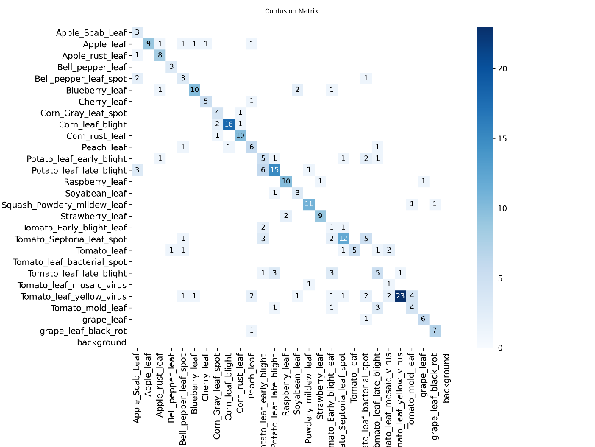
Fig. 1 Confusion matrix of YOLOv8n model training
- Ablation Study
The results of the experiments conducted to measure the effect of model capacity (Nano, Small, Medium) and learning rate on model success are detailed in Table 2. All experiments were carried out for a standard duration of 10 epochs. The results of the experiments conducted to measure the effect of model capacity and hyperparameters are given in Table 2.
TABLe 2
YOLO Variations and Hyperparameter Analysis (Ablation Study)
Model | Learning Rate | Top1 Accuracy | Epoch
yolov8m-cls.pt | 0.0001 | 0.6111 | 10
yolov8m-cls.pt | 0.001 | 0.6111 | 10
yolov8s-cls.pt | 0.0001 | 0.5873 | 10
yolov8s-cls.pt | 0.001 | 0.5873 | 10

In the experiments performed, it was observed that increasing the model capacity did not increase the success as expected; on the contrary, it showed a decrease. The lightest architecture, YOLOv8n (Nano), surpassed the Small (58.73%) and Medium (61.11%) models with a 67.10% accuracy rate. Additionally, it was determined that changing the Learning Rate value (1e-3 vs 1e-4) in Small and Medium models did not change the final Top-1 accuracy score in the 10-epoch short training process.

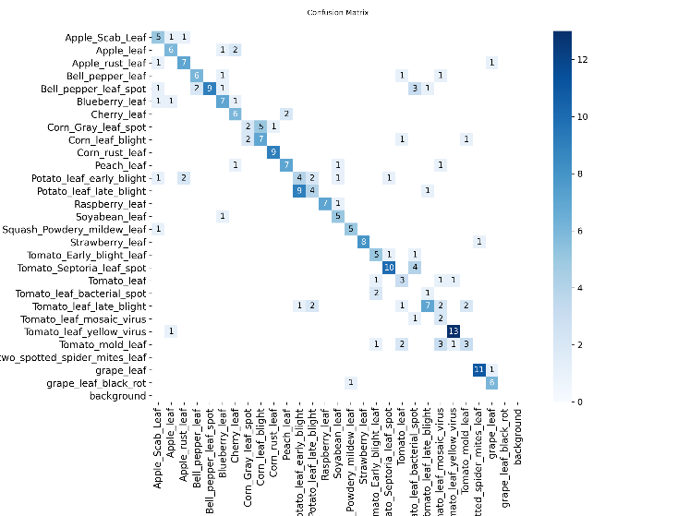
Fig. 2 Confusion matrix of YOLOv8s model training with 1e-3 learning rate
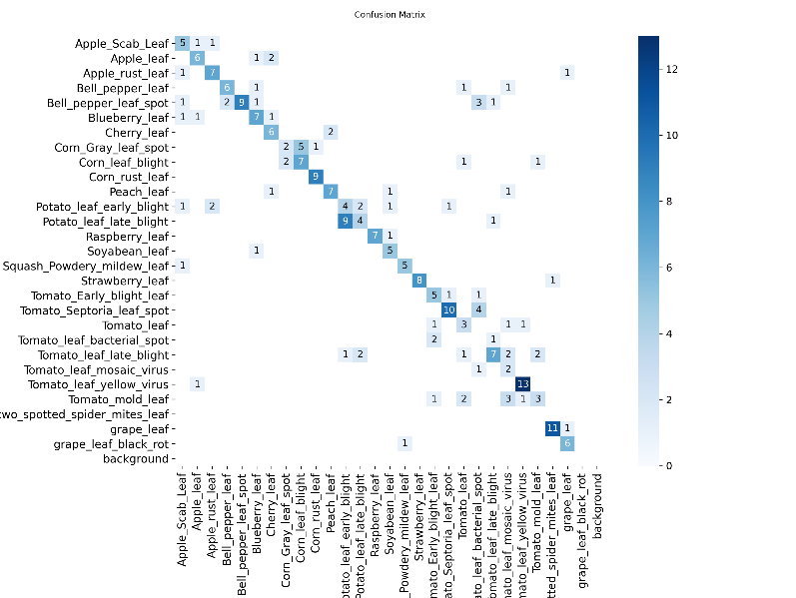 Fig. 3. Confusion matrix of YOLOv8s model training with 1e-4 learning rate
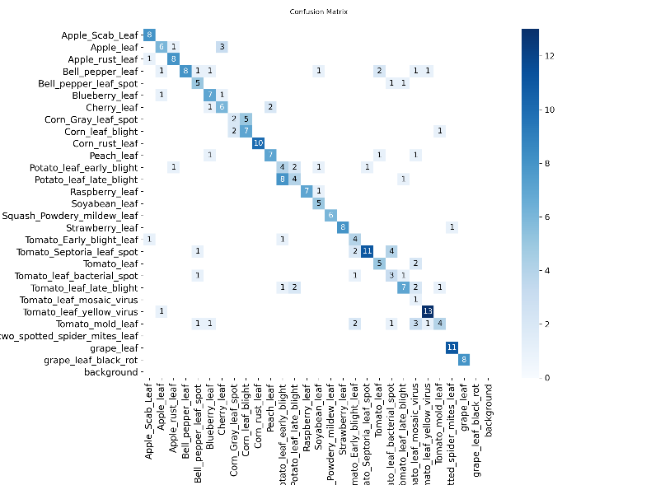
Fig. 4 Confusion matrix of YOLOv8m model training with 1e-3 learning rate
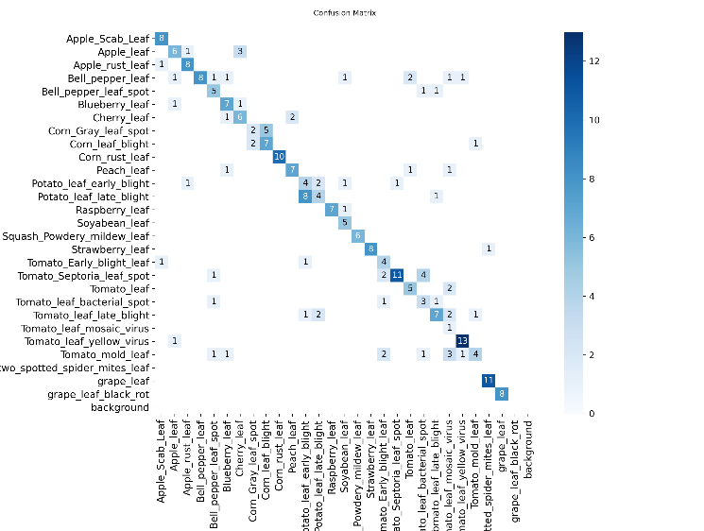Fig. 5 Confusion matrix of YOLOv8m model training with 1e-4 learning rate
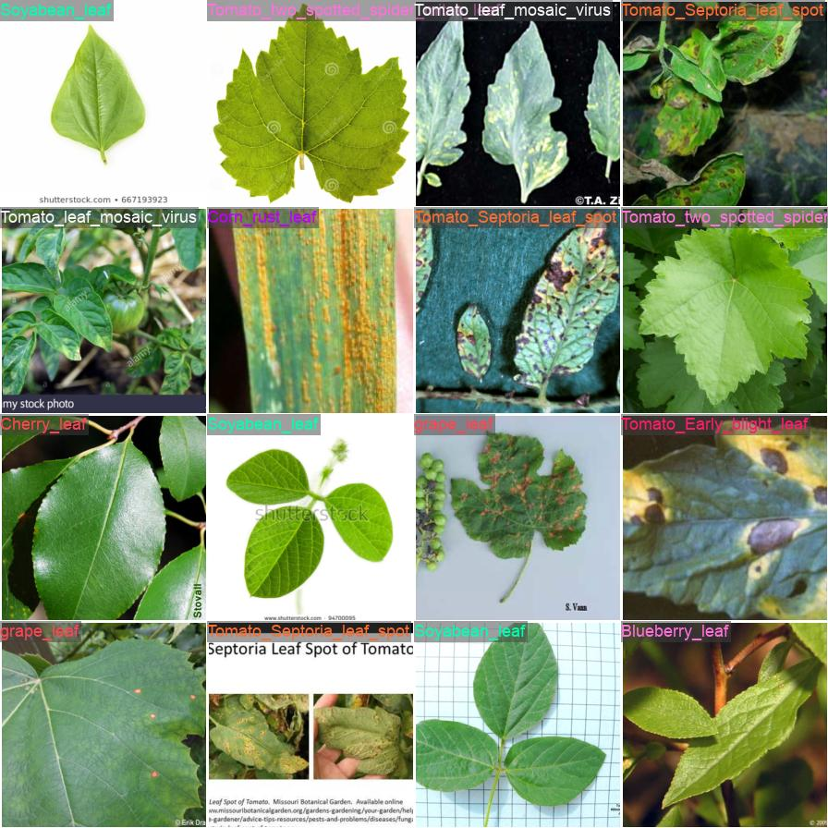
Fig. 6 16 sample images found in the validation set and their true class labels
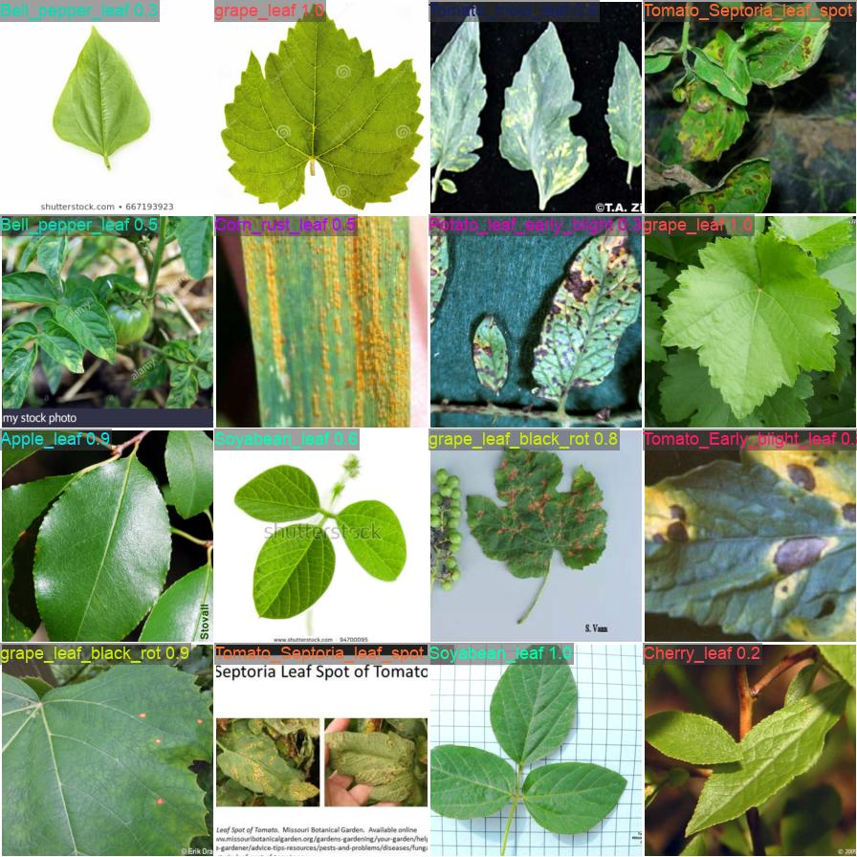
Fig. Test result of YOLOv8m model training with 1e-4 learning rate on 16 images in the validation set
- Error Analysis
When the confusion matrices of the models were examined, it was observed that YOLOv8s and YOLOv8m models had more difficulty than the Nano model in distinguishing classes that are visually very similar (E.g., Tomato Leaf Mold vs. Potato Early Blight). The tendency of large models to overfit the training data or their inability to reach the optimum point within 10 epochs due to the high number of parameters (underfitting) were evaluated as the main reasons for this performance decrease.
- Discussion
The findings obtained in this study showed that the perception of "a deeper model is always better" in the literature may not be valid when limited datasets and noisy backgrounds (PlantDoc) are in question.

- Model Capacity and Data Fit: The fact that the YOLOv8n model, which has the lowest number of parameters (67.1%), was more successful than the YOLOv8m (61.1%) and YOLOv8s (58.7%) models, which have a much higher number of parameters, supports the "Occam's Razor" principle. The limited number of samples in the dataset may have restricted the generalization ability of larger models (Small/Medium).
- Training Time: The fact that large models (Medium/Small) did not react to the learning rate and remained at low success suggests that these models need a training period longer than 10 epochs for convergence. However, under current hardware and time constraints, YOLOv8n stands out as the most efficient (efficiency/accuracy trade-off) model.
- ResNet vs. YOLO: The fact that the difference between a heavy architecture like ResNet50 (68.2%) and a very light one like YOLOv8n (67.1%) is only 1.1% proves that YOLOv8n is a much more suitable candidate for mobile applications.
- Conclusion
In this project, an end-to-end deep learning pipeline was established for plant disease detection on the PlantDoc dataset with noisy backgrounds. In the study comparing classical ML methods and different deep learning architectures (ResNet, YOLO-n/s/m), the YOLOv8n-cls model was determined as the most optimum solution in terms of speed and accuracy balance.
Experimental results revealed that the balance between dataset size and model complexity is critical; and that larger models (Small/Medium) experienced performance loss compared to the Nano model in this dataset.
References
- S. P. Mohanty, D. P. Hughes, and M. Salathé, "Using Deep Learning for Image-Based Plant Disease Detection," Frontiers in Plant Science, 2016.
- S. Sladojevic et al., "Deep Neural Networks Based Recognition of Plant Diseases by Leaf Image Classification," Computational Intelligence and Neuroscience, 2016.
- M. H. Saleem et al., "Plant Disease Detection and Classification by Deep Learning," Plants, 2020.
- S. M. Hassan et al., "A Novel Deep Learning Model for Plant Disease Detection," Computers, Materials & Continua, 2021.
- "Vision Transformers for Plant Disease Detection: A Performance Comparison," IEEE Access, 2023.
- Y. Zhao et al., "Plant Disease Detection using Generated Leaves based on GAN," 2021.
- J. Chen et al., "Using Deep Transfer Learning for Image-Based Plant Disease Identification," Computers and Electronics in Agriculture, 2020.
- J. Liu and X. Wang, "Plant Disease Detection Using YOLOv5 Algorithm," 2021.
- A. Abbas et al., "Tomato Plant Disease Detection Using Transfer Learning with C-GAN," 2021.
- E. C. Too et al., "A comparative study of fine-tuning deep learning models for plant disease identification," 2019

