

**T.R.  
GEBZE TECHNICAL UNIVERSITY  
FACULTY of ENGINEERING  
DEPARTMENT of COMPUTER ENGINEERING**

**SELF BALANCED TREES**

**CSE 222 DATA STRUCTURES AND ALGORITHMS  
HOMEWORK 7 REPORT**

**STUDENT  
Şeyda Nur DEMİR  
12 10 44 042**

**LECTURER  
Prof. Dr. Fatih Erdoğan SEVİLGEN**

**TEACHING ASSISTANT  
Başak KARAKAŞ  
Mehmet Burak KOCA**

**KOCAELİ, 2021**

**1.DESCRIPTION**

This homework has 3 parts.

**Part 1**

Provide two partial implementations of NavigableSet interface:

* Implement following methods of NavigableSet interface using skip-list
  + insert
  + delete
  + descendingIterator
* Implement following methods of NavigableSet interface using AVL tree
  + insert
  + iterator
  + headSet
  + tailSet

**Part 2**

Write method that takes a BinarySearchTree and checks whether the tree is

* an AVL tree
* a Red-Black tree (Suppose BinarySearchTree has a method isRed which returns a boolean value which indicates whether the root node is a red node or not).

**Part 3**

Compare insertion performance of the following data structures :

* Binary search tree implementation in the book
* Red-Black tree implementation in the book
* 2-3 tree implementation in the book
* B-tree implementation in the book
* Skip list implementation in the book

For each data structure ;

* Construct an instance of each data structure by inserting a collection of randomly generated (non-repeating) numbers. Perform this operation 10 times for 10.000, 20.000, 40.000 and 80.000 random numbers (10 times for each). So, you will have 10 instances for each data structure and each different size (i.e., 200 instances in total).
* Compare the experimental run-time performance of the insertion operation for the data structures above as follows:
  + Insert 100 extra random numbers into the structures you built and measure the running time
  + Calculate the average running time for each data structure and problem size (i.e., number of elements in data structure)
  + Draw a graph for running-time vs problem size.
  + Compare the running times and their increase rate.

**Restrictions**

* Can be only one main class in project
* Don’t use any other third part library

**General Rules**

* For any question firstly use course news forum in Moodle, and then the contact TA.
* You can submit assignment one day late and will be evaluated over sixty percent (%60).

**Technical Rules**

* You must write a driver function that demonstrates all possible actions in your homework. For example, if you are asked to implement an array list and perform an iterative search on the list then. The driver function should run when the code file is executed.
* Implement clean code standards in your code ;
  + Classes, methods and variables names must be meaningful and related with the functionality.
  + Your functions and classes must be simple, general, reusable and focus on one topic.
  + Use standard java code name conventions.

**Report Rules**

* Add all javadoc documentations for classes, methods, variables …etc. All explanation must be meaningful and understandable.
* You should submit your homework code, Javadoc and report to Moodle in a “studentid_hw7.tar.gz” file.
* Use the given homework format including selected parts from the table below:
  + Problem solutions approach
  + Test cases
  + Running command and results

**Grading**

* No OOP design: -100
* No interface: -95
* No method overriding: -95
* No error handling: -50
* No inheritance: -95
* No polymorphism: -95
* No javadoc documentation: -50
* No report: -90
* Disobey restrictions: -100
* Cheating: -200
* Your solution is evaluated over 100 as your performance.

**2.REPORT**

I detailed here what I did in my homework.

I detailed Part 1, Part 2, Part 3 separately.

**Part 3 : 2.1.Problem Solutions Approach**

**Note :** I googled the way you said in the report to problem solving approach, but I could not any useful article, what I found was either paid or long. After all I found a useful post from medium. I prepared this part according to this post. I hope I got it right.

* **Clearly understanding and/or defining the problem :**

I understood and defined the problem clearly.

* + We should **implement 5 self balanced tree**.
  + And **compare their running time performances**.
* **Breaking down large problems into smaller problems :**

I broke down large problem **implementation and running time comparisons**,

to small problems “**data structures implementations**”, “**writing main method and test of the methods**”, get them together and print results.

* + We have a large problem, implementations and comparisons.
  + I have now small problems, “**Binary Search Tree** implementation”, “**Red Black Tree** implementation”, “**Two Three Tree** implementation”, “**B Tree** implementation”, “**Skip List** implementation”, “**Main Class** and **main method**”, “**Test Class** and **test methods**”, “**calculating running times** and **drawing graph**” modules
* **Solving the problem at an abstract level first :**

I solved the problem at an abstract level first.

* + I thought a lot about the problem.
  + I scribbled something about this subject in the ledger.
  + Something started to take shape in my head.
  + I used my knowledge of data structures, and it is.
* **Using notes and pseudo-code :**

I noted what I thought and wrote permanently pseudo-codes mixed with java codes.

* + If I understand or find something new, I noted.
  + I wrote pseudo-codes mixed with java codes, not clear.
* **Running code early and often :**

I wrote real codes and run them often.

* + I turned my pseudo-codes into real java codes.
  + I coded them in ide and run them often.

**Part 3 : 2.2.Uml Diagram**

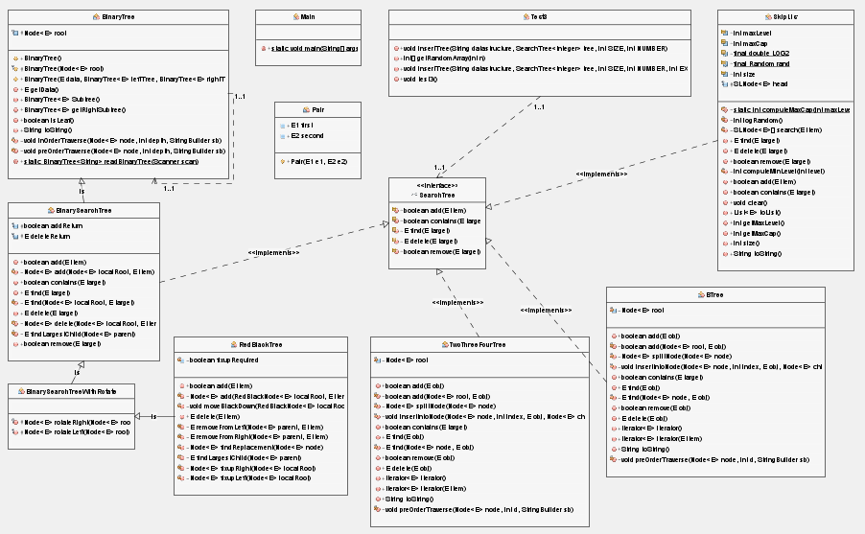You can also see uml diagram in png format in “Report” directory.

**Part 3 : 2.3.Test Cases**

**Testing Requirements**

|  |  |  |
| --- | --- | --- |
| **Test Case** | **Pres / Posts** | **Done** |
| Construct Data Structures | * Should have implementations of needed data structures | Done |
| Insert 10000 Elements  Insert 20000 Elements  Insert 40000 Elements  Insert 80000 Elements | * Should have constructed instances of data structures * Should have constructed instances as array with given size | Done |
| Insert Extra 100 Elements | * Should have constructed instances of data structures   with given sizes   * Should have an array with 100 random numbers to insert   to the data structures | Done |

**Part 3 : 2.4.Running Commands and Results**

**Compile and Run Commands, Testing Steps**

Usage of my program :

1. Compile program with “**javac *.java**” command
2. Run program with “**java Main**” command

**Simply Follow This Screenshot**

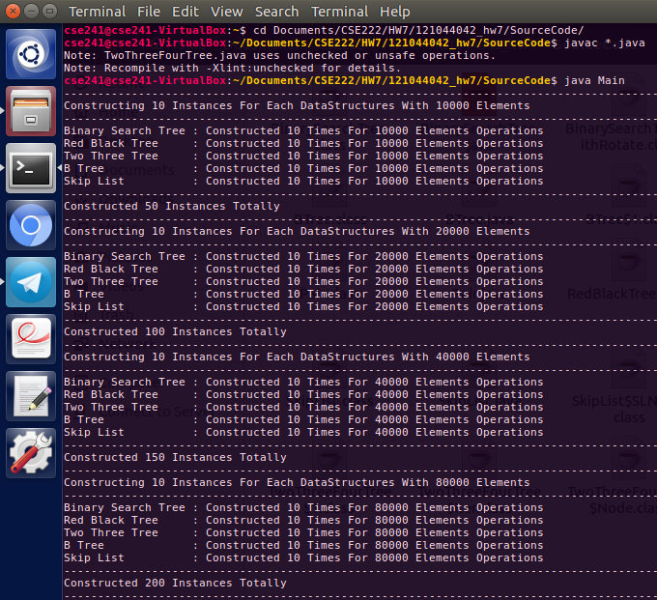

**Javadoc Command**

Usage of my program’s javadoc code :

1. Compile program with “**javadoc *.java**” command

**Simply Follow This Screenshot**

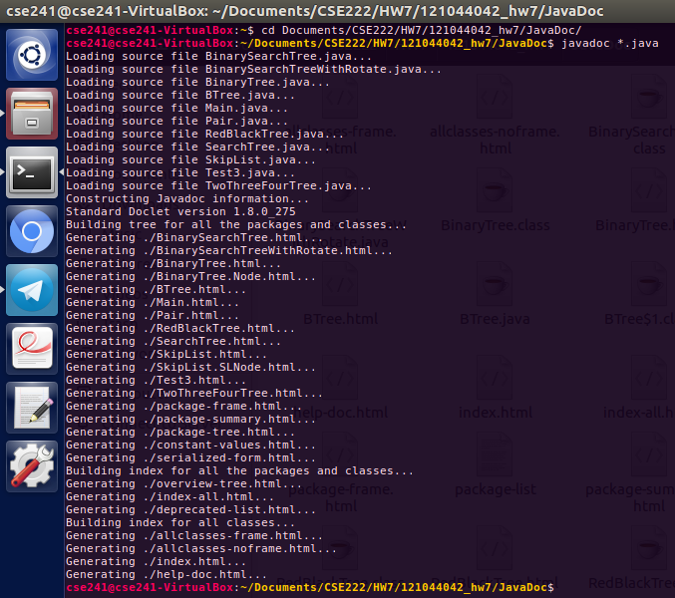

**Commands and Results with Screenshots**

**Test Results : Construct Data Structures**

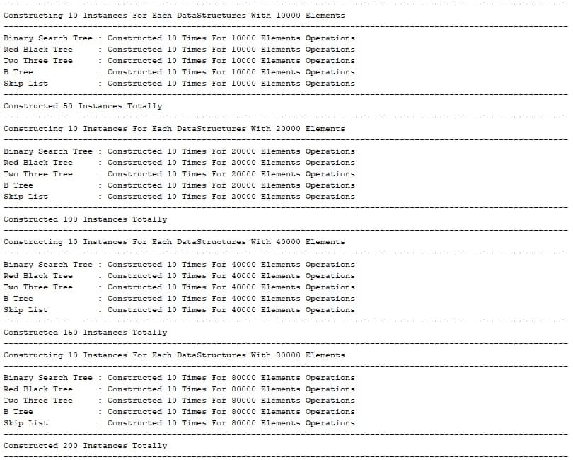

**Test Results : Insert Elements**

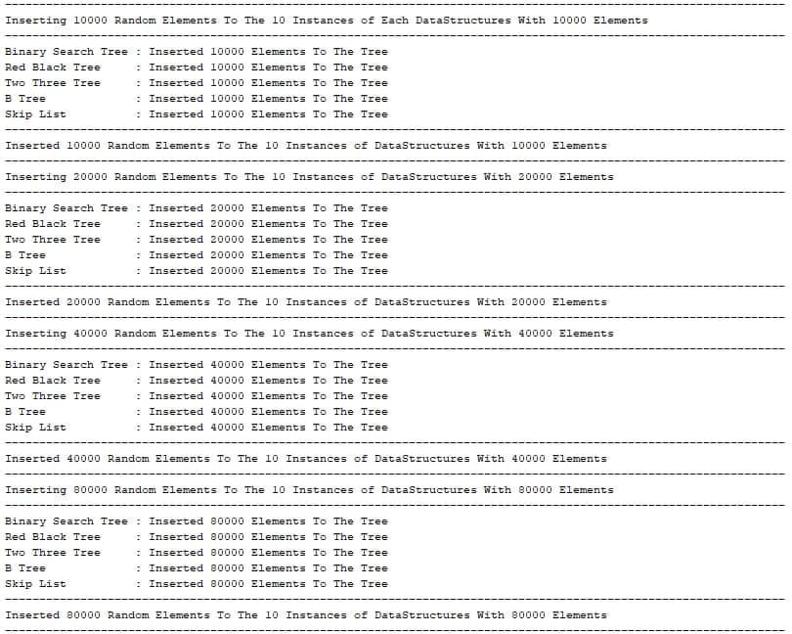

**Test Results : Inserting Extra 100 Elements and Calculating Running Times**

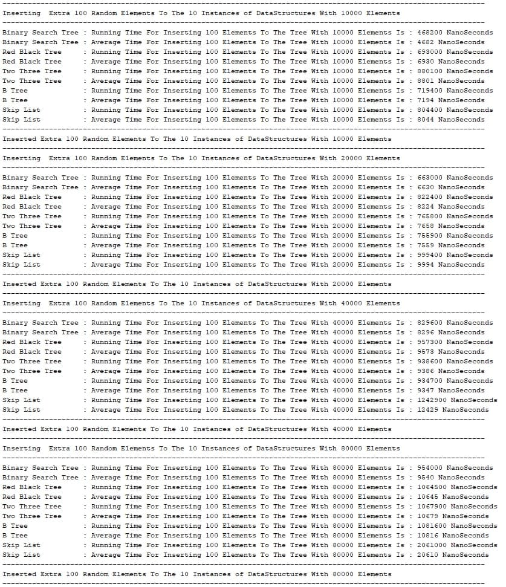

**Test Results : Graph of Total and Average Running Times**

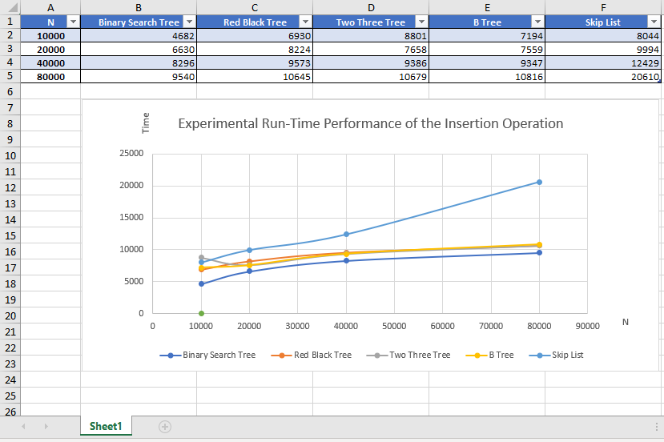

**END OF THE REPORT**

**LAST UPDATE**

**Jun 12, 2021 Saturday 10:00**

**STUDENT  
Şeyda Nur DEMİR  
12 10 44 042**

**LECTURER  
Prof. Dr. Fatih Erdoğan SEVİLGEN**

**TEACHING ASSISTANT  
Başak KARAKAŞ  
Mehmet Burak KOCA**

**KOCAELİ, 2021**