ŞEYDA NUR SERT  Computer Engineering Graduate  Data Science & Machine Learning  +90 542 540 6696  seydanur.sert@gmail.com  LinkedIn | GitHub | Portfolio | 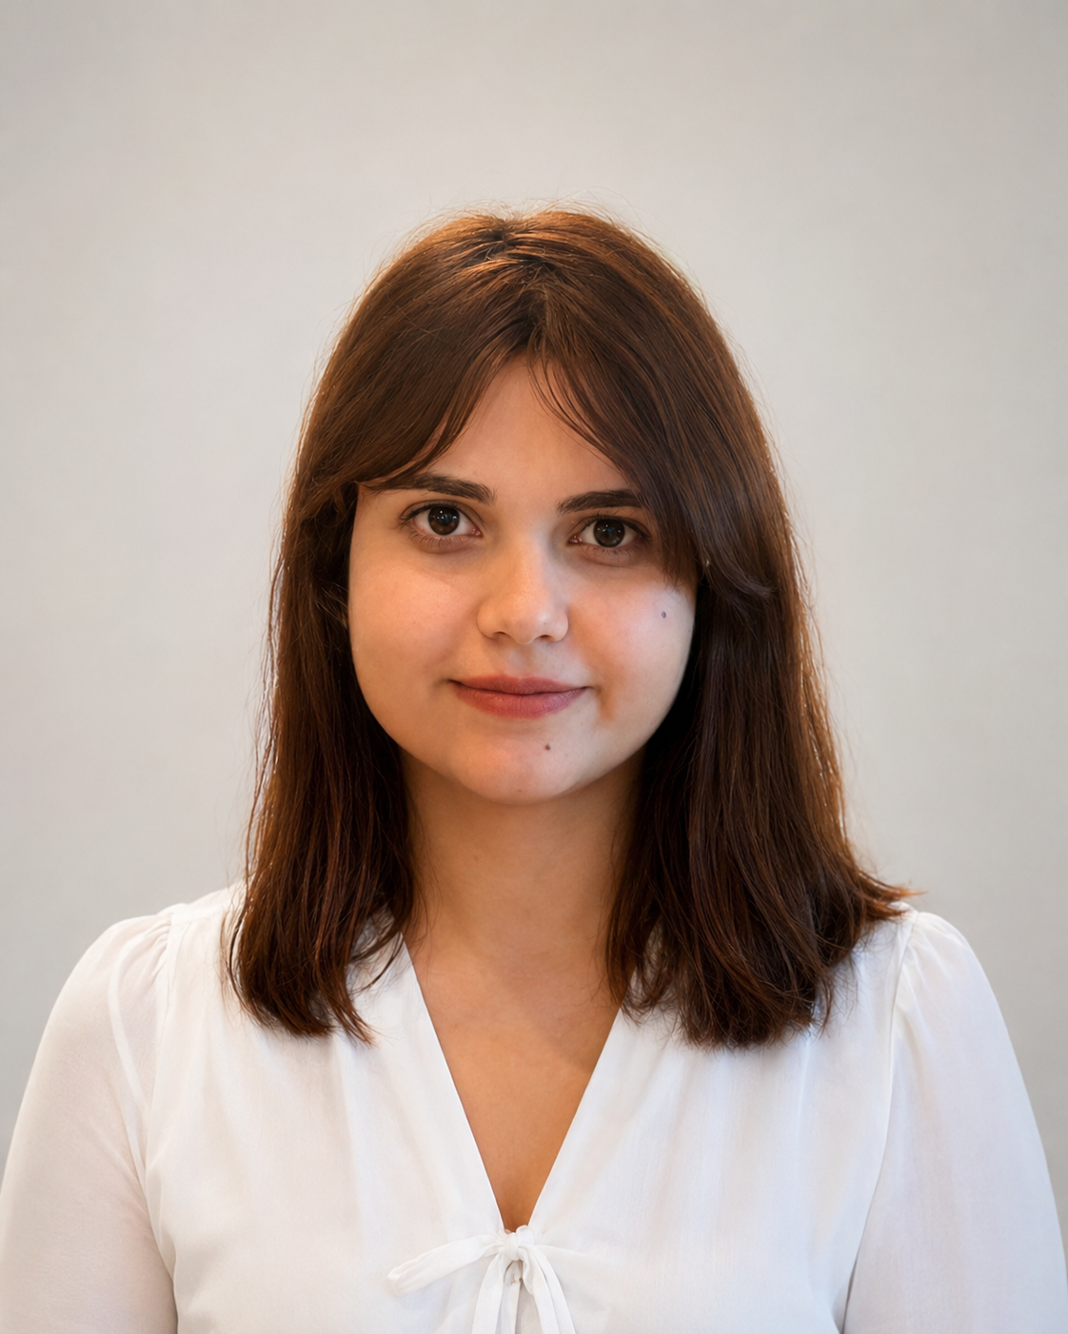

PROFESSIONAL SUMMARY
Computer Engineering graduate with experience in data science, machine learning, data analytics, and database-driven applications. Developed projects using Python, SQL, PostgreSQL, scikit-learn, Streamlit, Flask, and Tableau. Focused on data preparation, model development, visualization, dashboard design, and user-oriented software solutions.

TECHNICAL SKILLS
Programming: Python, SQL, Java, C | Web & Design: Flask, Streamlit, HTML/CSS, UI/UX
Databases: PostgreSQL, Database Design, ER Modeling | Data Science & ML: Pandas, NumPy, scikit-learn, SHAP, Matplotlib
Software Practices: Git, GitHub, Data Preprocessing, Model Evaluation | Visualization & Tools: Tableau, Dashboard Design, Jupyter Notebook
EXPERIENCE
Intern | TÜBİTAK UZAY | Jul 2025
- Contributed to API operations, user interface development, and database design processes.
- Gained hands-on experience in backend structure, data flow, and interface-database integration.

EDUCATION
B.Sc. in Computer Engineering | Alanya Alaaddin Keykubat University | 2022 - 2026
Relevant focus: data science, machine learning, database systems, software development, and data visualization.

SELECTED PROJECTS
Explainova - Explainable Machine Learning Platform | Python, Streamlit, scikit-learn, SHAP
- Developed a web-based platform that enables users with limited technical background to analyze tabular data and compare ML models.
- Contributed to preprocessing, classification/regression workflow, SHAP, PDP/ICE outputs, and reporting steps.
E-Commerce Data Analysis and Dashboard | Tableau, Data Analysis, Data Visualization
- Cleaned e-commerce data and prepared an interactive Tableau dashboard to track sales, customer, and product performance.
- Built a reporting structure that supports decision-making with KPIs, filters, and visual analysis.
Online Reservation and Order Management System | Java, PostgreSQL, SQL
- Designed a relational database for reservation and order processes; created normalized tables and SQL queries.
Student Attendance Tracking System | Python, Flask, PostgreSQL, ZeroMQ
- Developed a real-time student attendance tracking system using ZeroMQ-based messaging architecture.

CERTIFICATIONS & PROGRAMS
Certifications / Programs: Samsung AI Course; 100 Days of ML - Udemy; Software Testing - Udemy; UX-UI 101; Womentum Training Program - Enerjisa Üretim & imeceLAB. Language: English B2.

