Lab 1

# Lab 1

*Yang Zhou 43413986*

## 1. Summary for graph in Part A

### 1.1 Histogram

attach(faithful)  
hist(eruptions, seq(1.6, 5.2 ,0.2), prob=TRUE)  
lines(density(eruptions, bw = 0.1), col = "blue")  
rug(eruptions)

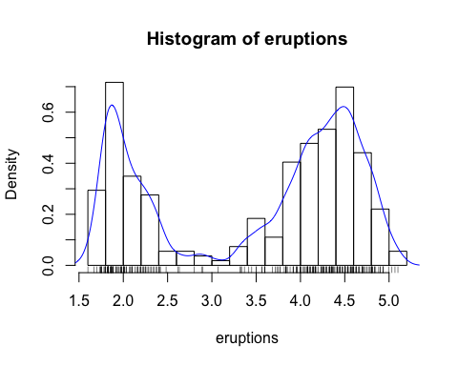

hist() produces the histogram, density() provides kernel density estimation, line() plots the density on the graph and rug() adds the actual data points

### 1.2 Scatter Plot & Regression line

plot(eruptions, waiting, pch = 3, xlab = "Eruptions duration", ylab = "Waiting duration", main = "Scatter Plot with regression lines")  
abline(lm(waiting ~ eruptions), col = "blue")

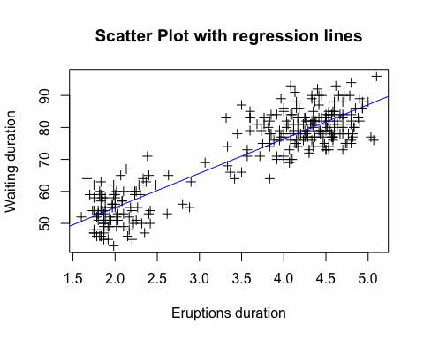

plot(x, y) ouputs the scatter plot, abline() add line into the existing plot and lm() fits a regression line.

### 1.3 Boxplot

weather <- read.table(paste0(path.expand("~"),"/STAT/stat828/hw/data/weather.txt"),  
 header = TRUE)  
attach(weather)  
weather$monthF <- factor(month)  
plot(weather$monthF, upper, xlab = "Month", ylab = "Temperature",  
 main = "Boxplot of upper temperatures for each month")

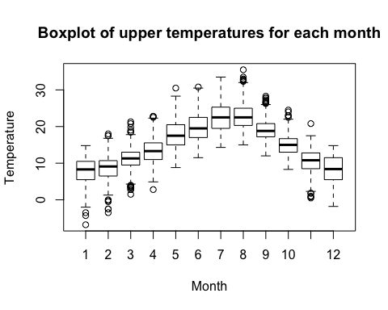

plot(x,y) outputs a boxplot when x is categorical variable (factor). is.factor() can be used to assert if a variable is factor or not.

### 1.4 colorful boxplot

boxplot(upper ~ monthF, data = weather, xlab = "Month", ylab = 'Temperature',  
 main = "Box plot of upper temperatures for each month",  
 boxwex = 0.25, boxfill = "lightblue", pch = 20, xlim = c(0,12),  
 ylim = c(-10, 40))  
legend(1, 40, c("Upper Temperatures"), fill = c("lightblue"))

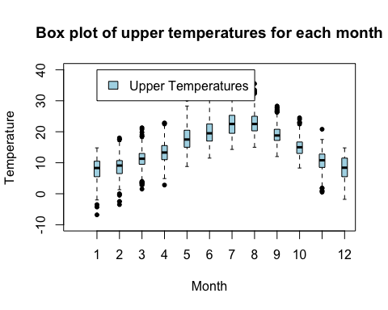

boxplot() outputs a prettier boxplot, data are inputed as formula y ~ x where y is the numeric variable and x is the categorical variable. boxwex makes boxes narrower, boxfill gives it a nice colour. pch = 20 set the data points to a solid black dot. xlim is the range of x axis. lengend(x,y, legend) adds legends to the plot, x,y are the co-ordinates of the legend position. legend is a string to appear.

### 1.5 Scatter Plot Matrix

pairs(weather[-c(5,6)], main = "Scatter Plot Matrix of Weather Data", panel = panel.smooth)

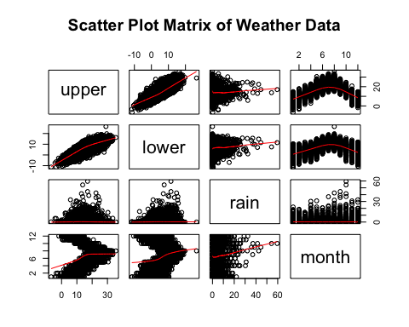

pairs() outputs the scatterplots matrix. panel = panel.smooth() adds a smooth function to each of the panels. weather[-c(5,6)] removes the 5th and 6th column of weather dataset.

## 2. What I have done of Maindonald and Braun Advanced.R script

## search attached objects  
search()

## [1] ".GlobalEnv" "weather" "faithful"   
## [4] "package:stats" "package:graphics" "package:grDevices"  
## [7] "package:utils" "package:datasets" "package:methods"   
## [10] "Autoloads" "package:base"

## workspace mangement  
## save & load Objects  
save(weather, file = "lab1.weather.RData")  
rm(list = ls())  
attach(paste0(getwd(),"/lab1.weather.RData"))  
ls(pos = 2)

## [1] "weather"

load(file = "lab1.weather.RData")  
ls(all = TRUE) # to display hidden object like '.XXX'

## [1] ".Random.seed" "weather"

xy <- matrix(rnorm(60000), nrow = 600)  
xy.rowrange <- apply(xy, MARGIN = 1, FUN = range) # MARGIN means the axis apply to  
save(xy, xy.rowrange, file = "xy.RData")  
  
save.image() # save the whole workspace  
  
## data input and output  
unique(count.fields("../data/weather.txt")) # check the number of columns of a file

## [1] 5

write.table(weather, file = "weather2.txt", sep = '|', quote = FALSE)  
  
## database connection  
  
## string functions  
substring("abcdefg", 5,7)

## [1] "efg"

nchar("abcde")

## [1] 5

strsplit("abc|def|ggg", split = '|')

## [[1]]  
## [1] "a" "b" "c" "|" "d" "e" "f" "|" "g" "g" "g"

## anonymous functions  
#sapply(weather, FUN = function(x)  
  
## working with date and time  
dd <- as.Date(c("2015-02-28", "2014-02-28"))  
diff(dd)

## Time difference of -365 days

dd <- as.Date(c("2015-02-28", "2015-02-29"))  
diff(dd)

## Time difference of NA days

as.Date("1/1/1999", format = "%d/%m/%Y")

## [1] "1999-01-01"

julian(dd)

## [1] 16494 NA  
## attr(,"origin")  
## [1] "1970-01-01"

weekdays(dd)

## [1] "Saturday" NA

months(dd)

## [1] "February" NA

quarters(dd)

## [1] "Q1" "QNA"

format(dd, format = "%b %d %Y")

## [1] "Feb 28 2015" NA

format(dd, format = "%a %A %b %B %d %m %y %Y")

## [1] "Sat Saturday Feb February 28 02 15 2015"  
## [2] NA

startOfMonth <- seq(from = as.Date("2015-03-01"), by = "1 month", length = 24)  
startOfMonth

## [1] "2015-03-01" "2015-04-01" "2015-05-01" "2015-06-01" "2015-07-01"  
## [6] "2015-08-01" "2015-09-01" "2015-10-01" "2015-11-01" "2015-12-01"  
## [11] "2016-01-01" "2016-02-01" "2016-03-01" "2016-04-01" "2016-05-01"  
## [16] "2016-06-01" "2016-07-01" "2016-08-01" "2016-09-01" "2016-10-01"  
## [21] "2016-11-01" "2016-12-01" "2017-01-01" "2017-02-01"

## 3 Two most important things identified from two-crows book

### Hierarchy of choices

In the process of using Data mining to solve business problem, the different aspects of data mining might be confusing, so a hierarchy of decisions need to be made before start.

1. Business goal. the ultimate purpose should be clearly defined. Define the project scope.
2. Type of prediction. Classification or Regression.
3. Model type. might need to try different algorithms.
4. Product. Different products might have different implementations of the same algorithm, which can affect operational performance.

### Data preparation

Data preperation steps may take away from 50% to 90% of the time and efforts of the entire knowledge discovery process. So plan ahead, colloect data preperation tool knowledge and routines. Use dedicated DBMS(rather than sharing the same data warehouse environment). Try to write scripts to automate the process and make the process iterable. Avoid GIGO, good model needs good data.

## 4. Would you consider CRISP-DM way of report for your statistical report

In my opinion, CRISP-DM is very important as it provides the skeleton of data mining process. Data mining is a complex process, a priciple guideline can lead the project to follow current best practice and walk around the common pit-falls, which means efficiency and less risk. It also makes it easier to initiate a DM project. As a beginner of DM, I hope learning to use CRISP-DM in my statistical report can quickly bring me up-to-date to the industrial level. And since this is major process adopted, it will be extremely helpful when I start working together with other experienced professionals in the DM industry.