**Seyed Ehsan seyed bolouri 1567349**

**Survival Case**

b C SIGMA D ACCURACY

Lin_primal 2.4776 32 -- -- 0.8583

Lin_dual 19.58 0.1250 -- -- 0.8500

Poly 341.6239 32 -- 2 error

Rbf -4.8645 32 8 -- error

**Chess Case**

b C SIGMA D ACCURACY

Lin_primal 2.4776 .5 -- -- .5209

Lin_dual 27.6927 32 -- -- .4958

Poly -17.1489 8 -- 8 .767

Rbf error error error -- error

**Iris Case**

b C SIGMA D ACCURACY

Lin_primal 2.8819 32 -- -- 0.6415

Lin_dual 0.0852 0.313 -- -- 0.6586

Poly error error -- error error

Rbf error error error -- error

* I do not know why I get some non-convex error in chess case and iris case for polynomial and Gaussian distribution!! I checked the process several times but unfortunately, I could not debug it. Would you please consider partial points for these parts?

Polynomial-survival

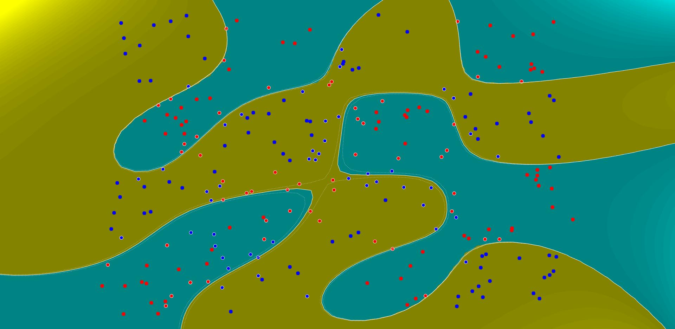

Rbf_survival

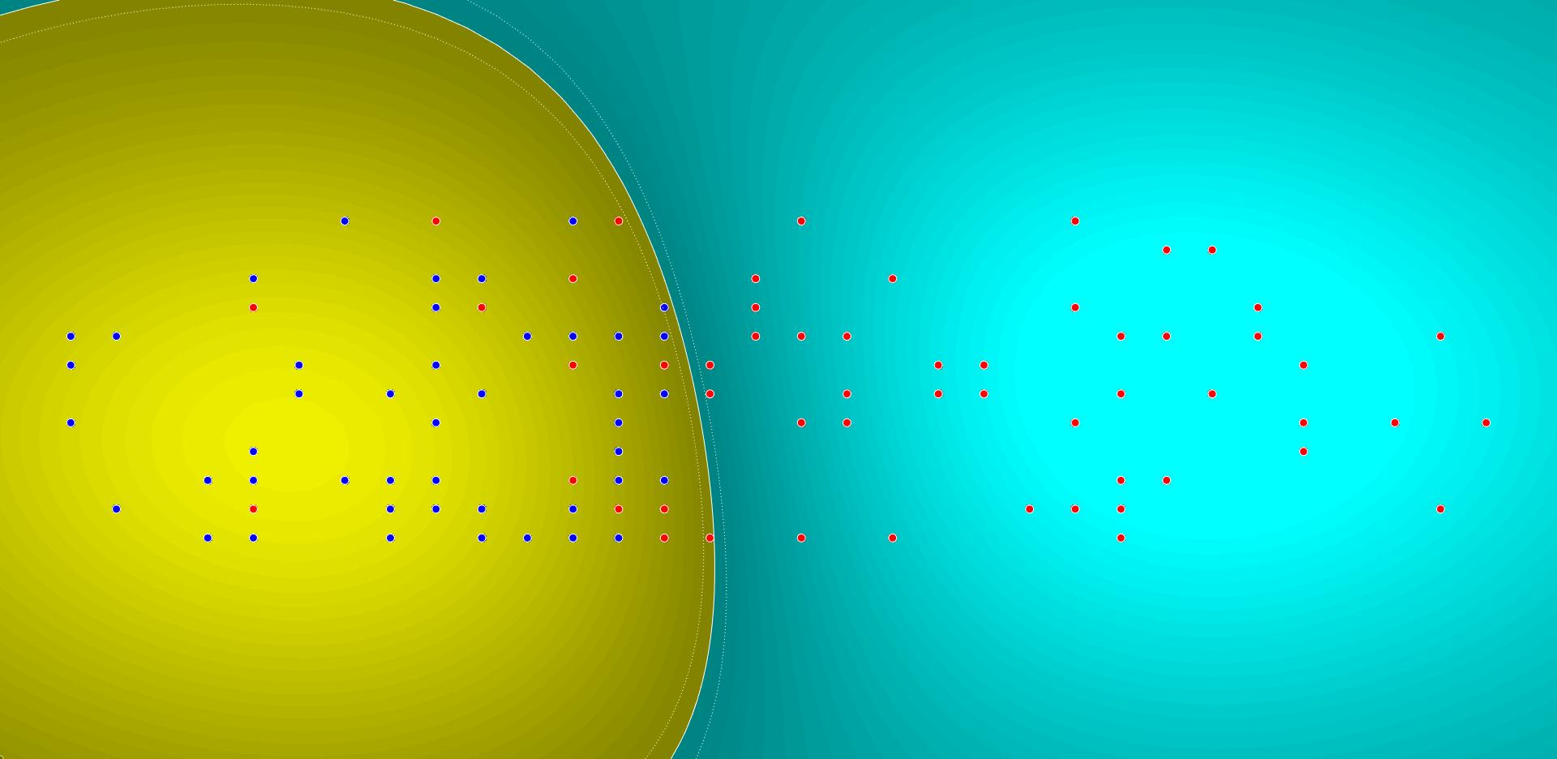

Survival_lindual

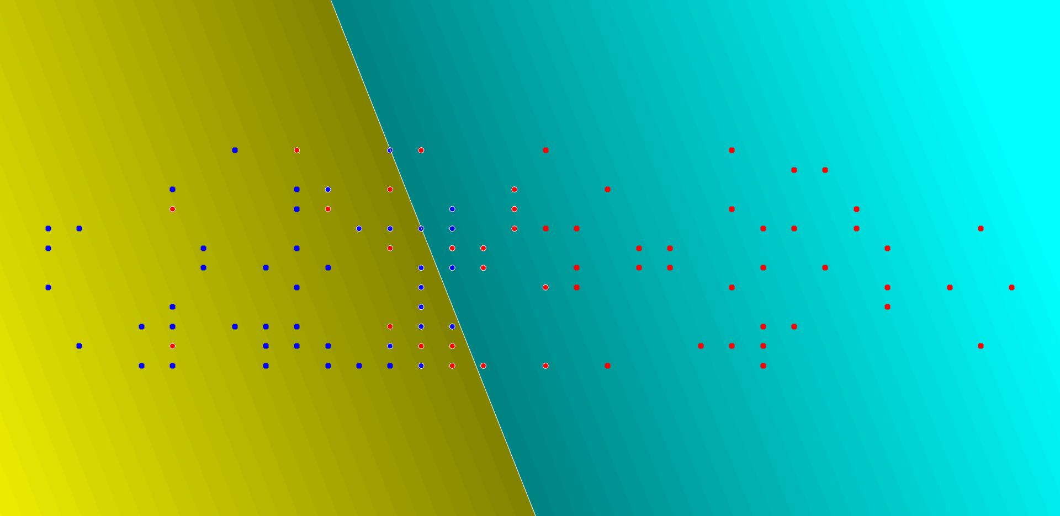

Survival_linprimal

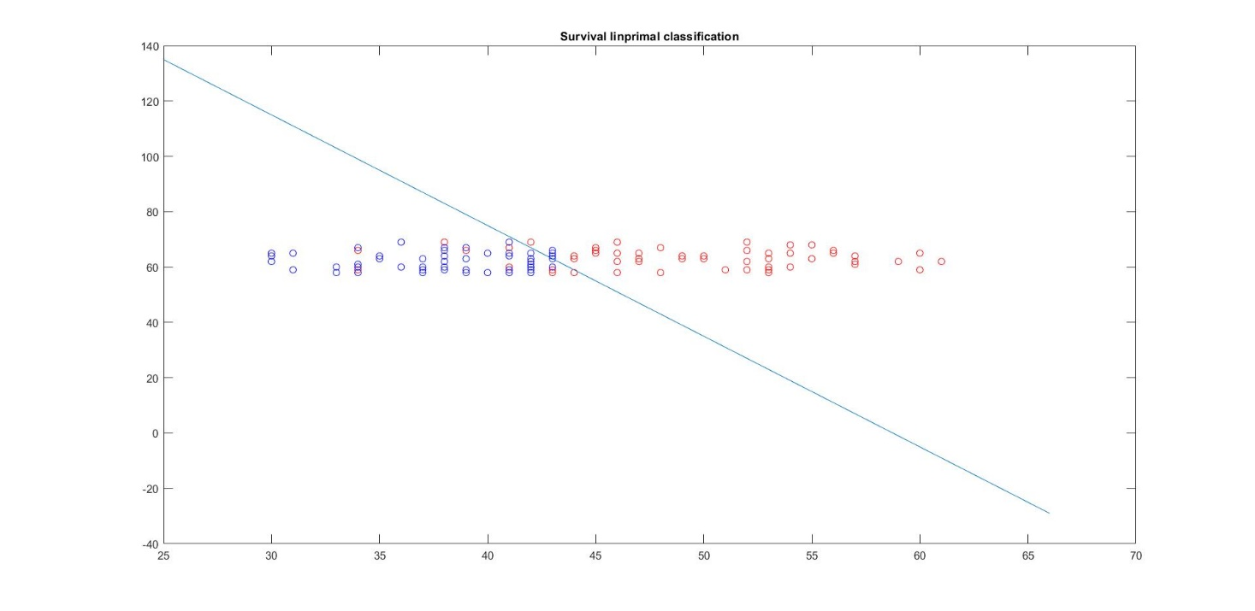

Chess_polynomial



Chess_linprimal

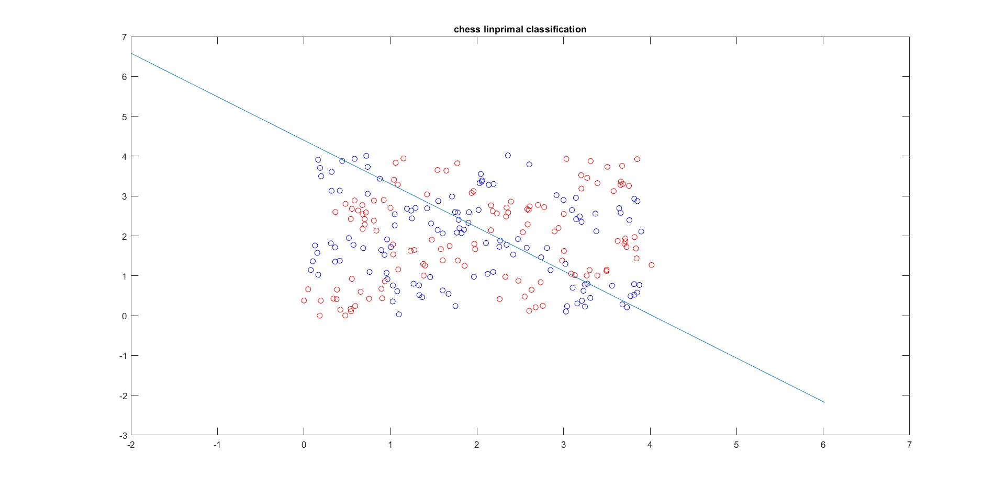

Chess_lindual

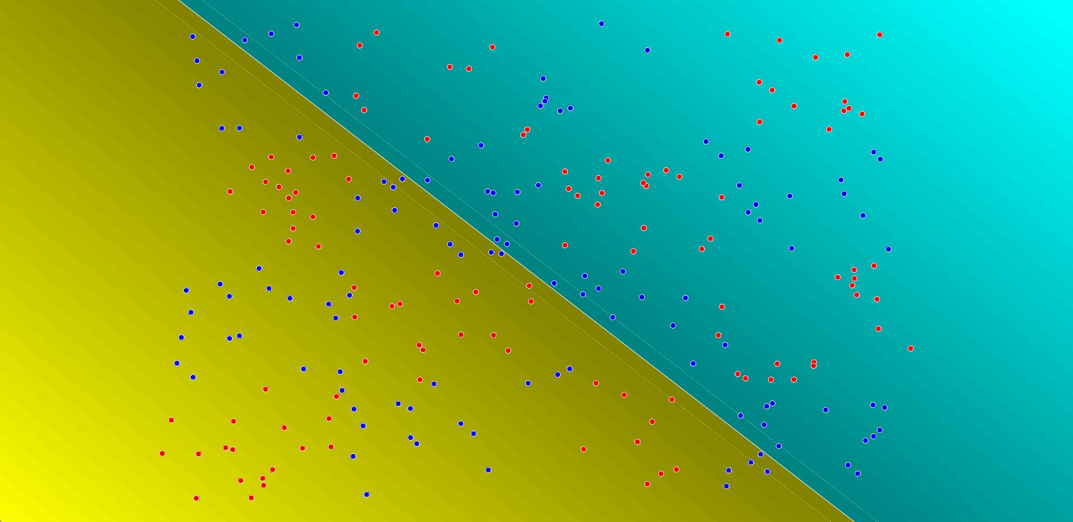

Iris_linprimal

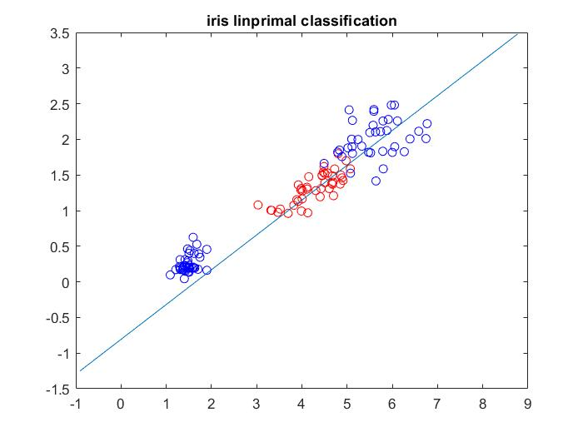

Iris_lindual

